Supplementary Appendix

Supplementary table 1: Detailed search strategy for each of the included databases.

Supplementary table 2: Quality Assessment of Randomized Controlled Trials with Cochrane Risk-of-Bias Tool.

Supplementary figure 1: Funnel plot assessing publication bias.

Supplementary figure 2: Forest plot comparing guided antiplatelet therapy with standard antiplatelet therapy for major adverse cardiovascular events.
Supplementary figure 3: Forest plot comparing guided antiplatelet therapy with standard antiplatelet therapy for cardiovascular mortality.
Supplementary figure 4: Forest plot comparing guided antiplatelet therapy with standard antiplatelet therapy for all-cause mortality.

Supplementary figure 5: Forest plot comparing guided antiplatelet therapy with standard antiplatelet therapy for myocardial infarction.
Supplementary figure 6: Forest plot comparing guided antiplatelet therapy with standard antiplatelet therapy for stent thrombosis.
Supplementary figure 7: Forest plot comparing guided antiplatelet therapy with standard antiplatelet therapy for stroke.

Supplementary figure 8: Forest plot comparing guided antiplatelet therapy with standard antiplatelet therapy for major bleeding.

Supplementary figure 9: Forest plot comparing guided antiplatelet therapy with standard antiplatelet therapy for minor bleeding.

Supplementary table 1: Detailed search strategy for each of the included databases.

Database | Search Strategy | Articles retrieved
MEDLINE | ("phenotype"[MeSH Terms] OR "phenotype"[All Fields] OR "phenotypes"[All Fields] OR "phenotyped"[All Fields] OR "phenotypic"[All Fields] OR "phenotypical"[All Fields] OR "phenotypically"[All Fields] OR "phenotyping"[All Fields] OR "phenotypings"[All Fields] OR ("genotype"[MeSH Terms] OR "genotype"[All Fields] OR "genotypes"[All Fields] OR "genotypic"[All Fields] OR "genotype s"[All Fields] OR "genotyped"[All Fields] OR "genotyper"[All Fields] OR "genotypical"[All Fields] OR "genotypically"[All Fields] OR "genotyping"[All Fields] OR "genotypings"[All Fields] OR "genotypization"[All Fields])) AND ("clopidogrel"[MeSH Terms] OR "clopidogrel"[All Fields] OR "clopidogrel s"[All Fields] OR ("antiplatelet"[All Fields] OR "antiplatelets"[All Fields]) OR ("percutaneous coronary intervention"[MeSH Terms] OR ("percutaneous"[All Fields] AND "coronary"[All Fields] AND "intervention"[All Fields]) OR "percutaneous coronary intervention"[All Fields])) | 1941
Cochrane  Central | (phenotype OR genotype) AND (clopidogrel OR antiplatelet OR percutaneous coronary intervention) | 369

Supplementary Table 2: Quality Assessment of Randomized Controlled Trials with Cochrane Risk-of-Bias Tool.

# | Study, year | Sequence Generation  (selection bias) | Allocation concealment (selection bias) | Blinding of Participants (performance bias) | Blinding of Outcome assessment (detection bias) | Incomplete outcome data (attrition bias) | Selective outcome reporting (reporting bias) | Other sources of bias
1 | Hazarbasanov et al, 2012 | Unclear | Low | Low | High | Low | Unclear | High
2 | Collet et al, 2012  (ARCTIC) | Low | Low | Low | Low | Low | Low | Low
3 | Xie et al, 2013  (IAC-PCI) | Low | Unclear | Low | High | Low | Low | High
4 | Zhu et al, 2015 | Low | Low | Low | High | Low | Low | High
5 | Cayla et al, 2016 (ANTARCTIC) | Low | Low | Low | Low | Low | Low | Low
6 | Sibbing et al, 2017 (TROPICAL-ACS) | Low | Low | Low | Low | Low | Low | Low
7 | Notarangelo et al, 2018  (PHARMCLO) | Low | Low | Low | High | Low | Low | High
8 | Claassens et al, 2019  (POPular Genetics) | Low | Low | Low | Low | Low | Low | Low
9 | Tuteja et al, 2020 | High | High | Low | High | Low | Low | High
10 | Zheng et al, 2020  (PATH-PCI) | High | High | High | High | Low | Low | High
11 | Pereira et al, 2020 (TAILOR-PCI) | Low | Low | Low | Low | Low | Low | Low

Supplementary figure 1: Funnel plot assessing publication bias.

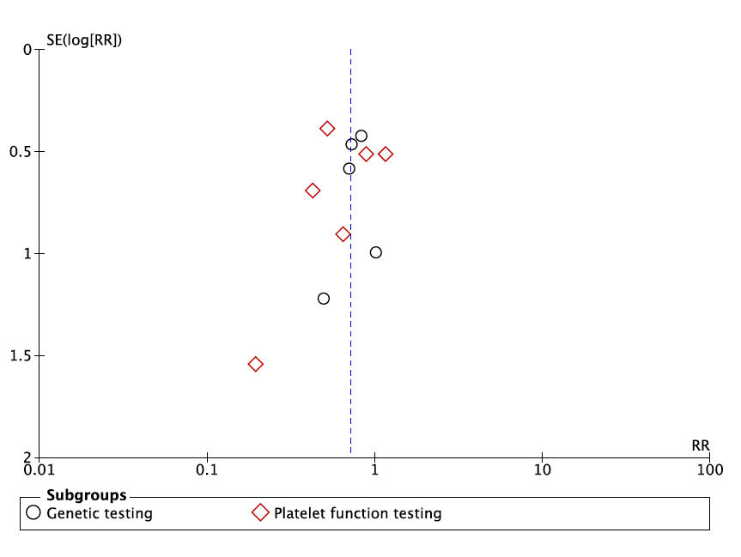

SE, standard error; RR, risk ratio

Supplementary figure 2: Forest plot comparing guided antiplatelet therapy with standard antiplatelet therapy for major adverse cardiovascular events.
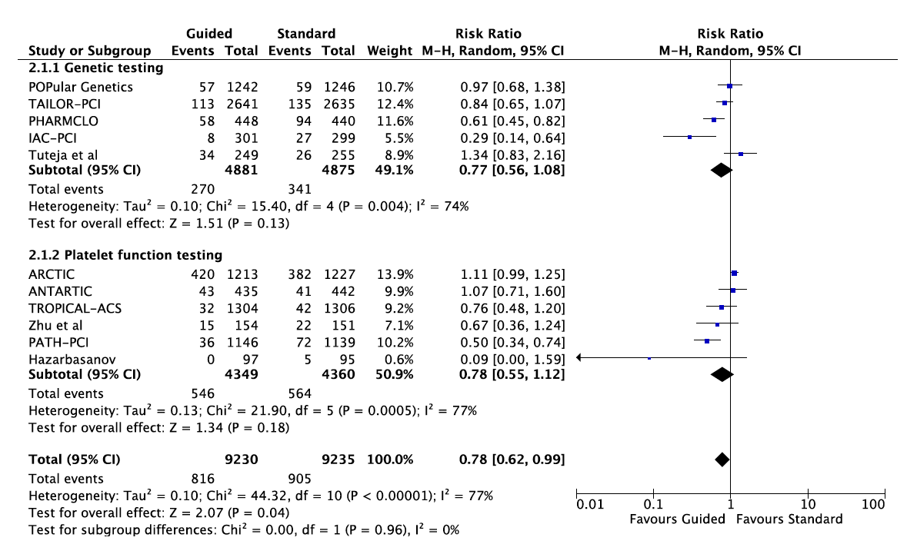
Supplementary figure 3: Forest plot comparing guided antiplatelet therapy with standard antiplatelet therapy for cardiovascular mortality.
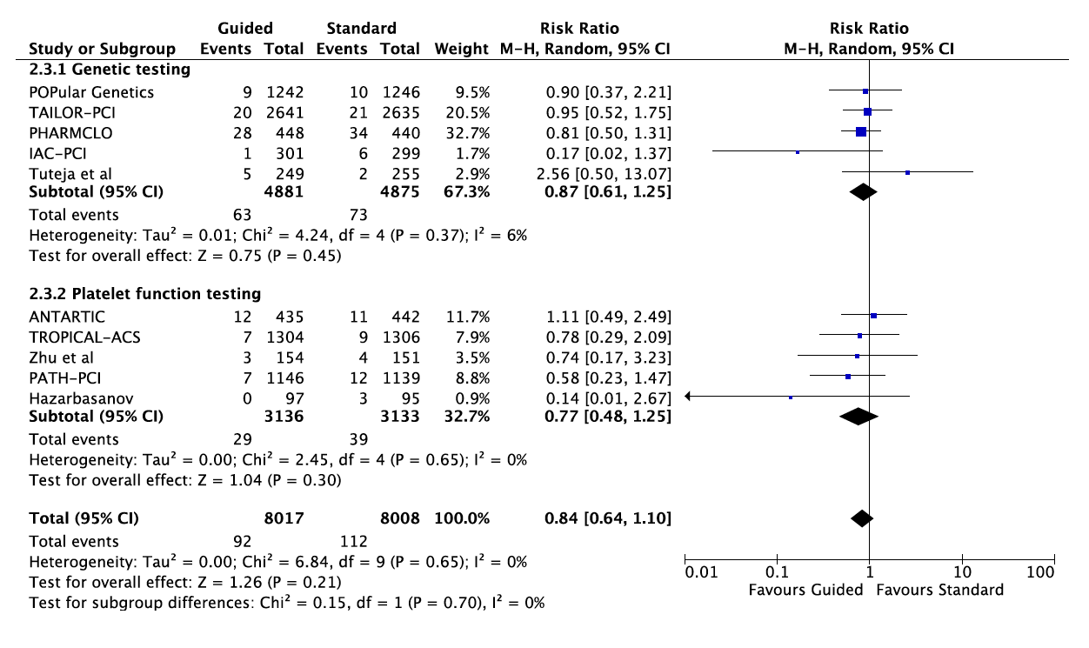

Supplementary figure 4: Forest plot comparing guided antiplatelet therapy with standard antiplatelet therapy for all-cause mortality.
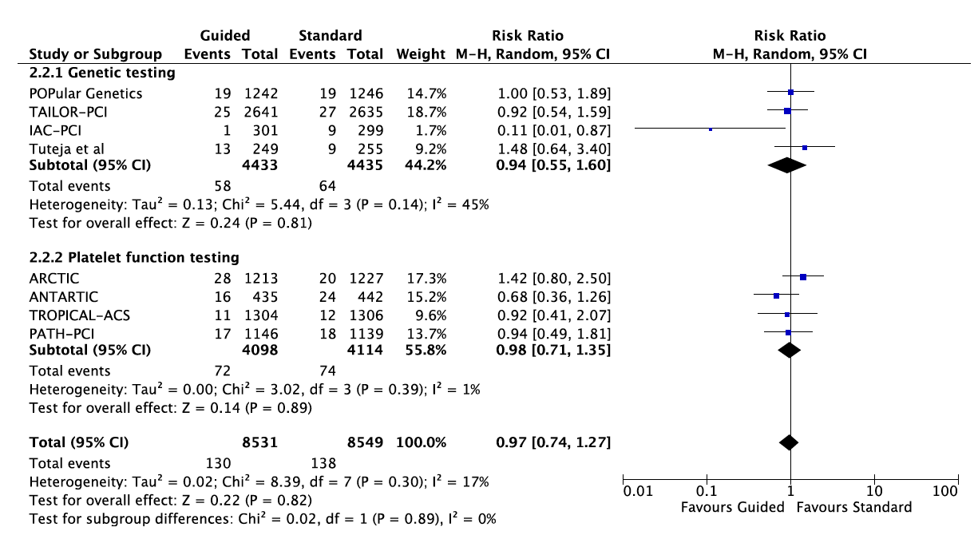

Supplementary figure 5: Forest plot comparing guided antiplatelet therapy with standard antiplatelet therapy for myocardial infarction.
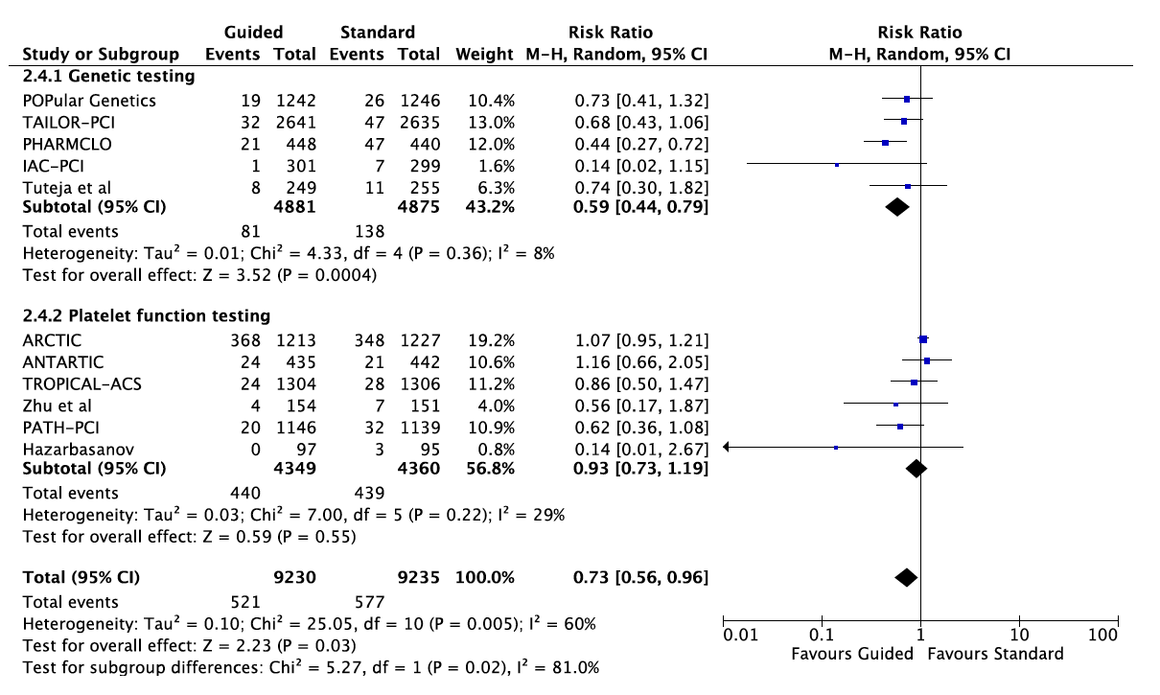

Supplementary figure 6: Forest plot comparing guided antiplatelet therapy with standard antiplatelet therapy for stent thrombosis.
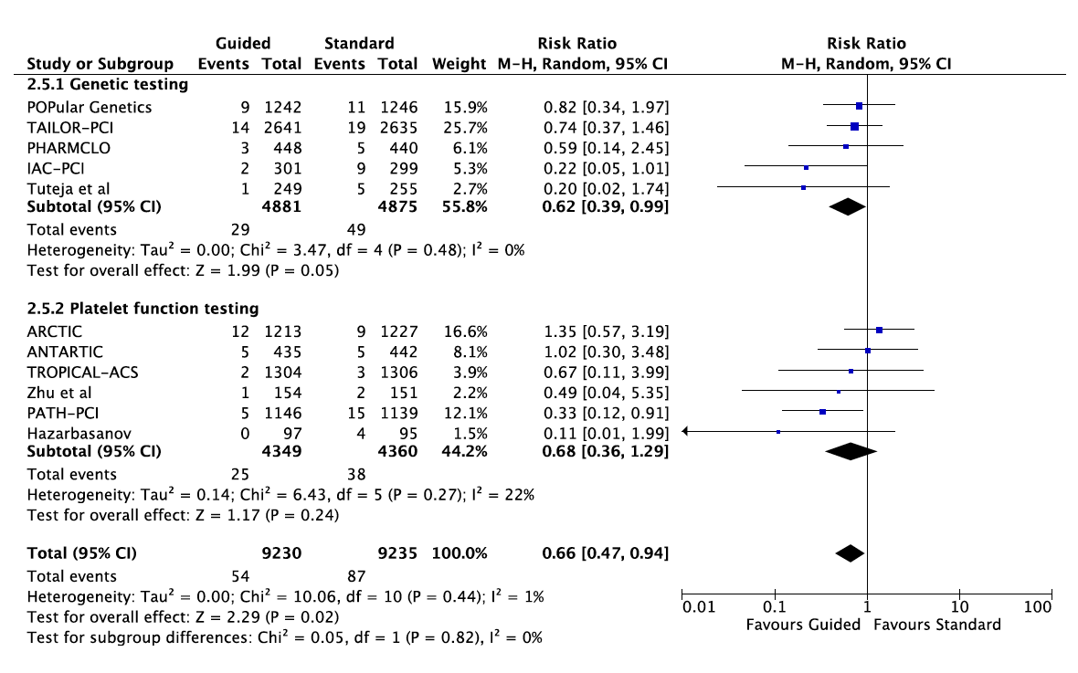

Supplementary figure 7: Forest plot comparing guided antiplatelet therapy with standard antiplatelet therapy for stroke.
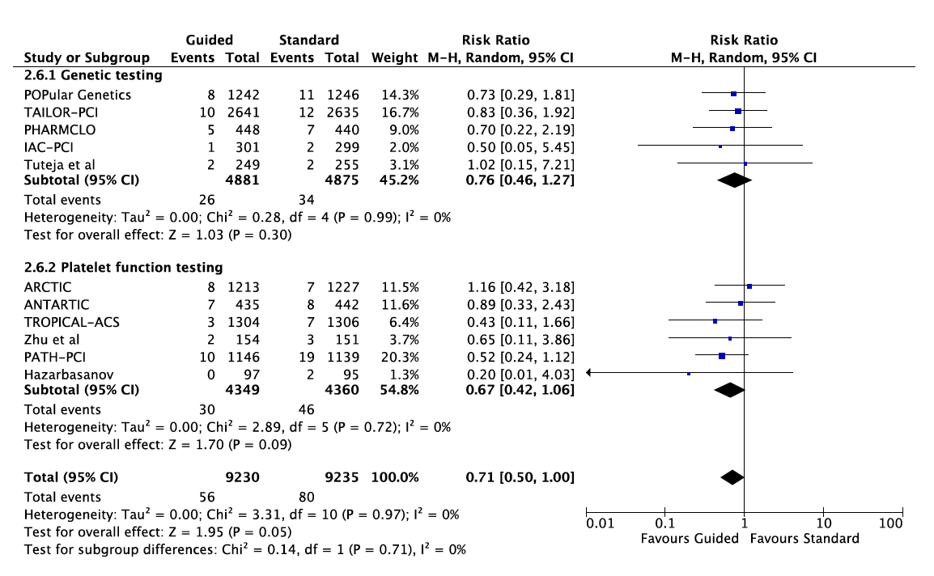

Supplementary figure 8: Forest plot comparing guided antiplatelet therapy with standard antiplatelet therapy for major bleeding.
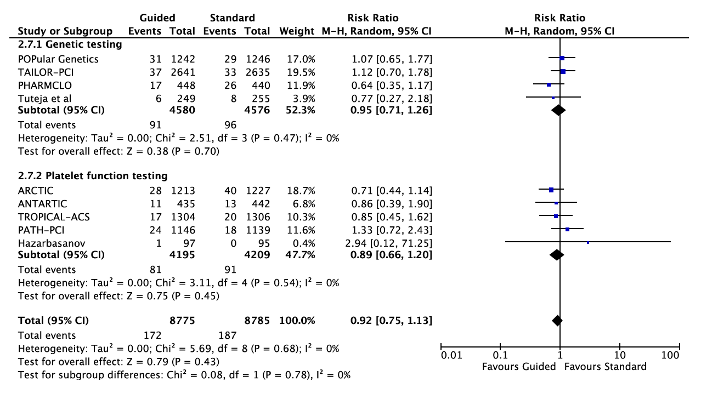

Supplementary figure 9: Forest plot comparing guided antiplatelet therapy with standard antiplatelet therapy for minor bleeding.


