SUPPLEMENTAL APPENDIX

Supplemental Table S1. Search strategy used in each database searched

Supplemental Figure 1. Prisma Flow Diagram

Supplemental Figure 2a. Quality Assessment of Included Randomized Controlled Trials using Cochrane Risk of Bias Tool; Risk of Bias Graph
Supplemental Figure 2b. Quality Assessment of Included Randomized Controlled Trials using Cochrane Risk of Bias Tool; Risk of Bias Summary
Supplemental Table S2. Baseline Characteristics of Patients

Supplemental Figure 3. Forest displaying subgroup analysis according to type of DOAC for the following outcomes: (A) venous thromboembolism, (B) major bleeding
Supplemental Figure 4. Forest plot displaying subgroup analysis according to type of cancer for venous thromboembolism
Supplemental Figure 5. Forest displaying sensitivity analysis for clinically relevant non-major bleeding

Supplemental Table 1. Search strategy used in each database searched

Database (Articles  Retrieved) | Search Strategy
((("direct"[All Fields] OR "directed"[All Fields] OR "directing"[All Fields] OR "direction"[All Fields] OR "directional"[All Fields] OR "directions"[All Fields] OR "directivities"[All Fields] OR "directivity"[All Fields] OR "directs"[All Fields]) AND ("mouth"[MeSH Terms] OR "mouth"[All Fields] OR "oral"[All Fields]) AND ("anticoagulants"[Pharmacological Action] OR "anticoagulants"[MeSH Terms] OR "anticoagulants"[All Fields] OR "anticoagulant"[All Fields] OR "anticoagulate"[All Fields] OR "anticoagulated"[All Fields] OR "anticoagulating"[All Fields] OR "anticoagulation"[All Fields] OR "anticoagulations"[All Fields] OR "anticoagulative"[All Fields])) OR "DOAC"[All Fields] OR (("novel"[All Fields] OR "novel s"[All Fields] OR "novels"[All Fields]) AND ("mouth"[MeSH Terms] OR "mouth"[All Fields] OR "oral"[All Fields]) AND ("anticoagulants"[Pharmacological Action] OR "anticoagulants"[MeSH Terms] OR "anticoagulants"[All Fields] OR "anticoagulant"[All Fields] OR "anticoagulate"[All Fields] OR "anticoagulated"[All Fields] OR "anticoagulating"[All Fields] OR "anticoagulation"[All Fields] OR "anticoagulations"[All Fields] OR "anticoagulative"[All Fields])) OR ("New"[All Fields] AND ("mouth"[MeSH Terms] OR "mouth"[All Fields] OR "oral"[All Fields]) AND ("anticoagulants"[Pharmacological Action] OR "anticoagulants"[MeSH Terms] OR "anticoagulants"[All Fields] OR "anticoagulant"[All Fields] OR "anticoagulate"[All Fields] OR "anticoagulated"[All Fields] OR "anticoagulating"[All Fields] OR "anticoagulation"[All Fields] OR "anticoagulations"[All Fields] OR "anticoagulative"[All Fields])) OR ("n 4 oleylcytosine arabinoside"[Supplementary Concept] OR "n 4 oleylcytosine arabinoside"[All Fields] OR "noac"[All Fields]) OR ("Target-specific"[All Fields] AND ("mouth"[MeSH Terms] OR "mouth"[All Fields] OR "oral"[All Fields]) AND ("anticoagulants"[Pharmacological Action] OR "anticoagulants"[MeSH Terms] OR "anticoagulants"[All Fields] OR "anticoagulant"[All Fields] OR "anticoagulate"[All Fields] OR "anticoagulated"[All Fields] OR "anticoagulating"[All Fields] OR "anticoagulation"[All Fields] OR "anticoagulations"[All Fields] OR "anticoagulative"[All Fields])) OR ("2 2 6 6 tetramethylpiperidine n oxide 4 amino 4 carboxylic acid"[Supplementary Concept] OR "2 2 6 6 tetramethylpiperidine n oxide 4 amino 4 carboxylic acid"[All Fields] OR "toac"[All Fields]) OR ("factor xa inhibitors"[Pharmacological Action] OR "factor xa inhibitors"[MeSH Terms] OR ("factor"[All Fields] AND "xa"[All Fields] AND "inhibitors"[All Fields]) OR "factor xa inhibitors"[All Fields] OR ("direct"[All Fields] AND "factor"[All Fields] AND "xa"[All Fields] AND "inhibitors"[All Fields]) OR "direct factor xa inhibitors"[All Fields]) OR ("Non-Vitamin"[All Fields] AND "K"[All Fields] AND ("antagonist"[All Fields] OR "antagonists and inhibitors"[MeSH Subheading] OR ("antagonists"[All Fields] AND "inhibitors"[All Fields]) OR "antagonists and inhibitors"[All Fields] OR "antagonists"[All Fields])) OR "non-VKA"[All Fields] OR ("rivaroxaban"[MeSH Terms] OR "rivaroxaban"[All Fields]) OR ("apixaban"[Supplementary Concept] OR "apixaban"[All Fields] OR "apixaban s"[All Fields]) OR ("edoxaban"[Supplementary Concept] OR "edoxaban"[All Fields]) OR ("dabigatran"[MeSH Terms] OR "dabigatran"[All Fields] OR "dabigatran s"[All Fields]) OR ("betrixaban"[Supplementary Concept] OR "betrixaban"[All Fields]) OR (("vitamin k"[MeSH Terms] OR "vitamin k"[All Fields]) AND ("antagonist"[All Fields] OR "antagonists
and inhibitors"[MeSH Subheading] OR ("antagonists"[All Fields] AND "inhibitors"[All Fields]) OR "antagonists and inhibitors"[All Fields] OR

Cochrane Library (1587 results) | "antagonists"[All Fields])) OR "VKA"[All Fields] OR ("warfarin"[MeSH Terms] OR "warfarin"[All Fields] OR "warfarin s"[All Fields] OR "warfarinization"[All Fields] OR "warfarinized"[All Fields] OR "warfarins"[All Fields]) OR ("warfarin"[MeSH Terms] OR "warfarin"[All Fields] OR "coumadin"[All Fields] OR "warfarin s"[All Fields] OR "warfarinization"[All Fields] OR "warfarinized"[All Fields] OR "warfarins"[All Fields]) OR ("heparin"[MeSH Terms] OR "heparin"[All Fields] OR "heparine"[All Fields] OR "heparins"[All Fields] OR "heparin s"[All Fields] OR "heparinate"[All Fields] OR "heparinated"[All Fields] OR "heparines"[All Fields] OR "heparinic"[All Fields] OR "heparinisation"[All Fields] OR "heparinised"[All Fields] OR "heparinization"[All Fields] OR "heparinize"[All Fields] OR "heparinized"[All Fields] OR "heparinizing"[All Fields])) AND ("cancer s"[All Fields] OR "cancerated"[All Fields] OR "canceration"[All Fields] OR "cancerization"[All Fields] OR "cancerized"[All Fields] OR "cancerous"[All Fields] OR "neoplasms"[MeSH Terms] OR "neoplasms"[All Fields] OR "cancer"[All Fields] OR "cancers"[All Fields] OR ("cysts"[MeSH Terms] OR "cysts"[All Fields] OR "cyst"[All Fields] OR "neurofibroma"[MeSH Terms] OR "neurofibroma"[All Fields] OR "neurofibromas"[All Fields] OR "tumor s"[All Fields] OR "tumoral"[All Fields] OR "tumorous"[All Fields] OR "tumour"[All Fields] OR "neoplasms"[MeSH Terms] OR "neoplasms"[All Fields] OR "tumor"[All Fields] OR "tumour s"[All Fields] OR "tumoural"[All Fields] OR "tumourous"[All Fields] OR "tumours"[All Fields] OR "tumors"[All Fields]) OR ("malign"[All Fields] OR "malignance"[All Fields] OR "malignances"[All Fields] OR "malignant"[All Fields] OR "malignants"[All Fields] OR "malignities"[All Fields] OR "malignity"[All Fields] OR "malignization"[All Fields] OR "malignized"[All Fields] OR "maligns"[All Fields] OR "neoplasms"[MeSH Terms] OR "neoplasms"[All Fields] OR "malignancies"[All Fields] OR "malignancy"[All Fields]) OR ("carcinoma"[MeSH Terms] OR "carcinoma"[All Fields] OR "carcinomas"[All Fields] OR "carcinoma s"[All Fields]) OR ("metastasi"[All Fields] OR "neoplasm metastasis"[MeSH Terms] OR ("neoplasm"[All Fields] AND "metastasis"[All Fields]) OR "neoplasm metastasis"[All Fields] OR "metastasis"[All Fields]))  (Direct Oral Anticoagulants OR DOAC OR Novel Oral Anticoagulants OR New Oral Anticoagulants OR NOAC OR Target-specific Oral Anticoagulants OR TOAC OR Direct Factor Xa Inhibitors OR Non-Vitamin K Antagonists OR non-VKA OR Rivaroxaban OR Apixaban OR Edoxaban OR Dabigatran OR Betrixaban OR Vitamin K antagonists OR VKA OR Warfarin OR Coumadin OR Heparin) AND (Cancer OR Tumor OR Malignancy OR Carcinoma OR Metastasis) in Title Abstract Keyword

Supplemental Figure 1: Prisma Flow Diagram

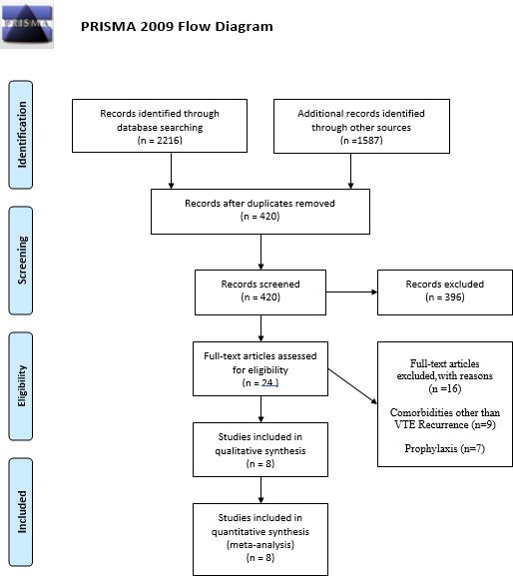

Supplemental Figure 2a. Quality Assessment of Included Randomised Controlled Trials using Cochrane Risk of Bias Tool; Risk of Bias Graph
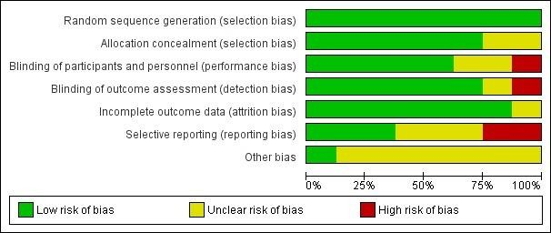

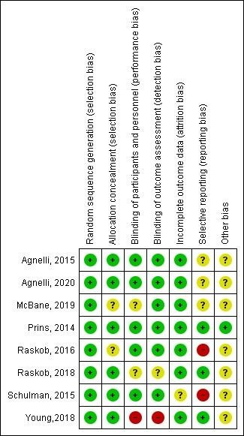
Supplemental Figure 2b. Quality Assessment of Included Randomised Controlled Trials using Cochrane Risk of Bias Tool; Risk of Bias Summary

Supplemental Table 2. S2. Baseline Characteristics of Patie  Agnelli, 2020 |  |  | nts  McBane, 2019 |  | Young, 2018 |  | Raskob, 2018
 | Apixaban n = 576 | Dalteparin n = 576 | Apixaba n  n = 150 | Daltepari n  n = 150 | Rivaroxaba n  n = 203 | Daltepari n  n = 203 | Edoxaba n  n = 522 | Daltepari n  n = 524
Age,y, mean (SD), or (%) | 67.2±11.3 | 67.2±10.9 | 64.4  (11.3) | 64.0  (10.8) | 67  (median) | 67  (median) | 64.3±11.  0 | 63.7±11.  7
Female sex no. (%) | 284(49.3) | 300(52.3) | 78  (52.0) | 77 (51.3) | 87(43) | 105(52) | 245(46.9  ) | 261(49.8  )
Male sex no. (%) | 292 (50.7) | 276 (47.7) | 72(48.0) | 73(48.7) | 116(57) | 98(48) | 277  (53.1) | 263  (50.2)
BMI, kg/m2, mean (SD) | NA | NA | NA | NA | 26.7  (median) | 26.6  (median) | NA | NA
Weight, mean (SD), kg | 75.7±16.1 | 76.1±16.7 | 84.8  (23.2 | 86.8  (20.5) | NA | NA | 78.8±17.  9 | 79.1±18.  1
Creatinine clearance ≤50 ml  per min — no. (%) | 51 (8.9) | 61 (10.5) | 14  (9.3%) | 14  (9.3%) | 40 (19) | 38 (18) | 38 (7.3) | 34 (6.5)
Qualifying thrombus n,
(%
pulmonary embolism only (PE) | 304 (52.8) | 334 (57.7) | 64  (43.5%) | 57  (38.5%) | 40 (19) | 38 (18) | 328  (62.8) | 329  (62.8)
deep vein thrombosis only (DVT) | 272 (47.2) | 245 (42.3) | 54  (36.7%) | 52  (35.1%) | 53 (25) | 57 (28) | 194  (37.2) | 195  (37.2)
Type of cancer — no. (%)
Active | 559 (97.0) | 565 (97.6) | NA | NA | NA | NA | 513  (98.3) | 511  (97.5)
History of Cancer | NA | NA | NA | NA | NA | NA | NA | NA
Recurrent locally advanced  or metastatic | 389 (67.5) | 396 (68.4) | 96  (65.3%) | 97  (66.0%) | 199(98) | 197(97) | NA | NA
Cancer treatment — no.
(%)
At enrolment | 350 (60.8) | 367 (63.4) | NA | NA | NA | NA | NA | NA
Withing previous 6mo | 143 (24.8) | 129 (22.3) | NA | NA | NA | NA | 374  (71.6) | 383  (73.1)
During trial period | 344 (59.7) | 346 (59.8) | NA | NA | NA | NA | NA | NA

Supplemental Table 2. S2. Baseline Characteristics of Patients (Continued)

Raskob, 2016 |  |  | Agnelli, 2015 |  | Schulman, 2015 |  | Prins, 2014
 | Edoxaban n = 487 | Warfarin n = 492 | Apixaban n = 274 | Warfarin n = 260 | Dabigatran n = 59 | Warfarin n = 55 | Rivaroxaban n = 491 | Warfarin n = 440
Age, y, mean (SD), or (%) | 66.5(62.22) | 66(59.04) | 67.4 | 66.3 | 60.9 ± 13.5 | 65.3 ± 13.2 | 65-75(31.4) | 65-75(39.5)
Female sex no. (%) | 252(51.7) | 226(45.9) | 133(48.5) | 182(60.0) | 22 (37) | 13 (24) | 219(44.6) | 208(47.3)
Male sex no. (%) | 235(48.3) | 266(54.1) | 141(51.5) | 78(30.0) | 37(63) | 42(76) | 272(55.4) | 232(52.7)
BMI, kg/m2, mean (SD) | NA | NA | NA | NA | 28.0 ± 5.4 | 28.2 ± 4.8 | 27.6 (mean) | 27.8(mean)
Weight, mean (SD), kg | NA | NA | 81.1 | 82.1 | 82.7 ± 16.3 | 82.7 ± 15.6 | NA | NA
Creatinine clearance ≤50 ml per min — no. (%) | NA | NA | NA | NA | 90.7 ± 27.2 | 83.9 ± 30.4 | 75 | 65
Qualifying thrombus n, (%
pulmonary embolism only (PE) | 215(44.1) | 229(46.5) | NA | NA | 16 (27) | 8 (15) | NA | NA
deep vein thrombosis only (DVT) | 272(55.9) | 263(53.5) | NA | NA | 36 (61) | 40 (73) | NA | NA
Type of cancer — no. (%)
Active | 109(22.4) | 99(20.1) | 88 | 81 | NA | NA | NA | NA
History of Cancer | 378(77.6) | 393(79.9) | 186 | 179 | NA | NA | NA | NA
Recurrent locally advanced or metastatic | NA | NA | NA | NA | NA | NA | 49(10) | 52(11.8)
Cancer treatment — no. (%)
At enrolment | NA | NA | NA | NA | NA | NA | NA | NA
Withing previous 6mo | NA | NA | NA | NA | NA | NA | NA | NA
During trial period | NA | NA | NA | NA | NA | NA | NA | NA

Supplemental Figure 3. Forest displaying subgroup analysis according to type of DOAC for the following outcomes: (A) venous thromboembolism, (B) major bleeding

Venous thromboembolism

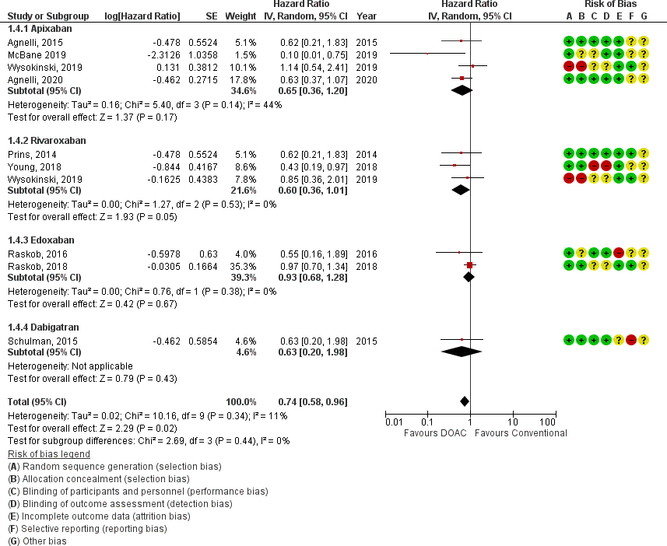

- Major Bleeding
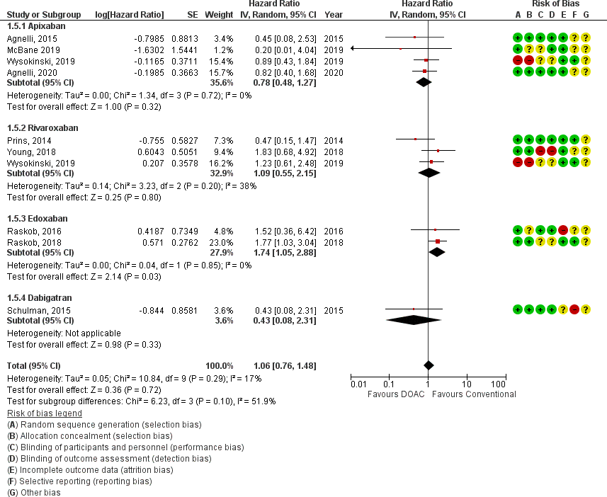

Supplemental Figure 4. Forest plot displaying subgroup analysis according to type of cancer for venous thromboembolism
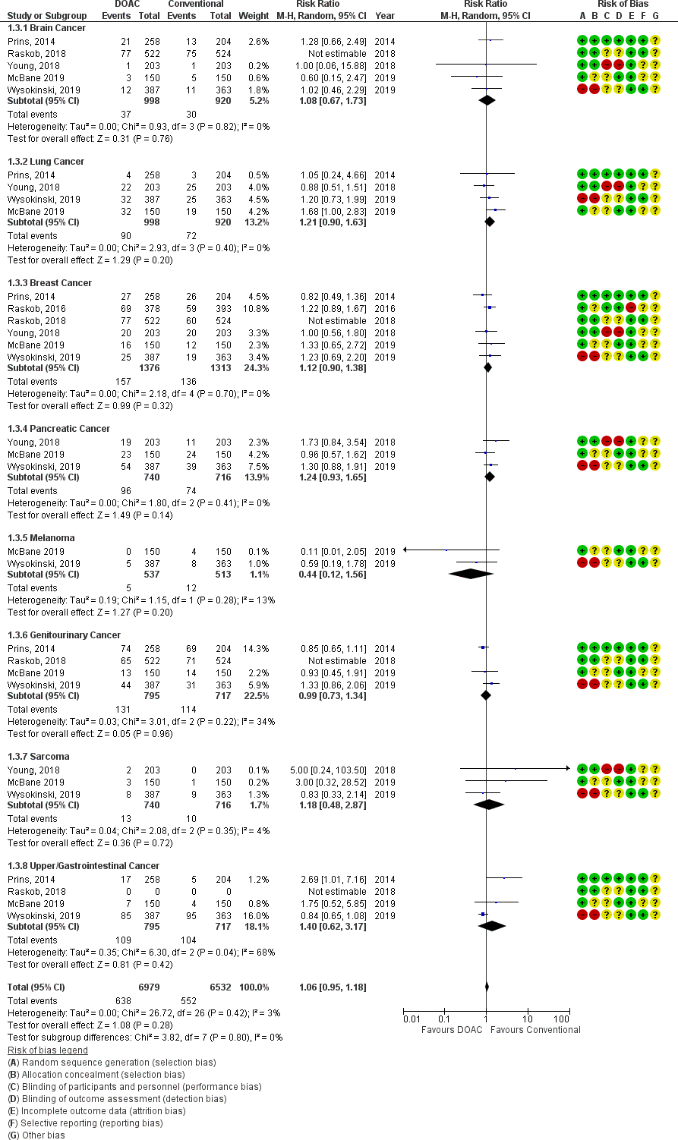

Supplemental Figure 5. Forest displaying sensitivity analysis for clinically relevant non- major bleeding


