Supplementary Material
Hepatic Arterial Infusion Pump Chemotherapy for Unresectable Intrahepatic Cholangiocarcinoma: A Systematic Review and Meta-Analysis
Jessica J. Holster, Marouan el Hassnaoui, Stijn Franssen, Jan N.M. IJzermans, Jeroen de Jonge, Bianca Mostert, Wojciech G. Polak, Roeland F. de Wilde, Marjolein Y.V. Homs and Bas Groot Koerkamp
FIG. S1 The Newcastle-Ottawa Scale (NOS) for assessing the quality of non-randomized studies in meta-analyses.
(a)
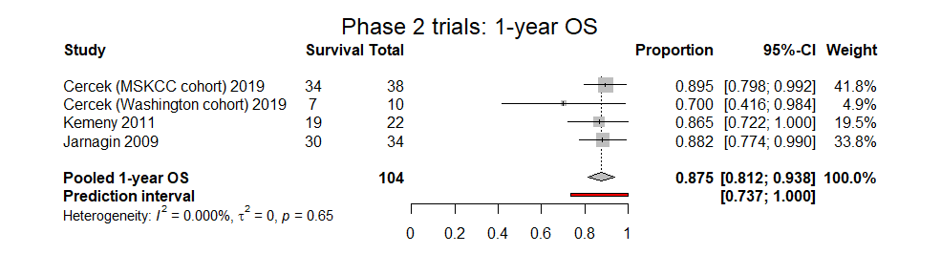

(b)
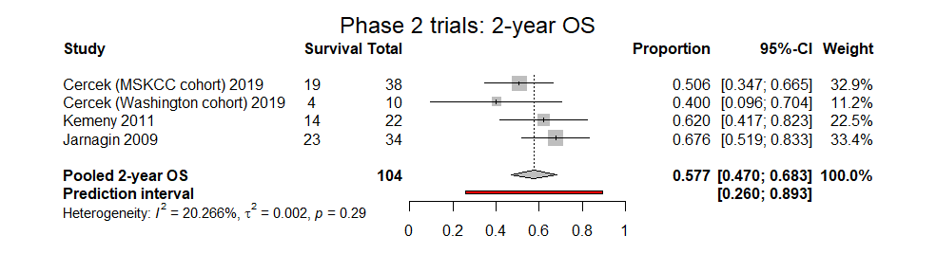
(c)
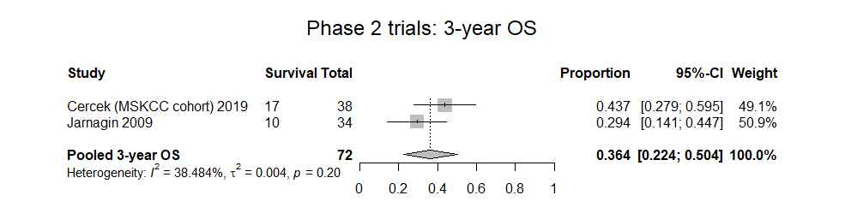

FIG. S2 Sensitivity analysis of the 1-, 2-, and 3-year OS identified in the 3 phase II trials. Forest plots showing (a) pooled 1-year OS, (b) pooled 2-year OS, and (c) pooled 3-year OS.
OS Overall Survival; CI Confidence Interval.

TABLE S1 Search strategy for each database.
Database | Search terms | Results
PubMed | ("Cholangiocarcinoma"[Mesh] OR “Biliary tract neoplasms”[Mesh] OR “cholangiocarcinoma”[tiab] OR Biliary tract neoplasm* OR Biliary tract cancer* OR Bile duct cancer* OR Bile duct carcinoma* OR biliary tree carcinoma* OR carcinoma of the biliary tract* OR cholangiocellular carcinoma*) AND (("Floxuridine"[Mesh] OR floxuridine* OR FUDR* OR Fluorodeoxyuridine* OR 5-FUDR* OR 5-Fluorodeoxyuridine* OR chemotherapy*) AND (“Infusions, Intra-Arterial”[Mesh] OR infusion pump* OR HAIP* OR HAIT* OR hepatic arterial infusion* OR hepatic artery infusion* OR hepatic intra-arterial* OR Intra-arterial therapy* OR HAI chemotherapy*)) AND English[lang] | 220
Embase | ('bile duct carcinoma'/de OR (cholangiocarcinoma* OR malignant-cholangioma* OR ((cholangiocellular* OR cholangiolar*) NEAR/3 (intrahepatic*) NEAR/6 (unresect*)) OR ((bile-tract* OR biliar* OR bile-duct*) NEAR/3 (carcinom* OR cancer* OR neoplasm* OR tumor* OR tumour*))):ab,ti,kw) AND ('floxuridine'/de OR 'implantable infusion pump'/de OR 'continuous infusion'/de OR (floxuridin* OR FUDR* OR Fluorodeoxyuridine* OR 5FUDR* OR 5Fluorodeoxyuridine* OR HAIP* OR HAIT* OR HAI-chemotherap* OR ((implant*) NEAR/3 (infus*) NEAR/3 (pump*)) OR ((continu*) NEAR/3 (infus*))):ab,ti,kw) | 330
Medline(Ovid) | (exp "Biliary Tract Neoplasms"/ OR "Cholangiocarcinoma"/ OR (cholangiocarcinoma* OR malignant-cholangioma* OR ((cholangiocellular* OR cholangiolar*) ADJ3 (intrahepatic*) ADJ6 (unresect*)) OR ((bile-tract* OR biliar* OR bile-duct*) ADJ3 (carcinoma* OR cancer* OR neoplasm* OR tumor* OR tumour*))).ab,ti,kf.) AND ("Floxuridine"/ OR "Infusion Pumps, Implantable"/ OR ((floxuridine* OR FUDR* OR Fluorodeoxyuridine* OR 5FUDR* OR 5Fluorodeoxyuridine* OR HAIP* OR HAIT* OR HAI-chemotherap* OR ((implant*) ADJ3 (infus*) ADJ3 (pump*)) OR ((continu*) ADJ3 (infus*))).ab,ti,kf.)) | 143
Web-of-Science | TS=(((cholangiocarcinoma* OR malignant-cholangioma* OR ((cholangiocellular* OR cholangiolar*) NEAR/2 (intrahepatic*) NEAR/5 (unresect*)) OR ((bile-tract* OR biliar* OR bile-duct*) NEAR/2 (carcinom* OR cancer* OR neoplasm* OR tumor* OR tumour*)))) AND ((floxuridin* OR FUDR* OR Fluorodeoxyuridine* OR 5FUDR* OR 5Fluorodeoxyuridine* OR HAIP* OR HAIT* OR HAI-chemotherap* OR ((implant*) NEAR/2 (infus*) NEAR/2 (pump*)) OR ((continu*) NEAR/2 (infus*))))) | 91
Cochrane | ((cholangiocarcinoma* OR malignant-cholangioma* OR ((cholangiocellular* OR cholangiolar*) NEAR/3 (intrahepatic*) NEAR/6 (unresect*)) OR ((bile-tract* OR biliar* OR bile-duct*) NEAR/3 (carcinom* OR cancer* OR neoplasm* OR tumor* OR tumour*))):ab,ti) AND ((floxuridin* OR FUDR* OR Fluorodeoxyuridine* OR 5FUDR* OR 5Fluorodeoxyuridine* OR HAIP* OR HAIT* OR HAI-chemotherap* OR ((implant*) NEAR/3 (infus*) NEAR/3 (pump*)) OR ((continu*) NEAR/3 (infus*))):ab,ti) | 69
Google Scholar  (50 top ranked) | unresectable cholangiocarcinoma floxuridine|FUDR|fluorodeoxyuridine|5FUDR|HAIP|HAIT|"HAI chemotherapy"|"implantable infusion pump”|"continuous infusion"  unresectable cholangiocarcinoma floxuridine|FUDR|fluorodeoxyuridine|5FUDR|HAIP|HAIT|'HAI chemotherapy'|'implantable infusion pump'|'continuous infusion' | 50

TABLE S2 List of excluded articles based on full text with exclusion criteria.
References | Reasons
¹ | <5 patients with intrahepatic cholangiocarcinoma
² | <5 patients with intrahepatic cholangiocarcinoma
³ | <5 patients with intrahepatic cholangiocarcinoma
⁴ | <5 patients with intrahepatic cholangiocarcinoma
⁵ | Did not report (median) overall survival for cholangiocarcinoma
⁶ | Did not report (median) overall survival for cholangiocarcinoma
⁷ | No separate results reported for patients treated with HAIP chemotherapy
⁸ | No separate results reported for patients treated with HAIP chemotherapy
⁹ | No outcomes reported for solely iCCA patients
¹⁰ | No usage of HAIP chemotherapy with floxuridine for (all) intrahepatic cholangiocarcinomas
¹¹ | No usage of HAIP chemotherapy with floxuridine for (all) intrahepatic cholangiocarcinomas
¹² | No usage of HAIP chemotherapy with floxuridine for (all) intrahepatic cholangiocarcinomas
¹³ | No usage of HAIP chemotherapy with floxuridine for (all) intrahepatic cholangiocarcinomas
¹⁴ | No usage of HAIP chemotherapy with floxuridine for (all) intrahepatic cholangiocarcinomas
¹⁵ | No usage of HAIP chemotherapy with floxuridine for (all) intrahepatic cholangiocarcinomas
¹⁶ | No usage of HAIP chemotherapy with floxuridine for (all) intrahepatic cholangiocarcinomas
¹⁷ | No usage of HAIP chemotherapy with floxuridine for (all) intrahepatic cholangiocarcinomas
Abbreviation: HAIP Hepatic arterial infusion pump; iCCA Intrahepatic cholangiocarcinoma.

TABLE S3 Prior systemic chemotherapy.
Author | Sample size, No. | Prior systemic chemotherapy, No. (%) | Regimen
Pietge ¹⁸ | 12 | 2 (16.7) | NR
Cercek ¹⁹ | 38 | 3 (7.9) | Gemcitabine/cisplatin (n = 2),  FOLFIRINOX (n = 1)
 | 10 | 2 (20.0) | Gemcitabine/cisplatin (n = 1), capecitabine/oxaliplatin (n = 1)
Konstantinidis ²⁰ | 44 | 7 (15.9) | Gemcitabine/capecitabine (n = 2), gemcitabine/cisplatin (n = 1),  gemcitabine (n = 1), carboplatin/docetaxel/bevacizumab (n = 1),  >1 chemotherapy line (n = 2)
Kemeny ²¹ | 22 | 3 (13.6) | Gemcitabine/cisplatin (n = 1),  irinotecan/Xeloda (n = 1), Tarceva (n = 1)
Jarnagin ²² | 34 | 3 (8.8) | NR
Abbreviation: NR Not reported.

TABLE S4 Quality assessment of included studies with the Newcastle-Ottawa Scale (NOS).
 | Selection |  |  |  | Comparability | Outcome
Author | 1 | 2 | 3 | 4 | 1 | 1 | 2 | 3 | Total
Jolissaint ²³ | b | a | a | a | - | b | a | d | 6
Pietge ¹⁸ | b | NA | a | a | - | b | a | a | 6
Cercek ¹⁹ | b | NA | a | a | NA | b | a | a | 6
Wright ²⁴ | b | NA | a | a | b | b | a | d | 6
Konstantinidis ²⁵ | b | NA | a | a | NA | b | a | a | 6
Konstantinidis ²⁰ | b | NA | a | a | NA | b | a | a | 6
Kemeny ²¹ | b | a | a | a | a,b | b | a | d | 8
Jarnagin ²² | b | NA | a | a | NA | b | a | a | 6
Endo ²⁶ | b | c | a | a | - | b | a | d | 5
Abbreviation: NA Not applicable.

REFERENCES
1. Lawrence TS, Dworzanin LM, Walker-Andrews SC, et al. Treatment of cancers involving the liver and porta hepatis with external beam irradiation and intraarterial hepatic fluorodeoxyuridine. Int J Radiat Oncol Biol Phys. 1991;20(3):555-561.
2. Seeger J, Woodcock TM, Blumenreich MS, Richardson JD. Hepatic perfusion with FUdR utilizing an implantable system in patients with liver primary cancer or metastatic cancer confined to the liver. Cancer Invest. 1989;7(1):1-6.
3. Atiq OT, Kemeny N, Niedzwiecki D, Botet J. Treatment of unresectable primary liver cancer with intrahepatic fluorodeoxyuridine and mitomycin C through an implantable pump. Cancer. 1992;69(4):920-924.
4. Magge D, Choudry HA, Zeh HJ,3rd, et al. Outcome analysis of a decade-long experience of isolated hepatic perfusion for unresectable liver metastases at a single institution. Ann Surg. 2014;259(5):953-959.
5. Robertson JM, Lawrence TS, Dworzanin LM, et al. Treatment of primary hepatobiliary cancers with conformal radiation therapy and regional chemotherapy. J Clin Oncol. 1993;11(7):1286-1293.
6. Brajcich BC, Bentrem DJ, Yang AD, et al. Short-term risk of performing concurrent procedures with hepatic artery infusion pump placement. Ann Surg Oncol. 2020;27(13):5098-5106.
7. Ben-Josef E, Normolle D, Ensminger WD, et al. Phase II trial of high-dose conformal radiation therapy with concurrent hepatic artery floxuridine for unresectable intrahepatic malignancies. J Clin Oncol. 2005;23(34):8739-8747.
8. Robertson JM, McGinn CJ, Walker S, et al. A phase I trial of hepatic arterial bromodeoxyuridine and conformal radiation therapy for patients with primary hepatobiliary cancers or colorectal liver metastases. Int J Radiat Oncol Biol Phys. 1997;39(5):1087-1092.
9. Fowler K, Saad NE, Brunt E, et al. Biphenotypic primary liver carcinomas: Assessing outcomes of hepatic directed therapy. Ann Surg Oncol. 2015;22(13):4130-4137.
10. Spolverato G, Kim Y, Alexandrescu S, et al. Management and outcomes of patients with recurrent intrahepatic cholangiocarcinoma following previous curative-intent surgical resection. Ann Surg Oncol. 2016;23(1):235-243.
11. Melichar B, Voboril Z, Dvorák J, Ferko A, Rozkos T, Krajina A. Hepatic arterial infusion for biliary tract carcinoma: Single-center experience. Anticancer Res. 2013;33(3):1201-1207.
12. Kim JH, Yoon HK, Sung KB, et al. Transcatheter arterial chemoembolization or chemoinfusion for unresectable intrahepatic cholangiocarcinoma: Clinical efficacy and factors influencing outcomes. Cancer. 2008;113(7):1614-1622.
13. Hamada A, Yamakado K, Nakatsuka A, Takaki H, Takeda K. Clinical utility of coaxial reservoir system for hepatic arterial infusion chemotherapy. J Vasc Interv Radiol. 2007;18(10):1258-1263.
14. Cady B. Hepatic arterial patency and complications after catheterization for infusion chemotherapy. Ann Surg. 1973;178(2):156-161.
15. Reed ML, Vaitkevicius VK, Al-Sarraf M, et al. The practicality of chronic hepatic artery infusion therapy of primary and metastatic hepatic malignancies: Ten-year results of 124 patients in a prospective protocol. Cancer. 1981;47(2):402-409.
16. Gou Q, Wu L, Cui W, et al. Stent placement combined with intraluminal radiofrequency ablation and hepatic arterial infusion chemotherapy for advanced biliary tract cancers with biliary obstruction: A multicentre, retrospective, controlled study. Eur Radiol. 2021.
17. Shirono T, Niizeki T, Iwamoto H, et al. Therapeutic outcomes and prognostic factors of unresectable intrahepatic cholangiocarcinoma: A data mining analysis. J Clin Med. 2021;10(5):987. doi: 10.3390/jcm10050987.
18. Pietge H, Sánchez-Velázquez P, Akhoundova D, et al. Combination of HAI-FUDR and systemic gemcitabine and cisplatin in unresectable cholangiocarcinoma: A dose finding single center study. Oncology. 2021;99(5):300-309.
19. Cercek A, Boerner T, Tan BR, et al. Assessment of hepatic arterial infusion of floxuridine in combination with systemic gemcitabine and oxaliplatin in patients with unresectable intrahepatic cholangiocarcinoma: A phase 2 clinical trial. JAMA Oncol. 2020;6(1):60-67.
20. Konstantinidis IT, Do RK, Gultekin DH, et al. Regional chemotherapy for unresectable intrahepatic cholangiocarcinoma: A potential role for dynamic magnetic resonance imaging as an imaging biomarker and a survival update from two prospective clinical trials. Ann Surg Oncol. 2014;21(8):2675-2683.
21. Kemeny NE, Schwartz L, Gönen M, et al. Treating primary liver cancer with hepatic arterial infusion of floxuridine and dexamethasone: Does the addition of systemic bevacizumab improve results? Oncology. 2011;80(3-4):153-159.
22. Jarnagin WR, Schwartz LH, Gultekin DH, et al. Regional chemotherapy for unresectable primary liver cancer: Results of a phase II clinical trial and assessment of DCE-MRI as a biomarker of survival. Ann Oncol. 2009;20(9):1589-1595.
23. Jolissaint JS, Soares KC, Seier KP, et al. Intrahepatic cholangiocarcinoma with lymph node metastasis: Treatment-related outcomes and the role of tumor genomics in patient selection. Clin Cancer Res. 2021.
24. Wright GP, Perkins S, Jones H, et al. Surgical resection does not improve survival in multifocal intrahepatic cholangiocarcinoma: A comparison of surgical resection with intra-arterial therapies. Ann Surg Oncol. 2018;25(1):83-90.
25. Konstantinidis IT, Groot Koerkamp B, Do RK, et al. Unresectable intrahepatic cholangiocarcinoma: Systemic plus hepatic arterial infusion chemotherapy is associated with longer survival in comparison with systemic chemotherapy alone. Cancer. 2016;122(5):758-765.
26. Endo I, Gonen M, Yopp AC, et al. Intrahepatic cholangiocarcinoma: Rising frequency, improved survival, and determinants of outcome after resection. Ann Surg. 2008;248(1):84-96.

