Single session
Knowledge
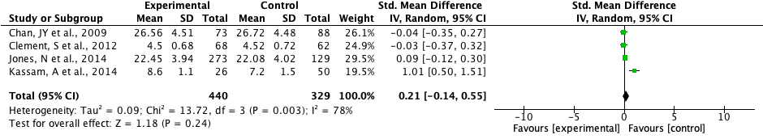
Attitude
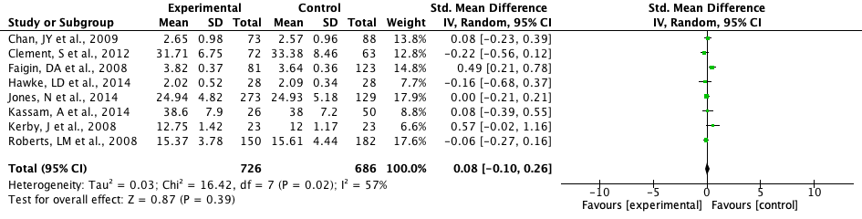
Behavior
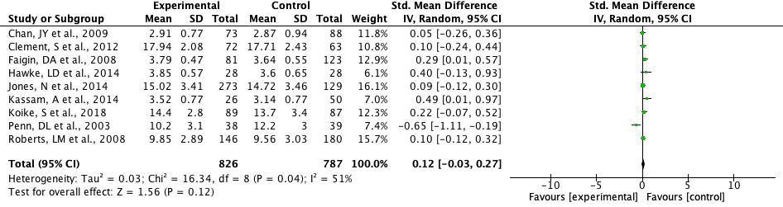Multi-session
Knowledge
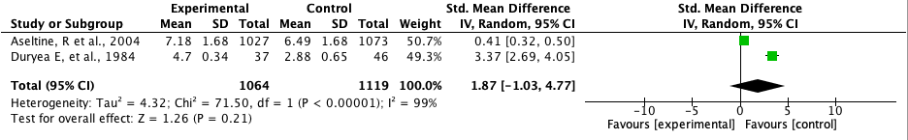
Attitude
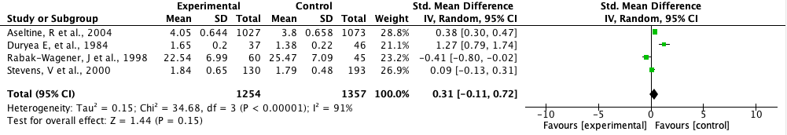
Behavior


