Supplementary Material
SM-1. Study Design Definitions (from the Cochrane Handbook)
SM-2. Electronic Search Strategies (Not Filtered for Language)
SM-3. Exposure and Outcome LQAT Scores

SM-1. Study Design Definitions (from the Cochrane Handbook)
Quasi-Randomized Controlled Trial: A study with an experimental design where participants are allocated to different interventions using a quasi-random method, such as date of birth, alternation, and medical record number.
Non-Randomized Controlled Trial: A study with an experimental design where participants are allocated to different interventions using a non-random method.
Controlled Before-and-After Study: A study where observations are made in a control and intervention group, before and after the implementation of an intervention.
Interrupted-Time-Series Study: A study in which observations are done at multiple time points before and after an intervention (interruption). The design of the study enables to see if the intervention has an effect that is significantly greater than underlying trend over time.
Historically Controlled Study: A study comparing a group of participants receiving an intervention with a similar group from the past that didn’t.
Case-Control Study: A study that compares participants with a certain outcome (cases) with people from the same source population without the outcome (controls) and examines the associations between the outcome and prior exposures (e.g. receiving an intervention).
Cohort Study: A study that follows a defined group of people (cohort) over a period of time to examine interventions received and subsequent outcomes. A ‘prospective’ cohort study recruits participants before an intervention and follows them whereas a ‘retrospective’ cohort study recruits participants from the past using records from the past that describe the interventions received and follows them in the past using the records.
Cross-Sectional Study: A study where information on past or current interventions and health outcomes are collected for a group of people at a particular time point in order to study associations between outcomes and exposure to interventions.

SM-2. Electronic Search Strategies (Not Filtered for Language)
Database | Search | Hits (as of 12/1/2019)
PubMed | (("Occupational Exposure"[Mesh] OR "Accidents, Occupational"[Mesh] OR "Occupational Injuries"[Mesh] OR "Occupational Diseases"[Mesh] OR “occupational health”[Mesh] OR occupational[tw]) AND ("latrine cleaning"[tw] OR "toilet cleaning"[tw] OR "manual emptying"[tw] OR "collectors of sludge"[tw] OR "collectors of waste"[tw] OR "fecal sludge handling"[tw] OR "fecal sludge management"[tw] OR "sludge handling"[tw] OR "mechanical emptying"[tw] OR "septic tank desludging”[tw] OR "septic tank emptying"[tw] OR "septic tank management"[tw] OR "septic tank handing"[tw] OR "sewer cleaning"[tw] OR "sewer pumping"[tw] OR "solid waste collector"[tw] OR "solid waste segregator"[tw] OR "waste collector"[tw] OR "manhole cleaning"[tw] OR "sewage treatment"[tw] OR "manual waste disposal"[tw] OR "mechanical waste disposal"[tw] OR "manual disposal"[tw] OR "mechanical disposal"[tw] OR “domestic waste”[tw])) OR (municipal solid waste worker*[tw] OR domestic waste collector*[tw] OR solid waste management worker*[tw] OR municipal solid waste collector*[tw] OR sewage worker*[tw] OR sanitary worker*[tw] OR sewage exposed worker*[tw] OR sewage worker*[tw] OR pit latrine emptier*[tw] OR (worker* exposed to waste water[tw]) OR waste management worker*[tw]) | 267
MEDLINE | (("Occupational Exposure"[Mesh] OR "Accidents, Occupational"[Mesh] OR "Occupational Injuries"[Mesh] OR "Occupational Diseases"[Mesh] OR “occupational health”[Mesh] OR occupational[tw]) AND ("latrine cleaning" OR "toilet cleaning" OR "manual emptying" OR "collectors of sludge" OR "collectors of waste" OR "fecal sludge handling" OR "fecal sludge management" OR "sludge handling" OR "mechanical emptying" OR "septic tank desludging” OR "septic tank emptying" OR "septic tank management" OR "septic tank handing" OR "sewer cleaning" OR "sewer pumping" OR "solid waste collector" OR "solid waste segregator" OR "waste collector" OR "manhole cleaning" OR "sewage treatment" OR "manual waste disposal" OR "mechanical waste disposal" OR "manual disposal" OR "mechanical disposal" OR “domestic waste”)) OR (municipal solid waste worker* OR domestic waste collector* OR solid waste management worker* OR municipal solid waste collector* OR sewage worker* OR sanitary worker* OR sewage exposed worker* OR sewage worker* OR pit latrine emptier* OR (worker* exposed to waste water) OR waste management worker*) | 82

Database | Search | Hits (as of 12/1/2019)
Embase | (('occupational exposure' OR 'occupational accident' OR 'occupational disease' OR 'occupational health') AND ("latrine cleaning" OR "toilet cleaning" OR "manual emptying" OR "collectors of sludge" OR "collectors of waste" OR "fecal sludge handling" OR 'fecal sludge' OR 'sludge management' OR 'septic tank' OR "sewer cleaning" OR "sewer pumping" OR 'solid waste management' OR 'waste collection' OR "manhole cleaning" OR 'sewage treatment' OR "manual waste disposal" OR "mechanical waste disposal" OR "manual disposal" OR "mechanical disposal" OR 'domestic waste')) OR (“municipal solid waste worker*” OR “domestic waste collector*” OR “solid waste management worker*” OR ”municipal solid waste collector*” OR ”sewage worker*” OR ”sanitary worker*” OR ”sewage exposed worker*” OR ”sewage worker*” OR ”pit latrine emptier*” OR (”worker* exposed to waste water”) OR ”waste management worker*”) | 526
LILACS | (("OCCUPATIONAL ACCIDENT" or "OCCUPATIONAL ASTHMA" or "EXPOSURE, OCCUPATIONAL" or "occupational injury" or " occupational disease" or "occupational health") and ("SLUDGE" or "SEWER" or "FECAL" or "WASTE DISPOSAL FACILITIES" or "WASTE DISPOSAL, SOLID" or "WASTE DISPOSALS, FLUID" or "LATRINE" or "latrine cleaning" or "toilet cleaning" or "manual emptying" or "collectors of sludge" or "collectors of waste" or "fecal sludge handling" or "fecal sludge management" or "sludge handling" or "mechanical emptying" or "septic tank emptying" or "septic tank management" or "septic tank handing" or "sewer cleaning" or "sewer pumping" or "solid waste collector" or "solid waste segregator" or "waste collector" or "manhole cleaning" or "sewage treatment" or "manual waste disposal" or "mechanical waste disposal" or "manual disposal" or "mechanical disposal" or “domestic waste”)) or ("municipal solid waste worker" or "domestic waste collector" or "solid waste management worker" or "municipal solid waste collector" or "sewage worker" or "sanitary worker" or "sewage exposed worker" or "sewage worker" or "pit latrine emptier" or "workers exposed to waste water" or "worker exposed to waste water" or "waste management worker") | 166

SM-3. Exposure and Outcome LQAT Scores
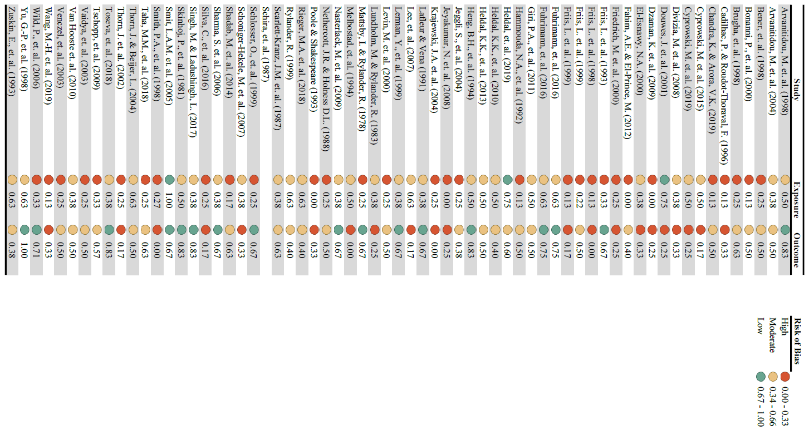
* Studies reporting multiple odds ratios for hepatitis A by using a single exposed group and more than one control (unexposed) group.

