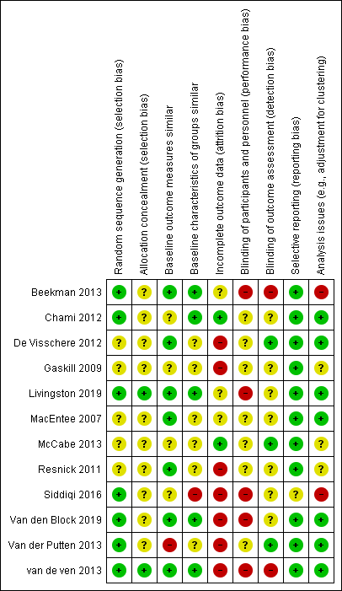
Additional file 4. Risk of bias

