Supplementary Material

Search strategy
Search strategy for Embase
1. 'tomosynthesis':ti,ab
2. '3d mammography':ti,ab
3. 'digital breast tomosynthesis'/exp
4. dbt:ti,ab OR synthesized:ti,ab OR synthetic:ti,ab OR reconstructed:ti,ab
5. #1 OR #2 OR #3 OR #4
6. 'breast cancer'/exp
7. breast cancer':ti,ab
8. 'breast carcinoma'/exp
9. 'breast carcinoma':ti,ab
10. 'breast tumor'/exp
11. 'breast tumo*':ti,ab OR 'breast neoplasm*':ti,ab
12. #6 OR #7 OR #8 OR #9 OR #10 OR #11
13. 'screening'/exp
14. screening:ti,ab OR screen:ti,ab
15. #13 OR #14
16. #5 AND #12 AND #15
17. limit 16 to year="2010 -Current"

Search strategy for Medline
1. Tomosynthesis.ti,ab.
2. DBT.ti,ab OR synthesized.ti,ab OR synthetic.ti,ab OR reconstructed.ti,ab.
3. "3D mammogra*".mp. [mp=title, abstract, original title, name of substance word, subject heading word, floating sub-heading word, keyword heading word, organism supplementary concept word, protocol supplementary concept word, rare disease supplementary concept word, unique identifier, synonyms]
4. exp breast neoplasms/
5. "breast cancer".ti,ab.
6. "breast tumo*".ti,ab.
7. "breast carcinoma*".ti,ab.
8. "breast neoplasm*".ti,ab.
9. exp Early Detection of Cancer/
10. exp Mass Screening/
11. (screening or screen).ti,ab.
12. or/1-3
13. or/4-8
14. or/9-11
15. 12 and 13 and 14
16. limit 15 to yr="2010 -Current"

Search strategy for CENTRAL
1. Tomosynthesis:ti,ab,kw
2. (DBT OR synthesized OR synthetic OR reconstructed):ti,ab,kw
3. "3D mammogra*":ti,ab,kw
4. [mh "breast neoplasms"]
5. "breast cancer":ti,ab
6. "breast tumo*":ti,ab
7. "breast carcinoma*":ti,ab
8. "breast neoplasm*":ti,ab
9. [mh "Early Detection of Cancer"]
10. [mh "Mass Screening"]
11. (screening or screen):ti,ab
12. #1 OR #2 OR #3
13. #4 OR #5 OR #6 OR #7 OR #8
14. #9 OR #10 OR #11
15. #12 AND #13 AND #14
16. limit #15 to year="2010 -Current"

Search strategy for Web of science
1. TS=(Tomosynthesis)
2. TS=(DBT OR synthesized OR synthetic OR reconstructed)
3. TS="3D mammogra*"
4. TS=("breast cancer" OR "breast tumo*" OR "breast carcinoma*" OR "breast neoplasm*")
5. TS=(screening or screen)
6. #3 OR #2 OR #1
7. #6 AND #5 AND #4
8. limit #7 to year="2010 -Current"

Supplementary Tables
Supplementary Table 1. Cross-classification of SM/DBT and DM/DBT results for paired studies
Screening outcome | Study | Both tests positive (n) | Both tests  negative (n) | SM/DBT (+) ,  DM/DBT(-)  (n) | SM/DBT (-) ,  DM/DBT(+)  (n) | Total (N)
CDR | STORM-2 | 77 | 9587 | 8 | 5 | 9677
CDR | OTTS* | 177 | 24695 | 11 | 18 | 24901
Recall | STORM-2 | 258 | 8960 | 254 | 205 | 9677
 | OTTS* | 323 | 23998 | 256 | 324 | 24901
* The cross-classification data were estimated using STROM-2 data

Supplementary Table 2. Cross-classification of SM/DBT and DM results for paired studies
Screening outcome | Study | Both tests positive (n) | Both tests  negative (n) | SM/DBT (+) ,  DM (-)  (n) | SM/DBT (-) ,  DM (+)  (n) | Total (N)
CDR | STORM-2 | 58 | 9589 | 27 | 3 | 9677
 | OTTS* | 145 | 24100 | 49 | 7 | 24301
 | Martin (2018) * | 63 | 15977 | 24 | 3 | 16067
Recall | STORM-2 | 192 | 8968 | 320 | 197 | 9677
 | Martin (2018) * | 238 | 15324 | 244 | 261 | 16067
* The cross-classification data were estimated using STROM-2 data

Supplementary Figures
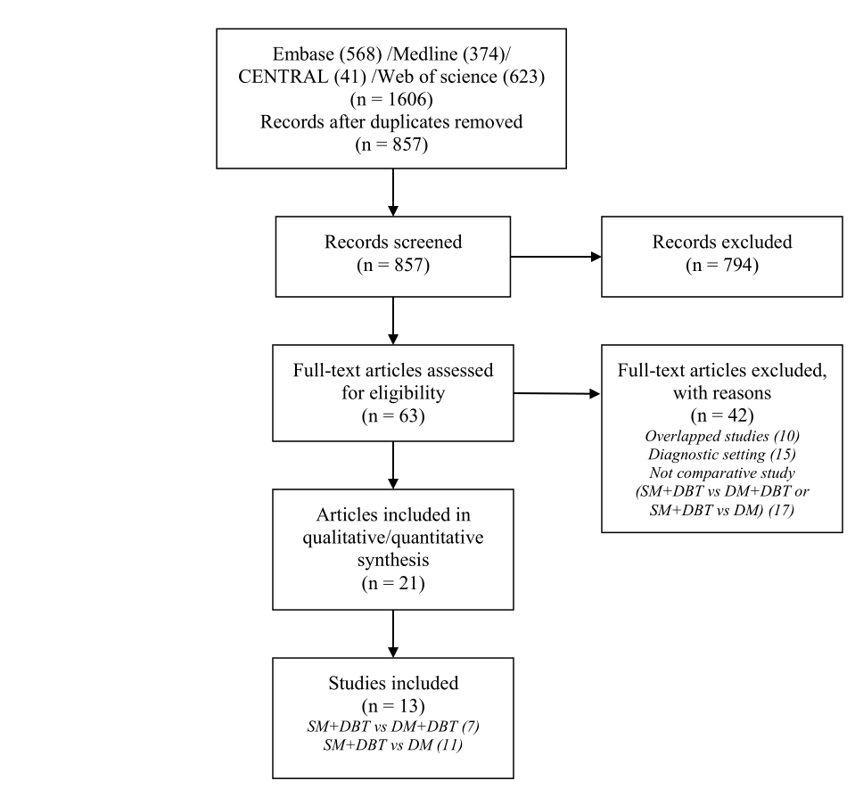
Supplementary Fig. 1 Flow chart of literature search and study selection.

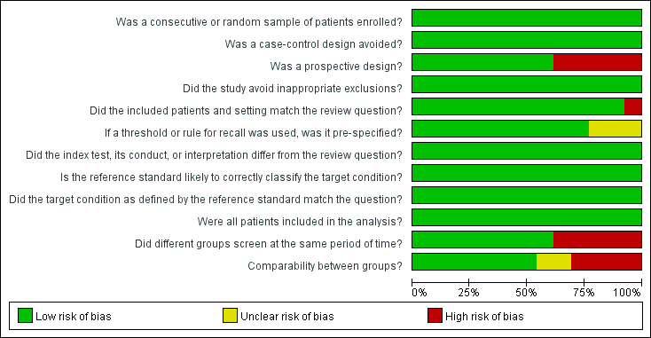
Supplementary Fig. 2 Summary of risk of bias

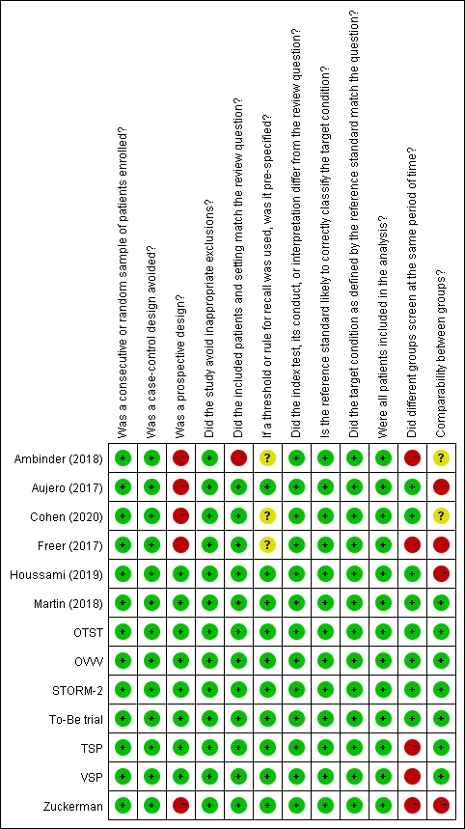
Supplementary Fig. 3 Risk of bias for each included study

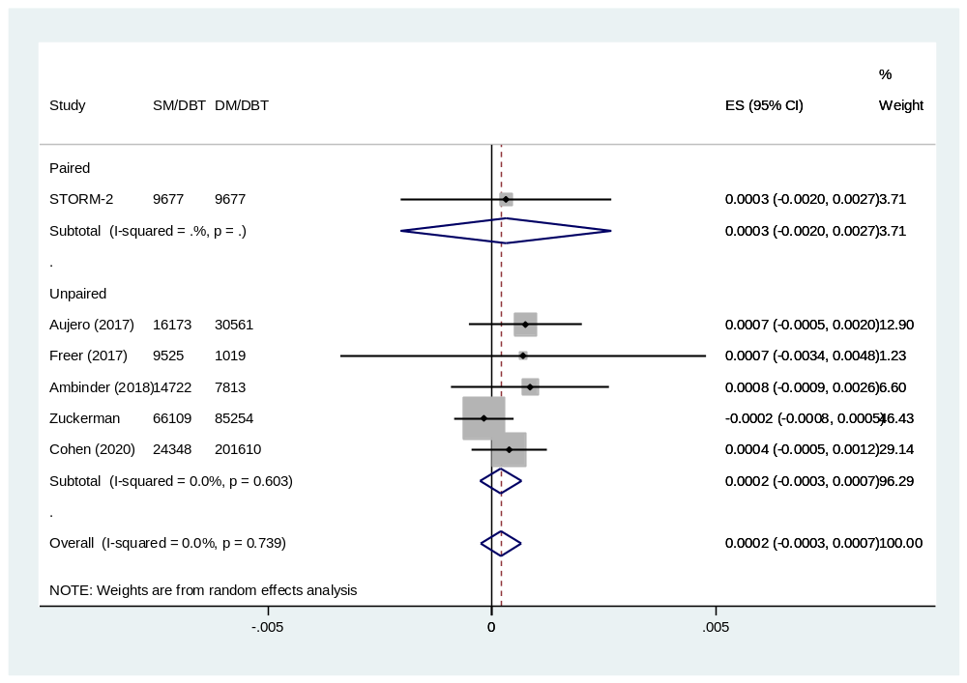
Supplementary Fig. 4 Forest plot for the invasive CDR of SM/DBT vs DM/DBT.

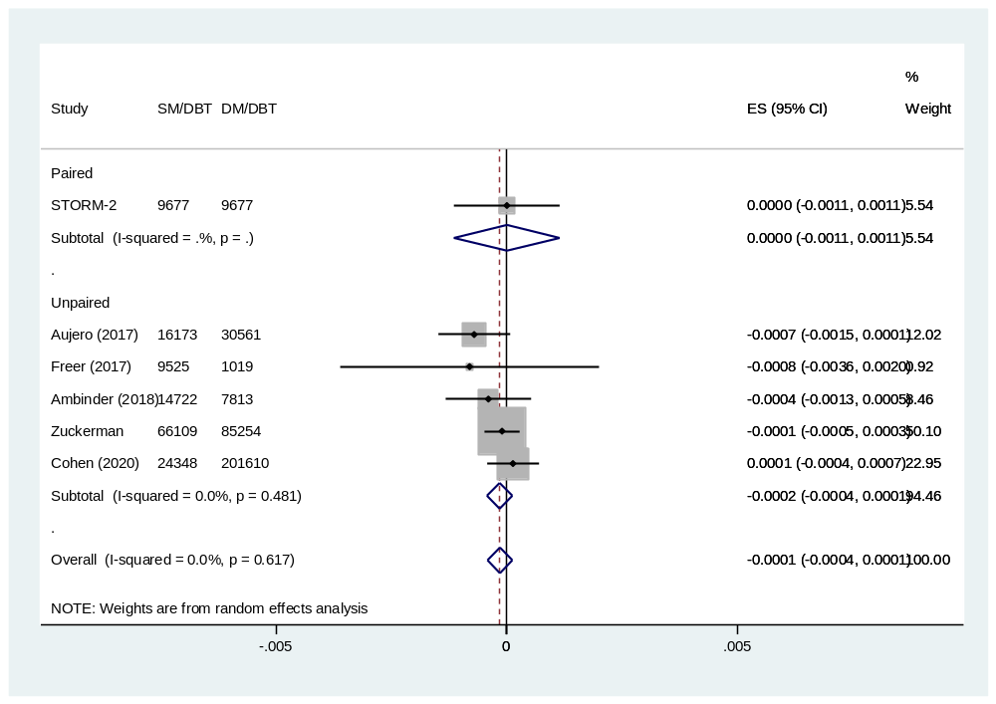
Supplementary Fig. 5 Forest plot for the DCIS rate of SM/DBT vs DM/DBT.

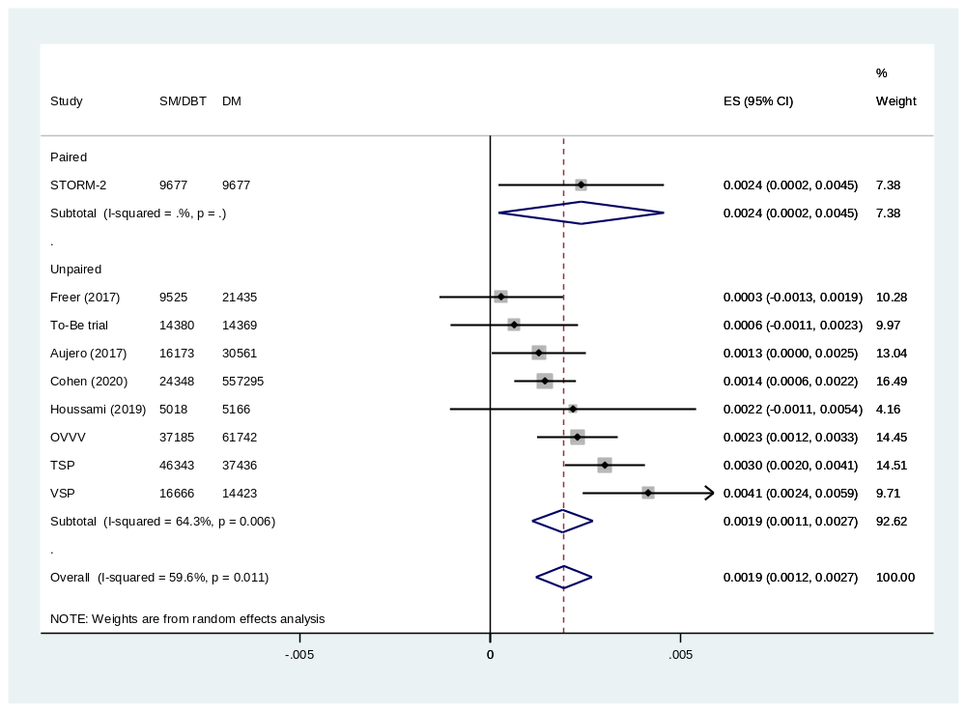
Supplementary Fig. 6 Forest plot for the invasive CDR of SM/DBT vs DM.

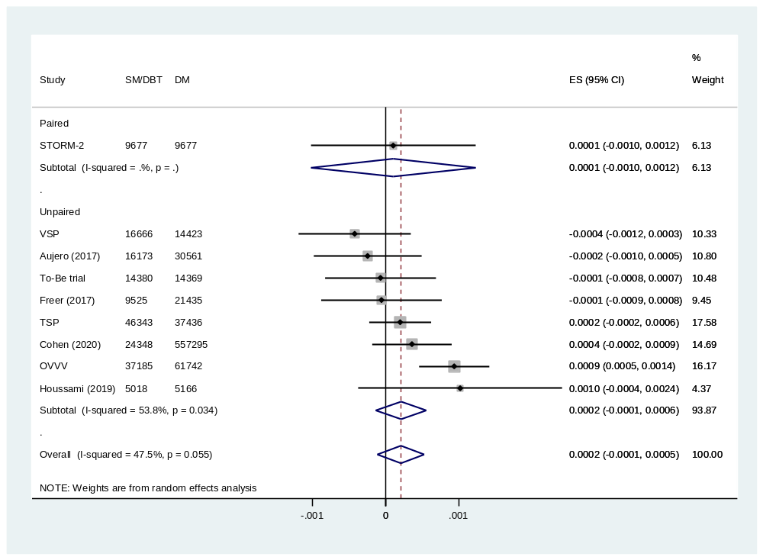
Supplementary Fig. 7 Forest plot for the DCIS rate of SM/DBT vs DM.

