Supplementary Tables and Figures

Study | Breast Condition | Demographics | Sample size | Preparation | Sequencing / Primers | Bacteria (Phyla / Genera / Species)
Gaitanis  2019⁶⁰ | HC | Healthy mothers.  Ethnicity: Caucasian.  Antibiotics: exclusion of antibiotics given 1 month prior. | N = 17 Chest/Abdomen. | Cotton pledget soaked into phosphate-buffered saline with 0.1% Tween-20.  Inoculated into solid media (blood agar, mannitol salt agar, McConkey agar, D-Coccosel Agar, and MRS agar). | Culture media w/ API identification. | 6 frequently isolated species/genera: Staphylococcus aureus (20%), Pseudomonas, Enterobacter, Enterococcus, Proteus, Klebsiella.
Park 2018³⁵ | Abscess & AD vs HC | Females aged 13 and 15 years. | N = 2 Abscess. | No comment on collection technique. | 16S rRNA gene-targeted sequencing. | S. aureus was frequently isolated from the lesional area compared to normal-appearing skin.  AD lesional skin: Elevated abundance of Firmicutes and a decreased abundance of Proteobacteria.
Pannaraj  2017¹³ | HC | Healthy mothers (1-331 days postpartum).  Ethnicity: African American (4.1%), Asian/Pacific Islander (9.1%), Hispanic/Latino (66.1%), White (13.2%), Mixed (2.5%), Unknown (5.0%)  Antibiotics: delivered in 30.6% of mothers. | N = 68 Areolar skin.  N = 238 Breast milk.  N = 225 Infant stool. | No comment on collection technique. | 16S V4 rRNA primer. | Milk, areolar skin and stool microbiota differ in composition.  Firmicutes (Staphylococcaceae and Streptococcaceae) were dominant in areolar skin.
Chan 2016²⁹ | Breast cancer vs HC | Females aged 41-66.  Ethnicity: Caucasian.  Antibiotics: in the past year (33%).  Post-menopausal (58%). | N = 8 HC nipple skin.  N = 5 BC nipple skin. | Sterile cotton swab for:  (1) de-keratinised mild abrasive gel nipple skin.  (2) nipple skin swab post-betadine solution.  (3) nipple skin swab.  Samples placed in RNase/DNase free Eppendorf tubes.  Stored at -80˚C until DNA extraction. | 16S V4 rRNA primer. | Healthy Control vs. Breast Cancer.  Proteobacteria: 30% vs. 32%.  Firmicutes: 40% vs. 43%.  Actinobacteria: 4% vs. 1%.  Bacteroidetes: 20% vs. 15%.  Other: 6% vs. 9%.
Hieken 2016⁹ | Breast cancer vs HC | Females aged 33-84.  Post-menopausal (66.7%).  Excluded patients w/ antibiotics used within 14 days of operation or signs of infection.  BMI≥30 (36.4%).  No prior history of: Invasive cancer, allergy to medication, pregnancy, lactation, bone transplant, breast surgery. | N = 17 BC.  N = 16 Benign.  Skin swab adjacent to incision site. | Collection: 20 strokes with a sterile Dacron swab.  Skin swab obtained adjacent to the incision site. Skin sample (2mm by 20mm excised).  ChloroPrep preparation. Snap frozen at -80˚C and transferred to =20˚C freezer. | 16S V3-V5 rRNA primers. | Richness in bacterial species is greater in tissue, but species evenness is similar between breast tissue and skin tissue.  Major differences lie in rare or less abundant lineages.  Greater Bacteroidetes abundance in skin than breast tissue, greater Firmicutes in breast tissue than skin.  Skin Swab Phylum:  Proteobacteria: 30%  Firmicutes: 40%  Actinobacteria: 10%  Bacteroidetes: 20%
Supplementary Table 1: Key study characteristics and methodological quality for studies that included breast skin of HC and BD.

Study | Breast Condition | Demographics | Sample size | Preparation | Sequencing / Primers | Bacteria (Phyla / Genera / Species)
Chiba 2020³⁰ | Breast cancer | Females.  Age 65.3 (Pretreatment) and 58.9 (neoadjuvant chemo) and 64.3 (tumor recurrence).  Diagnosed with invasive ductal carcinoma. | N = 15 Neoadjuvant therapy.  N = 18 No prior therapy. | Specimens snap frozen within 45-60mins of surgery.  Visual gross inspection by pathologist to differentiate tumor and normal samples prior to submitting to Tumor Bank. | 16S rRNA sequencing, targeting V4 region. | Primary breast tumors from patients that received neoadjuvant chemotherapy displayed no broad-spectrum differences in bacterial phylum level proportional abundances.  At the genus level, neoadjuvant chemotherapy–treated tumors have elevated proportional abundance of Pseudomonas.  No bacterial differences at the phylum level in proportional abundance between tumor recurrence and non-recurrence.
Klann 2020²⁸ | BC vs. HC | Females.  Ethnicity: White non-hispanic.  Undergoing reduction mammoplasty. | N = 10 BC tissue.  N = 36 Healthy Tissue (adjacent to tumor and bilateral breast). | Tissue collected, de-identified, placed in RNA later preservative solution. | 16s rRNA gene sequencing, V1 - V2 regions. | Most abundant OTU:  Family: Ruminococcaceae  Genera: Acidaminococcus, Acinetobacter, Akkermansia, Bacteroides, and Sutterella.  In tumor: ↑ Ruminococcaceae, Akkermansia.  In HT: ↑ Bacteroides, Sutterella.
Thyagarajan 2020²⁴ | BC vs. HC | Women diagnosed with BC.  Age = 27-78 years.  No antibiotic regimen prior to tissue collection.  No radiation treatment. | N = 50 tissue samples.  N = 23 tumor.  N = 23 NPT.  N = 4 excluded. | Frozen breast tissue samples from biorepository. | 16s rRNA gene sequencing, targeting V3-V4 region. | Across all breast:  Proteobacteria: 59.4%.  Actinobacteria: 19.1%.  Firmicutes: 17.7%.  Bacteroidetes: 1.9%.
Bachour 2019⁴⁴ | Capsular Contracture vs. HC | 25 cis-gendered females,  1 trans-gendered female. Average age 46.  Undergoing implant replacement/removal. | N = 50 Capsules (normal and contracture)  N = 10 breast tissue. | (1) Capsules removed within the first 10 mins of surgery and no contact with breast skin. Snap frozen at -20˚C.  (2). Skin chlorhexidine swab at site of incision with skin sample taken as well. Tissue sample removed and stored within 2 hours at -20˚C. | 16S-23S rDNA. | Breast tissue (glandular) found to be generally sterile. Normal and contracted capsules were generally sterile, save some bacteria from the skin.
Smith 2019²² | BC vs. HC | Females, average age 30 (HC) and 47 (BC).  BC samples from women with stage I-IV.  Healthy women undergoing reduction mammoplasty. | N = 8 (HC).  N = 64 BC.  N = 11 PNT. | Surgical breast tissue extracted and snap-frozen from the NHB and NHW women (ages 18-90 years), w/ or w/o BC. Samples stored at -80˚C for processing. | 16S rRNA gene sequencing targeting V4 region. | Proteobacteria, Firmicutes, Bacteroidetes and Actinobacteria in order of abundance in phylum.  Significant difference between paired normal tissue and HC tissue, as well as BC tissue and paired normal tissue.  Significant differences in phyla abundance of tissue between NHB and NHW subjects.
Walker 2019⁴⁷ | Lymphoma | Females.  Ages 36-66. | N = 7 ALCL (post implant).  N = 5 contralateral controls. | Specimens in EtOH were frozen at −80 °C until DNA extraction. The DNeasy PowerBiofilm kit was used. | Immunofluorescence staining and culture.  16S rRNA sequencing, targeting V1-V3 regions. | Coagulase negative staphylococci, including S. epidermidis, were the most common bacteria isolated and were present in 2 of 7 samples from BIA-ALCL-affected breasts as well as one contralateral control.  Paenibacillus spp. was cultured from one ALCL-affected breast and Lactococcus lactis was cultured from one non-ALCL breast.  No significant differences observed between the BIA-ALCL and contralateral control samples.
Wang 2019³⁶ | Mastitis | Females.  Ages 21-41.  35 had a mass with abscess, two had a mass, one had an abscess, 17 had an ulcer, and eight had nipple retraction; five patients had bilateral mastitis. | N = 40 GLM | Paraffin sections of 4mm thickness were mounted onto 3- aminopropyltriethoxysilane-coated glass slides.  Hematoxylin and eosin (HE) staining was performed to evaluate histopathological features.  Gram staining, periodic acid–Schiff staining, and acid-fast staining were performed in all cases to detect bacteria, fungi, and Mycobacterium tuberculosis, respectively. | Sample DNA extracted directly from the paraffin-embedded tissue using the MagPure FFPE DNA LQ Kit.  16s rRNA sequencing. | Top five prevalent genera: Pseudomonas (32/40), Brevundimonas (26/40), Stenotrophomonas (8/40), Acinetobacter (8/40), and Aspergillus (4/40).  Top species prevalence: Pseudomonas aeruginosa (27/40), Pseudomonas stutzeri (26/40), Brevundimonas diminuta (19/40), Brevundimonas subvibrioides (12/40), and Stenotrophomonas maltophilia (9/40).
Costantini 2018²³ | BC vs. HC | Females, average age 59.  Pre-menopausal: 12.5%.  Peri-menopausal: 18.8%.  Post-menopausal: 68.8%.  BMI average: 26%. | N = 30 samples.  N = 9 core needle biopsy (PNT + BC).  N = 6 surgical excisional biopsies (PNT + BC). | Both procedures: healthy adjacent tissue from outside marginal zone 5cm away from tumors edge.  Both cancer and paired normal tissue.  Environmental control samples collected to identify possible contamination.  Fresh tissues were immediately placed in sterile labelled DNA-free vials on ice and were processed within 3 hours of collection. | 16s rRNA gene sequencing (V2, V3, V4, V6 + V7, V8, V9). | Proteobacteria, Firmicutes, Actinobacteria, and Bacteroidetes were all present in order of abundance.  (83% Proteobacteria, 11% Firmicutes) via V4.  No significant differences seen in the microbiota between breast cancer (BC) tissue and paired normal tissue (PNT). Significant differences were seen between patients.
Meng 2018⁵¹ | BC vs. HC | Females aged 29-77.  Not pregnant or lactating. No other comorbidities.  Antibiotics: no antibiotics within 6 months. | N = 22 Benign.  N = 72 Malignant Breast Tissue. | Aseptic percutaneous needle biopsy. Samples in sterile tubes, stored at -196˚C in nitrogen canisters then transferred to -80˚C freezer. | 16s rRNA (V1-V2 primers). | Benign vs. Malignant:  Proteobacteria: 31.77% vs. 37.55%.  Firmicutes: 26.36% vs. 22.56%.  Actinobacteria: 21.9% vs. 23.2%.  Bacteroidetes: 17.53% vs. 14.57%.  Genus: Propionicimonas and five families Micrococcaeae, Caulobacteraceae, Rhodobacteraceae, Nocardioidaeceae and Methylobacteriaecea were abundant in malignant disease compared to benign disease.  Methylobacteriaecea family was found to be the only common biomarker in the tissue microbiomes between tumor/malignant and normal/benign.
Thompson 2017⁶¹ | BC vs.HC | Females.  No prior history of breast cancer, no neoadjuvant therapy. | N = 668 BC.  N = 72 Healthy Adjacent Tissue. | Frozen breast tissue with >60% tumor composition stored at -80˚C before DNA extraction. | 16s rRNA gene sequencing V3-V5 region. | Proteobacteria, Actinobacteria and Firmicutes were most abundant in the breast.  24 species constituted ~86% of tissue microbiota.
Wang 2017⁶² | BC vs. HC | Females average age 55 (BC) and 43 (HC).  BC patients who have had no prior neoadjuvant therapy. HC had no history of cancer.  Ethnicity: white 74%; black 23%; other 3%.  BMI average: 25 (BC) and 35 (HC).  Antibiotics: used in <1 month (17%). No patients had active infection. | N = 39 BC (17 cancer; 22 PNT).  N = 24 HC. | Aseptic extraction of two tissue samples from each patient. Left and right breast for control; and tumor and PNT for cancer patients.  Flash frozen and stored at -80˚C. Frozen environmental controls from the operating room were collected as well. | 16s rRNA gene sequencing with V3 reagent kit. | Cancer and non-cancer patients had significantly different microbiomes, characterized largely by the decreased abundance of Methylobacterium in cancer patients.  Cancer patients harbor urinary microbiomes with increased abundance of gram-positive bacteria associated with skin flora.  No significant difference between PNT and tumor tissue in BC patients.  The primary bacterial genus driving the cancer versus-non-cancer breast tissue microbiomic separation was Methylobacterium, of the phylum Proteobacteria.
Hieken 2016⁹ | BC vs. HC | Females aged 33-84.  Post-menopausal (66.7%).  Antibiotics: excluded patients w/ antibiotics used within 14 days of operation or signs of infection.  BMI≥30 (36.4%).  No prior history of: Invasive cancer, allergy to medication, pregnancy, lactation, bone transplant, breast surgery. | N = 17 BC.  N = 16 HC (Benign). | Collection: 20 strokes with a sterile Dacron swab.  Skin swab obtained adjacent to the incision site. Skin sample (2mm by 20mm excised).  Normal adjacent tissue from the margin of the lumpectomy cavity.  ChloroPrep preparation. Snap frozen at -80˚C and transferred to =20˚C freezer. | 16S rRNA gene sequencing, targeting V3-V5 regions. | Microbiota of the normal breast tissue adjacent to invasive cancer was significantly different from that of normal breast tissue adjacent to benign disease  Greater Bacteroidetes abundance in skin than breast tissue, greater Firmicutes in breast tissue than skin.
Hu 2016⁴⁶ | Lymphoma | Females.  Duration of implant (3-25 years). | N = 19 ALCL capsule.  N = 12 nontumor capsule / high-grade capsular contracture. | Tumor material sent for analysis was preserved in formalin and/or mounted on slides following formalin fixation.  Detection and identification of bacteria in fixed tissue was less sensitive than analysis of fresh tissue. | 16S rRNA sequencing, targeting V1-V3 regions. | Both the breast implant–associated ALCL and nontumor capsule samples yielded high numbers of bacteria.  ALCL specimens showed significant differences with species identified in nontumor capsule specimens.  Significantly greater proportion of Ralstonia spp. present in ALCL specimens compared with nontumor capsule specimens  Significantly more Staphylococcus spp. were found with nontumor capsule specimens compared with breast implant–associated ALCL specimens.
Urbaniak 2016²⁷ | BC vs HC | Females aged between 19-90.  No antibiotics within 3 months.  Healthy controls: lumpectomies and cosmetic breast augmentation. | N = 35 HC.  N = 65 Cancerous.  N = 24 Benign. | Post excision, fresh tissue put into vial and homogenized within 30 mins.  Environmental control tubes processed in parallel. Skin swab of breast was used as a control as well.  Stored at -80˚C. | 16s rRNA gene sequencing, targeting V6 region. | Contamination present but only took up a small proportion (10%). Microbiota dominated by Firmicutes (36%) and Proteobacteria (29%). Actinobacteria and (10%) Bacteroidetes (<10%) were next.  Enterobacteriaceae and Staphylococcus are two taxa found in higher abundances in breast cancer patients than in healthy controls.
Yu 2016⁴ | Mastitis | Females.  Ages 25-36.  Clinical symptoms included a breast lump, abscess, sinus, and/or cutaneous ulceration.  No antibiotic treatment. | N = 19 GLM | Specimens from breast core biopsies or surgical excision were sent for histological examination.  Breast pus was aspirated with a sterile syringe and divided into two samples, one for metagenomic analysis and the other for bacterial culture. | 16S rRNA sequencing. | Corynebacterium was present in the 19 GLM patients, with abundances ranging from 1.1% to 58.9%.  Corynebacterium was the most abundant taxon in seven patients.
Urbaniak 2014⁷ | BC vs HC | Females aged 18-90 (Canadian) and 20-85 (Irish).  Ethnicity: Canadian and Irish. | Canadian:  N = 11 benign.  N = 27 tumors.  N = 5 HC.  Irish:  N = 33 BC  N = 5 HC | CANADIAN:  Tissue collected outside the marginal zone, 5cm away from tumor.  Homogenate + controls plated on agar for culture analysis and remainder stored at -80˚C for extraction. DNA stored at -20˚C until further use.  IRISH:  Tissue collected at least 5cm away from the primary tumor site. Samples flash frozen within 45 minutes and stored at -80˚C for extraction.  Tissue placed in sterile vial on ice and homogenized in sterile PBS within 30 minutes. A control tube was also used to capture environmental contamination. | 16s rRNA sequencing, targeting V6 region. | 7 phyla: Proteobacteria, Firmicutes, Actinobacteria, Bacteroidetes, Deinococcus-Thermus, Verrucomicrobia, and Fusobacteria, with Proteobacteria being the most abundant, followed by Firmicutes.  Abundant OTUs in Canadian samples: Bacillus (11.4%), Acinetobacter (10.0%), unclassified Enterobacteriaceae (8.3%), Pseudomonas (6.5%), Staphylococcus (6.5%), Propionibacterium (5.8%), unclassified Comamonadaceae (5.7%), unclassified Gammaproteobacteria (5.0%), and Prevotella (5.0%).  Abundant OTUs in Irish samples: unclassified Enterobacteriaceae (30.8%), Staphylococcus (12.7%), Listeria welshimeri (12.1%), Propionibacterium (10.1%), and Pseudomonas (5.3%).
Xuan 2014²⁵ | BC vs HC | Females aged 38-84.  Age range: 38-84.  All patients had breast cancer. | N = 20 BC tissue.  N = 20 PNT. | Formalin fixed paraffin-embedded and fresh-frozen breast tissue obtained. | 16s rRNA sequencing, targeting V4 region. | HC (PNT) Vs. BC:  Proteobacteria: 67% vs. 69%  Firmicutes: 13% vs. 13%  Actinobacteria: 7% vs. 5%  Bacteroidetes: 7% vs. 5%  Verrucomicrobia: 4% vs. 4%  Other: 2% vs. 4%  No significant difference in richness between the HC and BC communities.  Diversity between communities was significantly different.
Supplementary Table 2: Key study characteristics and methodological quality for studies that included breast tissue of HC and BD.

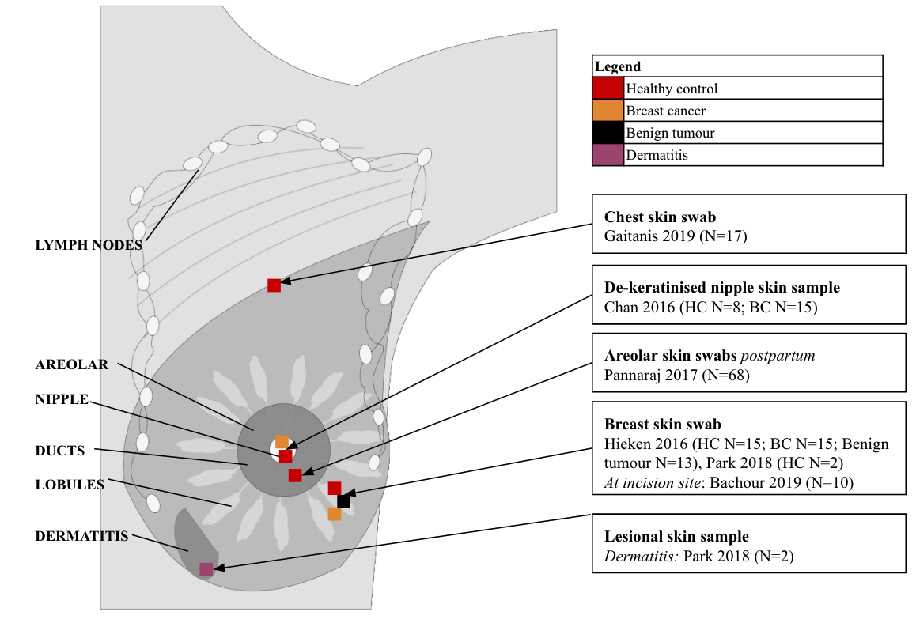

Supplementary Figure 1. Location of breast skin samples.

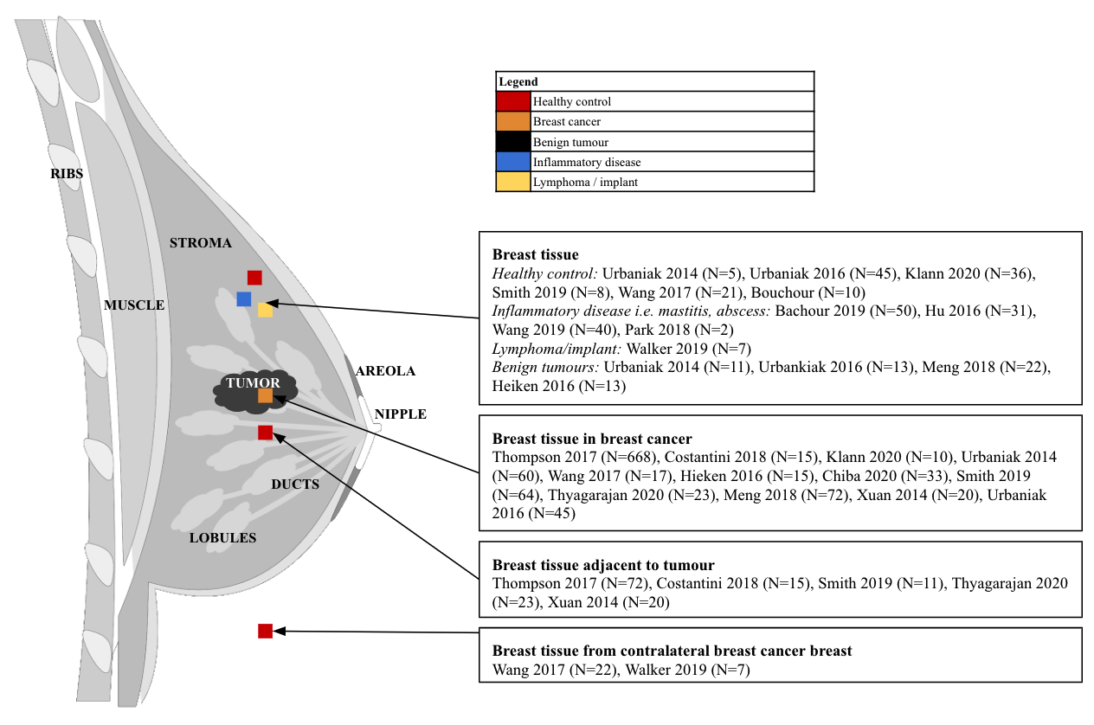

Supplementary Figure 2. Location of breast tissue samples

