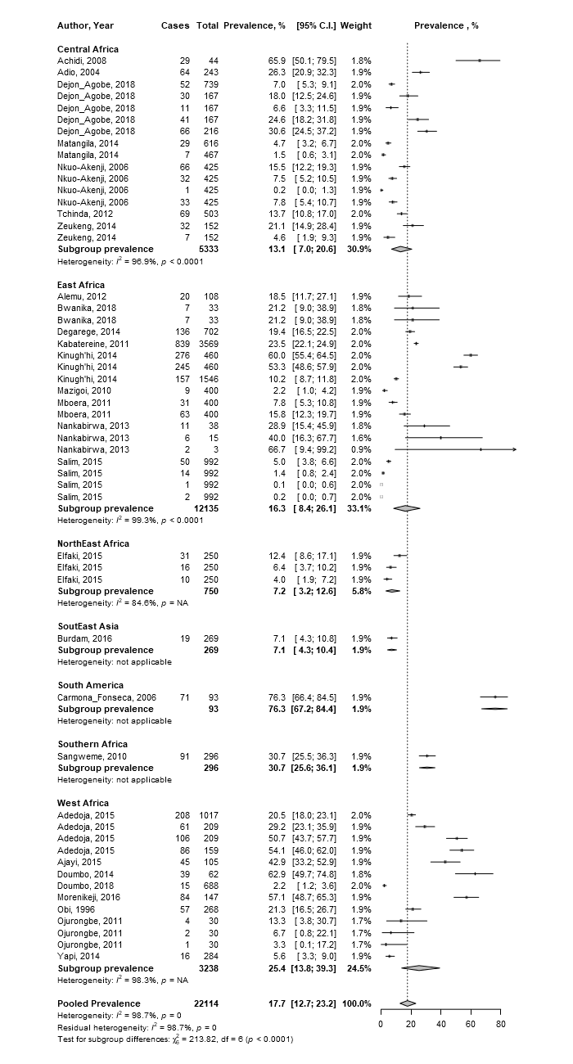
S1_Fig 1: Forest plot showing pooled prevalence of malaria-helminth co-infection by geographic region

