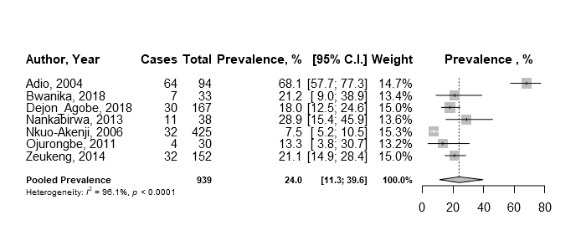
S2 Fig 2b: Forest plot showing sub-group analysis of summary estimates of prevalence of P.falciparum-hookworm co-infection
S2 Fig 2a: Forest plot showing sub-group analysis of summary estimates of prevalence of P.falciparum-A. lumbricoides co-infection

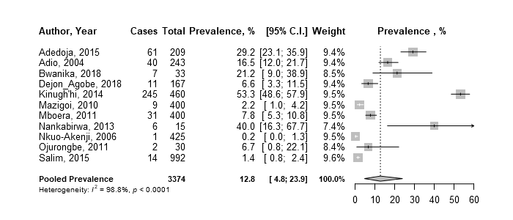
S2 Fig 2c: Forest plot showing sub-group analysis of summary estimates of prevalence of P.falciparum-T.trichuria co-infection



