S3 Fig 3a: Forest plot showing sub-group analysis of prevalence of Plasmodium-S. haematobium co-infection in children in LMIC
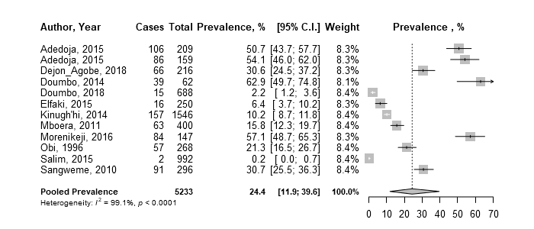

S3 Fig 3b: Forest plot showing sub-group analysis of prevalence of Plasmodium-S.mansoni co-infection in children in LMIC


