Supplementary Material for
Effects of Non-invasive Brain Stimulation in Multiple Sclerosis: Systematic Review and Meta-analysis
Running head: NIBS in MS

Rebecca L.D. Kan, Grace X.J. Xu, Kate T. Shu, Frank H.Y. Lai, Gottfried Kranz, Georg S. Kranz *

This file includes:
01. Study selection
02. Table. S1: tDCS and TMS treatment parameters regard of pain, spasticity, motor function, mood and cognitive funciton
03. Table. S2 Quality assessment of included studies
04. Adverse events of non-invasive brain stimulation
05. Assessment tools of core symptoms in MS
06. Short-term durability of tDCS on fatigue in MS
07. Fig. S1: Effects of rTMS on fatigue in MS, short-term durability of tDCS on fatigue in MS and tDCS on fatigue in RR-MS patients
08. Fig. S2: tDCS on depression and tDCS on anxiety in MS

01. Study selection
Our search strategy yielded 202 results in total. 134 articles were identiﬁed after the removal of duplicates, whereas 61 studies remained after reading titles and abstracts. Studies were further excluded because they were published as a conference paper or abstract (28 studies), as a protocol (two studies), the full text was unavailable (two studies), they were not published in English (one study), they were a case report (one study), or they were not related to the topic (one study), not RCT (one study), the stimulation target is outside the brain (one study), not use sham stimulation as control group (one study). The remaining 25 RCTs were included in the present review and 23 RCTs were included in the meta-analysis.

02. Table S1:
Treatment parameters of tDCS interventions for pain symptoms (n=4)
Author & Year | Intervention Site | Intensity  (mA) | Duration | Intervention |  |  | Control | Outcome measure | Assessment timepoint | side affect | Findings
Mori et al. (2010) | C3 or C4 | 2 | 20min/session,  5 sessions |  | Active tDCS |  | Sham tDCS | VAS-pain,  SF-MPQ | before, after, 1w after, 2w after, 3w after |  | A-tDCS has immediate and long-lasting effects on pain but not on depression and anxiety when compared to sham stimulation
Meesen et al. (2014) | C3, C4 | 1 | 20 min/session,  1 session |  |  | Active tDCS + motor training | Sham tDCS+ motor training | VAS-fatigue | before, during, 30 minutes after | / | A single session a-tDCS does not relief fatigue when compared to sham stimulation
Ayache et al. (2016) | Left DLPFC | 2 | 3 sessions |  |  | Active tDCS | Sham tDCS | MFIS, BPI, VAS | before, after | tDCS group: 3 headaches.  sham group: 1 headache, 1 Phosphenes | A-tDCS yielded significant effects on pain; there were no effects on mood, fatigue, or attention when compared to sham stimulation.
Young et al. (2020) | C3 or C4 | 2.0 | 20min/session,  5 sessions |  |  | Active tDCS | Sham tDCS | VAS, NPS | before, after | / | A-tDCS has immediate and long-lasting effects on pain but not on depression and anxiety when compared to sham stimulation
Treatment parameters of rTMS interventions for pain symptoms (n=1)
Author & Year | Brain target | Type of coil | Intensity (RMT) | Frequency (HZ) | Total pulses per session | Number of sessions | Experiment group | Control group | Assessment of time points | outcome measures | Findings
Korzhova et al. (2018) | both M1 | figure of eight | 80% | E1: 20  E2: 5-35 | E1: 1600  E2: 1200 | 10 | E1: active HF-rTMS + physical therapy  E2: active iTBS | E1: sham HF-rTMS + physical therapy  E2: sham iTBS | before, after, 2w after, 12w after | MAS, NAS, SESS;  MFIS; | Both HF-rTMS and iTBS can reduce spasticity, but only iTBS also has long-term effects on spasticity compared to sham stimulation  HF-rTMS also relieved pain and fatigue. compared to sham stimulation
Treatment parameters of tDCS interventions for spasticity symptoms (n=1)
Author & Year | Intervention Site | Intensity  (mA) | Duration | Intervention | Control | Outcome measure | Assessment timepoint | side affect | Findings
Iodice et al. (2015) | M1 | 2 | 20min/session,  5 sessions | Active tDCS | Sham tDCS | MAS, MSSS-88, MSWS-12 | before, after |  | A-tDCS applied at M1 does not ameliorate spasticity when compared to sham stimulation
Treatment parameters of rTMS interventions for spasticity symptoms (n=4)
Author & Year | Brain target | Type of coil | Intensity (RMT) | Frequency (HZ) | Total pulses per session | Number of sessions | Experiment group | Control group | Assessment of time points | outcome measures | Findings
Mori et al. (2011) | leg area of M1 | / | 80% of AMT | 5/50 | / | 10 | Active iTBS +exercise | sham iTBS +exercise | before, after | MAS,  MSSS-88,  FSS | iTBS can reduce spasticity and fatigue significantly compared to sham stimulation
Boutiere et al. (2017) | leg area of M1 | 70-mm Air Film Coil | 80% of AMT | 5/50 | 600 | 13 | Active iTBS + standardized rehabilitation protocol | sham iTBS + standardized rehabilitation protocol | before, after, 2 weeks after | MAS,  VAS (0-100) | iTBS show positive effects on spasticity compared to sham stimulation
Korzhova et al. (2018) | both M1 | figure of eight | 80% | E1: 20  E2: 5-35 | E1: 1600  E2: 1200 | 10 | E1: active HF-rTMS + physical therapy  E2: active iTBS | E1: sham HF-rTMS + physical therapy  E2: sham iTBS | before, after, 2w after, 12w after | MAS, NAS, SESS;  MFIS; | Both HF-rTMS and iTBS can reduce spasticity, but only iTBS also has long-term effects on spasticity compared to sham stimulation  HF-rTMS also relieved pain and fatigue. compared to sham stimulation
San et al. (2019) | vertex region targeting the leg motor area | figure of eight | 110% | 5 | 900 | 10 | Active TMS + rehabilitation program | sham TMS  + rehabilitation program | before, 1w after, 1month after | MAS, PSFS | A-rTMS reduced spasticity significant compared to sham stimulation
Treatment parameters of tDCS interventions for motor function symptoms (n=5)
Author & Year | Intervention Site | Intensity  (mA) | Duration | Intervention | Control | Outcome measure | Assessment timepoint | side affect | Findings
Meesen et al. (2014) | C3, C4 | 1 | 20 min/session,  1 session | Active tDCS + motor training | Sham tDCS+ motor training | VAS-fatigue | before, during, 30 minutes after | / | A single session a-tDCS does not relief fatigue when compared to sham stimulation
Tecchio, et al. (2015) | E1: Bilateral S1  E2: SM1 | 1.5 | 5 sessions | Active tDCS | Sham tDCS | MFIS | before, after | no | A-tDCS over bilateral somatosensory areas is effective on fatigue when compared to sham stimulation
Iodice et al. (2015) | M1 | 2 | 20min/session,  5 sessions | Active tDCS | Sham tDCS | MAS, MSSS-88, MSWS-12 | before, after |  | A-tDCS applied at M1 does not ameliorate spasticity when compared to sham stimulation
Oveisgharan et al. (2019) | 1 cm anterior to the Cz | 2.5 | 30 mins/7 days | Active tDCS | Sham tDCS | T25-FW, MSWS-12 | Before and after intervention | / | tDCS stimulation of the lower limb motor cortex speeded up patients with MS in walking, but without improvement in patients’ mobility in daily activities.
Pilloni et al. (2020) | C3 | 2.5 | 20min/session, 10 sessions | Active tDCS + physical training | Sham tDCS + physical training | MFIS-21 | before, after, 1 month after | / | A-tDCS has immediate and long-lasting effects on walking and endurance when compared to sham stimulation
Treatment parameters of rTMS interventions for motor function symptoms (n=1)
Author & Year | Brain target | Type of coil | Intensity (RMT) | Frequency (HZ) | Total pulses per session | Number of sessions | Experiment group | Control group | Assessment of time points | outcome measures | Findings
Tramontano et al. (2020) | Active: left cerebellum Sham: right cerebellum | figure of eight | / | / | / | 10 | Active iTBS+vestibular rehabilitation | Sham iTBS+vestibular rehabilitation | Before, after | FSS | C-iTBS showed significant improvement on lower limb function compared to sham stimulation
Treatment parameters of tDCS interventions for mood (n=5)
Author & Year | Intervention Site | Intensity  (mA) | Duration | Intervention | Control | Outcome measure | Assessment timepoint | side affect | Findings
Mori et al. (2010) | C3 or C4 | 2 | 20min/session,  5 sessions | Active tDCS | Sham tDCS | VAS-pain,  SF-MPQ | before, after, 1w after, 2w after, 3w after |  | A-tDCS has immediate and long-lasting effects on pain but not on depression and anxiety when compared to sham stimulation
Ayache et al. (2016) | Left DLPFC | 2 | 3 sessions | Active tDCS | Sham tDCS | MFIS, BPI, VAS | before, after | tDCS group: 3 headaches.  sham group: 1 headache, 1 Phosphenes | A-tDCS yielded significant effects on pain; there were no effects on mood, fatigue, or attention when compared to sham stimulation.
Chalah et al. (2017) | E1: Left DLPFC  E2: Right PPC | 2 | 20min/session,  5 sessions | Active tDCS | Sham tDCS | FSS, MFIS  VAS-fatigue | before, after | active right PPC:  3 insomnia, 2 headaches | A-tDCS left DLPFC stimulation significantly ameliorated fatigue when compared to sham stimulation; a-tDCS over the right PPC was able to improve anxiety and depression when compared to sham stimulation; no effect of any intervention on attention
Chalah et al. (2020) | left DLPFC | 2 | 20min/session,  5 sessions | Active tDCS | Sham tDCS | FSS, MFIS | before, after, 1w after | no | A-tDCS show effects on fatigue and anxiety but not depression when compared to sham stimulation
Young et al. (2020) | C3 or C4 | 2.0 | 20min/session,  5 sessions | Active tDCS | Sham tDCS | VAS, NPS | before, after | / | A-tDCS has immediate and long-lasting effects on pain but not on depression and anxiety when compared to sham stimulation
Treatment parameters of tDCS interventions for cognitive function (n=4)
Author & Year | Intervention Site | Intensity  (mA) | Duration | Intervention | Control | Outcome measure | Assessment timepoint | side affect | Findings
Meesen et al. (2014) | C3, C4 | 1 | 20 min/session,  1 session | Active tDCS + motor training | Sham tDCS+ motor training | VAS-fatigue | before, during, 30 minutes after | / | A single session a-tDCS does not relief fatigue when compared to sham stimulation
Mattioli et al. (2015) | Left DLPFC | 2 | 20min/10 days | Active tDCS + cognitive training | Sham tDCS+ cognitive training | SRT, SPART, SDMT, WCST | Before and after intervention, 2 weeks follow up, 6 months follow up | / | a-tDCS on the DLPFC show improvements  in attention and executive function when compared to sham stimulation
Ayache et al. (2016) | Left DLPFC | 2 | 3 sessions | Active tDCS | Sham tDCS | MFIS, BPI, VAS | before, after | tDCS group: 3 headaches.  sham group: 1 headache, 1 Phosphenes | A-tDCS yielded significant effects on pain; there were no effects on mood, fatigue, or attention when compared to sham stimulation.
Hanken et al. (2016) | Right PC | 1.5 | 20min/session,  1 session | ActivetDCS | Sham tDCS | VAS-fatigue | before, after | / | A-tDCS over the right parietal show positive effects on fatigue-associated performance but not on fatigue when compared to sham stimulation

03. Table S2: The quality assessment of included studies
Studies | 1 | 2 | 3 | 4 | 5 | 6 | 7 | 8 | 9 | 10 | 11 | Total | Class of the study
Ferrucci et al. (2014) | 1 | 1 | 0 | 1 | 1 | 0 | 1 | 1 | 0 | 1 | 1 | 7 | Ⅱ
Meesen et al. (2014) | 1 | 1 | 0 | 1 | 1 | 0 | 1 | 1 | 1 | 1 | 1 | 8 | Ⅱ
Saiote et al. (2014) | 1 | 1 | 0 | 1 | 1 | 0 | 1 | 1 | 1 | 1 | 1 | 8 | Ⅱ
Tecchio et al. (2014) | 1 | 1 | 1 | 1 | 1 | 0 | 1 | 1 | 0 | 1 | 1 | 8 | Ⅱ
Tecchio, et al. (2015) | 1 | 1 | 0 | 1 | 1 | 0 | 1 | 1 | 1 | 1 | 1 | 8 | Ⅱ
Ayache et al. (2016) | 1 | 1 | 1 | 1 | 1 | 0 | 1 | 1 | 1 | 1 | 1 | 9 | Ⅱ
Hanken et al. (2016) | 1 | 1 | 0 | 1 | 1 | 0 | 1 | 1 | 0 | 1 | 1 | 7 | Ⅱ
Chalah et al. (2017) | 1 | 1 | 1 | 1 | 1 | 0 | 1 | 1 | 0 | 0 | 1 | 7 | Ⅱ
Charvet et al. (2017) | 1 | 1 | 0 | 1 | 1 | 0 | 0 | 1 | 0 | 1 | 1 | 6 | Ⅱ
Cancelli et al. (2018) | 1 | 1 | 1 | 1 | 1 | 0 | 1 | 1 | 1 | 1 | 1 | 9 | Ⅱ
Fiene et al. (2018) | 1 | 1 | 0 | 1 | 1 | 0 | 0 | 1 | 1 | 1 | 1 | 7 | Ⅱ
Chalah et al. (2020) | 1 | 1 | 0 | 1 | 1 | 0 | 1 | 1 | 1 | 1 | 1 | 8 | Ⅱ
San et al. (2019) | 1 | 1 | 0 | 1 | 1 | 0 | 0 | 1 | 1 | 1 | 1 | 7 | Ⅱ
Korzhova et al. (2019) | 1 | 1 | 1 | 1 | 1 | 0 | 1 | 1 | 1 | 1 | 1 | 9 | Ⅰ
Boutiere et al. (2017) | 1 | 1 | 0 | 1 | 1 | 0 | 1 | 1 | 1 | 1 | 1 | 8 | Ⅱ
Iodice et al. (2015) | 1 | 1 | 0 | 1 | 1 | 0 | 1 | 1 | 1 | 1 | 1 | 8 | Ⅱ
Mori et al. (2010) | 1 | 1 | 0 | 1 | 1 | 0 | 1 | 1 | 1 | 1 | 1 | 8 | Ⅱ
Mori et al. (2011) | 1 | 1 | 0 | 1 | 1 | 0 | 1 | 1 | 1 | 1 | 1 | 8 | Ⅱ
Mortezanejad et al. (2020) | 1 | 1 | 0 | 1 | 1 | 0 | 1 | 1 | 0 | 1 | 1 | 7 | Ⅱ
Gaede et al. (2018) | 1 | 1 | 1 | 1 | 1 | 0 | 1 | 0 | 0 | 1 | 1 | 7 | Ⅱ
Pilloni et al. (2020) | 1 | 1 | 1 | 1 | 1 | 0 | 1 | 1 | 0 | 1 | 1 | 8 | Ⅱ
Young et al. (2020) | 1 | 1 | 0 | 1 | 1 | 0 | 0 | 1 | 1 | 1 | 1 | 7 | Ⅱ
Tramontano et al. (2020) | 1 | 1 | 1 | 1 | 1 | 0 | 1 | 1 | 1 | 1 | 1 | 9 | Ⅱ
Oveisgharan et al. (2019) | 1 | 1 | 0 | 1 | 1 | 0 | 1 | 0 | 0 | 1 | 1 | 6 | Ⅱ
Mattioli et al. (2015) | 1 | 1 | 0 | 1 | 1 | 0 | 1 | 1 | 1 | 1 | 1 | 8 | Ⅱ

04. Adverse events of non-invasive brain stimulation
Seven RCTs using tDCS reported the occurrence of adverse events including headache, phosphenes, insomnia, weariness, tingling and pain ¹⁻⁷. Here, side effects occurred in the tDCS group as well as in the sham stimulation group. Six RCTs mentioned the absence of side effects ⁸⁻¹³, whereas six RCTs did not report on any side effects ¹⁴⁻¹⁹. tDCS was generally well tolerated without serious adverse reactions and no study indicated a significant difference in side effects between groups. As for rTMS intervention, no serious adverse events were reported in any of the included studies ²⁰⁻²⁶.

05. Assessment tools of core symptoms in MS
Fatigue
Fatigue (including its motor as well as cognitive component) was measured using a variety of validated self-assessment and observer-rating scales (see Table 2.1 and 2.2), such as the Modified Fatigue Impact Scale (MFIS) or the Fatigue Severity Scale (FSS).
Pain
Two different scales were used including VAS (four studies) and the Brief Pain Inventory (BPI)-short form (one study) for pain assessment.
Spasticity
Four studies used the Modified Ashworth Scale (MAS), the remaining study used a VAS scale as an assessment tool.
Motor function
Assessment tools of motor function included the Timed 25-foot walk test (T25FW) and the Multiple sclerosis walking scale (MSWA-12).
Depression and anxiety
Five studies investigated depression and anxiety symptoms by using the Hospital anxiety and depression scale (HADS), the Depression anxiety stress scales (DASS) and the Beck depression inventory (BDI).
Cognitive function
The attention network test (ANT) and Wisconsin card sorting test (WCST) are assessment tools of cognitive function.

06. Short-term durability of tDCS on fatigue in MS
Six studies (seven datasets) (Class Ⅱ) investigated the short-term durability of tDCS effects by measuring endpoints at a follow-up visit one to four weeks (mean=3.2 weeks) after the last treatment session ^{4, 5, 8, 10, 13, 16}. This analysis indicated a medium significant effect of real stimulation compared with sham stimulation (Hedges’s g=-0.501, 95%CI from -0.853 to -0.150, NNT=3, I²=30.70%), (see supplementary Fig. S.2b). The result was robust to leave-one-out sensitivity analysis.

07. Fig. S1: Effects of rTMS on fatigue in MS, short-term durability of tDCS on fatigue in MS and tDCS on fatigue in RR-MS patients
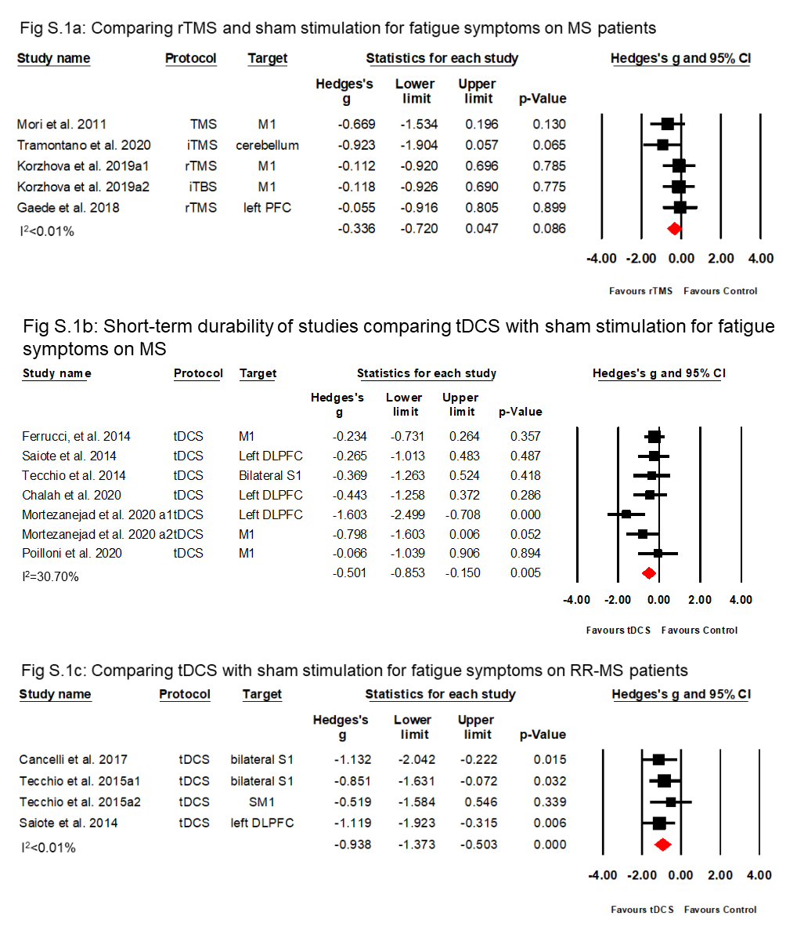

08. Fig. S2: tDCS on depression and tDCS on anxiety in MS
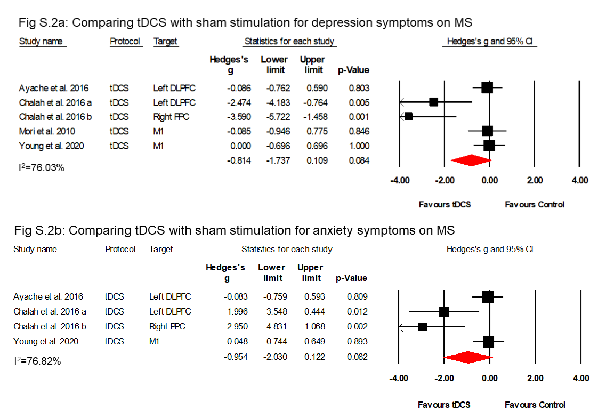

Reference:
1. Cancelli A, Cottone C, Giordani A, et al. Personalized, bilateral whole-body somatosensory cortex stimulation to relieve fatigue in multiple sclerosis. Multiple Sclerosis Journal. 2017 2018/09/01;24(10):1366-74.
2. Chalah MA, Riachi N, Ahdab R, et al. Effects of left DLPFC versus right PPC tDCS on multiple sclerosis fatigue. J Neurol Sci. 2017 2017/01/15/;372:131-7.
3. Charvet LE, Dobbs B, Shaw MT, Bikson M, Datta A, Krupp LB. Remotely supervised transcranial direct current stimulation for the treatment of fatigue in multiple sclerosis: Results from a randomized, sham-controlled trial. Mult Scler. 2018 Nov;24(13):1760-9.
4. Ferrucci R, Vergari M, Cogiamanian F, et al. Transcranial direct current stimulation (tDCS) for fatigue in multiple sclerosis. NeuroRehabilitation. 2014;34(1):121-7.
5. Mortezanejad M, Ehsani F, Masoudian N, Zoghi M, Jaberzadeh S. Comparing the effects of multi-session anodal trans-cranial direct current stimulation of primary motor and dorsolateral prefrontal cortices on fatigue and quality of life in patients with multiple sclerosis: a double-blind, randomized, sham-controlled trial. Clin Rehabil. 2020 2020/08/01;34(8):1103-11.
6. Ayache SS, Palm U, Chalah MA, Al-Ani T, Brigno A, Abdellaoui M. Prefrontal tDCS decreases pain in patients with multiple sclerosis. Front Neurosci. 2016;10:147.
7. Mattioli F, Bellomi F, Stampatori C, Capra R, Miniussi CJMSJ. Neuroenhancement through cognitive training and anodal tDCS in multiple sclerosis. 2016;22(2):222-30.
8. Chalah MA, Grigorescu C, Padberg F, Kümpfel T, Palm U, Ayache SS. Bifrontal transcranial direct current stimulation modulates fatigue in multiple sclerosis: a randomized sham-controlled study. J Neural Transm. 2020.
9. Tecchio F, Cancelli A, Cottone C, et al. Brain plasticity effects of neuromodulation against multiple sclerosis fatigue. Front Neurol. 2015;6(JUL).
10. Tecchio F, Cancelli A, Cottone C, et al. Multiple sclerosis fatigue relief by bilateral somatosensory cortex neuromodulation. J Neurol. 2014 Aug;261(8):1552-8.
11. Mori F, Codecà C, Kusayanagi H, et al. Effects of anodal transcranial direct current stimulation on chronic neuropathic pain in patients with multiple sclerosis. 2010;11(5):436-42.
12. Iodice R, Dubbioso R, Ruggiero L, Santoro L, Manganelli FJRn, neuroscience. Anodal transcranial direct current stimulation of motor cortex does not ameliorate spasticity in multiple sclerosis. 2015;33(4):487-92.
13. Pilloni G, Choi C, Shaw MT, et al. Walking in multiple sclerosis improves with tDCS: a randomized, double-blind, sham-controlled study. Annals of clinical and translational neurology. 2020.
14. Hanken K, Bosse M, Möhrke K, et al. Counteracting fatigue in MS with right parietal anodal tDCS -preliminary results of a doubleblind placebo-controlled study. Neurologie und Rehabilitation. 2016;22(1):69-70.
15. Meesen RL, Thijs H, Leenus DJ, Cuypers K. A single session of 1 mA anodal tDCS-supported motor training does not improve motor performance in patients with multiple sclerosis. Restor Neurol Neurosci. 2014;32(2):293-300.
16. Saiote C, Goldschmidt T, Timaus C, et al. Impact of transcranial direct current stimulation on fatigue in multiple sclerosis. Restor Neurol Neurosci. 2014;32(3):423-36.
17. Fiene M, Rufener KS, Kuehne M, Matzke M, Heinze HJ, Zaehle T. Electrophysiological and behavioral effects of frontal transcranial direct current stimulation on cognitive fatigue in multiple sclerosis. J Neurol. 2018 Mar;265(3):607-17.
18. Young J, Zoghi M, Khan F, Galea MP. The Effect of Transcranial Direct Current Stimulation on Chronic Neuropathic Pain in Patients with Multiple Sclerosis: randomized Controlled Trial. Pain medicine (Malden, Mass). 2020.
19. Oveisgharan S, Karimi Z, Abdi S, Sikaroodi H. The use of brain stimulation in the rehabilitation of walking disability in patients with multiple sclerosis: A randomized double-blind clinical trial study. Iranian journal of neurology. 2019 Apr 4;18(2):57-63.
20. Gaede G, Tiede M, Lorenz I, et al. Safety and preliminary efficacy of deep transcranial magnetic stimulation in MS-related fatigue. Neurology - Neuroimmunology Neuroinflammation. 2018;5(1):e423.
21. Mori F, Ljoka C, Magni E, et al. Transcranial magnetic stimulation primes the effects of exercise therapy in multiple sclerosis. 2011;258(7):1281-7.
22. Boutière C, Rey C, Zaaraoui W, et al. Improvement of spasticity following intermittent theta burst stimulation in multiple sclerosis is associated with modulation of resting-state functional connectivity of the primary motor cortices. Mult Scler. 2017 May;23(6):855-63.
23. Korzhova J, Bakulin I, Sinitsyn D, et al. High-frequency repetitive transcranial magnetic stimulation and intermittent theta-burst stimulation for spasticity management in secondary progressive multiple sclerosis. Eur J Neurol. 2019 Apr;26(4):680-e44.
24. Şan AU, Yılmaz B, Kesikburun S. The Effect of Repetitive Transcranial Magnetic Stimulation on Spasticity in Patients with Multiple Sclerosis. J Clin Neurol. 2019 Oct;15(4):461-7.
25. Tramontano M, Grasso MG, Soldi S, et al. Cerebellar Intermittent Theta-Burst Stimulation Combined with Vestibular Rehabilitation Improves Gait and Balance in Patients with Multiple Sclerosis: a Preliminary Double-Blind Randomized Controlled Trial. Cerebellum (London, England). 2020.
26. Darwish MH, El-Tamawy MS, Basheer MA, Khalifa H, Elsherif AA. Effect of repetitive transcranial magnetic stimulation on motor functions in multiple sclerosis patients: A randomized controlled trial. Indian Journal of Public Health Research and Development. 2019;10(11):3368-73.

