Supplementary Materials

Table S1. Formulas used to calculate sample size, mean, and standard deviation when combining subgroups.
 | FEP | CTRL | Formula
Sample Size | Nı | N2 | $$N_{1}+N_{2}$$
Mean | Mı | M2 | $$\frac{N_{1}M_{1}+ N_{2}M_{2}}{N_{1}+N_{2}}$$
Standard  Deviation | SDı | SD2 | $$\sqrt{\frac{\left(Nı-1\right)SDı^{2}+\left(N_{2}-1\right){SD2}_{}^{2}+ \frac{N_{1}N_{2}}{N_{1}+ N_{2}} (M_{1}²{+M}_{2}²-2M_{1}M_{2})}{N_{1}+N_{2}-1}}$$

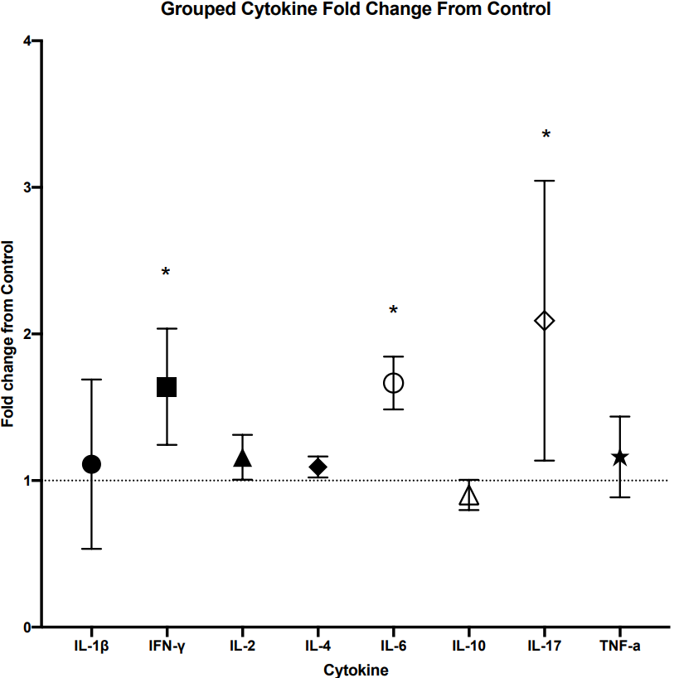
Figure S1. A Scatter plot displaying the fold-change for each cytokine measured in 3 or more studies with over 100 participants, with reference to control subjects normalised to 1.0. The horizontal line represents control, symbols represent each cytokine fold change in FEP with SD, ‘*’ denotes a significant difference.

Additional Data excluded from Meta-Analysis

IL-3 was assessed in FEP patients in only one study within this review, conducted by Yang et al ⁴⁸. This study reported significantly decreased IL-3 concentrations in FEP patients, when compared to healthy controls (p <.01), however the change in IL-3 in FEP patients was not associated with changes in the PANSS negative score or any other symptomology. Xiu et al. ⁴⁹, assessed IL-18 in FEP, and similarly, this was the only study included in the present review to assess this cytokine. No significant difference in IL-18 concentration was found when compared to healthy controls, and no correlation was reported with the PANSS Negative score or any other symptomology (p >.05).
The study by Borovcanin et al ⁵⁰ was excluded from the meta-analysis as the data was presented as standard error of the mean (SEM) rather than standard deviation. The use of SEM would likely skew any meta-analysis, and following calculation of SD from the data provided, this was indeed the case. Borovcanin et al ⁵⁰, reported significantly elevated TGF-β in FEP when compared to healthy controls, with no significant difference reported for IFN-γ, IL-4, IL-6, IL-17, IL-27, and concentrations below detection limit for IL-10 and TNF-α. This group also reported that there was no relationship found between cytokines and symptomology. The study by Pesce et al ⁵¹ was excluded from the meta-analysis as actual values for cytokines were not stated, and no correspondence was made after an attempt to contact the authors. However, this study suggested that IL-1β, IL-2, and TNF-α were significantly increased in FEP patients when compared to control, and a significant positive relationship between IL-1β and SANS scores was presented, in which increasing IL-1β was associated with increased SANS scores, implying more severe negative symptomology.
The study by Petrikis et al ⁵², was excluded from the meta-analysis due to most data points presented being at or below the limit of detection of the ELISA. However, the study presented data to suggest a significant increase in IL-2 and IL-6 in FEP, though no relationship with negative symptomology was evident. Finally, the study by Karanikas et al ⁵³ was excluded from the meta-analysis as sufficient cytokine data was not available. This group reported significantly increased TNF-α, TNF-β, IFN-γ, and IL-4 in FEP, but no correlation with any symptomology was presented.

