Appendix 4: Supplementary Figures:
F1: PRISMA flow chart. Flowchart of the study selection process.
F2: Acute Vascular Events over 1-14 days post treatment (ORs).
F3: Acute Vascular Events over 4-8 weeks post treatment (ORs).

F1: PRISMA flow chart.
Flowchart of the study selection process. A systematic review yielded 12426 reports. After removal of duplicates and the application of inclusion and exclusion criteria, 3 studies were included in the meta-analysis. Medline OVID SP, EMBASE OVID SP, Cochrane library, CINAHL Ebsco Host, Web of Sciences Core Collection and SIGLE (System for Information on Grey Literature in Europe and manual search strategies are illustrated in Appendix T1).
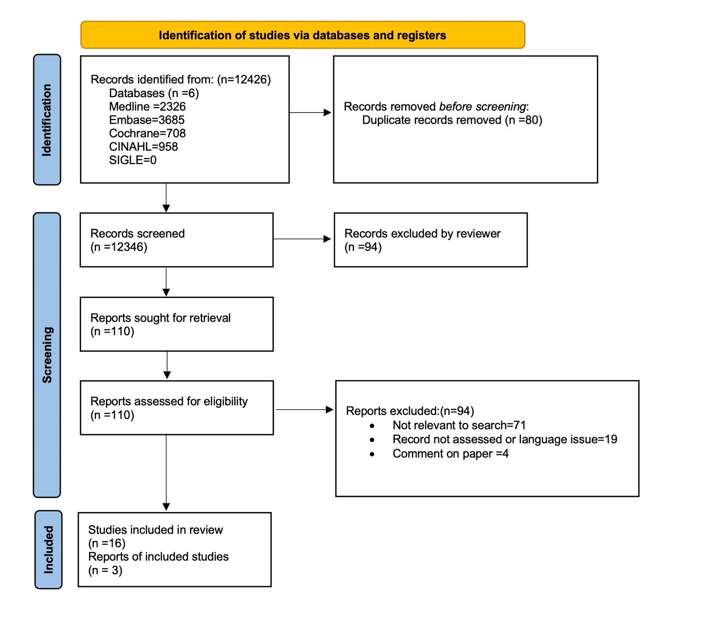

F2: Acute Vascular Events over 1-14 days post treatment (ORs).
Summary forest plot for odds ratio of acute vascular events over 1-14 days post treatment in case–control studies, (A): ischemic stroke (IS) and myocardial infarction (MI) between 2-7 days, (B): myocardial infarction (MI) at 2 weeks. The fixed effect, inverse variance weighed pooled analysis was used and the data markers indicates the time length and events in each study, OR, odds ratio, CI, confidence interval.

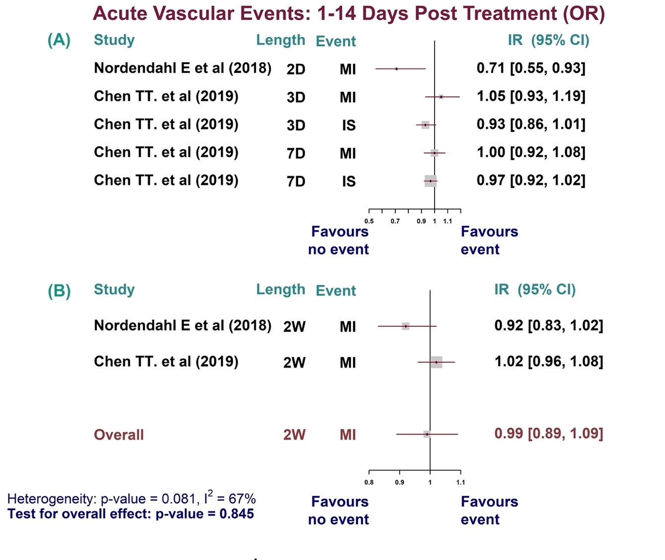

F3: Acute Vascular Events up to 8 weeks post treatment (ORs).
Summary forest plot for odds ratio of acute vascular events over 4-8 weeks post treatment in case–control studies, (A): myocardial infarction (MI) at 4 weeks, (B): myocardial infarction (MI), ischemic stroke (IS) and all combined vascular events at 8 weeks and (C): ischemic stroke (IS) between 2-8 weeks post treatment. The fixed effect, inverse variance weighed pooled analysis was used and the data markers indicates the time length and events in each study, OR, odds ratio, CI, confidence interval.



