Supplementary material

Parental smoking, type 1 diabetes, and islet autoantibody positivity in the offspring: a systematic review and meta-analysis

Edstorp Jessica Msc, Lampousi Anna-Maria Msc, Carlsson Sofia PhD
Institute of Environmental Medicine, Karolinska Institutet, Stockholm, Sweden.

Corresponding author:
Jessica Edstorp
Box 210
171 77 Stockholm
Sweden
jessica.edstorp@ki.se

Supplementary Table S1. Search strategy for identification of relevant articles in Medline
Interface: Ovid MEDLINE(R) and Epub Ahead of Print, In-Process & Other Non-Indexed Citations and Daily  Date of Search: 21 January 2021  Number of hits: 225  Comment: In Ovid, two or more words are automatically searched as phrases, i.e., no quotation marks are needed | Field labels  - exp/ = exploded MeSH term  - / = non exploded MeSH term  - .ti,ab,kf. = title, abstract and author keywords  - adjx = within x words, regardless of order  - * = truncation of word for alternate endings
1 | Diabetes Mellitus, Type 1 | 76776
2 | (diabet* adj3 (brittle or insulin-dependent or juvenile or sudden onset or "type 1" or "type I")).ti,ab,kf. | 80612
3 | (T1D or iddm).ti,ab,kf. | 14182
4 | ((islet* or diabet* or insulin*) adj5 (autoimmun* or autoantibod* or antibod*)).ti,ab,kf. | 16935
5 | or/1-4 | 115566
6 | Fetus/ | 78702
7 | Maternal Exposure/ | 9695
8 | Maternal-Fetal Exchange/ | 29569
9 | Paternal Exposure/ | 1096
10 | Pregnancy/ | 888882
11 | Prenatal Exposure Delayed Effects/ | 30079
12 | (fetal or fetus or foetal or matern* or offspring* or pregn* or parent* or patern* or perinatal or Prenatal).ti,ab,kf. | 1356727
13 | or/6-12 | 1694588
14 | Nicotine/ | 25929
15 | exp Smoking/ | 149889
16 | Tobacco Smoke Pollution/ | 13457
17 | Tobacco, Smokeless/ | 3734
18 | (cigarett* or nicotine or smok* or snuff or snus or tobacco).ti,ab,kf. | 368766
19 | or/14-18 | 402383
20 | 5 and 13 and 19 | 245
21 | 20 not (animals not humans).sh. | 244
22 | limit 21 to english language | 225

Supplementary Table S2. Search strategy for identification of relevant articles in Embase
Interface: embase.com  Date of Search: 21 January 2021  Number of hits: 471  Comment: Emtree is the controlled vocabulary in Embase | Field labels  - /exp = exploded Emtree term  - /de = non exploded Emtree term  - ti,ab = title and abstract  - NEAR/x = within x words, regardless of order  - * = truncation of word for alternate endings
#1 | 'insulin dependent diabetes mellitus'/de | 122,849
#2 | (diabet* NEAR/3 (brittle OR 'insulin-dependent' OR juvenile OR 'sudden onset' OR 'type 1' OR 'type i')):ti,ab,kw | 116,138
#3 | T1D:ti,ab,kw OR iddm:ti,ab,kw | 23,225
#4 | ((islet* OR diabet* OR insulin*) NEAR/5 (autoimmun* OR autoantibod* OR antibod*)):ti,ab,kw | 22,929
#5 | #1 OR #2 OR #3 OR #4 | 168,48
#6 | 'fetoMaternal transfusion'/de | 13,723
#7 | 'fetus'/de | 208,86
#8 | 'Maternal exposure'/de | 2,781
#9 | 'paternal exposure'/de | 326
#10 | 'pregnancy'/de | 710,86
#11 | 'Prenatal exposure'/de | 25,243
#12 | fetal:ti,ab,kw OR fetus:ti,ab,kw OR foetal:ti,ab,kw OR matern*:ti,ab,kw OR offspring*:ti,ab,kw OR pregn*:ti,ab,kw OR parent*:ti,ab,kw OR patern*:ti,ab,kw OR perinatal:ti,ab,kw OR Prenatal:ti,ab,kw | 1,711,487
#13 | #6 OR #7 OR #8 OR #9 OR #10 OR #11 OR #12 | 1,982,490
#14 | 'nicotine'/de | 48,896
#15 | 'passive smoking'/de | 13,477
#16 | 'smoking'/exp | 405,207
#17 | 'smokeless tobacco'/de | 4,943
#18 | 'snus'/de | 202
#19 | 'tobacco snuff'/de | 177
#20 | cigarett*:ti,ab,kw OR nicotine:ti,ab,kw OR smok*:ti,ab,kw OR snuff:ti,ab,kw OR snus:ti,ab,kw OR tobacco:ti,ab,kw | 522,05
#21 | #14 OR #15 OR #16 OR #17 OR #18 OR #19 OR #20 | 620,816
#22 | #5 AND #13 AND #21 | 497
#23 | #22 NOT ([animals]/lim NOT [humans]/lim) | 493
#24 | #23 AND [english]/lim | 471

Interface: Wiley  Date of Search: 21 Jan 2021  Number of hits: 31 | Field labels  - ti,ab,kw = title, abstract and author keywords  - NEAR/x = adjacent within x words, regardless of order  - * = truncation of word for alternate endings
#1 | (diabet* NEAR/3 (brittle or "insulin-dependent" or juvenile or "sudden onset" or "type 1" or "type I")):ab,ti,kw | 27074
#2 | (T1D or iddm):ab,ti,kw | 2044
#3 | ((islet* or diabet* or insulin*) NEAR/5 (autoimmun* or autoantibod* or antibod*)):ab,ti,kw | 969
#4 | #1 OR #2 OR #3 | 27559
#5 | (fetal or fetus or foetal or matern* or offspring* or pregn* or parent* or patern* or perinatal or Prenatal):ab,ti,kw | 119791
#6 | (cigarett* or nicotine or smok* or snuff or snus or tobacco):ab,ti,kw | 39929
#7 | #4 AND #5 AND #6 | 144
#8 |  | 31
  #7 NOT (clinicaltrials or trialsearch):so

Supplementary Table S3. Search strategy for identification of relevant articles in Cochrane Library

Supplementary Table S4. Characteristics of studies assessing offspring type 1 diabetes in relation to maternal smoking during pregnancy.

Author | Country | Cohort  name | Study design | Total sample | N cases | Age at diagnosis | Exposure | Exposure assessment | Time of exposure | Outcome | Outcome assessment | Adjusted factors | Risk of bias
Adlercreutz, 2015 | Sweden |  | Cohort | 768, 395 | 4,327 | <14 years | Maternal smoking  (yes vs. no) | Medical Birth Register | Prenatal | Type 1 diabetes | National Patient Register | None | Serious
Begum, 2020 | Australia |  | Cohort | 264,542 | 442 | ≤15 years | Maternal smoking (consistent vs. none) | South Australian Perinatal Statistics Collection | Prenatal | Type 1 diabetes | Inpatient Hospital Register | Parents’ age and occupation, mother’s birth region, maternal ethnicity, remoteness, socioeconomic factors, hospital category, parity, pre-pregnancy hypertension, pre-pregnancy diabetes, child’s year of birth | Low
Boljat, 2017 | Croatia |  | Case-control  (hospital controls) | 504 | 249 | <21 years | Maternal smoking  (yes vs. no) | Questionnaire  (retrospective) | Prenatal | Type 1 diabetes | Pediatrics Department at a University Hospital | Maternal diseases, maternal drugs, maternal alcohol consumption during pregnancy, stressful life events, maternal age at delivery | Moderate
D’Angeli, 2010 | US |  | Case-control | 9,041 | 1,789 | <19 years | Maternal smoking  (yes vs. no) | Birth records | Prenatal | Type 1 diabetes | Hospital records | Birth year, maternal age, marital status | Moderate
Dahlquist,  1992 | Sweden |  | Case-control | 11,028 | 2,757 | <15 years | Maternal smoking  (yes vs. no) | Medical Birth Register | Prenatal | Type 1 diabetes | Nationwide Childhood Diabetes Register | Maternal age, diabetes and toxicosis, gestational age, cesarian section, neonatal respiratory disease, blood group incompatibility | Moderate
Frederiksen, 2013 | US | DAISY | Cohort | 1,835 | 53 | <1.35 years | Maternal smoking  (yes vs. no) | Not stated | Prenatal | Type 1 diabetes | Clinical diagnosis, no details given | HLA genotype, first-degree relative with T1D, maternal education, mode of delivery | Low
Haynes, 2014 | Australia |  | Cohort | 226,233 | 287 | <15 years | Maternal smoking  (yes vs. no) | Medical Birth Register | Prenatal | Type 1 diabetes | Western Australian Children’s Diabetes Database | Maternal socioeconomic status, maternal age, birth weight, gestational age, birth order, child’s year of birth | Low
Hussen, 2015* | Sweden |  | Cohort | 902,725 | 4,933 | <19 years | Maternal smoking  (yes vs. no) | Medical Birth Register | Prenatal | Type 1 diabetes | National Patient Register | Parental diabetes, maternal BMI, maternal age, size for gestational age, parental level of education, mode of delivery, sex, age at follow-up, birth cohort | Low
Lund-Blix, 2015 | Norway | Midia | Cohort | 726 | 25 | <12 years | Maternal smoking  (yes vs. no) | Questionnaires administered at 3, 6, 9, and 12 months and then annually | Prenatal | Type 1 diabetes | No details given | None | Serious
Magnus, 2018 | Denmark | DNBC | Cohort | 86,789 | 340 | <18 years | Maternal smoking  (consistent vs. none) | Questionnaire | Prenatal | Type 1 diabetes | National Childhood Diabetes Registers | Maternal age, parity, education, pre-pregnancy BMI, maternal diabetes | Low
Magnus, 2018# | Norway | MoBa | Cohort | 98,287 | 349 | <16 years | Maternal smoking (consistent vs. none) | Questionnaire | Prenatal | Type 1 diabetes | National Childhood Diabetes Registers | Maternal age, parity, education, pre-pregnancy BMI, maternal T1D | Low
Magnus, 2018# | Norway | NNRC | Cohort | 434,627 | 692 | 1-11 years | Maternal smoking (consistent vs. none) | National Birth Register | Prenatal | Type 1 diabetes | Prescription and Patient Register | Maternal age, parity, education, and insulin-treated diabetes | Low
Marshall, 2004 | UK |  | Case-control | 577 | 196 | <16 years | Maternal smoking  (yes vs. no) | Questionnaire (retrospective) | Prenatal | Type 1 diabetes | Pediatric diabetic clinics | Room shared, social contact, consumption of sugary food, parental diabetes, maternal thyroid disease, pre-school milk consumption, father’s qualifications, age of introduction to formula, maternal age at birth, infections, illnesses or conditions in pregnancy, race, typhoid vaccination, regular contact with animals | Moderate
Mattsson, 2015* | Sweden |  | Case-control | 1,275 | 319 | <15 years | Maternal smoking  (yes vs. no) | Regional birth register | Prenatal | Type 1 diabetes | All children diagnosed with T1D registered in the Skane study (1999–2005), and the Better Diabetes Diagnosis study (2005-). | Maternal age at birth, parity, mode of delivery, birth weight, gestational age | Serious
Metsälä, 2020 | Finland |  | Case-cohort | 130,554 | 6,670 | ≤16 years | Maternal smoking  (yes vs. no) | Finnish Medical Birth Register | Prenatal | Type 1 diabetes | Special Reimbursement Register | Maternal age, diabetes, and asthma, child's birth decade. | Moderate
Robertson, 2020 | Scotland |  | Case-control | 1,152 | 285 | <15 years | Maternal smoking  (yes vs. no) | Aberdeen Maternity Neonatal Databank | Prenatal | Type 1 diabetes | Diabetes Register | Maternal age, birth weight, breastfeeding, maternal deprivation, pre-eclampsia, gestational age, mode of delivery | Low
Rosenbauer, 2007 | Germany |  | Case-control | 1,383 | 755 | <5 years | Maternal smoking  (yes vs. no) | Questionnaire (retrospective) | Prenatal | Type 1 diabetes | Hospital Register | Age and sex | Serious
Stene, 2003 | Norway |  | Case-control | 2,187 | 538 | <15 | Maternal smoking  (most of the pregnancy vs. none) | Questionnaire (retrospective) | Prenatal | Type 1 diabetes | Diabetes Register | Maternal age, supplements during pregnancy, supplements during the first year of life, age, sex, maternal education, breastfeeding, introduction of solid foods, number of siblings, sibling or parent with T1D. | Moderate
Svensson, 2005 | Denmark |  | Case-control | 1,455 | 581 | <15 years | Maternal smoking  (yes vs. no) | Questionnaire (retrospective) | Prenatal | Type 1 diabetes | Diabetes Register | Maternal age, birth cohort, sex | Serious
Toschke, 2007 | UK | NCDS | Cohort | 5,214 | 38 | Not stated | Maternal smoking  (yes vs. no) | Interviews of mothers by midwifes | Prenatal | Type 1 diabetes | No details given | Paternal smoking, maternal smoking, sex, maternal age, paternal age, number of siblings, social class | Serious
Toschke, 2007 | UK | BCS70 | Cohort | 6,068 | 27 | Not stated | Maternal smoking  (yes vs. no) | Interviews of mothers by midwifes | Prenatal | Type 1 diabetes | No details given | Paternal smoking, maternal smoking, sex, maternal age, paternal age, number of siblings, social class | Serious
Wadsworth, 1997 | UK |  | Case-control | 637 | 275 | <5 years | Maternal smoking  (yes vs. no) | Questionnaire (retrospective) | Prenatal | Type 1 diabetes | Pediatric Register | Parental age, sex, infant feeding, maternal social class, maternal age, birth order | Serious
DNBC-the Danish National Birth Cohort, MoBa-The Norwegian Mother-Child Cohort, NNRC-Norwegian National Register Cohort, NCDS-the National Child Development Study, BCS70-the 1970 British Birth Cohort Study. Midia- Norwegian acronym for “Environmental Triggers of Type 1 diabetes”. *Two of the Swedish studies had partially overlapping study populations; Hussen et al. included all children diagnosed with diabetes age <19 years, 1992-2009 in Sweden and Mattsson et al. included children diagnosed with diabetes age <15 years, 1999-2013 in the county of Scania (Mattson used a case-control design with matching for HLA genotype). #Three Norwegian cohorts included partially overlapping study populations; MoBA included a sample of children born 1999-2008, NNRC included all children born in Norway 2004-2012 and Midia included a sample of children born 2001-2007.

Supplementary Table S5. Characteristics of studies assessing paternal smoking during pregnancy in relation to incidence of type 1 diabetes.

MoBa-The Norwegian Mother-Child Cohort, DNBC-the Danish National Birth Cohort.
Author | Country | Cohort name | Study design | Total sample | N cases | Age at diagnosis | Exposure | Exposure assessment | Time of exposure | Outcome | Outcome assessment | Adjusted factors | Risk of bias
Magnus, 2018 | Norway | MoBa | Paternal during pregnancy | 98,287 | 349 | <16 years | Paternal smoking during pregnancy | Self-report | Prenatal | Type 1 diabetes | Clinical diagnosis of type 1 diabetes, ascertained by national Childhood Diabetes Registers | Paternal age, education, BMI, diabetes | Moderate
Magnus, 2018 | Denmark | DNBC | Paternal during pregnancy | 86,789 | 340 | <18 years | Paternal smoking during pregnancy | Self-report | Prenatal | Type 1 diabetes | National Childhood Diabetes Registers | Paternal age, education, BMI | Moderate

Supplementary Table S6. Characteristics of studies assessing islet autoantibody positivity in relation to maternal smoking during pregnancy or childhood.
Author | Country | Cohort name | Study design | Total sample | N cases | Age at diagnosis | Exposure | Exposure assessment | Time of exposure | Outcome | Outcome assessment | Adjusted factors | RR  (95% CI) | Risk of bias
Wahlberg, 2011 | Sweden | ABIS | Cohort | 5,916 | 342 | 2.5 years | Maternal smoking during second year of child | Questionnaire  Not clear whether analyses were prospective or cross-sectional | Childhood | Antibody positivity | GADA  Above 95th percentile (82.2 RA units). | None | 0.5  (0.3-0.8) | Serious
Wahlberg, 2011 | Sweden | ABIS | Cohort | - | 376 | 2.5 years | Smoking in the home  (>10 vs. ≤10 cigarettes daily) | Questionnaire  Not clear whether analyses were prospective or cross-sectional | Childhood | Antibody positivity | IA-2A  Above 95th percentile (26 RA units). | None | 2.9  (1.1-7.7) | Serious
Wahlberg, 2011 | Sweden | ABIS | Cohort | 6,990 | 3776 | 2.5 years | Maternal smoking  (yes vs. no) | Questionnaire  Not clear whether retrospective information was used | Prenatal | Antibody positivity | IA-2A  Above 95th percentile (26 RA units). | None | 1.6  (1.2-2.2) | Serious
Lund-Blix, 2015 | Norway | Midia | Cohort | 726 | 56 | <12 years | Maternal smoking during pregnancy  (yes vs. no) | Questionnaires administered at 3, 6, 9, and 12 months and then annually | Prenatal | Antibody positivity | IAA, GADA, IA-2A  High titers of one  autoantibody or above cutoff for two or three autoantibodies in two or more consecutive samples. | None | 0.76  (0.34–1.67) | Serious
Virtanen,  2006 | Finland | DIPP | Cohort | 3,455 | 106 | ≤2 years | Maternal smoking during pregnancy  (yes vs. no) | Medical Birth Registries | Prenatal | Antibody positivity | ICA, IAA, GADA, IA-2A  Repeated positivity for ICA together with at least one of IAA, GADA or IA–2A. | Genetic risk | 0.52  (0.23–1.18) | Serious
Stene, 2004 | US | DAISY | Cohort | 1,354 | 52 | Mean follow-up 4 years | Maternal smoking during pregnancy  (yes vs. no) | Questionnaire soon after birth | Prenatal | Antibody positivity | GADA, IAA, IA-2A  Positivity for one or more autoantibodies at two or more consecutive clinic visits at 1–6 months intervals. | First-degree relative with T1D, HLA risk category, ethnic group. | 0.57  (0.18-1.86) | Moderate

ABIS-All babies in southeast Sweden, DIPP-Type 1 diabetes prevention and prediction study, Midia- Norwegian acronym for “Environmental Triggers of Type 1 diabetes”, IAA-autoantibodies against insulin, GADA-autoantibodies against glutamic acid decarboxylase65, IA-2A- tyrosine phosphatase-related islet antigen 2, ICA- islet cell antibodies. HLA- human leukocyte antigen

Supplementary Table S7. Characteristics of studies assessing maternal smoking during childhood in relation to type 1 diabetes.

Author | Country | Cohort  name | Study design | Total sample | N cases | Age at diagnosis | Exposure | Exposure assessment | Time of exposure | Outcome | Outcome assessment | Adjusted factors | RR  (95% CI) | Risk of bias
Magnus, 2018 | Norway | MoBa | Cohort | 98,287 | 349 | <16 years | Maternal smoking  (yes vs. no) | Questionnaire | Infancy  (0-6 months) | Type 1 diabetes | National Childhood Diabetes Registers | Maternal smoking during pregnancy, age, parity, education, maternal type 1 diabetes, pre-pregnancy BMI | 0.70  (0.42–1.2) | Low
Magnus, 2018 | Denmark | DNBC | Cohort | 86,789 | 340 | <18 years | Maternal smoking  (yes vs. no) | Questionnaire | Infancy  (0-6 months) | Type 1 diabetes | National Childhood Diabetes Registers | Maternal smoking during pregnancy, age, parity, education, maternal type 1 diabetes, pre-pregnancy BMI | 0.86  (0.53–1.4) | Low
Rosenbauer, 2007 | Germany |  | Case-control | 1370 | 741 | <5 years | Maternal smoking in childhood  (current smoking yes vs. no) | Questionnaire (retrospective) | Childhood | Type 1 diabetes | Hospital  Register | Age and sex | 1.04  (0.82–1.32) | Serious
Siemiatycki, 1989 | Canada |  | Case-control | 482 | 161 | <18 years | Maternal smoking  (yes vs. no) | Questionnaire (retrospective) | Childhood | Type 1 diabetes | Hospital  records | Age and sex | 0.8  (0.5–1.4) | Serious
Toschke, 2007 | UK | NCDS | Cohort | 5,214 | 38 | Not given | Maternal smoking  (yes vs. no) | Questionnaire at age 16 years | Childhood (probably also prenatally) | Type 1 diabetes | No details  given | Maternal smoking in pregnancy, social class, maternal and paternal age, number of siblings | 1.10  (0.49–2.49) | Serious
Toschke, 2007 | UK | BCS70 | Cohort | 6,068 | 27 | Not given | Maternal smoking (yes vs. no) | Questionnaire at age 5 or 10 years | Childhood | Type 1 diabetes | No details  given | Paternal smoking, maternal smoking in pregnancy, sex, maternal age, paternal age, number of siblings, social class | 0.66  (0.21–2.02) | Serious
MoBa-The Norwegian Mother-Child Cohort, DNBC-the Danish National Birth Cohort, NCDS-the National Child Development Study, BCS70-the 1970 British Birth Cohort Study

Supplementary Table S8. Characteristics of studies assessing paternal smoking during childhood in relation to type 1 diabetes.

Author | Country | Cohort  name | Study design | Total sample | N cases | Age at diagnosis | Exposure | Exposure assessment | Time of exposure | Outcome | Outcome assessment | Adjusted factors | RR  (95% CI) | Risk of bias
Magnus, 2018 | Norway | MoBa | Cohort | 98,287 | 349 | <16 years | Paternal smoking  (yes vs. no) | Questionnaire | Infancy  (0-6 months) | Type 1 diabetes | National Childhood Diabetes Registers | Paternal age, education, BMI, diabetes | 1.0  (0.79-1.3) | Low
Magnus, 2018 | Denmark | DNBC | Cohort | 86,789 | 340 | <18 years | Paternal smoking  (yes vs. no) | Questionnaire | Infancy  (0-6 months) | Type 1 diabetes | National Childhood Diabetes Registers | Paternal age, education, BMI | 0.93  (0.73-1.2) | Low
Rosenbauer, 2007 | Germany |  | Case-control | 1,331 | 719 | <5 years | Paternal smoking in childhood  (current smoking yes vs. no) | Questionnaire (retrospective) | Childhood | Type 1 diabetes | Hospital  Register | Age and sex | 1.31  (1.05-1.64) | Serious
Siemiatycki, 1989 | Canada |  | Case-control | 482 | 161 | <18 years | Smoking father  (yes vs. no) | Questionnaire (retrospective) | Childhood | Type 1 diabetes | Hospital  records | Age and sex | 0.9  (0.6-1.4) | Serious
Toschke, 2007 | UK | NCDS | Cohort | 5214 | 38 | Not given | Paternal smoking  (yes vs. no) | Questionnaire at 16 years | Childhood (probably also prenatally) | Type 1 diabetes | No details  given | Maternal smoking in pregnancy and childhood, social class, maternal and paternal age, number of siblings | 0.37  (0.18-0.75) | Serious
Toschke, 2007 | UK | BCS70 | Cohort | 6068 | 27 |  | Paternal smoking  (yes vs. no) | Questionnaire at age 5 or 10 years | Childhood | Type 1 diabetes | No details  given | Maternal smoking in pregnancy and childhood, social class, maternal and paternal age, number of siblings | 0.54  (0.24-1.27) | Serious
MoBa-The Norwegian Mother-Child Cohort, DNBC-the Danish National Birth Cohort, NCDS-the National Child Development Study, BCS70-the 1970 British Birth Cohort Study.

Supplementary Table S9. Quality of evidence rating using the GRADE system.

Study question: Is maternal smoking during pregnancy associated with incidence of T1D in the offspring?
Summary relative risk and 95% CI: 0.78 (0.71-0.86)
Characteristic | Certainty | Comment
Study limitations/risk of bias | Not Serious | There are several prospective cohort studies where recall bias is not a concern. Associations remain even after adjustment for several potential confounders including socioeconomic status, breastfeeding and diabetes in the mother. Some underreporting of smoking habits during pregnancy is expected due to social desirability. However, in prospective studies, misclassification of smoking habits can be expected to be non-differential and will result in dilution of the effect estimates.
Inconsistency of results | Not Serious | When the analysis is restricted to prospective cohort studies, there is very little heterogeneity across studies.
Indirectness of evidence | Not Serious | The study populations are relevant and there are several population-based studies.
Imprecision | Not Serious | The confidence interval does not include 1 and ranges from 0.71-0.86
Publication bias | Not Serious
Overall assessment | High degree of certainty

Study question: Is paternal smoking during pregnancy associated with T1D in the offspring?
Summary relative risk and 95% CI: 0.97 (0.81-1.15)
Characteristic | Certainty | Comment
Study limitations/risk of bias | Serious | There are only two studies and neither adjusted for maternal smoking. Some underreporting of smoking habits is expected due to social desirability. However, in prospective studies, misclassification of smoking habits can be expected to be non-differential and will result in dilution of the effect estimates.
Inconsistency of results | Not Serious | There is not a lot of heterogeneity across studies.
Indirectness of evidence | Not Serious | The study populations are relevant and there are population-based studies.
Imprecision | Serious | The confidence interval includes 1 and is wide, ranging from 0.81-1.15
Reporting bias | Could not be assessed
Overall assessment | Low degree of certainty

Study question: Is maternal smoking during pregnancy associated with incidence of islet autoimmunity in the offspring?
Summary relative risk and 95% CI: 0.86 (0.44-1.65)
Characteristic | Certainty | Comment
Study limitations/risk of bias | Very Serious | There are few studies and only one adjusted for potential confounders. Some underreporting of smoking habits during pregnancy is expected due to social desirability. However, in prospective studies, misclassification of smoking habits can be expected to be non-differential and will result in dilution of the effect estimates.
Inconsistency of results | Serious | There is a lot of heterogeneity across studies. However, it is driven by one out of the four studies.
Indirectness of evidence | Not Serious | The study populations are relevant and there are population-based studies.
Imprecision | Very Serious | The confidence interval includes 1 and is wide, ranging from 0.44-1.65
Reporting bias | Could not be assessed
Overall assessment | Very low degree of certainty

Study question: Is maternal smoking during childhood associated with T1D in the offspring?
Summary relative risk and 95% CI: 0.95(0.78-1.14)
Characteristic | Certainty | Comment
Study limitations/risk of bias | Serious | There are few studies (six, of which four are prospective cohort studies with adjustment for maternal smoking during pregnancy). Some underreporting of smoking habits is expected due to social desirability. However, in prospective studies, misclassification of smoking habits can be expected to be non-differential and will result in dilution of the effect estimates.
Inconsistency of results | Not Serious | There is not a lot of heterogeneity across studies.
Indirectness of evidence | Not Serious | The study populations are relevant and there are population-based studies.
Imprecision | Serious | The confidence interval includes 1 and is wide, ranging from 0.78-1.14
Reporting bias | Could not be assessed
Overall assessment | Low degree of certainty

Study question: Is paternal smoking during childhood associated with T1D in the offspring?
Summary relative risk and 95% CI: 0.90 (0.70-1.17)
Characteristic | Certainty | Comment
Study limitations/risk of bias | Not Serious | There are few studies (five prospective cohort studies with adjustment for maternal smoking during pregnancy). Some underreporting of smoking habits is expected due to social desirability. However, in prospective studies, misclassification of smoking habits can be expected to be non-differential and will result in dilution of the effect estimates.
Inconsistency of results | Not Serious | There is not a lot of heterogeneity across studies.
Indirectness of evidence | Not Serious | The study populations are relevant and there are population-based studies.
Imprecision | Serious | The confidence interval includes 1 and is wide, ranging from 0.70-1.17
Reporting bias | Could not be assessed
Overall assessment | Low degree of certainty

Supplementary Figure S1. Funnel plot of studies assessing maternal smoking during pregnancy and incidence of type 1 diabetes in the offspring.

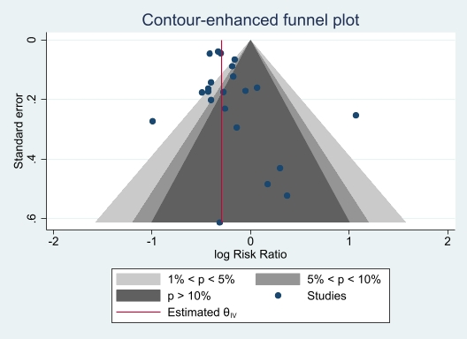

Supplementary Figure S2. Maternal smoking during pregnancy and incidence of type 1 diabetes in the offspring, only prospective cohort studies. Study-specific and pooled risk ratios and 95% confidence intervals.

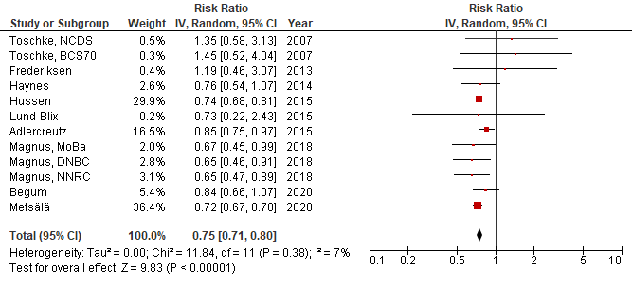

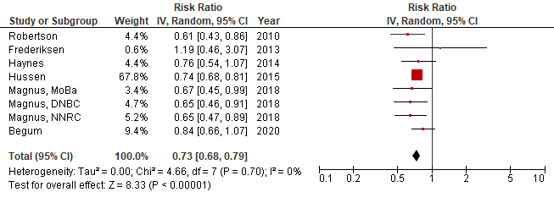
Supplementary Figure S3. Maternal smoking during pregnancy and incidence of type 1 diabetes in the offspring, studies with low risk of bias. Study-specific and pooled risk ratios and 95% confidence intervals.

Supplementary Figure S4. Maternal smoking during pregnancy and incidence of type 1 diabetes or islet autoantibody positivity, studies of children with high genetic risk (HLA genotypes associated with diabetes or family history of T1D). Study-specific and pooled risk ratios and 95% confidence intervals.

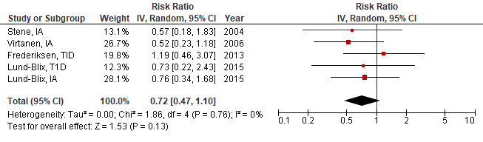

Supplementary Figure S5. Paternal smoking during pregnancy and incidence of type 1 diabetes in the offspring. Study-specific and pooled risk ratios and 95% confidence intervals.

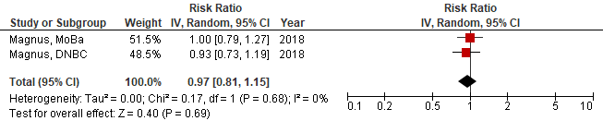

Supplementary Figure S6. Maternal smoking during pregnancy and incidence of islet autoantibody positivity in the offspring. Study-specific and pooled risk ratios and 95% confidence intervals.

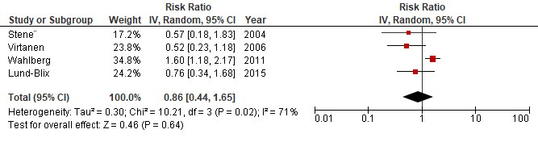

Supplementary Figure S7. Maternal smoking during childhood and incidence of type 1 diabetes, prospective cohort studies. Study-specific and pooled risk ratios and 95% confidence intervals.

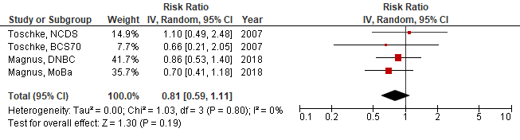

Supplementary Figure S8. Maternal smoking during childhood and incidence of type 1 diabetes in the offspring, studies with low risk of bias. Study-specific and pooled risk ratios and 95% confidence intervals.

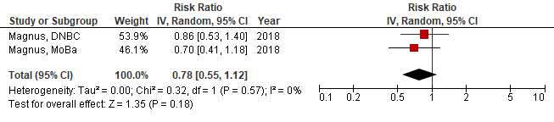

Supplementary Figure S9. Paternal smoking during childhood and incidence of type 1 diabetes in the offspring, prospective studies. Study-specific and pooled risk ratios and 95% confidence intervals.

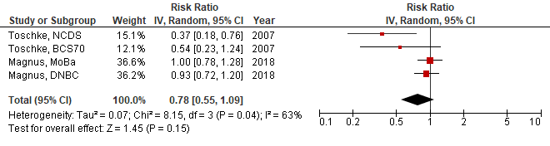

Supplementary Figure S10. Paternal smoking during childhood and incidence of type 1 diabetes in the offspring, studies with low risk of bias. Study-specific and pooled risk ratios and 95% confidence intervals.



