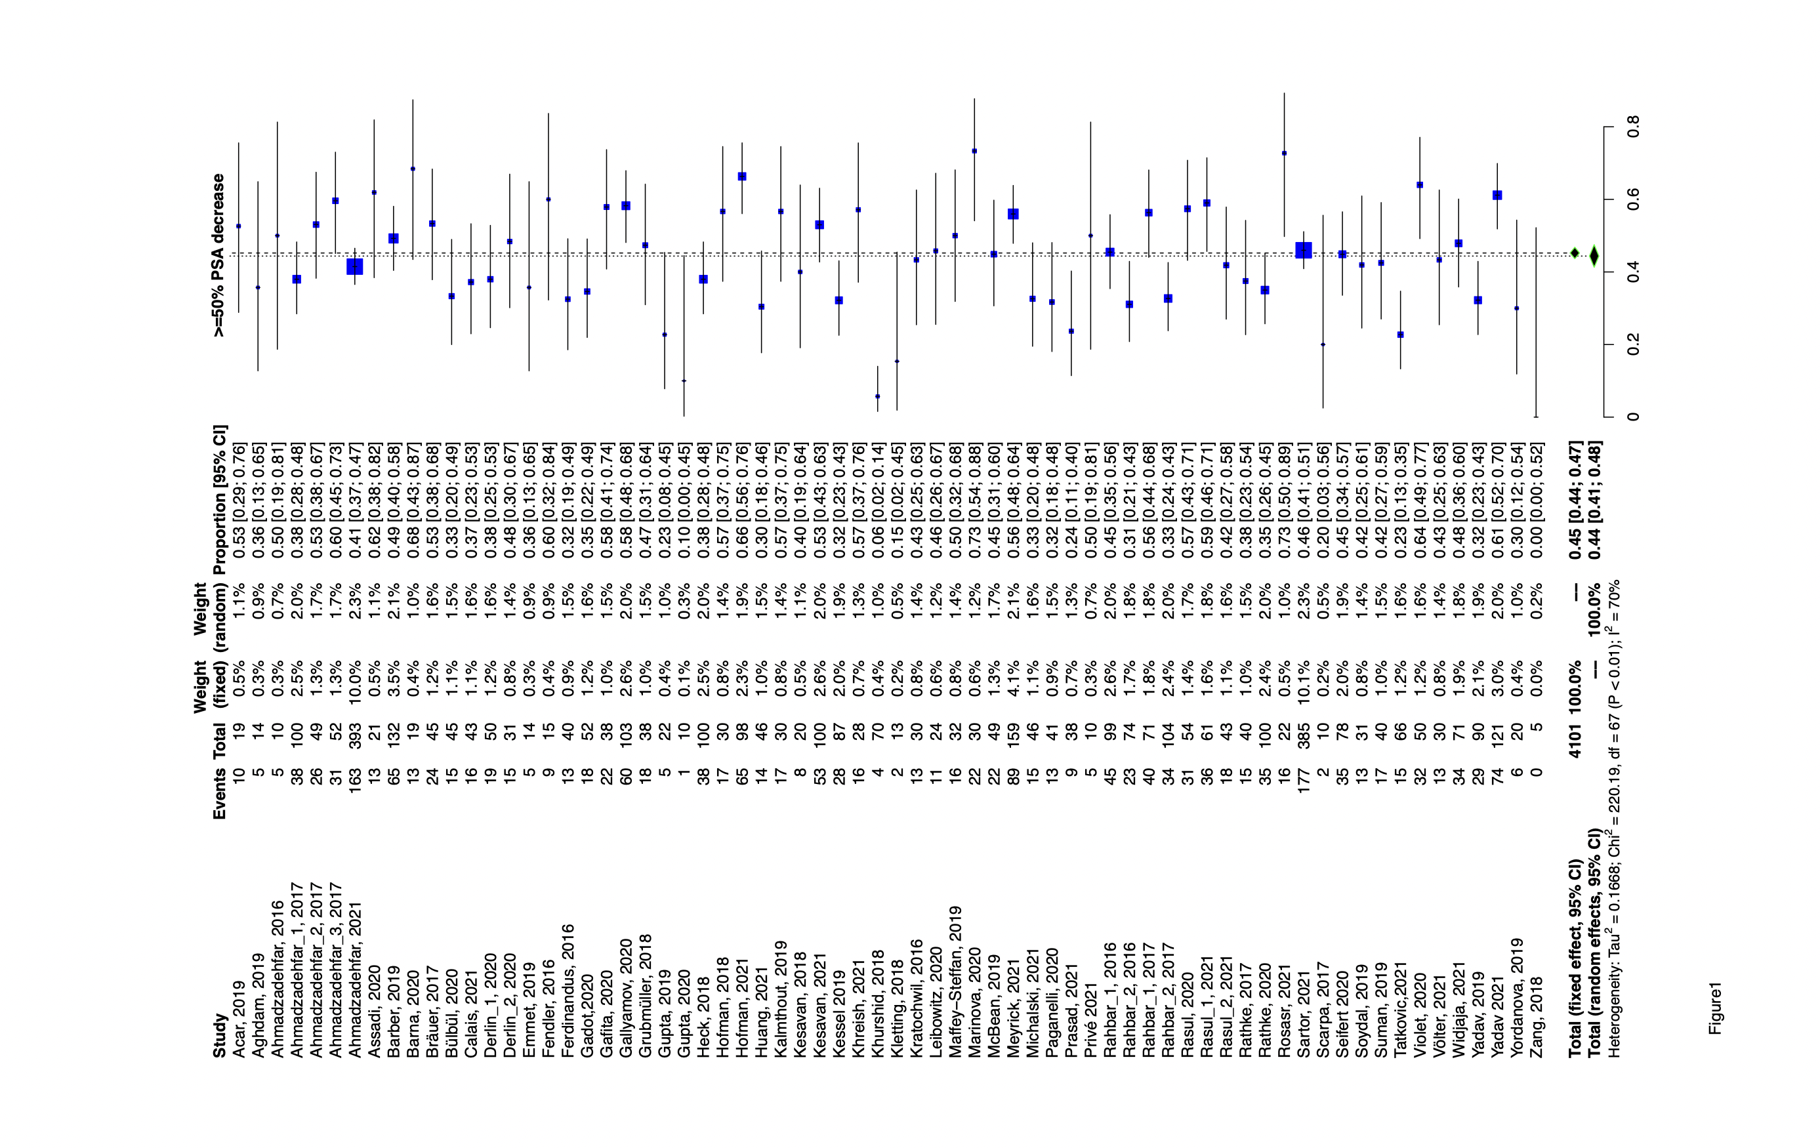
Supplemental Figure 1. Forest plot demonstrating the proportions of patients showing ≥50% PSA decrease after therapy with ¹⁷⁷Lu-PSMA-I&T or ¹⁷⁷Lu-PSMA-617

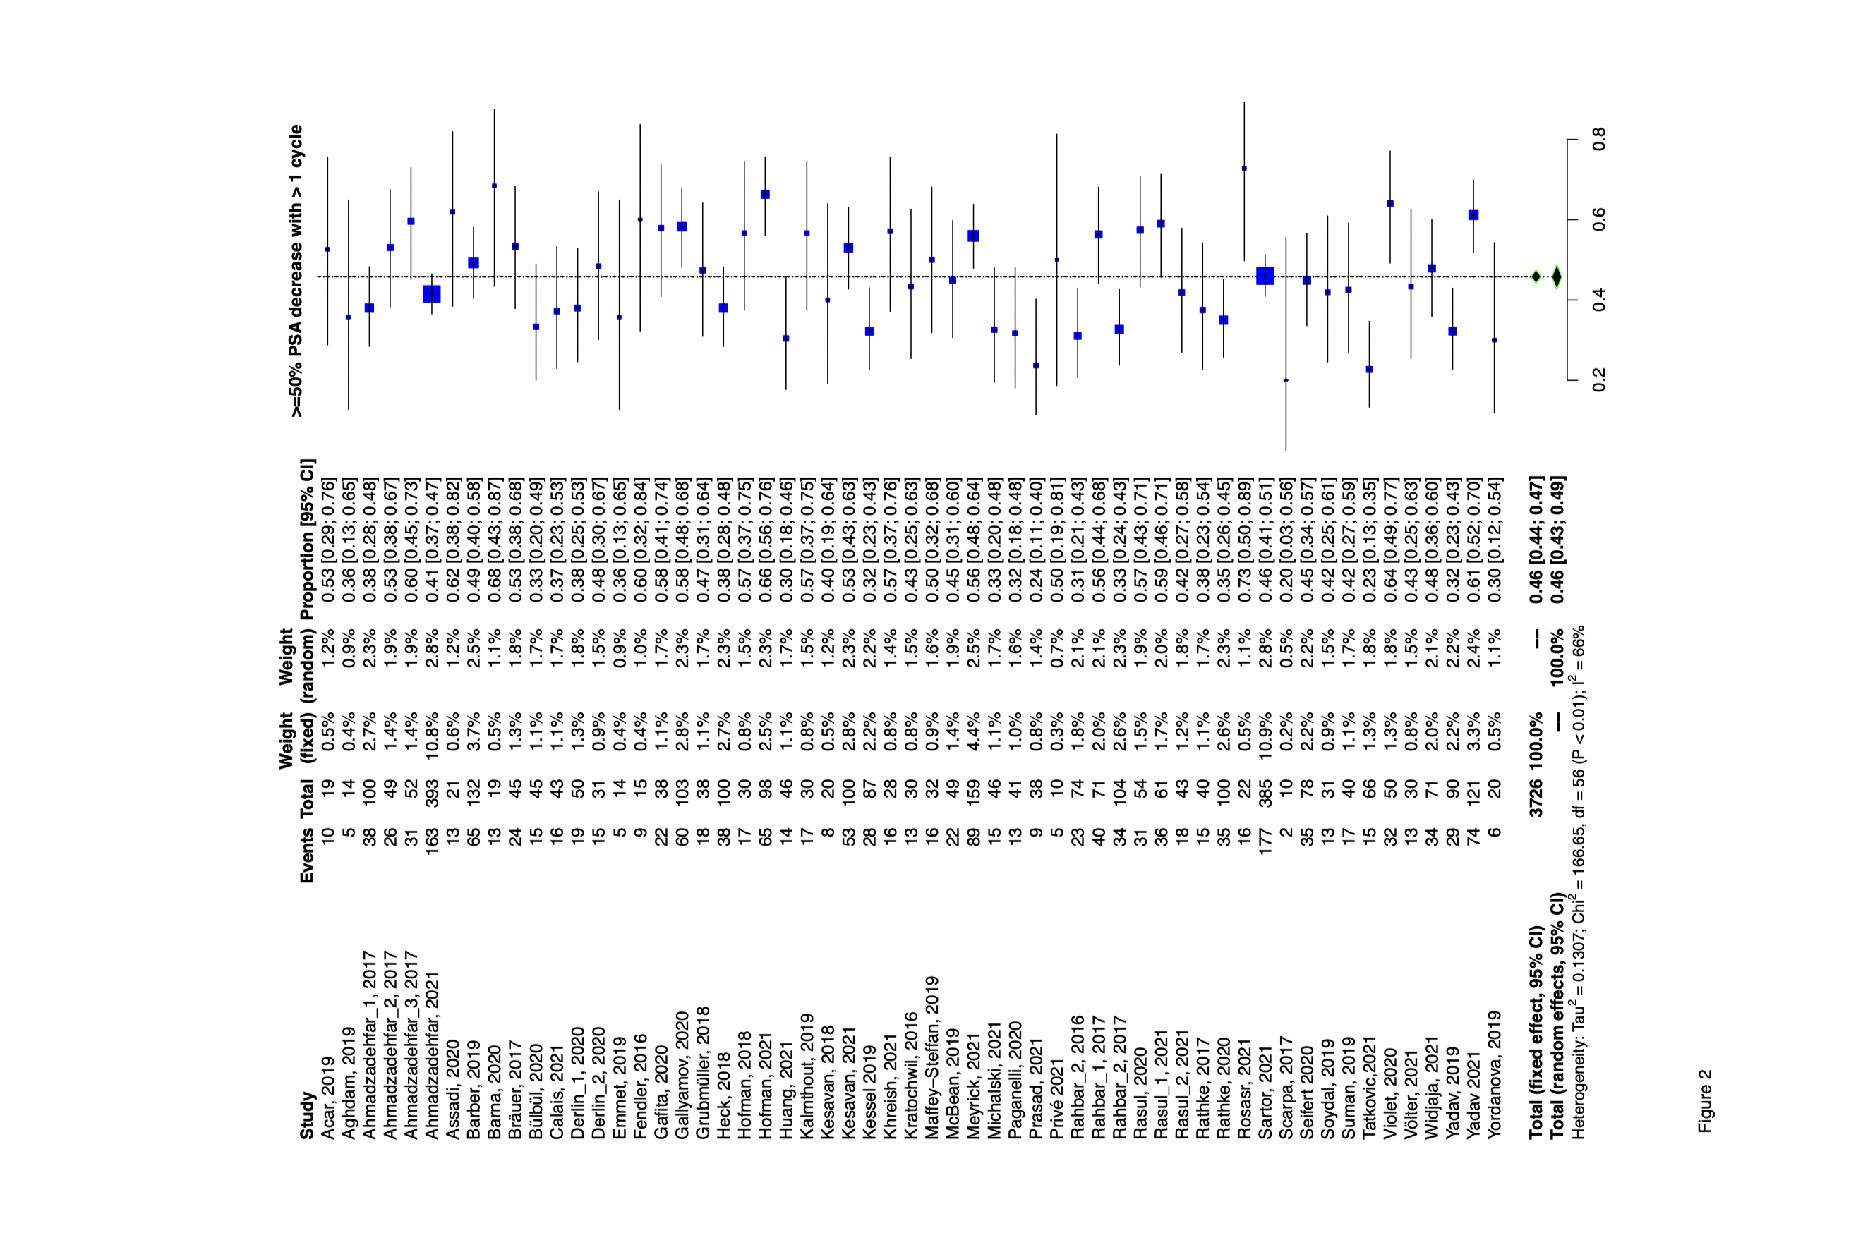

Supplemental Figure 2. Forest plot demonstrating the proportions of patients showing ≥50% PSA decrease after more than one cycle therapy with ¹⁷⁷Lu-PSMA-I&T or ¹⁷⁷Lu-PSMA-617

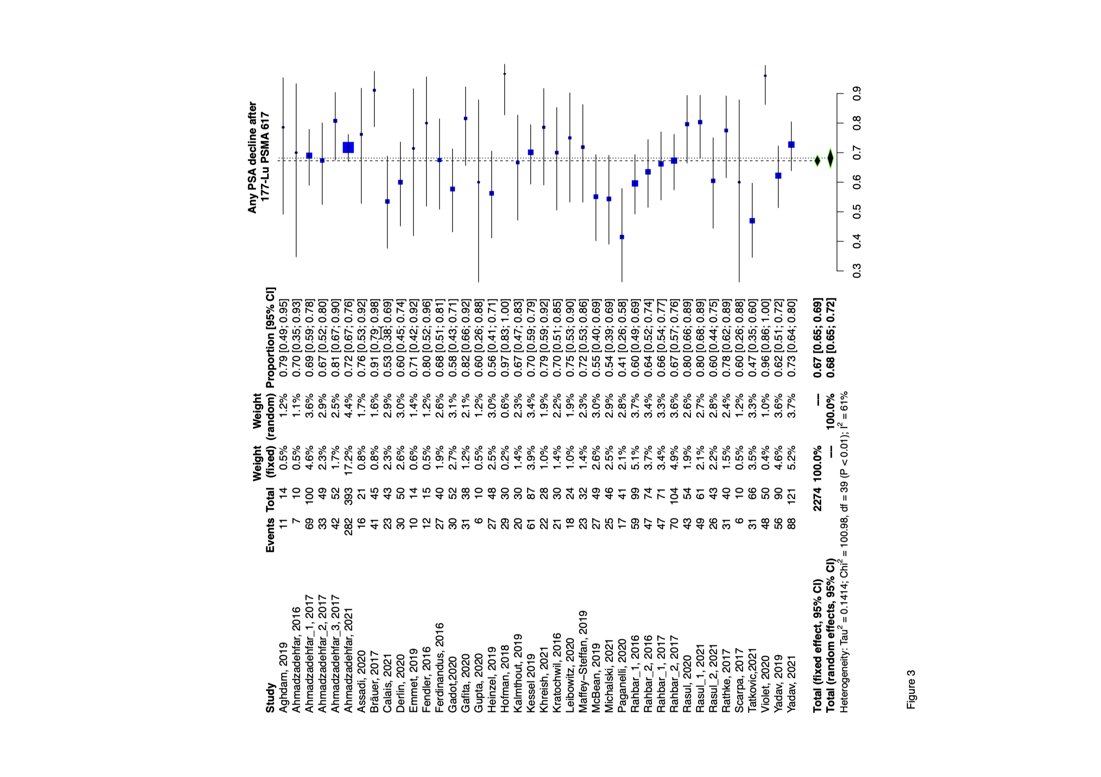
Supplemental Figure 3. Forest plot demonstrating the proportions of patients showing ≥50% PSA decrease after more than cycle of ¹⁷⁷Lu-PSMA-617 therapy.

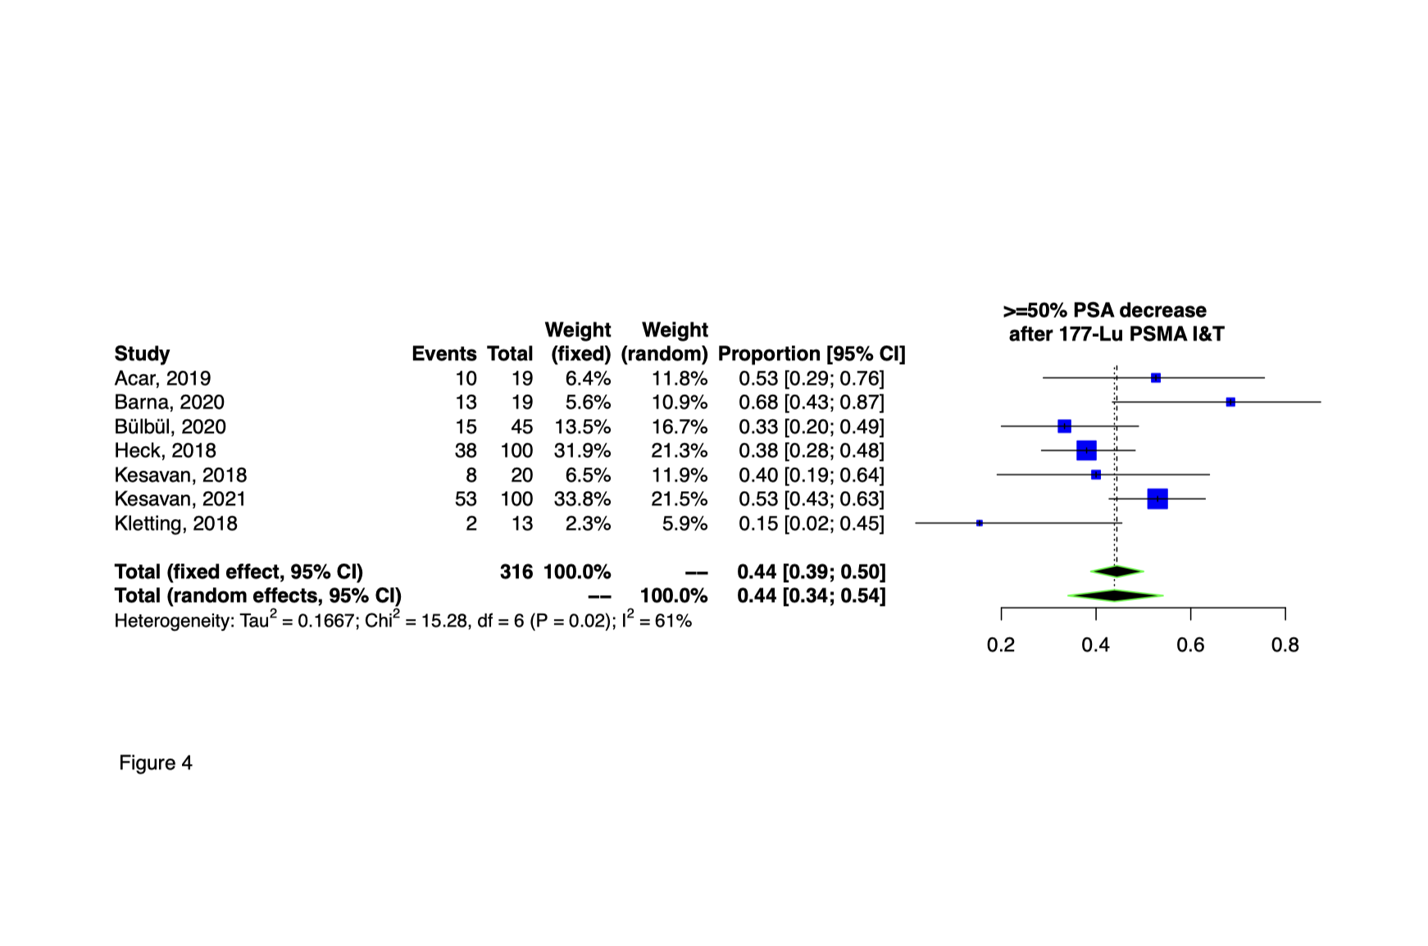
Supplemental Figure 4. Forest plot demonstrating the proportions of patients showing ≥50% PSA decrease after ¹⁷⁷Lu-PSMA-I&T

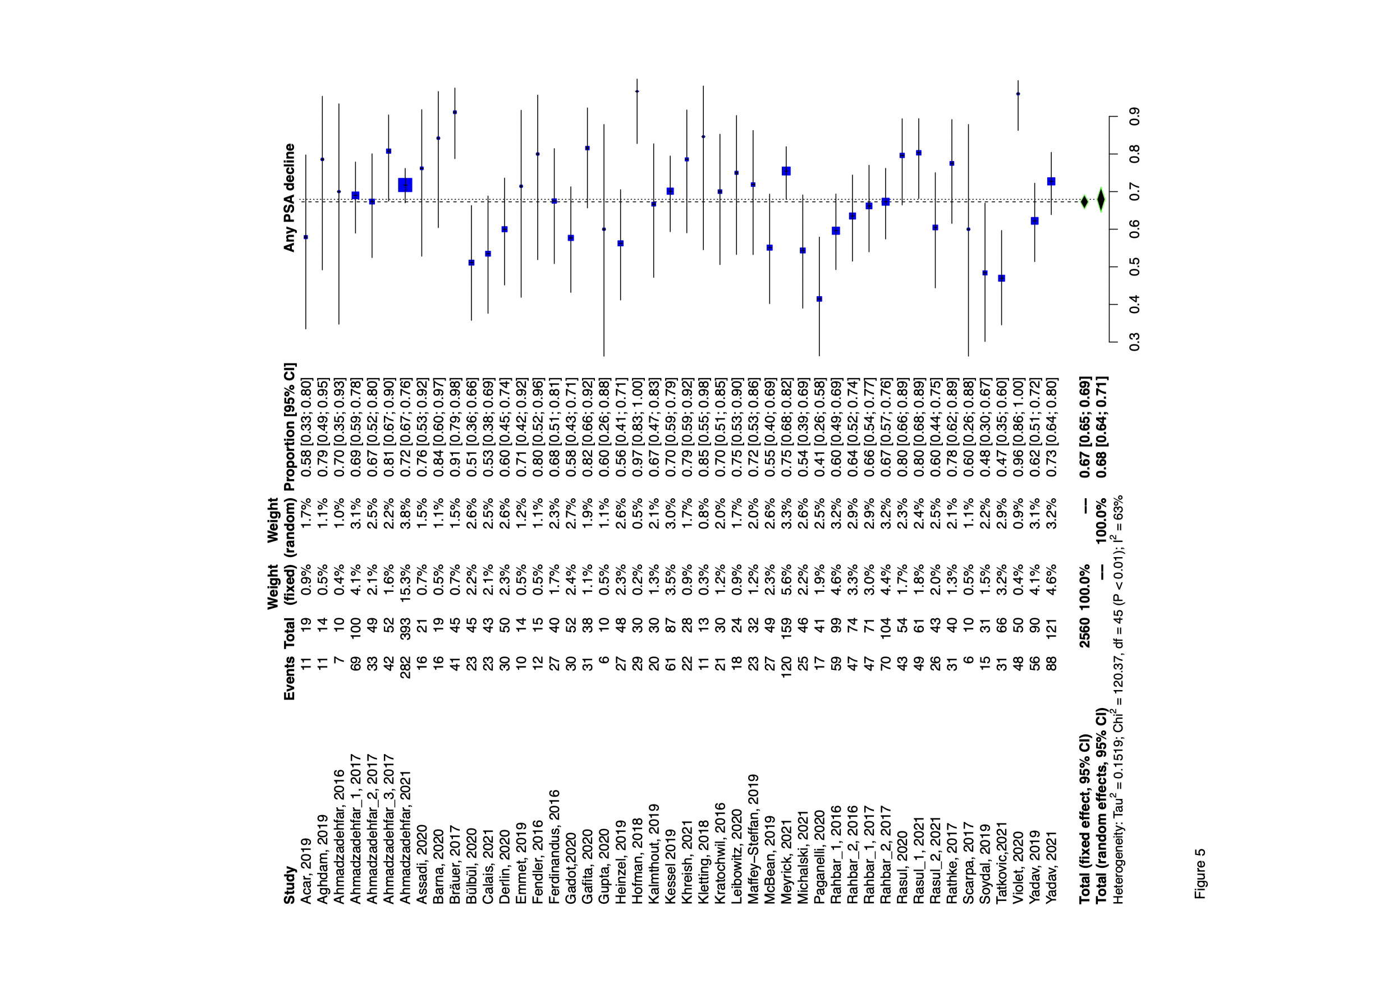
Supplemental Figure 5. Forest plot demonstrating the proportions of patients showing any decline after ¹⁷⁷Lu-PSMA-I&T or ¹⁷⁷Lu-PSMA-617

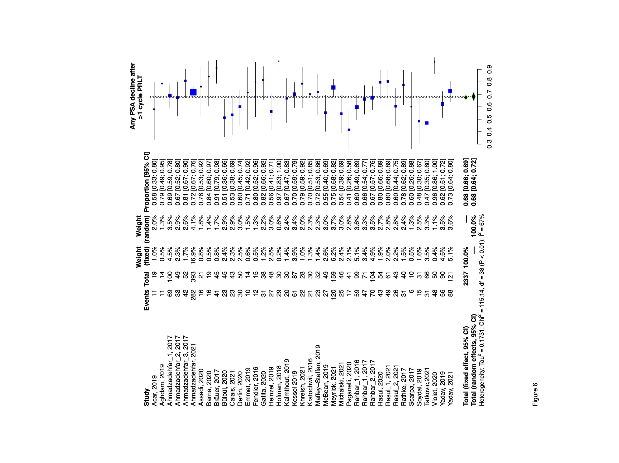

Supplemental Figure 6. Forest plot demonstrating the proportions of patients showing any decline after more than one cycle therapy ¹⁷⁷Lu-PSMA-I&T or ¹⁷⁷Lu-PSMA-617

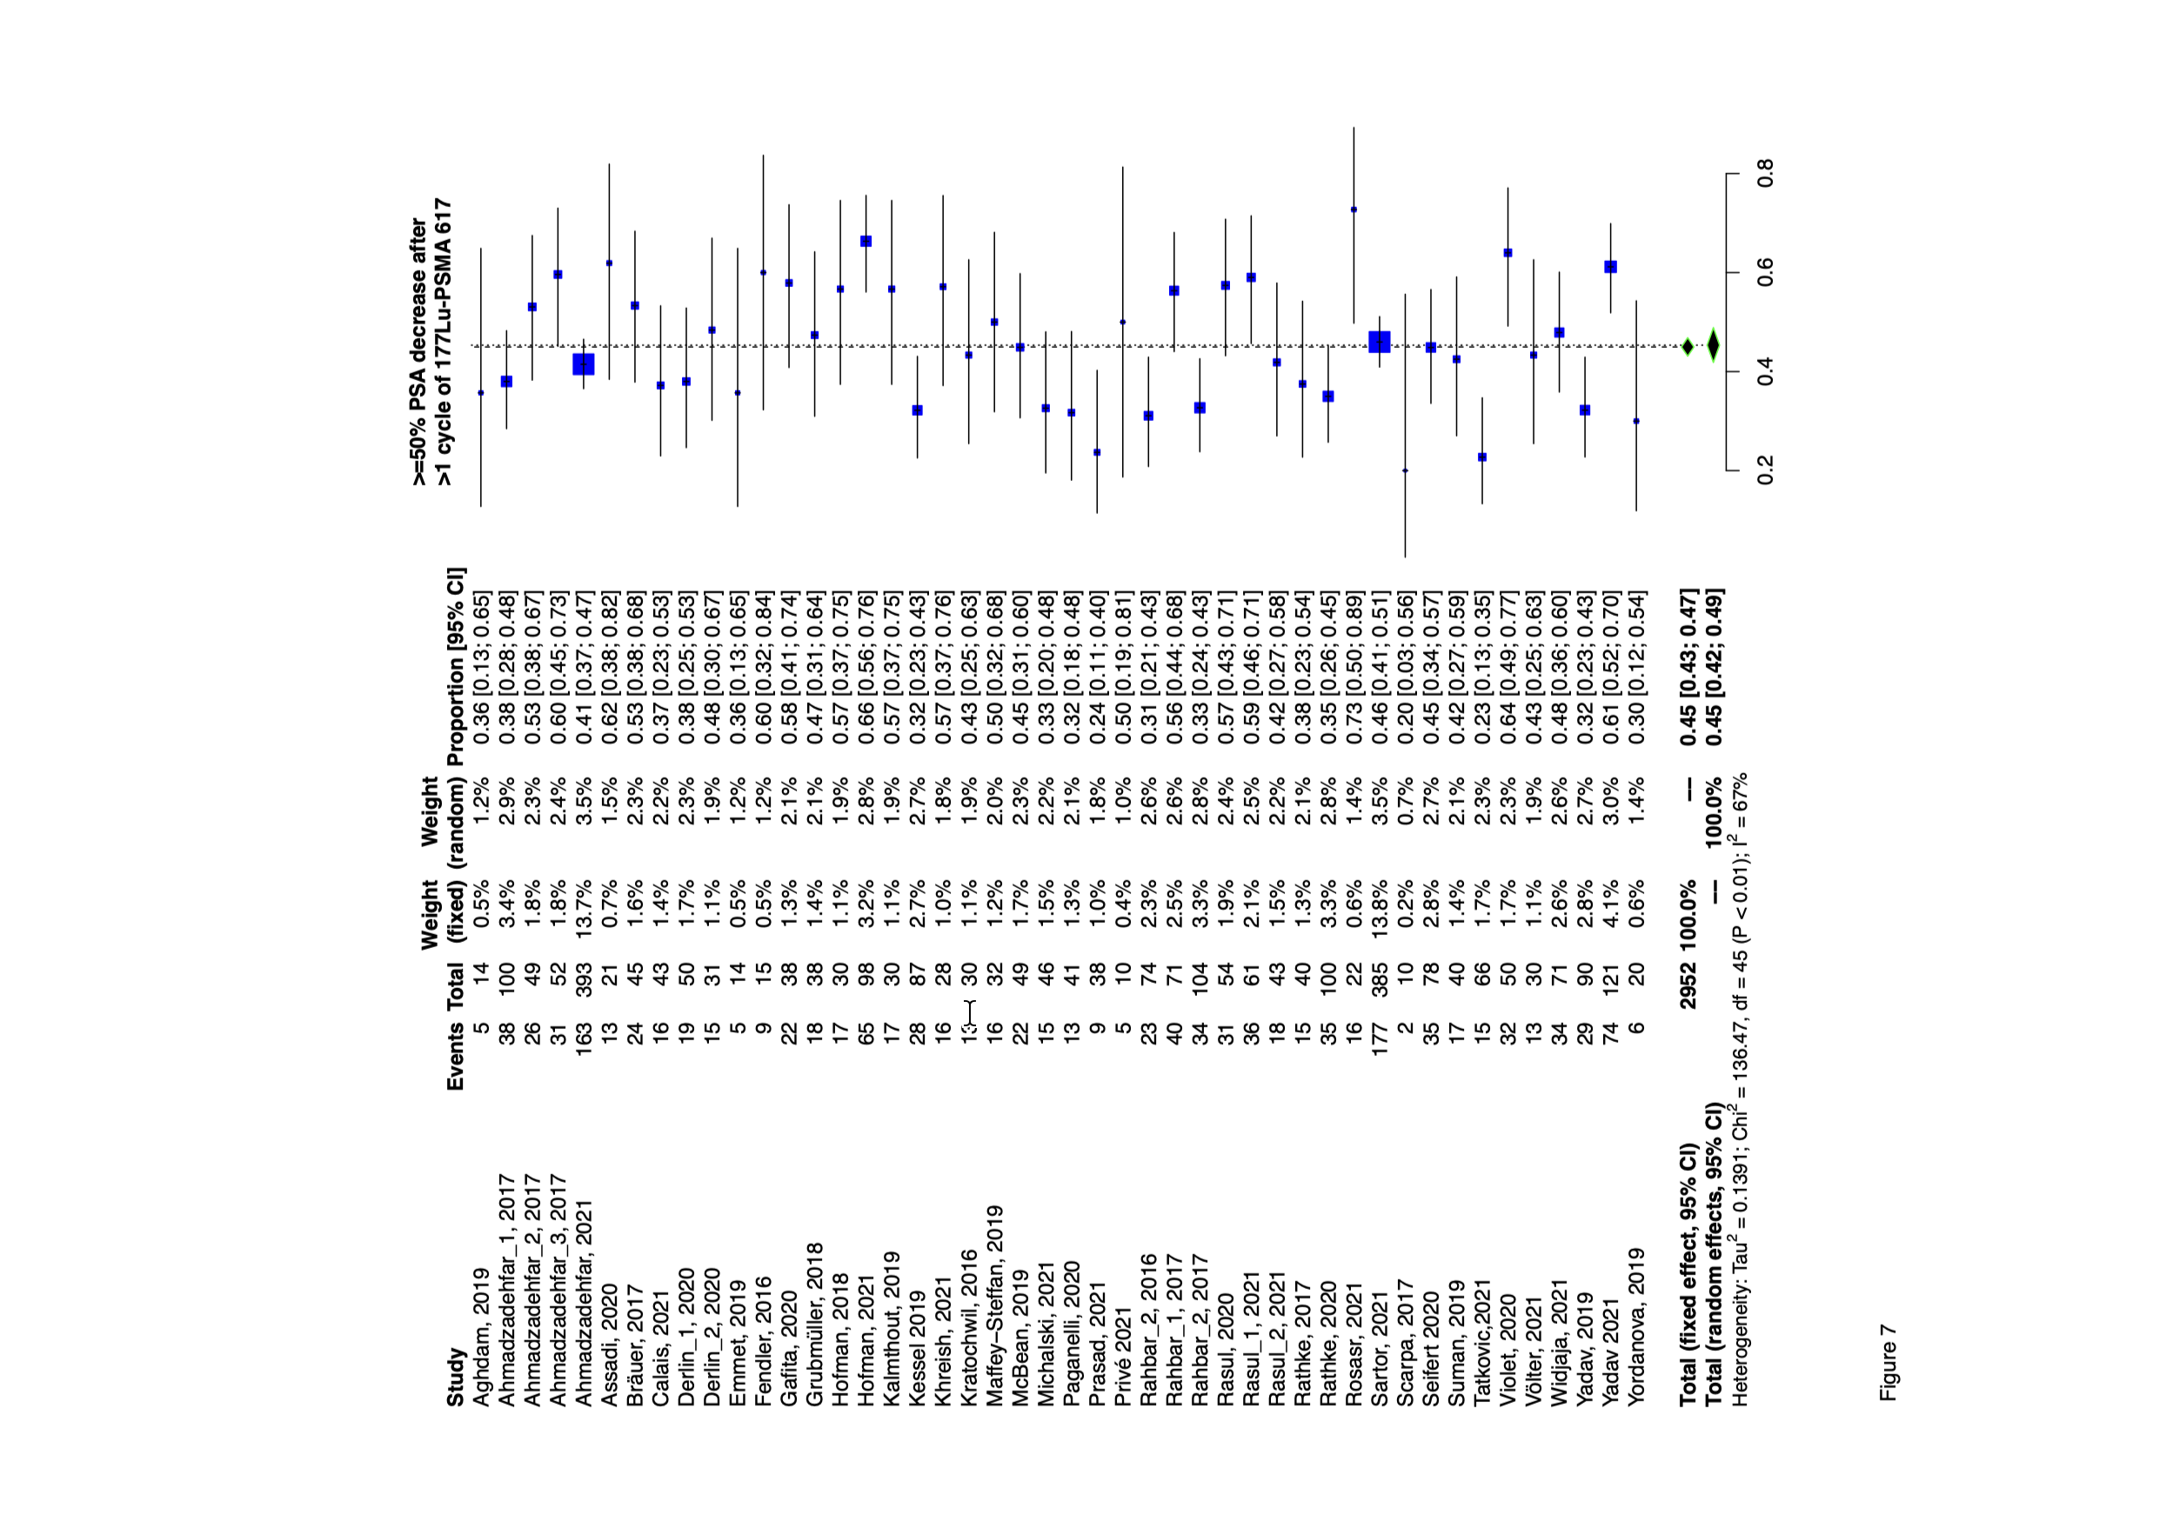
Supplemental Figure 7. Forest plot demonstrating the proportions of patients showing any PSA decrease after ¹⁷⁷Lu-PSMA-617

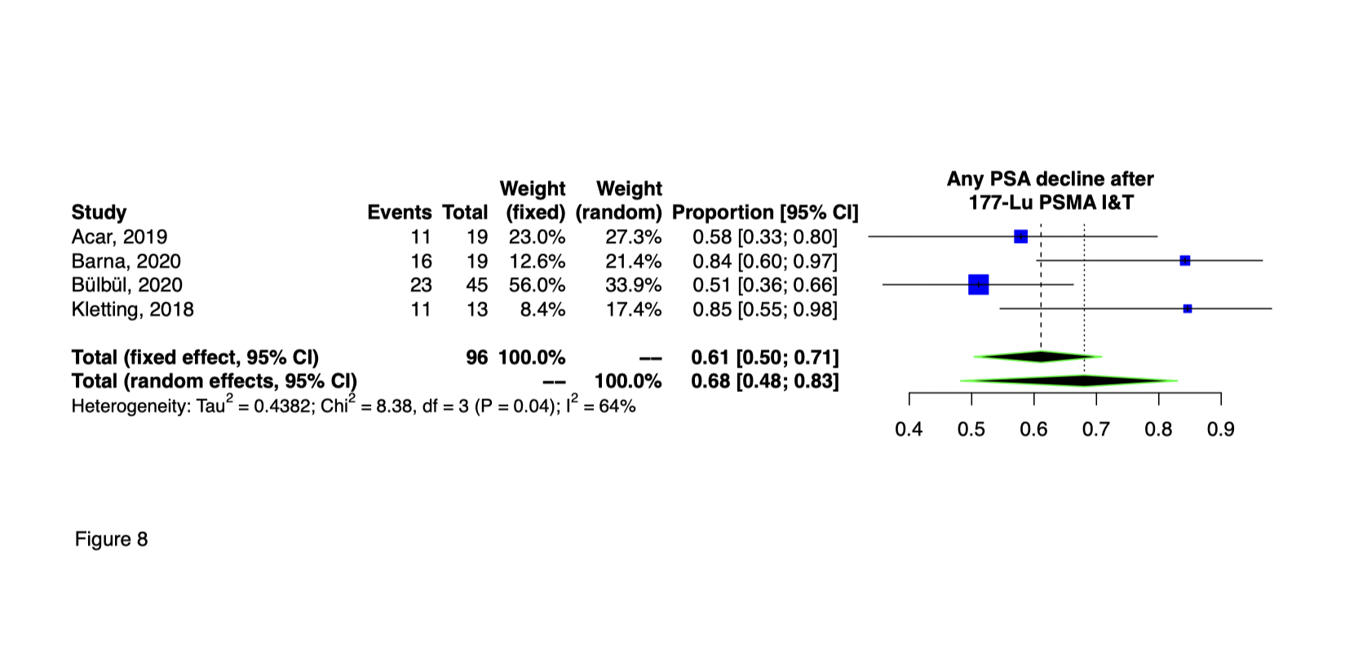
Supplemental Figure 8. Forest plot demonstrating the proportions of patients showing any PSA decrease after ¹⁷⁷Lu-PSMA-I&T

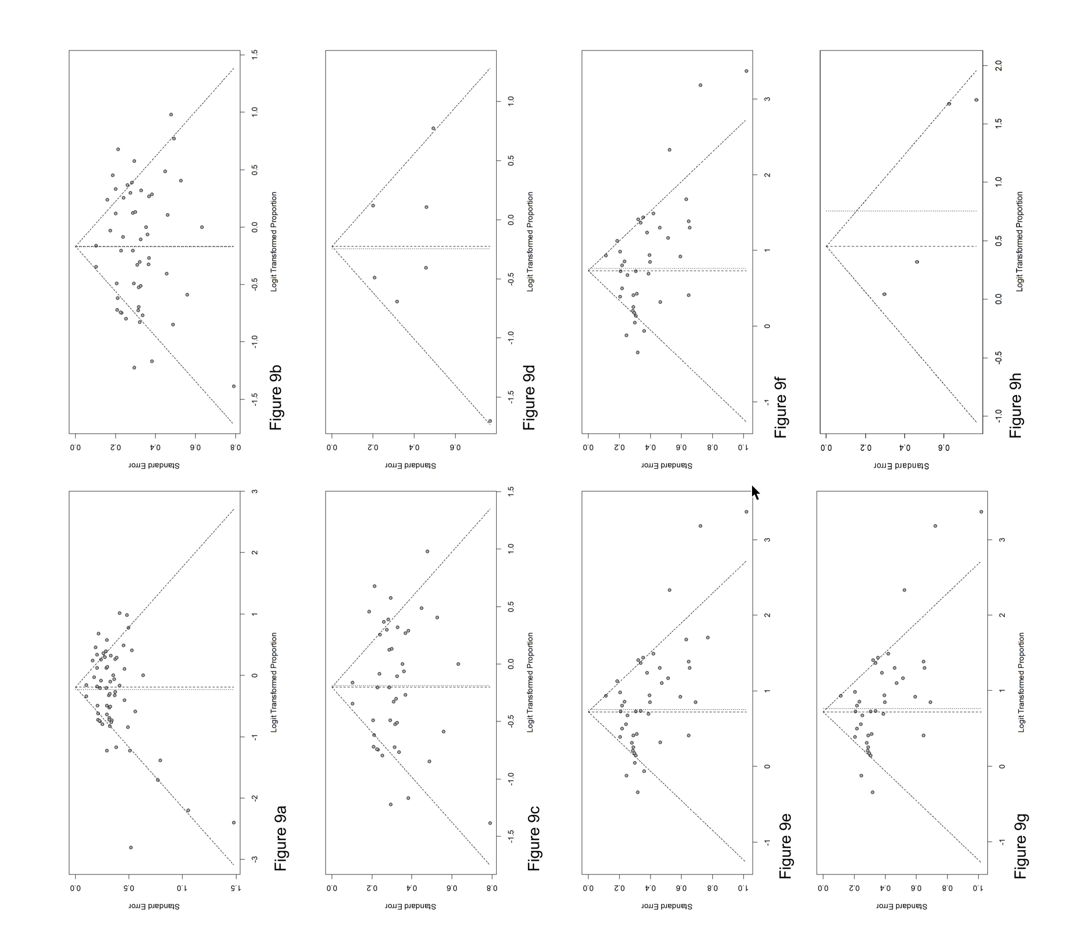

Supplemental Figure 9 Funnel plot demonstrating the risk of bias in proportion of patients with ≥ 50% PSA reduction after ¹⁷⁷Lu-PSMA I&T or 617 (Figure 9a). Funnel plot demonstrating the risk of bias in proportion of patients with 50%PSA reduction after more than one cycle of ¹⁷⁷Lu-PSMA-I&T or 617 (Figure 9b). Funnel plot demonstrating the risk of bias in proportion of patients with ≥50%PSA reduction after more than one cycle ¹⁷⁷Lu-PSMA- 617 (Figure 9c). Funnel plot demonstrating the risk of bias in proportion of patients with ≥ 50%PSA reduction after ¹⁷⁷Lu-PSMA-I&T (Figure 9d). Funnel plot demonstrating the risk of bias in proportion of patients with any PSA reduction after ¹⁷⁷Lu-PSMA-I&T or 617 (Figure 9e). Funnel plot demonstrating the risk of bias in proportion of patients with any PSA reduction after more than one cycle of ¹⁷⁷Lu-PSMA-I&T or 617 (Figure 9f). Funnel plot demonstrating the risk of bias in proportion of patients with any PSA reduction after ¹⁷⁷Lu-PSMA-617 (Figure 9g). Funnel plot demonstrating the risk of bias in proportion of patients with any PSA reduction after ¹⁷⁷Lu-PSMA-I&T (Figure 9h).

