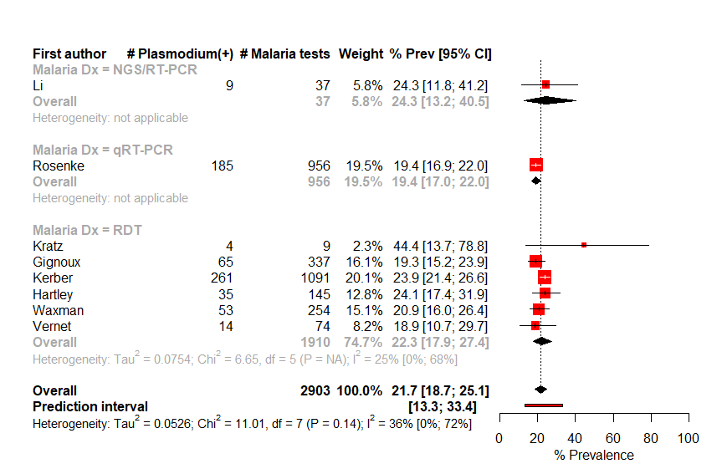
S1 Fig. Prevalence of Plasmodium coinfection among EVD cases by malaria diagnostic.

