Supplement 1. Search Terms Used for All Databases

Search terms | Search strategies
intergeneration program | Inter-generat* OR intergenerat* OR cross-generational OR cross-age OR multi-generation OR multigenerat* OR trans-generation* OR transgenerat* OR age integration
environment | Environment*
dementia | Dementia OR alzheimer* OR cogni* OR alzh*
adolescents | Adolescent* OR child* OR student* OR youth* OR volunteer* OR teens

Supplement 2. Present results of JBI quality across studies
RCT Studies | Was true randomization used for assignment of participants to treatment groups? | Was allocation to treatment groups concealed? | Were treatment groups similar at the baseline? | Were participants blind to treatment assignment? | Were those delivering treatment blind to treatment assignment? | Were outcomes assessors blind to treatment assignment? | Were treatments groups treated identically other than the intervention of interest? | Was follow-up complete, and if not, were strategies to address incomplete follow-up utilized? | Were participants analysed in the groups to which they were randomized? | Were outcomes measured in the same way for treatment groups? | Were outcomes measured in a reliable way?
Lee 2007 |  | unclear |  |  | unclear |  |  | low risk |  |  | 
Low 2015 |  |  |  |  |  |  |  |  |  |  | 
George 2011 |  |  |  |  |  |  |  |  |  |  | 
Prospective retrospective Studies | Is it clear in the study what is the ‘cause’ and what is the ‘effect’ (i.e. there is no confusion about which variable comes first)? | Were the participants included in any comparisons similar? | Were the participants included in any comparisons receiving similar treatment/care, other than the exposure or intervention of interest? | Was there a control group? | Were there multiple measurements of the outcome both pre and post the intervention/exposure? | Was follow-up complete, and if not, was follow-up adequately reported and strategies to deal with loss to follow-up employed? | Were the outcomes of participants included in any comparisons measured in the same way? | Were outcomes measured in a reliable way | Was appropriate statistical analysis used?
Ward 1996 |  |  |  |  | unclear | low risk |  |  | 
Newma 1993 |  |  |  |  |  | low risk |  |  | 
Sauer 2014 |  |  |  |  | unclear | low risk |  |  | 
Jarrott 2007 |  |  | unclear | unclear | unclear | low risk |  | unclear | 
Jarrott 2003 |  |  |  |  | unclear | low risk |  |  | 
Cohort Studies | Were the groups similar and recruited from the same population? | Were the exposures measured similarly to assign people | Was the exposure measured in a valid and reliable way? | Were confounding factors identified? | Were strategies to deal with confounding factors stated? | Were the groups/participants free of the outcome at the start of the study (or at the moment of exposure)? | Were the outcomes measured in a valid and reliable way? | Was the follow up time reported and sufficient to belong enough for outcomes to occur? | Was follow-up complete, and if not, were the reasons to loss to follow-up described and explored? | Were strategies to address incomplete follow up utilized? | Was appropriate statistical analysis used?
Cohort Studies |  | to both exposed and unexposed groups?
Kamei 2011 |  |  |  |  | unclear |  |  |  | low risk | low risk | 
Skropeta 2014 |  |  |  | unclear | unclear |  |  |  | low risk | low risk | 
Xaverius 2004 |  |  |  | unclear | unclear |  |  |  | low risk | low risk | 
Camp 1997 |  |  |  | unclear | unclear | unclear |  |  | low risk | low risk | 
Qualitative Studies | Is there congruity between the stated philosophical | Is there congruity between the research methodology | Is there congruity between the research methodology | Is there congruity between the research methodology | Is there congruity between the research methodology | Is there a statement locating the researcher culturally | Is the influence of the researcher on the research, and | Are participants, and their voices, adequately | Is the research ethical according to current criteria or, | Do the conclusions drawn in the research report flow
Qualitative Studies | perspective and the research methodology? | and the research question or objectives? | and the methods used to collect data? | and the representation and analysis of data? | and the interpretation of results? | or theoretically? | vice- versa, addressed? | represented? | for recent studies, and is there evidence of ethical | from the analysis, or interpretation, of the data?
Qualitative Studies |  |  |  |  |  |  |  |  | approval by an appropriate body?
Lokon 2012 |  |  |  |  |  |  | unclear |  |  | 

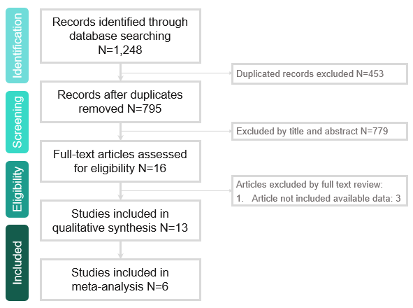
Supplement 3. Flowchart of search results and article retrieval
The electronic database searches found a total of 1,248 records, and of this total number 16 full texts were retrieved for detailed examination. A total of 13 articles were included in the final review and 6 articles included in meta-analysis. The main reasons were that the studies not meet inclusion criteria.

