Figure S1. Data origin

Information obtained from the article
Information obtained from the authors
Information not available

Figure S2. Survival at day 28 according to the number of participating centers
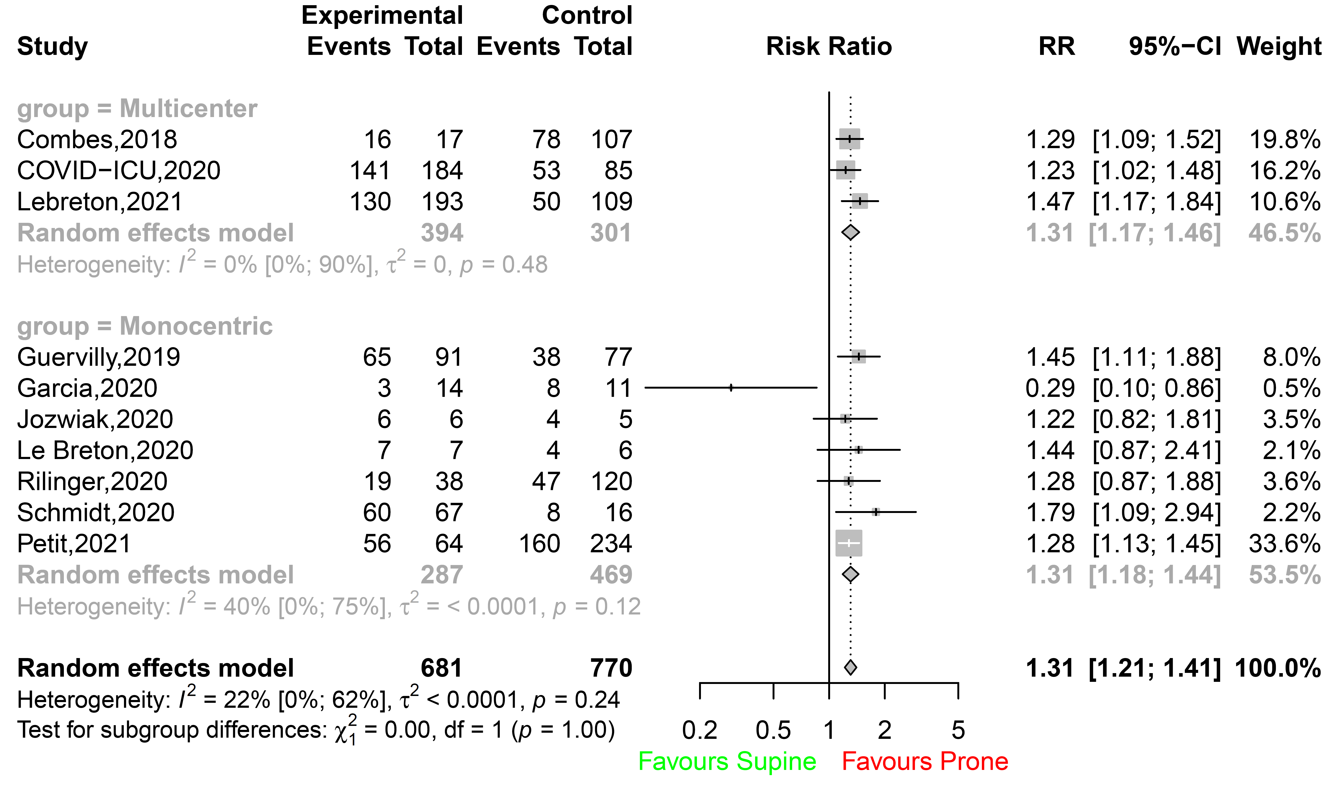
Figure S3. Survival at day 28 according to the study design
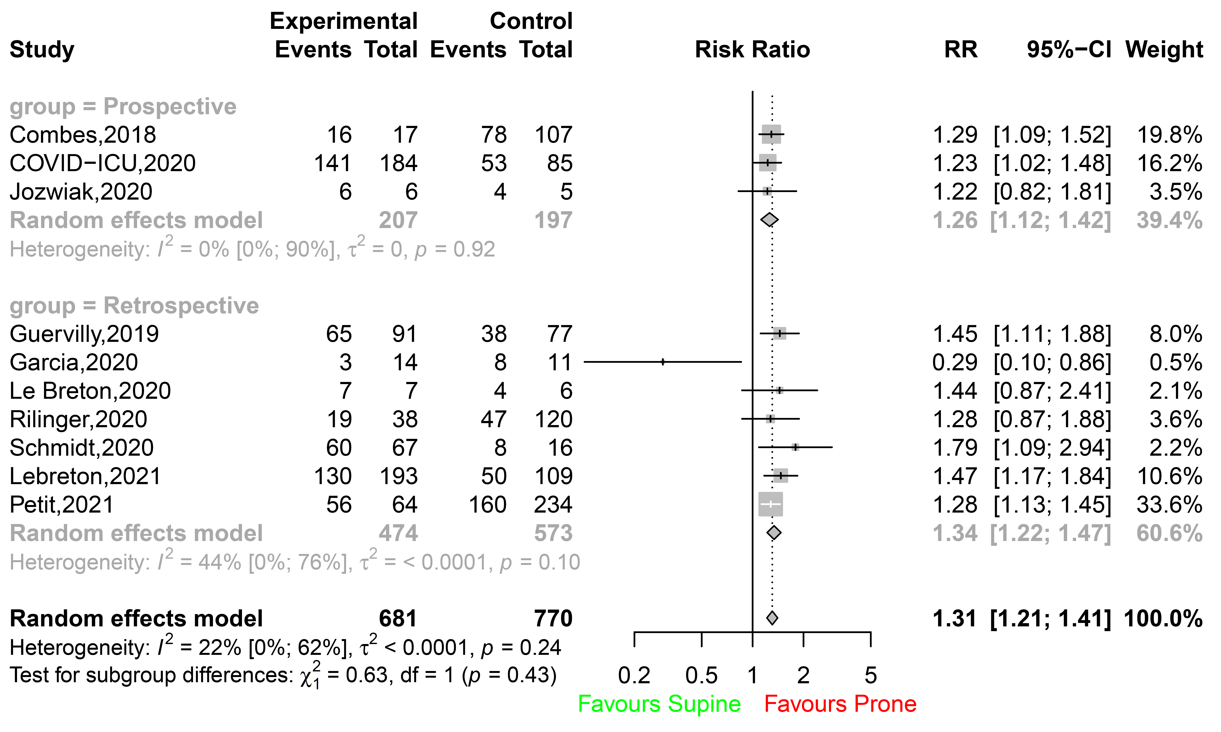
Figure S4. Survival at day 60

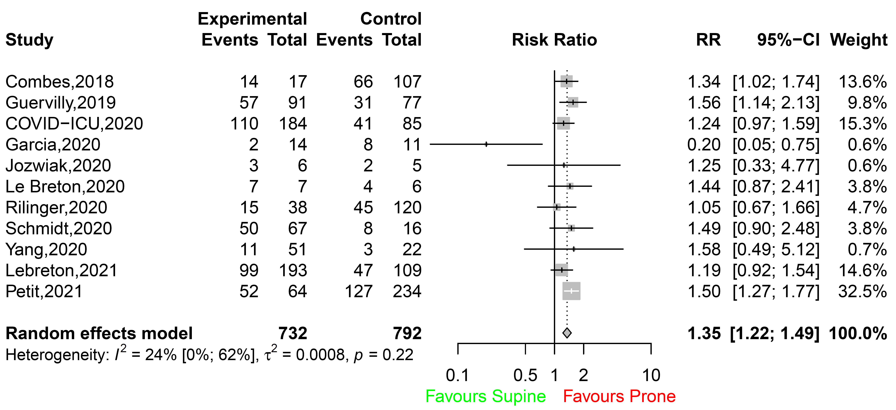

Figure S5. Survival at day 90

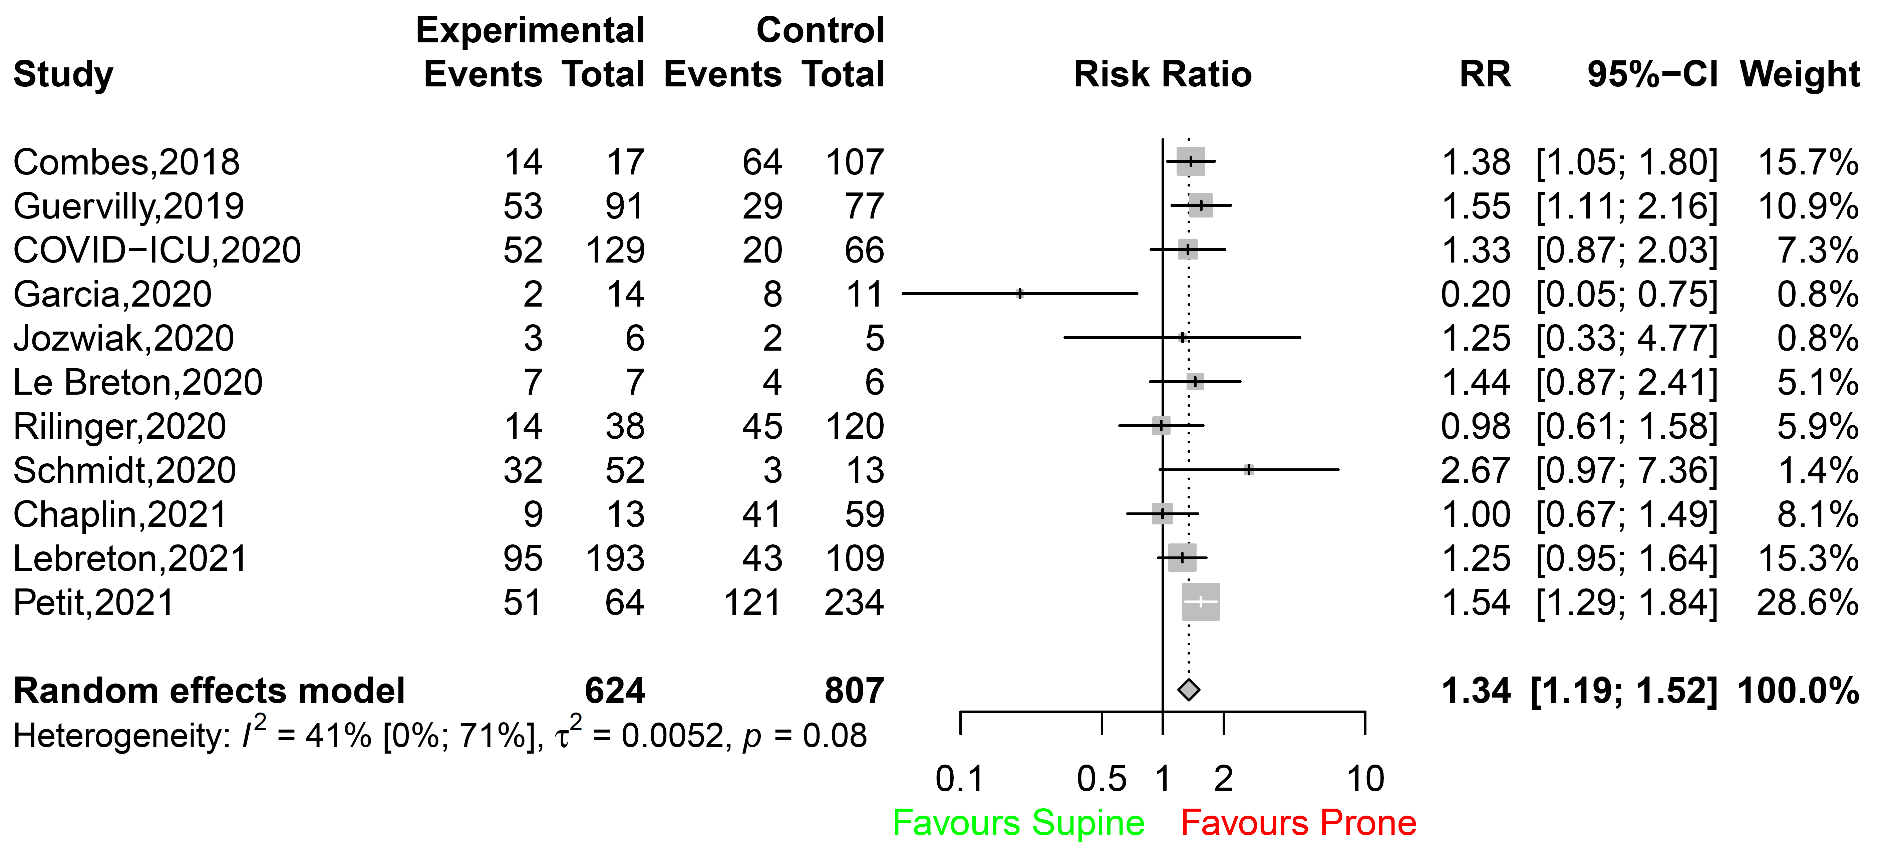

Figure S6. ICU survival

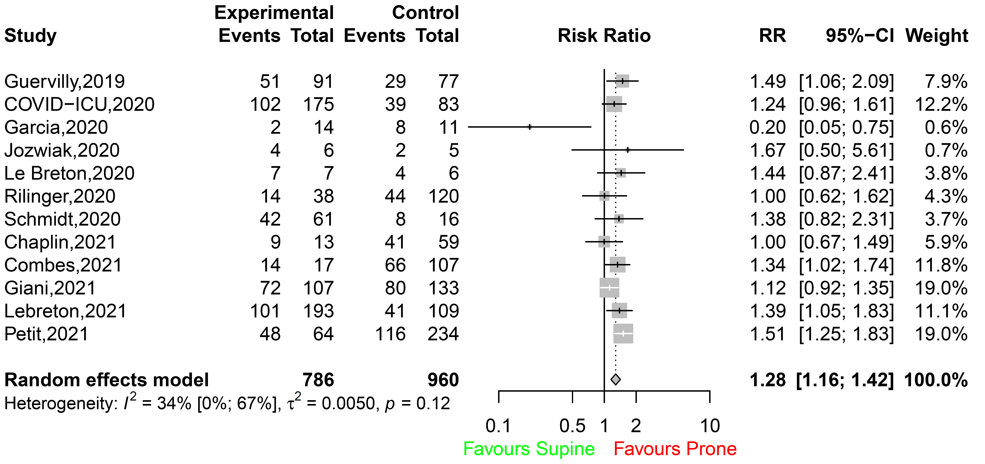

Figure S7. Duration of mechanical ventilation

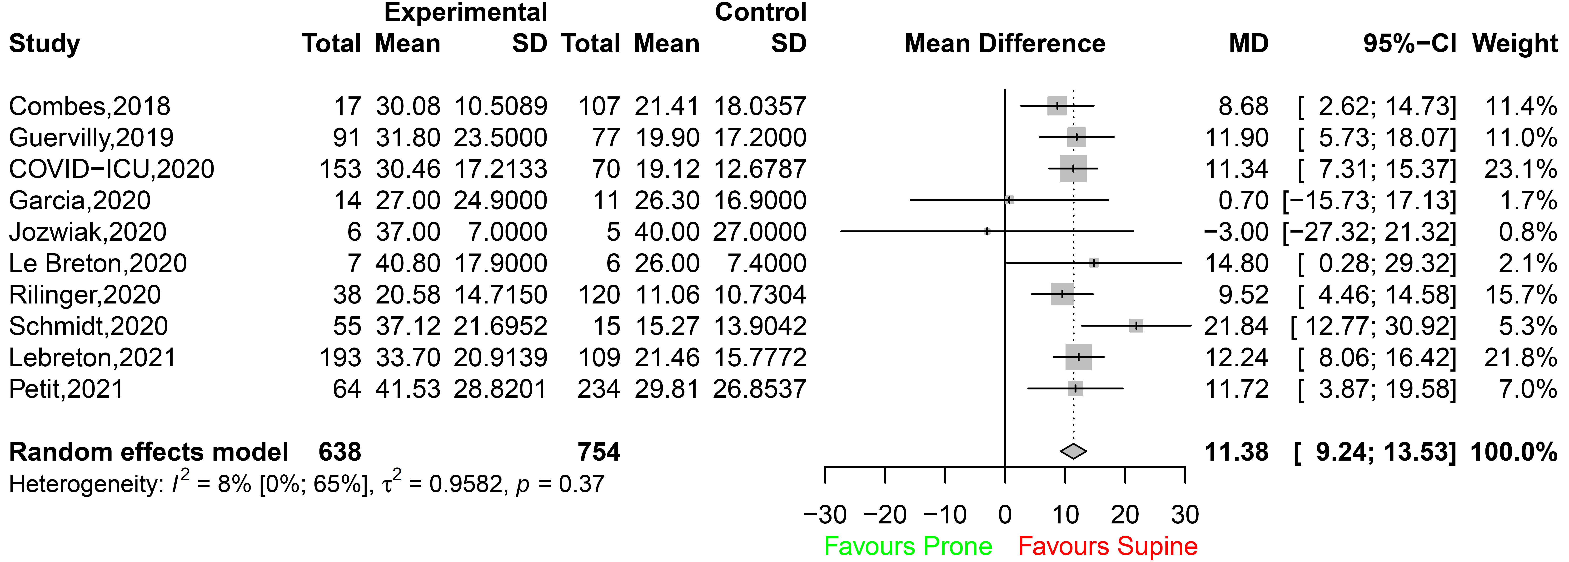

Figure S8. Ventilator-free days to day 28

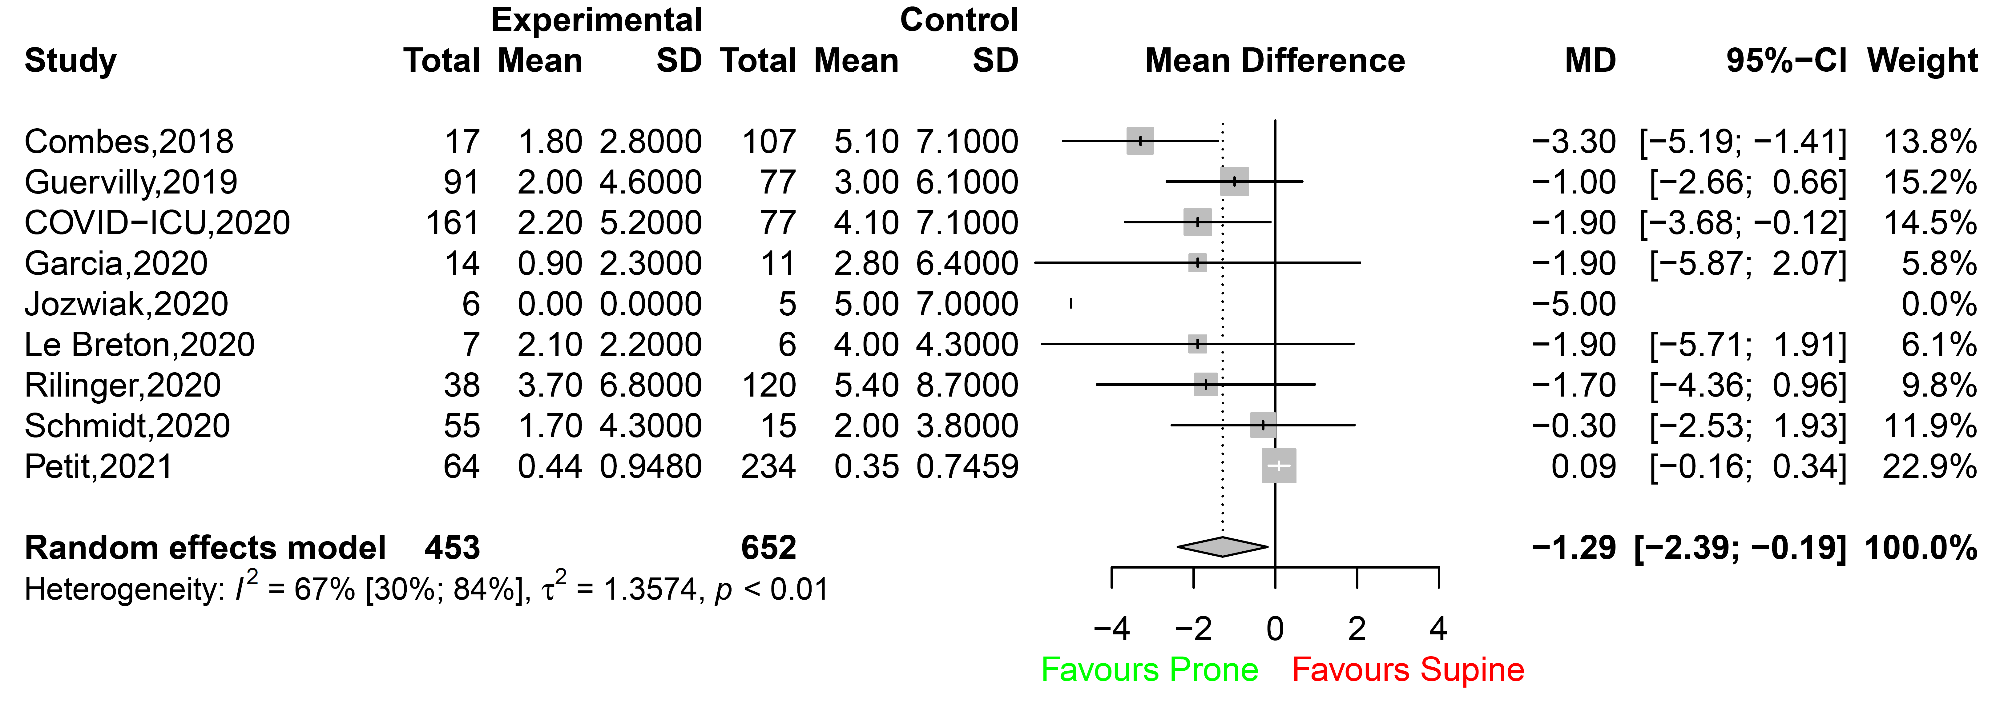

Figure S9. Funnel plots

Mortality D28
Mortality D60
Mortality D90
ICU mortality

Ventilator-free days to day28
Duration of mechanical ventilation
Hospital mortality

Figure S10. Forest plot of the results of the leave-one-out sensitivity analysis (survival at day 28)

