Supplementary Material

The search strategy used for PubMed:
Query | Results
(((Postoperative Cognitive Dysfunctions[MeSH Terms]) OR (((((((((((((((((Postoperative Cognitive Dysfunctions)) OR (Cognitive Complication, Postoperative)) OR (Cognitive Complications, Postoperative)) OR (Complication, Postoperative Cognitive)) OR (Complications, Postoperative Cognitive)) OR (Postoperative Cognitive Complication)) OR (Postoperative Cognitive Dysfunction)) OR (Cognitive Dysfunction, Postoperative)) OR (Cognitive Dysfunctions, Postoperative)) OR (Dysfunction, Postoperative Cognitive)) OR (Dysfunctions, Postoperative Cognitive)) OR (Postoperative Cognitive Dysfunctions)) OR (Postoperative Decline)) OR (Decline, Postoperative)) OR (Declines, Postoperative)) OR (Postoperative Declines))) AND (randomized controlled trial[Publication Type] OR randomized[Title/Abstract] OR placebo[Title/Abstract])) AND ((Electroacupuncture[MeSH Terms]) OR (Electroacupuncture)) | 6
The search strategy used for EMBASE:
#1 'postoperative cognitive dysfunction'/exp 1285
#2 'cognitive complication, postoperative' OR 'cognitive complications, postoperative' OR 'complication, postoperative cognitive' OR 'complications, postoperative cognitive' OR 'postoperative cognitive complication' OR 'postoperative cognitive dysfunction' OR 'cognitive dysfunction, postoperative' OR 'cognitive dysfunctions, postoperative' OR 'dysfunction, postoperative cognitive' OR 'dysfunctions, postoperative cognitive' OR 'postoperative cognitive dysfunctions' OR 'postoperative decline' OR 'decline, postoperative' OR 'declines, postoperative' OR 'postoperative declines' 2294
#3 'electroacupuncture'/exp 6942
#4 ' electroacupuncture' 8144
#5 #1 OR #2 2294
#6 #3 OR #4 8144
#7 'randomized controlled trial'/exp OR 'controlled clinical trial'/exp OR 'randomized':ti,ab OR 'placebo':ti,ab OR 'drug therapy':lnk OR 'randomly':ti,ab OR 'trial':ti,ab OR 'groups':ti,ab
7576398
#8 #5 AND #6 AND #7 8
The search strategy used for CINAHL:
#1 MeSH descriptor: [Postoperative Cognitive Complications] explode all trees 13
#2 (((((((((((((((((Postoperative Cognitive Dysfunctions)) OR (Cognitive Complication, Postoperative)) OR (Cognitive Complications, Postoperative)) OR (Complication, Postoperative Cognitive)) OR (Complications, Postoperative Cognitive)) OR (Postoperative Cognitive Complication)) OR (Postoperative Cognitive Dysfunction)) OR (Cognitive Dysfunction, Postoperative)) OR (Cognitive Dysfunctions, Postoperative)) OR (Dysfunction, Postoperative Cognitive)) OR (Dysfunctions, Postoperative Cognitive)) OR (Postoperative Cognitive Dysfunctions)) OR (Postoperative Decline)) OR (Decline, Postoperative)) OR (Declines, Postoperative)) OR (Postoperative Declines)):ti,ab,kw (Word variations have been searched) 2516
#3 MeSH descriptor: [Electroacupuncture] explode all trees 802
#4 (Electroacupuncture):ti,ab,kw (Word variations have been searched) 2505
#5 #1 OR #2 2516
#6 #3 OR #4 2505
#7 #5 AND #6 15

The search strategy used for CNKI:
(SU%电针 OR SU%针刺 OR SU%针) AND (SU%术后 AND SU%认知) 79

The search strategy used for Wanfang Data:
主题:(电针 OR 针刺) AND 主题:(术后 AND 认知) 441

The search strategy used for VIP
任意字段:(电针 OR 针刺) AND 主题:(术后 AND 认知) 68

The search strategy used for SinoMed (CBM)
"电针"[全部字段:智能] AND "认知"[全部字段:智能] 396

Supplementary Figure 1. The search strategy in this review.
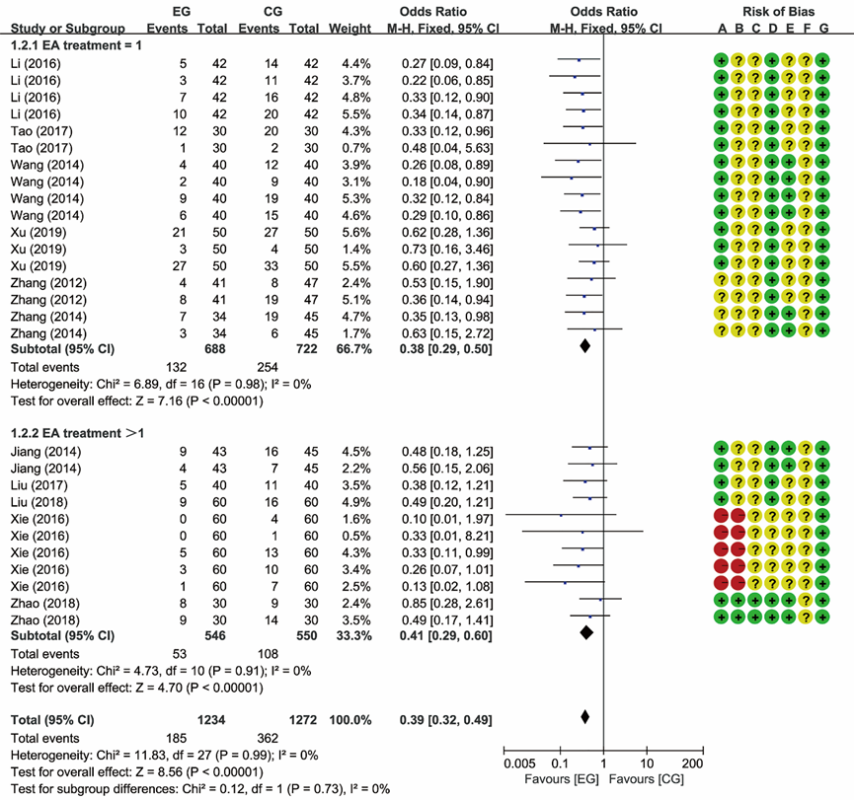
Supplementary Figure 2. Meta-analysis and forest plot and for the incidence of POCD at different treatment courses.
Supplementary Figure 3. Meta-analysis and forest plot and for the incidence of POCD at different anesthesia method.

Supplementary Table 1. Sensitivity analysis for MMSE scores, IL-1β, and TNF-α.
Outcomes | References | Effect size | 95% CI | P | I²
MMSE scores | Xu et al. (2019) | 2.03 | 1.66, 2.41 | < 0.00001 | 87%
MMSE scores | Zhao et al. (2018) | 2.28 | 1.88, 2.67 | = 0.0002 | 82%
MMSE scores | Liu et al. (2017) | 2.42 | 2.04, 2.80 | < 0.00001 | 87%
MMSE scores | Liu et al. (2018) | 2.30 | 1.90, 2.70 | < 0.00001 | 89%
MMSE scores | Xu et al. (2019) | 1.85 | 1.46, 2.23 | = 0.0006 | 80%
MMSE scores | Zhao et al. (2018) | 2.25 | 1.90, 2.61 | < 0.00001 | 89%
IL-1β | Liu et al. (2017) | -16.71 | -26.08, -7.33 | < 0.00001 | 99%
IL-1β | Liu et al. (2018) | -16.43 | -26.16, -6.71 | < 0.00001 | 99%
IL-1β | Zhang et al. (2014) | -16.58 | -25.88, -7.28 | < 0.00001 | 99%
IL-1β | Liu et al. (2017) | -14.23 | -23.66, -4.81 | < 0.00001 | 99%
IL-1β | Liu et al. (2018) | -13.17 | -21.72, -4.62 | < 0.00001 | 99%
IL-1β | Zhang et al. (2014) | -16.93 | -26.12, -7.74 | < 0.00001 | 99%
IL-1β | Zhao et al. (2018) | -14.53 | -24.47, -4.58 | < 0.00001 | 99%
IL-1β | Liu et al. (2017) | -11.89 | -19.95, -3.82 | < 0.00001 | 99%
IL-1β | Zhao et al. (2018) | -13.69 | -22.86, -4.53 | < 0.00001 | 99%
TNF-α | Liu et al. (2017) | -19.97 | -31.04, -8.91 | < 0.00001 | 99%
TNF-α | Liu et al. (2018) | -19.98 | -30.96, -9.00 | < 0.00001 | 99%
TNF-α | Zhang et al. (2014) | -20.54 | -31.18, -9.90 | < 0.00001 | 99%
TNF-α | Liu et al. (2017) | -16.45 | -27.12, -5.78 | < 0.00001 | 100%
TNF-α | Liu et al. (2018) | -15.98 | -26.23, -5.73 | < 0.00001 | 99%
TNF-α | Zhang et al. (2014) | -20.58 | -31.19, -9.97 | < 0.00001 | 99%
TNF-α | Zhao et al. (2018) | -16.98 | -27.97, -6.00 | < 0.00001 | 99%
TNF-α | Liu et al. (2017) | -15.92 | -26.33, -5.50 | < 0.00001 | 99%
TNF-α | Zhao et al. (2018) | -17.05 | -28.05, -6.06 | < 0.00001 | 100%

Supplementary Table 2. Assessment of publication bias.
Outcomes | N | Begg' s test | Egger's test
Incidence of POCD (1 d) | 7 | 0.548 | 0.590
Incidence of POCD (3 d) | 7 | 0.072 | 0.050
Incidence of POCD (7 d) | 8 | 0.711 | 0.425
Incidence of POCD (3 m) | 2 | 1 | NA
Incidence of POCD (6 m) | 2 | 1 | NA
MMSE scores (1 d) | 2 | 1 | NA
MMSE scores (3 d) | 4 | 1 | 0.815
NSE (0 h) | 2 | 1 | NA
NSE (24 h) | 2 | 1 | NA
NSE (48 h) | 2 | 1 | NA
S-100β (0 h) | 4 | 0.089 | 0.065
S-100β (24 h) | 5 | 0.462 | 0.057
S-100β (48 h) | 2 | 1 | NA
S-100 (72 h) | 2 | 1 | NA
IL-1β（0 h） | 3 | 1 | 0.749
IL-1β（24 h） | 4 | 0.734 | 0.998
IL-1β（72 h） | 2 | 1 | NA
TNF-α（0 h） | 3 | 0.296 | 0.26
TNF-α （24 h） | 4 | 1 | 0.868
TNF-α （72 h） | 2 | 1 | NA
N: number of studies; NA: not available.
(Continued)
(Continued)
Supplementary Figure 4. Summary of findings table.

