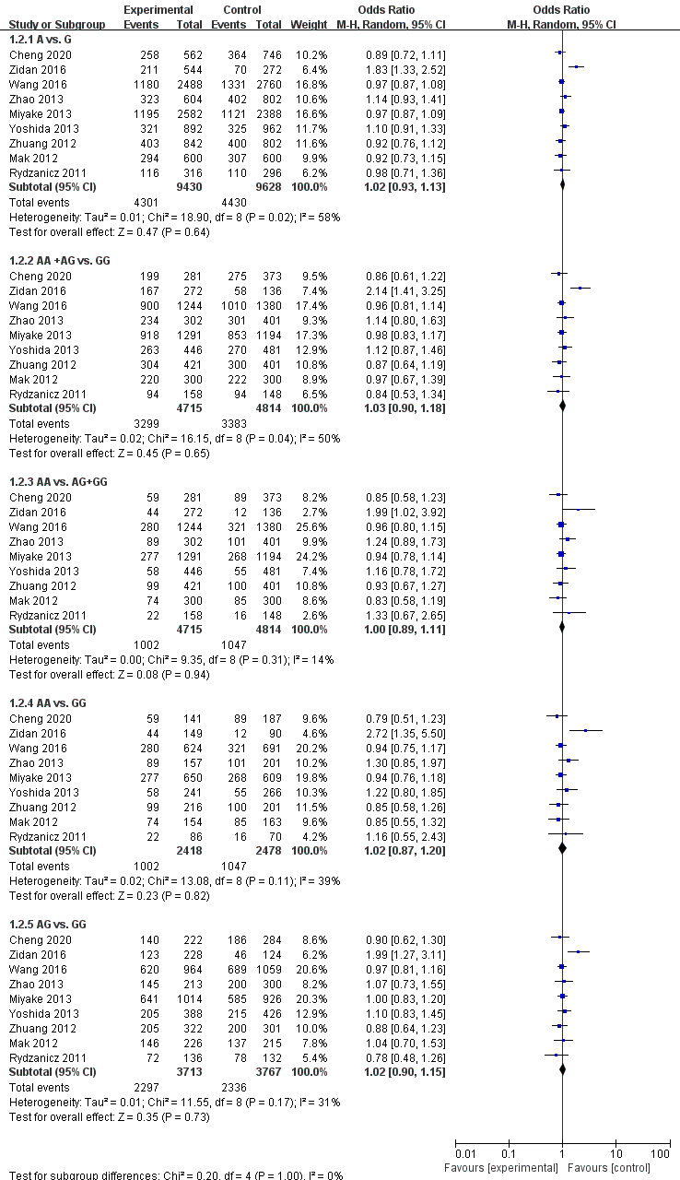
Figure a
Meta-analysis of the association of IGF1 rs6214 with any myopia.
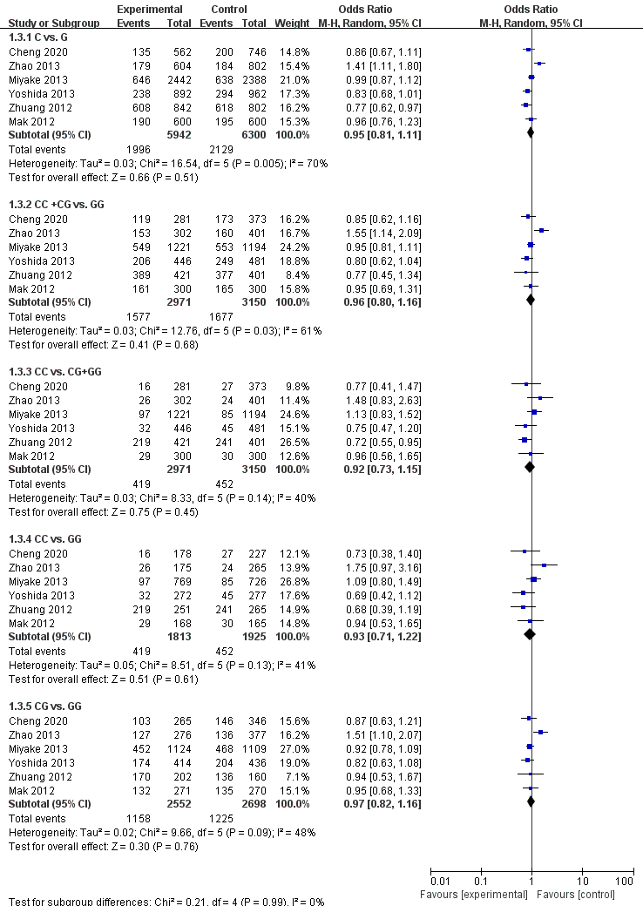
Figure b
Meta-analysis of the association of IGF1 rs12423791 with any myopia.
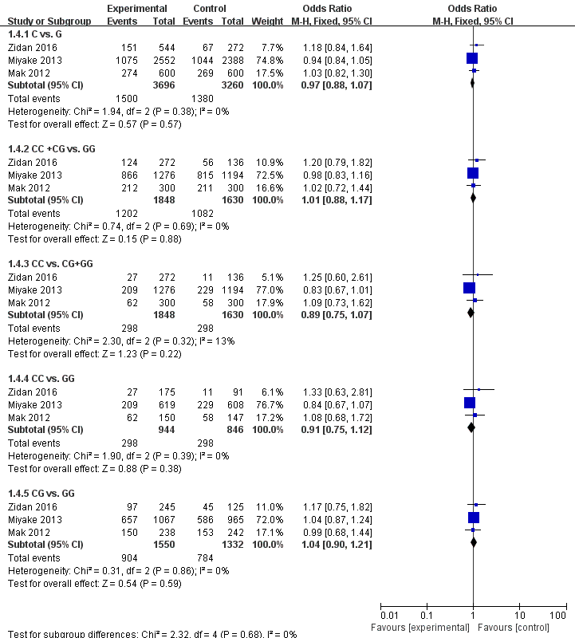

Figure c
Meta-analysis of the association of IGF1 rs5742632 with any myopia.

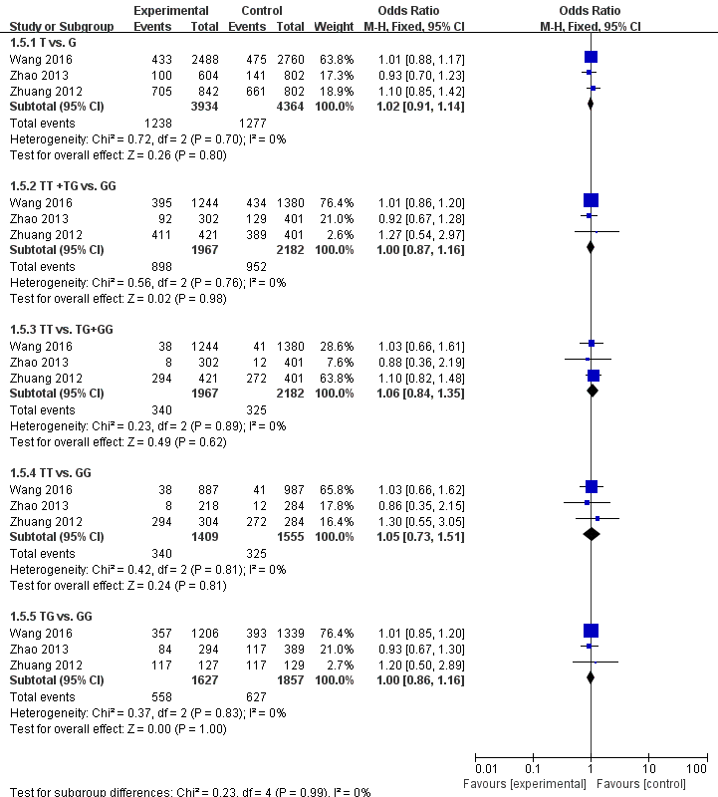

Figure d
Meta-analysis of the association of IGF1 rs10860862 with any myopia.

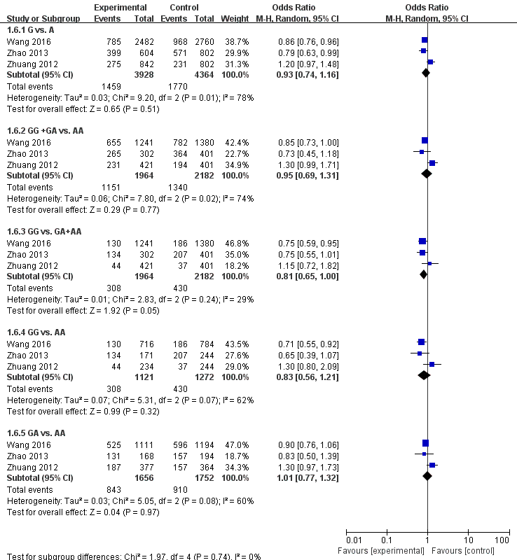

Figure e
Meta-analysis of the association of IGF1 rs35766 with any myopia.

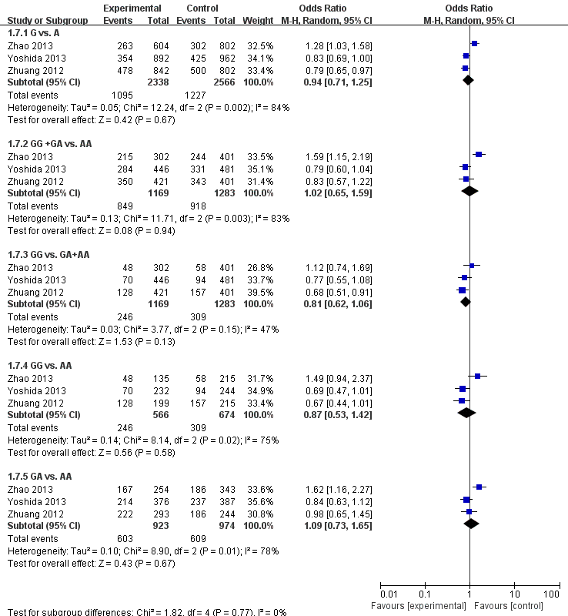

Figure f
Meta-analysis of the association of IGF1 rs5742629 with any myopia.

