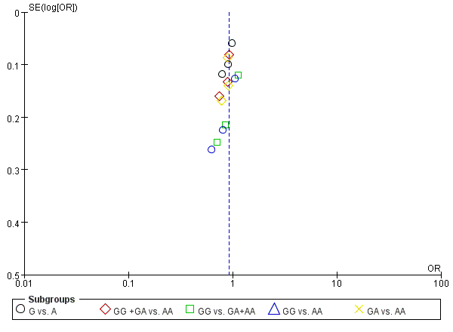
Figure a
Funnel plot analysis for publication bias as to SNP rs2162679.

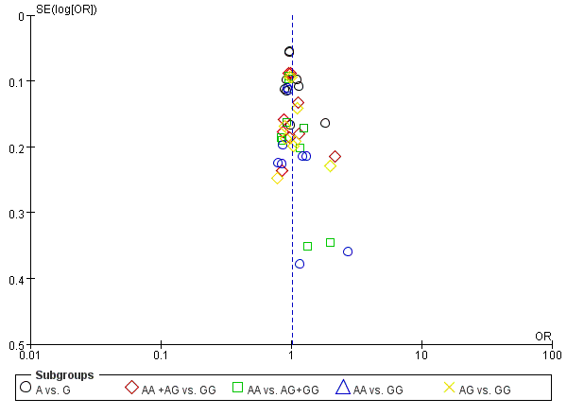
Figure b
Funnel plot analysis for publication bias as to SNP rs6214.

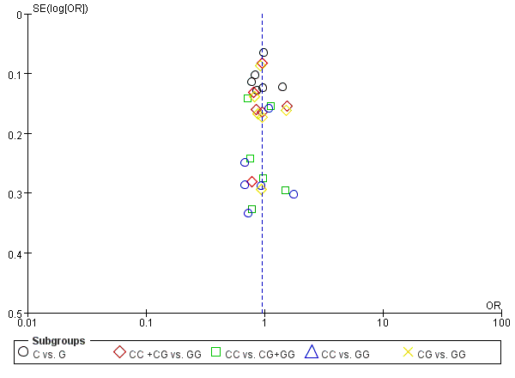
Figure c
Funnel plot analysis for publication bias as to SNP rs12423791.

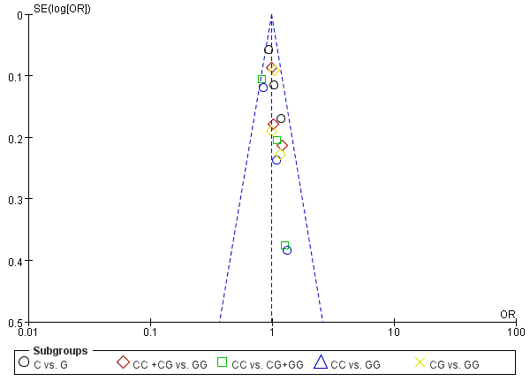
Figure d
Funnel plot analysis for publication bias as to SNP rs5742632.

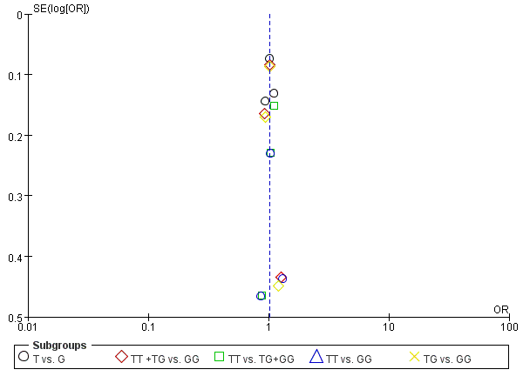
Figure e
Funnel plot analysis for publication bias as to SNP rs10860862.

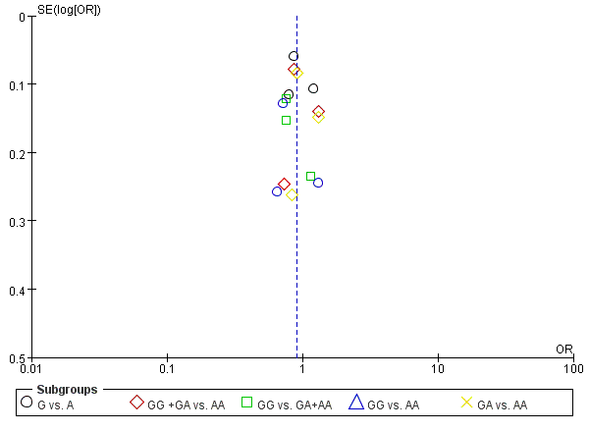
Figure f
Funnel plot analysis for publication bias as to SNP rs35766.

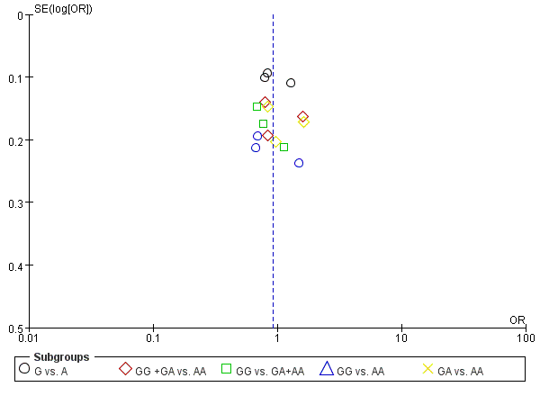
Figure g
Funnel plot analysis for publication bias as to SNP rs5742629.

