The efficacy of toothbrushes following a brushing exercise:

-A Systematic Review and Network Meta-Analysis-

Tim M.J.A. Thomassen

G.A. (Fridus) Van der Weijden

Dagmar E. Slot

Online Appendices

Online supporting information index

Appendix S1.
Papers excluded after full text reading with the details for rejection.

Appendix S2.
Overview of the included studies and characteristics processed for data extraction

Appendix S3a.
Summary Information on studies included in the network meta-analyse (NMA), including interventions, data on Difference of Means, Risk of Bias and Indirectness. (M)Q&HPI.

Appendix S3b.
Summary Information on studies included in the network meta-analyse (NMA), including interventions, data on Difference of Means, Risk of Bias and Indirectness. RMNPI

Appendix S4.
Methodological quality and potential risk of bias scores of the individual included studies

Appendix S5a.
Forest plot of the overall analysis of the comparisons at pre-brushing.

Appendix S5b.
Forest plot comparing OR and HFS with the MTB. Overall. Pre-Brushing

Appendix S6a.
Forest plot of the sub analysis of the comparisons. (M)Q&HPI. Pre-brushing

Appendix S6b.
Forest plot of the sub analysis comparing OR and HFS with the MTB. (M)Q#HPI. Pre-Brushing

Appendix S7a.
Forest plot of the sub analysis of the comparisons. RMNPI. Pre-brushing

Appendix S7b.
Forest plot of the sub analysis comparing OR and HFS with the MTB. RMNPI. Pre-Brushing

Appendix S8a.
Forest plot of the overall analysis of the comparisons at post-brushing

Appendix S8b.
Treatment Ranking. Overall results presented irrespective of indices used. Post-Brushing

Appendix S8c.
Forest plot comparing OR and HFS with the MTB. Post-Brushing

Appendix S9a.
Forest plot of the sub analysis of the comparisons. (M)QHPI. Post-brushing

Appendix S9b. Treatment Ranking. Sub-analysis on (M)Q&HPI. Post-Brushing

Appendix S9c.
Forest plot comparing OR and HFS with the MTB. Sub-analysis on (M)Q&HPI. Post-Brushing

Appendix S9d.
Specific Ranking table for all studies using (M)Q&HPI- Probability for each treatment to be the best. Post-Brushing

Appendix S10a.
Forest plot of the sub analysis of the comparisons. RMNPI. Post-brushing

Appendix S10b.
Treatment Ranking. Sub-analysis on RMNPI. Post-Brushing

Appendix S10c.
Forest plot comparing OR and HFS with the MTB. Sub-analysis on RMNPI. Post-Brushing

Appendix S10d.
Specific Ranking table for all studies using RMNPI- Probability for each treatment to be the best. Post-Brushing

Appendix S11a.
Forest plot of the overall analysis of the comparisons of the reduction in plaque scores, irrespective of the plaque indices used.

Appendix S11b.
Treatment Ranking. Overall results presented irrespective of indices used. Incremental reduction between pre- and post brushing

Appendix S11c.
Forest plot comparing OR and HFS with the MTB. Incremental reduction between pre- and post brushing

Appendix S12a. Forest plot of the overall analysis of the comparisons of the change in plaque scores on the (M)Q&HPI

Appendix S12b.
Treatment Ranking. Sub-analysis on (M)Q&HPI. Incremental reduction between pre- and post brushing

Appendix S12c.
Forest plot comparing OR and HFS with the MTB. Sub-analysis on (M)Q&HPI. Incremental reduction between pre- and post brushing

Appendix S12d.
Specific Ranking table for all studies using (M)Q&HPI- Probability for each treatment to be the best. Incremental reduction between pre- and post brushing

Appendix S13a.
Forest plot of the overall analysis of the comparisons of the change in plaque scores on the RMNPI.

Appendix S13b.
Treatment Ranking. Sub-analysis on RMNPI. Incremental reduction between pre- and post brushing

Appendix S13c.
Forest plot comparing OR and HFS with the MTB. Sub-analysis on RMNPI. Incremental reduction between pre- and post brushing

Appendix S13d.
Specific Ranking table for all studies using RMNPI- Probability for each treatment to be the best. Incremental reduction between pre- and post brushing

Appendix S14.
MetaInsight Network meta-analysis graphs. Post-Brushing

Appendix S15.
MetaInsight Network meta-analysis graphs. Incremental reduction between pre- and post brushing

Appendix S16a.
Confidence in Network Meta-Analysis (CINeMA). Confidence Rating. Overall. Post-Brushing

Appendix S16b.
Confidence in Network Meta-Analysis (CINeMA). Risk of bias contributions. Overall. Post-Brushing

Appendix S16c.
Confidence in Network Meta-Analysis (CINeMA). Reporting Bias. Overall. Post-Brushing

Appendix S16d.
Confidence in Network Meta-Analysis (CINeMA). Indirectness contributions. Overall. Post-Brushing

Appendix S16e.
Confidence in Network Meta-Analysis (CINeMA). Imprecision.Overall. Post-Brushing

Appendix S16f.
Confidence in Network Meta-Analysis (CINeMA). Heterogeneity.Overall. Post-Brushing

Appendix S16g.
Confidence in Network Meta-Analysis (CINeMA). Incoherence. Separating indirect from direct evidence. Overall. Post-Brushing

Appendix S17a.
Confidence in Network Meta-Analysis (CINeMA). Confidence Rating. Sub-analysis (M)Q&HPI. Post-Brushing

Appendix S17b.
Confidence in Network Meta-Analysis (CINeMA). Risk of bias contributions. Sub-analysis (M)Q&HPI. Post-Brushing

Appendix S17c.
Confidence in Network Meta-Analysis (CINeMA). Reporting Bias. Sub-analysis (M)Q&HPI. Post-Brushing

Appendix S17d.
Confidence in Network Meta-Analysis (CINeMA). Indirectness contributions. Sub-analysis (M)Q&HPI. Post-brushing

Appendix S17e.
Confidence in Network Meta-Analysis (CINeMA). Imprecision. Sub-analysis (M)Q&HPI. Post-Brushing

Appendix S17f.
Confidence in Network Meta-Analysis (CINeMA). Heterogeneity. Sub-analysis (M)Q&HPI. Post-Brushing

Appendix S17g.
Confidence in Network Meta-Analysis (CINeMA). Incoherence. Separating indirect from direct evidence. Sub-analysis (M)Q&HPI. Post-Brushing

Appendix S18a.
Confidence in Network Meta-Analysis (CINeMA). Confidence Rating. Sub-analysis RMNPI. Post-Brushing

Appendix S18b.
Confidence in Network Meta-Analysis (CINeMA). Risk of bias contributions. Sub-analysis RMNPI. Post-Brushing

Appendix S18c.
Confidence in Network Meta-Analysis (CINeMA). Reporting Bias. Sub-analysis RMNPI. Post-Brushing

Appendix S18d.
Confidence in Network Meta-Analysis (CINeMA). Indirectness contributions. Sub-analysis RMNPI. Post-Brushing

Appendix S18e.
Confidence in Network Meta-Analysis (CINeMA). Imprecision. Sub-analysis RMNPI. Post-Brushing

Appendix S18f.
Confidence in Network Meta-Analysis (CINeMA). Heterogeneity. Sub-analysis RMNPI. Post-Brushing

Appendix S18g.
Confidence in Network Meta-Analysis (CINeMA). Incoherence. Separating indirect from direct evidence. Sub-analysis RMNPI. Post-Brushing

Appendix S19a.
Confidence in Network Meta-Analysis (CINeMA). Confidence Rating. Incremental reduction between pre- and post brushing

Appendix S19b.
Confidence in Network Meta-Analysis (CINeMA). Risk of bias contributions. The bar chart shows the contributions of each piece of study to the network estimate. Incremental reduction between pre- and post brushing

Appendix S19c.
Confidence in Network Meta-Analysis (CINeMA). Reporting Bias. Incremental reduction between pre- and post brushing

Appendix S19d.
Confidence in Network Meta-Analysis (CINeMA). Indirectness contributions. Incremental reduction between pre- and post brushing

Appendix S19e.
Confidence in Network Meta-Analysis (CINeMA). Imprecision. Incremental reduction between pre- and post brushing

Appendix S19f.
Confidence in Network Meta-Analysis (CINeMA). Heterogeneity. Incremental reduction between pre- and post brushing

Appendix S19g.
Confidence in Network Meta-Analysis (CINeMA). Incoherence. Separating indirect from direct evidence. Incremental reduction between pre- and post brushing

Appendix S20a.
Confidence in Network Meta-Analysis (CINeMA). Confidence Rating. Sub-analysis (M)Q&HPI. Incremental reduction between pre- and post brushing

Appendix 20b.
Confidence in Network Meta-Analysis (CINeMA). Risk of bias contributions. Sub-analysis (M)Q&HPI. Incremental reduction between pre- and post brushing

Appendix S20c.
Confidence in Network Meta-Analysis (CINeMA). Reporting Bias. Sub-analysis (M)Q&HPI. Incremental reduction between pre- and post brushing

Appendix S20d.
Confidence in Network Meta-Analysis (CINeMA). Indirectness contributions. Sub-analysis (M)Q&HPI. Incremental reduction between pre- and post brushing

Appendix S20e.
Confidence in Network Meta-Analysis (CINeMA). Imprecision. Sub-analysis (M)Q&HPI. Incremental reduction between pre- and post brushing

Appendix S20f.
Confidence in Network Meta-Analysis (CINeMA). Heterogeneity. Sub-analysis (M)Q&HPI. Incremental reduction between pre- and post brushing

Appendix S20g.
Confidence in Network Meta-Analysis (CINeMA). Incoherence. Separating indirect from direct evidence. Sub-analysis (M)Q&HPI. Incremental reduction between pre- and post brushing

Appendix S21a.
Confidence in Network Meta-Analysis (CINeMA). Confidence Rating. Sub-analysis RMNPI. Incremental reduction between pre- and post brushing

Appendix S21b.
Confidence in Network Meta-Analysis (CINeMA). Risk of bias contributions. Sub-analysis RMNPI. Incremental reduction between pre- and post brushing

Appendix S21c.
Confidence in Network Meta-Analysis (CINeMA). Reporting Bias. Sub-analysis RMNPI. Incremental reduction between pre- and post brushing

Appendix S21d.
Confidence in Network Meta-Analysis (CINeMA). Indirectness contributions. Sub-analysis RMNPI. Incremental reduction between pre- and post brushing

Appendix S21e.
Confidence in Network Meta-Analysis (CINeMA). Imprecision. Sub-analysis RMNPI. Incremental reduction between pre- and post brushing

Appendix S21f.
Confidence in Network Meta-Analysis (CINeMA). Heterogeneity. Sub-analysis RMNPI. Incremental reduction between pre- and post brushing

Appendix S21g.
Confidence in Network Meta-Analysis (CINeMA). Incoherence. Separating indirect from direct evidence. Sub-analysis RMNPI. Incremental reduction between pre- and post brushing

Appendix S22.
References used in the online appendices

Appendix S1. Papers excluded after full text reading with the details for rejection.
Excluded
Children (8) | Ghassemi et al. 2013; Kallar et al. 2011; Garcia-Godoy et al. 2001; McCracken et al. 2001; Jongenelis et al. 1997; Grossman et al. 1997; Tewari et al. 1992; Erbe et al. 2018
No Single use (44) | García-Carrillo et al. 2016; Klukowska et al. 2014; Nobre et al. 2014; Nightingale et al. 2014; Jain et al. 2013; Sharma et al. 2012; Parizi et al. 2011; Sharma et al. 2010; Pelka et al. 2011; Moritis et al. 2008; Zimmer et al. 2005; Barnes et al. 2003; Lazarescu et al. 2003; Danser et al. 2003; Zimmer et al. 2002; Dentino et al. 2002; Warren et al. 2001; Zimmer et al. 2000; Aass et al. 2000; van der Weijden et al. 1998; Cronin et al. 1998; Yankell et al. 1997; Tritten et al. 1996; Stabholz et al. 1996; Terezhalmy et al. 1995; Stoltze et al. 1994; van der Weijden et al. 1994; Yankell et al. 1994; Emling et al. 1994; Grossman et al. 1994; van der Weijden et al. 1993; Barnes et al. 1993; Hotta et al. 1992; Silverstone et al. 1992; Preber et al. 1991; Mayer et al. 1990; De Beule et al. 1990; Tscharre-Zachhuber et al. 1989; Walsh et al. 1989; Baab et al. 1989; Niemi et al. 1987; Glavind et al. 1986; Walsh et al. 1984; Goldman et al. 1974
No full mouth scores (3) | Oijma et al. 2003; Wiedemann et al. 2001; Niemi et al. 1986
Other devices than OR and HFS (3) | McCracken et al. 2000; Killoy et al. 1989; Khocht et al. 1992
Others (11) | Kemp et al. 2012; Haffajee et al. 2001; Haffajee et al. 2001; Steenackers et al. 2001; Addy et al. 1999; Johnson et al. 1994; Rapley et al. 1994; Engel et al. 1993; Van der Weijden et al. 1993; Manhold et al. 1967; Davidovich et al. 2017

Appendix S2. Overview of the included studies and characteristics processed for data extraction

Authors  (year) | Study design | Plaque index | Participants baseline (end),  gender,  age (mean/range), | Mode of action per group/  brands | Instruction method (I),  Familiarization phase  (F) | Conclusions of the original authors
Renton-Harper  et al. (2001) | RCT  Cross over | Q&H | 16 (16)  ♀: 10  ♂: 6  Mean age: ?  Age range: 23-41 | OR-PTB  (Braun Oral-B Plaque Remover D5)  OR-PTB  (Braun Oral-B Plaque Remover D9)  MTB  (Oral-B 35) | I:  PTB> written  MTB> none  F: yes, 7 days | The present study showed greater benefits from the use of electric brushes.
Heasman et al. (1999) | RCT  Parallel | Q&H | 75 (74)  ♀: ?  ♂: at least 10  Mean age: ?  Age range: 18-25 | OR-PTB  (Philips Jordan HP 735)  OR-PTB  (Braun Oral-B D7)  MTB  (Oral-B 35 advantage) | I: visual  F: yes, 6 weeks | There were no significant differences for PI between groups following supervised brushing at 24h.
Van der Weijden et al. (1996) | RCT  Cross over | Q&H | 20 (20)  ♀: ?  ♂: ?  Mean age: ?  Age range:? | OR-PTB  (Braun Plak Control)  MTB  (?) | I: written  F: no | The PTB is more effective in plaque removal than the MTB.
Moritis et al. (2002) | RCT  Cross over | Q&H | 25 (25)  ♀: 17  ♂: 8  Mean age:45.3  (10.9)  Age range: ? | SS-PTB  (Sonicare Elite)  MTB  (Oral-B 35) | I: written  F: yes, 10 days | The SS-PTB achieved a significantly greater reduction in plaque than the MTB.
Sharma et al. (2006)³⁴ | RCT  Parallel | RMNPI | 144 (144)  ♀: 96  ♂: 48  Mean age: 37.5 (10.94)  Age range: 19-66 | SS-PTB  (Sonicare Elite)  SS-PTB  (Oral-B Sonic Complete)  SS-PTB  (Waterpik Sensonic)  MTB  (Oral-B 35 Indicator) | I: none  F: no | Two out of the three SS-PTB compared favorably to the MTB.
Pizzo et al. (2010)³⁵ | RCT  Cross over | Q&H | 66(66)  ♀: 28  ♂: 38  Mean age: 36.5 (10.1)  Age range: 18-59 | OR-PTB  (Oral-B PC 8500)  MTB  (Oral-B Crossaction Vitalizer)  MTB  (Oral-B Indicator) | I:  PTB> written  MTB> none  F: no | The OR-PTB demonstrated to be more effective in plaque control than the 2 MTBs.
Sharma et al. (2011) | RCT  Cross over | RMNPI | 40 (40)  ♀: 28  ♂: 12  Mean age: 42.3 (11.36)  Age range: 20-69 | OR-PTB  (Oral-B Professional Care 1000)  MTB  (Oral-B Indicator) | I: written  F: yes, 1 week | The OR-PTB with a novel brush head showed statistically significantly superior plaque reduction compared to an MTB.
Nathoo et al. (2012) | RCT  Parallel | RMNPI | 82 (76)  ♀: 51  ♂: 25  Mean age: 43  Age range: 18-66 | SS-PTB  (Colgate Pro Clinical A1500 Triple clean brush head)  MTB  (Oral-B Indicator) | I: written  F: no | The SS-PTB provides statistically significant and clinically relevant levels of efficacy in the removal of supragingival dental plaque after a single tooth brushing compared to an MTB.
Klukowska et al. (2012) | RCT  Cross over | Q&H | 36 (36)  ♀: 31  ♂: 5  Mean age: 45.6 (8.63)  Age range: 25-60 | OR-PTB (with SS movement)  (Oral-B Vitality TriZone)  MTB  (?) | I: written  F: yes, 2- to 3-days | Comparing the brushes, the SS-PTB provided a significantly superior mean whole mouth plaque reduction relative to the manual brush control.
Nathoo et al. (2014) | RCT  Parallel | RMNPI | 120 (120)  ♀:71  ♂: 49  Mean age: 41.4  Age range: 18-67 | SS-PTB(Colgate Pro Clinical C200 Triple clean brush head)  SS-PTB(Colgate Pro Clinical C200 Sensitive clean brush head)  MTB  (Oral-B indicator) | I: written  F: no | Both SS-PTB’s provides statistically significant and clinically relevant levels of efficacy in the removal of supragingival dental plaque when compared to a manual flat-trim toothbrush.
Rosema et al.  (2014) | CCT  Cross sectional | Q&H | 181 (181)  ♀: 125  ♂: 56  Mean age: 22.7  Age range: 18-35 | OR-PTB  (?)  MTB  (?) | I: none  F: no | The PTB removed significantly more plaque than the MTB.
Re et al.  (2015) | RCT  Cross over | Q&H | 40 (40)  ♀: 22  ♂: 18  Mean age: 24 (3.5)  Age range: 18-32 | SS-PTB  (Philips Sonicare DiamondClean 300)  MTB (Butler Gum 409 Compact Soft) | I: visual  F: no | In subjects without any previous experience of a similar technology, the SS-PTB showed a significantly greater plaque reduction compared to the MTB.
Gallob et al. (2015) | RCT  Parallel | RMNPI | 80 (79)  ♀: 58  ♂: 21  Mean age: 49.3  Age range: 19-69 | SS-PTB  (Colgate ProClinical A1500)  MTB  (Oral-B Indicator) | I: written  F: no | Compared to the MTB, the SS-PTB demonstrates statistically and clinically significantly greater levels of plaque removal
Kurtz et al. (2016) | RCT  Cross over | Q&H | 95 (87)  ♀: 54  ♂: 41  Mean age: 30.2 (11.87)  Age range: 18-67 | OR-PTB  (Oral-B Vitality D12)  MTB  (?) | I:  PTB> written  MTB> none  F: no | The OR-PTB removed significantly more plaque than the MTB.
Kulkarni et al.  (2018) | RCT  Parallel | Q&H | 45  ♀: 30  ♂: 15  Mean age: ?  Age range: 18-25 | OR-PTB  (Oral-B 2D)  MTB  (Oral-B 40 advantage) | I: written  F: no | All individuals within both groups showed reduction in PI.
Robinson et al. (1997) | RCT  Parallel | Q&H | 66 (54)  ♀: 32◊  ♂: 22◊  Age ?  Range ? | OR-PTB  (Braun Oral-B D7)  HFS-PTB:  (Side to side Optiva Corporation) | I: verbal and video  F: yes, 2-3 weeks | Both the OR-PTB and the HFS-PTB improved the mean overall plaque scores.
Yankell et al.(1997) | RCT  Parallel | Q&H | 128 (115◊)  ♀: ?  ♂: ?  Age ?  Range 18-50 | OR-PTB:  (Braun Oral-B)  HFS-PTB:  (Side to side Optiva) | I: written  F: no | The OR-PTB and the HFS-PTB removed statistically significant amounts of plaque after brushing.
Sharma et al. (1998) | RCT  Parallel | RMNPI | 44 (44)  ♀: 26  ♂: 18  36.6 (9.6)  22-60 | OR-PTB:  (Braun Oral-B 3D)  HFS-PTB:  (Side to side) | I: visual, written  F: yes, 4 weeks | Significantly greater plaque reduction was achieved with a new electric toothbrush with a three-dimensional action (OR-PTB), when compared with the HFS-PTB. The OR-PTB was also greatly preferred by the participants, a fact which is likely to increase long-term compliance
Sharma et al. (2005) | RCT  Cross-over | RMNPI | 79 (79)  ♀: 51  ♂: 28  36.3 (?)  18-53 | OR-PTB:  (Oral-B PC7000)  OR-PTB:  (Oral-B 3D)  HFS-PTB:  (Side to side) | I: written  F: no | Both OR-PTBs were more effective in plaque removal than the HFS-PTB.
Strate et al. (2005) | RCT  Cross-over | RMNPI | 61 (61)  ♀: 38  ♂: 23  37.8 (?)  19-64 | OR-PTB:  (Oral-B Professional )  HFS-PTB:  (Side to side Elite, Philips) | I: written  F: no | The OR-PTB is more effective at plaque removal than a HFS-PTB.
Biesbrock et al. (2007-1) | RCT  Cross-over | RMNPI | 50 (50)  ♀: 36  ♂: 14  41.1 (?)  18-64 | OR-PTB:  (Oral-B Triumph)  HFS-PTB:  (Side to side Elite 7300) | I: written  F: yes, 7 days | The OR-PTB was significantly more effective in single-use plaque removal than the HFS-PTB with a standard brush head.
Biesbrock et al. (2007-2) | RCT  Cross-over | RMNPI | 49 (48)  Participants in general good health  ♀: 34  ♂: 14  43.5 (?)  20-67 | OR-PTB:  (Oral-B Triumph)  HFS-PTB:  (Side to side Elite 7300) | I: written  F: yes, 10 days | The OR-PTB was significantly more effective in single-use plaque removal than the HFS-PTB with a compact brush head.
Biesbrock et al. (2008) | RCT  Cross-over | RMNPI | 48 (45)  Participants in good general health  ♀: 37  ♂: 8  41.2 (?)  27-55 | OR-PTB:  (Oral-B Triumph with)  HFS-PTB:  (Side to side FlexCare) | I: written  F: yes, 5-6 days per brush | The OR-PTB was significantly more effective in plaque removal after single brushing than the HFS-PTB.
Putt et al. (2008) | RCT  Cross-over | Q&H | 94 (93)  Population ?  ♀: 64  ♂: 30  38.1 (11.6)  18-60 | OR-PTB:  (Oral-B Triumph  Professional Care 9000)  HFS-PTB:  (Philips Side to side Flexcare) | I: written  F: yes, 7 days | Both the HFS-PTB and the OR-PTB were safe and effective. HFS-PTB reduced plaque scores significantly better than the OR- PTB
Williams et al. (2008) | RCT  Cross-over | Q&H | 48 (47)  Healthy adults  ♀: 41  ♂: 7  43.5 (12.1)  20-66 | OR-PTB:  (Oral-B Triumph  Professional Care 9000)  HFS-PTB:  (Philips Side to side Flexcare) | I: written  F: yes, 10-14 days | The OR-PTB delivered superior plaque removal by reducing plaque scores more than the HFS-PTB.
Goyal et al. (2009) | RCT  Parallel | RMNPI | 175 (171)  Participants in good general health  ♀: 120  ♂: 55  41 (10.77)  18-68 | OR-PTB:  (Oral-B Triumph Floss-Action brush head)  HFS-PTB:  (Side to side FlexCare with ProResults brush head) | I: written  F: no | The OR-PTB was significantly more efficacious than the HFS-PTB in reducing plaque levels.
Williams et al. (2009) | RCT  Parallel | Q&H | 179 (171)  ♀: 123  ♂: 56  42.3 (12.2)  19-67 | OR-PTB:  (Oral-B Triumph with FlossAction brush head.)  HFS-PTB:  (Side to side FlexCare with the ProResults brush head) | I: written, verbal  F: no | The OR-PTB was significantly more effective than the HF-STB, both for whole mouth plaque scores and for gingival margin and interproximal scores.
Ayad et al. (2012) | RCT  Parallel | RMNPI | 184 (184)  Participants in general good health  ♀: 138◊  ♂: 46◊  45◊ (?)  18-69◊ | OR-PTB:  (Oral-B Smart Series 5000 with Flossaction brush head)  HFS-PTB:  (Side to side Flexcare Contoured brush head)  HFS-PTB:  (Colgate ProClinical A1500) | I: written  F: yes, 4 weeks | The HFS-PTB Colgate ProClinical A1500Triple Clean Brush head provided statistically significantly greater reductions compared to the other two PTBs in whole mouth plaque index scores after a single tooth brushing.
Adam et al (2020) | RCT  Cross-over | Q&H | 27 (27)  Participants in general good health  ♀: 14  ♂: 13  42.0 (10.46)  24-62 | OR-PTB  (Oral B iO/ Ultimate Clean)  MTB  (ADA) | I: visual  F: yes, 3-4 days | OR- toothbrush with microvibrations produced significantly greater plaque reduction compared to the manual toothbrush.

RCT: Randomized controlled trial
OR-PTB: Oscillating-rotating power toothbrush
HFS-PTB: High Frequency sonic power toothbrush
OP: Oral prophylaxis
DF: Dentifrice
◊: Calculated by the authors of this review based on the presented data in the selected paper
NR: Not reported
?: Unknown
Appendix S3a. Summary Information on studies included in the network meta-analyse (NMA), including interventions, data on Difference of Means, Risk of Bias and Indirectness. (M)Q&HPI.
Risk of Bias: (1) Low,(2) Moderate, (3) High. Indirectness: (L) Low, (M) Moderate, (H) High
Author | Comparison | N | Brushing
Author | Comparison | N | pre |  | Post |  | Diff
Author | Comparison | N | Mean | SD | Mean | SD | Mean | SD | Risk of Bias | Indirectness
Adam et al 2020¹ | OR | 27 | 3.987 | 0.35 | 1.702 | 0.49 | -2.250 | 0.49 | 1 | L
Adam et al 2020¹ | MTB | 27 | 3.924 | 0.35 | 2.631 | 0.49 | -1.321 | 0.49 | 1 | L
Heasman et al 1999² | OR | 25 | 2,03 | 0,55 | 0,82 | 0,54 | ? | ? | 1 | L
Heasman et al 1999² | MTB | 12 | 2,27 | 0,54 | 1,05 | 0,51 | ? | ? | 1 | L
Klukowska et al 2012³ | OR | 36 | 2,146 | 0,3551 | 1,104 | 0,4017 | -1.042 | 0.2174 | 1 | L
Klukowska et al 2012³ | MTB | 36 | 2,169 | 0,323 | 1,196 | 0,408 | -0.973 | 0.2516 | 1 | L
Kulkarni et al 2017⁴ | OR | 22 | 1,77 | 0,34 | 0,81 | 0,39 | -0.957 | 0.4233 | 3 | L
Kulkarni et al 2017⁴ | MTB | 23 | 1,56 | 0,44 | 0,61 | 0,34 | -0.946 | 0.4066 | 3 | L
Kulkarni et al 2017⁴ | OR | 22 | 1,43 | 0,56 | 0,54 | 0,36 | -0.885 | 0.3938 | 3 | L
Kulkarni et al 2017⁴ | MTB | 23 | 1,53 | 0,54 | 0,58 | 0,42 | -0.957 | 0.4088 | 3 | L
Kulkarni et al 2017⁴ | OR | 22 | 0,98 | 0,45 | 0,25 | 0,19 | -0.725 | 0.3701 | 3 | L
Kulkarni et al 2017⁴ | MTB | 23 | 0,88 | 0,37 | 0,29 | 1,24 | -0.592 | 0.3236 | 3 | L
Kulkarni et al 2017⁴ | OR | 22 | 0,7 | 0,44 | 0,13 | 0,13 | -0.566 | 0.4223 | 3 | L
Kulkarni et al 2017⁴ | MTB | 23 | 0,71 | 0,31 | 0,17 | 0,19 | -0.537 | 0.2619 | 3 | L
Kurtz et al 2016⁵ | OR | 90 | 2,331 | 0,4842 | 1,604 | 0,4353 | -0.726 | 0.2996 | 2 | L
Kurtz et al 2016⁵ | MTB | 90 | 2,307 | 0,5212 | 1,741 | 0,4293 | -0.567 | 0.2429 | 2 | L
Kurtz et al 2016⁵ | OR | 90 | 2,275 | 0,4306 | 1,527 | 0,377 | -0.748 | 0.2568 | 2 | L
Kurtz et al 2016⁵ | MTB | 90 | 2,272 | 0,4501 | 1,677 | 0,3891 | -0.594 | 0.2158 | 2 | L
Kurtz et al 2016⁵ | OR | 60 | 2,325 | 0,3954 | 1,508 | 0,4205 | -0.817 | 0.2705 | 2 | L
Kurtz et al 2016⁵ | MTB | 60 | 2,31 | 0,4378 | 1,597 | 0,3662 | -0.713 | 0.249 | 2 | L
Kurtz et al 2016⁵ | OR | 32 | 2,203 | 0,5313 | 1,555 | 0,3931 | -0.649 | 0.247 | 2 | L
Kurtz et al 2016⁵ | MTB | 32 | 2,167 | 0,4892 | 1,695 | 0,3953 | -0.473 | 0.2117 | 2 | L
Moritis et al 2002⁶ | HFS | 25 | 2,7 | 0,4 | 1,73 | 0,47 | ? | ? | 1 | L
Moritis et al 2002⁶ | MTB | 25 | 2,55 | 0,44 | 1,89 | 0,47 | ? | ? | 1 | L
Pizzo et al 2010⁷ | OR | 33 | 3,4 | 0,67 | 2,43 | 0,78 | -0.97 | 0.43 | 2 | L
Pizzo et al 2010⁷ | MTB | 66 | 3,42 | 0,69 | 2,65 | 0,86 | -0.78 | 0.38 | 2 | L
Pizzo et al 2010⁷ | OR | 33 | 3,4 | 0,67 | 2,43 | 0,78 | -0.97 | 0.43 | 2 | L
Pizzo et al 2010⁷ | MTB | 66 | 3,36 | 2,86 | 2,86 | 0,9 | -0.49 | 0.33 | 2 | L
Re et al 2015⁸ | HFS | 40 | 1,85 | 0,51 | 0,66 | 0,47 | -1.19 | 0.37 | 1 | L
Re et al 2015⁸ | MTB | 40 | 1,83 | 0,65 | 0,66 | 0,48 | -1.05 | 0.22 | 1 | L
Renton-Harper et al. 2001⁹ | OR | 16 | 3.137 | 0.147 | 2.481 | 0.349 | -0.656 | ? | 2 | L
Renton-Harper et al. 2001⁹ | MTB | 8 | 3.179 | 0.208 | 2.402 | 0.414 | -0.777 | ? | 2 | L
Renton-Harper et al. 2001⁹ | OR | 16 | 3.205 | 0.24 | 2.464 | 0.368 | -0.741 | ? | 2 | L
Renton-Harper et al. 2001⁹ | MTB | 8 | 3.179 | 0.208 | 2.402 | 0.414 | -0.777 | ? | 2 | L
Renton-Harper et al. 2001⁹ | OR | 16 | 3.137 | 0.147 | 2.095 | 0.433 | -1.042 | ? | 2 | L
Renton-Harper et al. 2001⁹ | MTB | 8 | 3.179 | 0.208 | 2.02 | 0.417 | -1.159 | ? | 2 | L
Renton-Harper et al. 2001⁹ | OR | 16 | 3.205 | 0.24 | 2.132 | 0.467 | -1.073 | ? | 2 | L
Renton-Harper et al. 2001⁹ | MTB | 8 | 3.179 | 0.208 | 2.02 | 0.417 | -1.159 | ? | 2 | L
Renton-Harper et al. 2001⁹ | OR | 16 | 3.137 | 0.147 | 1.736 | 0.474 | -1.401 | ? | 2 | L
Renton-Harper et al. 2001⁹ | MTB | 8 | 3.179 | 0.208 | 1.669 | 0.358 | -1.51 | ? | 2 | L
Renton-Harper et al. 2001⁹ | OR | 16 | 3.205 | 0.24 | 1.775 | 0.478 | -1.430 | ? | 2 | L
Renton-Harper et al. 2001⁹ | MTB | 8 | 3.179 | 0.208 | 1.669 | 0.358 | -1.51 | ? | 2 | L
Robinson et al1997¹⁰ | HFS | 29 | 1.99 | 0.44 | 1.78 | 0.39 | ? | ? | 1 | M
Robinson et al1997¹⁰ | OR | 25 | 1.84 | 0.43 | 1.69 | 0.38 | ? | ? | 1 | M
Robinson et al1997¹⁰ | HFS | 29 | 1.82 | 0.51 | 1.47 | 0.35 | ? | ? | 1 | M
Robinson et al1997¹⁰ | OR | 25 | 1.72 | 0.42 | 1.43 | 0.36 | ? | ? | 1 | M
Robinson et al1997¹⁰ | HFS | 29 | 1.69 | 0.53 | 1.33 | 0.44 | ? | ? | 1 | M
Robinson et al1997¹⁰ | OR | 25 | 1.65 | 0.43 | 1.37 | 0.39 | ? | ? | 1 | M
Rosema et al 2014¹¹ | OR | 91 | 2,8 | 0,45 | 1,56 | 0,471 | -1.24 | 0.301 | 1 | L
Rosema et al 2014¹¹ | MTB | 90 | 2,5 | 0,366 | 1,51 | 0,349 | -0.594 | 0.2158 | 1 | L
Yankell et al.1997¹² | HFS | 31 | 2.69 | 0.46 | 2.22 | 0.59 | ? | ? | 1 | M
Yankell et al.1997¹² | OR | 28 | 2.66 | 0.45 | 2.23 | 0.60 | ? | ? | 1 | M
Yankell et al.1997¹² | HFS | 31 | 2.83 | 0.45 | 2.34 | 0.55 | ? | ? | 1 | M
Yankell et al.1997¹² | OR | 28 | 2.66 | 0.39 | 2.23 | 0.55 | ? | ? | 1 | M
Yankell et al.1997¹² | HFS | 31 | 2.22 | 0.58 | 2.33 | 0.65 | ? | ? | 1 | M
Yankell et al.1997¹² | OR | 28 | 2.66 | 0.39 | 2.72 | 0.44 | ? | ? | 1 | M
Van der Wijden et al. 1996¹³ | OR | 20 | 2.1 | 0.3 | 0.8 | 0.3 | -1.3 | ? | 1 | L
Van der Wijden et al. 1996¹³ | MTB | 20 | 2.2 | 0.3 | 0.9 | 0.3 | -1.3 | ? | 1 | L
Williams et al. 2008¹⁴ | HFS | 47 | 2.87 | 0.39 | ? | ? | -0.95 | 0.40 | 1 | M
Williams et al. 2008¹⁴ | OR | 48 | 2.85 | 0.38 | ? | ? | -1.06 | 0.39 | 1 | M
Williams et al. 2009¹⁵ | HFS | 89 | 3.12 | 0.42 | 2.32 | 0.47 | -0.8 | 0.33 | 1 | M
Williams et al. 2009¹⁵ | OR | 90 | 3.18 | 0.49 | 2.31 | 0.53 | -0.87 | 0.35 | 1 | M
Williams et al. 2009¹⁵ | HFS | 85 | 2.76 | 0.44 | 1.97 | 0.51 | -0.79 | 0.31 | 1 | M
Williams et al. 2009¹⁵ | OR | 87 | 2.75 | 0.48 | 1.97 | 0.52 | -0.79 | 0.32 | 1 | M
Williams et al. 2009¹⁵ | HFS | 85 | 2.81 | 0.50 | 2.07 | 0.60 | -0.75 | 0.36 | 1 | M
Williams et al. 2009¹⁵ | OR | 86 | 2.78 | 0.53 | 2.06 | 0.53 | -0.73 | 0.33 | 1 | M
Williams et al. 2009¹⁵ | HFS | 47 | 2.87 | 0.39 | ? | ? | -0.95 | 0.40 | 1 | M
Williams et al. 2009¹⁵ | OR | 48 | 2.85 | 0.38 | ? | ? | -1.06 | 0.39 | 1 | M

Appendix S3b. Summary Information on studies included in the network meta-analyse (NMA), including interventions, data on Difference of Means, Risk of Bias and Indirectness. RMNPI
Risk of Bias: (1) Low,(2) Moderate, (3) High. Indirectness: (L) Low, (M) Moderate, (H) High
Author | Comparison | N | Brushing
Author | Comparison | N | pre |  | Post |  | Diff
Author | Comparison | N | Mean | SD | Mean | SD | Mean | SD | Risk of Bias | Indirectness
Ayad et al 2012¹⁶ | HFS | 62 | 0.67 | 0.04 | 0.36 | 0.05 | -0.31 | 0.06 | 1 | M
Ayad et al 2012¹⁶ | OR | 60 | 0,67 | 0.05 | 0.35 | 0.06 | -0.32 | 0.06 | 1 | M
Ayad et al 2012¹⁶ | HFS | 62 | 0.68 | 0.05 | 0.29 | 0.07 | -0.39 | 0.08 | 1 | M
Ayad et al 2012¹⁶ | OR | 60 | 0,67 | 0.05 | 0.35 | 0.06 | -0.32 | 0.06 | 1 | M
Biesbrock et al 2007¹⁷ | HFS | 50 | 0.63 | 0.03 | ? | ? | -0.44 | 0.06 | 1 | M
Biesbrock et al 2007¹⁷ | OR | 50 | 0.62 | 0.03 | ? | ? | -0.54 | 0.03 | 1 | M
Biesbrock et al 2007¹⁷ | HFS | 48 | 0.62 | 0.03 | ? | ? | -0.45 | 0.03 | 1 | M
Biesbrock et al 2007¹⁷ | OR | 48 | 0.62 | 0.03 | ? | ? | -0.5 | 0.03 | 1 | M
Biesbrock et al 2008¹⁸ | HFS | 45 | 0.62 | 0.03 | ? | ? | -0.41 | 0.05 | 1 | M
Biesbrock et al 2008¹⁸ | OR | 45 | 0.62 | 0.03 | ? | ? | -0.5 | 0.05 | 1 | M
Gallob et al 2015¹⁹ | HFS | 39 | 0.66 | 0.04 | 0.27 | 0.07 | -0.39 | 0.06 | 1 | L
Gallob et al 2015¹⁹ | MTB | 40 | 0.65 | 0.04 | 0.41 | 0.09 | -0.24 | 0.07 | 1 | L
Goyal et al 2009²⁰ | HFS | 87 | 0.59 | 0.04 | 0.16 | 0.06 | -0.43 | 0.07 | 1 | M
Goyal et al 2009²⁰ | OR | 84 | 0.60 | 0.05 | 0.11 | 0.04 | -0.51 | 0.05 | 1 | M
Goyal et al 2009²⁰ | HFS | 88 | 0.60 | 0.03 | 0.17 | 0.06 | -0.43 | 0.05 | 1 | M
Goyal et al 2009²⁰ | OR | 85 | 0.61 | 0.05 | 0.12 | 0.05 | -0.49 | 0.05 | 1 | M
Goyal et al 2009²⁰ | HFS | 88 | 0.61 | 0.04 | 0.18 | 0.07 | -0.43 | 0.05 | 1 | M
Goyal et al 2009²⁰ | OR | 87 | 0.62 | 0.04 | 0.11 | 0.05 | -0.49 | 0.05 | 1 | M
Nathoo et al 2012²¹ | HFS | 40 | 0.75 | 0.09 | 0.35 | 0.08 | -0.4 | 0.08 | 1 | L
Nathoo et al 2012²¹ | MTB | 36 | 0.74 | 0.09 | 0.49 | 0.08 | -0.25 | 0.05 | 1 | L
Nathoo et al 2014²² | HFS | 40 | 0.71 | 0.1 | 0.3 | 0.1 | -0.41 | 0.07 | 1 | L
Nathoo et al 2014²² | MTB | 20 | 0.72 | 0.14 | 0.35 | 0.08 | -0.27 | 0.15 | 1 | L
Nathoo et al 2014²² | HFS | 40 | 0.75 | 0.11 | 0.32 | 0.1 | -0.43 | 0.09 | 1 | L
Nathoo et al 2014²² | MTB | 20 | 0.75 | 0.14 | 0.45 | 0.13 | -0.27 | 0.15 | 1 | L
Sharma et al 1998²³ | HFS | 44 | 0.68 | 0.05 | 0.34 | 0.08 | -0.34 | 0.08 | 1 | M
Sharma et al 1998²³ | OR | 44 | 0.67 | 0.04 | 0.22 | 0.08 | -0.45 | 0.08 | 1 | M
Sharma et al 2005²⁴ | HFS | 61 | 0.61 | 0.03 | 0.31 | 0.09 | -0.33 | 0.07 | 1 | M
Sharma et al 2005²⁴ | OR | 61 | 0.61 | 0.03 | 0.26 | 0.08 | -0.38 | 0.06 | 1 | M
Sharma et al 2005²⁴ | HFS | 61 | 0.61 | 0.03 | 0.31 | 0.09 | -0.33 | 0.07 | 1 | M
Sharma et al 2005²⁴ | OR | 61 | 0.63 | 0.03 | 0.26 | 0.07 | -0.38 | 0.06 | 1 | M
Sharma et al 2006²⁵ | HFS | 35 | 0.66 | 0.04 | 0.16 | 0.09 | -0.5 | 0.08 | 1 | L
Sharma et al 2006²⁵ | MTB | 12 | 0.65 | 0.03 | 0.14 | 0.07 | -0.51 | 0.06 | 1 | L
Sharma et al 2006²⁵ | HFS | 36 | 0.66 | 0.04 | 0.11 | 0.06 | -0.54 | 0.05 | 1 | L
Sharma et al 2006²⁵ | MTB | 12 | 0.65 | 0.03 | 0.14 | 0.07 | -0.51 | 0.06 | 1 | L
Sharma et al 2006²⁵ | HFS | 36 | 0.66 | 0.04 | 0.07 | 0.05 | -0.59 | 0.05 | 1 | L
Sharma et al 2006²⁵ | MTB | 12 | 0.65 | 0.03 | 0.14 | 0.07 | -0.51 | 0.06 | 1 | L
Sharma et al 2011²⁶ | OR | 40 | 0.632 | 0.0223 | 0.076 | 0.026 | -0.554 | 0.034 | 1 | L
Sharma et al 2011²⁶ | MTB | 40 | 0.625 | 0.0264 | 0.195 | 0.0557 | -0.43 | 0.034 | 1 | L
Strate et al 2005²⁷ | HFS | 61 | 0.63 | 0.03 | 0.25 | 0.10 | -0.38 | 0.08 | 1 | M
Strate et al 2005²⁷ | OR | 61 | 0.63 | 0.03 | 0.08 | 0.05 | -0.55 | 0.05 | 1 | M
Terézhalmy et al. 2005²⁸ | OR | 108 | 0.374 | 0.101 | ? | ? | -0.27 | 0.07 | 1 | L
Terézhalmy et al. 2005²⁸ | MTB | 216 | 0.376 | 0.093 | ? | ? | -0.211 | 0.07 | 1 | L
Terézhalmy et al. 2005²⁸ | OR | 108 | 0.374 | 0.101 | ? | ? | -0.27 | 0.07 | 1 | L
Terézhalmy et al. 2005²⁸ | MTB | 216 | 0.373 | 0.087 | ? | ? | -0.19 | 0.07 | 1 | L

Appendix S4. Methodological quality and potential risk of bias scores of the individual included studies
Study  Quality criteria |  | Vd Weijden et al. 1996 | Robinson et al. 1997 | Yankel & Emling 1997 | Sharma et al. 1998 | Sharma et al. 2005 | Strate et al. 2005 | Biesbrock et al. 2007 | Biesbrock et al. 2008 | William et al. 2008 | Goyal et al. 2009 | William et al. 2009 | Ayad et al. 2012
 | Study design | PA | PA | PA | PA | CO | CO | CO | CO | CO | PA | PA | PA
Internal validity | Random allocation* | + | + | + | + | + | + | + | + | + | + | + | +
Internal validity | Allocation concealment | ? | ? | ? | ? | ? | ? | ? | ? | ? | ? | ? | ?
Internal validity | Blinded to product* | NA | NA | NA | NA | NA | NA | NA | NA | NA | NA | NA | NA
Internal validity | Blinded to examiner* | + | + | + | + | + | + | + | + | + | + | + | +
Internal validity | Blinding during statistical analysis | ? | ? | ? | ? | ? | ? | ? | ? | ? | ? | ? | ?
Internal validity | Balanced experimental groups* | + | + | + | + | + | + | + | + | + | + | + | +
Internal validity | Reported loss to follow up* | - | + | + | + | + | + | + | + | + | + | + | +
Internal validity | # (%) of drop-outs | ? | 12  (18,2%◊) | 13◊  (10,2%◊) | 0  (0%◊) | 0  (0%◊) | 0  (0%◊) | 0  (0%◊) | 3  (6,3%◊) | 1  (2,1%◊) | 4  (2,3%◊) | 8  (4,5%◊) | 0  (0%◊)
Internal validity | Treatment identical, except for intervention* | + | + | + | + | + | + | + | + | + | + | + | +
Externl validity | Representative population group | + | + | + | ? | + | + | ? | ? | ? | ? | + | +
Externl validity | Eligibility criteria defined* | + | + | + | + | + | + | + | + | + | + | + | +

Statistical validity | Sample size calculation and power | - | - | - | - | + | + | - | - | - | + | + | -
Statistical validity | Point estimates presented for the primary outcome | + | + | + | + | + | + | + | + | + | + | + | +
Statistical validity | Measures of variability presented for the primary outcome | + | + | + | + | + | + | + | + | + | + | + | +
Statistical validity | Unit of analysis | subject | subject | group | subject | subject | subject | subject | subject | subject | subject | subject | ?
Statistical validity | Include an per protocol analysis | - | + | ? | ? | ? | ? | ? | ? | ? | ? | ? | ?
Statistical validity | Include an intention- to-treat analysis | ? | ? | ? | ? | ? | ? | ? | ? | ? | ? | ? | ?
Statistical validity | Correction for multiple comparisons | NA | NA | NA | NA | NA | NA | NA | NA | NA | NA | NA | NA
Clinical aspects | Validated measurement | + | + | + | + | + | + | + | + | + | + | + | +
Clinical aspects | Calibration examiner | - | + | + | + | + | - | ? | - | + | + | + | +
Clinical aspects | Reproducibility data shown | - | - | + | - | - | - | - | - | - | - | - | -
Authors estimated risk of bias |  | low | low | low | low | low | low | low | low | low | low | low | low

Study  Quality criteria |  | Van der Weijden et al 1996 | Heasman et al. 1999 | Renton-Harper et all. 2001 | Moritis et al. 2002 | Sharma et al. 2006 | Pizzo et al. 2010 | Sharma et al. 2011 | Nathoo et al. 2012 | Klukowska et al. 2012 | Nathoo et al. 2014 | Rosema et al. 2014 | Gallob et al. 2015 | Re et al. 2015 | Kurtz et al. 2016 | Kulkarni et al/. 2018 | Adam et al 2020
 | Study design | cross-over | parallel | cross-over | cross-over | parallel | cross-over | cross-over | parallel | cross-over | parallel | cross  sectional | parallel | cross-over | cross-over | parallel | Cross-over
internal validity | Random allocation * | + | + | + | + | + | + | + | + | + | + | NA | + | + | + | ? | +
internal validity | Allocation concealment | ? | ? | ? | ? | ? | + | + | ? | + | ? | - | + | ? | + | ? | ?
internal validity | Blinded to  product * | NA | NA | NA | NA | NA | NA | NA | NA | NA | NA | NA | NA | NA | NA | NA | NA
internal validity | Blinded to examiner * | + | + | + | + | + | + | + | + | + | + | + | + | + | + | ? | +
internal validity | Blinding during statistical analysis | ? | ? | ? | ? | ? | ? | ? | ? | ? | ? | ? | ? | ? | ? | ? | ?
internal validity | Balanced experimental groups * | + | + | + | + | + | + | + | + | + | + | + | + | + | + | + | +
internal validity | Reported loss to follow up* | + | + | + | + | + | + | + | + | + | + | + | + | + | + | + | +
internal validity | # (%) of drop-outs | 0 | 1 (1%)◊ | 0 | 0 | 0 | 0 | 0 | 6 (7%)◊ | 0 | 0 | 0 | 1 (1%)◊ | 0 | 8 (8%)◊ | 0 | 0
internal validity | Treatment identical, except for intervention * | + | + | - | + | + | - | + | + | + | + | + | + | + | - | + | +
External validity | Representative population group | + | + | + | + | + | + | + | + | + | + | + | + | + | + | + | +
External validity | Eligibility criteria defined * | + | + | + | + | + | + | + | + | + | + | + | + | + | + | + | +
Statistical validity | Sample size calculation and power | ? | + | ? | ? | ? | + | + | ? | + | ? | - | + | ? | + | + | +
Statistical validity | ADA sample size n≥30⌂⌂ | - | - | - | - | + | + | + | + | + | + | + | + | + | + | - | -
Statistical validity | Point estimates presented for the primary outcome | + | + | + | + | + | + | + | + | + | + | + | + | + | + | + | +
Statistical validity | Measures of variability presented for the primary outcome | + | + | + | + | + | + | + | + | + | + | + | + | + | + | + | +
Statistical validity | Unit of analysis | full mouth | full mouth | full mouth | full mouth | full mouth | full mouth | full mouth | full mouth | full mouth | full mouth | full mouth | full mouth | full mouth | full mouth | full mouth | Full mouth
Statistical validity | Include an per protocol analysis | ? | ? | ? | ? | ? | ? | ? | ? | ? | ? | ? | ? | ? | ? | ? | ?
Statistical validity | Include an intention- to-treat analysis | + | + | + | + | + | + | + | + | + | + | + | + | + | + | + | +
Statistical validity | Correction for multiple comparisons | ? | ? | ? | ? | ? | ? | ? | ? | ? | ? | ? | ? | ? | ? | ? | ?
 | Validated measurement | + | + | + | + | + | + | + | + | + | + | + | + | + | + | + | +
 | Calibration examiner | ? | + | ? | + | + | + | ? | + | + | + | + | + | - | - | + | +
 | Reproducibility data shown | - | - | - | - | - | - | - | - | - | - | - | - | - | - | - | -
Authors estimated risk of bias |  | Low | Low | moderate | Low | Low | moderate | Low | Low | Low | Low | Low | Low | Low | moderate | High | Low

Appendix S5a. Forest plot of the overall analysis of the comparisons at pre-brushing.

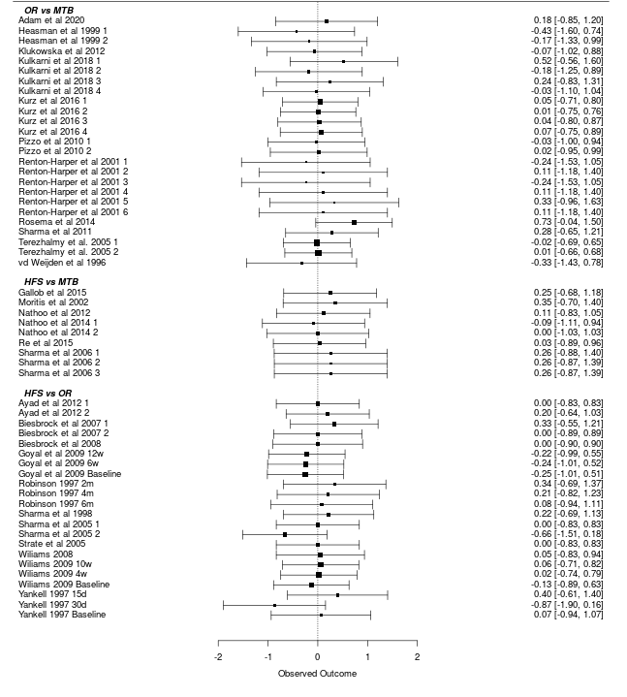
Appendix S5b. Forest plot comparing OR and HFS with the MTB. Overall. Pre-Brushing

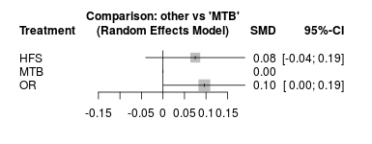
Appendix S6a. Forest plot of the sub analysis of the comparisons. (M)Q&HPI. Pre-brushing
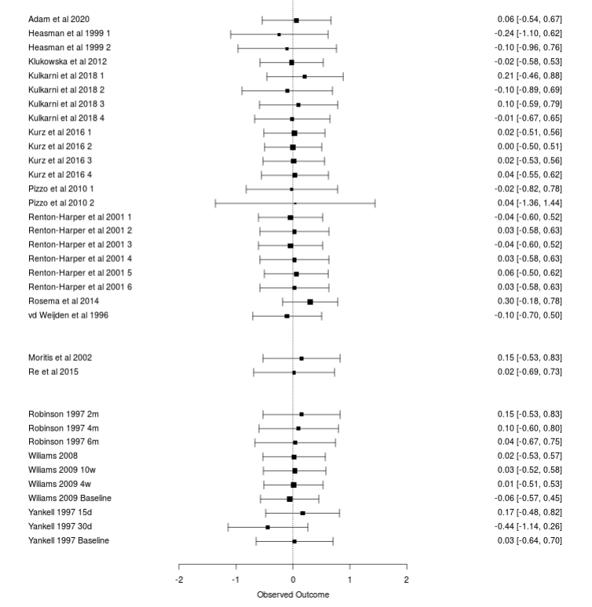

Appendix S6b. Forest plot of the sub analysis comparing OR and HFS with the MTB. (M)Q#HPI. Pre-Brushing

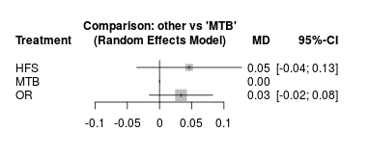

Appendix S7a. Forest plot of the sub analysis of the comparisons. RMNPI. Pre-brushing
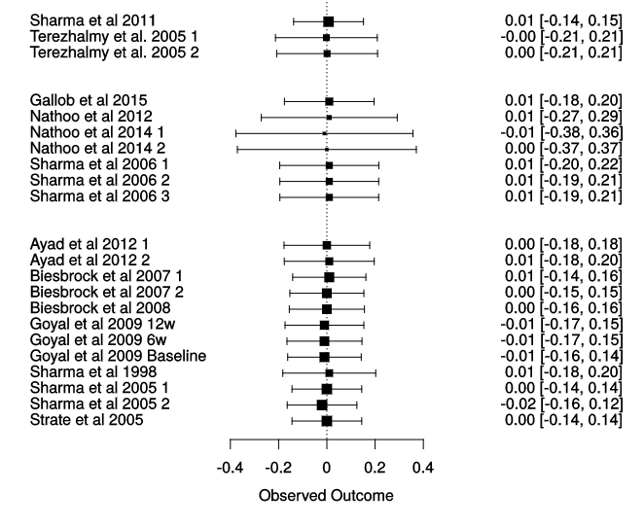

Appendix S7b. Forest plot of the sub analysis comparing OR and HFS with the MTB. RMNPI. Pre-Brushing
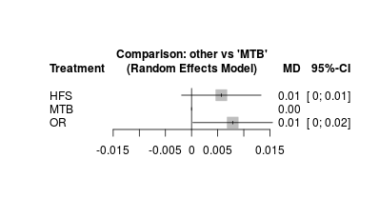

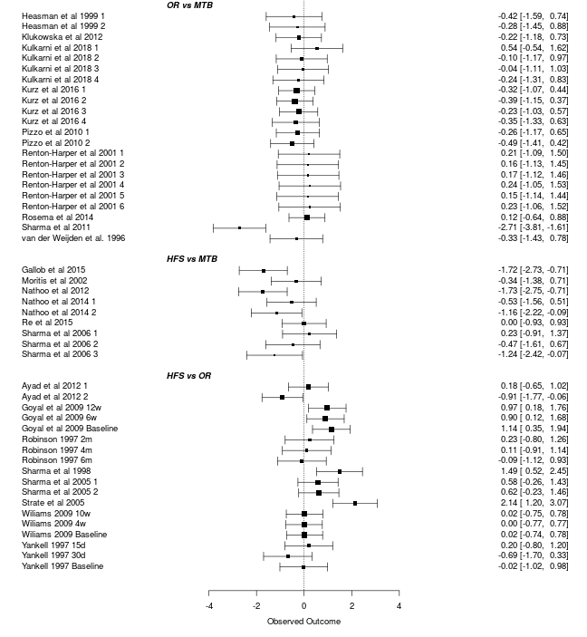
Appendix S8a. Forest plot of the overall analysis of the comparisons at post-brushing.

Appendix S8b. Treatments are ranked from best to worst along the leading diagonal. Above the leading diagonal are estimates from pairwise meta-analyses (Direct comparison), below the leading diagonal are estimates from network meta-analyses (presented as NMA estimates (95%CI)). Overall results presented irrespective of indices used. Post-Brushing

OR | -0.39 [-0.70; -0.08] | -0.23 [-0.52; -0.07]
-0.16 [-0.43; -0.11] | HFS | -0.77 [-1.24; -0.31]
-0.43 [-0.70; -0.17] | -0.27 [-0.59; -0.04] | MTB

Appendix S8c. Forest plot comparing OR and HFS with the MTB. Post-Brushing

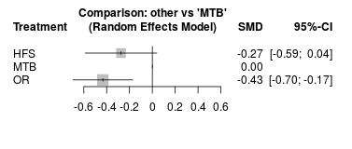

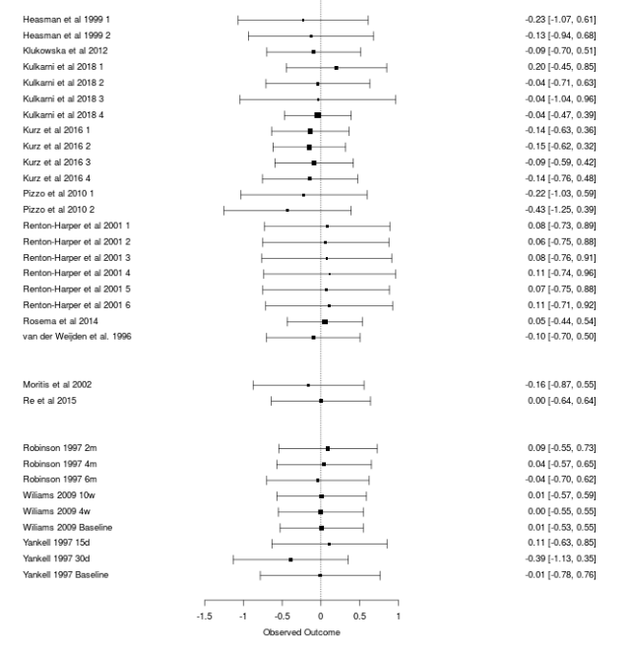
Appendix S9a. Forest plot of the sub analysis of the comparisons. (M)QHPI. Post-brushing

Appendix S9b. Treatments are ranked from best to worst along the leading diagonal. Above the leading diagonal are estimates from pairwise meta-analyses (Direct comparison), below the leading diagonal are estimates from network meta-analyses (presented as NMA estimates (95%CI)). Sub-analysis on (M)Q&HPI. Post-Brushing

HFS | -0.00 [-0.07;0.07] | -0.06 [-0.24; -0.11]
-0.00 [-0.07; 0.06] | OR | -0.06 [-0.11; -0.01]
-0.06 [-0.14;-0.01] | -0.06 [-0.11; -0.02] | MTB

Appendix S9c. Forest plot comparing OR and HFS with the MTB. Sub-analysis on (M)Q&HPI. Post-Brushing
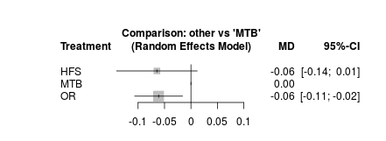

Appendix S9d. Specific Ranking table for all studies using (M)Q&HPI- Probability for each treatment to be the best. Post-Brushing

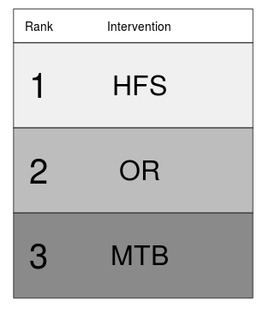
 | Rank 1 | Rank 2 | Rank 3
HFS | 0.53 | 0.42 | 0.05
MTB | 0.00 | 0.06 | 0.94
OR | 0.47 | 0.53 | 0.01

Appendix S10a. Forest plot of the sub analysis of the comparisons. RMNPI. Post-brushing

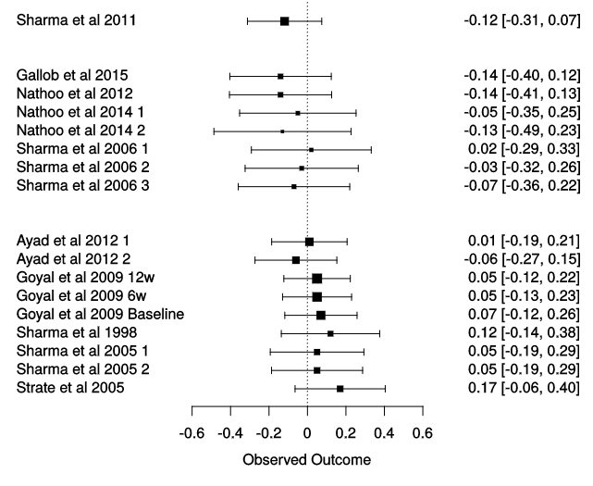

Appendix S10b. Treatments are ranked from best to worst along the leading diagonal. Above the leading diagonal are estimates from pairwise meta-analyses (Direct comparison), below the leading diagonal are estimates from network meta-analyses (presented as NMA estimates (95%CI)). Sub-analysis on RMNPI. Post-Brushing

OR | -0.06 [-0.09; -0.02] | -0.12 [-0.22; -0.02]
-0.05 [-0.09; -0.02] | HFS | -0.08 [-0.12; -0.04]
-0.13 [-0.18; -0.08] | -0.08 [-0.11; -0.04] | MTB

Appendix S10c. Forest plot comparing OR and HFS with the MTB. Sub-analysis on RMNPI. Post-Brushing
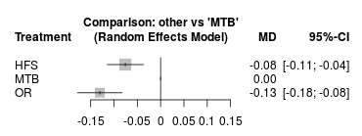

Appendix S10d. Specific Ranking table for all studies using RMNPI- Probability for each treatment to be the best. Post-Brushing
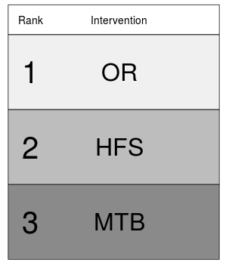
 | Rank 1 | Rank 2 | Rank 3
HFS | 0.00 | 0.99 | 0.00
MTB | 0.00 | 0.00 | 1.00
OR | 0.99 | 0.00 | 0.00

Appendix S11a. Forest plot of the overall analysis of the comparisons of the change in plaque scores, irrespective of the plaque indices used.

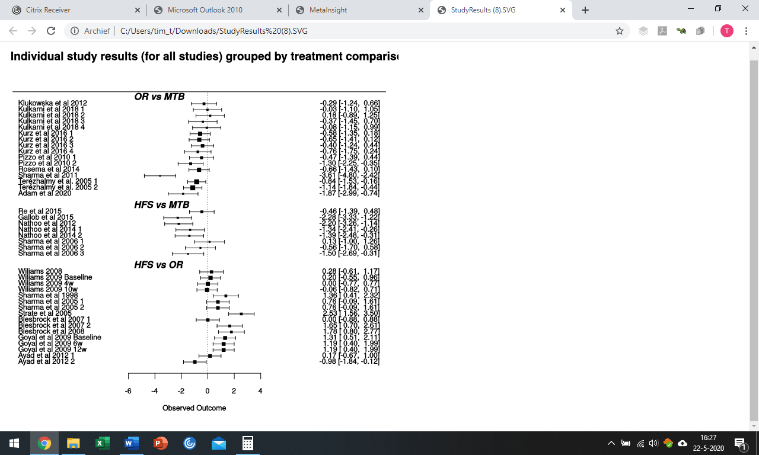

Appendix S11b. Treatments are ranked from best to worst along the leading diagonal. Above the leading diagonal are estimates from pairwise meta-analyses (Direct comparison), below the leading diagonal are estimates from network meta-analyses (presented as NMA estimates (95%CI)). Overall results presented irrespective of indices used. Incremental reduction between pre- and post brushing

OR | -0.75 [-1.12; -0.38] | -0.79 [-1.17; -0.41]
-0.47 [-0.80; -0.15] | HFS | -1.20 [-1.75; -0.65]
-1.07 [-1.40; -0.74] | -0.60 [-0.98; -0.21] | MTB

Appendix S11c. Forest plot comparing OR and HFS with the MTB. Incremental reduction between pre- and post brushing

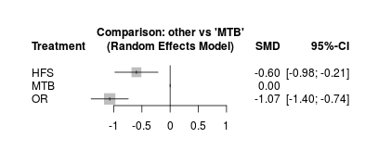

Appendix S12a. Forest plot of the overall analysis of the comparisons of the change in plaque scores on the (M)Q&HPI

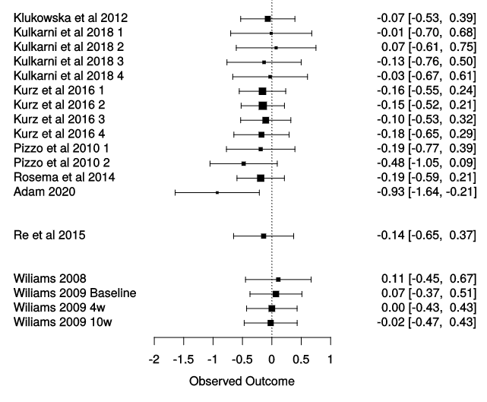

Appendix S12b. Treatments are ranked from best to worst along the leading diagonal. Above the leading diagonal are estimates from pairwise meta-analyses (Direct comparison), below the leading diagonal are estimates from network meta-analyses (presented as NMA estimates (95%CI)). Sub-analysis on (M)Q&HPI. Incremental reduction between pre- and post brushing

OR | -0.04 [-0.15; 0.08] | -0.18 [-0.25; -0.11]
-0.04 [-0.14; 0.07] | HFS | -0.14 [-0.38; 0.10]
-0.18 [-0.25; -0.11] | -0.14 [-0.26; -0.03] | MTB

Appendix S12c. Forest plot comparing OR and HFS with the MTB. Sub-analysis on (M)Q&HPI. Incremental reduction between pre- and post brushing

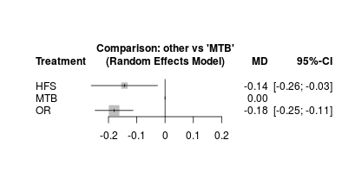

Appendix S12d. Specific Ranking table for all studies using (M)Q&HPI- Probability for each treatment to be the best. Incremental reduction between pre- and post brushing

 | Rank 1 | Rank 2 | Rank 3
HFS | 0.31 | 0.64 | 0.05
MTB | 0.00 | 0.05 | 0.95
OR | 0.69 | 0.30 | 0.00

Appendix S13a. Forest plot of the overall analysis of the comparisons of theincremental reduction in plaque scores on the RMNPI.

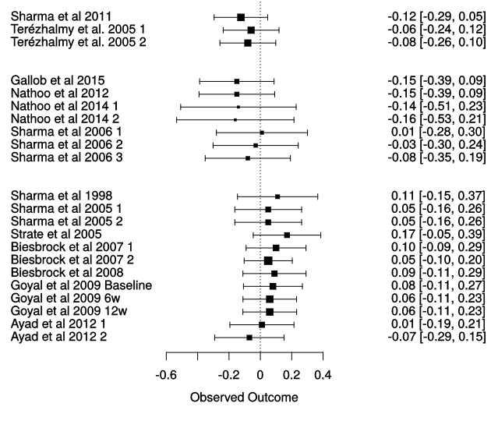

Appendix S13b. Treatments are ranked from best to worst along the leading diagonal. Above the leading diagonal are estimates from pairwise meta-analyses (Direct comparison), below the leading diagonal are estimates from network meta-analyses (presented as NMA estimates (95%CI)). Sub-analysis on RMNPI. Incremental reduction between pre- and post brushing

OR | -0.06 [-0.09; -0.04] | -0.09 [-0.14; -0.03]
-0.05 [-0.08; -0.03] | HFS | -0.10 [-0.14; -0.06]
-0.13 [-0.17; -0.09] | -0.08 [-0.11; -0.04] | MTB

Appendix S13c. Forest plot comparing OR and HFS with the MTB. Sub-analysis on RMNPI. Incremental reduction between pre- and post brushing

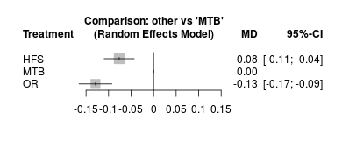

Appendix S13d. Specific Ranking table for all studies using RMNPI- Probability for each treatment to be the best. Incremental reduction between pre- and post brushing

 | Rank 1 | Rank 2 | Rank 3
HFS | 0.00 | 1.00 | 0.00
MTB | 0.00 | 0.00 | 1.00
OR | 1.00 | 0.00 | 0.00

Appendix S14. MetaInsight Network meta-analysis graphs. Each node represents a device, manual toothbrush (MTB), an oscillating-rotating power toothbrush (OR) an a high frequency sonic power toothbrush (HFS). Each line between the nodes show the amount of comparisons. Post-Brushing

Appendix S14a: Network meta-analysis graph irrespective of the plaque indices. Post-Brushing
Appendix S14b: Network meta-analysis graph using only the (M)Q&HPI. Post-Brushing
Appendix S14c: Network meta-analysis graph using only the RMNPI. Post-Brushing

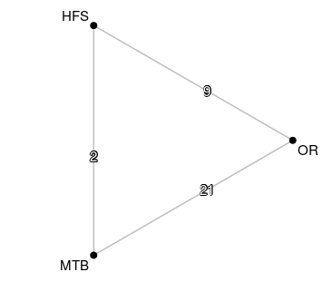
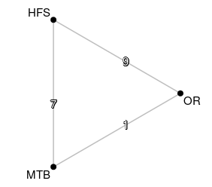
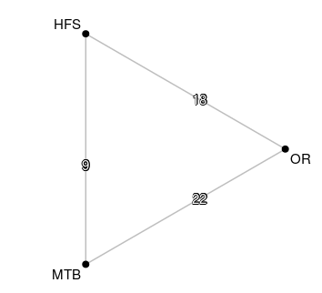
S14a S14b S14c

Appendix S15. MetaInsight Network meta-analysis graphs. Each node represents a device, manual toothbrush (MTB), an oscillating-rotating power toothbrush (OR) an a high frequency sonic power toothbrush (HFS). Each line between the nodes show the amount of comparisons. Incremental reduction between pre- and post brushing
Appendix S15a: Network meta-analysis graph irrespective of the plaque indices. Difference
Appendix S15b: Network meta-analysis graph using only the (M)Q&HPI. Difference
Appendix S15c: Network meta-analysis graph using only the RMNPI. Difference

S15a S15b S15c
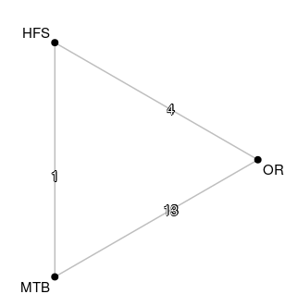
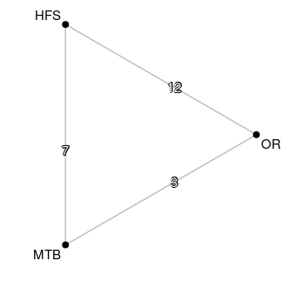
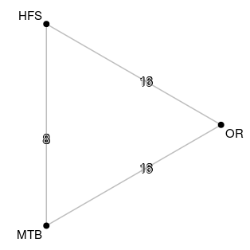

Appendix S16a. Confidence in Network Meta-Analysis (CINeMA). Confidence Rating. Overall. Post-Brushing

Comparison | Number of studies | Within-study bias | Reporting bias | Indirectness | Imprecision | Heterogeneity | Incoherence | Confidence rating
HFS:MTB | 8 | No concerns | Undetected | No concerns | Some concerns | Some concerns | Major concerns | Moderate
HFS:OR | 16 | No concerns | Undetected | Some concerns | Some concerns | Some concerns | Major concerns | Moderate
MTB:OR | 16 | Some concerns | Undetected | No concerns | No concerns | Major concerns | Some concerns | Moderate

Appendix S16b. Confidence in Network Meta-Analysis (CINeMA). Risk of bias contributions. The bar chart shows the contributions of each piece of study to the network estimate. Overall. Post-Brushing

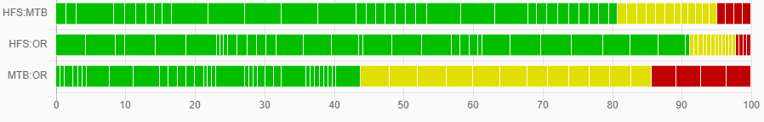
Appendix S16c. Confidence in Network Meta-Analysis (CINeMA). Reporting Bias. Overall. Post-Brushing

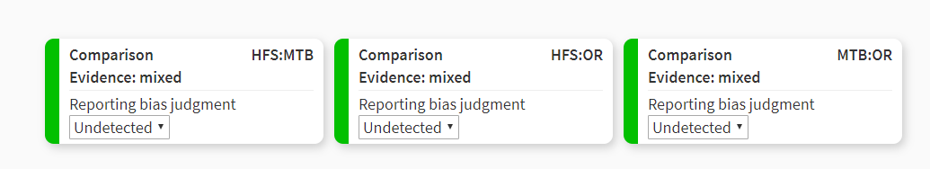

Appendix S16d. Confidence in Network Meta-Analysis (CINeMA). Indirectness contributions The bar chart shows the contributions of each study to the network estimate.Overall. Post-Brushing
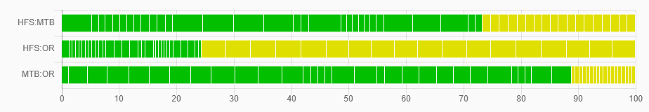

Appendix S16e. Confidence in Network Meta-Analysis (CINeMA). Imprecision.Overall. Post-Brushing
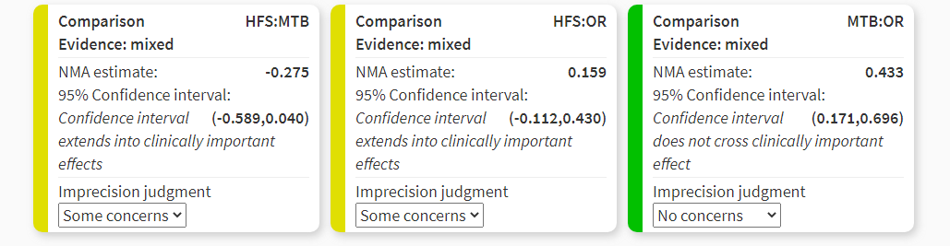

Appendix S16f. Confidence in Network Meta-Analysis (CINeMA). Heterogeneity.Overall. Post-Brushing
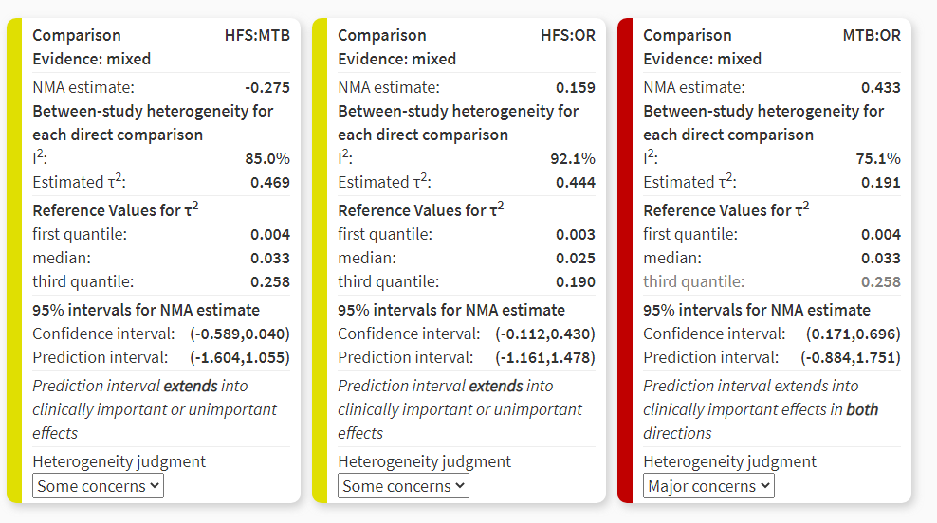
Appendix S16g. Confidence in Network Meta-Analysis (CINeMA). Incoherence. Separating indirect from direct evidence. Overall. Post-Brushing

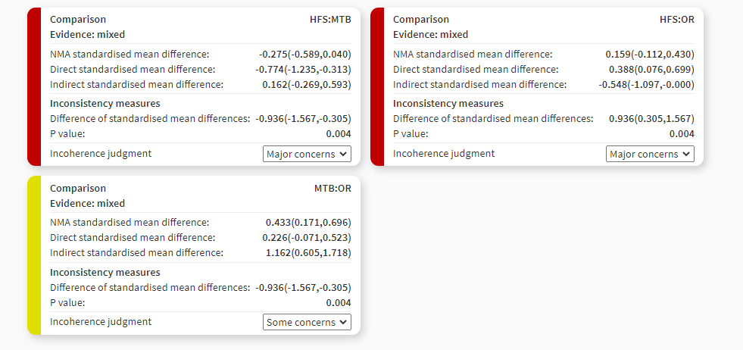

Appendix S17a. Confidence in Network Meta-Analysis (CINeMA). Confidence Rating. Sub-analysis (M)Q&HPI. Post-Brushing

Comparison | Number of studies | Within-study bias | Reporting bias | Indirectness | Imprecision | Heterogeneity | Incoherence | Confidence rating
HFS:MTB | 1 | No concerns | Undetected | No concerns | No concerns | No concerns | No concerns | High
HFS:OR | 4 | No concerns | Undetected | Some concerns | No concerns | No concerns | No concerns | High
MTB:OR | 13 | Some concerns | Undetected | No concerns | No concerns | No concerns | No concerns | High

Appendix S17b. Confidence in Network Meta-Analysis (CINeMA). Risk of bias contributions. The bar chart shows the contributions of each piece of study to the network estimate. Sub-analysis (M)Q&HPI. Post-Brushing

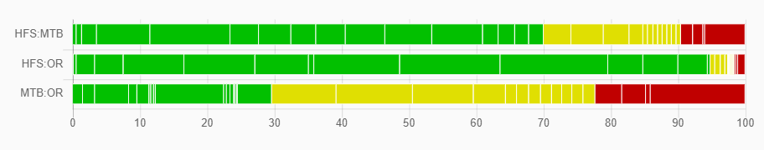

Appendix S17c. Confidence in Network Meta-Analysis (CINeMA). Reporting Bias. Sub-analysis (M)Q&HPI. Post-Brushing
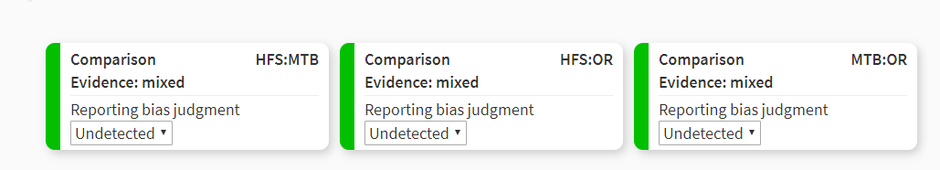

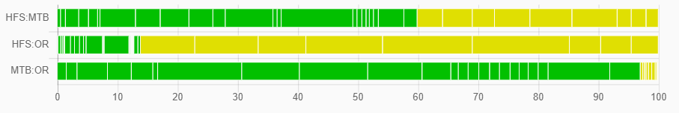
Appendix S17d. Confidence in Network Meta-Analysis (CINeMA). Indirectness contributions The bar chart shows the contributions of each study to the network estimate. Sub-analysis (M)Q&HPI. Post-Brushing

Appendix S17e. Confidence in Network Meta-Analysis (CINeMA). Imprecision. Sub-analysis (M)Q&HPI. Post-Brushing

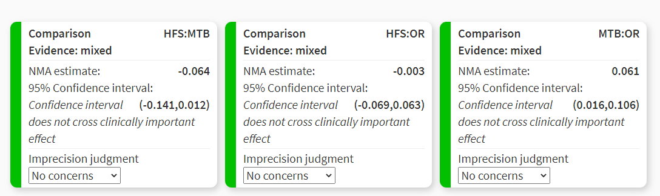

Appendix S17f. Confidence in Network Meta-Analysis (CINeMA). Heterogeneity. Sub-analysis (M)Q&HPI. Post-Brushing
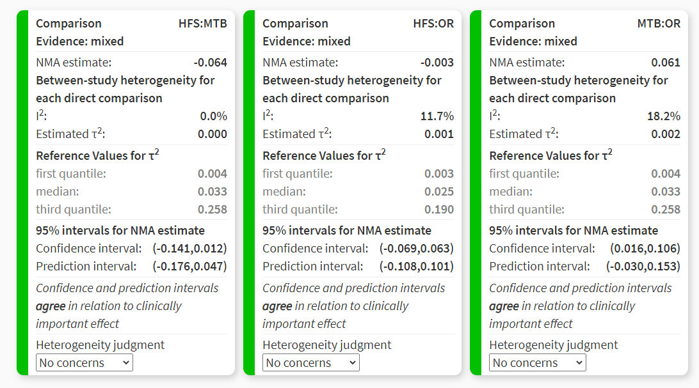

Appendix S17g. Confidence in Network Meta-Analysis (CINeMA). Incoherence. Separating indirect from direct evidence. Sub-analysis (M)Q&HPI. Post-Brushing

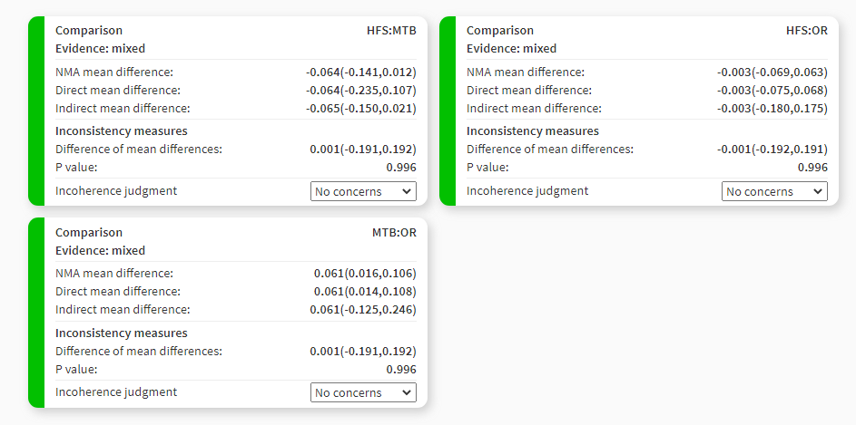
Appendix S18a. Confidence in Network Meta-Analysis (CINeMA). Confidence Rating. Sub-analysis RMNPI. Post-Brushing

Comparison | Number of studies | Within-study bias | Reporting bias | Indirectness | Imprecision | Heterogeneity | Incoherence | Confidence rating
HFS:MTB | x | No concerns | Undetected | No concerns | No concerns | No concerns | No concerns | High
HFS:OR | x | No concerns | Undetected | Some concerns | No concerns | No concerns | No concerns | High
MTB:OR | x | No concerns | Undetected | No concerns | No concerns | Some concerns | No concerns | High

Appendix S18b. Confidence in Network Meta-Analysis (CINeMA). Risk of bias contributions. The bar chart shows the contributions of each piece of study to the network estimate. Sub-analysis RMNPI. Post-Brushing

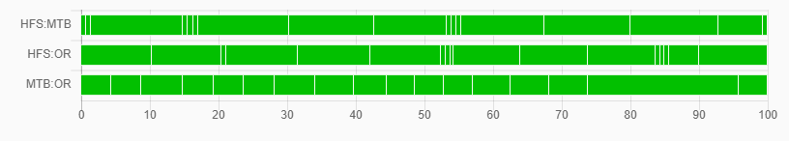

Appendix S18c. Confidence in Network Meta-Analysis (CINeMA). Reporting Bias. Sub-analysis RMNPI. Post-Brushing

Appendix S18d. Confidence in Network Meta-Analysis (CINeMA). Indirectness contributions The bar chart shows the contributions of each study to the network estimate. Sub-analysis RMNPI. Post-Brushing
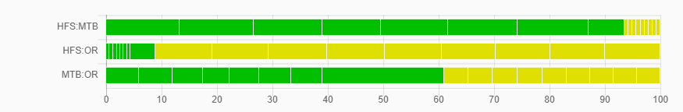

Appendix S18e. Confidence in Network Meta-Analysis (CINeMA). Imprecision. Sub-analysis RMNPI. Post-Brushing

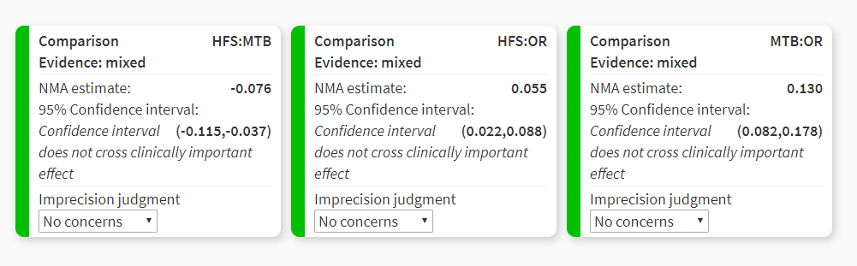

Appendix S18f. Confidence in Network Meta-Analysis (CINeMA). Heterogeneity. Sub-analysis RMNPI. Post-Brushing

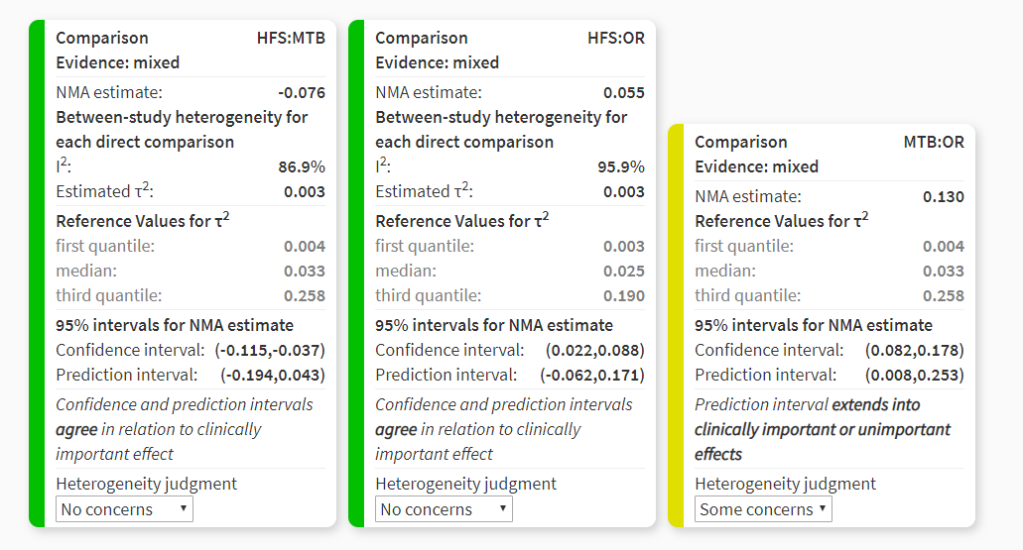

Appendix S18g. Confidence in Network Meta-Analysis (CINeMA). Incoherence. Separating indirect from direct evidence. Sub-analysis RMNPI. Post-Brushing

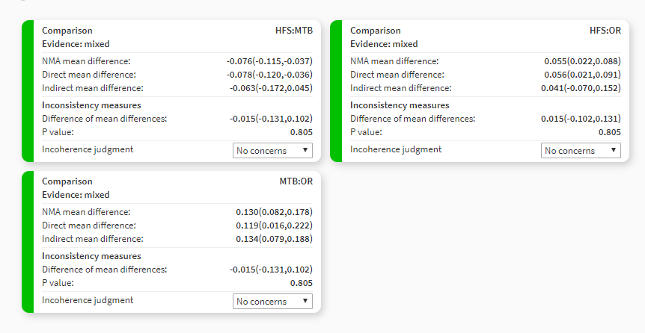

Appendix S19a. Confidence in Network Meta-Analysis (CINeMA). Confidence Rating. Incremental reduction between pre- and post brushing

Comparison | Number of studies | Within-study bias | Reporting bias | Indirectness | Imprecision | Heterogeneity | Incoherence | Confidence rating
HFS:MTB | 8 | No concerns | Undetected | No concerns | No concerns | Major concerns | Major concerns | Moderate
HFS:OR | 16 | No concerns | Undetected | Some concerns | No concerns | Major concerns | Major concerns | Moderate
MTB:OR | 16 | Some concerns | Undetected | No concerns | No concerns | Major concerns | No concerns | Moderate

Appendix S19b. Confidence in Network Meta-Analysis (CINeMA). Risk of bias contributions. The bar chart shows the contributions of each piece of study to the network estimate. Incremental reduction between pre- and post brushing

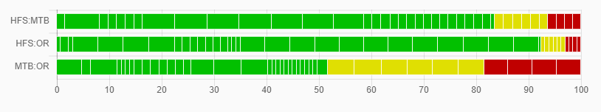

Appendix S19c. Confidence in Network Meta-Analysis (CINeMA). Reporting Bias. Incremental reduction between pre- and post brushing

Appendix S19d. Confidence in Network Meta-Analysis (CINeMA). Indirectness contributions The bar chart shows the contributions of each study to the network estimate. Incremental reduction between pre- and post brushing
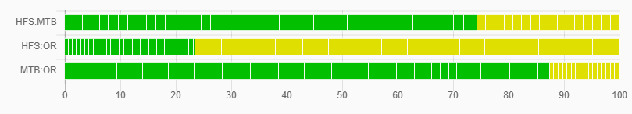

Appendix S19e. Confidence in Network Meta-Analysis (CINeMA). Imprecision. Incremental reduction between pre- and post brushing

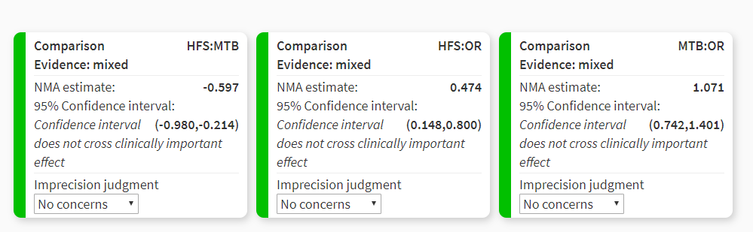

Appendix S19f. Confidence in Network Meta-Analysis (CINeMA). Heterogeneity. Incremental reduction between pre- and post brushing

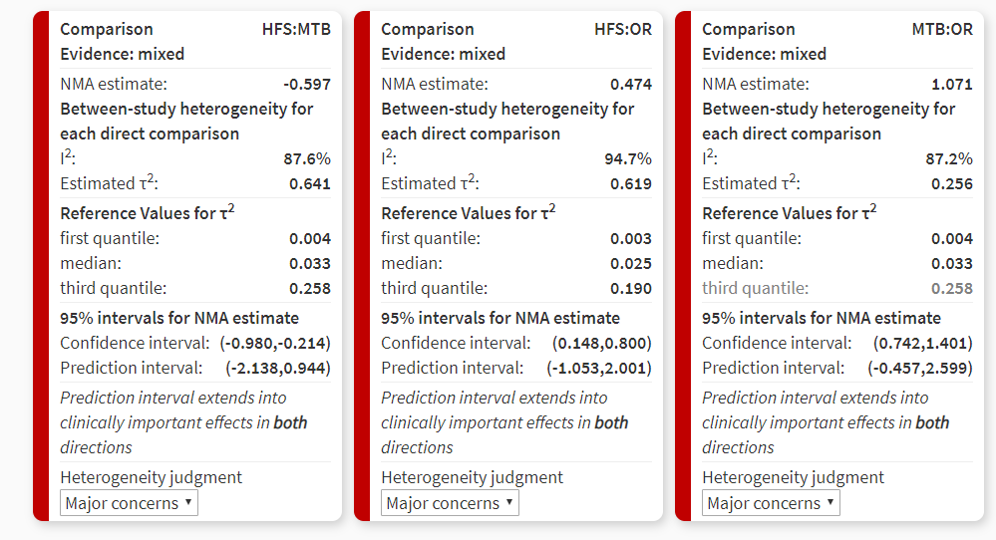

Appendix S19g. Confidence in Network Meta-Analysis (CINeMA). Incoherence. Separating indirect from direct evidence. Incremental reduction between pre- and post brushing

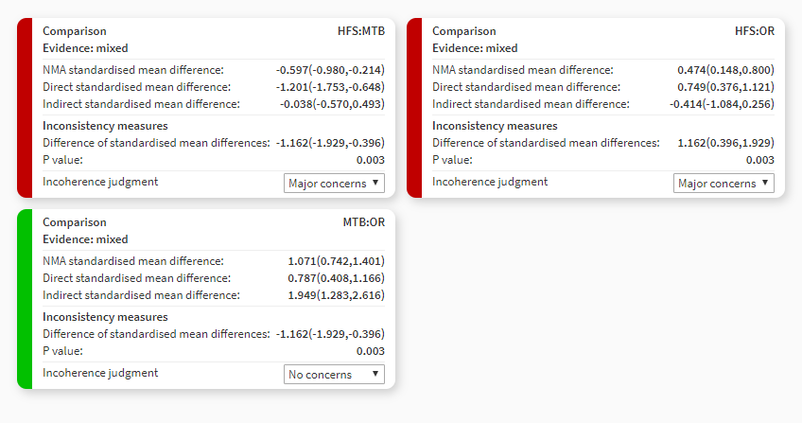

Appendix S20a. Confidence in Network Meta-Analysis (CINeMA). Confidence Rating. Sub-analysis (M)Q&HPI. Incremental reduction between pre- and post brushing

Comparison | Number of studies | Within-study bias | Reporting bias | Indirectness | Imprecision | Heterogeneity | Incoherence | Confidence rating
HFS:MTB | 1 | No concerns | Undetected | No concerns | No concerns | Some concerns | No concerns | High
HFS:OR | 4 | No concerns | Undetected | Some concerns | No concerns | Major concerns | No concerns | Moderate
MTB:OR | 13 | Some concerns | Undetected | No concerns | No concerns | Some concerns | No concerns | High

Appendix 20b. Confidence in Network Meta-Analysis (CINeMA). Risk of bias contributions. The bar chart shows the contributions of each piece of study to the network estimate. Sub-analysis (M)Q&HPI. Incremental reduction between pre- and post brushing

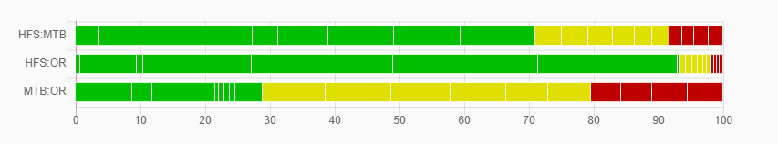

Appendix S20c. Confidence in Network Meta-Analysis (CINeMA). Reporting Bias. Sub-analysis (M)Q&HPI. Incremental reduction between pre- and post brushing

Appendix S20d. Confidence in Network Meta-Analysis (CINeMA). Indirectness contributions The bar chart shows the contributions of each study to the network estimate. Sub-analysis (M)Q&HPI. Incremental reduction between pre- and post brushing
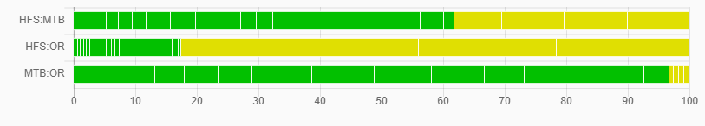

Appendix S20e. Confidence in Network Meta-Analysis (CINeMA). Imprecision. Sub-analysis (M)Q&HPI. Incremental reduction between pre- and post brushing

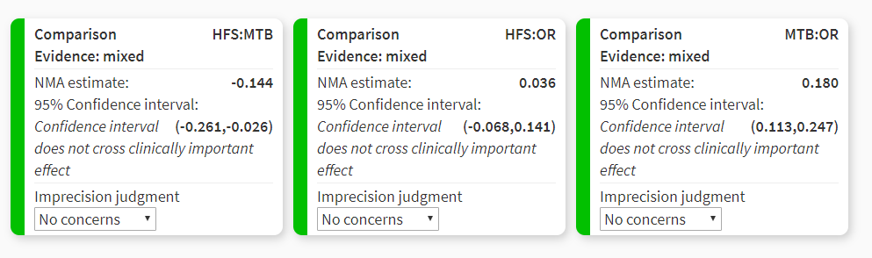

Appendix S20f. Confidence in Network Meta-Analysis (CINeMA). Heterogeneity. Sub-analysis (M)Q&HPI. Incremental reduction between pre- and post brushing

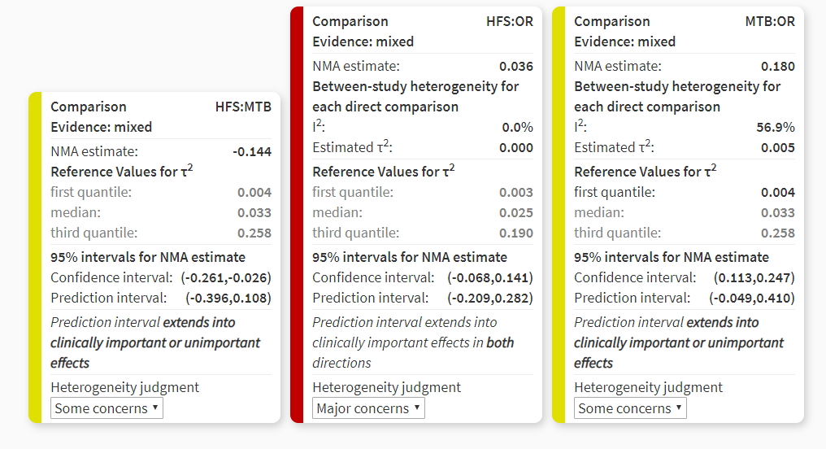

Appendix S20g. Confidence in Network Meta-Analysis (CINeMA). Incoherence. Separating indirect from direct evidence. Sub-analysis (M)Q&HPI. Incremental reduction between pre- and post brushing

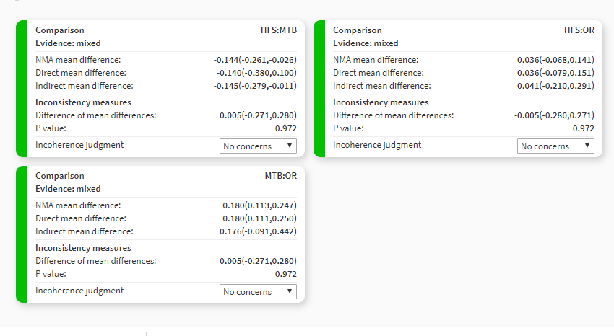

Appendix S21a. Confidence in Network Meta-Analysis (CINeMA). Confidence Rating. Sub-analysis RMNPI. Incremental reduction between pre- and post brushing

Comparison | Number of studies | Within-study bias | Reporting bias | Indirectness | Imprecision | Heterogeneity | Incoherence | Confidence rating
HFS:MTB | x | No concerns | Undetected | No concerns | No concerns | No concerns | No concerns | High
HFS:OR | x | No concerns | Undetected | Some concerns | No concerns | No concerns | No concerns | High
MTB:OR | x | No concerns | Undetected | No concerns | No concerns | Some concerns | Some concerns | Moderate

Appendix S21b. Confidence in Network Meta-Analysis (CINeMA). Risk of bias contributions. The bar chart shows the contributions of each piece of study to the network estimate. Sub-analysis RMNPI. Incremental reduction between pre- and post brushing

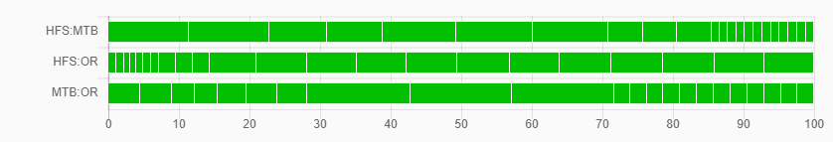

Appendix S21c. Confidence in Network Meta-Analysis (CINeMA). Reporting Bias. Sub-analysis RMNPI. Incremental reduction between pre- and post brushing

Appendix S21d. Confidence in Network Meta-Analysis (CINeMA). Indirectness contributions The bar chart shows the contributions of each study to the network estimate. Sub-analysis RMNPI. Incremental reduction between pre- and post brushing
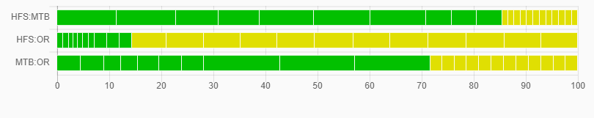

Appendix S21e. Confidence in Network Meta-Analysis (CINeMA). Imprecision. Sub-analysis RMNPI. Incremental reduction between pre- and post brushing

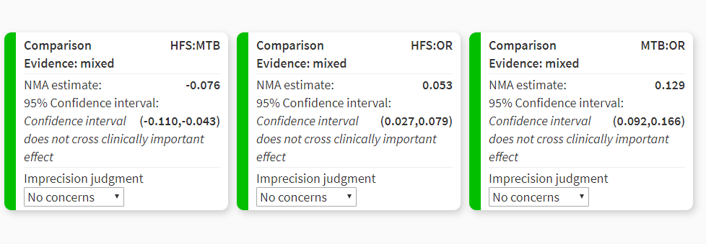

Appendix S21f. Confidence in Network Meta-Analysis (CINeMA). Heterogeneity. Sub-analysis RMNPI. Incremental reduction between pre- and post brushing

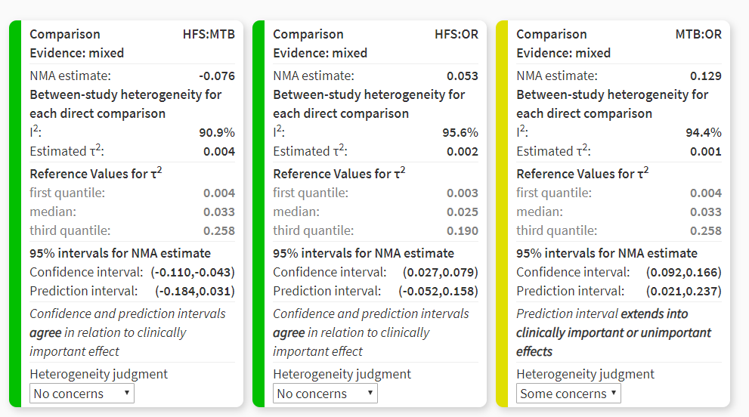

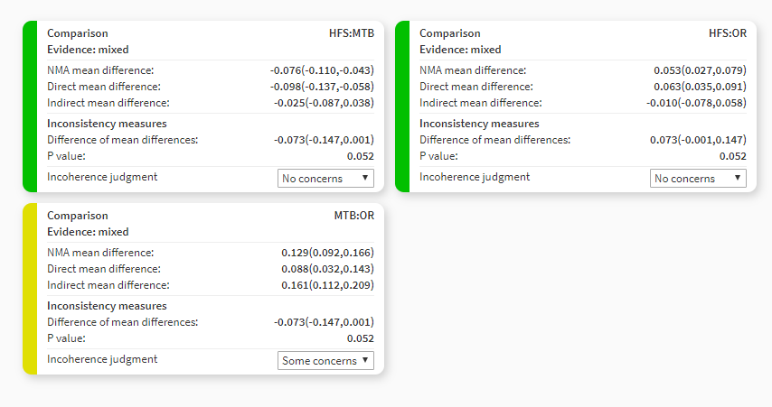
Appendix S21g. Confidence in Network Meta-Analysis (CINeMA). Incoherence. Separating indirect from direct evidence. Sub-analysis RMNPI. Incremental reduction between pre- and post brushing

Appendix S22.
References used in the online appendices

1. Adam R, Erb J, Grender J. Randomized controlled trial assessing plaque removal of an oscillating-rotating electric toothbrush with micro-vibrations. Int Dent J. 2020;70:S22-S27. doi:10.1111/idj.12568
2. Heasman PA, Stacey F, Heasman L, Sellers P, Macgregor IDM, Kelly PJ. A comparative study of the Philips HP 735, Braun/Oral B D7 and the Oral B 35 Advantage toothbrushes. J Clin Periodontol. 1999;26:85-90. doi:10.1034/j.1600-051X.1999.260204.x
3. Klukowska M, Grender JM, Timm H. A single-brushing study to compare plaque removal efficacy of a new power brush to an ADA reference manual toothbrush. Am J Dent. 2012;25(SPEC. ISSUE A):10A-13A
4. Kulkarni P, Singh DK, Jalaluddin M. Comparison of efficacy of manual and powered toothbrushes in plaque control and gingival inflammation: A clinical study among the population of east indian region. J Int Soc Prev Community Dent. 2017;7:168-174. doi:10.4103/jispcd.JISPCD_133_17
5. Kurtz B, Reise M, Klukowska M, Grender JM, Timm H, Sigusch BW. A randomized clinical trial comparing plaque removal efficacy of an oscillating–rotating power toothbrush to a manual toothbrush by multiple examiners. Int J Dent Hyg. 2016;14:278-283. doi:10.1111/idh.12225
6. Moritis K, Delaurenti M, Johnson MR, Berg J, Boghosian AA. Comparison of the Sonicare Elite and a manual toothbrush in the evaluation of plaque reduction. Am J Dent. 2002;15 Spec No:23B-25B. http://www.ncbi.nlm.nih.gov/pubmed/12516678. Accessed June 1, 2021
7. Pizzo G, Licata ME, Pizzo I, D’Angelo M. Plaque removal efficacy of power and manual toothbrushes: A comparative study. Clin Oral Investig. 2010;14:375-381. doi:10.1007/s00784-009-0303-3
8. Re D, Augusti G, Battaglia D, Giannì AB, Augusti D. Is a new sonic toothbrush more effective in plaque removal than a manual toothbrush? Eur J Paediatr Dent. 2015;16:13-18.
9. Renton-Harper P, Addy M, Newcombe RG. Plaque removal with the uninstructed use of electric toothbrushes: Comparison with a manual brush and toothpaste slurry. J Clin Periodontol. 2001;28:325-330. doi:10.1034/j.1600-051x.2001.028004325.x
10. Robinson PJ, Maddalozzo D, Breslin S. A Six-Month Clinical Comparison of the Efficacy of the Sonicare® and the Braun Oral-B® Electric Toothbrushes on Improving Periodontal Health in Adult Periodontitis Patients. J Clin Dent. 1997;8:4-9.
11. Rosema NAM, Adam R, Grender JM, Van der Sluijs E, Supranoto SC, Van der Weijden GA. Gingival abrasion and recession in manual and oscillating-rotating power brush users. Int J Dent Hyg. 2014;12:257-266. doi:10.1111/idh.12085
12. Yankell SL, Emling RC. A Thirty-Day Safety and Efficacy Evaluation of the Rowenta, Braun and Sonicare Powered Toothbrushes and a Manual Toothbrush. J Clin Dent. 1997;8(4):120-123.. http://www.ncbi.nlm.nih.gov/pubmed/26630722. Accessed June 1, 2021
13. Van der Weijden GA, Timmerman MF, Reijerse E, Snoek CM, Van der Velden U. Comparison of an oscillating/rotating electric toothbrush and a “sonic” toothbrush in plaque-removing ability. A professional toothbrushing and supervised brushing study. J Clin Periodontol. 1996;23:407-411. doi:10.1111/j.1600-051x.1996.tb00565.x
14. Williams K, Rapley K, Huan J, et al. A study comparing the plaque removal efficacy of an advanced rotation-oscillation power toothbrush to a new sonic toothbrush. J Clin Dent. 2008;19:154-158. http://www.ncbi.nlm.nih.gov/pubmed/19278087. Accessed June 1, 2021.
15. Williams K, Rapley K, Haun J, et al. Comparison of rotation/oscillation and sonic power toothbrushes on plaque and gingivitis for 10 weeks. Am J Dent. 2009;22:345-349.
16. Ayad F, Petrone DM, Wachs GN, Mateo LR, Chaknis P, Panagakos F. Comparative efficacy of a specially engineered sonic powered toothbrush with unique sensing and control technologies to two commercially available power toothbrushes on established plaque and gingivitis. J Clin Dent. 2012;23:A5-10.
17. Biesbrock AR, Bartizek RD, Walters PA, et al. Clinical evaluations of plaque removal efficacy: An advanced rotating-oscillating power toothbrush versus a sonic toothbrush. J Clin Dent. 2007;18:106-111.
18. Biesbrock AR, Walters PA, Bartizek RD, Goyal CR, Qaqish JG. Plaque removal efficacy of an advanced rotation-oscillation power toothbrush versus a new sonic toothbrush. Am J Dent. 2008;21:185-188.
19. Gallob JT, Lynch M, Charles C, et al. A randomized trial of ethyl lauroyl arginate-containing mouthrinse in the control of gingivitis. J Clin Periodontol. 2015;42:740-747. doi:10.1111/jcpe.12428
20. Goyal CR, Qaqish J, He T, Walters P, Grender J, Biesbrock AR. A randomized 12-week study to compare the gingivitis and plaque reduction benefits of a rotation-oscillation power toothbrush and a sonic power toothbrush. J Clin Dent. 2009;20:93-98.
21. Nathoo S, Mankodi S, Mateo LR, Chaknis P, Panagakos F. A Clinical study comparing the supragingival plaque and gingivitis efficacy of a specially engineered sonic powered toothbrush with unique sensing and control technologies to a commercially available manual flat-trim toothbrush. J Clin Dent. 2012;23(SPEC. ISS. A):A11-6
22. Nathoo S, Mateo LR, Chaknis P, et al. Efficacy of two different toothbrush heads on a sonic power toothbrush compared to a manual toothbrush on established gingivitis and plaque. J Clin Dent. 2014;25:65-70.
23. Sharma NC, Galustians J, Qaqish J, Cugini M. A comparison of two electric toothbrushes with respect to plaque removal and subject preference. Am J Dent. 1998;11:S29-33.
24. Sharma NC, Goyal CR, Qaqish JG, Cugini MA, Thompson MC, Warren PR. Single-use plaque removal efficacy of three power toothbrushes. J Dent. 2005;33S1:11-15.
25. Sharma NC, Lyle DM, Qaqish JG, Galustians J. Evaluation of the plaque removal efficacy of three power toothbrushes. J Int Acad Periodontol. 2006;8:83-88.
26. Sharma NC, Qaqish J, Klukowska M, Grender J, Rooney J. The plaque removal efficacy of a novel power brush head. J Clin Dent. 2011;22:19-22.
27. Strate J, Cugini MA, Warren PR, Qaqish JG, Galustians HJ, Sharma NC. A comparison of the plaque removal efficacy of two power toothbrushes: Oral-B Professional Care Series versus Sonicare Elite. Int Dent J. 2005;55:151-156. doi:10.1111/j.1875-595X.2005.tb00312.x
28. Terézhalmy GT, Bartizek RD, Biesbrock AR. Relative Plaque Removal of Three Toothbrushes in a Nine-Period Crossover Study. J Periodontol. 2005;76:2230-2235. doi:10.1902/jop.2005.76.12.2230

