Online supplement S7: Pooled estimates of effects

Analysis | Page
Peanut allergy
Oral immunotherapy – desensitisation and thresholds tolerated | 2
Oral immunotherapy – sustained unresponsiveness | 4
Oral immunotherapy – adverse reactions | 4
Oral immunotherapy – severe reactions | 5
Oral immunotherapy – life-threatening reactions | 5
Oral immunotherapy – anaphylaxis | 6
Oral immunotherapy – use of adrenaline | 6
Epicutaneous immunotherapy – desensitisation and thresholds tolerated | 7
Epicutaneous immunotherapy – adverse reactions | 7
Epicutaneous immunotherapy – severe reactions | 7
Sublingual immunotherapy | 8
Subcutaneous immunotherapy | 8
Duration of treatment | 9
Cow’s milk protein allergy – oral immunotherapy
Desensitisation | 10
Adverse reactions | 12
Severe reactions | 14
Use of adrenaline | 15
Life-threatening reactions | 16
Anaphylaxis | 17
Hen’s egg allergy – oral immunotherapy
Desensitisation | 18
Sustained unresponsiveness | 19
Adverse reactions | 20
Severe reactions | 21
Life-threatening reactions | 22
Anaphylaxis | 23
Use of adrenaline | 24
All studies combined
Desensitisation | 25
Sustained unresponsiveness | 30
Number experiencing any adverse reaction | 31
People with adverse reactions related to therapy | 32
Doses associated with any adverse reaction | 33
Doses with adverse events related to therapy | 36
Number experiencing severe reactions | 37
People with severe reactions related to therapy | 39
Doses associated with severe reactions | 40
Number experiencing life-threatening events | 41
Doses associated with life-threatening events | 43
People who received adrenaline | 44
People with anaphylaxis | 46
Duration of treatment | 48
Direct comparison studies of oral versus sublingual immunotherapy | 49

See Supplement S3 for the definitions of severe adverse reactions, life-threatening reactions, anaphylaxis and use of adrenaline. S5 contains study characteristics.
Peanut allergy

Oral immunotherapy

Desensitisation

Pooled data from 7 studies suggested increased desensitisation with oral immunotherapy. However the results were heterogeneous. This was not explained by age or allergy severity.

All but one study was in children with mixed levels of allergy severity (RR 12.17, 95% CI 5.43 to 27.32). The other study had mixed age groups and moderate level of severity (RR 4.1, 95% CI 1.8 to 9.3).

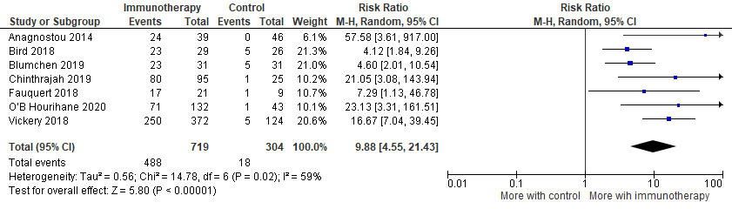

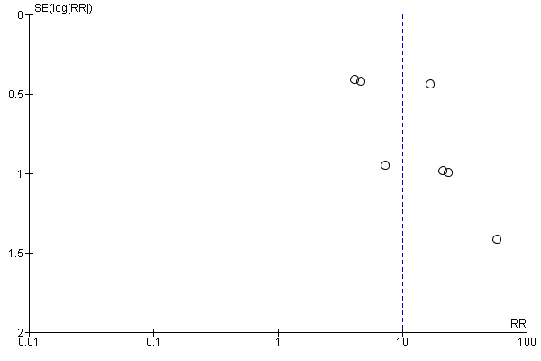

All of the studies were at low or moderate risk of bias. Excluding studies at moderate risk of bias, the trend was maintained in pooled data from 6 studies at low risk (RR 9.09, CI 3.80 to 21.73).

Tolerated 300mg single dose of peanut protein

Pooled data from 5 studies found that oral immunotherapy was associated with an increased likelihood of being able to tolerate a dose of 300mg at study exit. 4 of these studies were in children with mixed levels of allergy severity and 1 in mixed age groups with moderate level severity. 4 of the studies included exact data for the proportion tolerating a 300mg dose. We extracted data in the range 300 to 600mg from 1 study.

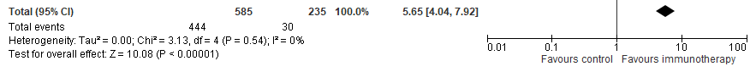

Tolerated cumulative dose of 300mg peanut protein

Pooled data from the same 5 studies found that oral immunotherapy was associated with an increased likelihood of being able to tolerate a cumulative dose of 300mg at study exit. 1 of the studies included exact data for the proportion tolerating a cumulative 300mg dose. We extracted data in the range 300 to 600mg from the other 4 studies.
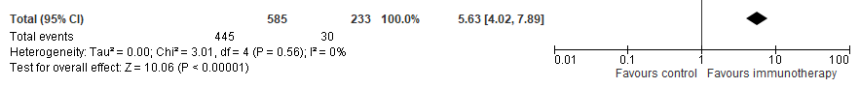

Tolerated single dose of 1000mg peanut protein at exit

Pooled data from 5 studies found that oral immunotherapy was associated with an increased likelihood of being able to tolerate a dose of 1000mg at study exit. All studies included exact data about the proportion tolerating a 1000mg dose.

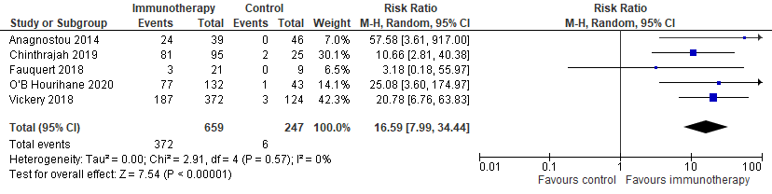

Tolerated cumulative dose of 1000mg peanut protein at exit

Pooled data from 6 studies found that oral immunotherapy was associated with an increased likelihood of being able to tolerate a cumulative dose of 1000mg at study exit. 3 of these studies included exact data about the proportion tolerating a 1000mg cumulative dose. We extracted data in the range 1000 to 2000mg from the other 3 studies.
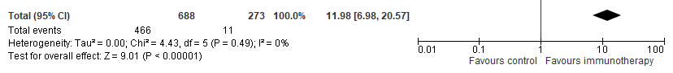

Sustained unresponsiveness

1 study in children found an increased proportion of sustained responsiveness in the oral immunotherapy group. This study was at low risk of bias. The children had mixed levels of allergy severity.

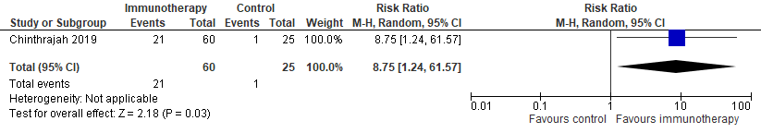

Any adverse reactions

7 comparisons examined the number of people experiencing adverse events of any type, not necessarily linked to therapy. Oral immunotherapy was not associated with an increased number of people experiencing adverse events compared to control (placebo), but the data were heterogeneous. The trend was also borderline, with P=0.06.

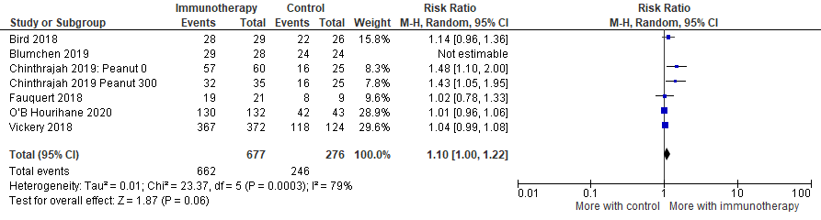

6 of the comparisons were in children (figure below) and 1 in mixed age groups.

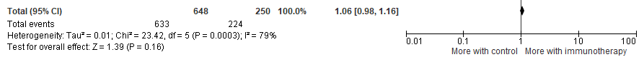

Only 2 studies explicitly focused on drug-related adverse events. Here again, there was no significant difference between groups but the data were heterogeneous. These studies were both at low risk of bias. One was in children and 1 in mixed age groups.

There were too few studies to pool with data about the number of doses associated with any adverse event or events linked to therapy.

Severe reactions

6 comparisons explored the number of people experiencing severe reactions, whether related to the intervention or not. There was no significant difference between oral immunotherapy and placebo. All of the studies were in children and participants had mixed levels of allergy severity.

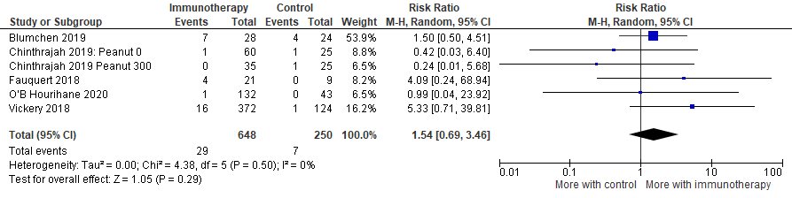

Life-threatening reactions

7 comparisons collected data about the number of people experiencing life-threatening reactions. Most had no events. There was no difference between oral immunotherapy and controls. Continuity correction did not affect this conclusion. 6 of the comparisons were in groups of children with mixed allergy severity. 1 was in mixed age groups with moderate severity.

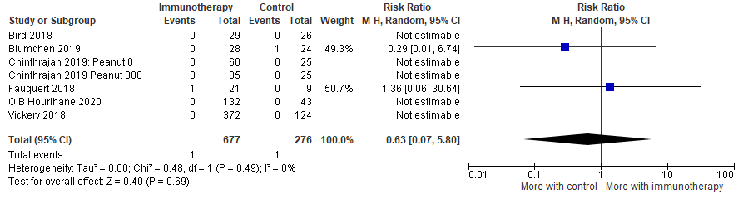

Risk difference
Note that for risk differences, a pooled value of around 0 means no difference between groups.

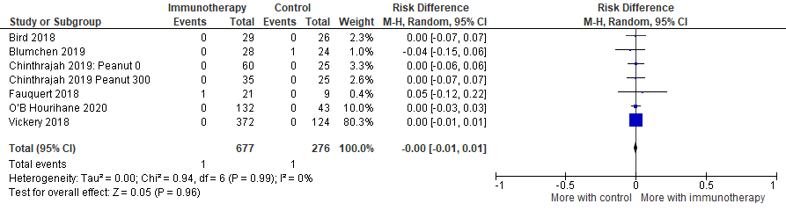

Anaphylaxis

3 studies collected data about anaphylaxis, as defined by the included studies. There was no difference between immunotherapy and control groups in the number of people who had anaphylaxis. Continuity correction did not affect this conclusion.

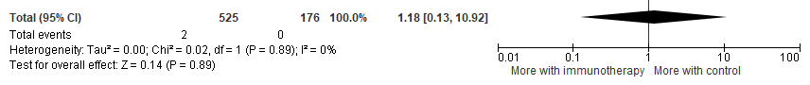

Adrenaline

5 studies included data about the number of people given intravenous adrenaline for anaphylaxis during the study period. Continuity correction did not affect this conclusion. People receiving oral immunotherapy were 2.5 times more likely to be given adrenaline for anaphylaxis. Continuity correction did not affect this conclusion. However, it is difficult to interpret these findings because studies found that immunotherapy was not associated with a great risk of anaphylaxis so findings about adrenaline may be linked to variations in how this is used in different countries.

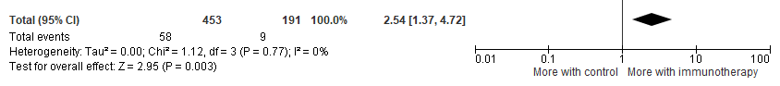
Epicutaneous immunotherapy

Desensitisation
Pooled data from 3 studies suggested increased rates of desensitisation with epicutaneous immunotherapy compared to controls. There were too few studies to examine subgroups. 1 study was in children and two in mixed age groups. 2 studies focused on people with mild/moderate allergy and 1 with mixed levels of severity.

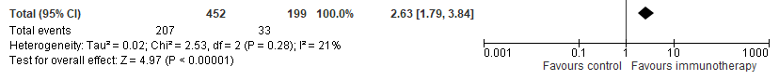

Tolerated 300mg peanut protein single dose (and same figures for cumulative dose)
Pooled data from 3 comparisons from 1 study found an increased proportion of those receiving epicutaneous immunotherapy had a last tolerated dose of 300mg. The same is true for cumulative doses of 300mg. We used data in the range 300 to 600mg from this study for both single and cumulative doses.

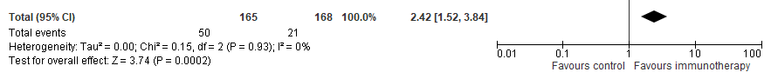

Tolerated cumulative dose of 1000mg peanut protein at exit
2 comparisons from 1 study found no difference in the proportion of epicutaneous and control participants who tolerated a cumulative dose of 1000mg peanut protein at study exit. We used data in the range 1000 to 2000mg from this study.

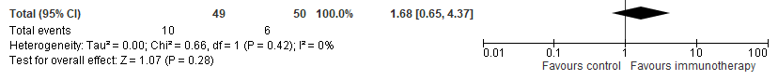

Any adverse reactions
4 comparisons explored any adverse reactions, not necessarily related to therapy. Epicutaneous immunotherapy was not associated with an increased proportion of people experiencing adverse reactions compared to placebo. However the data were heterogeneous. This was not explained by age. 1 of the studies was in children and the other 4 comparisons in mixed age groups.

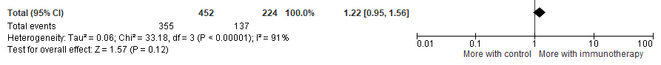
Only 1 study explicitly focused on drug-related adverse events. Here again, there was no significant difference between groups. There were too few studies to pool with data about the number of doses associated with any adverse event or events linked to therapy.

Severe reactions
4 comparisons explored the number of people experiencing severe reactions. There was no significant difference between epicutaneous immunotherapy and placebo. There were too few studies to pool data for the number of doses associated with severe reactions. There was no difference between groups in life-threatening events, use of adrenaline or anaphylaxis.

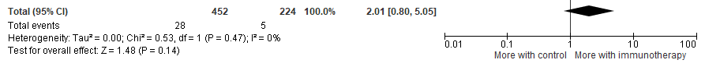

Sublingual immunotherapy

Desensitisation

We included only 1 study of sublingual immunotherapy for people with peanut allergy. This study found increased desensitisation. The study was in adults with mild/moderate peanut allergy.

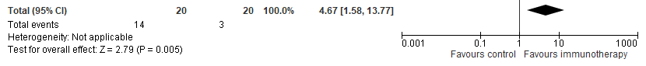

Tolerated 300mg peanut protein single dose

The 1 study of sublingual immunotherapy for people with peanut allergy found no increase in the proportion able to tolerate a last dose of 300mg peanut protein: RR 1.67 (0.46, 6.06). We extracted data about last tolerated dose in the range 300 to 600mg from this study.

Tolerated cumulative dose of 1000mg peanut protein at exit

The 1 study of sublingual immunotherapy for people with peanut allergy found no increase in the proportion able to tolerate a cumulative dose of 1000mg peanut protein: RR 1.50 (0.28, 8.04). We extracted cumulative data in the range 1000 to 2000mg from this study.

Severe reactions

The study examined severe reactions, but there were 0 events in each arm.

Subcutaneous immunotherapy

Desensitisation

We included only 1 study of subcutaneous immunotherapy for people with peanut allergy. This was in mixed age groups with severe allergy. In this study subcutaneous immunotherapy had no significant impact on desensitisation compared to control. It did not explore other outcomes of interest to the review.

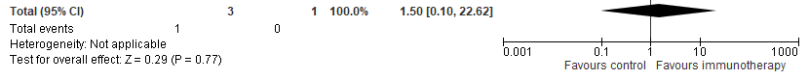

Duration of treatment

We found no clear relationship between the total duration of treatment (build up and maintenance) and outcomes of immunotherapy for people with peanut allergy.

Total number of weeks therapy vs absolute difference in % desensitised (intervention minus placebo)

Total number of weeks therapy vs absolute difference in % with adverse events (intervention - placebo)

Total number of weeks therapy vs absolute difference in % with severe adverse events (intervention - placebo)

Cow’s milk protein allergy

Oral immunotherapy

All of the data available for pooling about cow’s milk protein allergy was about oral immunotherapy, apart from rare events such as life-threatening events, people who experienced anaphylaxis and people given adrenaline. Here there was one additional study about epicutaneous immunotherapy focused on safety. Those data were pooled with oral immunotherapy safety data as there were 0 events and this did not affect the conclusions.

Desensitisation

Pooled data from 7 studies of oral immunotherapy in cow’s milk found increased likelihood of desensitisation but the data were heterogeneous. We performed subgroup analysis and found that heterogeneity decreased once studies at high risk of bias were removed.

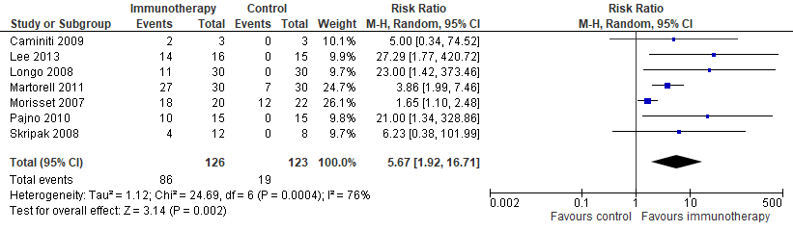

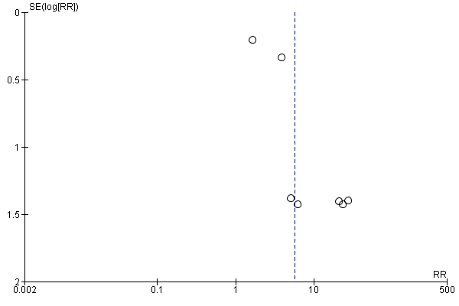

Risk of bias
3 studies were at moderate risk of bias (below). No studies were at low risk.

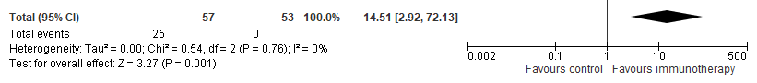

Desensitisation by comparator
Heterogeneity was high in the 4 studies which compared oral immunotherapy with an elimination diet.

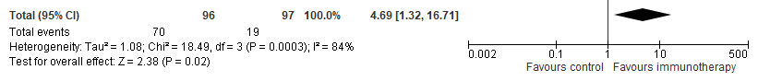

Heterogeneity was lower when oral immunotherapy was compared to placebo in 3 studies, though the confidence interval was wider.

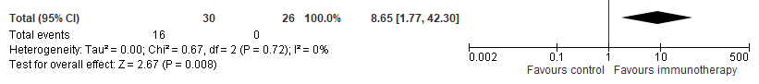

Desensitisation by age

Pooled data from 2 studies in infants found no statistically significant improvement in desensitisation, but the data were heterogeneous. The trend was positive, but it did not reach significance.

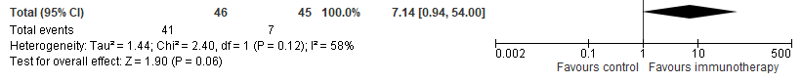

Pooled data from 4 studies in children found a significant improvement in desensitisation and low heterogeneity.

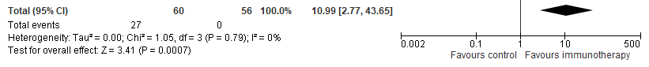

1 study was in mixed age groups.

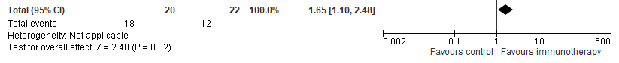

Desensitisation by severity of allergy

Oral immunotherapy was associated with a significant improvement in desensitisation using pooled data from the 3 studies of mild/moderate cow’s milk protein allergy. However heterogeneity remained.

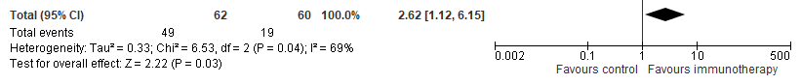

The trend was stronger in pooled data from 2 studies in people with severe allergy.
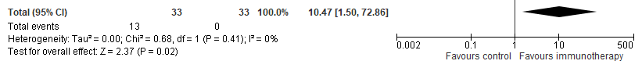
2 studies had mixed age groups.

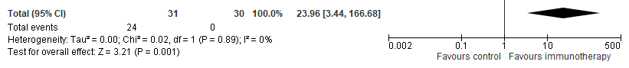

Adverse reactions

6 studies explored any adverse reactions, regardless of whether linked to therapy. Oral immunotherapy was associated with increased proportion of people with cow’s milk protein allergy experiencing adverse reactions, but the data were heterogeneous.

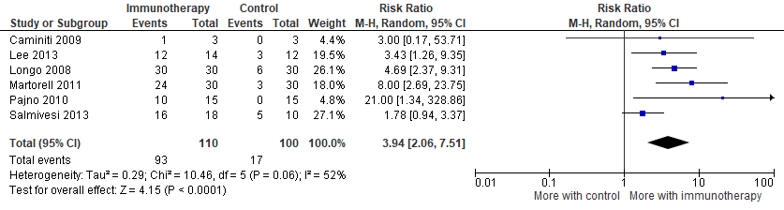

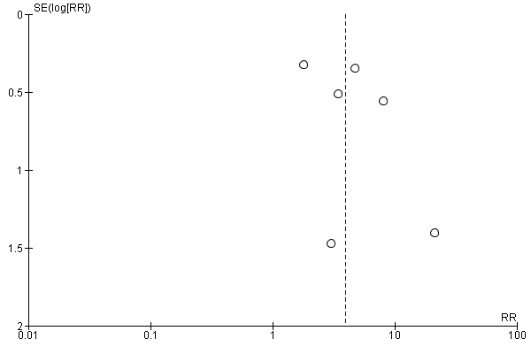

Risk of bias
Excluding studies at high risk of bias reduced the heterogeneity, but widened the confidence interval. Two studies were at moderate risk of bias (below). No studies were at low risk.

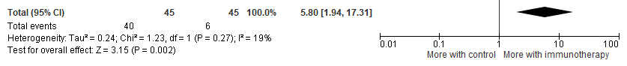

Adverse reactions by comparator
The trend towards increased proportion of people with adverse reactions held if oral immunotherapy was compared with an elimination diet (3 studies). However there was no significant difference between groups in adverse events when oral immunotherapy was compared with placebo (3 studies), though these data were heterogeneous.

Elimination diet

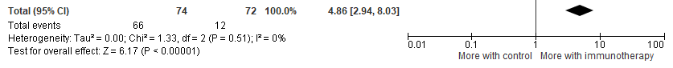

Placebo
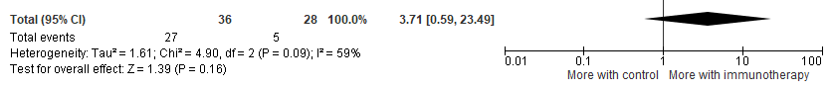

Adverse reactions by age
The trend of increased proportion with adverse reactions remained regardless of whether children or infants.

Infants (2 studies)
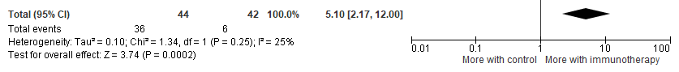

Children (4 studies)
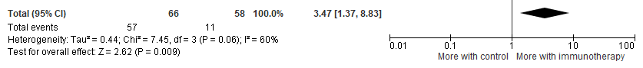

Adverse events by severity of allergy
The trend of increased proportion experiencing adverse reactions remained regardless of the level of severity of the allergy.

Mild/moderate (1 study)
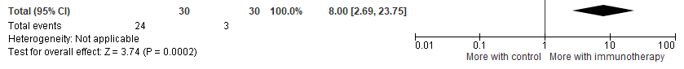

Severe (2 studies)
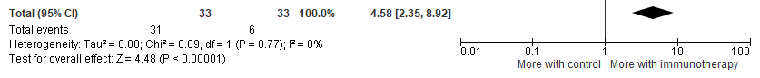

Mixed (3 studies)
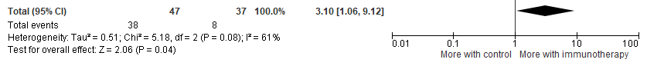
Severe reactions

Five studies measured the proportion of people with severe reactions, whether linked to therapy or not. Oral immunotherapy was not associated with an increased risk of severe reactions, whether data were pooled using a continuity correction or not.

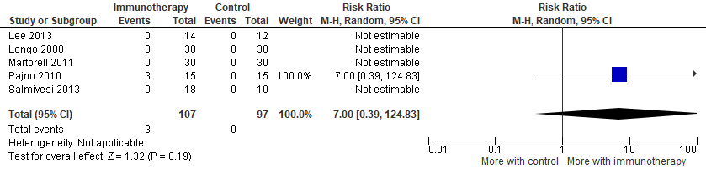
Continuity correction

Risk ratio 3.71 (0.27 to 51.84), Z 0.97, P 0.33, I² = 0%

Risk difference
Note that for risk differences, a pooled value of around 0 means no difference between groups.

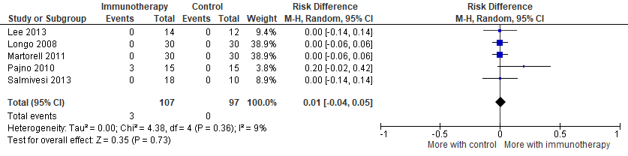

Too few events available for meaningful subgroup analysis.

There were too few studies with data available to pool information about:

- Number of people with adverse events linked to therapy (0 studies)
- Number of people with severe adverse events related to therapy (0 studies)
- Doses associated with adverse events (2 studies)
- Doses associated with severe events (0 studies)

People given adrenaline

In addition to the 6 studies of oral immunotherapy, 1 study of epicutaneous immunotherapy also explored rare events such as anaphylaxis, adrenaline use and life-threatening reactions. This was a small study with 0 events in each arm so the data were pooled with oral immunotherapy. Sensitivity analysis showed that this made no difference to the trends.

In basic analysis, it appeared that immunotherapy may increase the number of people given adrenaline. However once a continuity correction was applied to account for the studies with 0 in each arm, there was no significant difference between immunotherapy and controls.

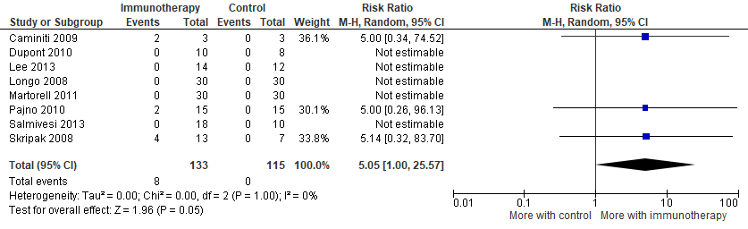
Continuity correction risk ratio 2.93 (0.6 to 14.31), Z 1.33, P 0.18, I² = 0%

Risk difference
Note that for risk differences, a pooled value of around 0 means no difference between groups.

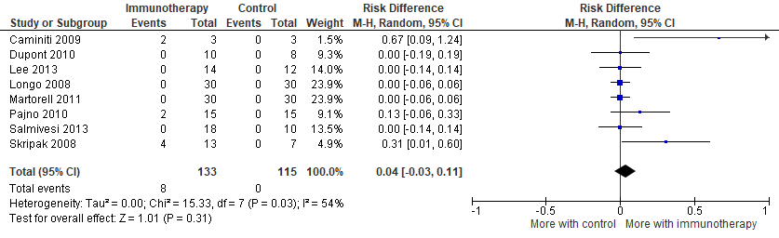

There were too few events available for meaningful subgroup analysis.

Life-threatening adverse events

There was no significant difference between groups in the proportion who experienced life-threating adverse events.

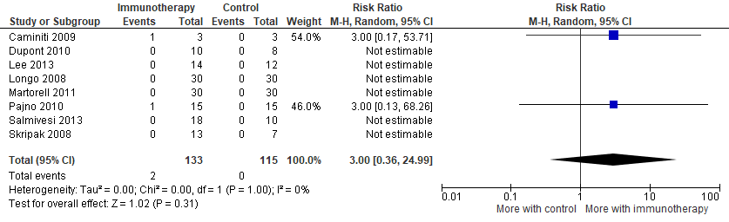
Continuity correction risk ratio 1.59 (0.2 to 12.46), Z 0.44, P 0.66, I² = 0%

Risk difference
Note that for risk differences, a pooled value of around 0 means no difference between groups.

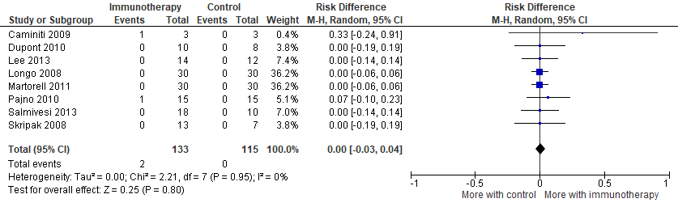

People with anaphylaxis

There was no significant difference between groups in the proportion with anaphylaxis.

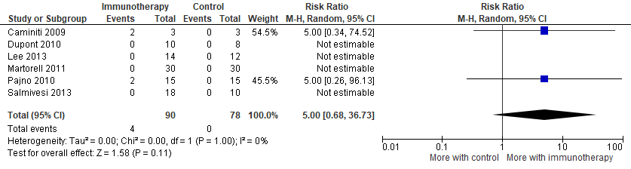

Continuity correction risk ratio 2,76 (0.39 to 19.21), Z 1.02, P 0.31, I² = 0%.

Risk difference
Note that for risk differences, a pooled value of around 0 means no difference between groups.

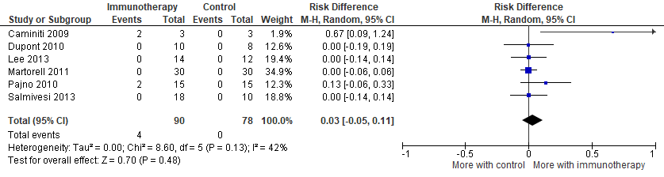

Hen’s egg allergy

Oral immunotherapy

All included studies about hen’s egg allergy investigated oral immunotherapy.

Desensitisation

Pooled data from 6 studies, all of which were in children, found increased likelihood of desensitisation compared to controls.

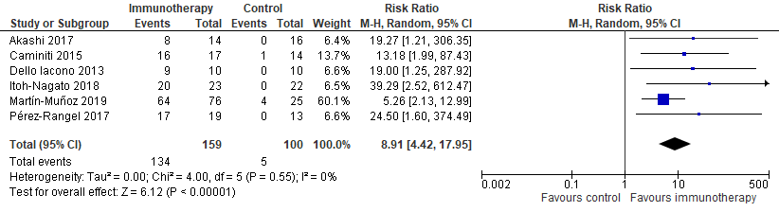

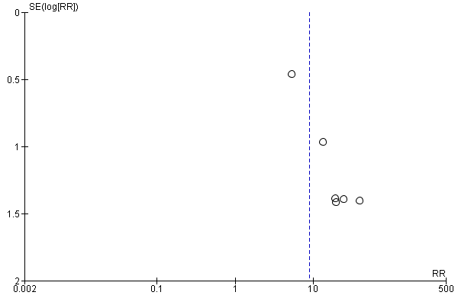

Risk of bias
This trend remained regardless of study risk of bias, or when studies at high risk of bias were removed. 5 studies were at low or moderate risk of bias.

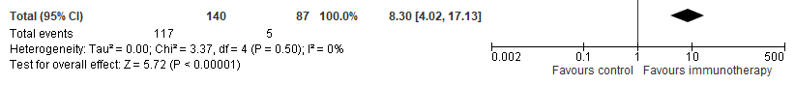

1 study was at low risk of bias.

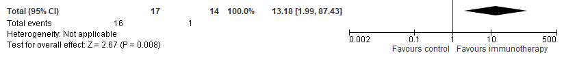
Desensitisation by comparator
The finding of increased desensitisation held regardless of whether oral immunotherapy was compared with an elimination diet or placebo.

Elimination diet (5 studies)

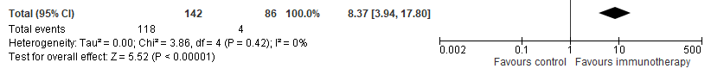

Placebo (1 study)

Desensitisation by severity of allergy
The finding of increased desensitisation held regardless of the severity of hen’s egg allergy.

Mild/moderate (3 studies)

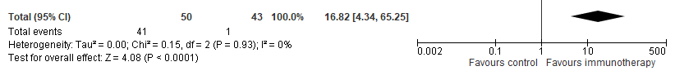

Severe (1 study)
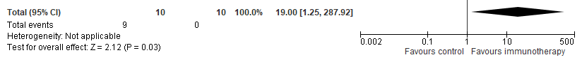

Mixed (2 studies)
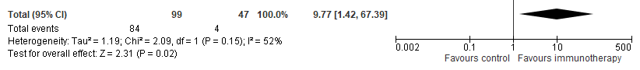

Sustained unresponsiveness

Oral immunotherapy was associated with increased proportions of sustained unresponsiveness in children (2 studies).

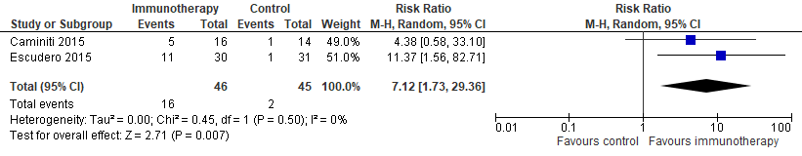

Adverse reactions

6 studies in children explored adverse reactions, regardless of whether linked to therapy. Oral immunotherapy was associated with increased proportion of children with adverse reactions, though the data were heterogeneous.

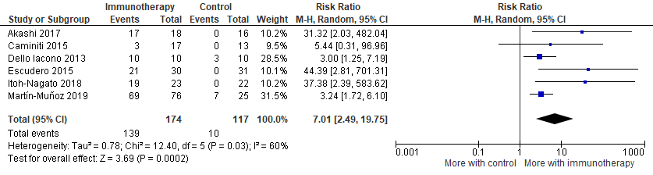

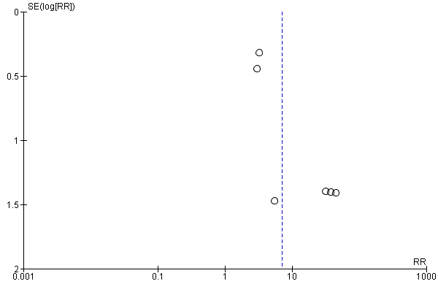

All 6 studies were at low or moderate risk of bias. The single study at low risk of bias did not find that oral immunotherapy significantly increased adverse reactions.

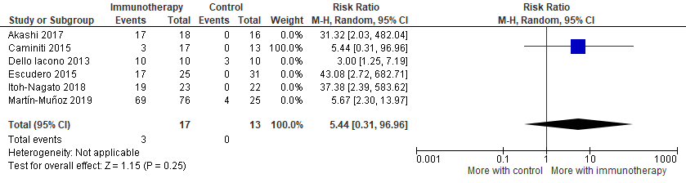

Adverse reactions by comparator
Studies which compared oral immunotherapy versus an elimination diet found that immunotherapy was associated with increased numbers of children with adverse reactions. The study that compared immunotherapy with placebo found no difference in the proportion with adverse reactions.

Elimination diet (5 studies)
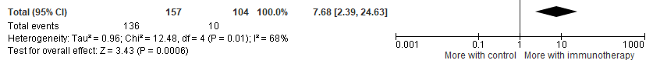

Placebo (1 study)

Adverse reactions by severity of allergy
The trend towards an increased proportion experiencing adverse events held regardless of the level of severity of hen’s egg allergy.

Mild/moderate (2 studies)
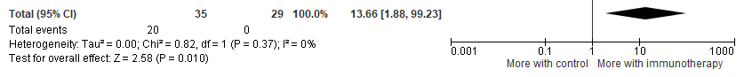

Severe (1 study)
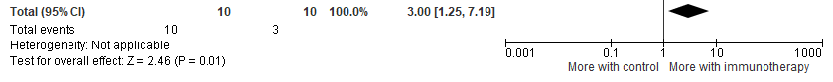

Mixed (3 studies)
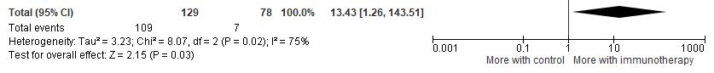

Severe reactions

Four studies included data about the number of people experiencing severe reactions. These were rare. Oral immunotherapy was not associated with an increased proportion of people experiencing severe reactions.

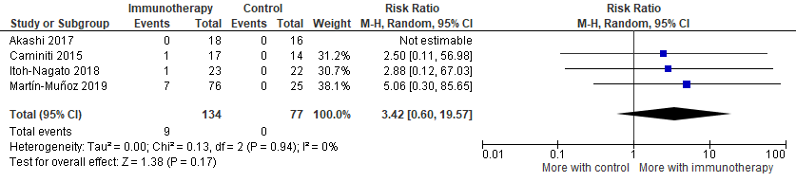
Continuity correction made minimal difference to estimates.

All 3 studies were with children. All 3 studies were at low or moderate risk of bias. The 1 study at low risk of bias also found no significant difference between groups: RR 2.50 (0.11, 56.98).

Risk difference
Note that for risk differences, a pooled value of around 0 means no difference between groups.

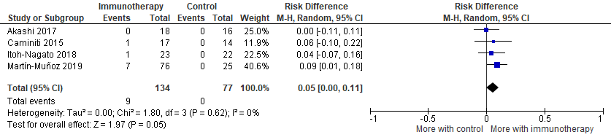
Severe reactions by comparator
The finding of no difference between groups in the proportion of people with severe reactions held regardless of whether oral immunotherapy was compared to elimination diet or placebo.

Elimination diet (2 studies)
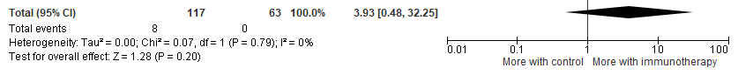

Placebo (1 study): RR 2.50 (0.11, 56.98)

Severe reactions by severity of allergy
The finding of no difference between groups in the proportion with severe reactions held regardless of people’s level of allergy severity.

Mild/moderate (1 study): RR 2.50 (0.11, 56.98)

Mixed (2 studies)
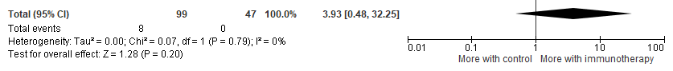

Life threatening events
No study reported any life-threatening events.

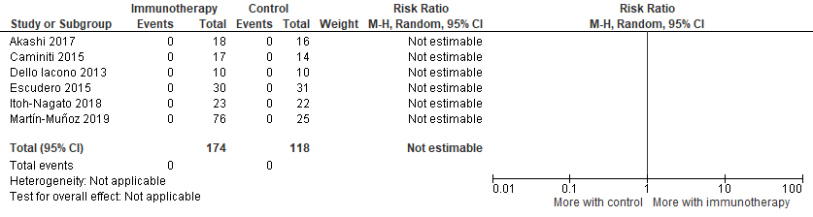

Continuity correction risk ratio 0.79 (0.01 to 123.37), Z 0.073, P 0.92, I² = 0%
Risk difference
Note that for risk differences, a pooled value of around 0 means no difference between groups.

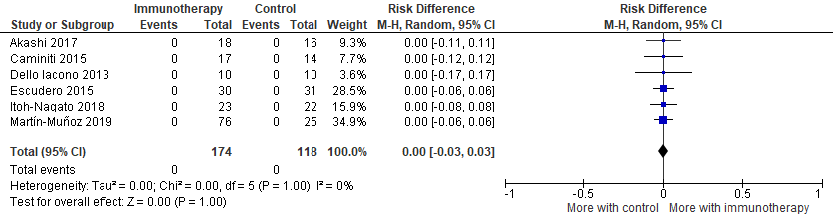

People with anaphylaxis
Few people experienced anaphylaxis during the studies and there was no significant difference between groups.

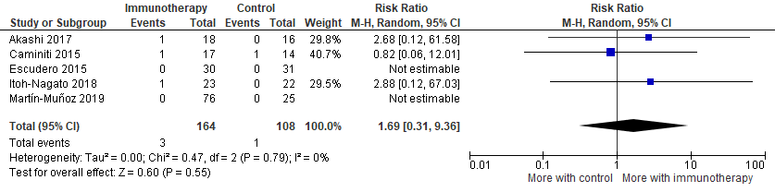

Continuity correction risk ratio 1.25 (0.22 to 7.1), Z 0.25, P 0.80, I² 0.0%.

Risk difference
Note that for risk differences, a pooled value of around 0 means no difference between groups.

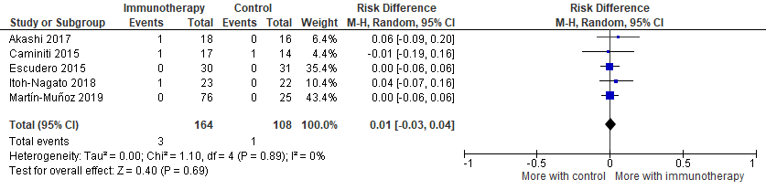

People given adrenaline
Few people were given adrenaline for adverse reactions and there was no significant difference between groups.

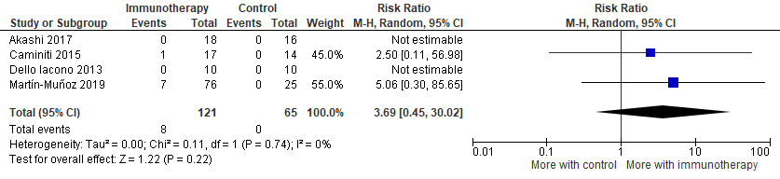
Continuity correction risk ratio 2.67 (0.33 to 21.58), Z 0.919, P 0.35, I² = 0%.

Risk difference
Note that for risk differences, a pooled value of around 0 means no difference between groups.

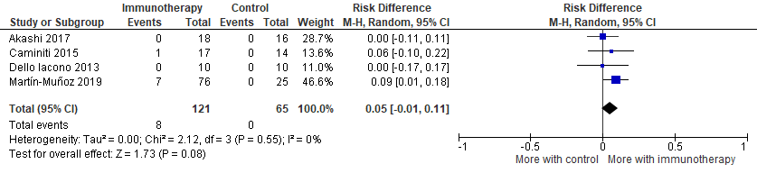

Combined data from all included allergen immunotherapy studies

Desensitisation

28 studies included a measure of desensitisation. Measures differed across studies. There was a trend towards an increased proportion of people receiving immunotherapy achieving desensitisation compared to controls, but the studies and findings were too heterogeneous.

The broad trend held regardless of age group, type of food allergy, allergy severity, type of immunotherapy, study region or risk of bias.

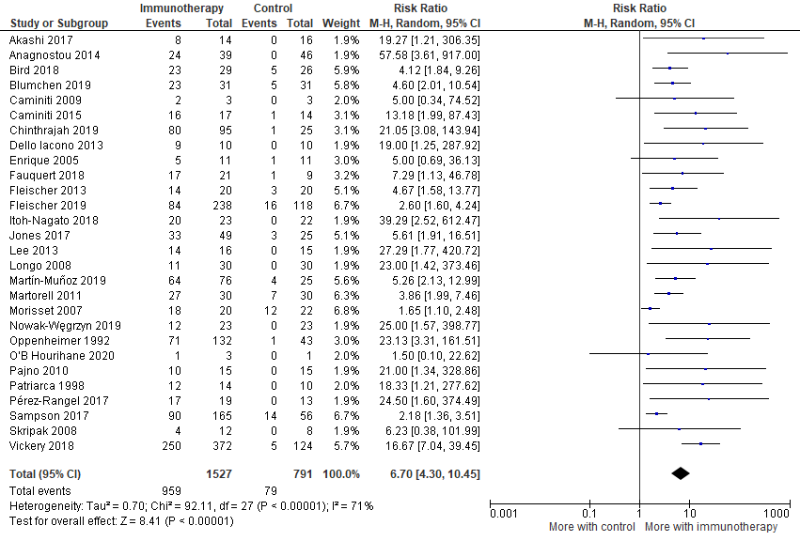

Funnel plot

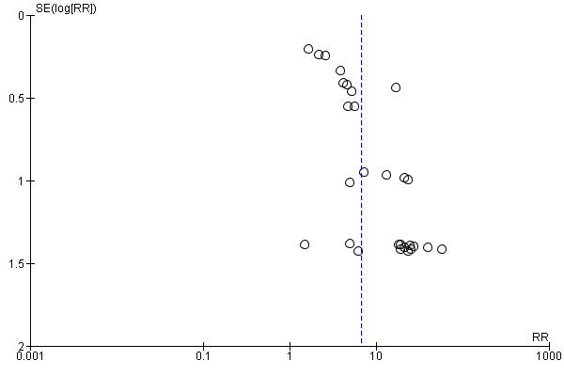
Desensitisation depending on study risk of bias

Studies at low or moderate risk of bias (21 studies)

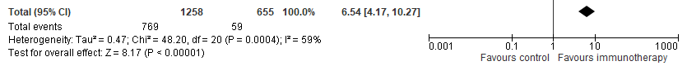
More with immunotherapy

Studies at low risk of bias (10 studies)

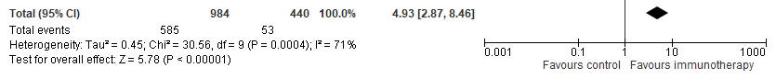
More with immunotherapy

Desensitisation by study region

Asia (3 studies)

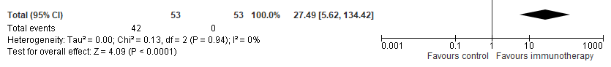
More with immunotherapy

Europe (15 studies)

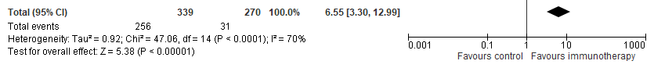
More with immunotherapy

North America (7 studies)

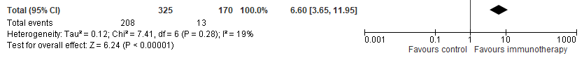
More with immunotherapy

Mixed (3 studies)

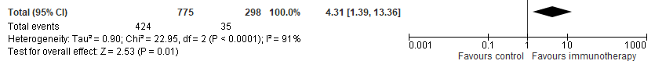
More with immunotherapy

Desensitisation by age

Infants (<3 years) (2 studies)

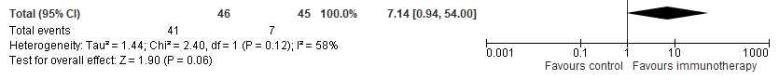
More with immunotherapy

Children (3-17 years) (18 studies)

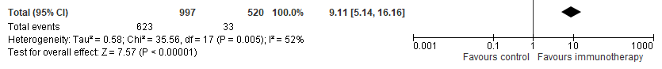
More with immunotherapy

Adults (18+ years) (2 studies)
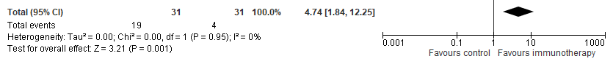
More with immunotherapy

Mixed ages (6 studies)

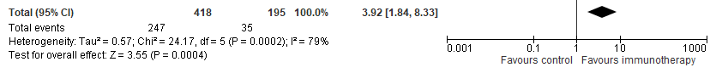
More with immunotherapy

Desensitisation by immunotherapy route

Oral (22 studies)

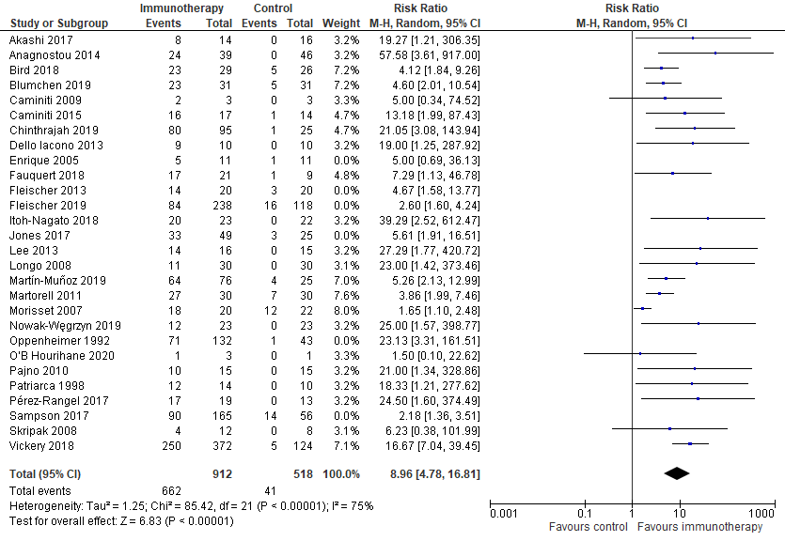

Epicutaneous (3 studies)

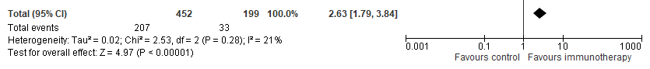

Sublingual (2 studies)

Subcutaneous (1 study)

RR 23.13 (3.31 to 161.51)

Desensitisation by severity of food allergy

Mild / moderate (11 studies)

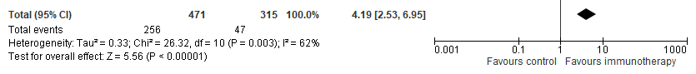
More with immunotherapy

Severe (4 studies)

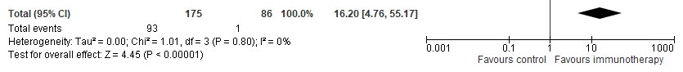
More with immunotherapy

Mixed (13 studies)

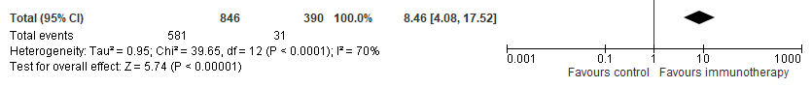
More with immunotherapy

Desensitisation by comparator type

Placebo (17 studies)

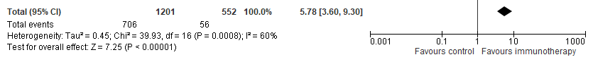
More with immunotherapy
Elimination diet (11 studies)

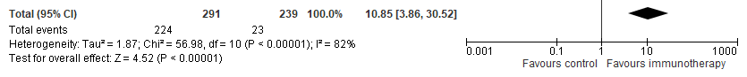
More with immunotherapy

Sustained unresponsiveness

Only 4 studies included a measure of sustained unresponsiveness (ability to tolerate allergen after ceasing immunotherapy). The findings were heterogeneous and did not reach statistical significance.

All 4 studies were in children and were of oral immunotherapy. 2 studies were in hen’s egg allergy, 1 in peanut and 1 in study of children with various types of allergy. 2 studies compared with placebo and 2 with elimination diet. All four studies were at low or moderate risk of bias.

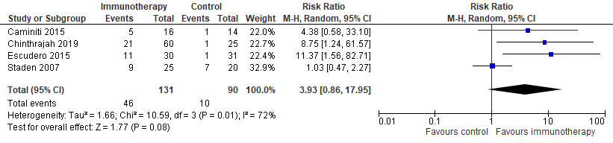
More with immunotherapy
Funnel plot
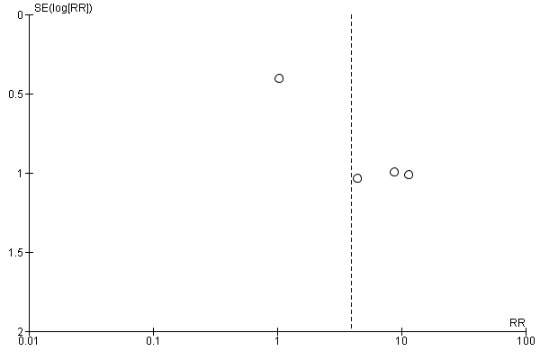

In the 2 studies at low risk of bias the trend did reach statistical significance.

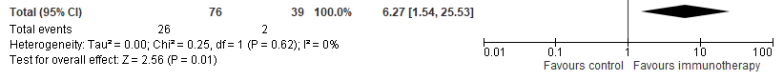

There was no difference in the trend based on the region (Europe versus North America). Studies with mixed levels of allergy severity were more likely to show a significant difference than children with mild/moderate allergy.

2 studies were with children with mild/moderate allergy
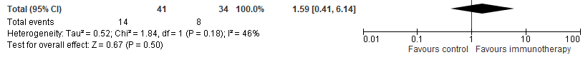

2 studies were with children with mixed allergy severity
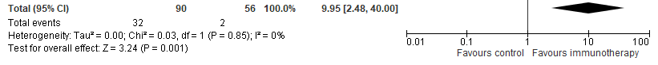
Number of people experiencing ANY adverse reaction

25 studies with 27 comparisons included a measure of adverse reactions. The definitions varied in each study (see S3). The data presented below relate to any reaction, whether linked to therapy or not. There were more adverse reactions with immunotherapy but the data were heterogeneous.

The broad trends held regardless of age group, allergy severity, type of immunotherapy, region or risk of bias

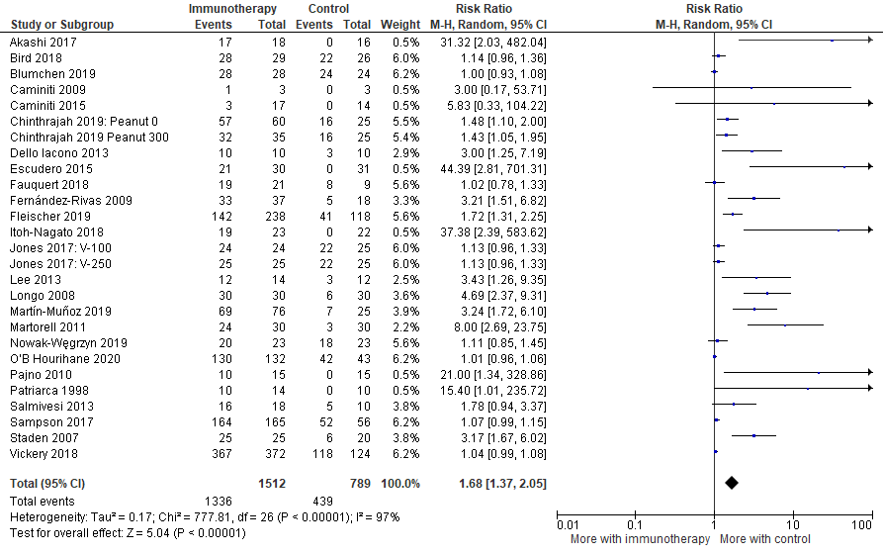
More with immunotherapy

Funnel plot

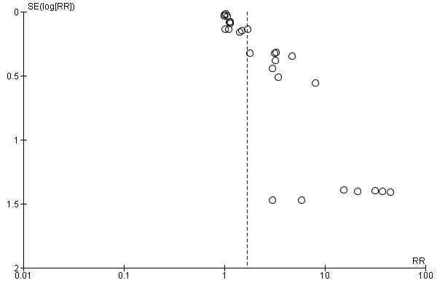

Number of people experiencing adverse reactions related to therapy

Only 4 studies contained data about adverse reactions explicitly linked to active or control therapy. Immunotherapy was not more likely to increase adverse reactions, but the data were too heterogeneous.

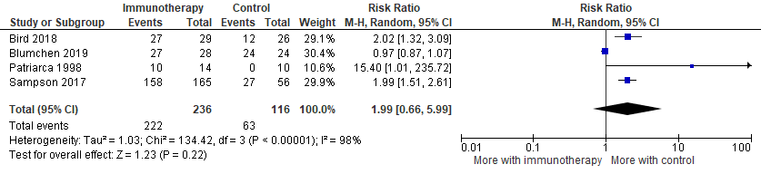
More with immunotherapy

Funnel plot

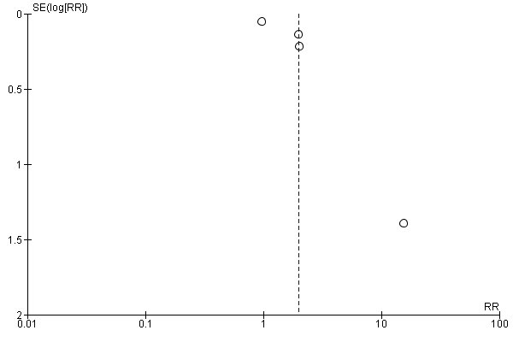

3 of the studies focused on peanut, one on multiple allergens.

For peanut all three studies were at low risk of bias. Immunotherapy did not increase adverse reactions linked to therapy, but the data were heterogeneous.

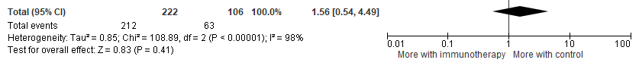
More with immunotherapy

The study exploring multiple food allergies was at high risk of bias: RR 15.4 (1.01 to 235.72)

Number of doses associated with ANY adverse reaction

In 9 comparisons, there was a trend towards doses of active immunotherapy increasing the likelihood of any adverse reaction (not necessarily linked to therapy), but the data were heterogeneous. The trend held regardless of study risk of bias. Studies in adults and North America were more likely to show a negative impact.

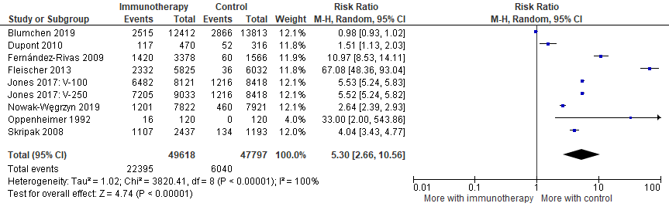
More with immunotherapy

All studies used placebo, not elimination diet

Funnel plot

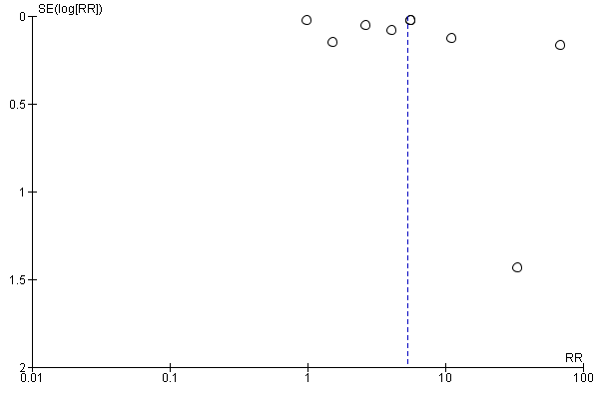

Doses with adverse events by study risk of bias

Low or moderate risk of bias (8 comparisons)

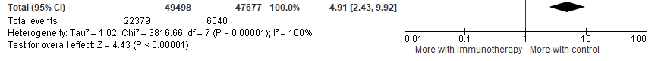
More with immunotherapy

Low risk of bias (4 comparisons)

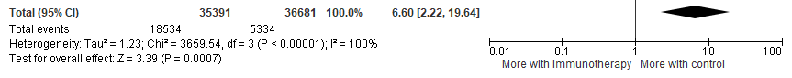
More with immunotherapy

Doses with adverse events by study region

Europe (3 studies)

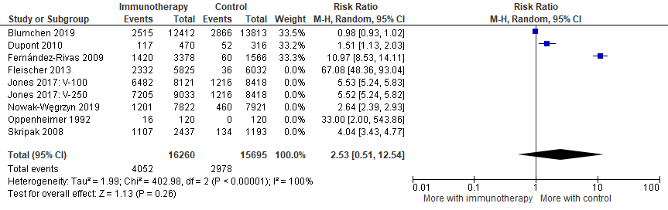
More with immunotherapy

North America (6 comparisons)

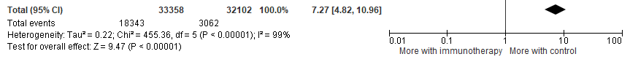
More with immunotherapy

Doses with adverse events by age

Children (2 studies)

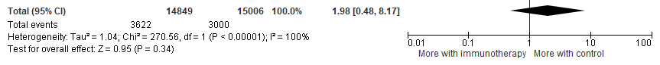
More with immunotherapy

Adults (2 studies)

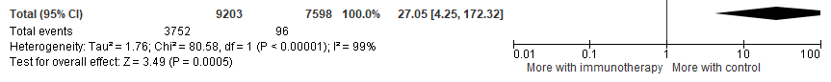
More with immunotherapy

Mixed (5 comparisons)

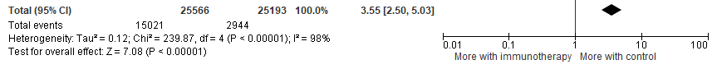
More with immunotherapy

Doses with adverse events by administration route

Oral (3 studies)

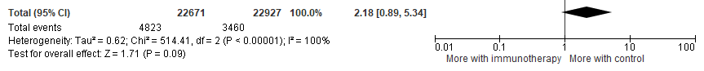
More with immunotherapy

Epicutaenous (3 comparisons)

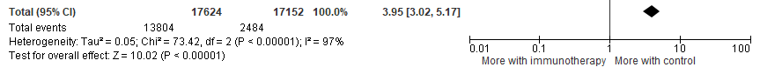
More with immunotherapy

Subcutaneous (1 study)

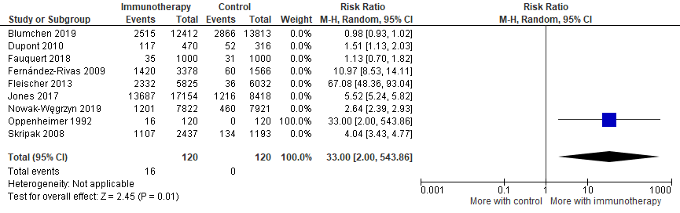
More with immunotherapy

Sublingual (2 studies)

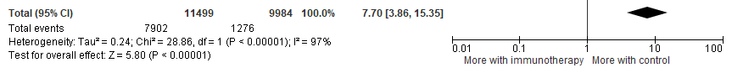
More with immunotherapy

Doses with adverse events by severity of food allergy

Mild/moderate (5 comparisons)

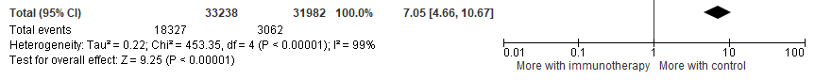
More with immunotherapy

Severe (1 study)

More with immunotherapy

Mixed (3 studies)

More with immunotherapy

Number of doses experiencing adverse reactions related to therapy

Only 2 studies explored doses with adverse reactions explicitly linked to therapy. The pooled data suggested that immunotherapy did not increase the risk but this conclusion cannot be relied on. The data were heterogeneous and both of the studies independently suggested increased numbers of immunotherapy doses had adverse events compared with control doses.

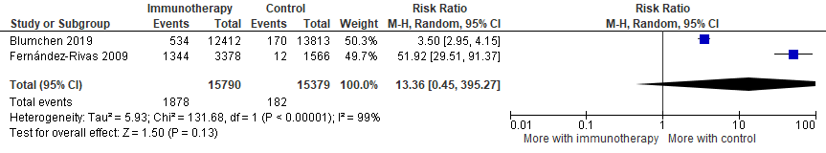
More with immunotherapy

Funnel plot

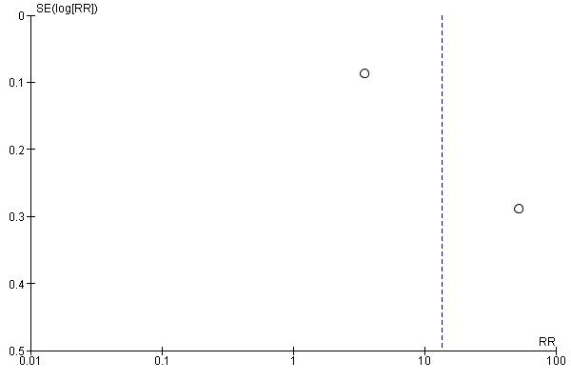

Number of people experiencing severe adverse reactions

There were 13 calculable comparisons about severe adverse reactions. All calculable studies were at low or moderate risk of bias. This analysis suggested a small increase in the risk of severe adverse reactions with immunotherapy, however once studies with 0 events in all arms were taken into account there was no significant difference in severe reactions with immunotherapy compared to placebo.

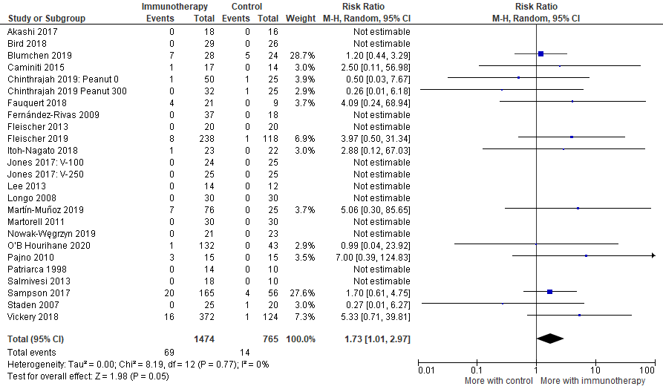

Funnel plot

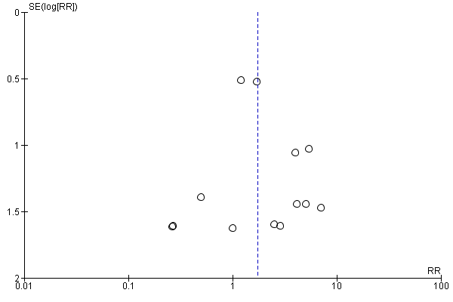

We used Revman 5.4 (Cochrane) to undertake meta-analysis. The Cochrane manual notes that Revman does not include studies where all arms have zero events when calculating risk ratios: “The standard practice in meta-analysis of odds ratios and risk ratios is to exclude studies from the meta-analysis where there are no events in both arms. This is because such studies do not provide any indication of either the direction or magnitude of the relative treatment effect. Whilst it may be clear that events are very rare on both the experimental intervention and the comparator intervention, no information is provided as to which group is likely to have the higher risk, or on whether the risks are of the same or different orders of magnitude.”
We reported using this convention in the text of the systematic review, but also took steps to check that the trends were not different when 0 events in each arm were accounted for. We did this by looking at the risk difference and also by undertaking a continuity correction (adding 0.05 to the numerators and denominators where all study arms had 0 events).

Risk difference using data from ALL studies, including 0 events
Note that for risk differences, a pooled value of around 0 means no difference between groups.

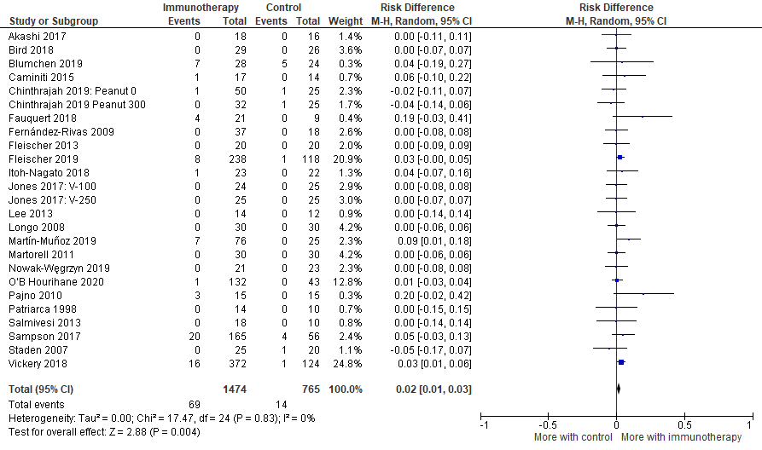
Continuity correction

There were 25 comparisons when including data with a continuity correction. Adding 0.05 to studies where all arms have 0 events suggested no significant difference in severe reactions with immunotherapy compared to placebo.

RR = 1.6 (0.93 to 2.76), Z score 1.7, p value 0.088, I² = 0.0%, Tau² = 0.0

Funnel plot

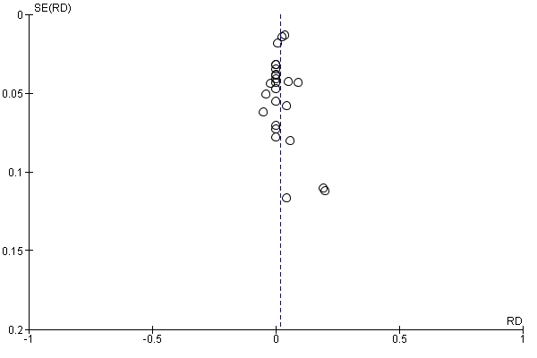
Number of people experiencing severe reactions related to therapy

Only two studies included data about severe reactions explicitly linked to therapy. There was no statistically significant increase in risk with immunotherapy, but the data were sparse and there was a wide potential range.

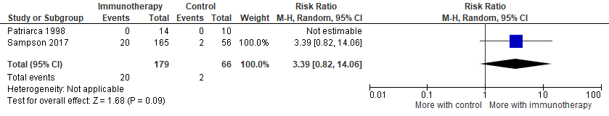

Risk difference
Note that for risk differences, a pooled value of around 0 means no difference between groups.

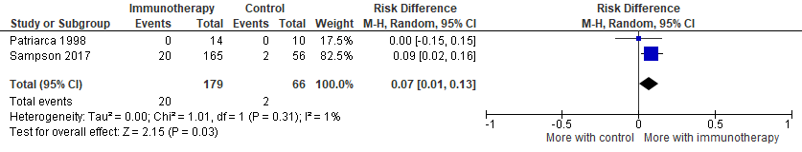

Number of doses with severe reactions

There was no significant difference between immunotherapy and controls in the number of doses with severe reactions, regardless of the cause. However the data were heterogeneous.

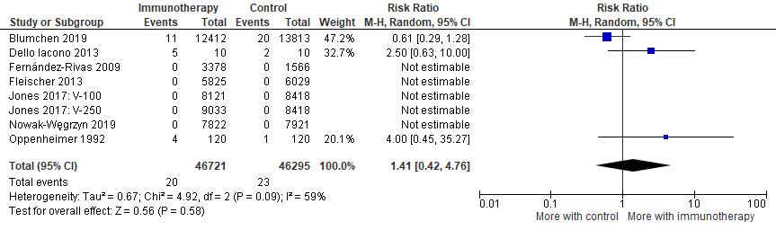
All calculable comparisons were with placebo.

Funnel plot

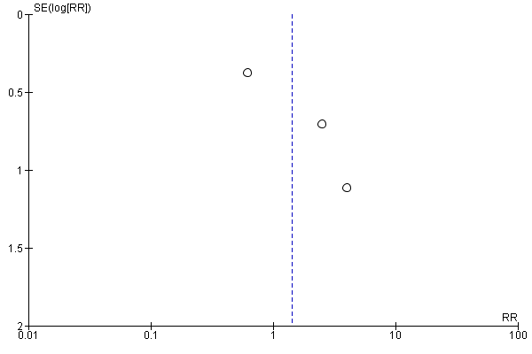

Continuity correction

Adding 0.05 to zero events: risk ratio 0.89 (0.48 to 1.66), Z 0.363, p 0.717, I² = 0.0%

Risk difference
Note that for risk differences, a pooled value of around 0 means no difference between groups.

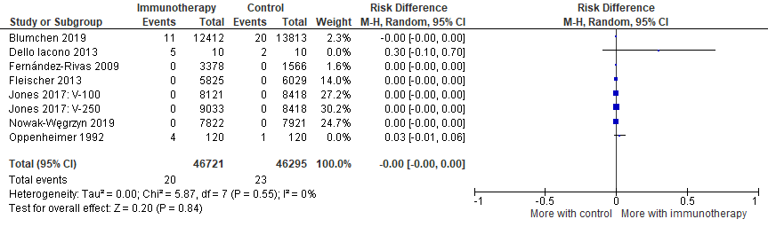

Number of people experiencing life-threatening adverse reactions

5 studies had calculable data. All calculable comparisons were with placebo, not elimination diet. Both this and analyses which corrected for the rarity of events found no significant difference in the proportion of people with immunotherapy or placebo having life-threatening reactions.

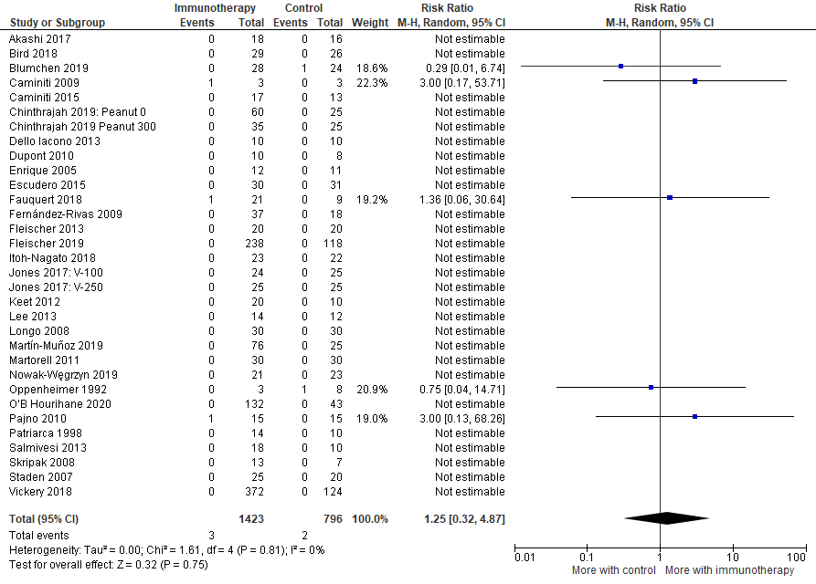

Funnel plot

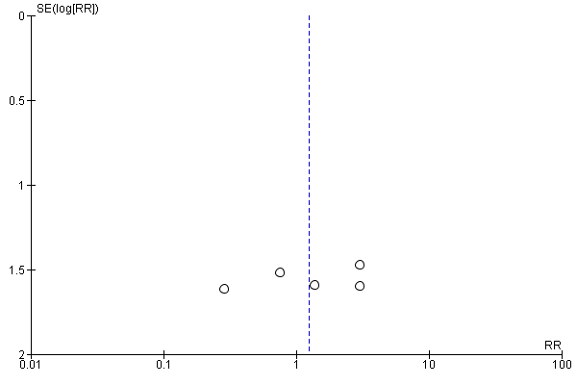

Continuity correction

Risk ratio 0.96 (0.25 to 3.66), Z 0.057, p 0.95, I² = 0.0%

Risk difference
Note that for risk differences, a pooled value of around 0 means no difference between groups.

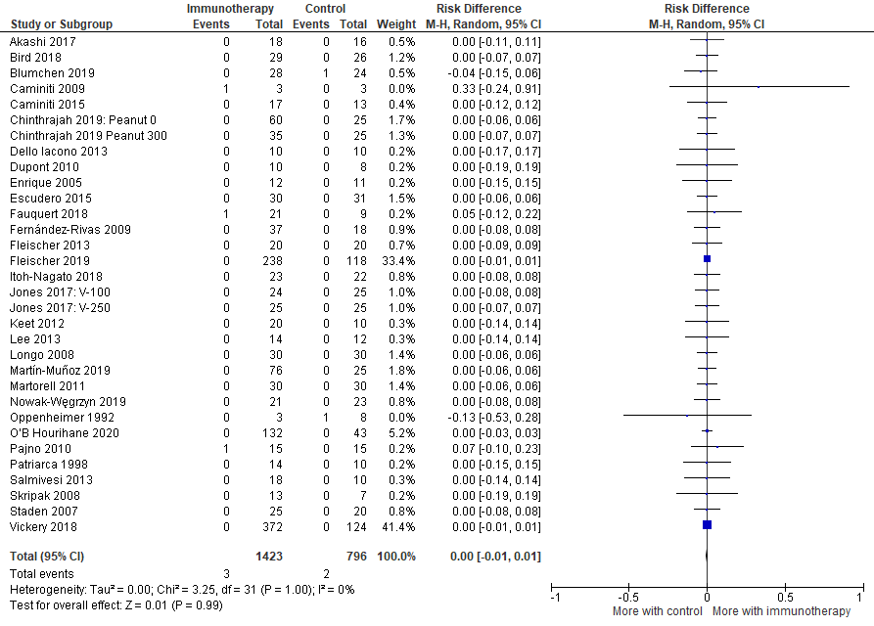

Number of doses associated with life-threatening adverse reactions

There was no difference in the risk of life-threatening adverse reactions based on doses of immunotherapy or placebo.

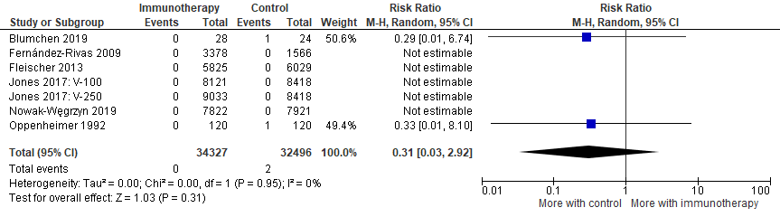

Continuity correction

Risk ratio 0.52 (0.06 to 4.6), Z 0.594, p 0.55, I² = 0.0%

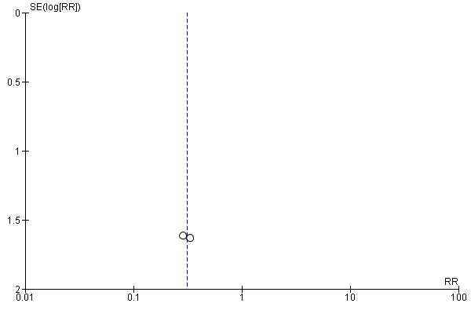

Risk difference
Note that for risk differences, a pooled value of around 0 means no difference between groups.

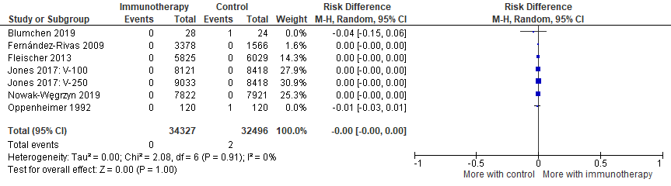

Number of people who received adrenaline

People receiving immunotherapy were more likely than controls to have received adrenaline for an adverse reaction during the study.

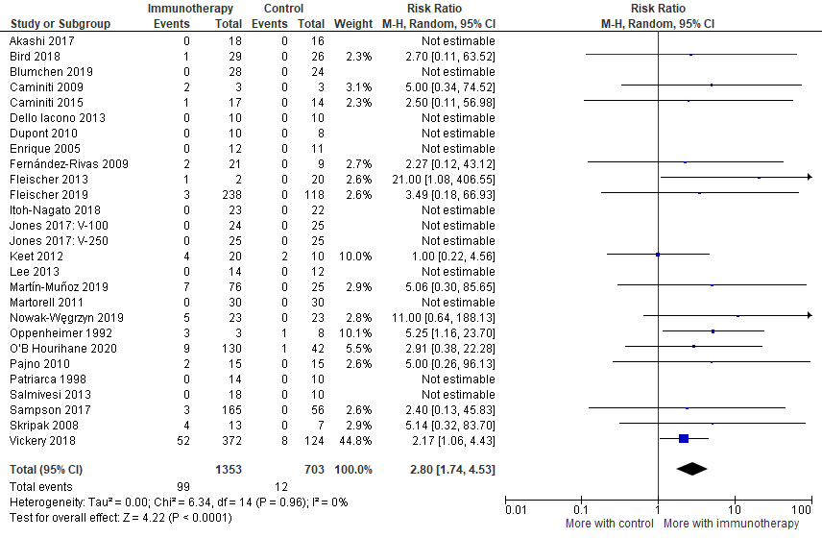

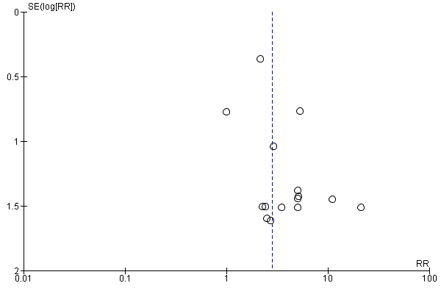

Continuity correction

Risk ratio 2.3 (1.41 to 3.76), Z 3.33, p 0.0008, I² 0.0%
Risk difference
Note that for risk differences, a pooled value of around 0 means no difference between groups.

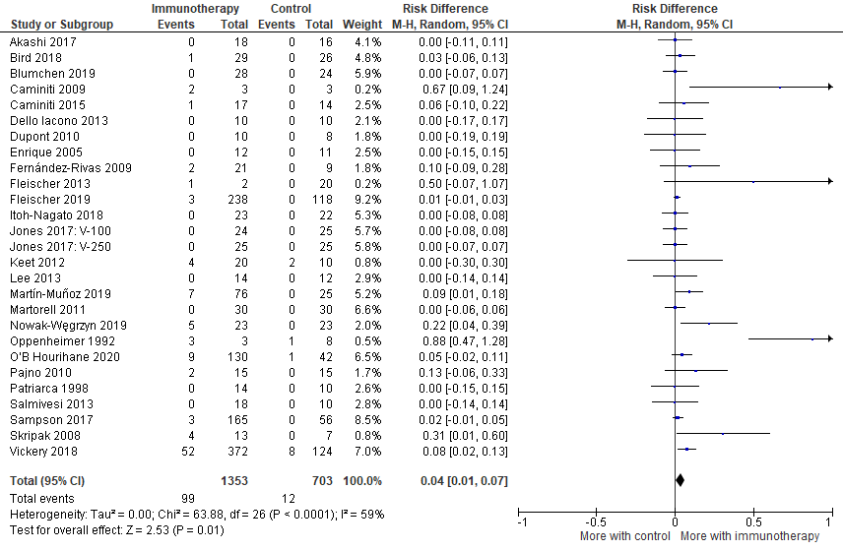

Number of people experiencing anaphylaxis

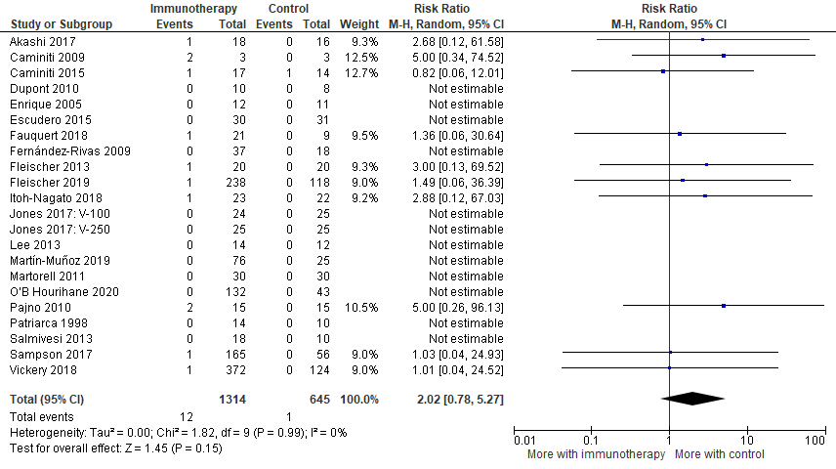

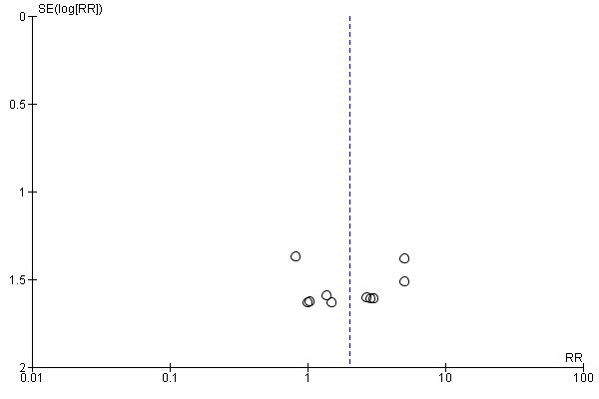

Continuity correction

Risk ratio 0.49 (0.51 to 3.48), Z 0.575, p 0.565, I² = 0,0%

Risk difference
Note that for risk differences, a pooled value of around 0 means no difference between groups.

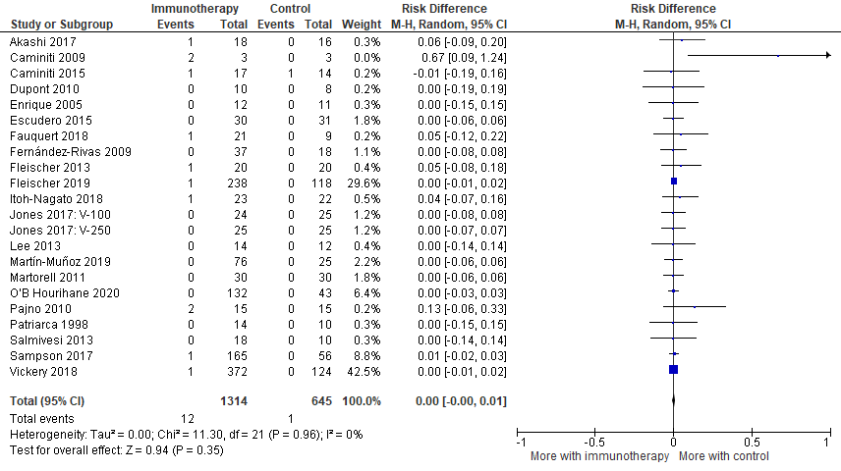

Relationship between weeks of therapy and outcomes

We found no clear impact of the duration of treatment on outcomes.

Data for all food allergies

Total number of weeks therapy vs absolute difference in % desensitised (intervention minus placebo)

Total number of weeks therapy vs absolute difference in % with adverse events (intervention - placebo)

Total number of weeks therapy vs absolute difference in % with severe adverse events (intervention - placebo)

Direct comparison of oral versus sublingual immunotherapy

There were only two studies directly comparing oral versus sublingual immunotherapy. These focused on different populations, with different regimes and measurement approaches. It is therefore not appropriate to combine and generalise the findings. Based on the limited information available, there was no significant difference between oral and sublingual immunotherapy in desensitisation, sustained unresponsiveness or adverse reactions. There was a trend towards greater efficacy and increased adverse reactions with oral immunotherapy, but this did not reach statistical significance and the data were heterogeneous.

Desensitisation

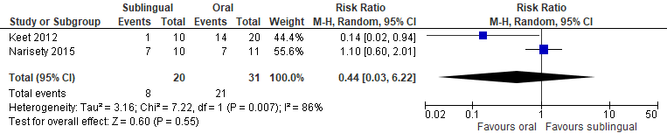

Sustained unresponsiveness

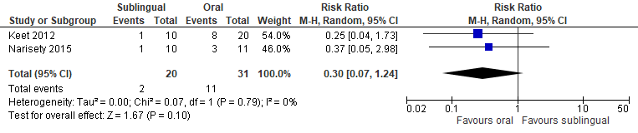

Adverse events

Measured in different ways in the two studies (people versus doses) so cannot combine apart from:

Doses with adverse events (2 studies)

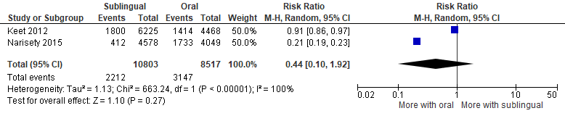

There was no comparable data to combine for severe adverse events.

