Supplementary Figures

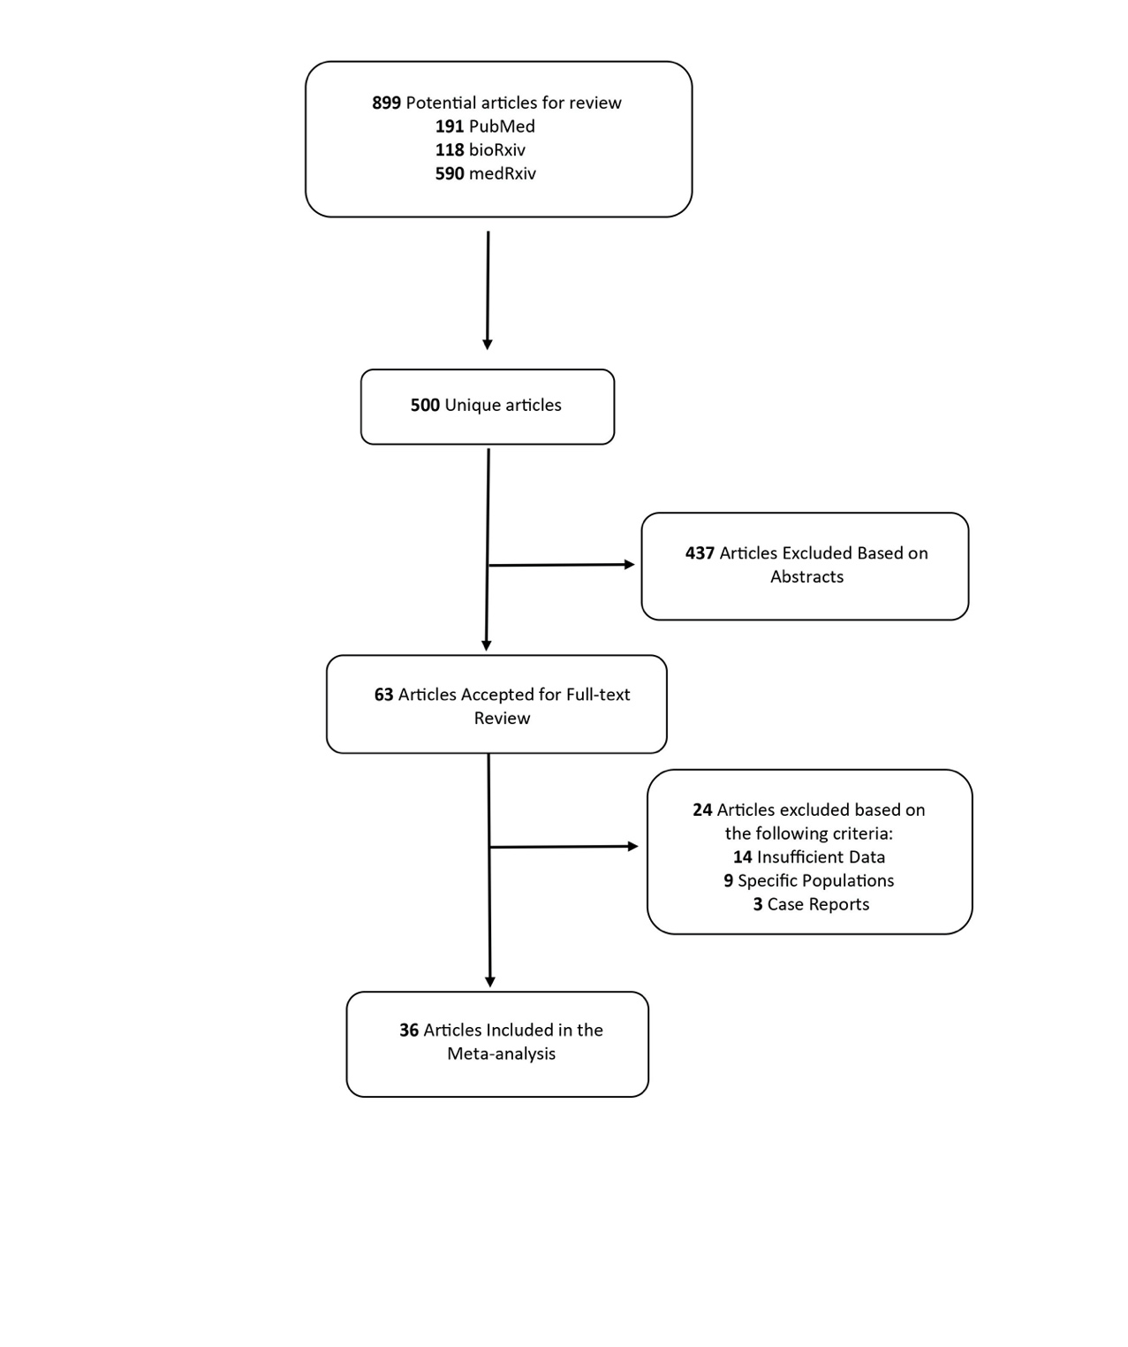
Fig S1: Schematic of meta-analysis workflow
Fig S2: Meta-analysis of the comorbidities in deceased (A, C, E, G) and surviving (B, D, F, H) COVID19 patients. A, C, E, G represent the proportions of hypertension, cardiovascular disease, cerebrovascular disease and chronic kidney disease respectively in deceased COVID19 patients. B, D, F, H represent the proportions of hypertension, cardiovascular disease, cerebrovascular disease and chronic kidney disease respectively in surviving COVID19 patients.

Fig S3: Meta-analysis of the comorbidities in severe (A, C, E, G) and non-severe (B, D, F, H) COVID19 patients. A, C, E, G represent the proportions of hypertension, cardiovascular disease, cerebrovascular disease and chronic kidney disease respectively in COVID19 patients with severe illness. B, D, F, H represent the proportions of hypertension, cardiovascular disease, cerebrovascular disease and chronic kidney disease respectively in COVID19 patients with non-severe illness.

Fig S4: Leave-one-out sensitivity analysis with studies involving deceased (A, C, E, G) and surviving (B, D, F, H) COVID19 patients.

Fig S5: Leave-one-out sensitivity analysis with studies involving severe (A, C, E, G) and non-severe (B, D, F, H) COVID19 patients.

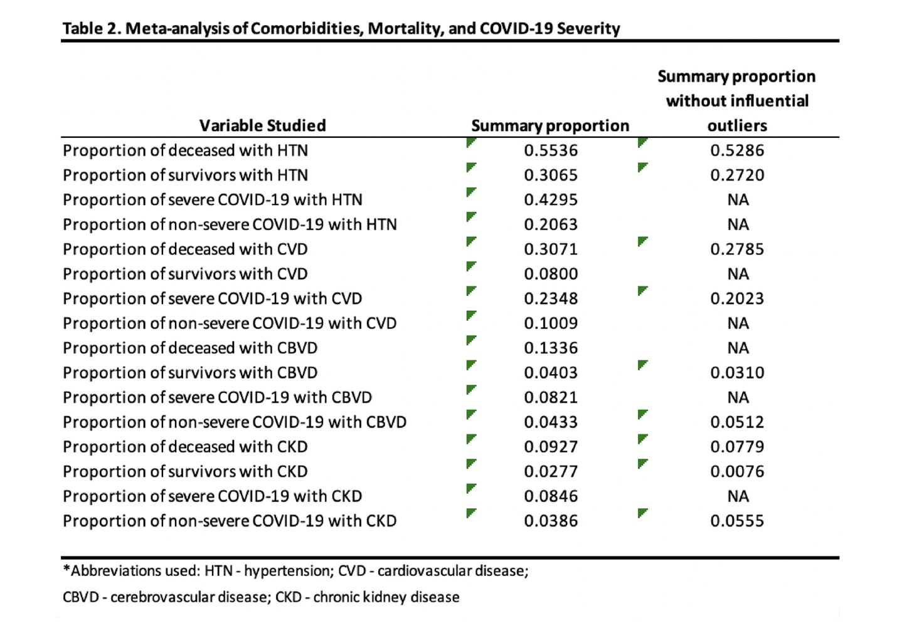
Supp Table 1: Summary proportions with and without influential outliers.

