SUPPLEMENTAL MATERIAL

Appendix 1. Study characteristics: controls, timepoints, and risk of bias
Four of the included studies had a self-controlled case-only design, i.e., the study determined the risk of acute CV event in the post-exacerbation period relative to the baseline risk of those patients, using only data for those patients who experience the CV outcome. Three of these studies used a case-series design,^{1–3} and one used a case-crossover design.⁴ One study used all stable time periods (excluding 7 weeks after an exacerbation) for all the patients with COPD included in the study as a reference period, whether they experienced an exacerbation or not.⁵ Two studies used data from RCTs and used a cohort design.^{6,7} Of these, one included only patients who had an exacerbation during the follow-up period, and determined incidence rate ratios from all patients before and after exacerbations.⁶ The other included all follow-up periods for the baseline reference period, whether they experienced an exacerbation or not (only pre-exacerbation periods were used for acute exacerbation of patients with COPD).⁷
The included studies reported a range of timepoints after acute exacerbation. The most comparable timepoints between studies were identified (28 days,²⁶ 30 days,^{22,23,24} 49 days,^{15,25} and 91 days.²⁷
Five of the studies were classed as having a low risk of bias,^{1,2,4,5,8} and two were categorised as having a high risk of bias.^{6,7}

Supplementary Table S1. PRISMA checklist

Section and Topic | Item # | Checklist item | Location where item is reported
TITLE
Title | 1 | Identify the report as a systematic review. | Title
ABSTRACT
Abstract | 2 | See the PRISMA 2020 for Abstracts checklist. | Not applicable
INTRODUCTION
Rationale | 3 | Describe the rationale for the review in the context of existing knowledge. | Introduction
Objectives | 4 | Provide an explicit statement of the objective(s) or question(s) the review addresses. | Introduction, last paragraph
METHODS
Eligibility criteria | 5 | Specify the inclusion and exclusion criteria for the review and how studies were grouped for the syntheses. | Methods, eligibility criteria, screening and abstraction
Information sources | 6 | Specify all databases, registers, websites, organisations, reference lists and other sources searched or consulted to identify studies. Specify the date when each source was last searched or consulted. | Methods, search strategy
Search strategy | 7 | Present the full search strategies for all databases, registers and websites, including any filters and limits used. | Table S2
Selection process | 8 | Specify the methods used to decide whether a study met the inclusion criteria of the review, including how many reviewers screened each record and each report retrieved, whether they worked independently, and if applicable, details of automation tools used in the process. | Methods, eligibility criteria, screening and abstraction
Data collection process | 9 | Specify the methods used to collect data from reports, including how many reviewers collected data from each report, whether they worked independently, any processes for obtaining or confirming data from study investigators, and if applicable, details of automation tools used in the process. | Methods, eligibility criteria, screening and abstraction
Data items | 10a | List and define all outcomes for which data were sought. Specify whether all results that were compatible with each outcome domain in each study were sought (e.g. for all measures, time points, analyses), and if not, the methods used to decide which results to collect. | Methods, eligibility criteria, screening and abstraction
Data items | 10b | List and define all other variables for which data were sought (e.g. participant and intervention characteristics, funding sources). Describe any assumptions made about any missing or unclear information. | Methods, eligibility criteria, screening and abstraction
Study risk of bias assessment | 11 | Specify the methods used to assess risk of bias in the included studies, including details of the tool(s) used, how many reviewers assessed each study and whether they worked independently, and if applicable, details of automation tools used in the process. | Methods, quality assessment
Effect measures | 12 | Specify for each outcome the effect measure(s) (e.g. risk ratio, mean difference) used in the synthesis or presentation of results. | Methods, statistical analysis
Synthesis methods | 13a | Describe the processes used to decide which studies were eligible for each synthesis (e.g. tabulating the study intervention characteristics and comparing against the planned groups for each synthesis (item #5)). | Methods, statistical analysis
Synthesis methods | 13b | Describe any methods required to prepare the data for presentation or synthesis, such as handling of missing summary statistics, or data conversions. | Methods, statistical analysis
Synthesis methods | 13c | Describe any methods used to tabulate or visually display results of individual studies and syntheses. | Not applicable
Synthesis methods | 13d | Describe any methods used to synthesize results and provide a rationale for the choice(s). If meta-analysis was performed, describe the model(s), method(s) to identify the presence and extent of statistical heterogeneity, and software package(s) used. | Methods, statistical analysis
Synthesis methods | 13e | Describe any methods used to explore possible causes of heterogeneity among study results (e.g. subgroup analysis, meta-regression). | Methods, statistical analysis
Synthesis methods | 13f | Describe any sensitivity analyses conducted to assess robustness of the synthesized results. | Methods, statistical analysis
Reporting bias assessment | 14 | Describe any methods used to assess risk of bias due to missing results in a synthesis (arising from reporting biases). | Methods, quality assessment
Certainty assessment | 15 | Describe any methods used to assess certainty (or confidence) in the body of evidence for an outcome. | Methods, quality assessment
RESULTS
Study selection | 16a | Describe the results of the search and selection process, from the number of records identified in the search to the number of studies included in the review, ideally using a flow diagram. | Figure S1 and S2
Study selection | 16b | Cite studies that might appear to meet the inclusion criteria, but which were excluded, and explain why they were excluded. | Discussion, eighth paragraph
Study characteristics | 17 | Cite each included study and present its characteristics. | Results, study characteristics. Table S4, S5. Appendix 1
Risk of bias in studies | 18 | Present assessments of risk of bias for each included study. | Appendix 1
Results of individual studies | 19 | For all outcomes, present, for each study: (a) summary statistics for each group (where appropriate) and (b) an effect estimate and its precision (e.g. confidence/credible interval), ideally using structured tables or plots. | Not applicable
Results of syntheses | 20a | For each synthesis, briefly summarise the characteristics and risk of bias among contributing studies. | Appendix 1
Results of syntheses | 20b | Present results of all statistical syntheses conducted. If meta-analysis was done, present for each the summary estimate and its precision (e.g. confidence/credible interval) and measures of statistical heterogeneity. If comparing groups, describe the direction of the effect. | Results, AMI risk after COPD exacerbation, Stroke risk after COPD exacerbation. Tables 1, 2
Results of syntheses | 20c | Present results of all investigations of possible causes of heterogeneity among study results. | Results, AMI risk after COPD exacerbation, Stroke risk after COPD exacerbation.
Results of syntheses | 20d | Present results of all sensitivity analyses conducted to assess the robustness of the synthesized results. | Results, Tables 1, 2. Figures S3, S4.
Reporting biases | 21 | Present assessments of risk of bias due to missing results (arising from reporting biases) for each synthesis assessed. | Results, publication bias. Figure S5, S6
Certainty of evidence | 22 | Present assessments of certainty (or confidence) in the body of evidence for each outcome assessed. | Not applicable
DISCUSSION
Discussion | 23a | Provide a general interpretation of the results in the context of other evidence. | Discussion
Discussion | 23b | Discuss any limitations of the evidence included in the review. | Discussion, sixth paragraph
Discussion | 23c | Discuss any limitations of the review processes used. | Not applicable
Discussion | 23d | Discuss implications of the results for practice, policy, and future research. | Discussion, interpretation and clinical implications
OTHER INFORMATION
Registration and protocol | 24a | Provide registration information for the review, including register name and registration number, or state that the review was not registered. | Abstract, last paragraph
Registration and protocol | 24b | Indicate where the review protocol can be accessed, or state that a protocol was not prepared. | Methods, search strategy
Registration and protocol | 24c | Describe and explain any amendments to information provided at registration or in the protocol. | Not applicable
Support | 25 | Describe sources of financial or non-financial support for the review, and the role of the funders or sponsors in the review. | Funding statement
Competing interests | 26 | Declare any competing interests of review authors. | Declaration of conflicting interests statement
Availability of data, code and other materials | 27 | Report which of the following are publicly available and where they can be found: template data collection forms; data extracted from included studies; data used for all analyses; analytic code; any other materials used in the review. | Not applicable

From: Page MJ, McKenzie JE, Bossuyt PM, Boutron I, Hoffmann TC, Mulrow CD, et al. The PRISMA 2020 statement: an updated guideline for reporting systematic reviews. BMJ 2021;372:n71. doi: 10.1136/bmj.n71

Supplementary Table S2. Search strategies
Ovid Embase <1974 to 14 May 2021>  Search Strategy: Date/Language restrictions applied (2000‐current, English language) | [Populations 1 & 2: COPD‐MACE]  1 (((chronic obstruct* adj (lung or pulmonary) adj disease*) or COPD or AECOPD) adj7 MACE).ti,ab,kw. (24)  2 ((((chronic obstruct* adj (lung or pulmonary) adj disease*) or COPD or AECOPD) adj7 (heart or cardiac or cardiovascular or coronary or myocardi* or AMI or CVD or MACE)) and (acute or adverse or event? or death? or mortality or heart death) and (exacerbat* or disease exacerbation?)).ti,ab,kw,sh. (1069)  3 ((chronic obstruct* adj (lung or pulmonary) adj disease*) or COPD or AECOPD).ti. and (risk? adj3 (heart or cardiac or cardiovascular or CVD or coronary or myocardi* or AMI or CVD or MACE)).ti,ab,kw. (1008)  4 ((((chronic obstruct* adj (lung or pulmonary) adj disease*) or COPD or AECOPD) adj7 (stroke? Or brain* or cerebr* or cerebell* or intracerebral or intracran* or apoplex* or TIA)) and (accident? Or acute or event? or death? or mortality or heart death) and (exacerbat* or disease exacerbation?)).ti,ab,kw,sh. (109)  5 ((chronic obstruct* adj (lung or pulmonary) adj disease*) or COPD or AECOPD).ti. and (risk? adj3 (stroke? or brain* or cerebr* or cerebell* or intracerebral or intracran* or apoplex* or TIA)).ti,ab,kw. (83)  [Population‐1: COPD]  6 chronic obstructive lung disease/ (134113)  7 ((chronic obstruct* adj3 (pulmonary or lung* or airway* or airflow* or bronch* or respirat*) adj (disease* or disorder*)) or COPD).ti,ab,kw. (119171)  8 *obstructive airway disease/ (936)  9 or/6‐8 (160775)  [Disease exacerbation]  10 disease exacerbation/ (117495)  11 exacerbat*.ti,ab,kw. (164195)  12 ((acute* or sever*) adj3 (inflam* or respirator*) adj3 (episod* or flare*)).tw,kw. (968)  13 or/10‐12 (238583)  14 AECOPD.mp. (2490)  15 ((acute or sever*) adj3 ((chronic obstruct* adj (lung or pulmonary) adj disease) or COPD)).ti,ab,kw. (19535)  16 (((chronic obstruct* adj (lung or pulmonary) adj disease) or COPD) adj7 hospitali*).ti,ab,kw. (4419)  17 (9 and 13) or (14 or 15 or 16) (40111)  [Population‐2: MACE]  18 major adverse cardiac event/ (6948)  19 acute heart infarction/ (74575)  20 (MACE or ((major or adverse) adj (heart or cardiac or cardio* or coronary or myocardi*)) or (acute adj (heart or myocardial) adj infarct*) or ((heart or cardiac or cardio* or coronary or myocardi*) adj death)).mp. (220167)  21 exp basal ganglion hemorrhage/ or exp brain hematoma/ or exp brain hemorrhage/ or exp brain infarction/ or exp brain ischemia/ or exp cerebrovascular accident/ or exp intracranial aneurysm/ or stroke/ or stroke patient/ or stroke unit/ (622348)  22 (stroke or poststroke or (acute adj (cereb* or brain)) or cva*).ti,ab,kw. (412494)  23 ((brain* or cerebr* or cerebell* or vertebrobasilar or hemispher* or intracran* or intracerebral or infratentorial or supratentorial or MCA or anterior circulation or posterior circulation or basal ganglia) adj3 (accident* or event? or isch?emi* or infarct* or thrombo* or emboli* or occlus*)).ti,ab,kw. (172140)  24 ((brain* or cerebr* or cerebell* or intracerebral or intracran* or parenchymal or intraventricular or infratentorial or supratentorial or basal gangli*) adj3 (haemorrhage* or hemorrhage* or haematoma* or hematoma* or bleed*)).ti,kw. (28583)  25 transient ischemic attack/ (37924)  26 (transient isch?emi* attack? or (transient adj2 (brain stem or brainstem or cerebral) adj2 isch?emi*) or TIA).ti,ab,kw. (36372)  27 exp heart infarction/ (377350)  28 exp *ischemic heart disease/ (335098)  29 exp *coronary artery disease/ (162505)  30 ((myocardi* adj2 (infarct* or isch?emi*)) or (heart adj2 (attack? or failure? or infarct* or isch?emi*)) or (cardiovascular adj2 (stroke? or thrombosis*))).ti,ab,kw. (617985)  31 cardiovascular mortality/ or heart death/ or ((heart or cardiac or cardio*) adj (death? Or mortalit*)).ti,ab,kw. (119768)  32 or/18‐31 (1607483)  33 2 or 3 or 4 or 5 or (17 and 32) (4787)  [Study‐Design‐1: Observational]  34 prospective study/ or retrospective study/ or longitudinal study/ or cohort analysis/ or crosssectional study/ or case control study/ or population based case control study/ (2395363)  35 (registry or registries or regist* based).ti,ab,kw,hw. (236855)  36 ((association or epidemiologic or prospective or retrospective or cross‐sectional or case control* or cohort or longitudinal or observational) adj3 study).ti,ab,kw. (1569801)  37 (case? adj (series or crossover or cross‐over)).ti,ab,kw,hw. (108529)  38 (case control* or cross‐sectional or cohort? or follow‐up or followup or follow* up or longitudinal or prospective or retrospective or observational or population).ti. (968035)  39 ((cohort? adj3 (analys* or compar* or data or study or studies or trial or randomi#ed or RCT)) or (population adj2 (based or data* or study or studies or register? or registry or registries or survey? or surveillance))).ab,kw. (662591)  40 COPD cohort?.mp. (815)  41 ((compar* adj3 (study or risk?)) and population).ti,ab,kw. (54296)  42 ((chart? adj (audit? or review?)) or ((autopsy or hospital* or medical or electronic health) adj2 (report? or record?)) or death certificate?).ti,ab,kw. (327782)  43 or/34‐42 (3802332)  44 1 or (33 and 43) (2007)  45 ((animal or nonhuman) not human).de. (5710969)  46 ((child or childhood or children or neonate or neonates or neonatal or p?ediatric or infant or infants or infantile or juvenile) not adult?).ti. (1306934)  47 (editorial or letter).pt. (1789148)  48 or/45‐47 (8650658)  49 44 not 48 (1983)  50 limit 49 to conference abstract status (882)  51 49 not 50 (1101)  52 limit 51 to (english language and yr="2000 ‐Current") (1015)  [Study‐Design‐2: Systematic Reviews]  53 systematic review/ or meta analysis/ or network meta‐analysis/ (352735)  54 ((systematic or structured or evidence or trials or studies) and (review or overview or look or examination or update* or summary)).ti. (185221)  55 (0266‐4623 or 1469‐493X or 1366‐5278 or 1530‐440X or 2046‐4053).is. (27636)  56 (systematic review? or evidence report* or technology assessment?).jw. (31265)  57 (meta‐analys* or meta analys* or metaanalys* or meta synth* or meta‐synth* or metasynth*).ti,ab,kw,hw. (304827)  58 ((systematic or meta) adj2 (analys* or review)).ti,kw. or ((systematic* or quantitativ* or methodologic*) adj5 (review* or overview*)).ti,ab,kw,sh. or (quantitativ* adj5 synthes*).ti,ab,kw,hw. (389953)  59 exp "clinical trial (topic)"/ and review.ti,kw,pt. (124363)  60 (integrative research review* or research integration).ti,ab,kw. or scoping review?.ti,kw. or (evidence adj3 review*).ti,ab,kw. (64084)  61 review.pt. and (medline or medlars or embase or pubmed or scisearch or psychinfo or psycinfo or psychlit or psyclit or cinahl or electronic database* or bibliographic database* or computeri#ed database* or online database* or pooling or pooled or mantel haenszel or peto or dersimonian or der simonian or fixed effect or ((hand adj2 search*) or (manual* adj2 search*))).ti,ab,kw,hw. (148820)  62 review.pt. and ((evidence based adj (medicine or practice)) or (outcome? adj (assessment or research)) or treatment outcome).hw. (212009)  63 or/53‐62 (825141)  64 33 and 63 (326)  65 64 not 48 (321)  66 limit 65 to (english language and yr="2000 ‐Current") (305)  67 limit 66 to conference abstract status (45)  68 66 not 67 (260)
Ovid MEDLINE(R) and Epub Ahead of Print, In‐Process & Other Non‐Indexed Citations and Daily <1946 to 14 May 2021>  Search Strategy: Date/Language restrictions applied (2000‐current, English language) | 1 (((chronic obstruct* adj (lung or pulmonary) adj disease*) or COPD or AECOPD) adj7 MACE).ti,ab,kf,kw. (10)  2 ((((chronic obstruct* adj (lung or pulmonary) adj disease*) or COPD or AECOPD) adj7 (heart or cardiac or cardiovascular or coronary or myocardi* or AMI or CVD or MACE)) and (acute or adverse or event? or death? or mortality or heart death) and (exacerbat* or disease exacerbation?)).ti,ab,kf,kw,hw. (469)  3 ((chronic obstruct* adj (lung or pulmonary) adj disease*) or COPD or AECOPD).ti. and (risk? adj3 (heart or cardiac or cardiovascular or CVD or coronary or myocardi* or AMI or CVD or MACE)).ti,ab,kf,kw. (534)  4 ((((chronic obstruct* adj (lung or pulmonary) adj disease*) or COPD or AECOPD) adj7 (stroke? Or brain* or cerebr* or cerebell* or intracerebral or intracran* or apoplex* or TIA)) and (accident? Or acute or event? or death? or mortality or heart death) and (exacerbat* or disease exacerbation?)).ti,ab,kf,kw,hw. (48)  5 ((chronic obstruct* adj (lung or pulmonary) adj disease*) or COPD or AECOPD).ti. and (risk? adj3 (stroke? or brain* or cerebr* or cerebell* or intracerebral or intracran* or apoplex* or TIA)).ti,ab,kf,kw. (48)  6 2 or 3 or 4 or 5 (963)  7 Pulmonary Disease, Chronic Obstructive/ (39751)  8 ((chronic obstruct* adj3 (pulmonary or lung* or airway* or airflow* or bronch* or respirat*) adj (disease* or disorder*)) or COPD).ti,ab,kf,kw. (67991)  9 or/7‐8 (73404)  10 Symptom flare up/ (472)  11 exacerbat*.ti,ab,kf,kw. (107491)  12 ((acute* or sever*) adj3 (inflam* or respirator*) adj3 (episod* or flare*)).ti,ab,kf,kw. (667)  13 or/10‐12 (108356)  14 9 and 13 (12377)  15 AECOPD.mp. (1129)  16 ((acute or sever*) adj3 ((chronic obstruct* adj (lung or pulmonary) adj disease) or  COPD)).ti,ab,kf,kw. (10529)  17 (((chronic obstruct* adj (lung or pulmonary) adj disease) or COPD) adj7 hospitali*).ti,ab,kf,kw. (2308)  18 or/15‐17 (11996)  19 14 or 18 (18797)  20 major adverse cardiac event.mp. (962)  21 (MACE or ((major or adverse) adj (heart or cardiac or cardio* or coronary or myocardi*)) or (acute adj (heart or myocardial) adj infarct*) or ((heart or cardiac or cardio* or coronary or myocardi*) adj death)).mp. (118295)  22 exp brain ischemia/ or exp intracranial hemorrhages/ or stroke/ or exp brain infarction/ (241397)  23 (stroke or poststroke or (acute adj (cereb* or brain)) or cva*).ti,ab,kf,kw. (256361)  24 ((brain* or cerebr* or cerebell* or vertebrobasilar or hemispher* or intracran* or intracerebral or infratentorial or supratentorial or MCA or anterior circulation or posterior circulation or basal ganglia) adj3 (accident* or event? or isch?emi* or infarct* or thrombo* or emboli* or occlus*)).ti,ab,kf,kw. (120984)  25 ((brain* or cerebr* or cerebell* or intracerebral or intracran* or parenchymal or intraventricular or infratentorial or supratentorial or basal gangli*) adj3 (haemorrhage* or hemorrhage* or haematoma* or hematoma* or bleed*)).ti,kf,kw. (23026)  26 Ischemic Attack, Transient/ (20360)  27 (transient isch?emi* attack? or (transient adj2 (brain stem or brainstem or cerebral) adj2 isch?emi*) or TIA).ti,ab,kf,kw. (21495)  28 exp Myocardial Infarction/ (175393)  29 *myocardial ischemia/ or acute coronary syndrome/ (43574)  30 ((myocardi* adj2 (infarct* or isch?emi*)) or (heart adj2 (attack? or failure? or infarct* or isch?emi*)) or (cardiovascular adj2 (stroke? or thrombosis*))).ti,ab,kf,kw. (415827)  31 exp *Cardiovascular Diseases/mo [Mortality] (39503)  32 ((heart or cardiac or cardio*) adj (death? or mortalit*)).ti,ab,kf,kw. (50591)  33 or/20‐32 (914699)  34 19 and 33 (1318)  35 case‐control studies/ or cohort studies/ or follow‐up studies/ or exp longitudinal studies/ or prospective studies/ or retrospective studies/ or controlled before‐after studies/ or cross‐sectional studies/ or historically controlled study/ (2495322)  36 (registry or registries or regist* based).ti,ab,kf,kw,hw. (172107)  37 ((association or epidemiologic or prospective or retrospective or cross‐sectional or case control* or cohort or longitudinal or observational) adj3 study).ti,ab,kf,kw. (1067734)  38 (case? adj (series or crossover or cross‐over)).ti,ab,kf,kw,hw. (77792)  39 (case control* or cross‐sectional or cohort? or follow‐up or followup or follow* up or longitudinal or prospective or retrospective or observational or population).ti. (733486)  40 ((cohort? adj3 (analys* or compar* or data or study or studies or trial or randomi#ed or RCT)) or (population adj2 (based or data* or study or studies or register? or registry or registries or survey? or surveillance))).ti,ab,kf,kw. (497095)  41 ((compar* adj3 (study or risk?)) and population).ti,ab,kf,kw. (34968)  42 ((chart? adj (audit? or review?)) or ((autopsy or hospital* or medical or electronic health) adj2 (report? or record?)) or death certificate?).ti,ab,kf,kw. (194493)  43 COPD cohort?.mp. (309)  44 or/35‐43 (3387299)  45 1 or ((6 or 34) and 44) (964)  46 exp animals/ not humans.sh. (4725239)  47 ((child or childhood or children or neonate or neonates or neonatal or p?ediatric or infant or infants or infantile or juvenile) not adult?).ti. (1135784)  48 (editorial or letter).pt. (1632174)  49 or/46‐48 (7357279)  50 45 not 49 (954)  51 limit 50 to (english language and yr="2000 ‐Current") (859)  52 (systematic or structured or evidence or trials or studies).ti. and ((review or overview or look or examination or update* or summary).ti. or review.pt.) (215855)  53 (0266‐4623 or 1469‐493X or 1366‐5278 or 1530‐440X or 2046‐4053).is. (18897)  54 meta‐analysis.pt. or (meta‐analys* or meta analys* or metaanalys* or meta synth* or metasynth* or metasynth*).ti,ab,kf,hw. (208881)  55 ((systematic or meta) adj2 (analys* or review)).ti,kf. or ((systematic* or quantitativ* or methodologic*) adj5 (review* or overview*)).ti,ab,kf,sh. or (quantitativ$ adj5 synthesis$).ti,ab,kf,hw. (277951)  56 (integrative research review* or research integration).tw. or scoping review?.ti,kf. Or (review.ti,kf,pt. and (trials as topic or studies as topic).hw.) or (evidence adj3 review*).ti,ab,kf. (197004)  57 review.pt. and ((medline or medlars or embase or pubmed or scisearch or psychinfo or psycinfo or psychlit or psyclit or cinahl or electronic database* or bibliographic database* or computeri#ed database* or online database* or pooling or pooled or mantel haenszel or peto or dersimonian or der simonian or fixed effect or ((hand adj2 search*) or (manual* adj2 search*))).tw,hw. Or (retraction of publication or retracted publication).pt.) (155638)  58 or/52‐57 (573078)  59 (6 or 34) and 58 (151)  60 59 not 49 (151)  61 limit 60 to (english language and yr="2000 ‐Current") (141)
Cochrane Library (CLib) Issue 8 of 12, 2020 | #1 (((chronic next obstruct* next (lung or pulmonary) next disease*) or COPD or AECOPD) AND MACE):ti,ab,kw  #2 ((((chronic next obstruct* next (lung or pulmonary) next disease*) or COPD or AECOPD) NEAR/7 (heart or cardiac or cardiovascular or coronary or myocardi* or AMI or CVD or MACE)) AND (acute or adverse or event or events or death or deaths or mortality or "heart death") and (exacerbat*)):ti,ab,kw  #3 ((chronic next obstruct* next (lung or pulmonary) next disease*) or COPD or AECOPD):ti AND (risk near/3 (heart or cardiac or cardiovascular or CVD or coronary or myocardi* or AMI or CVD or MACE)):ti,ab,kw  #4 ((((chronic next obstruct* next (lung or pulmonary) next disease*) or COPD or AECOPD) NEAR/7 (stroke* or brain* or cerebr* or cerebell* or intracerebral or intracran* or apoplex* or TIA)) and (accident* or acute or event or events or death or deaths or mortality or heart death) and (exacerbat*)):ti,ab,kw  #5 ((chronic next obstruct* next (lung or pulmonary) next disease*) or COPD or AECOPD):ti and (risk near/3 (stroke* or brain* or cerebr* or cerebell* or intracerebral or intracran* or apoplex* or TIA)):ti,ab,kw  #6 (#1 or #2 or #3 or #4 or #5)  #7 ("chronic obstructive lung disease" or ("Pulmonary Disease" next "Chronic Obstructive")):kw  #8 (((chronic next obstruct*) near/3 (pulmonary or lung* or airway* or airflow* or bronch* or respirat*) next (disease* or disorder*)) or COPD):ti,ab,kw  #9 "obstructive airway disease":ti,ab,kw  #10 (#7 or #8 or #9)  #11 exacerbat*:ti,ab,kw  #12 ((acute* or sever*) near/3 (episod* or flare*)):ti,ab,kw  #13 (symptom next flare*):ti,ab,kw  #14 (#11 or #12 or #13)  #15 (#10 and #14)  #16 AECOPD:ti,ab,kw  #17 ((acute or sever*) near/3 ((chronic next obstruct* next (lung or pulmonary) next disease) or COPD)):ti,ab,kw  #18 (((chronic next obstruct* next (lung or pulmonary) next disease) or COPD) near/7 hospitali*):ti,ab,kw  #19 (#16 or #17 or #18)  #20 ("major adverse cardiac event" or "acute heart infarction"):ti,ab,kw  #21 (MACE or ((major or adverse) next (heart or cardiac or cardio* or coronary or myocardi*)) or (acute next (heart or myocardial) next infarct*) or ((heart or cardiac or cardio* or coronary or myocardi*) next death)):ti,ab,kw  #22 (stroke or poststroke or (acute next (cereb* or brain)) or cva*):ti,ab,kw  #23 ((brain* or cerebr* or cerebell* or vertebrobasilar or hemispher* or intracran* or intracerebral or infratentorial or supratentorial or MCA or anterior circulation or posterior circulation or basal ganglia) near/3 (accident* or event or events or ischemi* or ischaemi* or infarct* or thrombo* or emboli* or occlus*)):ti,ab,kw  #24 ((brain* or cerebr* or cerebell* or intracerebral or intracran* or parenchymal or intraventricular or infratentorial or supratentorial or basal gangli*) near/3 (haemorrhage* or hemorrhage* or haematoma* or hematoma* or bleed*)):ti,ab,kw  #25 ("transient ischemic attack" or "transient ischaemic attack" or (transient near/2 (brain stem or brainstem or cerebral) near/2 (ischemi* or ischaemi*)) or TIA):ti,ab,kw  #26 ((myocardi* near/2 (infarct* or ischemi* or ischaemi*)) or (heart near/22 (attack* or failure* or infarct* or ischemi* or ischaemi*)) or (cardiovascular near/2 (stroke* or thrombosis*))):ti,ab,kw  #27 "acute coronary syndrome":ti,ab,kw  #28 ((heart or cardiac or cardio*) next (death or deaths or mortalit*)):ti,ab,kw  #29 MeSH descriptor: [Cardiovascular Diseases] explode all trees and with qualifier(s): [mortality ‐ MO]  #30 MeSH descriptor: [Myocardial Ischemia] explode all trees  #31 MeSH descriptor: [Myocardial Infarction] explode all trees  #32 MeSH descriptor: [Brain Ischemia] explode all trees  #33 MeSH descriptor: [Brain Infarction] explode all trees  #34 MeSH descriptor: [Intracranial Hemorrhages] explode all trees  #35 MeSH descriptor: [Stroke] explode all trees  #36 (#20 or #21 or #22 or #23 or #24 or #25 or #26 or #27 or #28 or #29 or #30 or #31 or #32 or #33 or #34 or #35)  #37 (( #15 or #19) and #36)  #38 (#6 or #37)  #39 ((case next control*) or cohort or cohorts or follow‐up or followup or “followed up” or longitudinal or (before next after) or cross‐sectional or “historically controlled” or registry or registries or (regist* next based)) or ((association or epidemiologic or prospective or retrospective or observational) near/3 study) or (case* next (series or crossover or cross‐over)) or (population near/2 (based or data* or study or studies or register* or registry or registries or survey* or surveillance)) or ((compar* near/3 (study or risk*)) and population) or ((chart* next (audit* or review*)) or ((autopsy or hospital* or medical or electronic health) near/2 (report* or record*)) or (death next certificate*)):ti,ab,kw  #40 (#38 and #39) 257  CDSR (3), Trials (205 (journal records))  Limited >2000  CDSR (3), Trials (202 (journal records))

Supplementary Table S3. Newcastle-Ottawa Scale
Cohort studies
Selection
- Representativeness of the exposed cohort
- Truly representative of the average _______________ (describe) in the community
- Somewhat representative of the average ______________ in the community
- Selected group of users e.g., nurses, volunteers
- No description of the derivation of the cohort
- Selection of the non-exposed cohort
- Drawn from the same community as the exposed cohort
- Drawn from a different source
- No description of the derivation of the non-exposed cohort
- Ascertainment of exposure
- Secure record (e.g., surgical records)
- Structured interview
- Written self-report
- No description
- Demonstration that outcome of interest was not present at start of study
- Yes
- No
Comparability
- Comparability of cohorts on the basis of the design or analysis
- Study controls for _____________ (select the most important factor)
- Study controls for any additional factor (this criterion could be modified to indicate specific control for a second important factor)
Outcome
- Assessment of outcome
- Independent blind assessment
- Record linkage
- Self-report
- No description
- Was follow up long enough for outcomes to occur
- Yes (select an adequate follow-up period for outcome of interest)
- No
- Adequacy of follow up of cohorts
- Complete follow up – all subjects accounted for
- Subjects lost to follow up unlikely to introduce bias – small number lost – > ____ % (select an adequate %) follow up, or description provided of those lost)
- Follow-up rate < ____% (select an adequate %) and no description of those lost
- No statement
Note: A study can be awarded a maximum of one star for each numbered item within the Selection and Outcome categories. A maximum of two stars can be given for Comparability.

Supplementary Table S4. Characteristics of studies included in the systematic review and meta-analysis
Author/year | Country | Study period | Patient data source | Reference population | Outcomes reported | Relative risk measure reported
Donaldson 2010¹ | England and Wales | Feb 2003 | THIN | Self-controlledª | AMI, stroke | IRR
Goto 2018² | USA (Florida, California, Nebraska) | Jan 2006 - Dec 2011 | SEDD and SID | Self-controlledª | AMI, stroke | IRR, OR
Halpin 2011⁶ | 47 countries | Jan 2003 - Mar 2004 | UPLIFT study (NCT00144339) | All patients with AECOPD in population | AMI, stroke | IRR
Kunisaki 2018⁷ | 43 countries | 2011 - 2013 | SUMMIT (NCT01313676) | All patients with COPD in population | AMI | HR
Portegies 2016⁵ | The Netherlands | 1990 - 2008 | The Rotterdam Study | All patients with COPD in population | Stroke | HR
Reilev 2019⁴ | Denmark | Jan 1997 – Dec 2014 | The Danish Health Data Authority | Self-controlledª | AMI, stroke | OR
Rothnie 2018³ | UK | Jan 2004 - Mar 2015 | CPRD + HES | Self-controlledª | AMI, stroke | IRR
AMI, acute myocardial infarction; COPD, chronic obstructive pulmonary disease; CPRD, The UK Clinical Practice Research Datalink; CV, cardiovascular; HES, Hospital Episode Statistics; HR; hazard ratio; IQR, interquartile range; IRR, incidence rate ratio; MI, myocardial infarction; OR, odds ratio; SD, standard deviation; SEDD, State Emergency Department Database; SID, State Inpatient Database; SUMMIT, Study to Understand Mortality and Morbidity Trial; THIN, The Health Improvement Network; UPLIFT, Understanding Potential Long-term Impacts on Function with Tiotropium

ª In self-controlled designs, only patients with the event are included in the analysis population

Supplementary Table S5. Definition of exacerbations, identification of CVD outcomes, number of patients exposed and controls, and follow-up length of studies included in the systematic review and meta-analysis
Author/year | Definition of exacerbation and severity | Identification of CVD outcomes | N participants | Time points/periods after exacerbation at which risk reported
Donaldson 2010¹ | Definition  (1) a prescription of oral steroids (except ﬂudrocortisone)  (2) a prescription of preselected oral antibiotics commonly used in treating exacerbations  (3) prescription of oral steroids and a preselected oral antibiotic | Read code  AMI: G30..00, G30..11, G30..12, G30..13, G30..14, G30..15, G30..16, G30..17, G300.00, G301.00, G301000, G301100, G301z00, G302.00, G303.00, G304.00, G305.00, G306.00, G307.00, G307000, G307100, G308.00, G309.00, G30A.00, G30B.00, G30X.00, G30X000, G30y.00, G30y000, G30y100, G30y200, G30yz00, G30z.00, G35..00, G350.00, G351.00, G353.00, G35X.00  Ischemic stroke: G63..11, G630.00, G631.00, G631.11, G631.12, G632.00, G633.00, G634.00, G63y.00, G63y000, G63y100, G63z.00, G64..00, G64..11, G64..12, G64..13, G640.00, G640000, G641.00, G641.11, G641000, G64z.00, G64z.11, G64z.12, G64z000, G64z200, G64z300, G64z400, G66..00, G66..11, G66..12, G66..13, G663.00, G664.00, G665.00, G666.00, G667.00, G668.00, G670.00, G670.11, G671000, G677000, G677100, G677200, G677300, G677400, G6W..00, G6X..00 | N=25,857 with COPD (N=426 with MI, N=482 with stroke) | 5 days  49 days  6-10 days  11-15 days  16-49 days
Goto 2018² | Definition  Primary discharge diagnosis of COPD (ICD-9-CM diagnosis codes: 491.21, 491.22, 491.8, 491.9, 492.8, 493.20, 493.21, 493.22, and 496) or those with a primary diagnosis of respiratory failure (ICD-9-CM diagnosis codes: 518.81, 518.82, 518.84, and 799.1) and a secondary diagnosis of COPD | ICD-9 code  AMI: 410.x1  Ischemic stroke: ICD-9 CM 433.x1, 434.x1, 436, 430, 431 | N=362,867 with AECOPD (N=1,200 with MI, N=650 with ischemic stroke, N=71 with haemorrhagic stroke) | 30 days  1 year
Halpin 2011⁶ | Definition  Increase in or the new onset of more than one respiratory symptom (cough, sputum, sputum purulence, wheezing, or dyspnoea) lasting 3 days or more and requiring treatment with an antibiotic or a systemic corticosteroid | MedDRA ver. 11.1  Adverse events for AMI and ischemic and hemorrhagic stroke | N=3,960 with exacerbation (N=13 with MI, N=9 with stroke) | 30 days  180 days
Kunisaki 2018⁷ | Definition  Increase in respiratory symptoms requiring treatment with antibiotics, systemic corticosteroids, and/or hospitalization. | MedDRA  A clinical endpoint committee reviewed all adverse events that met a broad list of possible cardiovascular terms in the MedDRA  Adverse events for AMI | N=16,485 with CV disease or at increased risk of CV disease (N=4,704 with AECOPD and N=13 with MI) | 30 days  31-90 days  91-360 days  >1 year
Portegies 2016⁵ | Definition and severity  Moderate exacerbation: needing a course of steroids and/or antibiotics  Severe exacerbation: as needing hospitalization | Ischemic and hemorrhagic stroke: Defined according to World Health Organization criteria as syndrome of rapidly developing clinical signs of focal (or global) disturbance of cerebral function, with symptoms lasting 24 hours or leading to death, with no apparent cause other than of vascular origin. Research physicians reviewed potential strokes using hospital discharge letters and information from general practitioners, and an experienced neurologist verified the stroke diagnoses  Strokes were subclassified in ischemic or hemorrhagic stroke based on neuroimaging reports. If no neuroimaging was performed, strokes were classified as unspecified. Ischemic strokes were further subclassified in two ways: cortical or lacunar ischemic stroke, based on clinical symptoms | N=1,028 incident COPD (N=22 with stroke) | 49 days
Reilev 2019⁴ | Definition  Prescriptions of antibiotics, oral corticosteroids, and hospitalizations due to COPD | ICD code  AMI: ICD-10 I200 I21; ICD-8 41009, 41099, 41309, 41339  Ischemic and hemorrhagic stroke: ICD-10 I63, I64, ICD-8 43309, 43399, 43409, 43499, 43509, 43599, 431, 430 | N=118,807 with AECOPD and MACE | 28 days
Rothnie 2018³ | Definition and severity  Moderate exacerbation: requiring treatment from their general practitioner  Severe exacerbation: requiring hospitalization | Read code  AMI: 241, 1204, 1677, 1678, 5387, 10562, 12229, 14658, 14897, 14898, 23892, 29758, 32854, 34803, 46017, 63467, 96838  Ischemic stroke: 94482, 91627, 92036, 90572, 53745, 19280, 32447, 8443, 25615, 15252, 4240, 39344, 40758, 5602, 17322, 8837, 15019, 34758, 23671, 27975, 24446, 36717, 3149, 16517, 33543, 5363, 40053, 12555, 569, 57495, 26424, 9985, 18689, 98642, 57527, 55602, 51759, 65770, 71274, 51326, 19260, 45781, 71585, 33499, 51767, 10504, 6155, 4152, 40847, 73901, 70536, 10062, 47607, 6116, 1298, 7780, 37493, 34117, 51311, 12833, 98188, 1469, 56279, 6253 | N=5,696 with COPD, AECOPD and either first MI (N=2,850) or ischemic stroke (N=3,466) | 91 days  1-3 days*  4-7 days*  8-14 days*  15-28 days*  29-91 days*
* Risks at these timepoints only reported for sub-populations
MedDRA, Medical Dictionary for Regulatory Activities

Supplementary Figure S1. Risk of acute CV event after COPD exacerbation: flow of information through the different phases of a systematic review⁹
Screening
Eligibility
Records identified through database searching (original search)
(n = 2,076)
Additional records identified through other sources
(n = 1)
Records after duplicates removed
(n = 1,587)
Records screened
(n = 1,587)
Records excluded
(n = 1,381)
Full-text articles assessed for eligibility
(n = 206)
Full-text articles excluded
(n = 199)
Reason for exclusion:
Comparison = 128
Outcome = 38
Study design = 27
Conference abstract = 3
Background article = 2
Population = 1
Studies included in qualitative synthesis
(n = 7)
Studies included in quantitative synthesis (meta-analysis)
(n = 7)
Records identified through database searching (update search)
(n = 3,040)
Identification
Included

Supplementary Figure S2. Risk of COPD exacerbation after acute CV event: flow of information through the different phases of a systematic review⁹
Screening
Eligibility
Records identified through database searching (original search)
(n = 2,076)
Additional records identified through other sources
(n = 1)
Records after duplicates removed
(n = 1,587)
Records screened
(n = 1,587)
Records excluded
(n = 1,381)
Full-text articles assessed for eligibility
(n = 206)
Full-text articles excluded
(n = 206)
Comparison = 128
Outcome = 38
Study design = 27
Population = 8
Conference abstract = 3
Background article = 2
Studies included in qualitative synthesis
(n = 0)
Studies included in quantitative synthesis (meta-analysis)
(n = 0)
Records identified through database searching (update search)
(n = 3,040)
Identification
Included

Supplementary Figure S3. Leave-1-out plot of the meta-analysis results on effect of prior COPD exacerbation on risk of AMI (random effects)
CI, confidence interval; df, degrees of freedom; RE, random effects.
Weight is calculated from the inverse of the variance

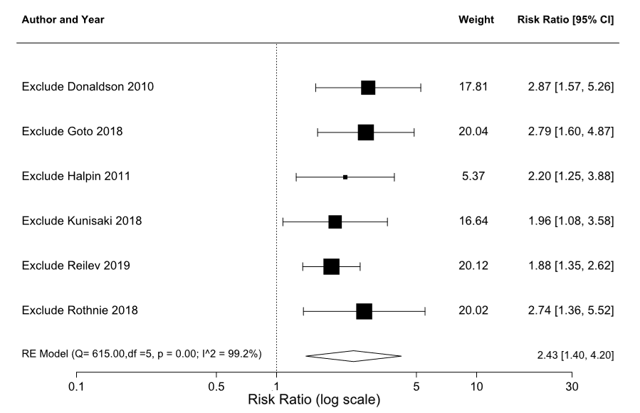

Supplementary Figure S4. Leave-1-out plot of the meta-analysis results on effect of prior COPD exacerbation on risk of stroke (random effects)
CI, confidence interval; df, degrees of freedom; RE, random effects.
Weight is calculated from the inverse of the variance
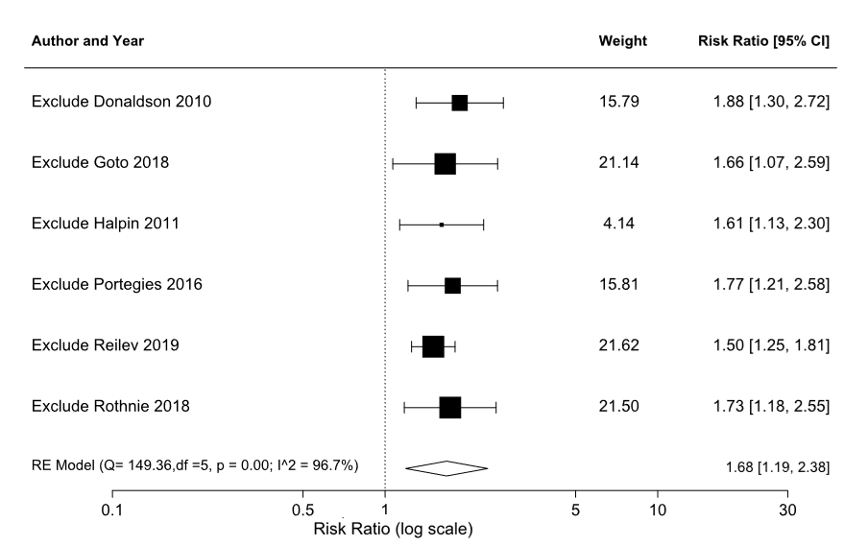

Supplementary Figure S5. Funnel plot of the meta-analysis results on effect of prior COPD exacerbation on risk of AMI (random effects)
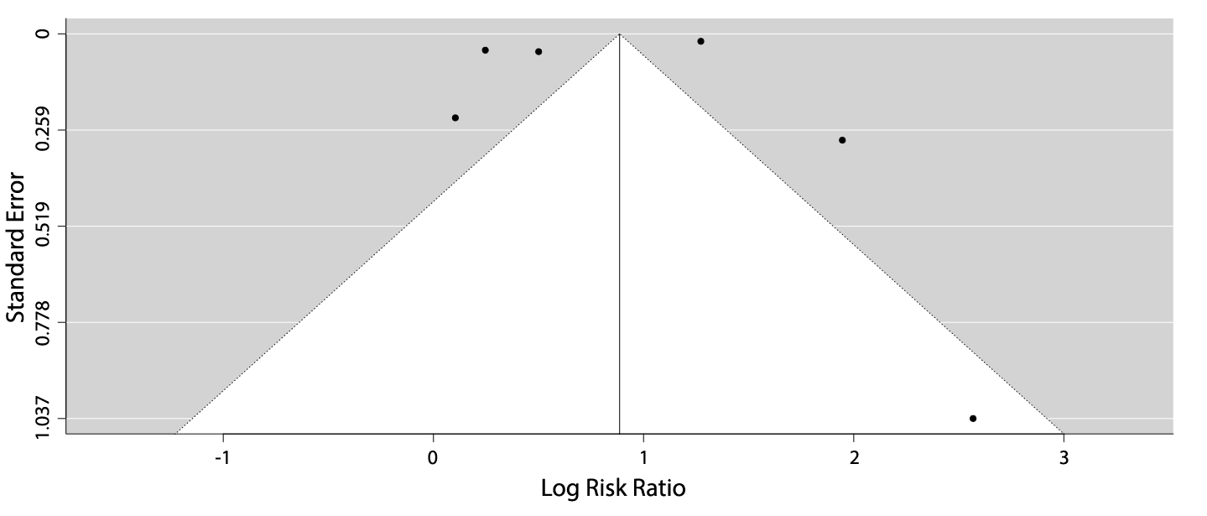

Supplementary Figure S6. Funnel plot of the meta-analysis results on effect of prior COPD exacerbation on risk of stroke (random effects)
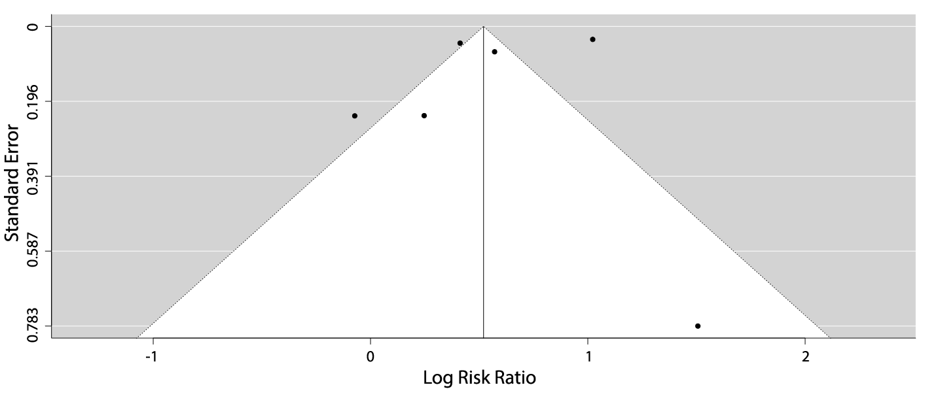

REFERENCES
1. Donaldson G, Hubbard R. Increased Risk of Myocardial Infarction and Stroke Following Exacerbation of COPD The upper and lower airway in COPD View project Sheffield Lung Cancer Projects View project. Chest 2010; 137: 1091–1097.
2. Goto T, Shimada YJ, Faridi MK, et al. Incidence of Acute Cardiovascular Event After Acute Exacerbation of COPD. J Gen Intern Med 2018; 33: 1461–1468.
3. Rothnie KJ, Connell O, Müllerová H, et al. Myocardial infarction and ischemic stroke after exacerbations of chronic obstructive pulmonary disease. Ann Am Thorac Soc 2018; 15: 935–946.
4. Reilev M, Pottegård A, Lykkegaard J, et al. Increased risk of major adverse cardiac events following the onset of acute exacerbations of COPD. Respirology 2019; 24: 1183–1190.
5. Portegies MLP, Lahousse L, Joos GF, et al. Chronic obstructive pulmonary disease and the risk of stroke the Rotterdam study. Am J Respir Crit Care Med 2016; 193: 251–258.
6. Halpin DMGG, Decramer M, Celli B, et al. Risk of nonlower respiratory serious adverse events following COPD exacerbations in the 4-year UPLIFT® Trial. Lung 2011; 189: 261–268.
7. Kunisaki KM, Dransfield MT, Anderson JA, et al. Exacerbations of chronic obstructive pulmonary disease and cardiac events. A post hoc cohort analysis from the SUMMIT randomized clinical trial. Am J Respir Crit Care Med 2018; 198: 51–57.
8. Rothnie KJ, Yan R, Smeeth L, et al. Risk of myocardial infarction (MI) and death following MI in people with chronic obstructive pulmonary disease (COPD): a systematic review and meta-analysis. BMJ Open 2015; 5: e007824.
9. Moher D, Liberati A, Tetzlaff J, et al. Preferred reporting items for systematic reviews and meta-analyses: the PRISMA statement. Ann Intern Med 2009; 151: 264–9, W64.

