Supplementary materials
S1: PROSPERO Protocol 2
S2: PRISMA Checklist 7
S3: Search strategy 9
Concept 9
PubMed 9
Embase 9
PsycINFO 9
S4. Study inclusion and exclusion criteria 10
S5. Supplementary materials for meta-analyses 11
Table S5.1 Data table for the unadjusted meta-analyses 11
Table S5.2 Data table for the adjusted meta-analyses 13
Table S5.3 Data table for opioid use dose and duration with depression (unadjusted meta-analyses) 14
Table S5.4 Data table for opioid use dose and duration with depression (adjusted meta-analyses) 15
Figure S5.1. Funnel plot for unadjusted meta-analysis of opioid use and diagnosed depression 16
S6. Newcastle Ottawa Quality Assessment Scale for cohort studies 18
S6.1. Assessment definition and scoring 18
S6.2. Assessment results 20
S7. Variables adjusted for by the included studies 21
S8. References of included studies 22

S1: PROSPERO Protocol

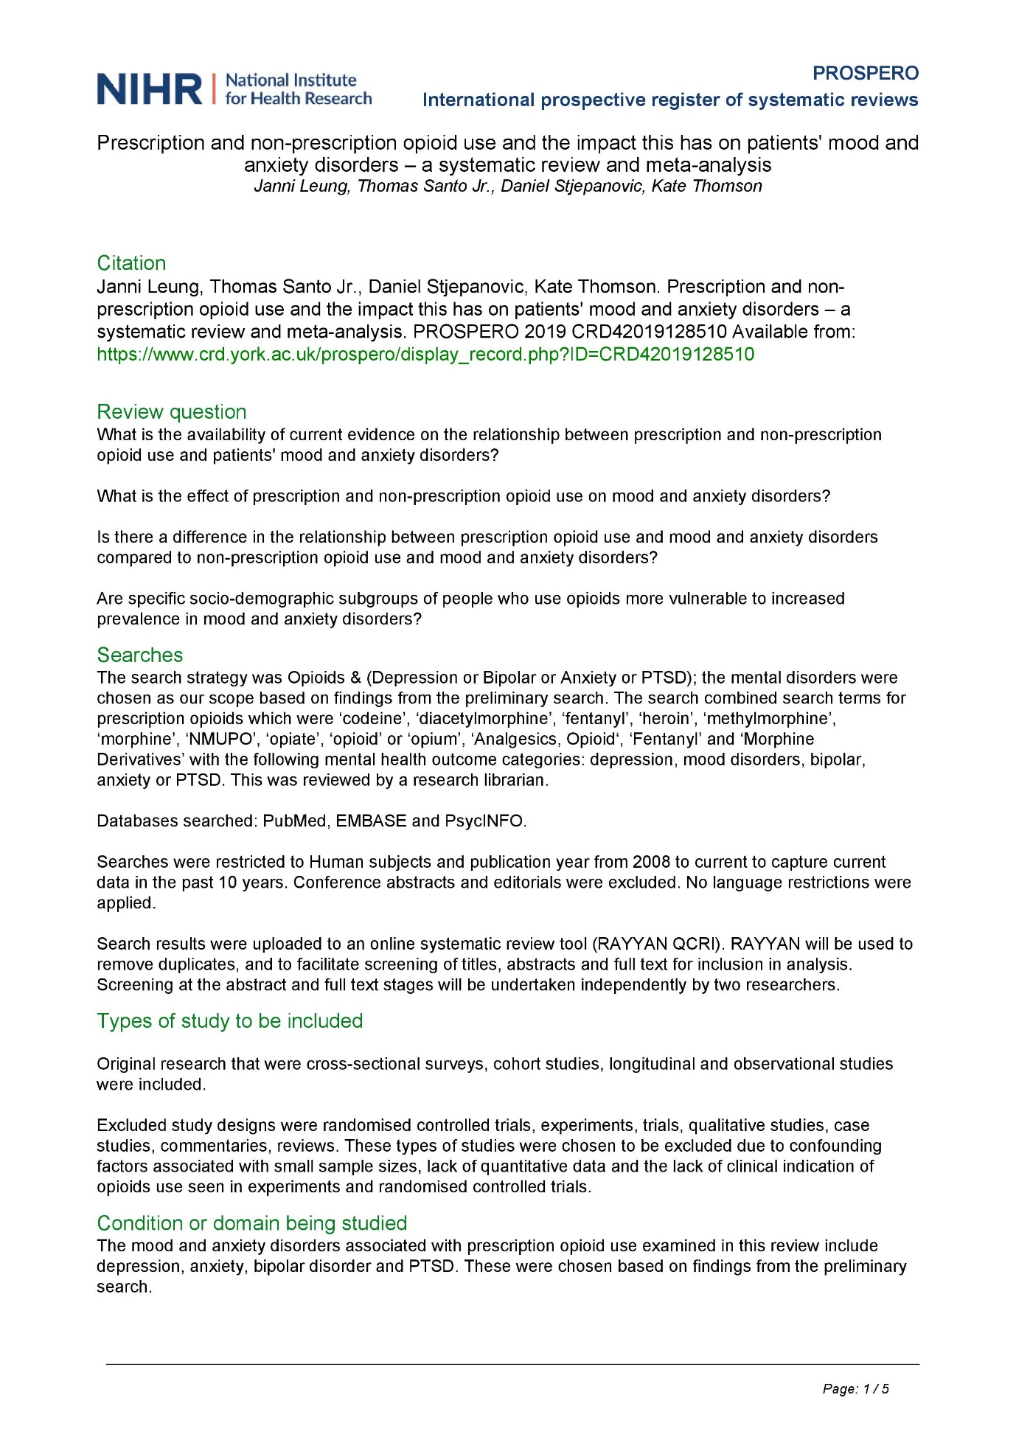
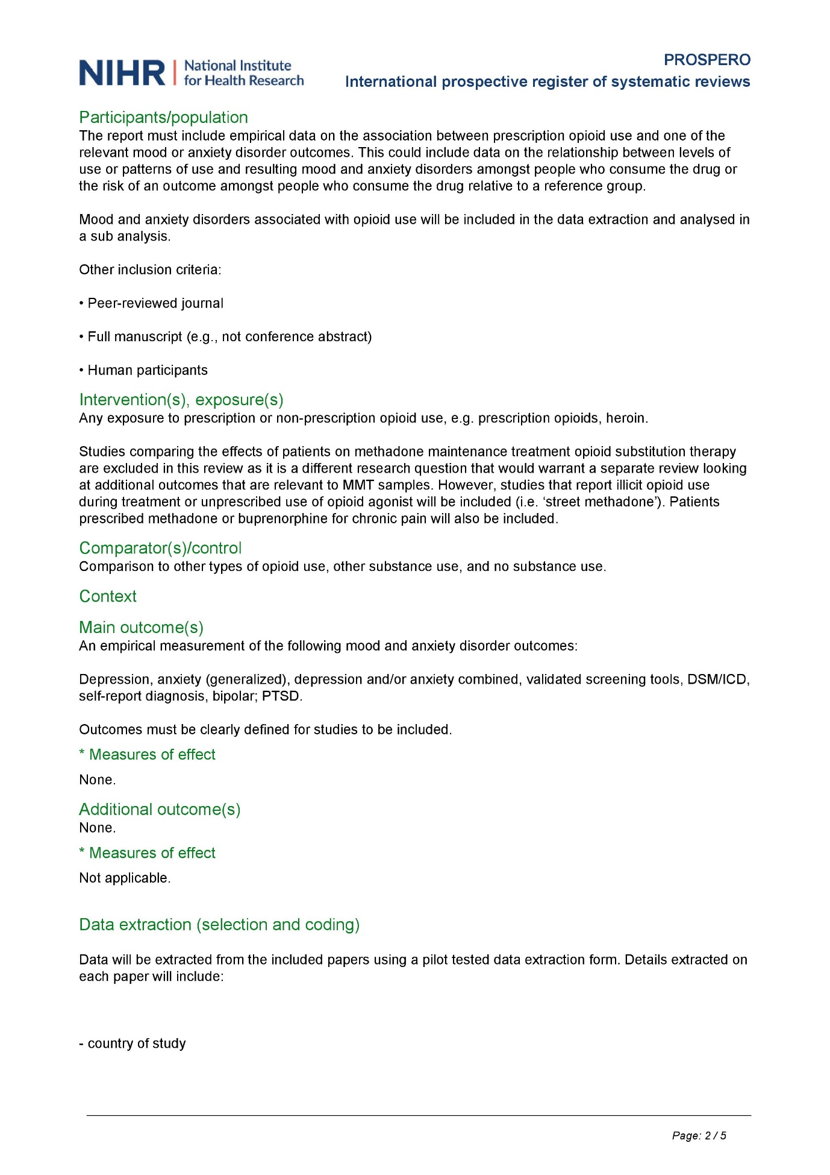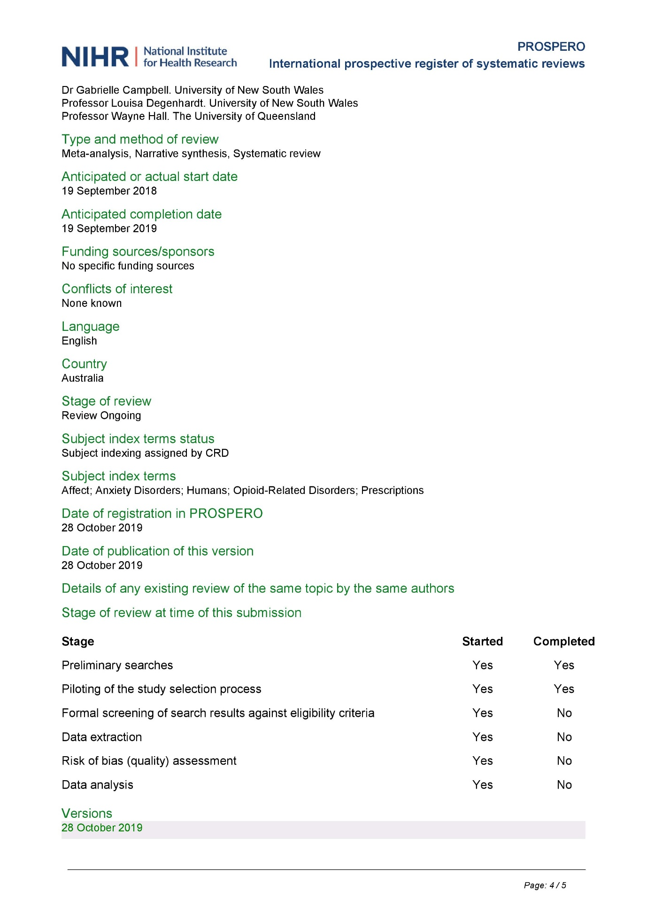

S2: PRISMA Checklist
Section/topic | # | Checklist item | Reported on page
Title | 1 | Identify the report as a systematic review, meta-analysis, or both. | 1
ABSTRACT
Structured summary | 2 | Provide a structured summary including, as applicable: background; objectives; data sources; study eligibility criteria, participants, and interventions; study appraisal and synthesis methods; results; limitations; conclusions and implications of key findings; systematic review registration number. | 2
INTRODUCTION
Rationale | 3 | Describe the rationale for the review in the context of what is already known. | 3, 4
Objectives | 4 | Provide an explicit statement of questions being addressed with reference to participants, interventions, comparisons, outcomes, and study design (PICOS). | 4
METHODS
Protocol and registration | 5 | Indicate if a review protocol exists, if and where it can be accessed (e.g., Web address), and, if available, provide registration information including registration number. | 4
Eligibility criteria | 6 | Specify study characteristics (e.g., PICOS, length of follow-up) and report characteristics (e.g., years considered, language, publication status) used as criteria for eligibility, giving rationale. | 4, 5
Information sources | 7 | Describe all information sources (e.g., databases with dates of coverage, contact with study authors to identify additional studies) in the search and date last searched. | 5
Search | 8 | Present full electronic search strategy for at least one database, including any limits used, such that it could be repeated. | 5
Study selection | 9 | State the process for selecting studies (i.e., screening, eligibility, included in systematic review, and, if applicable, included in the meta-analysis). | 6
Data collection process | 10 | Describe method of data extraction from reports (e.g., piloted forms, independently, in duplicate) and any processes for obtaining and confirming data from investigators. | 6
Data items | 11 | List and define all variables for which data were sought (e.g., PICOS, funding sources) and any assumptions and simplifications made. | 6
Risk of bias in individual studies | 12 | Describe methods used for assessing risk of bias of individual studies (including specification of whether this was done at the study or outcome level), and how this information is to be used in any data synthesis. | 7
Measures | 13 | State the principal summary measures (e.g., risk ratio, difference in means). | 7
Synthesis of results | 14 | Describe the methods of handling data and combining results of studies, if done, including measures of consistency (e.g., I²) for each meta-analysis. | 6, 7
Risk of bias across studies | 15 | Specify any assessment of risk of bias that may affect the cumulative evidence (e.g., publication bias, selective reporting within studies). | n/a
Additional analyses | 16 | Describe methods of additional analyses (e.g., sensitivity or subgroup analyses, meta-regression), if done, indicating which were pre-specified. | 7
RESULTS
Study selection | 17 | Give numbers of studies screened, assessed for eligibility, and included in the review, with reasons for exclusions at each stage, ideally with a flow diagram. | 7, 8
Study characteristics | 18 | For each study, present characteristics for which data were extracted (e.g., study size, PICOS, follow-up period) and provide the citations. | 8
Risk of bias within studies | 19 | Present data on risk of bias of each study and, if available, any outcome level assessment (see item 12). | 8
Results of individual studies | 20 | For all outcomes considered (benefits or harms), present, for each study: (a) simple summary data for each intervention group (b) effect estimates and confidence intervals, ideally with a forest plot. | 9 – 12
Synthesis of results | 21 | Present results of each meta-analysis done, including confidence intervals and measures of consistency. | 13
Risk of bias across studies | 22 | Present results of any assessment of risk of bias across studies (see Item 15). | n/a
Additional analysis | 23 | Give results of additional analyses, if done (e.g., sensitivity or subgroup analyses, meta-regression [see Item 16]). | n/a
DISCUSSION
Summary of evidence | 24 | Summarize the main findings including the strength of evidence for each main outcome; consider their relevance to key groups (e.g., healthcare providers, users, and policy makers). | 14
Limitations | 25 | Discuss limitations at study and outcome level (e.g., risk of bias), and at review-level (e.g., incomplete retrieval of identified research, reporting bias). | 15, 16
Conclusions | 26 | Provide a general interpretation of the results in the context of other evidence, and implications for future research. | 16
FUNDING
Funding | 27 | Describe sources of funding for the systematic review and other support; role of funders for the systematic review. | 16

S3: Search strategy

Concept
(Opioids search terms)
AND
((Depression search terms) OR
(Bipolar search terms) OR
(Anxiety search terms) OR
(PTSD search terms))

PubMed
((((((Analgesics, Opioid[MeSH Terms]) OR Fentanyl[MeSH Terms]) OR Morphine Derivatives[MeSH Terms])) OR ((((((((((codeine*[Title/Abstract]) OR diacetylmorphine[Title/Abstract]) OR fentanyl[Title/Abstract]) OR heroin[Title/Abstract]) OR methylmorphine[Title/Abstract]) OR morphine*[Title/Abstract]) OR NMUPO[Title/Abstract]) OR opiate*[Title/Abstract]) OR opioid*[Title/Abstract]) OR opium*[Title/Abstract]))) AND (((((((((((((depress*[Title/Abstract]) OR mood disorder*[Title/Abstract]) OR bipolar[Title/Abstract]) OR anxiety[Title/Abstract]) OR post traumatic stress disorder[Title/Abstract]) OR posttraumatic stress disorder[Title/Abstract]) OR post-traumatic stress disorder[Title/Abstract]) OR ptsd[Title/Abstract]) OR Depressive Disorder, Major[MeSH Terms]) OR Depression[MeSH Terms]) OR (Bipolar and Related Disorders[MeSH Terms])) OR Anxiety Disorders[MeSH Terms]) OR Stress Disorders, Post-Traumatic[MeSH Terms])

Embase
('codeine*':ab,ti,kw OR 'diacetylmorphine':ab,ti,kw OR 'fentanyl':ab,ti,kw OR 'heroin':ab,ti,kw OR 'methylmorphine':ab,ti,kw OR 'morphine*':ab,ti,kw OR 'nmupo':ab,ti,kw OR 'opiate*':ab,ti,kw OR 'opioid*':ab,ti,kw OR 'opium*':ab,ti,kw OR 'opiate'/exp OR 'opiate addiction'/exp OR 'diamorphine'/exp OR 'codeine'/exp OR 'fentanyl'/exp) AND ('depress*':ti,ab,kw OR 'mood disorder*':ti,ab,kw OR 'mood disorders':ti,ab,kw OR 'bipolar':ti,ab,kw OR 'anxiety':ti,ab,kw OR 'post traumatic stress disorder':ti,ab,kw OR 'posttraumatic stress disorder':ti,ab,kw OR 'post-traumatic stress disorder':ti,ab,kw OR 'ptsd':ti,ab,kw OR 'major depression'/exp OR 'depression'/exp OR 'mood disorder'/exp OR 'bipolar disorder'/exp OR 'anxiety disorder'/exp OR 'posttraumatic stress disorder'/exp) AND [2008-2018]/py

PsycINFO
(SU Major Depression OR SU Bipolar Disorder OR SU Anxiety Disorder OR SU Posttraumatic Stress Disorder OR AB depress* OR AB mood disorder* OR AB mood disorders OR AB bipolar OR AB anxiety OR AB post traumatic stress disorder OR AB posttraumatic stress disorder OR AB post-traumatic stress disorder ) AND (SU opiates OR AB opium* OR AB opioid* OR AB opiate* OR AB NMUPO OR AB morphine* OR AB methylmorphine OR AB heroin OR AB fentanyl OR AB diacetylmorphine OR AB codeine* )

S4. Study inclusion and exclusion criteria
Criterion | Inclusion criteria | Exclusion criteria
Study design | Observational quantitative studies, e.g. Cross-sectional, Cohort, Longitudinal, quasi-experimental, case-control, patient chart review / medical records | Experiments, trials, RCTs, cross-over, qualitative, case studies, commentary, guidelines, letters to editors, presentations, reviews, scale development, validation or psychometric studies
Sample population (P) | Males, Females, Sub-samples: e.g. Veteran samples, HIV samples, HCV/HBV samples | Small or special samples, e.g. sample size <30; pregnant women; methadone maintenance treatment; opiate substitution therapy
Intervention (I) | Prescription opioids / Any opioids / any use / diagnosis / frequency of use / prescriptions filled; methadone/buprenorphine use for chronic pain / concurrent heroin use during OST / misusing or using illegal methadone/suboxone | Injecting drug use not specified as opioids; specified as not prescription opioids;
Comparison (C) | No opioid use / dependence / cannabinoid use / heroin (compared to prescription opioids); lower dosage of prescribed opioids | No comparison group or no variations in levels of opioids
Outcome (O) | Depression, anxiety (broad any, or generalized), depression and/or anxiety combined; bipolar; PTSD  Diagnosis determined using any validated screening tools or DSM/ICD code. | Self-harm, suicide; phobias; specific anxiety sub-types, social anxiety; postpartum depression; dysthymic disorder; premenstrual dysphoric disorder; seasonal affective disorder; stress; psychological distress, emotional well-being, quality of life; mania.  Self-reported diagnoses that are not otherwise validated.
Publication year | 2010 onwards to be more reflective of current opioid use | Papers published before 2010
Language | No restriction. | n/a

S5. Supplementary materials for meta-analyses

Table S5.1 Data table for the unadjusted meta-analyses
Outcomes | Study or subgroup | ES | LCI 95% | HCI 95%
Incidence cases
Any mood outcomes | Opioid use
Any mood outcomes | Martins 2012: Non-medical use->Incident mood disorders | 2.10 | 1.60 | 2.80
Any mood outcomes | Opioid use disorder
Any mood outcomes | Martins 2012: Use disorder->Incident mood disorders | 2.00 | 1.30 | 3.10
Depressive outcomes | Opioid use
Depressive outcomes | Salas 2017: Slow increase->Incident depression | 1.40 | 1.20 | 1.62
Depressive outcomes | Salas 2017: Rapid increase->Incident depression | 2.00 | 1.66 | 2.42
Depressive outcomes | Scherrer 2016, VHA sample: 51-100vs 1-50mg/d->Incident depression | 1.20 | 1.10 | 1.31
Depressive outcomes | Scherrer 2016, VHA sample: >100vs 1-50mg/d->Incident depression | 1.74 | 1.49 | 2.04
Depressive outcomes | Scherrer 2016, BSWH sample: 51-100vs 1-50mg/d->Incident depression | 0.78 | 0.60 | 1.03
Depressive outcomes | Scherrer 2016, BSWH sample: >100vs 1-50mg/d->Incident depression | 1.15 | 0.72 | 1.86
Depressive outcomes | Scherrer 2016, HFHS sample: 51-100vs 1-50mg/d->Incident depression | 0.93 | 0.83 | 1.06
Depressive outcomes | Scherrer 2016, HFHS sample: >100vs 1-50mg/d->Incident depression | 1.13 | 0.84 | 1.53
Depressive outcomes | subgroup | 1.24 | 1.00 | 1.53
Any anxiety outcomes | Opioid use
Any anxiety outcomes | Martins 2012: Non-medical use->Incident anxiety disorders | 1.70 | 1.30 | 2.10
Any anxiety outcomes | Opioid use disorder
Any anxiety outcomes | Martins 2012: Use disorder->Incident anxiety disorders | 2.00 | 1.40 | 3.00
Prevalence cases
Any mood outcomes | Opioid use
Any mood outcomes | Martins 2012: Non-medical use->Incident mood disorders | 2.10 | 1.60 | 2.80
Any mood outcomes | Opioid use disorder
Any mood outcomes | Martins 2012: Use disorder->Incident mood disorders | 2.00 | 1.30 | 3.10
Bipolar outcomes | Opioid use
Bipolar outcomes | Martins 2012: Non-medical use->Bipolar disorder | 2.00 | 1.10 | 3.60
Bipolar outcomes | Opioid use disorder
Bipolar outcomes | Martins 2012: Use disorder->Bipolar disorder | 2.50 | 1.00 | 5.90
Depressive outcomes | Opioid use
Depressive outcomes | Martins 2012: Non-medical use->Major depressive disorder | 1.70 | 1.30 | 2.20
Depressive outcomes | Salas 2017: Slow increase->Incident depression | 1.40 | 1.20 | 1.62
Depressive outcomes | Salas 2017: Rapid increase->Incident depression | 2.00 | 1.66 | 2.42
Depressive outcomes | Scherrer 2016, VHA sample: 51-100vs 1-50mg/d->Incident depression | 1.20 | 1.10 | 1.31
Depressive outcomes | Scherrer 2016, VHA sample: >100vs 1-50mg/d->Incident depression | 1.74 | 1.49 | 2.04
Depressive outcomes | Scherrer 2016, BSWH sample: 51-100vs 1-50mg/d->Incident depression | 0.78 | 0.60 | 1.03
Depressive outcomes | Scherrer 2016, BSWH sample: >100vs 1-50mg/d->Incident depression | 1.15 | 0.72 | 1.86
Depressive outcomes | Scherrer 2016, HFHS sample: 51-100vs 1-50mg/d->Incident depression | 0.93 | 0.83 | 1.06
Depressive outcomes | Scherrer 2016, HFHS sample: >100vs 1-50mg/d->Incident depression | 1.13 | 0.84 | 1.53
Depressive outcomes | Rossof 2020: Use->Major depression | 1.14 | 1.06 | 1.22
Depressive outcomes | subgroup | 1.24 | 1.03 | 1.49
Depressive outcomes | Opioid use disorder
Depressive outcomes | Martins 2012: Use disorder->Major depressive disorder | 2.10 | 1.30 | 3.30
Dysthymia | Opioid use
Dysthymia | Martins 2012: Non-medical use->Dysthymia | 1.40 | 0.90 | 2.40
Any anxiety outcomes | Opioid use
Any anxiety outcomes | Martins 2012: Non-medical use->Incident anxiety disorders | 1.70 | 1.30 | 2.10
Any anxiety outcomes | Rossof 2020: Use->Anxiety and stress-related disorders | 1.24 | 1.07 | 1.44
Any anxiety outcomes | subgroup | 1.43 | 1.05 | 1.95
Any anxiety outcomes | Opioid use disorder
Any anxiety outcomes | Martins 2012: Use disorder->Incident anxiety disorders | 2.00 | 1.40 | 3.00
Other specific anxiety outcomes | Opioid use
Other specific anxiety outcomes | Martins 2012: Non-medical use->Panic disorder | 1.60 | 1.10 | 2.40
Other specific anxiety outcomes | Martins 2012: Non-medical use->Social anxiety disorder | 1.70 | 1.10 | 2.50
Other specific anxiety outcomes | Martins 2012: Non-medical use->Generalised anxiety disorder | 2.10 | 1.60 | 2.80
Other specific anxiety outcomes | Opioid use disorder
Other specific anxiety outcomes | Martins 2012: Use disorder->Panic disorder | 2.30 | 1.20 | 4.10
Other specific anxiety outcomes | Martins 2012: Use disorder->Social anxiety disorder | 1.80 | 1.00 | 3.30
Other specific anxiety outcomes | Martins 2012: Use disorder->Generalised anxiety disorder | 2.50 | 1.60 | 3.90

Table S5.2 Data table for the adjusted meta-analyses
Outcomes | Study or subgroup | ES | LCI 95% | HCI 95%
Incidence cases
Any mood outcomes | Opioid use
Any mood outcomes | Martins 2012: Non-medical use->Incident mood disorders | 1.80 | 1.40 | 2.30
Any mood outcomes | Opioid use disorder
Any mood outcomes | Martins 2012: Use disorder->Incident mood disorders | 1.50 | 0.90 | 2.50
Depressive outcomes | Opioid use
Depressive outcomes | Salas 2017: Slow increase->Incident depression | 1.22 | 1.05 | 1.42
Depressive outcomes | Salas 2017: Rapid increase->Incident depression | 1.58 | 1.30 | 1.93
Depressive outcomes | Scherrer 2016, VHA sample: Moderately higher dose->Incident depression | 1.02 | 0.93 | 1.12
Depressive outcomes | Scherrer 2016, VHA sample: Much higher dose ->Incident depression | 1.14 | 0.94 | 1.39
Depressive outcomes | Scherrer 2016, BSWH sample: Moderately higher dose ->Incident depression | 0.94 | 0.72 | 1.21
Depressive outcomes | Scherrer 2016, BSWH sample: Much higher dose ->Incident depression | 0.71 | 0.40 | 1.28
Depressive outcomes | Scherrer 2016, HFHS sample: Moderately higher dose->Incident depression | 0.98 | 0.86 | 1.10
Depressive outcomes | Scherrer 2016, HFHS sample: Much higher dose->Incident depression | 1.24 | 0.92 | 1.65
Depressive outcomes | subgroup | 1.10 | 0.89 | 1.36
Any anxiety outcomes | Opioid use
Any anxiety outcomes | Martins 2012: Non-medical use->Incident anxiety disorders | 1.40 | 1.10 | 1.80
Any anxiety outcomes | Opioid use disorder
Any anxiety outcomes | Martins 2012: Use disorder->Incident anxiety disorders | 1.60 | 1.00 | 2.40
Prevalence cases
Any mood outcomes | Opioid use
Any mood outcomes | Martins 2012: Non-medical use->Incident mood disorders | 1.80 | 1.40 | 2.30
Any mood outcomes | Opioid use disorder
Any mood outcomes | Martins 2012: Use disorder->Incident mood disorders | 1.50 | 0.90 | 2.50
Bipolar outcomes | Opioid use
Bipolar outcomes | Martins 2012: Non-medical use->Bipolar disorder | 2.00 | 1.10 | 3.70
Bipolar outcomes | Schepis 2013: Frequent use->Bipolar disorders | 2.12 | 1.52 | 2.96
Bipolar outcomes | subgroup | 2.09 | 1.56 | 2.80
Bipolar outcomes | Opioid use disorder
Bipolar outcomes | Martins 2012: Use disorder->Bipolar disorder | 2.60 | 1.00 | 6.80
Depressive outcomes | Opioid use
Depressive outcomes | Hong 2016: Higher dose->Depressive symptoms | 1.39 | 1.01 | 1.77
Depressive outcomes | Martins 2012: Non-medical use->Major depressive disorder | 1.40 | 1.10 | 1.90
Depressive outcomes | Salas 2017: Slow increase->Incident depression | 1.22 | 1.05 | 1.42
Depressive outcomes | Salas 2017: Rapid increase->Incident depression | 1.58 | 1.30 | 1.93
Depressive outcomes | Schepis 2013: Frequent use->Depressive disorders | 1.95 | 1.07 | 3.54
Depressive outcomes | Scherrer 2016, VHA sample: Moderately higher dose->Incident depression | 1.02 | 0.93 | 1.12
Depressive outcomes | Scherrer 2016, VHA sample: Much higher dose ->Incident depression | 1.14 | 0.94 | 1.39
Depressive outcomes | Scherrer 2016, BSWH sample: Moderately higher dose ->Incident depression | 0.94 | 0.72 | 1.21
Depressive outcomes | Scherrer 2016, BSWH sample: Much higher dose ->Incident depression | 0.71 | 0.40 | 1.28
Depressive outcomes | Scherrer 2016, HFHS sample: Moderately higher dose->Incident depression | 0.98 | 0.86 | 1.10
Depressive outcomes | Scherrer 2016, HFHS sample: Much higher dose->Incident depression | 1.24 | 0.92 | 1.65
Depressive outcomes | Rossof 2020: Use->Major depression | 1.14 | 1.04 | 1.25
Depressive outcomes | subgroup | 1.14 | 0.95 | 1.37
Depressive outcomes | Opioid use disorder
Depressive outcomes | Martins 2012: Use disorder->Major depressive disorder | 1.60 | 1.00 | 2.60
Dysthymia | Opioid use
Dysthymia | Martins 2012: Non-medical use->Dysthymia | 1.00 | 0.60 | 1.70
Any anxiety outcomes | Opioid use
Any anxiety outcomes | Martins 2012: Non-medical use->Incident anxiety disorders | 1.40 | 1.10 | 1.80
Any anxiety outcomes | Schepis 2013, Frequent use->Anxiety disorders | 1.72 | 1.28 | 2.30
Any anxiety outcomes | Rossof 2020: Use->Anxiety and stress-related disorders | 1.30 | 1.08 | 1.56
Any anxiety outcomes | subgroup | 1.42 | 1.22 | 1.65
Any anxiety outcomes | Opioid use disorder
Any anxiety outcomes | Martins 2012: Use disorder->Incident anxiety disorders | 1.60 | 1.00 | 2.40
Other anxiety outcomes | Opioid use
Other anxiety outcomes | Martins 2012: Non-medical use->Panic disorder | 1.30 | 0.90 | 2.00
Other anxiety outcomes | Martins 2012: Non-medical use->Social anxiety disorder | 1.10 | 0.70 | 1.70
Other anxiety outcomes | Martins 2012: Non-medical use->Generalized anxiety disorder | 1.50 | 1.10 | 2.10
Other anxiety outcomes | Opioid use disorder
Other anxiety outcomes | Martins 2012: Use disorder->Panic disorder | 1.80 | 0.90 | 3.40
Other anxiety outcomes | Martins 2012: Use disorder->Social anxiety disorder | 1.20 | 0.60 | 2.40
Other anxiety outcomes | Martins 2012: Use disorder->Generalized anxiety disorder | 1.60 | 1.00 | 2.50

Table S5.3 Data table for opioid use dose and duration with depression (unadjusted meta-analyses)
Opioid dose | Study or subgroup | ES | LCI 95% | HCI 95%
Incidence depression
Dose increase | Slow increase
Dose increase | Salas 2017: Slow increase->Incident depression | 1.40 | 1.20 | 1.62
Dose increase | Rapid increase
Dose increase | Salas 2017: Rapid increase->Incident depression | 2.00 | 1.66 | 2.42
Dose amount | 51-100mg/d vs 1-50mg/d
Dose amount | Scherrer 2016, VHA sample: 51-100vs 1-50mg/d->Incident depression | 1.20 | 1.10 | 1.31
Dose amount | Scherrer 2016, BSWH sample: 51-100vs 1-50mg/d->Incident depression | 0.78 | 0.60 | 1.03
Dose amount | Scherrer 2016, HFHS sample: 51-100vs 1-50mg/d->Incident depression | 0.93 | 0.83 | 1.06
Dose amount | subgroup | 1.01 | 0.75 | 1.36
Dose amount | >100mg/d vs 1-50mg/d
Dose amount | Scherrer 2016, VHA sample: >100vs 1-50mg/d->Incident depression | 1.74 | 1.49 | 2.04
Dose amount | Scherrer 2016, BSWH sample: >100vs 1-50mg/d->Incident depression | 1.15 | 0.72 | 1.86
Dose amount | Scherrer 2016, HFHS sample: >100vs 1-50mg/d->Incident depression | 1.13 | 0.84 | 1.53
Dose amount | subgroup | 1.40 | 0.90 | 2.17
Duration of use | >30 days
Duration of use | Scherrer 2014, 90-180 vs 1-89 days->Incident depression | 1.25 | 1.06 | 1.47
Duration of use | Scherrer 2014, >180 vs 1-89 days->Incident depression | 1.53 | 1.33 | 1.76
Duration of use | Scherrer 2016, VHA sample: 31-90 vs 1-30 days->Incident depression | 1.23 | 1.16 | 1.31
Duration of use | Scherrer 2016, VHA sample: >90 vs 1-30 days->Incident depression | 1.31 | 1.22 | 1.4
Duration of use | Scherrer 2016, BSWH sample: 31-90 vs 1-30 days->Incident depression | 1.22 | 0.97 | 1.52
Duration of use | Scherrer 2016, BSWH sample: >90 vs 1-30 days->Incident depression | 2.26 | 1.63 | 3.14
Duration of use | Scherrer 2016, HFHS sample: 31-90 vs 1-30 days->Incident depression | 1.39 | 1.22 | 1.59
Duration of use | Scherrer 2016, HFHS sample: >90 vs 1-30 days->Incident depression | 1.90 | 1.62 | 2.24
Duration of use | subgroup | 1.38 | 1.17 | 1.64
Duration of use | >=90 days
Duration of use | Scherrer 2014, 90-180 vs 1-89 days->Incident depression | 1.25 | 1.06 | 1.47
 | Scherrer 2014, >180 vs 1-89 days->Incident depression | 1.53 | 1.33 | 1.76
 | Scherrer 2016, VHA sample: >90 vs 1-30 days->Incident depression | 1.31 | 1.22 | 1.40
 | Scherrer 2016, BSWH sample: >90 vs 1-30 days->Incident depression | 2.26 | 1.63 | 3.14
 | Scherrer 2016, HFHS sample: >90 vs 1-30 days->Incident depression | 1.90 | 1.62 | 2.24
 | subgroup | 1.47 | 1.18 | 1.84
Depressive symptoms
Dose amount | Low dose
Dose amount | Scherrer 2015, Low dose vs no use->Depressive symptoms | 1.99 | 1.19 | 3.31
Dose amount | High dose
Dose amount | Scherrer 2015, High dose vs no use->Depressive symptoms | 3.32 | 1.43 | 7.69

Table S5.4 Data table for opioid use dose and duration with depression (adjusted meta-analyses)
Opioid dose | Study or subgroup | ES | LCI 95% | HCI 95%
Incidence depression
Dose increase | Slow increase
Dose increase | Salas 2017: Slow increase->Incident depression | 1.22 | 1.05 | 1.42
Dose increase | Rapid increase
Dose increase | Salas 2017: Rapid increase->Incident depression | 1.58 | 1.30 | 1.93
Dose amount | 51-100mg/d vs 1-50mg/d
Dose amount | Scherrer 2016, VHA sample: 51-100vs 1-50mg/d->Incident depression | 1.02 | 0.93 | 1.12
Dose amount | Scherrer 2016, BSWH sample: 51-100vs 1-50mg/d->Incident depression | 0.94 | 0.72 | 1.21
Dose amount | Scherrer 2016, HFHS sample: 51-100vs 1-50mg/d->Incident depression | 0.98 | 0.86 | 1.1
Dose amount | subgroup | 0.99 | 0.74 | 1.33
Dose amount | >100mg/d vs 1-50mg/d
Dose amount | Scherrer 2016, VHA sample: >100vs 1-50mg/d->Incident depression | 1.14 | 0.94 | 1.39
Dose amount | Scherrer 2016, BSWH sample: >100vs 1-50mg/d->Incident depression | 0.71 | 0.40 | 1.28
Dose amount | Scherrer 2016, HFHS sample: >100vs 1-50mg/d->Incident depression | 1.24 | 0.92 | 1.65
Dose amount | subgroup | 1.09 | 0.70 | 1.68
Duration of use | >30 days
Duration of use | Scherrer 2014, 90-180 vs 1-89 days->Incident depression | 1.24 | 1.05 | 1.46
Duration of use | Scherrer 2014, >180 vs 1-89 days->Incident depression | 1.51 | 1.31 | 1.74
Duration of use | Scherrer 2016, VHA sample: 31-90 vs 1-30 days->Incident depression | 1.18 | 1.10 | 1.25
Duration of use | Scherrer 2016, VHA sample: >90 vs 1-30 days->Incident depression | 1.35 | 1.26 | 1.44
Duration of use | Scherrer 2016, BSWH sample: 31-90 vs 1-30 days->Incident depression | 1.29 | 1.03 | 1.62
Duration of use | Scherrer 2016, BSWH sample: >90 vs 1-30 days->Incident depression | 1.88 | 1.27 | 2.78
Duration of use | Scherrer 2016, HFHS sample: 31-90 vs 1-30 days->Incident depression | 1.33 | 1.16 | 1.52
Duration of use | Scherrer 2016, HFHS sample: >90 vs 1-30 days->Incident depression | 2.05 | 1.75 | 2.40
Duration of use | subgroup | 1.38 | 1.16 | 1.63
Duration of use | >=90 days
Duration of use | Scherrer 2014, 90-180 vs 1-89 days->Incident depression | 1.24 | 1.05 | 1.46
 | Scherrer 2014, >180 vs 1-89 days->Incident depression | 1.51 | 1.31 | 1.74
 | Scherrer 2016, VHA sample: >90 vs 1-30 days->Incident depression | 1.35 | 1.26 | 1.44
 | Scherrer 2016, BSWH sample: >90 vs 1-30 days->Incident depression | 1.88 | 1.27 | 2.78
 | Scherrer 2016, HFHS sample: >90 vs 1-30 days->Incident depression | 2.05 | 1.75 | 2.40
 | subgroup | 1.49 | 1.19 | 1.86
Depressive symptoms
Dose amount | Low dose
Dose amount | Scherrer 2015, Low dose use vs no use->Depressive symptoms | 1.08 | 0.65 | 1.79
Dose amount | High dose
Dose amount | Scherrer 2015, High dose use vs no use->Depressive symptoms | 2.65 | 1.17 | 5.98
 | Hong 2016: Higher dose->Depressive symptoms | 1.39 | 1.01 | 1.77
 | subgroup | 1.63 | 0.86 | 3.08

Figure S5.1. Funnel plot for unadjusted meta-analysis of opioid use and diagnosed depression
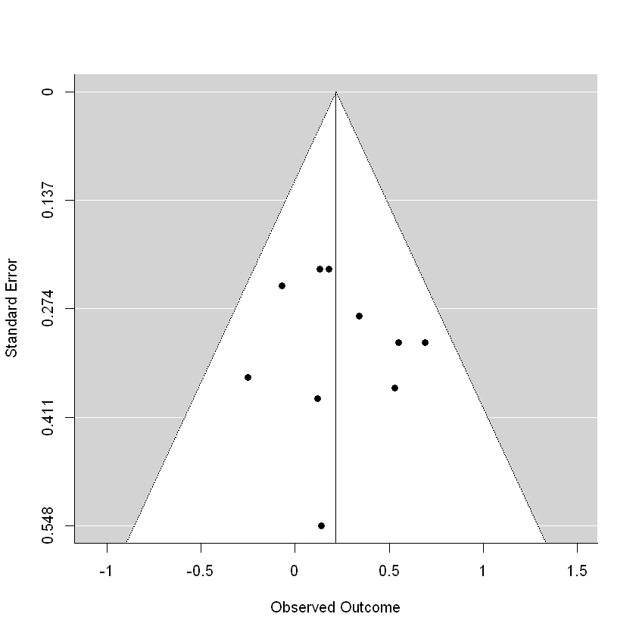

Regression Test for Funnel Plot Asymmetry

model: mixed-effects meta-regression model

predictor: standard error

test for funnel plot asymmetry: z = 0.5001, p = 0.6170
FigureS5.2. Funnel plot for adjusted meta-analysis of opioid use and diagnosed depression
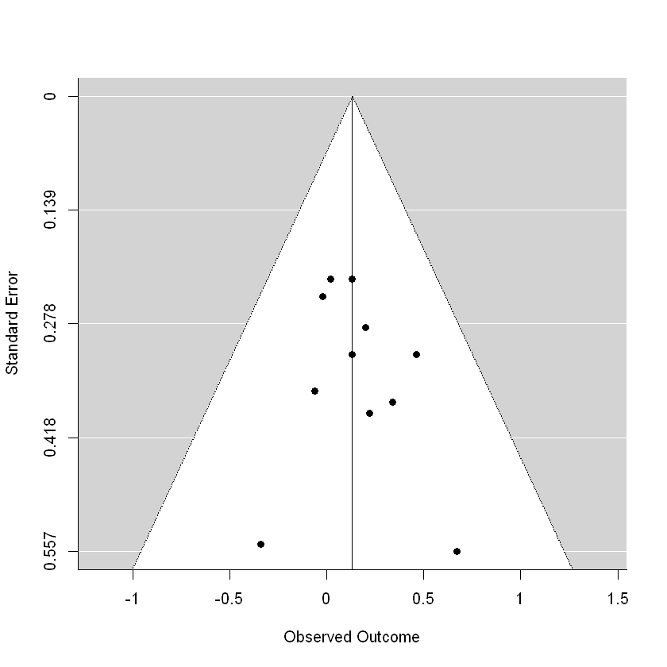
Regression Test for Funnel Plot Asymmetry

model: mixed-effects meta-regression model
predictor: standard error

test for funnel plot asymmetry: z = 0.5286, p = 0.5971

S6. Newcastle Ottawa Quality Assessment Scale for cohort studies

S6.1. Assessment definition and scoring

Source and adaptation notes:
- The definition and scoring system is sourced from: http://www.ohri.ca/programs/clinical_epidemiology/oxford.asp
- †For Selection item 4, we awarded half a point if the study adjusted for the outcome of interest at the start of the study in the analysis.

COHORT STUDIES
A study can be awarded a maximum of one star for each numbered item within the Selection and Outcome categories. A maximum of two stars can be given for Comparability

Selection
1) Representativeness of the exposed cohort
a) truly representative of the population in the community 
b) somewhat representative of the average population in the community 
c) selected group of users eg nurses, volunteers
d) no description of the derivation of the cohort
2) Selection of the non exposed cohort
a) drawn from the same community as the exposed cohort 
b) drawn from a different source
c) no description of the derivation of the non exposed cohort
3) Ascertainment of exposure
a) secure record (eg surgical records) 
b) structured interview 
c) written self report
d) no description
4†) Demonstration that outcome of interest was not present at start of study
a) yes 
b) no
Comparability
1) Comparability of cohorts on the basis of the design or analysis
a) study controls for _____________ (select the most important factor) 
b) study controls for any additional factor  (This criteria could be modified to indicate specific control for a second important factor.)

Outcome
1) Assessment of outcome
a) independent blind assessment 
b) record linkage 
c) self report
d) no description
2) Was follow-up long enough for outcomes to occur
a) yes (select an adequate follow up period for outcome of interest) 
b) no
3) Adequacy of follow up of cohorts
a) complete follow up - all subjects accounted for 
b) subjects lost to follow up unlikely to introduce bias - small number lost - > ____ % (select an adequate %) follow up, or description provided of those lost) 
c) follow up rate < ____% (select an adequate %) and no description of those lost
d) no statement

S6.2. Assessment results
 | Across all items | Assessment items and points
 | Across all items | S1 | S2 | S3 | S4 | C1 | O1 | O2 | O3
 | Across all items | *Representativeness | *Selection | *Exposure | *Outcome at start | **Control variables | *Outcome measure | *Follow-up period | *Follow-up adequacy
Individual studies
Hong 2016 [1] | 72% | 0 | 1 | 1 | 0.5 | 1 | 1 | 1 | 1
Martins 2012 [2] | 100% | 1 | 1 | 1 | 1 | 2 | 1 | 1 | 1
Rossof 2020 [3] | 78% | 1 | 1 | 1 | 1 | 1 | 1 | 0 | 1
Ruggles 2017 [4] | 83% | 0 | 1 | 1 | 0.5 | 2 | 1 | 1 | 1
Salas 2017 [5] | 89% | 0 | 1 | 1 | 1 | 2 | 1 | 1 | 1
Schepis 2013 [6] | 100% | 1 | 1 | 1 | 1 | 2 | 1 | 1 | 1
Scherrer 2014 [7] | 78% | 0 | 1 | 1 | 1 | 2 | 1 | 1 | 0
Scherrer 2015 [8] | 72% | 0 | 1 | 1 | 0.5 | 1 | 1 | 1 | 1
Scherrer 2016 [9] | 67% | 0 | 1 | 1 | 1 | 1 | 1 | 1 | 0
Trevino 2013 [10] | 72% | 0 | 1 | 1 | 0.5 | 1 | 1 | 1 | 1
Across all studies
Average | 81%
TOTAL % meeting each item |  | 30% | 100% | 100% | 80% | 75% | 100% | 90% | 80%
Note. 0 = 0 stars allocated, 0.5 = half a star allocated, 1 = 1 star allocated, 2 = 2 stars allocated. Definition and scoring for each of the assessment criteria are available in S5.1. The points were allocated to each of the item in relation to the aims of our study.

S7. Variables adjusted for by the included studies
Study | Adjusted variables
Hong 2016 | age, severity of injury
Martins 2012 | demographics, other substance use, co-morbid mood/anxiety disorders
Rossof 2020 | genetic variants
Ruggles 2017 | HIV status, depression at baseline, current opioid use, baseline and current alcohol use and smoking
Salas 2017 | maximum daily opioid medication dose, pain, comedication with benzodiazepines, age, sex, race, marital status, insurance, outpatient visits, psychiatric comorbidities (mental and substance use disorders), cardiometabolic conditions, testosterone, sleep
Schepis 2013 | sex, race/ethnicity, age, marital status, employment/student status, education level, household income, region of the US, personality disorder, axis I comorbidity
Scherrer 2014 | pain diagnoses (neuropathy, headaches, musculoskeletal, back pain, and arthritis)
Scherrer 2015 | pain characteristics, health-related quality of life, anxiety, BMI, stressful/supportive relationships, demographics (age, race, education, gender), disability status
Scherrer 2016 | demographics included age, sex, race, marital status, and insurance, marital status, and pain scores
Trevino 2013 | severity of injury, surgeries, length of stay, initial pain, pain score, baseline anxiety, depression, alcohol use, PTSD

S8. References of included studies
1. Hong N, Jung MH, Kim JW, Chun W, Choi I-G, Kang T-C, et al. Opioid analgesics and depressive symptoms in bum patients: What is the real relationship? Clinical Psychopharmacology and Neuroscience. 2016;14(3):295-8.
2. Martins SS, Fenton MC, Keyes KM, Blanco C, Zhu H, Storr CL. Mood and anxiety disorders and their association with non-medical prescription opioid use and prescription opioid-use disorder: longitudinal evidence from the National Epidemiologic Study on Alcohol and Related Conditions. Psychological medicine. 2012;42(6):1261-72.
3. Rosoff DB, Smith GD, Lohoff FW. Prescription Opioid Use and Risk for Major Depressive Disorder and Anxiety and Stress-Related Disorders: A Multivariable Mendelian Randomization Analysis. JAMA psychiatry. 2020.
4. Ruggles KV, Fang Y, Tate J, Mentor SM, Bryant KJ, Fiellin DA, et al. What are the Patterns Between Depression, Smoking, Unhealthy Alcohol Use, and Other Substance Use Among Individuals Receiving Medical Care? A Longitudinal Study of 5479 Participants. AIDS and behavior. 2017;21(7):2014-22.
5. Salas J, Scherrer JF, Schneider FD, Sullivan MD, Bucholz KK, Burroughs T, et al. New-onset depression following stable, slow, and rapid rate of prescription opioid dose escalation. Pain. 2017;158(2):306-12.
6. Schepis TS, Hakes JK. Dose-related effects for the precipitation of psychopathology by opioid or tranquilizer/sedative nonmedical prescription use: results from the National Epidemiologic Survey on Alcohol and Related Conditions. Journal of addiction medicine. 2013;7(1):39-44.
7. Scherrer JF, Svrakic DM, Freedland KE, Chrusciel T, Balasubramanian S, Bucholz KK, et al. Prescription opioid analgesics increase the risk of depression. Journal of general internal medicine. 2014;29(3):491-9.
8. Scherrer JF, Salas J, Lustman PJ, Burge S, David Schneider F. Change in opioid dose and change in depression in a longitudinal primary care patient cohort. Pain. 2015;156(2):348-55.
9. Scherrer JF, Salas J, Copeland LA, Stock EM, Ahmedani BK, Sullivan MD, et al. Prescription Opioid Duration, Dose, and Increased Risk of Depression in 3 Large Patient Populations. Annals of family medicine. 2016;14(1):54-62.
10. Trevino CM, deRoon-Cassini T, Brasel K. Does opiate use in traumatically injured individuals worsen pain and psychological outcomes? The journal of pain : official journal of the American Pain Society. 2013;14(4):424-30.

