Supplementary method 1. Detailed search queries used to identify records in PubMed, Embase, Scopus and the Cochrane central register for clinical trials.

Search 1: Update of the 2016 WHO systematic review report on dietary saturated fat, serum lipids and lipoproteins. (1)
(("saturated" AND ("fat" OR “fats” OR "fatty acid" OR “fatty acids”)) OR “SFA” OR "Butyric" OR "butanoic" OR "butyrates" OR "butyrate" OR "butanoates" OR "butanoate" OR "BTA" OR "C4:0" OR "caproic" OR "hexaenoic" OR "hexanoic" OR "hexanoate" OR "hexanoates" OR "caproates" OR "caproate" OR "C6:0" OR "caprylic" OR "octanoic" OR "C8:0" OR "capric" OR "decanoic" OR "decanoate" OR "decanoates" OR "caprate" OR “caprates" OR "C10:0" OR "lauric" OR "dodecanoic" OR "laurate" OR "laurates" OR "C12:0" OR "tetradecanoic" OR "myristic" OR "myristate" OR "myristates" OR "C14:0" OR "pentadecylic" OR "pentadecanoic" OR "C15:0" OR "palmitic" OR "palmitate" OR "palmitates" OR "hexadecanoic" OR "margaric" OR "heptadecanoic" OR "heptadecanoate" OR "C17:0" OR "stearic" OR "octadecanoic" OR "stearate" OR "stearates" OR "C18:0" OR "arachidic" OR "arachic" OR "eicosanoic" OR "icosanoic" OR "C20:0" OR "behenic" OR "docosanoic" OR "C22:0" OR "lignoceric" OR "tetracosanoic" OR "C24:0")
AND
“cholesterol” OR “high density lipoprotein” OR “HDL” OR “low density lipoprotein” OR “LDL” OR “triacylglycerol” OR “TC” OR “triglyceride” OR “TG” OR “ApoA-I” OR “Apolipoprotein A-I” OR “apoB” OR “apolipoprotein B” OR “Lipoproteins” OR “serum lipids”
AND
(randomized controlled trial[pt] OR controlled clinical trial[pt] OR randomized[tiab] OR placebo[tiab] OR clinical trials as topic[mesh:noexp] OR randomly[tiab] OR trial[ti] NOT (animals[mh] NOT humans [mh]))
AND
(“diet” OR “diets” OR “dietary” OR “intake” OR “intakes” OR “consumption” OR “consume” OR “substitution” OR “replacement” OR “change” OR “replace” OR “nutrition” OR “nutritional” OR “eat” OR “food” OR “foods” OR “source” OR “sources”
NOT
(“acute” OR “postprandial”))

Search 2: Search for RCTs investigating all other biomarkers of cardiometabolic disease risk.
(("saturated" AND ("fat" OR “fats” OR "fatty acid" OR “fatty acids”)) OR “SFA” OR "Butyric" OR "butanoic" OR "butyrates" OR "butyrate" OR "butanoates" OR "butanoate" OR "BTA" OR "C4:0" OR "caproic" OR "hexaenoic" OR "hexanoic" OR "hexanoate" OR "hexanoates" OR "caproates" OR "caproate" OR "C6:0" OR "caprylic" OR "octanoic" OR "C8:0" OR "capric" OR "decanoic" OR "decanoate" OR "decanoates" OR "caprate" OR “caprates" OR "C10:0" OR "lauric" OR "dodecanoic" OR "laurate" OR "laurates" OR "C12:0" OR "tetradecanoic" OR "myristic" OR "myristate" OR "myristates" OR "C14:0" OR "pentadecylic" OR "pentadecanoic" OR "C15:0" OR "palmitic" OR "palmitate" OR "palmitates" OR "hexadecanoic" OR "margaric" OR "heptadecanoic" OR "heptadecanoate" OR "C17:0" OR "stearic" OR "octadecanoic" OR "stearate" OR "stearates" OR "C18:0" OR "arachidic" OR "arachic" OR "eicosanoic" OR "icosanoic" OR "C20:0" OR "behenic" OR "docosanoic" OR "C22:0" OR "lignoceric" OR "tetracosanoic" OR "C24:0")
AND
("free fatty acid" OR "free fatty acids" OR "nonesterified fatty acid" OR "nonesterified fatty acids" OR “NEFA” OR “lipoprotein a” OR “lipoprotein (a)” OR “Lp(a)” OR “apoC2” OR “apolipoprotein C2” OR “apoC3” OR “apolipoprotein C3” OR “apolipoprotein CIII” OR “blood lipid” OR “dyslipidemia” OR “hyperlipidemia” OR “hyperlipoproteinemia” OR “hypercholesterolemia” OR “postprandial lipemia” OR “postprandial lipaemia” OR “serum lipids” OR "TNF-a" OR “TNF alpha” OR “TNFA” OR "IL-6" OR "IL6" OR "IL-10" OR "IL10" OR “CRP” OR “C-reactive protein” OR “reactive protein” OR “hsCRP” OR “high sensitivity CRP” OR “tumor necrosis factor” OR “inflammatory” OR “glucose” OR “insulin” OR "C-peptide" OR “homocysteine” OR “CGM” OR "dicarbonyl stress" OR "1,5-anhydroglucitol" OR “fructosamine” OR "glycated albumin" OR "glycated proteins" OR "advanced glycated end products" OR “HbA1c” OR “glycosylated haemoglobin” OR "hyperglycemic clamp" OR “IVGTT” OR "minimal model" OR “homeostatic model assessment” OR “HOMA” OR “QUICKI” OR “OGTT” OR “clamp” OR “glycemia” OR “glycaemia” OR “BMI” OR “body mass index” OR "waist-hip ratio" OR "waist-to-hip ratio" OR "waist circumference” OR “Body mass” OR “body fat” OR “fat mass” OR “Quetelet index” OR “Ponderal index” OR “Abdominal fat” OR “Visceral fat” OR “subcutaneous fat” OR “Overweight” OR “Over weight” OR “Obesity” OR “Obese” OR “Fatness” OR “glucagon” OR “GPL1” OR “GPL 1” OR “GIP” OR “CCK” OR “PPAR alpha” OR “gluco insulinotropic” OR “Cholecystokinin” OR “peroxisome receptor” OR “anthropometric” OR “fibrinogen” OR "platelet aggregation" OR “fibrinolysis” OR "red blood cell size" OR “factor VII” OR “FVII” OR “ischemia” OR “ischemic” OR “leptin” OR “adiponectin” OR "blood pressure" OR "vascular function" OR “vascular reactivity” OR "endothelial dysfunction" OR "flow-mediated dilation" OR “FMD” OR "intima media thickness" OR “IMT” OR "digital volume pulse" OR “DVP” OR "pulse wave analysis" OR "pulse wave velocity" OR “PWV” OR “ICAM” OR “VCAM” OR “*-selectin” OR “MCP1” OR “endothelial function” OR “arterial stiffness” OR “ankle-brachial index” OR “ABI” OR “ankle-brachial pressure index” OR “ABPI” OR “laser Doppler imaging” OR “endoPAT” OR “coagulation factors” OR “coagulation factor”)
AND
(randomized controlled trial[pt] OR controlled clinical trial[pt] OR randomized[tiab] OR placebo[tiab] OR clinical trials as topic[mesh:noexp] OR randomly[tiab] OR trial[ti] NOT (animals[mh] NOT humans [mh]))
AND
(“diet” OR “diets” OR “dietary” OR “intake” OR “intakes” OR “consumption” OR “consume” OR “substitution” OR “replacement” OR “change” OR “replace” OR “nutrition” OR “nutritional” OR “eat” OR “food” OR “foods” OR “source” OR “sources”
NOT
(“acute” OR “postprandial”))

Supplementary table 1. Outcomes reported in eligible randomized controlled trials for inclusion in the systematic literature review.

Outcome category | Outcomes included in SLR
Fasting lipid concentrations | ApoA-I, apoA-II, apoB, apoB:apoA-I ratio, apoE, HDL-C, HDL₂-C, HDL₃-C, LDL-C, LDL-C:HDL-C ratio, Lp(a), NEFA, TAG, TAG content of lipoproteins, TC, TC:HDL-C ratio, VLDL-C
Blood pressure and vascular function | N/A
Markers of inflammation | CRP, IL-6, TNF-α
Markers of glycaemic control | C-peptide, glucose, HOMA-IR, insulin
Markers of haemostasis | Fibrinogen, PAI-1 activity, tPA activity
Metabolic hormones concentrations | Adiponectin, leptin

Abbreviations: Apo: apolipoprotein, CRP: C-reactive protein, HDL: high-density lipoprotein, HOMA-IR: Homeostatic Model Assessment of Insulin Resistance, IL: interleukin, LDL: low-density lipoprotein, Lp(a): lipoprotein (a), N/A: not applicable, NEFA: non-esterified fatty acids, PAI-1: Plasminogen activator inhibitor-1, SLR: systematic literature review, TNF-α: tumor necrosis factor α, tPA: tissue plasminogen activator, VLDL: very low-density lipoprotein.

Supplementary table 2. Within-participant correlation coefficients used for the statistical syntheses of crossover randomized controlled trials.
Outcome | Correlation coefficient ¹
ApoA-I | 0.807
ApoB | 0.968
NEFA | 0.693
TAG | 0.899
HDL-C | 0.909
LDL-C | 0.937
LDL-C to HDL-C ratio | N/A
VLDL-C | N/A
Total cholesterol | 0.934
Total cholesterol to HDL-C ratio | 0.959
CRP | 0.472
Glucose | 0.895
Insulin | 0.818

¹ derived from Van Rooijen et al. (2020) (2)
Abbreviations: Apo: apolipoprotein, CRP: C-reactive protein, HDL-C: high-density lipoprotein cholesterol, LDL-C: low-density lipoprotein cholesterol, N/A: not available, NEFA: non-esterified fatty acids, TAG: triacylglycerol, VLDL-C: very low-density lipoprotein cholesterol.
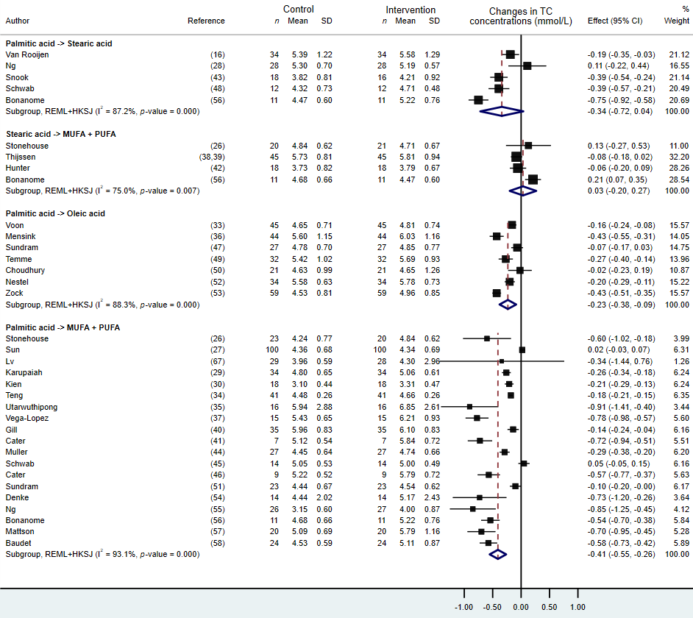
Supplementary figure 1. Sensitivity analyses of the impact of dietary fat replacements on total cholesterol (TC) concentrations, excluding trials with potential reporting errors in the full-text articles.
Abbreviations: MUFA: monounsaturated fatty acids, PUFA: polyunsaturated fatty acids

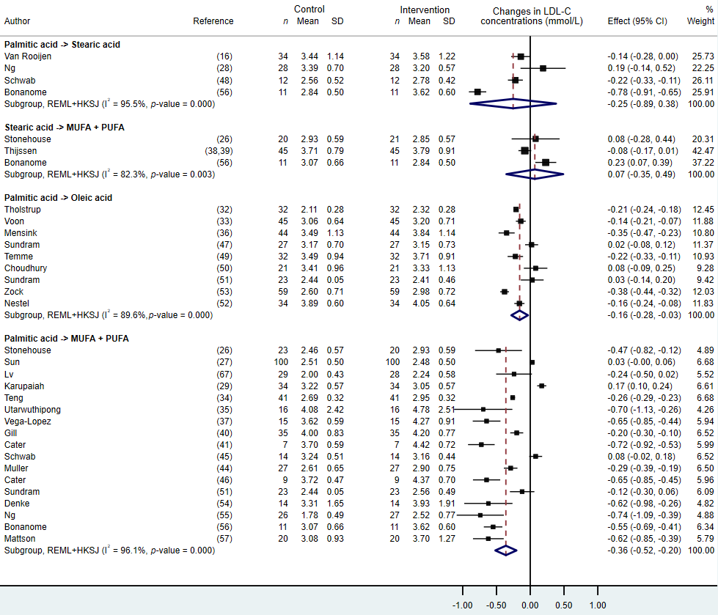
Supplementary figure 2. Sensitivity analyses of the impact of dietary fat replacements on low-density lipoprotein cholesterol (LDL-C) concentrations, excluding trials with potential reporting errors in the full-text articles.
Abbreviations: MUFA: monounsaturated fatty acids, PUFA: polyunsaturated fatty acids

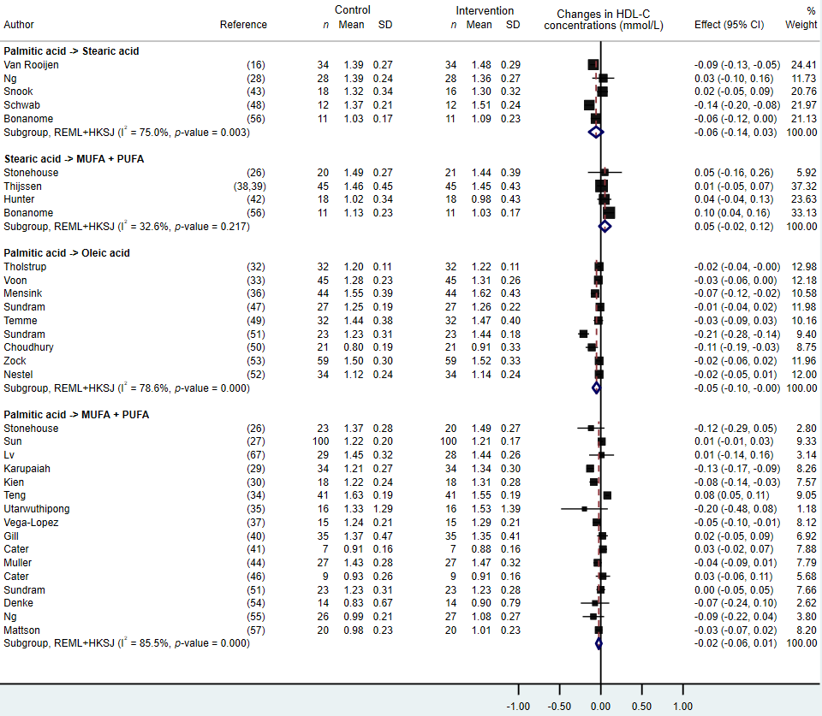
Supplementary figure 3. Sensitivity analyses of the impact of dietary fat replacements on high-density lipoprotein cholesterol (HDL-C) concentrations, excluding trials with potential reporting errors in the full-text articles.
Abbreviations: MUFA: monounsaturated fatty acids, PUFA: polyunsaturated fatty acids

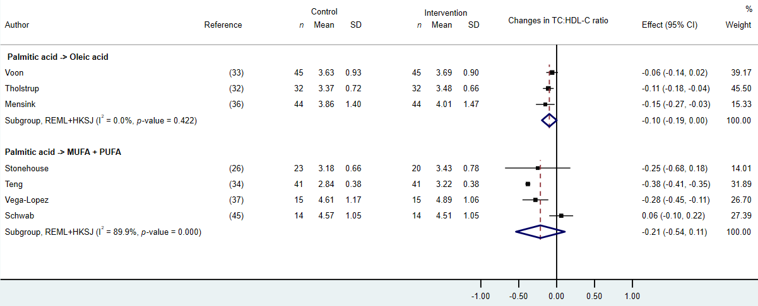
Supplementary figure 4. Forest plot of the effect of the dietary substitution of palmitic acid with unsaturated fat (MUFA + PUFA) on total cholesterol to high-density lipoprotein cholesterol (TC:HDL-C) ratio in randomized controlled trials.
Abbreviations: MUFA: monounsaturated fatty acids, PUFA: polyunsaturated fatty acids.

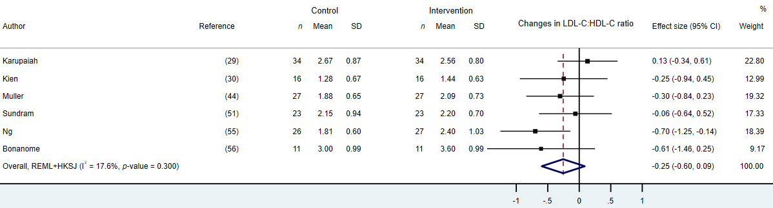

Supplementary figure 5. Forest plot of the effect of the dietary substitution of palmitic acid with unsaturated fat (MUFA + PUFA) on low-density lipoprotein cholesterol to high-density lipoprotein cholesterol (LDL-C:HDL-C) ratio in randomized controlled trials.
Abbreviations: MUFA: monounsaturated fatty acids, PUFA: polyunsaturated fatty acids.

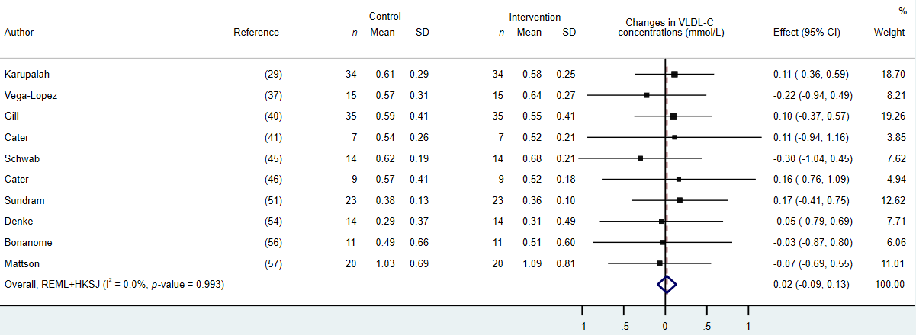
Supplementary figure 6. Forest plot of the effect of the dietary substitution of palmitic acid with unsaturated fat (MUFA + PUFA) on very low-density lipoprotein cholesterol (VLDL-C) in randomized controlled trials.
Abbreviations: MUFA: monounsaturated fatty acids, PUFA: polyunsaturated fatty acids.

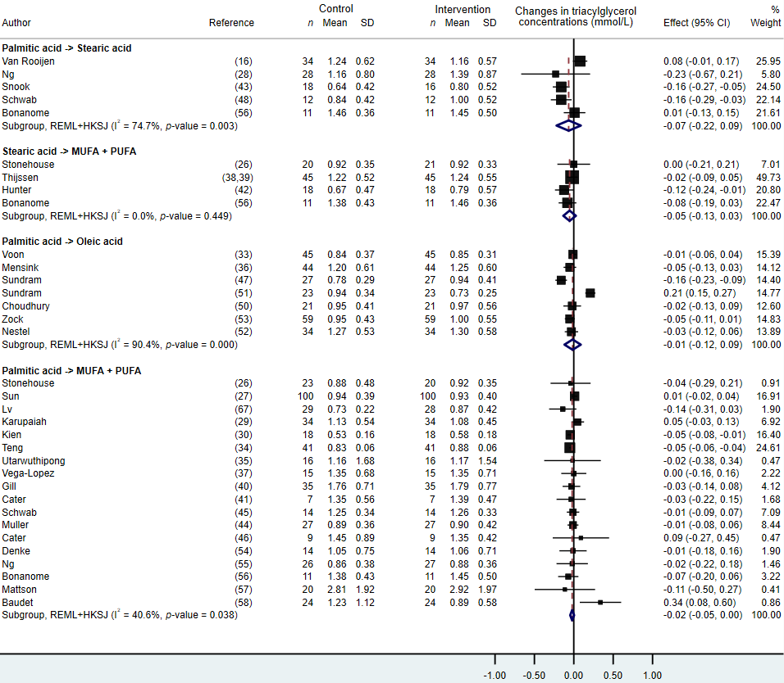
Supplementary figure 7. Sensitivity analyses of the impact of dietary fat replacements on triacylglycerol concentrations, excluding trials with potential reporting errors in the full-text articles.
Abbreviations: MUFA: monounsaturated fatty acids, PUFA: polyunsaturated fatty acids

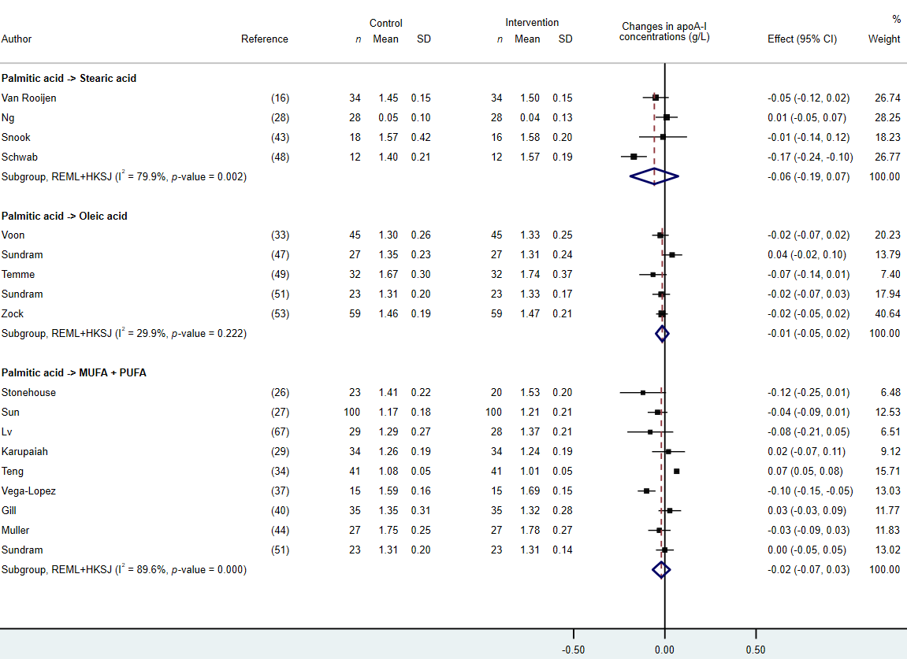
Supplementary figure 8. Sensitivity analyses of the impact of dietary fat replacements on apolipoprotein A-I (apoA-I) concentrations, excluding trials with potential reporting errors in the full-text articles.
Abbreviations: MUFA: monounsaturated fatty acids, PUFA: polyunsaturated fatty acids

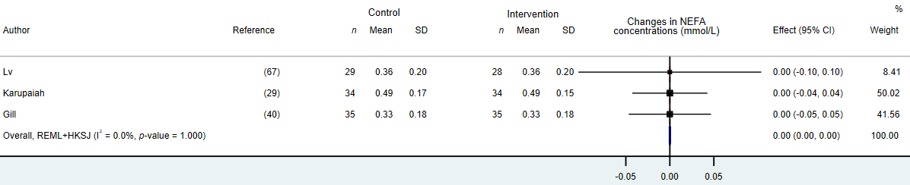
Supplementary figure 9. Forest plot of the effect of the dietary substitution of palmitic acid with unsaturated fat (MUFA + PUFA) on non-esterified fatty acid (NEFA) concentrations in randomized controlled trials.
Abbreviations: MUFA: monounsaturated fatty acids, PUFA: polyunsaturated fatty acids.
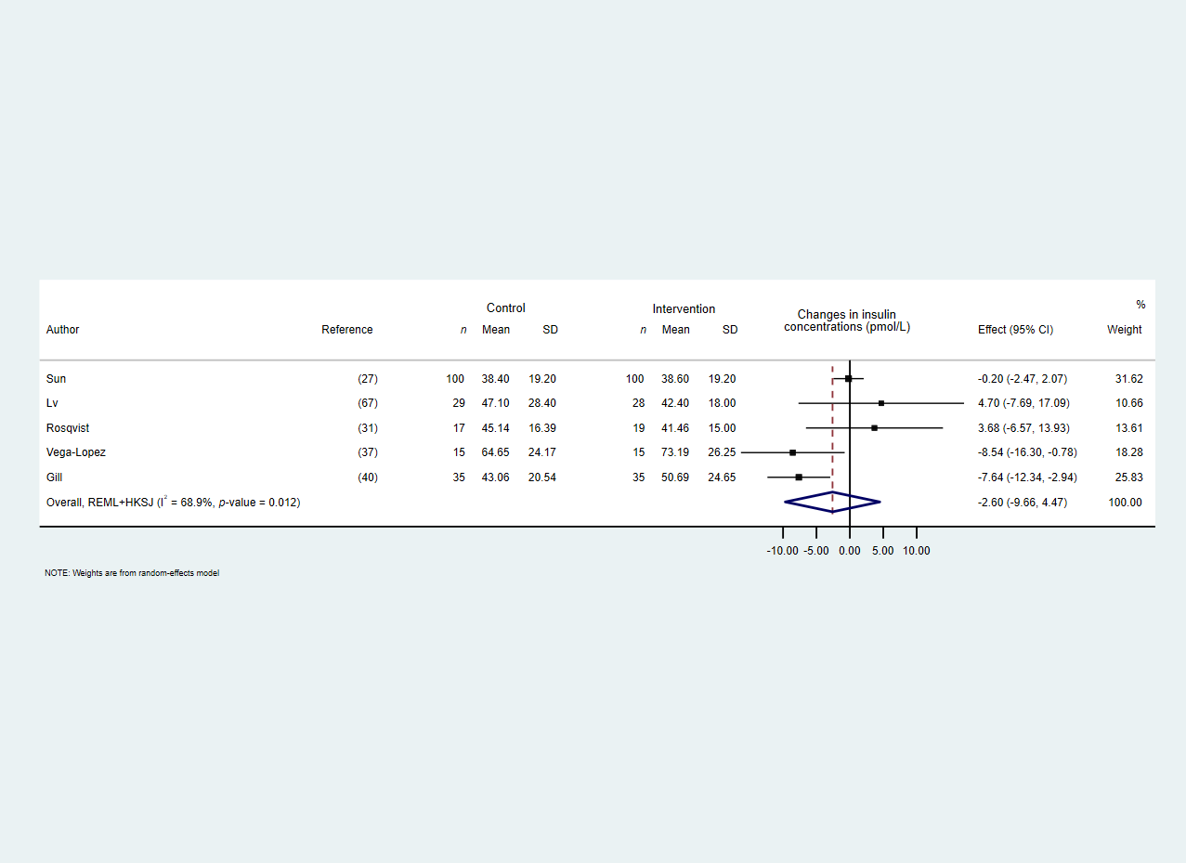
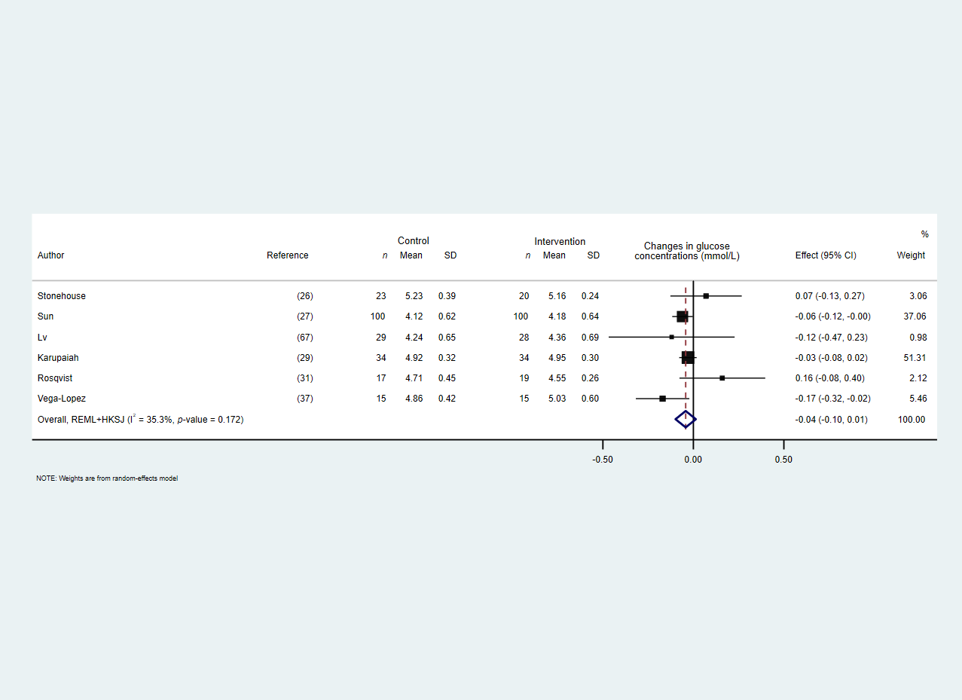
Supplementary figure 10. Forest plots of the effect of the dietary substitution of palmitic acid with unsaturated fat (MUFA + PUFA) on (A) fasting glucose and (B) insulin concentrations in randomized controlled trials.
A
B
Abbreviations: MUFA: monounsaturated fatty acids, PUFA: polyunsaturated fatty acids.
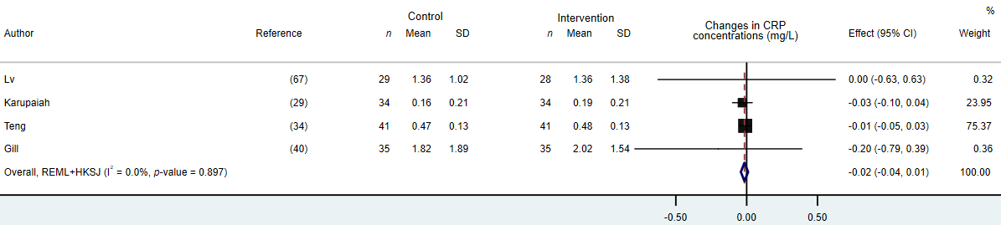
Supplementary figure 11. Forest plot of the effect of the dietary substitution of dietary palmitic acid with unsaturated fat (MUFA+ PUFA) on C-reactive protein (CRP) concentrations in randomized controlled trials.
Abbreviations: MUFA: monounsaturated fatty acids, PUFA: polyunsaturated fatty acids.

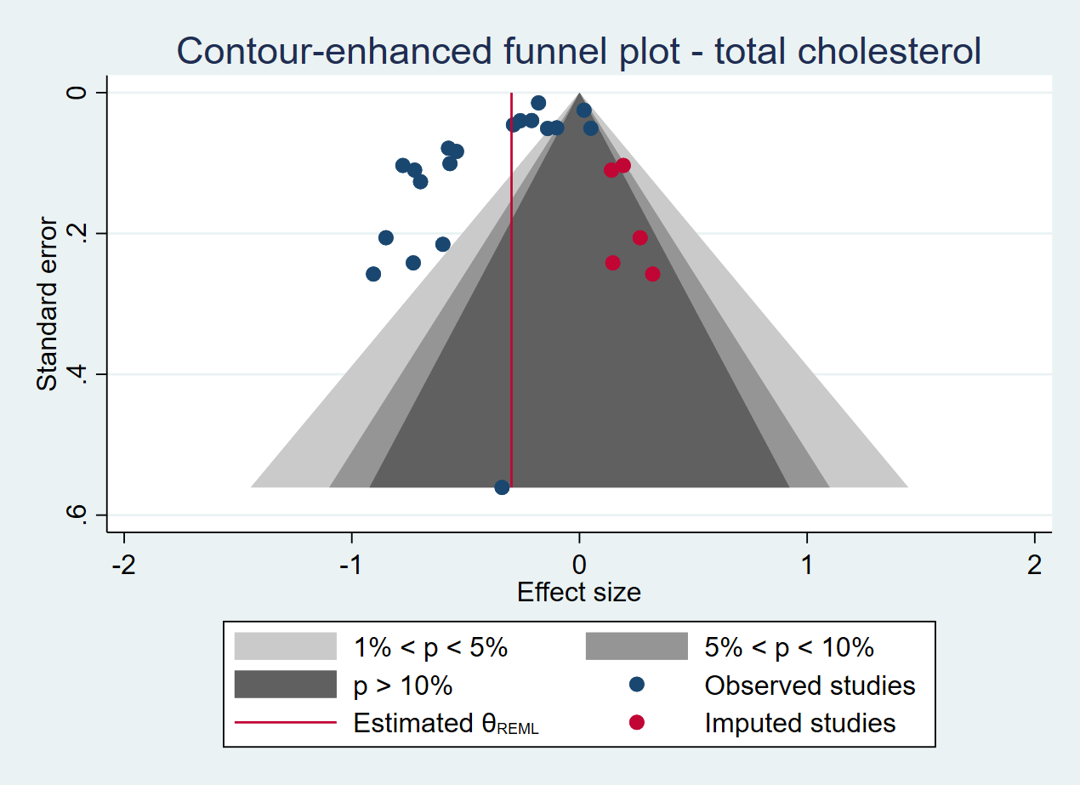
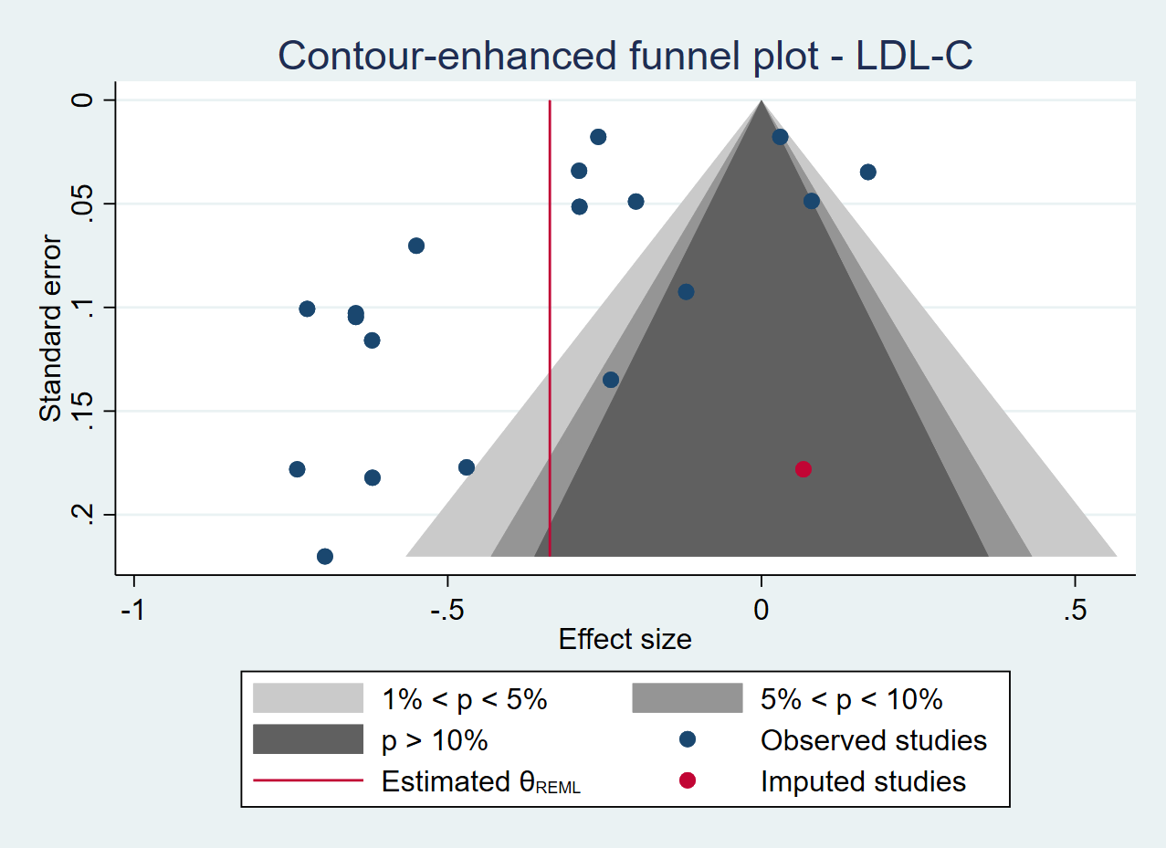
Changes in TC concentrations (mmol/L)
Standard Error
A

Changes in LDL-C concentrations (mmol/L)
Standard Error
B

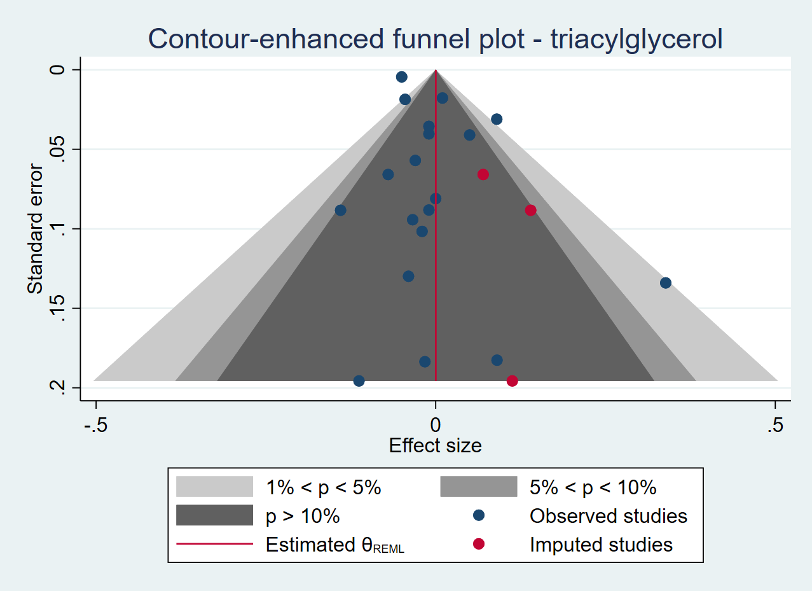
Changes in TAG concentrations (mmol/L)
Standard Error
C

Supplementary figure 12. Contour-enhanced funnel plots of RCTs investigating the impact of the dietary substitution of palmitic acid with unsaturated fat (MUFA + PUFA) on (A) total cholesterol (TC), (B) low-density lipoprotein cholesterol (LDL-C), and (C) triacylglycerol (TAG) concentrations, corrected with a trim and fill method and showing regions of statistical significance.
Abbreviations: LDL-C: low-density lipoprotein cholesterol, MUFA: monounsaturated fatty acids, PUFA: polyunsaturated fatty acids, TAG: triacylglycerol, TC: total cholesterol.

References:
1. Mensink RP. Effects of saturated fatty acids on serum lipids and lipoproteins: a systematic review and regression analysis [Internet]. Geneva: World Health Organization; 2016. Available from: http://apps.who.int/iris/bitstream/handle/10665/246104/9789241565349-eng.pdf;jsessionid=44E256334906BD5871B409827BF4DE82?sequence=1
2. van Rooijen MA, Plat J, Blom WAM, Zock PL, Mensink RP. Dietary stearic acid and palmitic acid do not differently affect ABCA1-mediated cholesterol efflux capacity in healthy men and postmenopausal women: A randomized controlled trial. Clin Nutr 2020;40:804–11.

