Supplementary File 7: GRADE assessment

Cumulative incidence for categorical data of number of teeth and ACVD
 | Study design | Number of studies | Study limitations | Inconsistency | Indirectness | Imprecision | Publication Bias | Magnitude of the effect | Dose-response gradient | Effect of plausible confounding | Strength of the evidence
0 vs.  1-32 teeth (ref.) | Observational | 10 | Low | Serious inconsistency  I² = 99% | None | None | Minor | Large | N.A. | None | Moderate  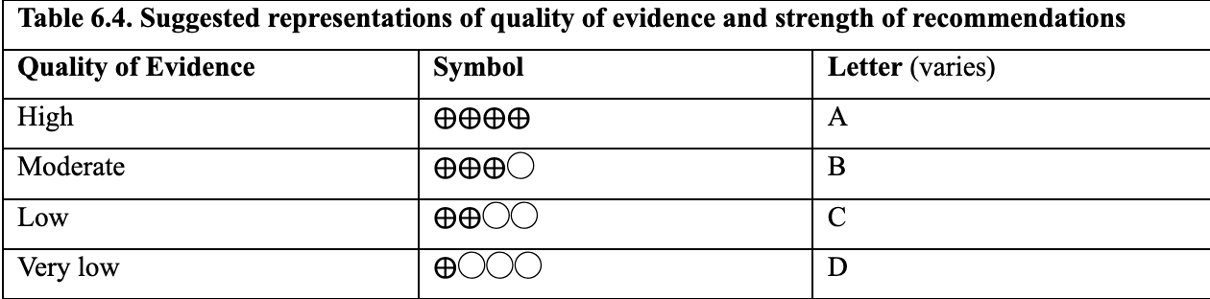
0-19 vs.  20-32 teeth (ref.) | Observational | 4 | Low | Low inconsistency  I² = 0% | None | None | N.A. | Moderate | N.A. | None | Moderate
0 vs.  1-19 vs.  20-32 teeth (ref.) | Observational | 2 | Low | Moderate  inconsistency  I² = 60% | None | None | N.A. | Large | Present | None | High
0-10 vs.  11-16 vs.  17-24 vs.  25-32 teeth (ref.) | Observational | 4 | Low | Serious inconsistency  I² = 87% | None | None | N.A. | Large | Present | None | High
Abbreviations: ACVD, Atherosclerotic Cardiovascular Disease; vs., versus; ref., reference group; I², I-square; N.A., Not Applicable

Cumulative incidence for categorical data of number of teeth and All-Cause Mortality
 | Study design | Number of studies | Study limitations | Inconsistency | Indirectness | Imprecision | Publication Bias | Magnitude of the effect | Dose-response gradient | Effect of plausible confounding | Strength of the evidence
0 vs.  1-32 teeth (ref.) | Observational | 14 | Low | Serious inconsistency  I² = 100% | None | None | Minor | Moderate | N.A. | None | Low
0-19 vs.  20-32 teeth (ref.) | Observational | 11 | Low | Serious inconsistency  I² = 95% | None | None | Minor | Moderate | N.A. | None | Low
0 vs.  1-19 vs.  20-32 teeth (ref.) | Observational | 8 | Low | Serious inconsistency  I² = 94% | None | None | N.A. | Large | Present | None | High
Abbreviations: vs., versus; ref., reference group; I², I-square; N.A., Not Applicable
Incidence density for categorical and continuous data of number of teeth and ACVD (multivariable)
 | Study design | Number of studies | Study limitations | Inconsistency | Indirectness | Imprecision | Publication Bias | Magnitude of the effect | Dose-response gradient | Effect of plausible confounding | Strength of the evidence
0 vs.  1-32 teeth (ref.) | Observational | 5 | Low | Low  inconsistency  I² = 35% | None | None | N.A. | Moderate | N.A. | None | Moderate
0-19 vs.  20-32 teeth (ref.) | Observational | 4 | Low | Low  inconsistency  I² = 0% | None | None | N.A. | Moderate | N.A. | None | Moderate
Continuous no. of lost teeth | Observational | 13 | Moderate | Serious  inconsistency  I² = 75% | None | None | Minor | Small | N.A. | None | Low
Abbreviations: ACVD, Atherosclerotic Cardiovascular Disease; vs., versus; ref., reference group; no., number; I², I-square; N.A., Not Applicable

Incidence density for categorical data and continuous data of number of teeth and All-Cause Mortality (multivariable)
 | Study design | Number of studies | Study limitations | Inconsistency | Indirectness | Imprecision | Publication Bias | Magnitude of the effect | Dose-response gradient | Effect of plausible confounding | Strength of the evidence
0 vs.  1-32 teeth (ref.) | Observational | 7 | Moderate | Low  inconsistency  I² = 20% | None | None | N.A. | Moderate | N.A. | None | Moderate
0-19 vs.  20-32 teeth (ref.) | Observational | 10 | Low | Serious  inconsistency  I² = 78% | None | None | Minor | Moderate | N.A. | None | Low
Continuous no. of lost teeth | Observational | 11 | Moderate | Serious  inconsistency  I² = 89% | None | None | Minor | Small | N.A. | None | Low
Abbreviations: vs., versus; ref., reference group; no., number; I², I-square; N.A., Not Applicable

