EUS-CGN Versus EUS-CPN in pancreatic cancer: a qualitative systematic review
Zihe Wang, MD
Bole Tian*, PhD

Supplemental Digital Content 2, Graphs and Tables that detail the assessment of risk-of-bias in two RCTs

SDC 2a. Risk of bias summary
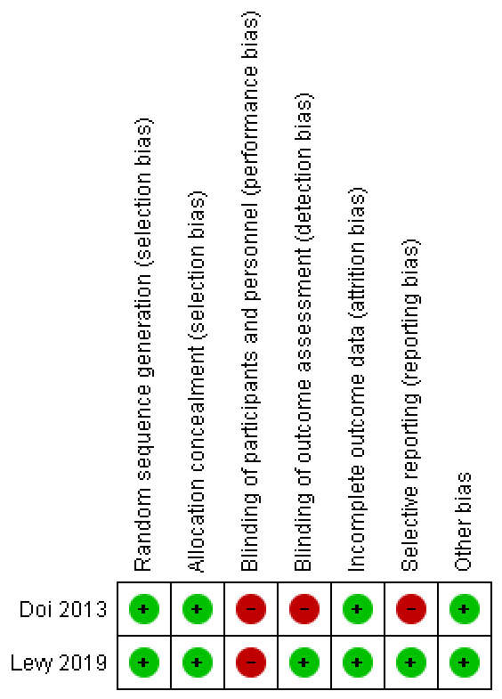
SDC 2b. Risk of bias graph.
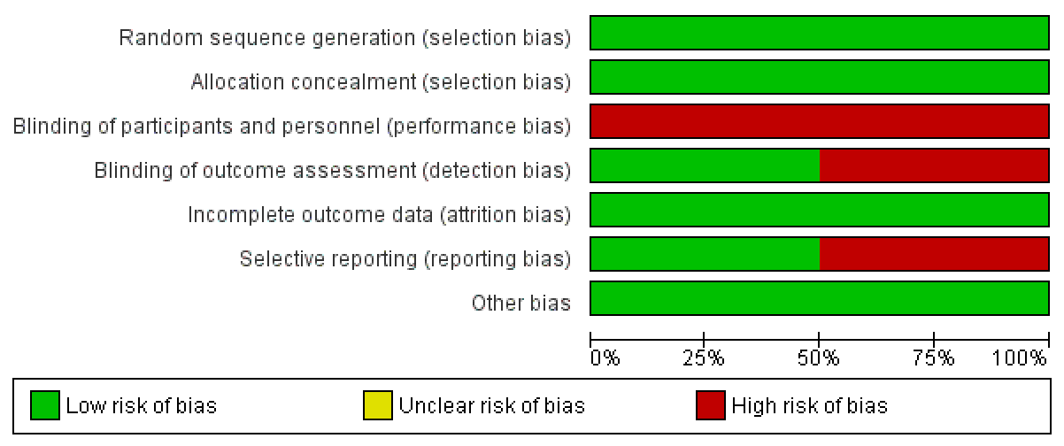

SDC 2c. Risk-of-bias table for the study of Doi et al.¹
Bias | Authors' judgement | Support for judgement
Random sequence generation (selection bias) | Low risk | Quote: "Randomization was computerized using a minimization algorithm with stratification for institution, type of primary tumor and preoperative pain score."
Allocation concealment (selection bias) | Low risk | Quote: "Allocation and data collection were carried out through a web-based system."
Blinding of participants and personnel (performance bias) | High risk | Quote: "no one is blinded" according to the protocol
Blinding of outcome assessment (detection bias) | High risk | Quote: "no one is blinded" according to the protocol
Incomplete outcome data (attrition bias) | Low risk | Comment: only 1 patient was excluded for having ileus on day2, and this patient originally had carcinomatous peritonitis and ascites
Selective reporting (reporting bias) | High risk | Comment: all outcomes except "procedure period" were reported.
Other bias | Low risk | Comment: no other sources of bias identified.
SDC 2d. Risk-of-bias table for the study of Levy et al.²
Bias | Authors' judgement | Support for judgement
Random sequence generation (selection bias) | Low risk | Quote: "The Division of Biostatistics conducted computer  randomization in blocks of 4, based on the technique and tumor stage"
Allocation concealment (selection bias) | Low risk | Quote: "Following stratification, an administrative assistant, not involved in the study, opened in sequence a sealed envelope containing the assignment"
Blinding of participants and personnel (performance bias) | High risk | Quote: "The operator (endosonographer) by necessity was not blinded to the intervention"
Blinding of outcome assessment (detection bias) | Low risk | Quote: "The blinded observer was a research nurse who performed all patient assessments"
Incomplete outcome data (attrition bias) | Low risk | Comment: all participants completed the designed assessment.
Selective reporting (reporting bias) | Low risk | Comment: all outcomes were reported.
Other bias | Low risk | Comment: no other sources of bias identified.

Reference:
1. Doi S, Yasuda I, Kawakami H, et al. Endoscopic ultrasound-guided celiac ganglia neurolysis vs. celiac plexus neurolysis: a randomized multicenter trial. Endoscopy. 2013;45(5):362‐369.
2. Levy MJ, Gleeson FC, Topazian MD, et al. Combined Celiac Ganglia and Plexus Neurolysis Shortens Survival, Without Benefit, vs Plexus Neurolysis Alone. Clinical Gastroenterology and Hepatology. 2019;17(4):728-738.e729.

