Supplementary figure 2: Meta-analysis of the association between hormonal contraceptives and STIs/BV outcome omitting studies with HIV-positive patients
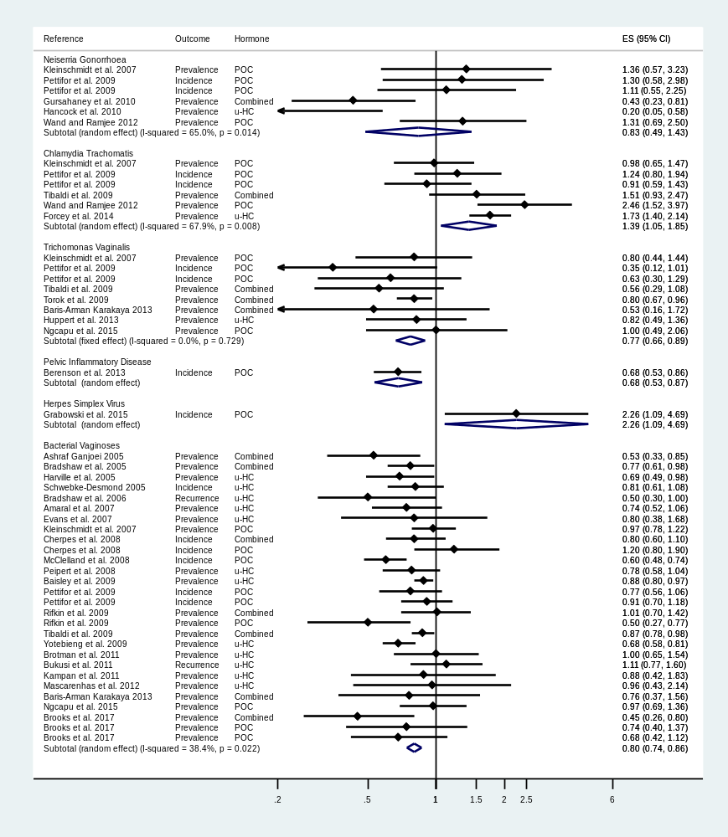
Note: the diamond in the middle of each horizontal line represents the point estimate of the effect for a single study. Each horizontal lines depict the 95% confidence interval (CI) for a study and the lines that extend beyond the specified value range are cropped and adorned with arrows. The group-specific effect size is plotted by diamond (without horizontal line) with the width corresponding to its 95% CI.

