Supplementary document 1

PICO Worksheet and Search Strategy Protocol

- Define your question using PICO by identifying: Patient/Problem, Intervention, Comparison group and Outcome: Patient/Problem: Healthcare workers
Intervention: None
Comparison: None
Outcomes: Mental health outcomes during COVID-19 pandemic
Study design: Observational study
- Type of question/problem:

Circle one: Therapy / Prevention / Diagnosis / Etiology / Prognosis / Proportion
- Type of studies/publications to include in the search: Check all that apply:
Meta-analysis Systematic review
Clinical practice guidelines Randomized controlled trial
Research studies or articles √Cohort study or cross-sectional study
Research report or other grey literature
- List main topics and alternate terms from your PICO question that can be used for your search:

Main topics | Alternate terms
Healthcare workers | Healthcare workers, HCWs, health worker, health care provider, professionals, front line workers, nurses, doctor, paramedic, medical workers
Mental health outcomes during COVID-19 pandemic | Mental health outcome, mental health impact, mental illness, mental disorder, psychiatric illness, mental health status, COVID-19, sars-cov-2, coronavirus disease 2019, con-19, coronavirus disease, 2019 n-cov
- Write out your search strategy:
Healthcare workers OR HCWs OR health worker OR health care provider OR professionals OR front line workers OR nurses OR doctor OR paramedic OR medical workers
AND Mental health outcome OR mental health impact OR mental illness OR mental disorder OR psychiatric illness OR mental health status
AND COVID-19 OR sars-cov-2 OR coronavirus disease 2019 OR con-19 OR coronavirus disease OR 2019 n-cov
- List any limits that may apply to your search:
Population: Healthcare workers
Outcomes: Anxiety, depression, distress, and PTSD
Study design: Observational study
Year(s) of publication: December 1st 2019 to November 2nd, 2020
Language(s): English
- List the databases you will search:
PubMed, academic search complete, Cumulative Index to Nursing and Allied Health Literature (CINAHL), Web of Science, MEDLINE Complete, and socINDEX
This form is adapted from: Miller, S.A. (2001). PICO worksheet and search strategy. US National Center for Dental Hygiene Research

Supplementary document 2

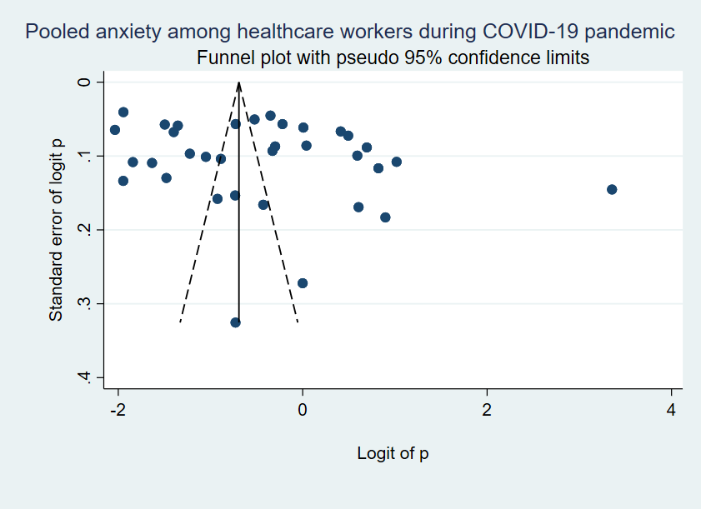
Figure 6. Funnel plot of anxiety among healthcare workers during COVID-19 pandemic

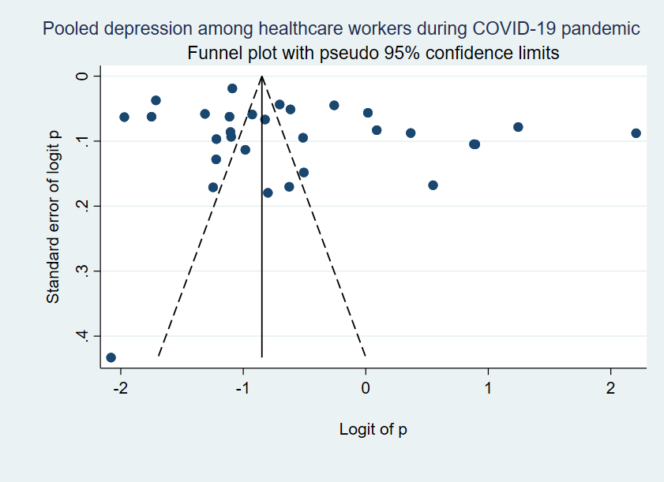
Figure 7. Funnel plot of depression among healthcare workers during COVID-19 pandemic

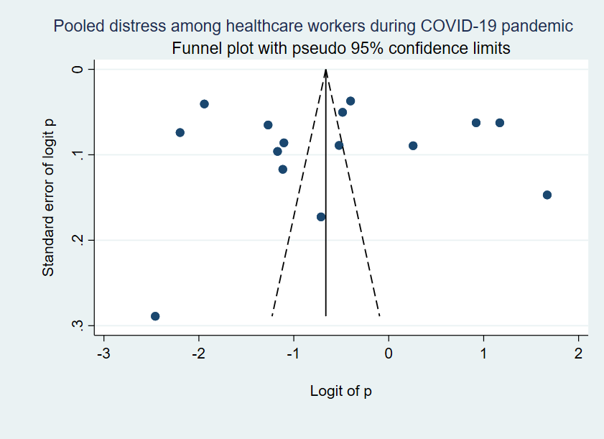
Figure 8. Funnel plot of distress among healthcare workers during COVID-19 pandemic

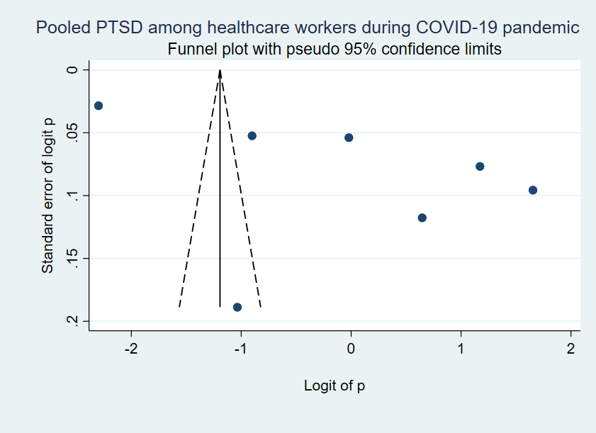
Figure 9. Funnel plot of post-traumatic stress disorder (PTSD) among healthcare workers during COVID-19 pandemic

