Figure C.1 Meta-analysis of controlled studies of nature-based interventions for depressive mood versus control at post-intervention across all populations
The size of the grey box reflects how much weight each study received in the meta-analysis (i.e., the larger the box the more this study contributed to the pooled effect represented by the blue diamond). Black bars represent the 95% CI for the SMD in each study.
CI = confidence interval; SMD = standardised mean difference

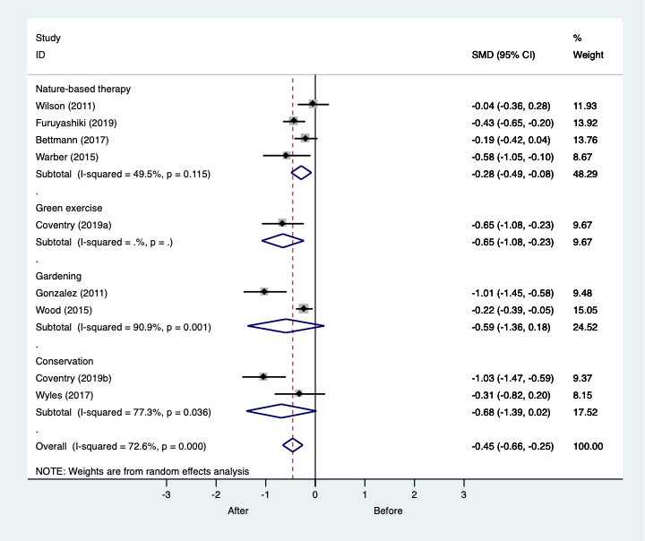
Figure C.2 Meta-analysis of single group before and after studies of nature-based interventions for depressive mood across all populations
The size of the grey box reflects how much weight each study received in the meta-analysis (i.e., the larger the box the more this study contributed to the pooled effect represented by the blue diamond). Black bars represent the 95% CI for the SMD in each study.
CI = confidence interval; SMD = standardised mean difference

Figure C.3 Meta-analysis of controlled studies of nature-based interventions for anxiety versus control at post-intervention across all populations
The size of the grey box reflects how much weight each study received in the meta-analysis (i.e., the larger the box the more this study contributed to the pooled effect represented by the blue diamond). Black bars represent the 95% CI for the SMD in each study.
CI = confidence interval; SMD = standardised mean difference

Figure C.4 Meta-analysis of single group before and after studies of nature-based interventions for anxiety across all populations
The size of the grey box reflects how much weight each study received in the meta-analysis (i.e., the larger the box the more this study contributed to the pooled effect represented by the blue diamond). Black bars represent the 95% CI for the SMD in each study.
CI = confidence interval; SMD = standardised mean difference

Figure C.5 Meta-analysis of controlled studies of nature-based interventions for positive affect versus control at post-intervention across all populations
The size of the grey box reflects how much weight each study received in the meta-analysis (i.e., the larger the box the more this study contributed to the pooled effect represented by the blue diamond). Black bars represent the 95% CI for the SMD in each study.
CI = confidence interval; SMD = standardised mean difference

Figure C.6 Meta-analysis of single group before and after studies of nature-based interventions for positive affect across all populations
The size of the grey box reflects how much weight each study received in the meta-analysis (i.e., the larger the box the more this study contributed to the pooled effect represented by the blue diamond). Black bars represent the 95% CI for the SMD in each study.
CI = confidence interval; SMD = standardised mean difference

Figure C.7 Meta-analysis of controlled studies of nature-based interventions for negative affect versus control at post-intervention across all populations
The size of the grey box reflects how much weight each study received in the meta-analysis (i.e., the larger the box the more this study contributed to the pooled effect represented by the blue diamond). Black bars represent the 95% CI for the SMD in each study.
CI = confidence interval; SMD = standardised mean difference

Figure C.8 Meta-analysis of single group before and after studies of nature-based interventions for negative affect across all populations
The size of the grey box reflects how much weight each study received in the meta-analysis (i.e., the larger the box the more this study contributed to the pooled effect represented by the blue diamond). Black bars represent the 95% CI for the SMD in each study.
CI = confidence interval; SMD = standardised mean difference

Figure C.9 Meta-analysis of RCTs of nature-based interventions for systolic blood pressure versus control at post-intervention across all populations
The size of the grey box reflects how much weight each study received in the meta-analysis (i.e., the larger the box the more this study contributed to the pooled effect represented by the blue diamond). Black bars represent the 95% CI for the SMD in each study.
CI = confidence interval; RCT = randomised controlled trial; SMD = standardised mean difference

Figure C.10 Meta-analysis of RCTs of nature-based interventions for diastolic blood pressure versus control at post-intervention across all populations
The size of the grey box reflects how much weight each study received in the meta-analysis (i.e., the larger the box the more this study contributed to the pooled effect represented by the blue diamond). Black bars represent the 95% CI for the SMD in each study.
CI = confidence interval; RCT = randomised controlled trial; SMD = standardised mean difference

Figure C.11 Meta-analysis of controlled studies of nature-based interventions for systolic blood pressure versus control at post-intervention across all populations
The size of the grey box reflects how much weight each study received in the meta-analysis (i.e., the larger the box the more this study contributed to the pooled effect represented by the blue diamond). Black bars represent the 95% CI for the SMD in each study.
CI = confidence interval; SMD = standardised mean difference

Figure C.12 Meta-analysis of controlled studies of nature-based interventions for diastolic blood pressure versus control at post-intervention across all populations
The size of the grey box reflects how much weight each study received in the meta-analysis (i.e., the larger the box the more this study contributed to the pooled effect represented by the blue diamond). Black bars represent the 95% CI for the SMD in each study.
CI = confidence interval; SMD = standardised mean difference

