Supplementary Materials
- Risk of bias summary
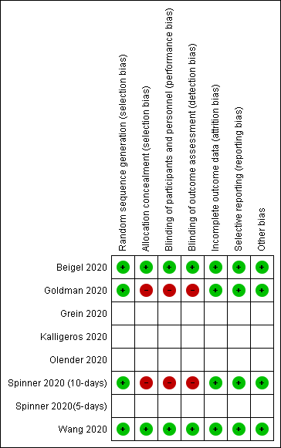
Note: Spinner 2020 (10-days) and Spinner 2020 (5-days) are the same study.
Figure 2: Review authors' judgements about each risk of bias item for included study (RCT).

Beigel et al. 2020
Methods | Study design: Randomized, double-blind, placebo-controlled trials.  Number of study arms:2  Study centres: 60 trial sites and 13 subsites  Length of follow-up: 2 months
Participants | Setting: United States (45 sites), Denmark (8), the United Kingdom (5), Greece (4), Germany (3), Korea (2), Mexico (2), Spain (2), Japan (1), and Singapore (1).  Number randomised: 1062  Number analysed: 1048  Number lost to follow-up: 14  Sample: Hospitalized adults with laboratory-confirmed COVID-19 and had evidence of  lower respiratory tract infection.  Age (years): 58.9±15.0  Sex: 64.4% were male  Ethnicity: American Indian or Alaska Native, Asian, Black or African American, White, Hispanic or Latino.  Inclusion criteria: Radiographic infiltrates by imaging study, peripheral oxygen saturation (SpO2) ≤94% on room air, or requiring supplemental oxygen, mechanical ventilation, or extracorporeal membrane oxygenation (ECMO).  Exclusion criteria: Alanine aminotransferase (ALT) or an aspartate aminotransferase (AST) > 5 times the upper limit of the normal range; impaired renal function as determined by calculating an estimated glomerular filtration rate (eGFR) or need for haemodialysis or hemofiltration; allergy to study product; pregnancy or breast-feeding; and anticipated discharge from the hospital or transfer to another hospital within 72 hours of enrolment.
Interventions | Type of intervention: Intravenous Remdesivir  Who delivered the intervention: The treating physician.  Compliance assessed: Not reported
Outcomes | Primary outcomes: Time to recovery  Secondary outcomes: Clinical status at day 15, time to improvement of the baseline ordinal score, mortality at 14 and 28 days after enrolment, safety outcome measures and changes in  assessed laboratory values over time.
Notes | Source of funding: The National Institute of Allergy and Infectious Diseases and others  Conflicts of interest: None  Economic information: Not reported

Spinner et al. 2020
Methods | Study design: Randomized, open-label trial.  Number of study arms: 3  Study centres: 105 hospitals in the United States, Europe, and Asia  Length of follow-up: March 15, 2020 to April 18,2020
Participants | Setting: United States, Europe, and Asia.  Number randomised: 596  Number analysed: 584  Number lost to follow-up: 12  Sample: Hospitalized patients with SARS-CoV-2 infection confirmed by polymerase chain reaction assay within 4 days of randomization and moderate COVID-19 pneumonia (defined as any radiographic evidence of pulmonary infiltrates and oxygen saturation >94% on room air) were enrolled.  Age (years): 56 (45-66) years in 10-day remdesivir group, 58 (48-66) years in 5-Day remdesivir and 57 (45-66) years in Standard care group.  Sex: 61% male  Ethnicity: White, Black, Asian and others.  Inclusion criteria: Aged ≥ 18 years (at all sites), or aged ≥ 12 and 94% on room air at screening; radiographic evidence of pulmonary infiltrates; SARS-CoV-2 infection confirmed by PCR ≤ 4 days before randomisation; currently hospitalised and requiring medical care for COVID-19; SpO2 > 94% on room air at screening; men and women of childbearing potential who engage in heterosexual intercourse and agree to use protocol specified method(s) of contraception.  Exclusion criteria: Participation in any other clinical trial of an experimental agent treatment for COVID-19; concurrent treatment with other agents with actual or possible direct acting antiviral activity against SARS-CoV-2 <24 hours prior to study drug dosing; requiring mechanical ventilation at screening; ALT or AST > 5 x ULN; creatinine clearance <50ml/minute; positive pregnancy test; breastfeeding woman; known hypersensitivity to the study drug, the metabolites, or formulation excipient.
Interventions | Type of intervention: 5-day course of remdesivir and 10-day course of remdesivir.  Who delivered the intervention: Unclear  Compliance assessed: Unclear
Outcomes | Primary outcomes: Clinical status assessed on the 7-point ordinal scale on study day 11.  Secondary outcomes: Proportion of patients with adverse events, duration of hospitalization, duration of different modes of respiratory support, and all-cause mortality.
Notes | Source of funding: Gilead Sciences.  Conflicts of interest: No  Economic information: No

Wang et al. 2020
Methods | Study design: Individually randomised, placebo-controlled, double-blind trial  Number of study arms: 2  Study centres: Wuhan, Hubei, China.  Length of follow-up: Between Feb 6, 2020 to March 12, 2020.
Participants | Setting: Ten hospitals in Wuhan  Number randomised: 237  Number analysed: 236  Number lost to follow-up: 1  Sample: Adults (aged ≥18 years) admitted to hospital with severe COVID-19  Age (years):66(57–73·) years in remdesivir group and 64(53–70) years in placebo group.  Sex: 59% male  Ethnicity: Nor reported  Inclusion criteria: Men and non-pregnant women with COVID-19 who were aged at least 18 years and were RT-PCR positive for SARS-CoV-2, had pneumonia confirmed by chest imaging, had oxygen saturation of 94% or lower on room air or a ratio of arterial oxygen partial pressure to fractional inspired oxygen of 300 mm Hg or less, and were within 12 days of symptom onset.  Exclusion criteria: Pregnancy or breast feeding; hepatic cirrhosis; alanine aminotransferase or aspartate aminotransferase more than five times the upper limit of normal; known severe renal impairment (estimated  glomerular filtration rate <30 mL/min per 1·73 m²) or receipt of continuous renal replacement therapy,  haemodialysis, or peritoneal dialysis; possibility of transfer to a non-study hospital within 72 h; and enrolment into an investigational treatment study for COVID-19 in the 30 days before screening.
Interventions | Type of intervention: Intravenous remdesivir (200 mg on day 1 followed by 100 mg on days 2–10 in single daily  infusions) or the same volume of placebo infusions for a total of 10 days.  Who delivered the intervention: Trained nurses.  Compliance assessed: The trial was monitored by a contract research organisation (Hangzhou Tigered Consulting).
Outcomes | The primary outcome: Time to clinical improvement within 28 days after randomisation.  Secondary outcomes: Proportions of patients in each category of the six-point scale at day 7, 14, and  28 after randomisation; all-cause mortality at day 28; frequency of invasive mechanical ventilation; duration  of oxygen therapy; duration of hospital admission; and proportion of patients with nosocomial infection.
Notes | Source of funding: Chinese Academy of Medical Sciences Emergency Project of COVID-19, National Key Research and Development Program of China, the Beijing Science and Technology Project.  Conflict of interest: No competing interests.

- Supplemental oxygen & mechanical ventilation requirement on day 7, 14 and 28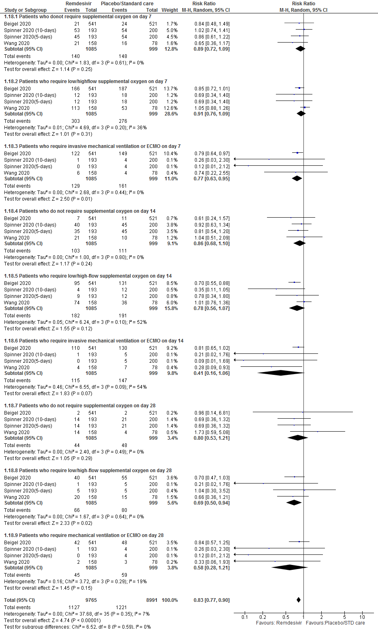

- Clinical status on the 7-point ordinal scale

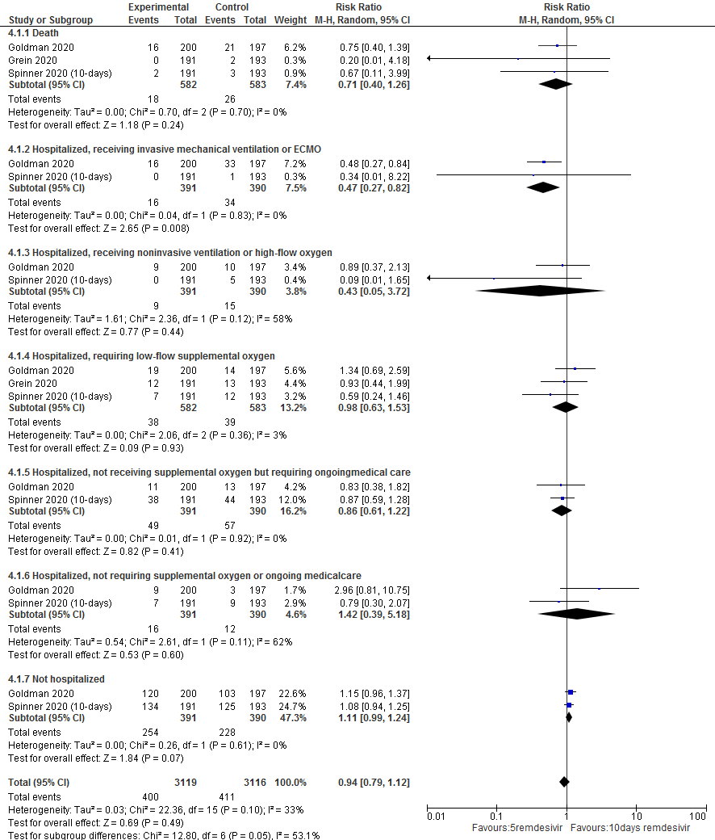

- Subgroup analysis using the parameters included to assess clinical effectiveness
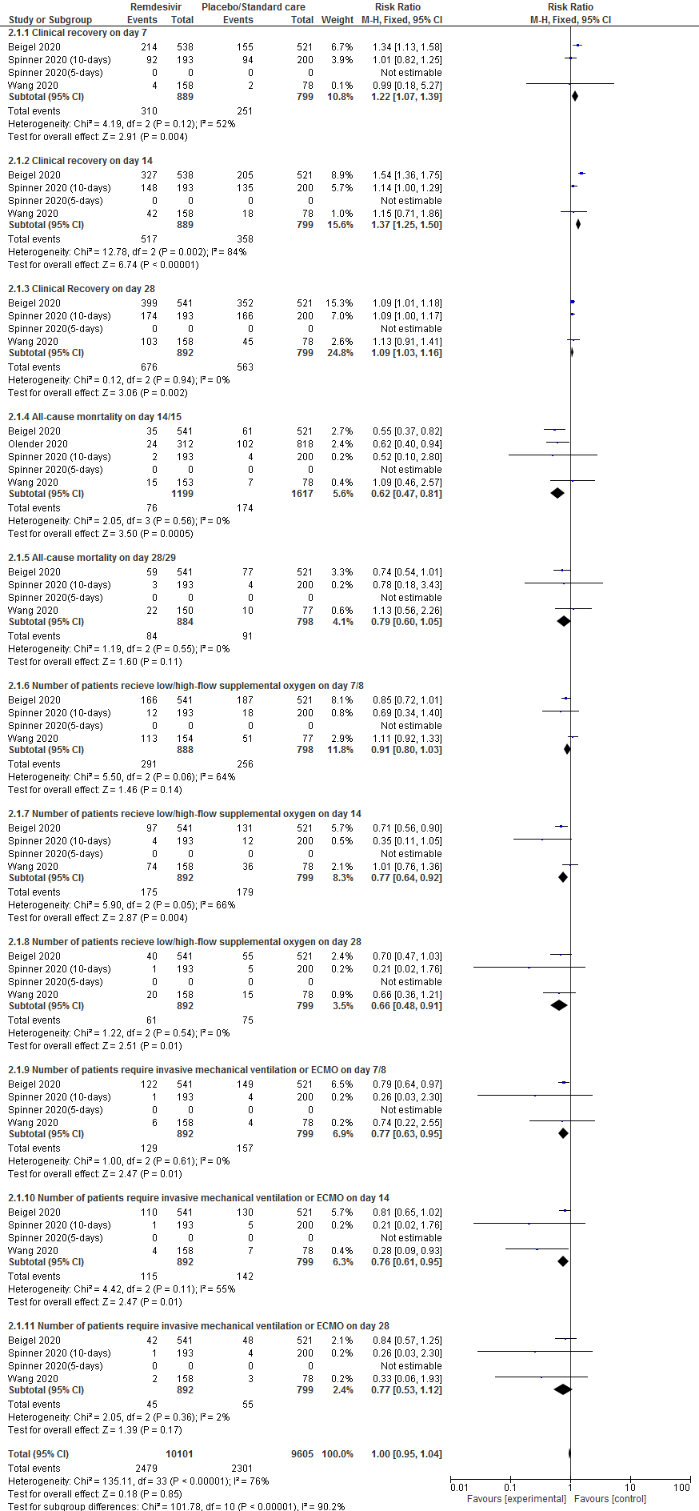
- Subgroup analysis using the parameters included in the RDV safety assessment
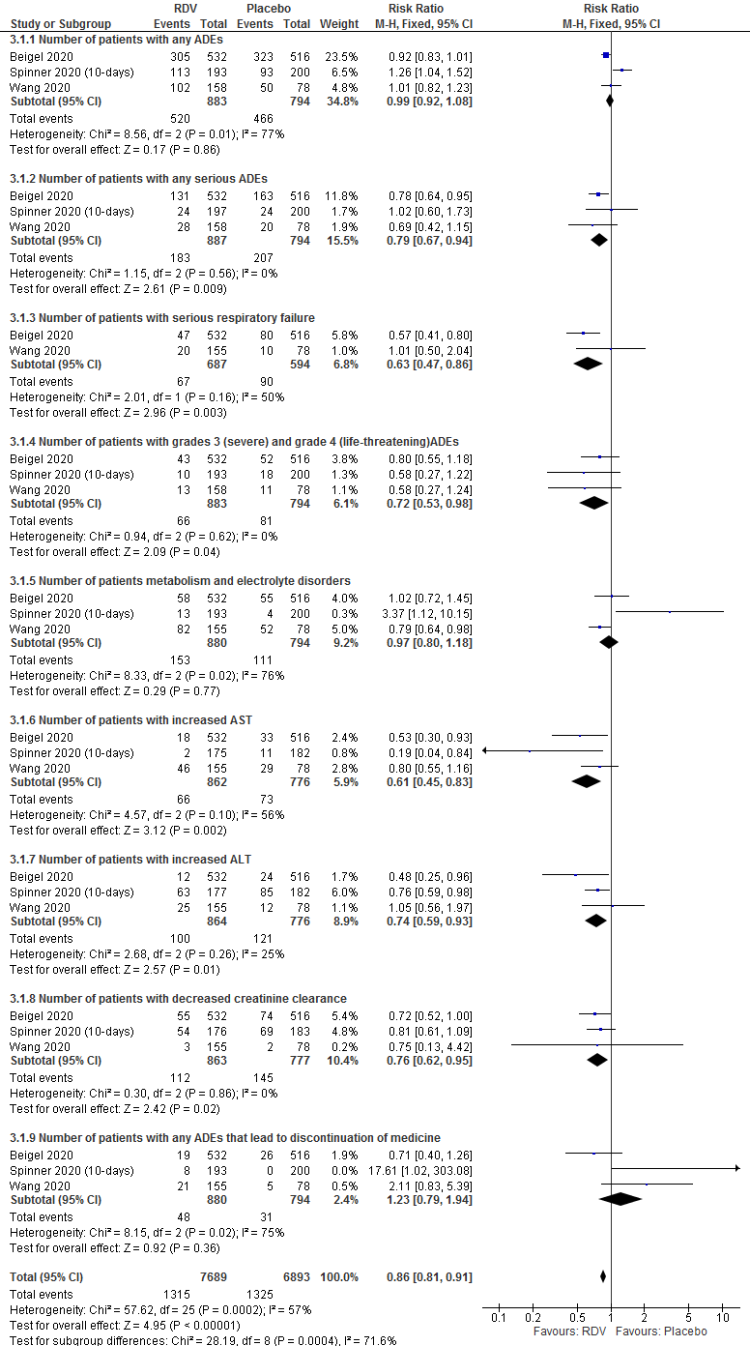
- PubMed search strategy: Long form
("remdesivir"[Supplementary Concept] OR "remdesivir"[All Fields]) AND ("covid 19"[All Fields] OR "covid 19"[MeSH Terms] OR "covid 19 vaccines"[All Fields] OR "covid 19 vaccines"[MeSH Terms] OR "covid 19 serotherapy"[All Fields] OR "covid 19 serotherapy"[Supplementary Concept] OR "covid 19 nucleic acid testing"[All Fields] OR "covid 19 nucleic acid testing"[MeSH Terms] OR "covid 19 serological testing"[All Fields] OR "covid 19 serological testing"[MeSH Terms] OR "covid 19 testing"[All Fields] OR "covid 19 testing"[MeSH Terms] OR "sars cov 2"[All Fields] OR "sars cov 2"[MeSH Terms] OR "severe acute respiratory syndrome coronavirus 2"[All Fields] OR "ncov"[All Fields] OR "2019 ncov"[All Fields] OR (("coronavirus"[MeSH Terms] OR "coronavirus"[All Fields] OR "cov"[All Fields]) AND 2019/11/01:3000/12/31[Date-Publication]) OR ("coronavirus"[MeSH Terms] OR "coronavirus"[All Fields] OR "coronaviruses"[All Fields]) OR (("coronavirus"[MeSH Terms] OR "coronavirus"[All Fields] OR "coronaviruses"[All Fields]) AND ("disease"[MeSH Terms] OR "disease"[All Fields] OR "diseases"[All Fields] OR "disease s"[All Fields] OR "diseased"[All Fields])) OR ("covid 19"[MeSH Terms] OR "covid 19"[All Fields] OR "coronavirus disease 19"[All Fields]) OR ("severe acute respiratory syndrome"[MeSH Terms] OR ("severe"[All Fields] AND "acute"[All Fields] AND "respiratory"[All Fields] AND "syndrome"[All Fields]) OR "severe acute respiratory syndrome"[All Fields]) OR ("sars cov 2"[MeSH Terms] OR "sars cov 2"[All Fields] OR "sars cov 2"[All Fields])).
Translations
remdesivir: "remdesivir"[Supplementary Concept] OR "remdesivir"[All Fields]
COVID-19: ("COVID-19" OR "COVID-19"[MeSH Terms] OR "COVID-19 Vaccines" OR "COVID-19 Vaccines"[MeSH Terms] OR "COVID-19 serotherapy" OR "COVID-19 serotherapy"[Supplementary Concept] OR "COVID-19 Nucleic Acid Testing" OR "covid-19 nucleic acid testing"[MeSH Terms] OR "COVID-19 Serological Testing" OR "covid-19 serological testing"[MeSH Terms] OR "COVID-19 Testing" OR "covid-19 testing"[MeSH Terms] OR "SARS-CoV-2" OR "sars-cov-2"[MeSH Terms] OR "Severe Acute Respiratory Syndrome Coronavirus 2" OR "NCOV" OR "2019 NCOV" OR (("coronavirus"[MeSH Terms] OR "coronavirus" OR "COV") AND 2019/11/01[PDAT] : 3000/12/31[PDAT]))
coronavirus: "coronavirus"[MeSH Terms] OR "coronavirus"[All Fields] OR "coronaviruses"[All Fields]
coronavirus: "coronavirus"[MeSH Terms] OR "coronavirus"[All Fields] OR "coronaviruses"[All Fields]
disease: "disease"[MeSH Terms] OR "disease"[All Fields] OR "diseases"[All Fields] OR "disease's"[All Fields] OR "diseased"[All Fields]
coronavirus disease-19: "covid-19"[MeSH Terms] OR "covid-19"[All Fields] OR "coronavirus disease 19"[All Fields]
severe acute respiratory syndrome: "severe acute respiratory syndrome"[MeSH Terms] OR ("severe"[All Fields] AND "acute"[All Fields] AND "respiratory"[All Fields] AND "syndrome"[All Fields]) OR "severe acute respiratory syndrome"[All Fields]
SARS-CoV-2: "sars-cov-2"[MeSH Terms] OR "sars-cov-2"[All Fields] OR "sars cov 2"[All Fields]

- PRISMA checklist
Section/topic | # | Checklist item | Reported on page #
TITLE
Title | 1 | Identify the report as a systematic review, meta-analysis, or both. | 1
ABSTRACT
Structured summary | 2 | Provide a structured summary including, as applicable: background; objectives; data sources and synthesis methods; results; conclusions and implications of key findings | 2
INTRODUCTION
Rationale | 3 | Describe the rationale for the review in the context of what is already known. | 3-4
Objectives | 4 | Provide an explicit statement of questions being addressed with reference to participants, interventions, comparisons, outcomes, and study design. | 4
METHODS
Protocol and registration | 5 | Indicate if a review protocol exists, if and where it can be accessed (e.g., Web address), and, if available, provide registration information including registration number. | NA
Eligibility criteria | 6 | Specify study characteristics (e.g., PICOS, length of follow-up) and report characteristics (e.g., years considered, language, publication status) used as criteria for eligibility, giving rationale. | 5-6
Information sources | 7 | Describe all information sources (e.g., databases with dates of coverage, contact with study authors to identify additional studies) in the search and date last searched. | 6-7
Search | 8 | Present full electronic search strategy for at least one database, including any limits used, such that it could be repeated. | 6
Study selection | 9 | State the process for selecting studies (i.e., screening, eligibility, included in systematic review, and, if applicable, included in the meta-analysis). | 6-7
Data collection process | 10 | Describe method of data extraction from reports (e.g., piloted forms, independently, in duplicate) and any processes for obtaining and confirming data from investigators. | 7
Data items | 11 | List and define all variables for which data were sought (e.g., PICOS, funding sources) and any assumptions and simplifications made. | 7-8
Risk of bias in individual studies | 12 | Describe methods used for assessing risk of bias of individual studies (including specification of whether this was done at the study or outcome level), and how this information is to be used in any data synthesis. | 7
Summary measures | 13 | State the principal summary measures (e.g., risk ratio, difference in means). | 5-7
Synthesis of results | 14 | Describe the methods of handling data and combining results of studies, if done, including measures of consistency (e.g., I²) for each meta-analysis. | 8

Section/topic | # | Checklist item | Reported on page
Risk of bias across studies | 15 | Specify any assessment of risk of bias that may affect the cumulative evidence (e.g., publication bias, selective reporting within studies). | 7-8
Additional analyses | 16 | Describe methods of additional analyses (e.g., sensitivity or subgroup analyses, meta-regression), if done, indicating which were pre-specified. | NA
RESULTS
Study selection | 17 | Give numbers of studies screened, assessed for eligibility, and included in the review, with reasons for exclusions at each stage, ideally with a flow diagram. | Fig 1
Study characteristics | 18 | For each study, present characteristics for which data were extracted (e.g., study size, PICOS, follow-up period) and provide the citations. | Table 1
Risk of bias within study | 19 | Present data on risk of bias of each study and, if available, any outcome level assessment (see item 12). | Sppl 1&2
Results of individual studies | 20 | For all outcomes considered (benefits or harms), present, for each study: (a) simple summary data for each intervention group (b) effect estimates and confidence intervals, ideally with a forest plot. | Table 1, 9-12
Synthesis of results | 21 | Present results of each meta-analysis done, including confidence intervals and measures of consistency. | Figure 2-6
Risk of bias across studies | 22 | Present results of any assessment of risk of bias across studies (see Item 15). | Sppl 1&2
Additional analysis | 23 | Give results of additional analyses, if done (e.g., sensitivity or subgroup analyses, meta-regression [see Item 16]). | NA
DISCUSSION
Summary of evidence | 24 | Summarize the main findings including the strength of evidence for each main outcome; consider their relevance to key groups (e.g., healthcare providers, users, and policy makers). | 13-15
Limitations | 25 | Discuss limitations at study and outcome level (e.g., risk of bias), and at review-level (e.g., incomplete retrieval of identified research, reporting bias). | 16
Conclusions | 26 | Provide a general interpretation of the results in the context of other evidence, and implications for future research. | 16
FUNDING
Funding | 27 | Describe sources of funding for the systematic review and other support (e.g., supply of data); role of funders for the systematic review. | Funding statement

