Appendix 3. Additional analysis
Patiromer and Sodium Zirconium Cyclosilicate in Treatment of Hyperkalemia: A Systematic Review and Meta-analysis
Dhan Bahadur Shrestha^{a*}, Pravash Budhathoki^{b}, Yub Raj Sedhai^{c}, Ramkaji Baniya^{d}, Casey A. Cable^{e}, Markos G. Kashiouris^{e}, Dave L. Dixon^{f}, Jason M. Kidd^{g}, Yuvraj Adhikari^{h}, Anupama Marasini^{h}, Shakar Bhandari^{h}
ªDepartment of Internal Medicine, Mount Sinai Hospital, Chiacgo, IL, USA
^{b}Department of Internal Medicine, Bronxcare Health System, NY, USA
^{c}Department of Internal Medicine, Division of Hospital Medicine, Virginia Commonwealth University, School of Medicine, Richmond, VA, USA
^{d}Hospitalist; Our Lady of the Lake Regional Medical Center; Baton Rouge, LA, USA
^{e}Assistant Professor; Department of Internal Medicine; Division of Pulmonary and Critical Care, VCU School of Medicine, Richmond, VA, USA
^{f}Associate Professor Department of Pharmacotherapy & Outcomes Science, Virginia Commonwealth University School of Pharmacy, Richmond, VA, USA
^{g}Associate Professor; Department of Internal Medicine; Division of Nephrology, Virginia Commonwealth University, School of Medicine, Richmond, VA, USA
^{h}Nepalese Army Institute of Health Sciences, Kathmandu, Nepal

- Patiromer vs placebo:
- Adverse effects
Running analysis using random effect model for adverse effects showed no significant difference among two groups for overall adverse effects (OR 1.24, 95% CI 0.77 to 2.01; n= 537; I2 = 36%), and treatment discontinuation as a result of adverse effects (OR 0.57, 95% CI 0.24 to 1.33; n= 400; I2 = 19%) (Figure 1.).
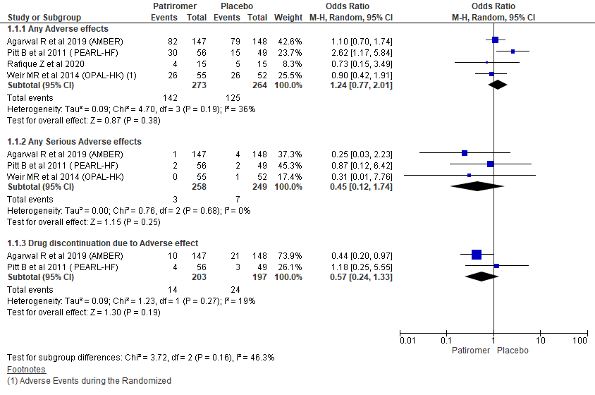
Figure 1. Comparing adverse effects between Patiromer and placebo group using random effect model
- Mortality
Only three studies reported mortality outcome and there was one mortality event in the placebo arm in all three studies, there was no significant difference between groups when pooled together (OR 0.31, 95% CI 0.05 to 1.98; n= 507; I² = 0%) (Figure 2.).

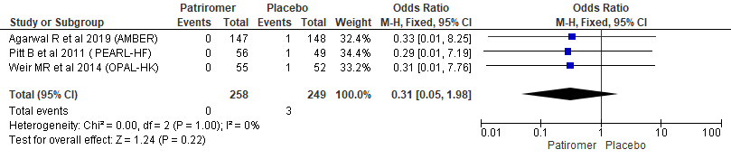
Figure 2. Forest plot showing mortality outcome in Patiromer vs placebo arms
- SZC vs placebo
- Adverse effects
Running analysis using random effect model for overall adverse effects showed no significant difference among two groups for overall adverse effects (OR 1.64, 95% CI 0.96 to 2.79; n= 629; I2 = 52%) (Figure 3.).
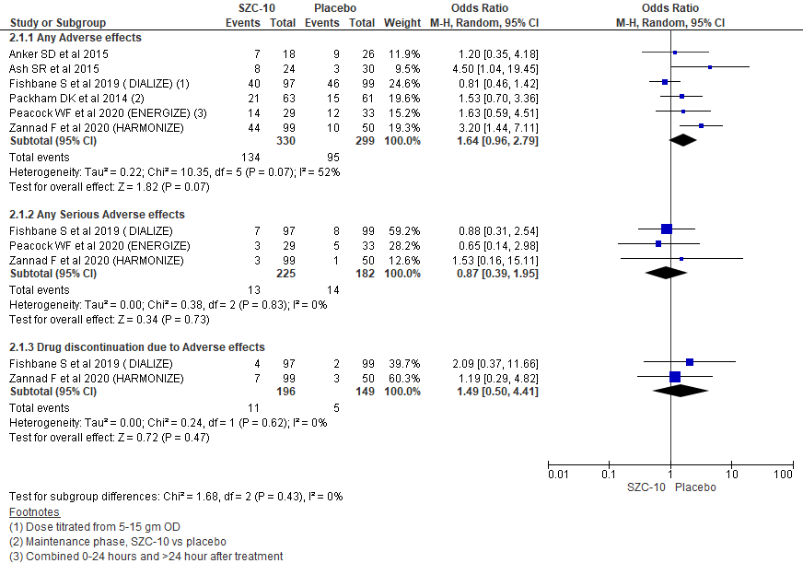
Figure 3. Comparing adverse effects between SZC and placebo group using random effect model
- Mortality outcome
Two studies reported mortality in their studies and there was one mortality event in placebo arm in one and treatment arm in another study (OR 1.08, 95% CI 0.15 to 7.88; n= 258; I² = 0%) (Figure 4.).
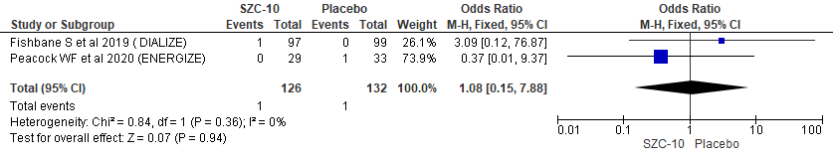
Figure 4. Forest plot showing mortality outcome comparing SZC-10 vs placebo
- SZC-10 Vs SZC-5
Comparing SZC at 10 grams and 5 grams for the treatment of hyperkalemia showed no significant between group differences in the occurrence of any adverse effects (OR 1.71, 95% CI 0.97 to 3.01; n = 410; I2 = 32%). Further, there were no significant between group differences in incidence of hyperkalemia (OR 0.40, 95% CI 0.05 to 3.09; n= 326; I2 = 0%); constipation (OR 2.24, 95% CI 0.08 to 62.43; n= 246; I2 = 67%); diarrhea (OR 2.36, 95% CI 0.34 to 16.42; n= 246; I2 = 0%); and UTI (OR 0.79, 95% CI 0.13 to 4.74; n= 176; I2 = 12%) while edema was higher among SZC-10 group (OR 3.13, 95% CI 1.19 to 8.27; n = 234; I2 = 0%) (Figure 5.).
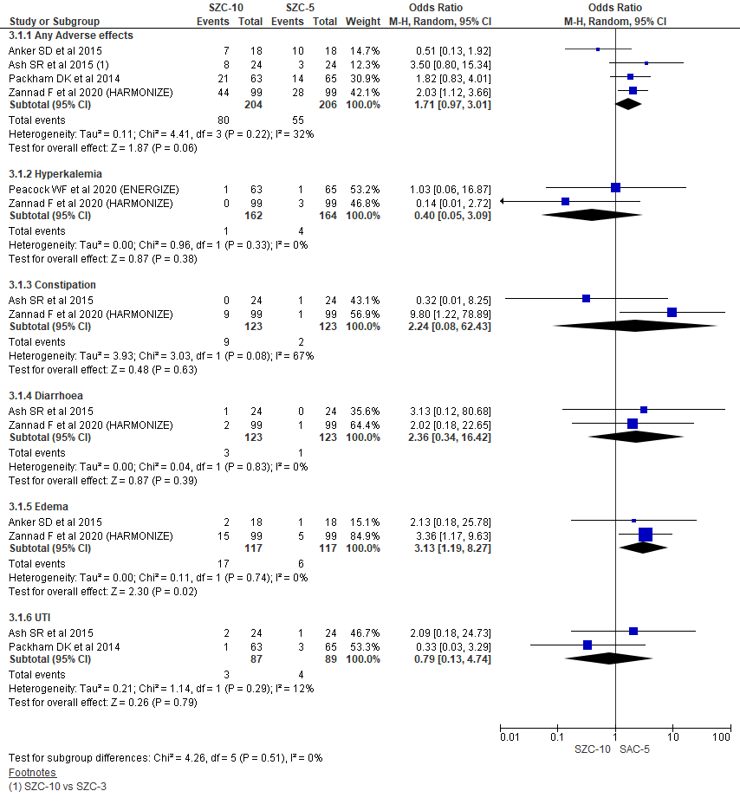
Figure 5. Forest plot comparing adverse events between two different doses of SZC
- Publication bias
We assessed publication bias of included studies, we constructed an Egger’s funnel plot using the MD and 1/SE values obtained from trials measuring the adverse effects across studies comparing patiromer Vs SOC and SZC-10 Vs placebo/SOC. The generated funnel plot suggested the possibility of publication bias in the analysis (Figure 6 and 7.).
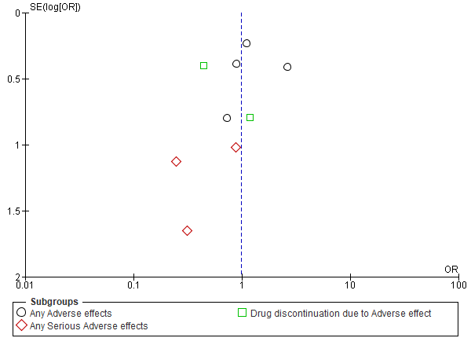
Figure 6. Funnel plot of adverse effects across studies comparing patiromer Vs placebo/SOC for publication bias
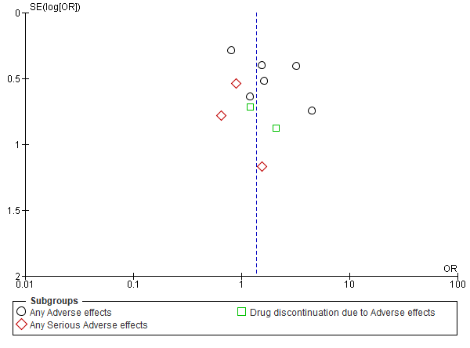
Figure 7. Funnel plot of adverse effects across studies comparing SZC-10 Vs placebo/ SOC for publication bias

