APPENDIX – Figure
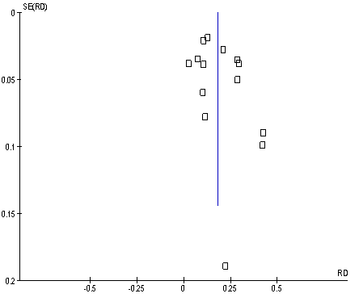
Appendix Figure – Funnel plot of included articles in this study (squares)

