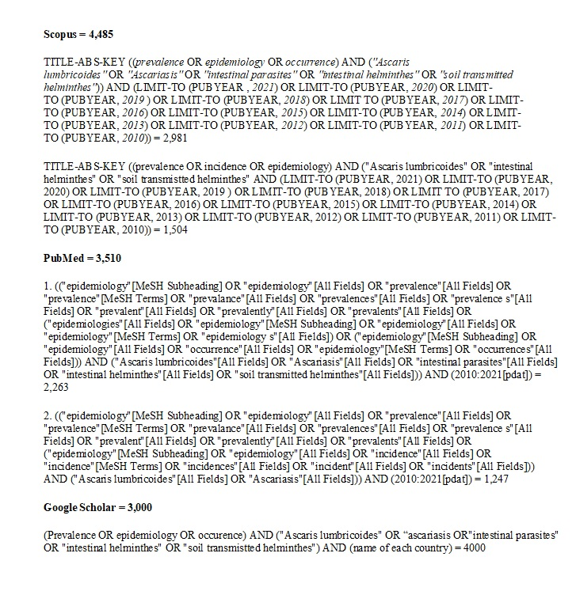
Figure S1. Search strategy in databases

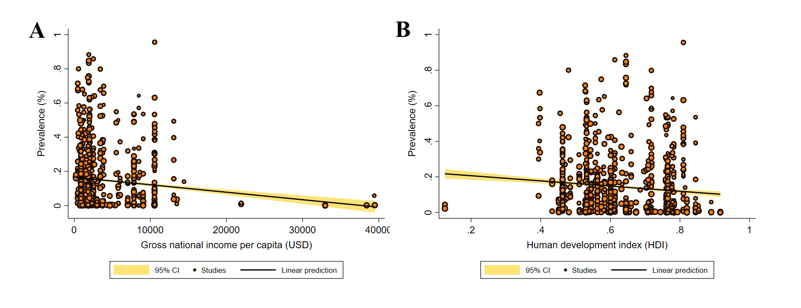

Figure S2. Random-effects meta-regression analyses of the prevalence of Ascaris infection in general population according to (A) a country's income level, showing a statistically significant downward trend in prevalence in countries with higher income levels; (B) human development index (HDI), showing a statistically significant downward trend in prevalence in countries with higher HDIs.
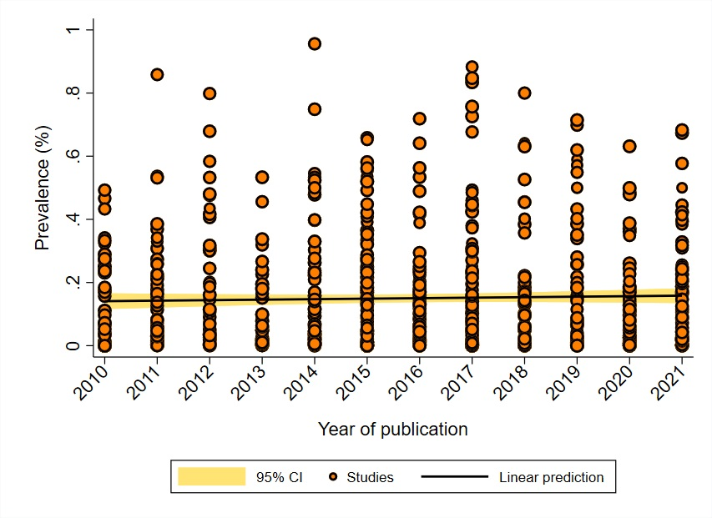

Figure S3. Random-effects meta-regression analyses of the prevalence of Ascaris infection in general population according to publication year, showing a statistically non-significant upward trend in prevalence in recent years.

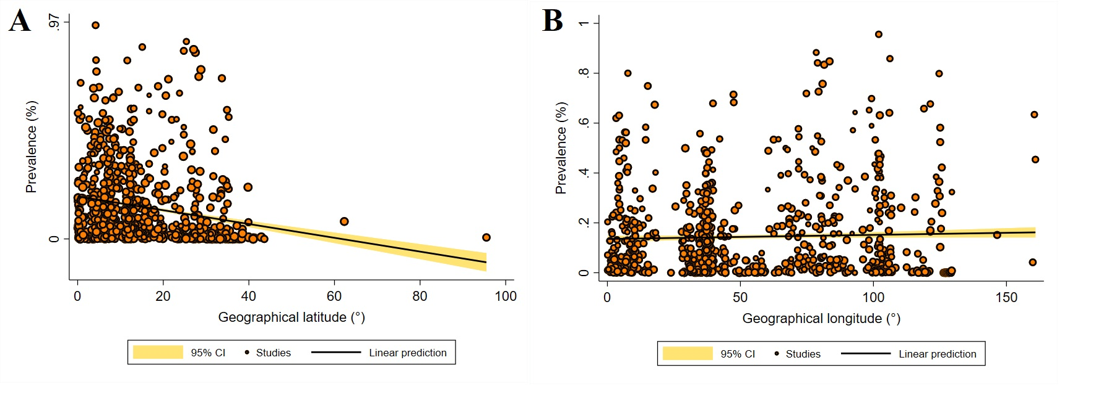
Figure S4. Random-effects meta-regression analyses of the prevalence of Ascaris infection in general population according to (A) geographical latitude, showing a statistically significant downward trend in prevalence with increasing geographical latitude; and (B) geographical longitude, showing a statistically non-significant upward trend in prevalence with increasing geographical longitude.

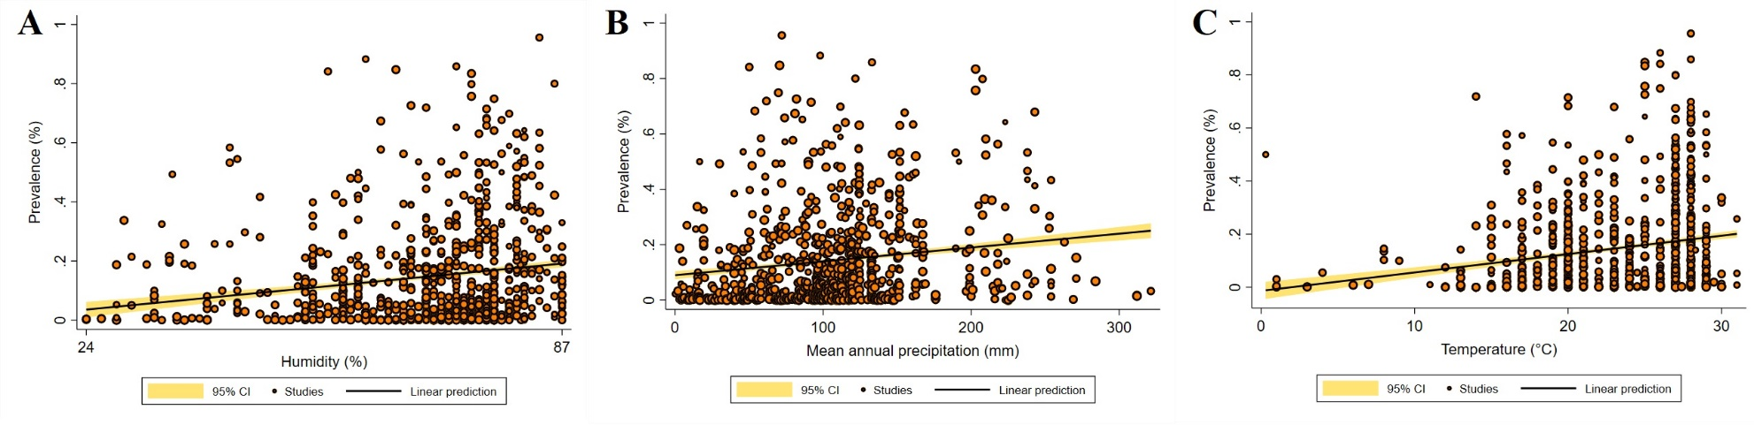
Figure S5. Random-effects meta-regression analyses of the prevalence of Ascaris infection in general population according to (A) the mean annual relative humidity, showing a statistically significant upward trend in prevalence with increasing humidity; and (B) the mean annual precipitation rate, showing a statistically significant upward trend in prevalence with increasing precipitation; (C), the mean annual temperature, showing a statistically significant upward trend in prevalence with increasing environmental temperature.

