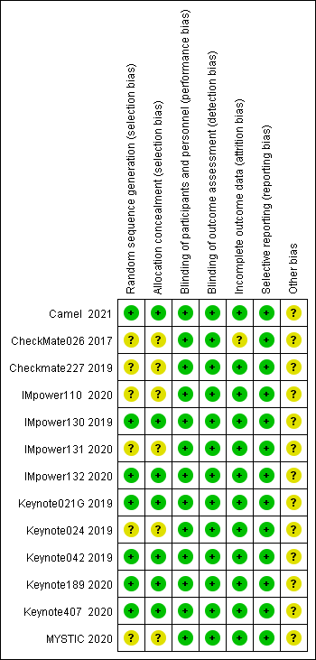
Figure S1 The bias assessment of eligible trials.

