Supplementary Table 4
Three nomograms for post-radiation hypothyroidism in head and neck cancer patients.

Luo 2016 | 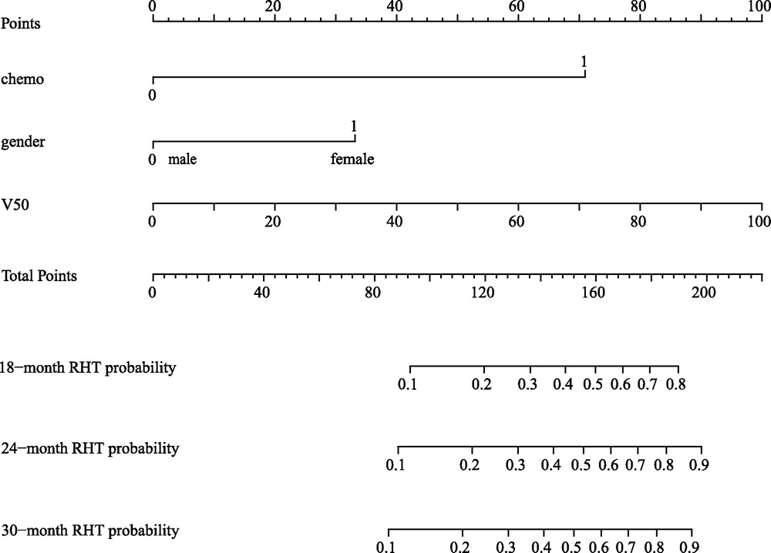
Prpic 2019 | Hypothyroidism risk score = Log(10) Dmin x 2.286 – Log(10) TV x 1.165
Zhu 2021 | 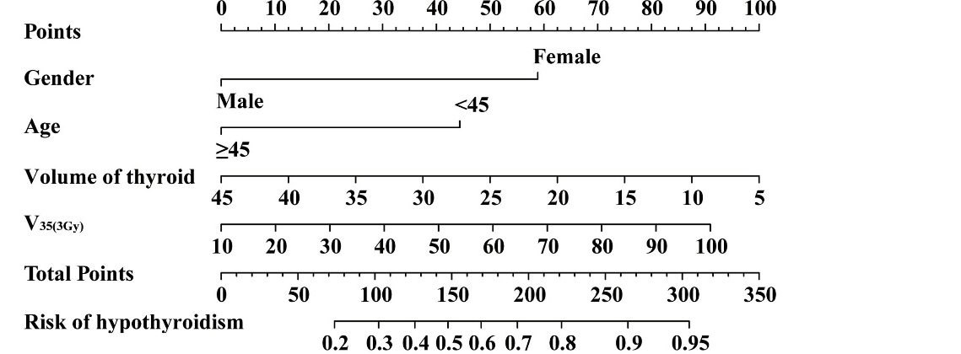
*Abbreviations: Chemo, chemotherapy; Dmin, minimal thyroid dose; RHT, radiation-associated hypothyroidism; TV, thyroid volume.

