Forest plots of the association between fatal risk of laboratory parameters

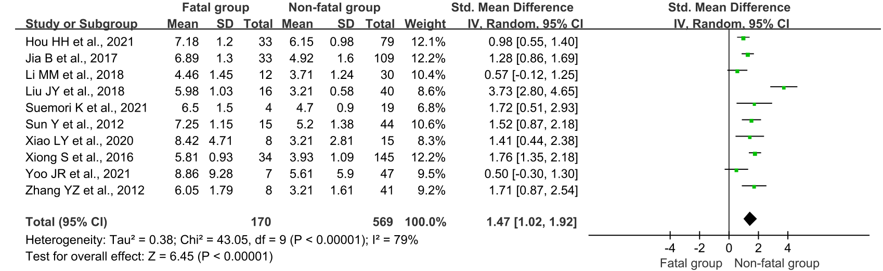
S1 Fig. Forest plot of the association between viral load and fatal risk of SFTS

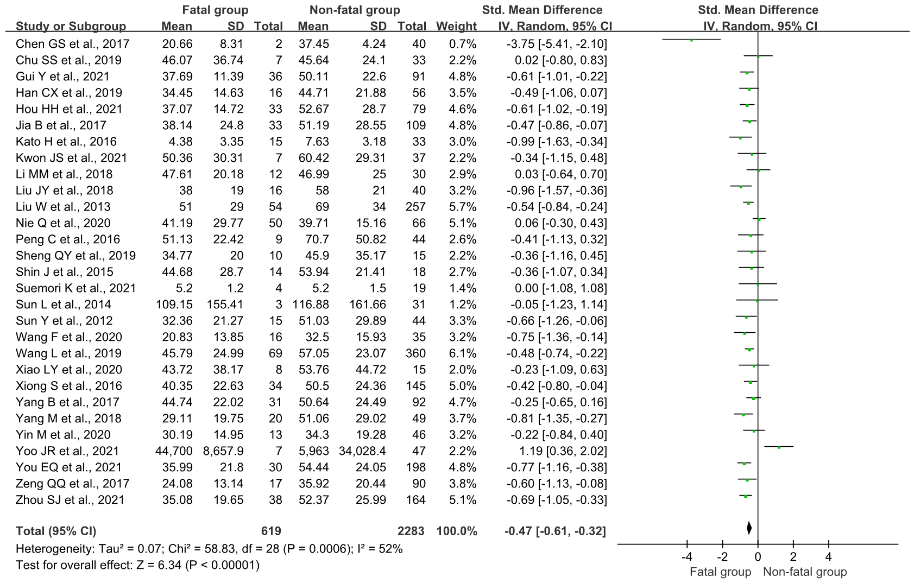
S2 Fig. Forest plot of the association between PLT and fatal risk of SFTS

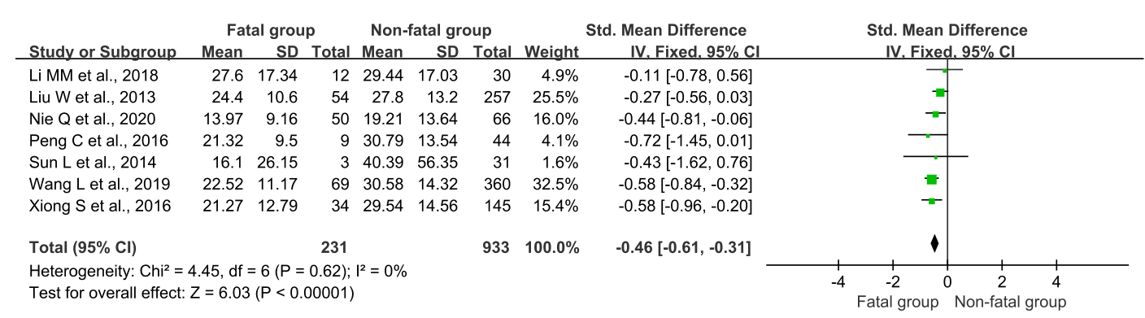
S3 Fig. Forest plot of the association between LYM% and fatal risk of SFTS

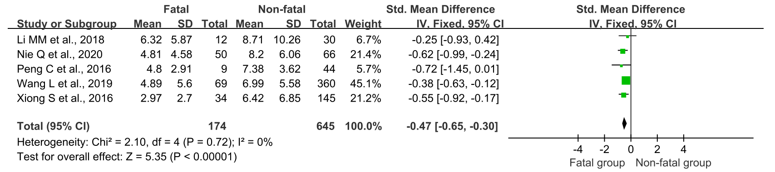
S4 Fig. Forest plot of the association between MON% and fatal risk of SFTS

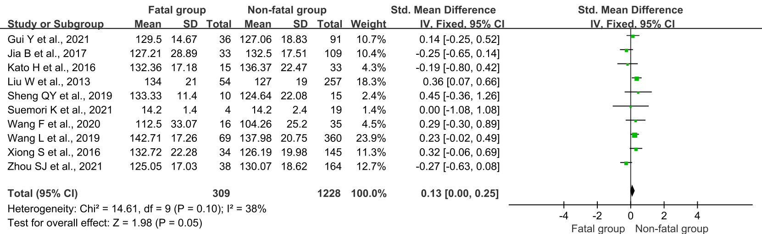
S5 Fig. Forest plot of the association between Hgb and fatal risk of SFTS

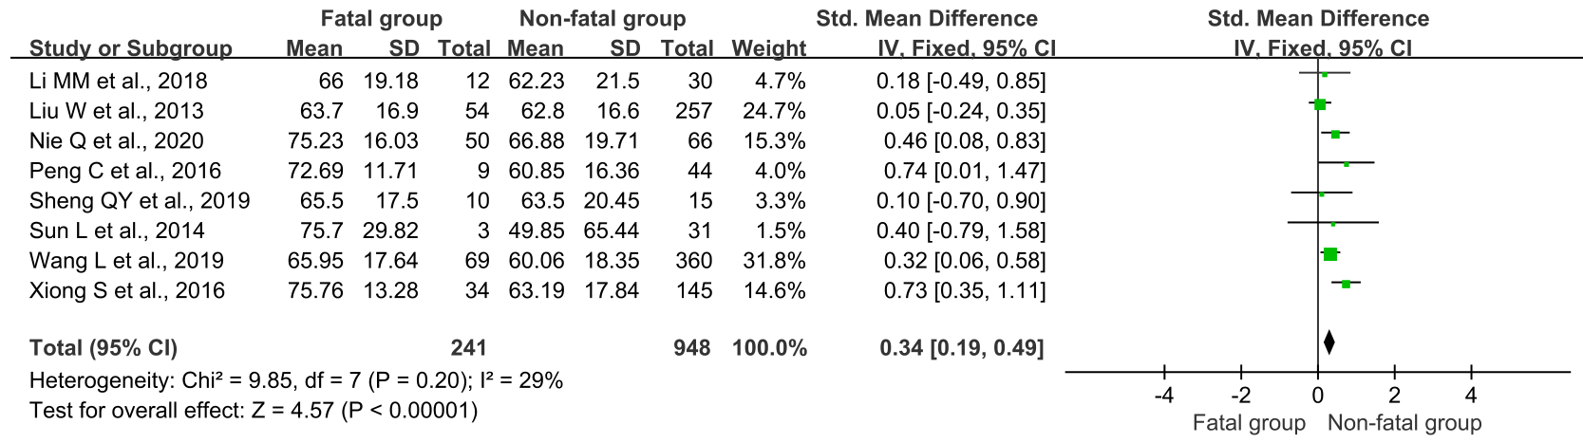
S6 Fig. Forest plot of the association between NEU% and fatal risk of SFTS

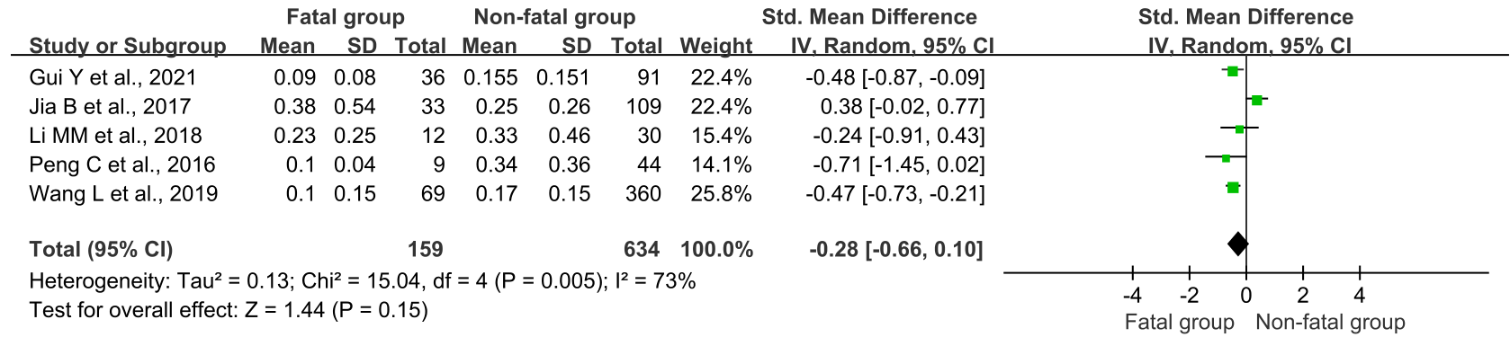
S7 Fig. Forest plot of the association between MON and fatal risk of SFTS

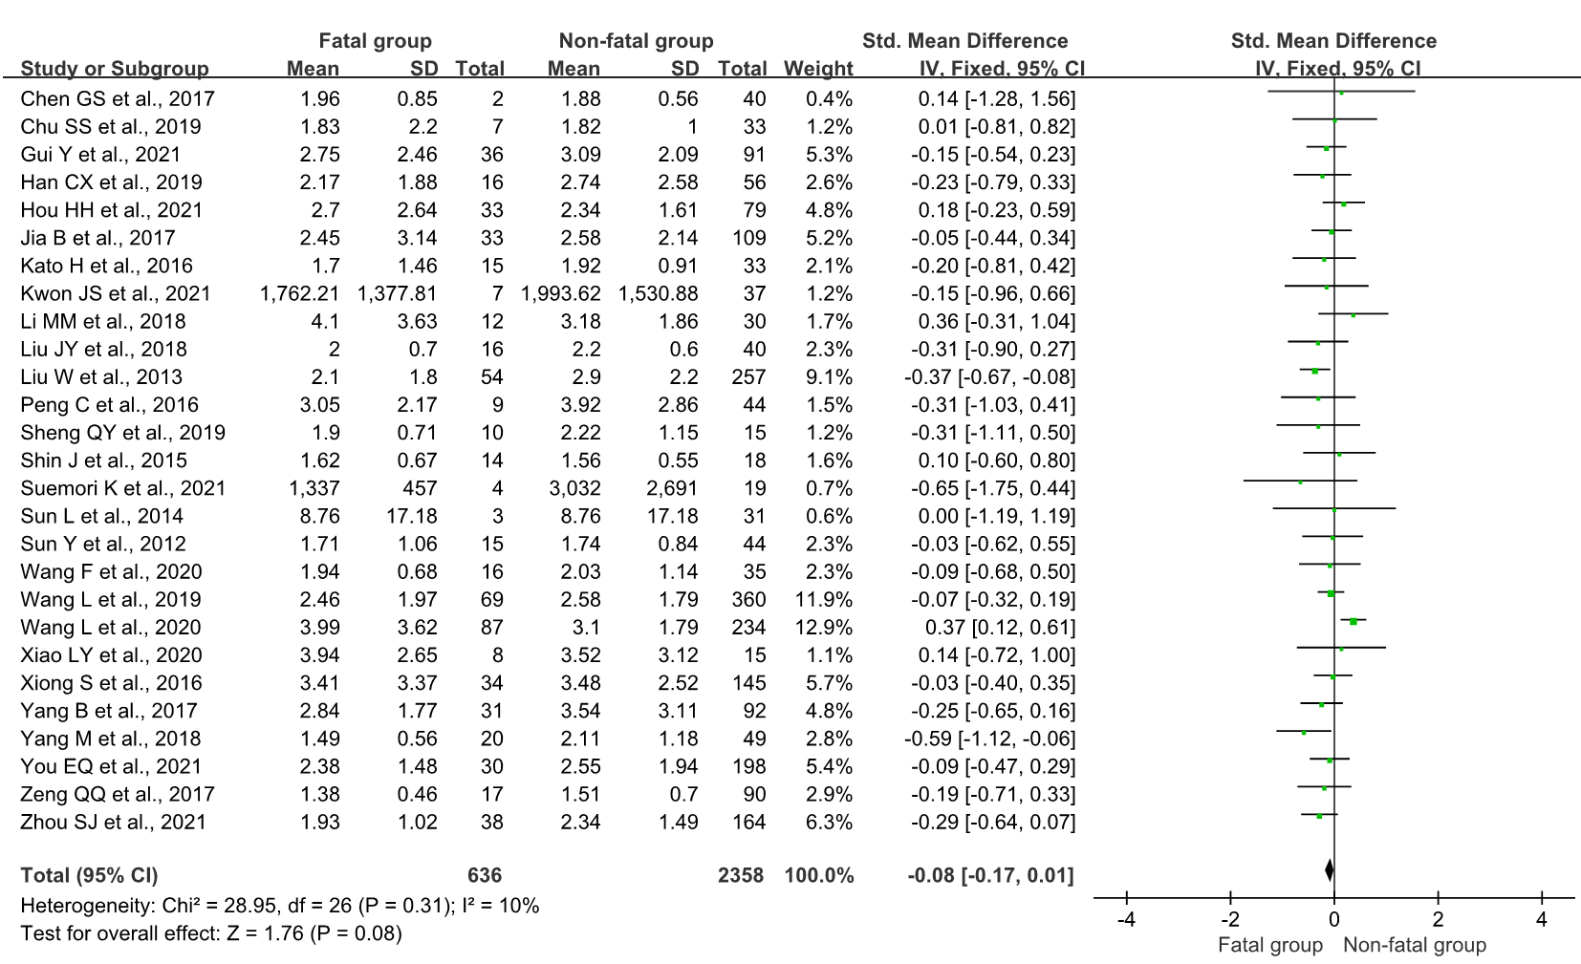
S8 Fig. Forest plot of the association between WBC and fatal risk of SFTS

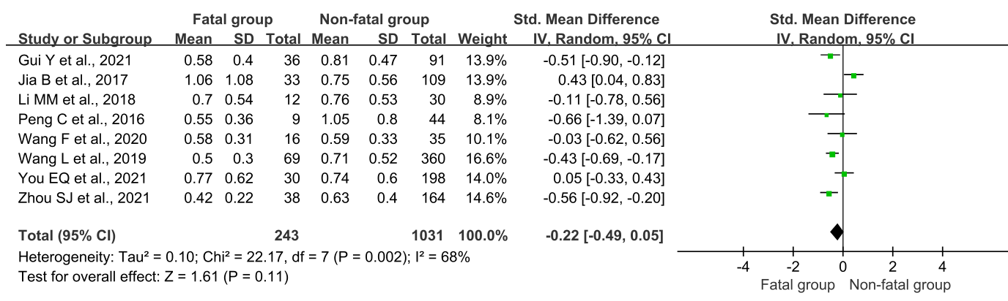
S9 Fig. Forest plot of the association between LYM and fatal risk of SFTS

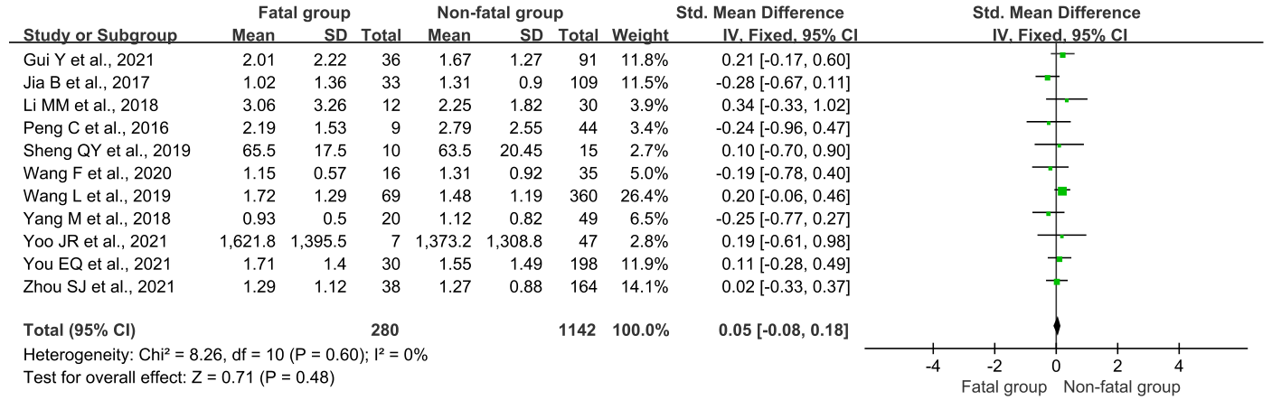
S10 Fig. Forest plot of the association between NEU and fatal risk of SFTS

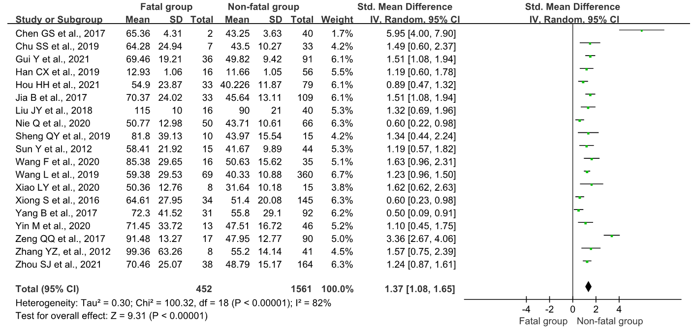
S11 Fig. Forest plot of the association between APTT and fatal risk of SFTS

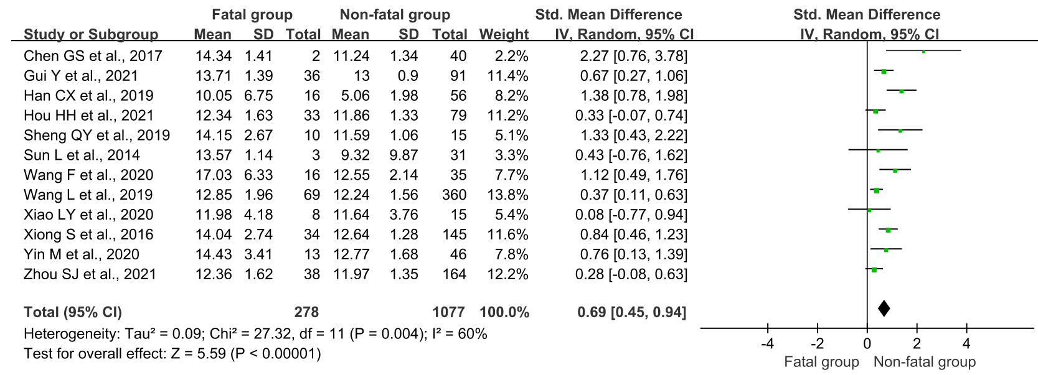
S12 Fig. Forest plot of the association between PT and fatal risk of SFTS

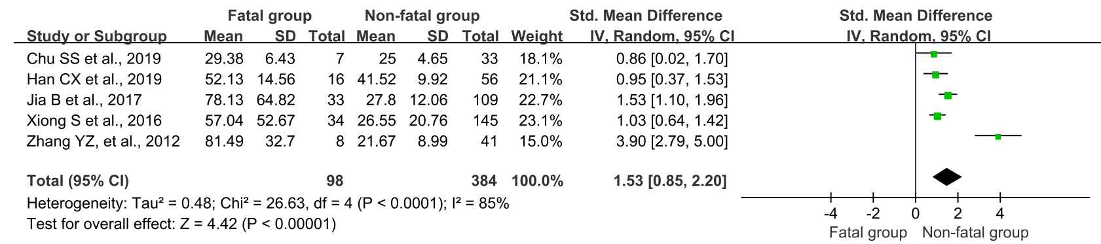
S13 Fig. Forest plot of the association between TT and fatal risk of SFTS

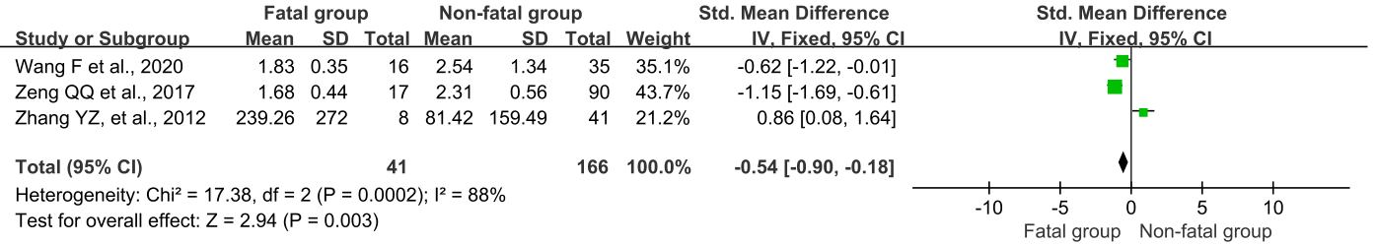
S14 Fig. Forest plot of the association between FIB and fatal risk of SFTS

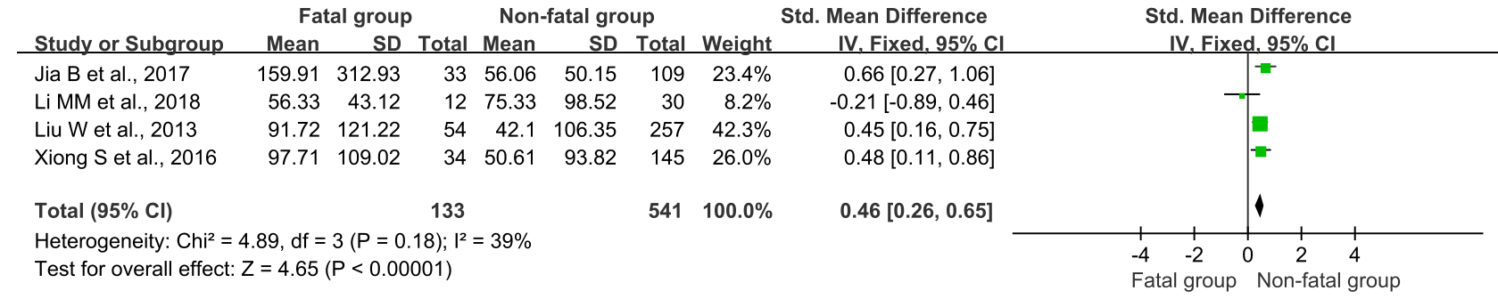
S15 Fig. Forest plot of the association between GGT and fatal risk of SFTS

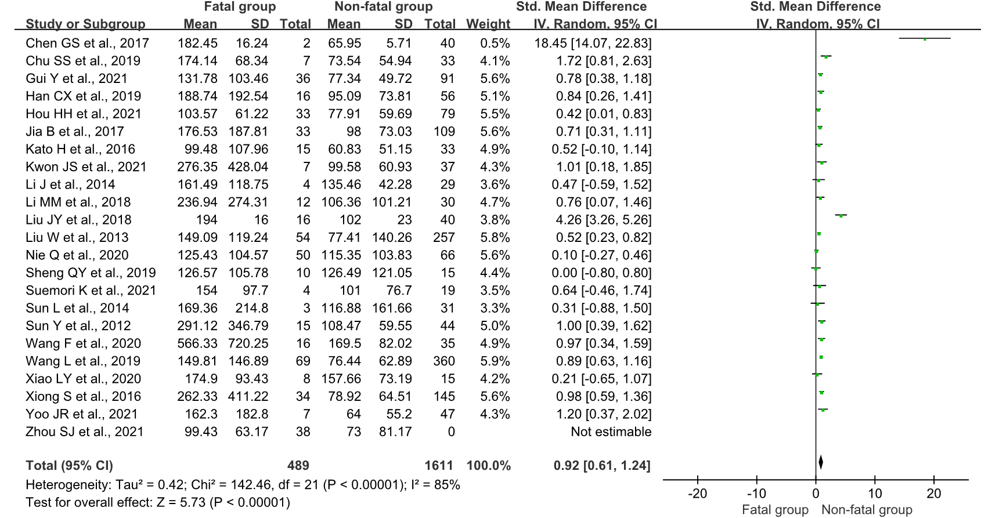
S16 Fig. Forest plot of the association between ALT and fatal risk of SFTS

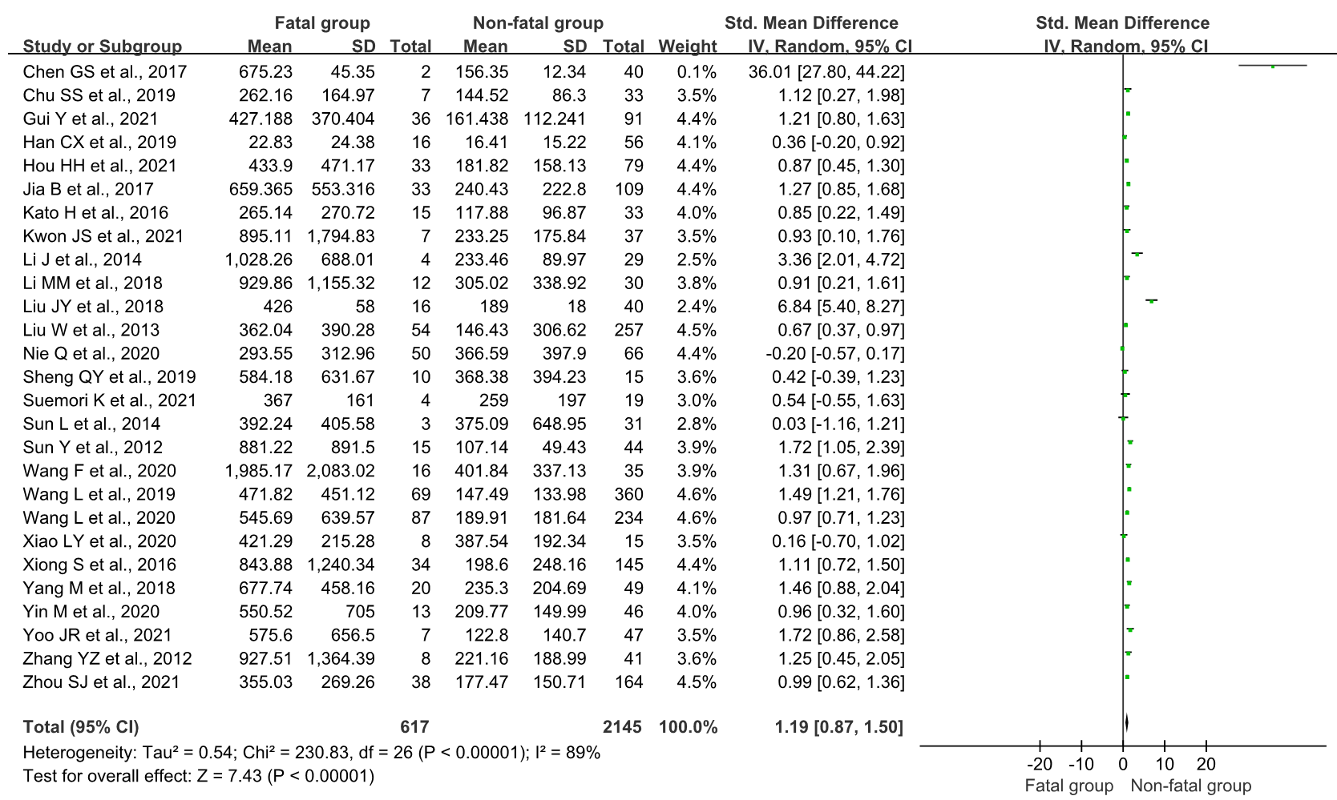
S17 Fig. Forest plot of the association between AST and fatal risk of SFTS

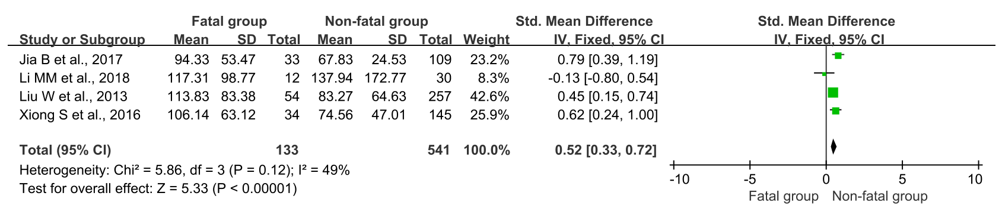
S18 Fig. Forest plot of the association between ALP and fatal risk of SFTS

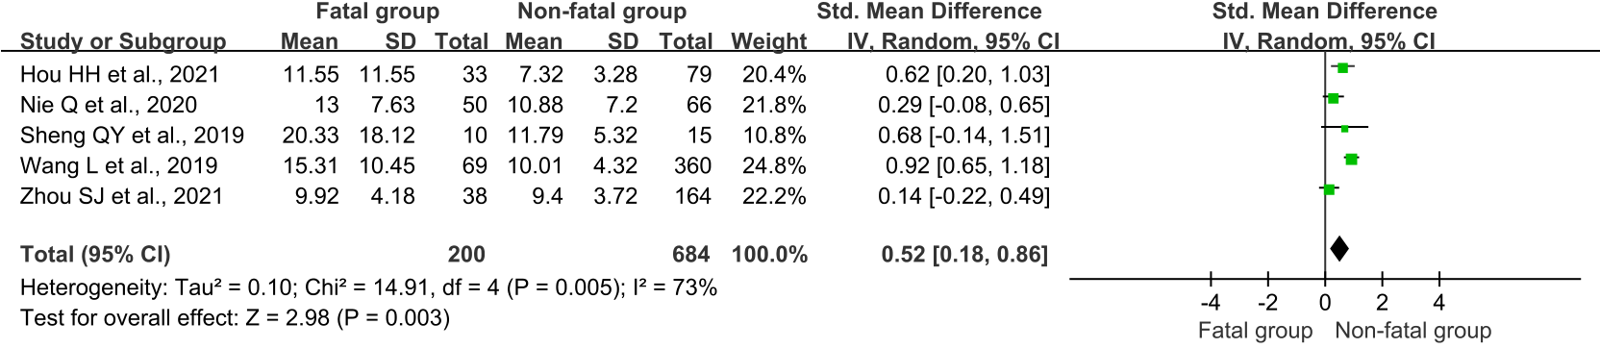
S19 Fig. Forest plot of the association between TB and fatal risk of SFTS

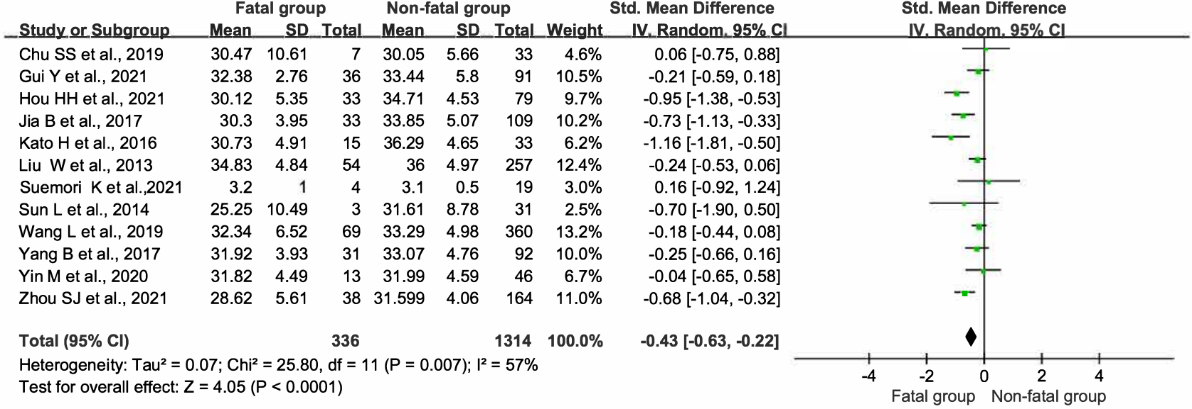
S20 Fig. Forest plot of the association between ALB and fatal risk of SFTS

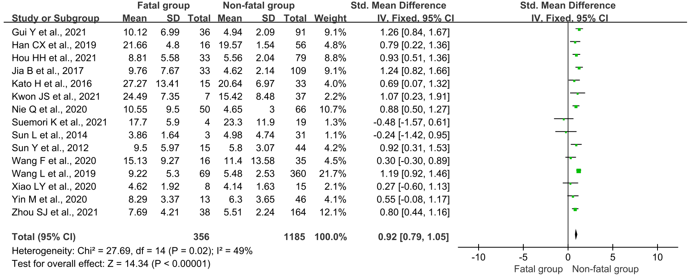
S21 Fig. Forest plot of the association between BUN and fatal risk of SFTS

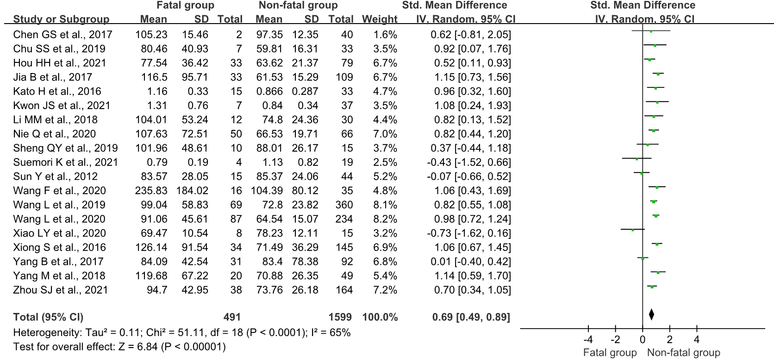
S22 Fig. Forest plot of the association between sCr and fatal risk of SFTS

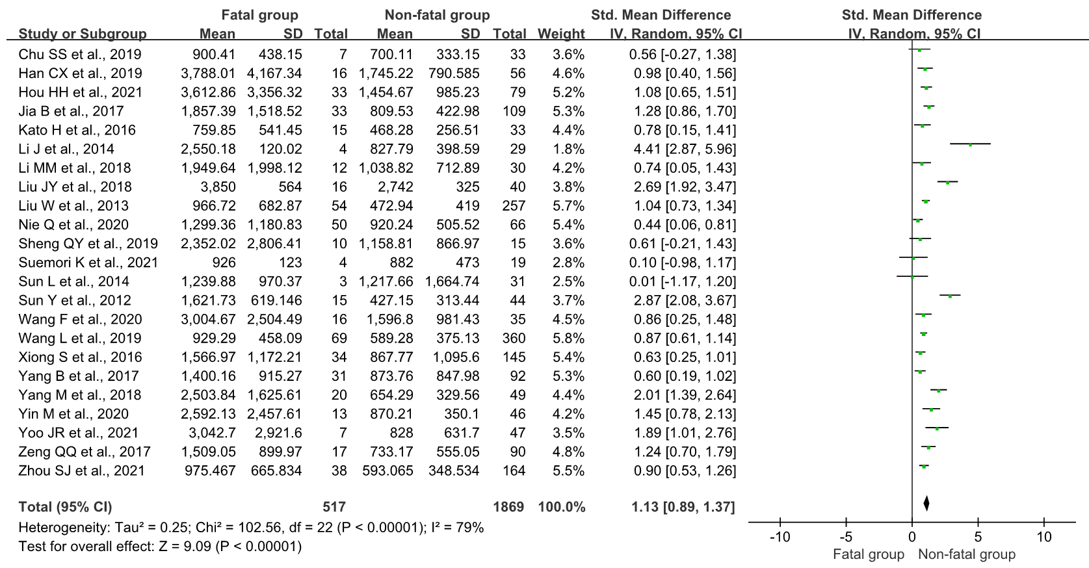
S23 Fig. Forest plot of the association between LDH and fatal risk of SFTS

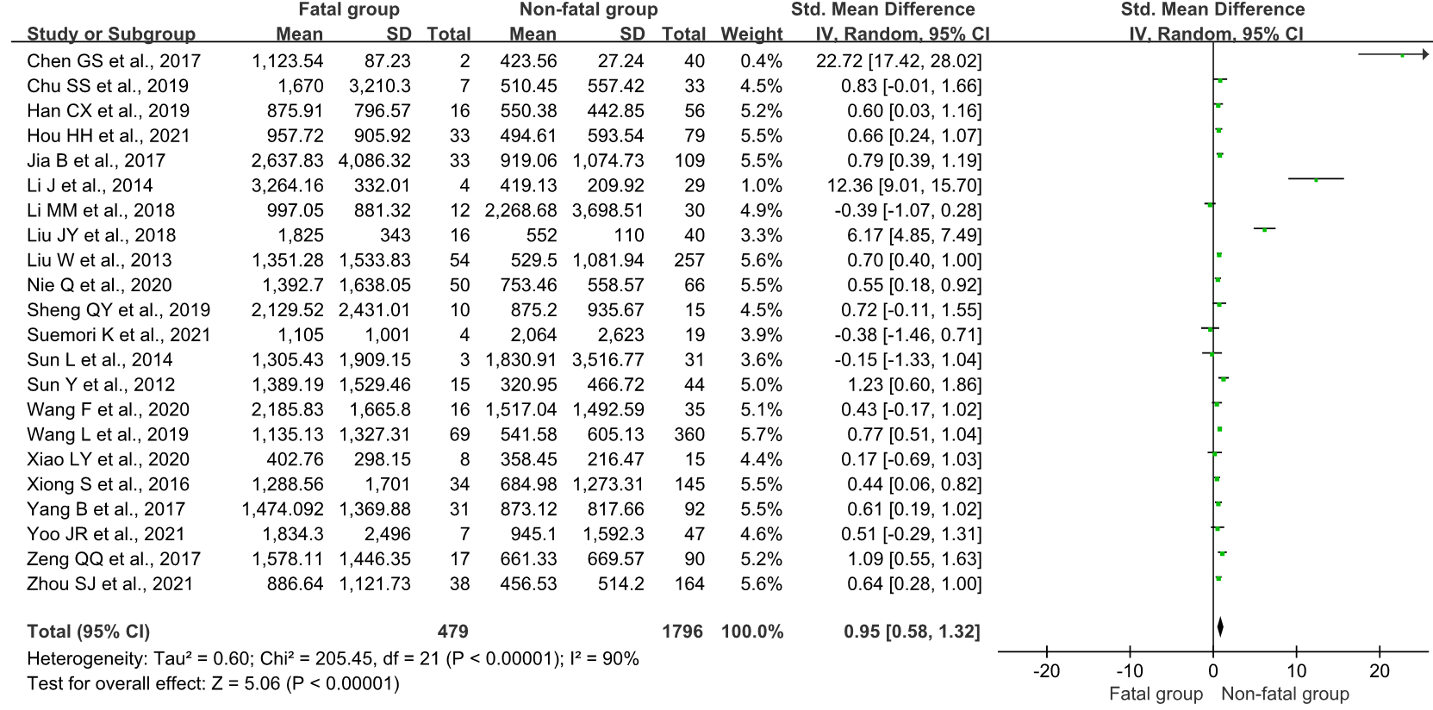
S24 Fig. Forest plot of the association between CK and fatal risk of SFTS

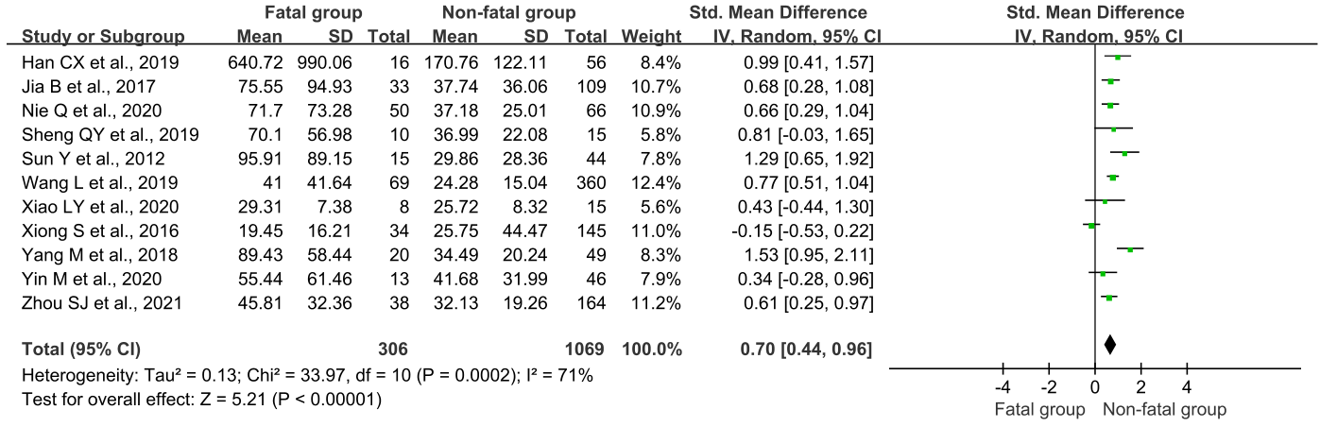
S25 Fig. Forest plot of the association between CK-MB and fatal risk of SFTS

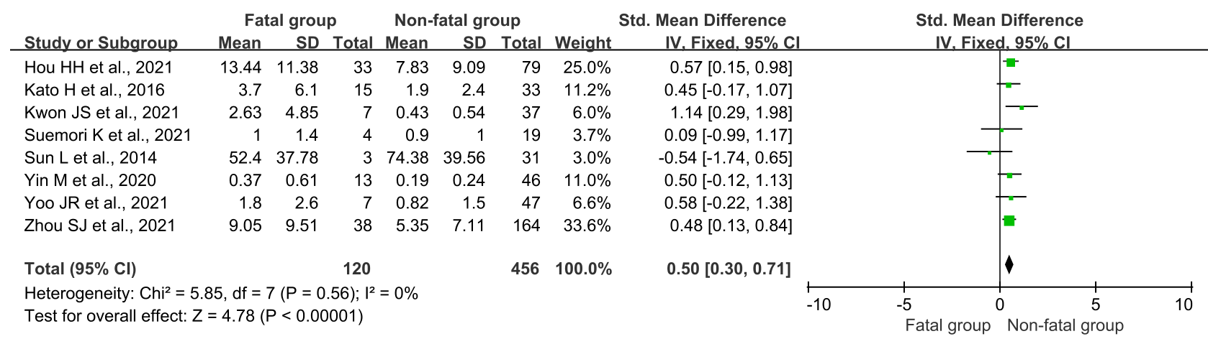
S26 Fig. Forest plot of the association between CRP and fatal risk of SFTS

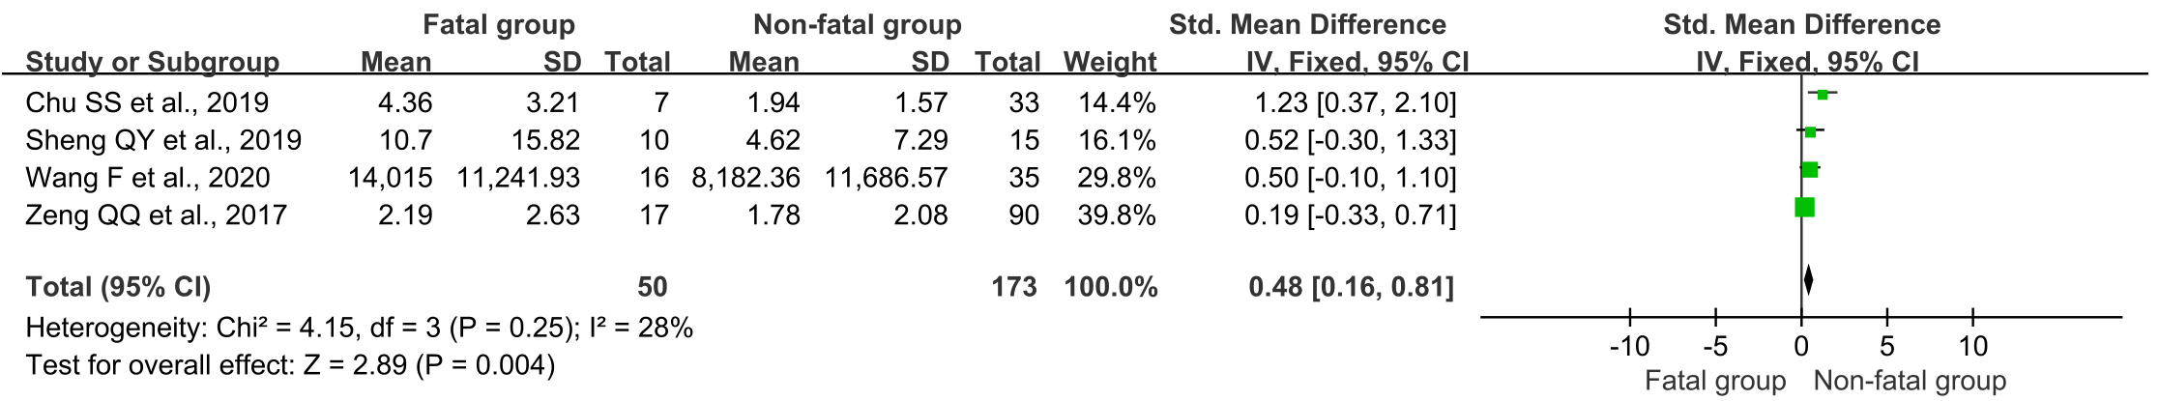
S27 Fig. Meta-analysis of the association between D-D and fatal risk of SFTS

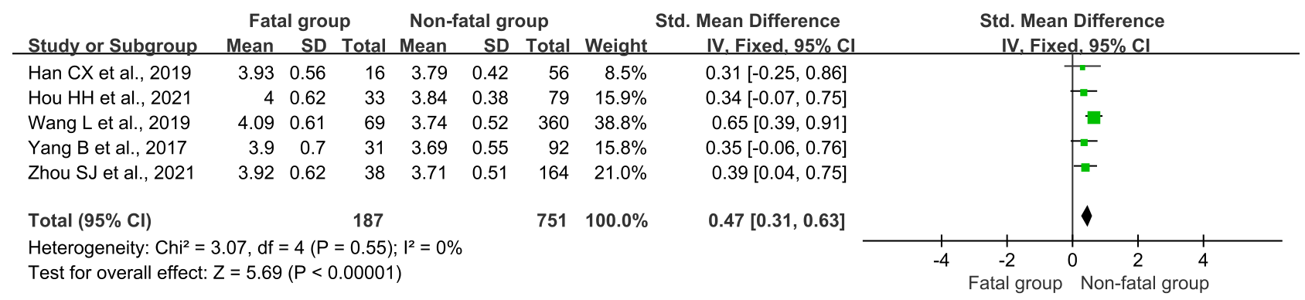
S28 Fig. Forest plot of the association between K and fatal risk of SFTS

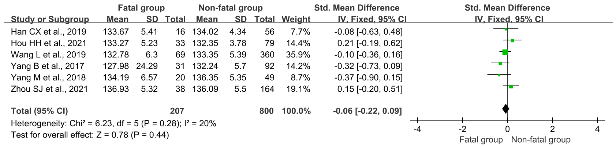
S29 Fig. Forest plot of the association between Na and fatal risk of SFTS

References (listed in alphabetical order)

Chen GS, Hu LF, Xu XH, Li JB. The clinical characteristics and prognostic indicators of severe fever with thrombocytopenia syndrome infected by new Bunia virus. China Medical Equipment. 2017; 14(5): 94-97. DOI: 10.3969/J.ISSN.1672-8270.2017.05.025.

Chu SS, Zheng W, Wang JW, Chen YJ, Yu L, Xu CD, et al. Clinical characteristics of 40 patients with severe fever with thrombocytopenia syndrome in Tiantai County. Inter J Epidemiol Infect Dis. 2019; 46(6): 526-529. DOI: 10.3760/cma.j.issn.1673-4149.2019.06.016.

Gui Y, Xu Y, Yang P. Predictive Value of the Platelet-to-Albumin Ratio (PAR) on the Risk of Death at Admission in Patients Suffering from Severe Fever with Thrombocytopenia Syndrome. J Inflamm Res. 2021; 14: 5647-5652. DOI: 10.2147/JIR.S335727.

Han CX, Sun AJ, Pu CW, Li YT, Sui F, Qin SJ, et al. Epidemiological characteristics of severe fever with thrombocytopenia syndrome caused by novel bunyavirus infection and influencing factors for prognosis. Chin J Nosocomiol. 2019; 29(2):171-174+187. DOI: 10.11816/cn.ni.2019-180685.

Hou HH, Mao LL, Liang HY, Liu Y, Liu XS, Deng BC. Clinical characteristics and influencing factors for prognosis of fever with severe thrombocytopenia syndrome in Dalian, Liaoning Province. Chin J Infect Control. 2021; 20(10): 897-902. DOI: 10.12138/j.issn.1671-9638.20218284.

Jia B, Yan X, Chen Y, Wang G, Liu Y, Xu B, et al. A scoring model for predicting prognosis of patients with severe fever with thrombocytopenia syndrome. PLoS Negl Trop Dis. 2017; 11(9): e0005909. DOI: 10.1371/journal.pntd.0005909.

Kato H, Yamagishi T, Shimada T, Matsui T, Shimojima M, Saijo M, et al. SFTS epidemiological research group-Japan. Epidemiological and Clinical Features of Severe Fever with Thrombocytopenia Syndrome in Japan, 2013-2014. PLoS One. 2016; 11(10): e0165207. DOI: 10.1371/journal.pone.0165207.

Kwon JS, Jin S, Kim JY, Ra SH, Kim T, Park SY, et al. Viral and Immunologic Factors Associated with Fatal Outcome of Patients with Severe Fever with Thrombocytopenia in Korea. Virus. 2021; 13(12): 2351. DOI: 10.3390/v13122351.

Li J, Han Y, Xing Y, Li S, Kong L, Zhang Y, et al. Concurrent measurement of dynamic changes in viral load, serum enzymes, T cell subsets, and cytokines in patients with severe fever with thrombocytopenia syndrome. PLoS One. 2014; 9(3): e91679. DOI: 10.1371/journal.pone.0091679.

Li MM, Zhang WJ, Weng XF, Li MY, Liu J, Xiong Y, et al. CD4 T cell loss and Th2 and Th17 bias are associate with the severity of severe fever with thrombocytopenia syndrome (SFTS). Clin Immunol. 2018; 195: 8-17. DOI: 10.1016/j.clim.2018.07.009.

Liu JY, Feng J, Li AL, Wang SY, Zheng R, Chen HZ. Analysis of clinical characteristics and death risk factors in patients infected with severe fever with thrombocytopenia syndrome bunyavirus. Chin J Postgrad Med, 2018; 41(5):429-433. DOI: 10.3760/cma.j.issn.1673-4904.2018.05.012.

Liu W, Lu QB, Cui N, Li H, Wang LY, Liu K, et al. Case-fatality ratio and effectiveness of ribavirin therapy among hospitalized patients in china who had severe fever with thrombocytopenia syndrome. Clin Infect Dis. 2013; 57(9):1292-9. DOI: 10.1093/cid/cit530.

Nie Q, Wang D, Ning Z, Li T, Tian X, Bian P, et al. Analysis of Severe Fever With Thrombocytopenia Syndrome in Critical Ill Patients in Central China. Shock. 2020; 54(4):451-457. DOI: 10.1097/SHK.0000000000001527.

Peng C, Wang H, Zhang W, Zheng X, Tong Q, Jie S, et al. Decreased monocyte subsets and TLR4-mediated functions in patients with acute severe fever with thrombocytopenia syndrome (SFTS). Int J Infect Dis. 2016; 43:37-42. DOI: 10.1016/j.ijid.2015.12.009.

Sheng QY, Sheng JF, Zhang X, Ye WW, Huang HJ. Clinical characteristics and prognostic factors of 25 patients with new bunyavirus infection. Chin J Crit Care Med (Electronic Edition) 2019; 12: 152-157. DOI: 10.3877/cma.j.issn.1674-6880.2019.03.002.

Shin J, Kwon D, Youn SK, Park JH. Characteristics and Factors Associated with Death among Patients Hospitalized for Severe Fever with Thrombocytopenia Syndrome, South Korea, 2013. Emerg Infect Dis. 2015; 21:1704-1710. DOI:10.3201/eid2110.141928.

Suemori K, Saijo M, Yamanaka A, Himeji D, Kawamura M, Haku T, et al. A multicenter non-randomized, uncontrolled single arm trial for evaluation of the efficacy and the safety of the treatment with favipiravir for patients with severe fever with thrombocytopenia syndrome. PLoS Negl Trop Dis. 2021; 15(2): e0009103. DOI: 10.1371/journal.pntd.0009103.

Sun L, Hu Y, Niyonsaba A, Tong Q, Lu L, Li H, et al. Detection and evaluation of immunofunction of patients with severe fever with thrombocytopenia syndrome. Clin Exp Med. 2014; 14(4):389-95. DOI: 10.1007/s10238-013-0259-0.

Sun Y, Jin C, Zhan F. Wang X, Lian M, Zhang Q, et al. Host cytokine storm is associated with disease severity of severe fever with thrombocytopenia syndrome. J Infect Dis. 2012; 206(7): 1085-94. DOI: 10.1093/infdis/jis452.

Wang F, Wu Y, Jiao J, Wang J, Ge Z. Risk Factors and Clinical Characteristics of Severe Fever with Thrombocytopenia Syndrome. Int J Gen Med. 2020; 13: 1661-1667. DOI: 10.2147/IJGM.S292735.

Wang L, Wan G, Shen Y, Zhao Z, Lin L, Zhang W, et al. A nomogram to predict mortality in patients with severe fever with thrombocytopenia syndrome at the early stage-A multicenter study in China. PLoS Negl Trop Dis. 2019; 13(11): e0007829. DOI: 10.1371/journal.pntd.0007829.

Wang L, Zou Z, Ding K, Hou C. Predictive risk score model for severe fever with thrombocytopenia syndrome mortality based on qSOFA and SIRS scoring system. BMC Infect Dis. 2020; 20(1): 595. DOI: 10.1186/s12879-020-05299-7.

Xiao LY, Shi DY, Liu YF, Zheng YS. Clinical characteristics and treatment efficacy of sever infection caused by new bunyaviridae. Electronic Journal of Emerging Infectious Diseases. 2020; 5(1): 16-19. DOI: 0.19871/j.cnki.xfcrbzz.2020.01.003.

Xiong S, Zhang W, Li M, Xiong Y, Li M, Wang H, et al. A simple and practical score model for predicting the mortality of severe fever with thrombocytopenia syndrome patients. Medicine (Baltimore). 2016; 95(52): e5708. DOI: 10.1097/MD.0000000000005708.

Yang B, Wang X, Li Y, Wu A, Liu Q, Lu Y, et al. A Newly Established Severity Scoring System in Predicting the Prognosis of Patients with Severe Fever with Thrombocytopenia Syndrome. Tohoku J Exp Med. 2017; 242(1): 19-25. DOI: 10.1620/tjem.242.19.

Yang M, Ye J, Li H, Hua TF, Zheng Y, Li J. Investigation of clinical characteristics and prognosis of severe fever with thrombocytopenia syndrome: 69 cases analysis. Chin J Dis Control Prev. 2018; 22(4): 402-405. DOI: 10.16462/j.cnki.zhjbkz.2018.04.018.

Yin M, Zhao ZH, Yang Y. Risk factors for death in 95 patients with fever and thrombocytopenia syndrome. Journal of Anhui Health Vocational & Technical College. 2020; 19(4): 21-23+25. DOI: 10.3969/j.issn.1671-8054.2020.04.009.

Yoo JR, Kim TJ. Heo ST, Hwang KA, Oh H, Ha T, et al. IL-6 and IL-10 Levels, Rather Than Viral Load and Neutralizing Antibody Titers, Determine the Fate of Patients With Severe Fsver With Thrombocytopenia Syndrome Virus Infection in South Korea. Front Immunol. 2021; 12:711847. DOI: 10.3389/fimmu.2021.711847.

You EQ, Wang L, Zhang L, Wu J, Zhao K, Huang F. Epidemiological characteristics of severe fever with thrombocytopenia syndrome in surveillance study from 2011 to 2018. Eur J Clin Microboil Infect Dis. 2021; 40(5): 929-939. DOI: 10.1007/s10096-020-04098-x.

Zeng QQ, Wang QJ, Zhang JJ, Yang ZJ, Li YC, Zhu HM, et al. Risk factors for mortality in patients with severe fever with thrombocytopenia syndrome. Chin J Infect Dis. 2017; 35(6):336-340. DOI: 10.3760/cma.j.issn.1000-6680.2017.06.004.

Zhang YZ, He YW, Dai YA, Xiong Y, Zheng H, Zhou DJ, et al. Hemorrhagic fever caused by a novel Bunyavirus in China: pathogenesis and correlates of fatal outcome. Clin Infect Dis. 2012; 54(4):527-33. DOI:10.1093/cid/cir804.

Zhao H, Yang GL, Han Y, Han XY, Lv Y, Ding XM, et al. Serum cytokines and chemokines in patients with severe fever with thrombocytopenia syndrome. Chinese J Exp Clin Virol. 2020; 34(5): 537-542. DOI: 10.3760/cma.j.cn112866-20190828-00132.

Zhou SJ, Xia GM, He TF, Xu MY, Ye J, Li X, et al. Clinical characteristics and prognostic factors of patients infected with novel Bunyavirus. Acta Universitatis Medicinalis Anhui. 2021; 56(6): 942-947. DOI: 10.19405/j.cnki.issn1000-1492.2021.06.020.

