Funnel plots for laboratory parameters reported in at least five studies

S1 Fig. Funnel plot of ALB estimates
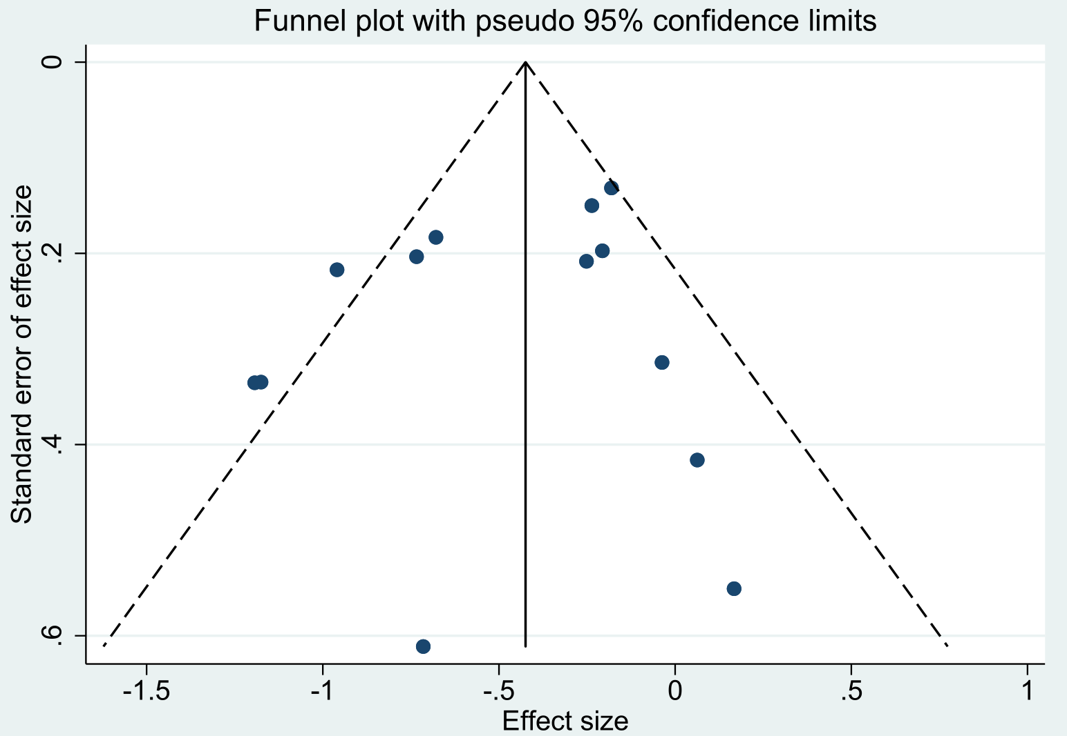
Egger’s test: bias=-0.94; standard error=1.17; t=-0.80; p-value=0.440

S2 Fig. Funnel plot of ALT estimates
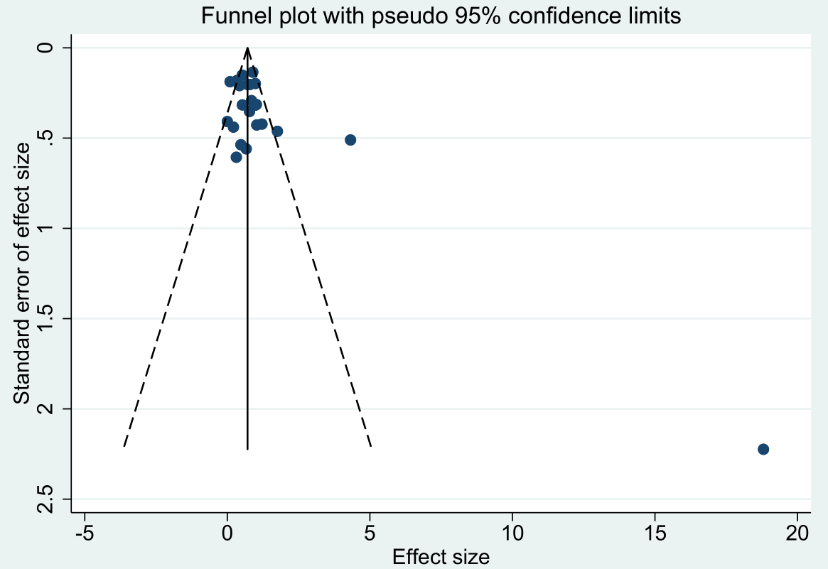
Egger’s test: bias=2.73; standard error=1.11; t=2.47; p-value=0.022

S3 Fig. Funnel plot of APTT estimates
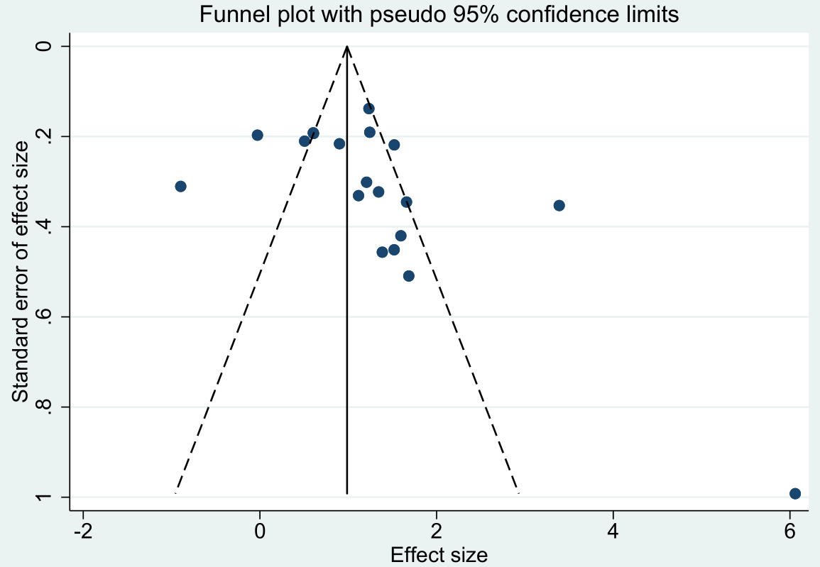
Egger’s test: bias=3.19; standard error=1.77; t=1.81; p-value=0.088

S4 Fig. Funnel plot of AST estimates
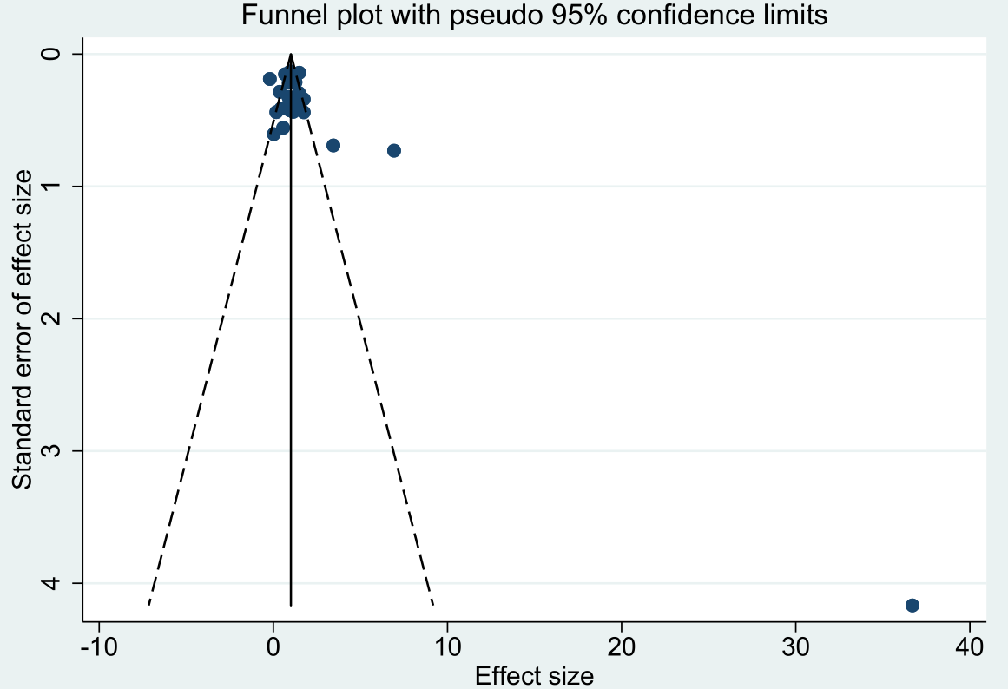
Egger’s test: bias=2.65; standard error=1.17; t=2.26; p-value=0.033

S5 Fig. Funnel plot of BUN estimates
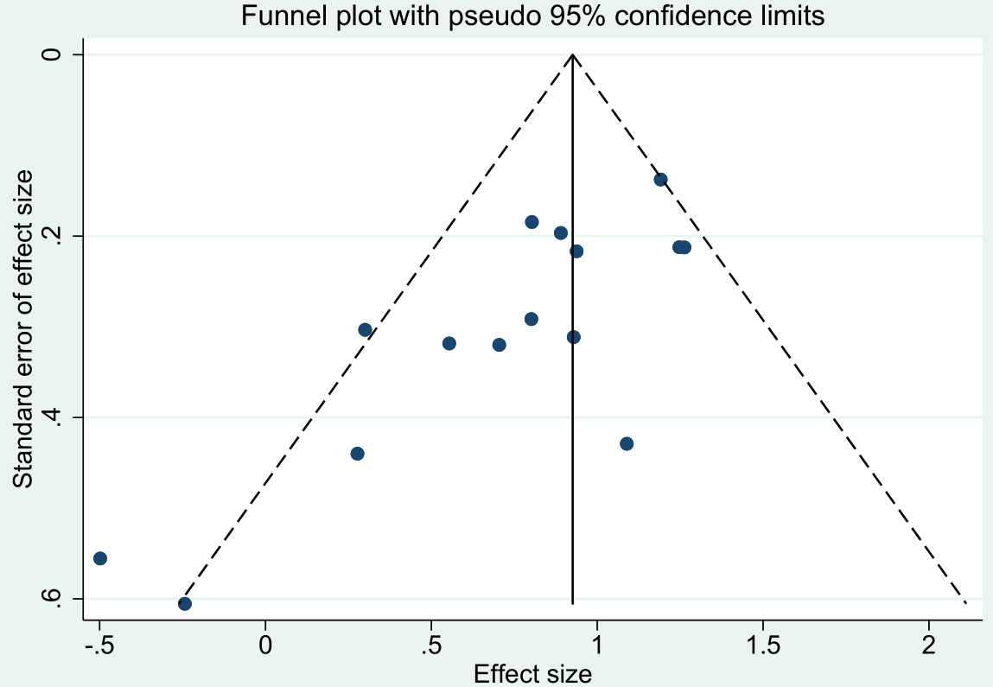
Egger’s test: bias=-2.77; standard error=0.67; t=-4.11; p-value=0.001

S6 Fig. Funnel plot of CK estimates
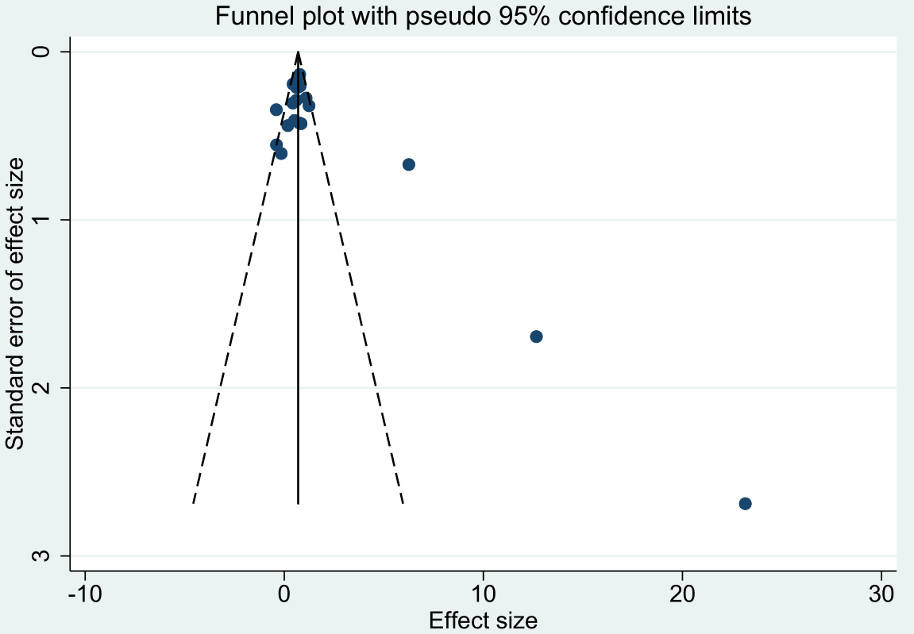
Egger’s test: bias=3.32; standard error=1.29; t=2.57; p-value=0.018

S7 Fig. Funnel plot of CK-MB estimates
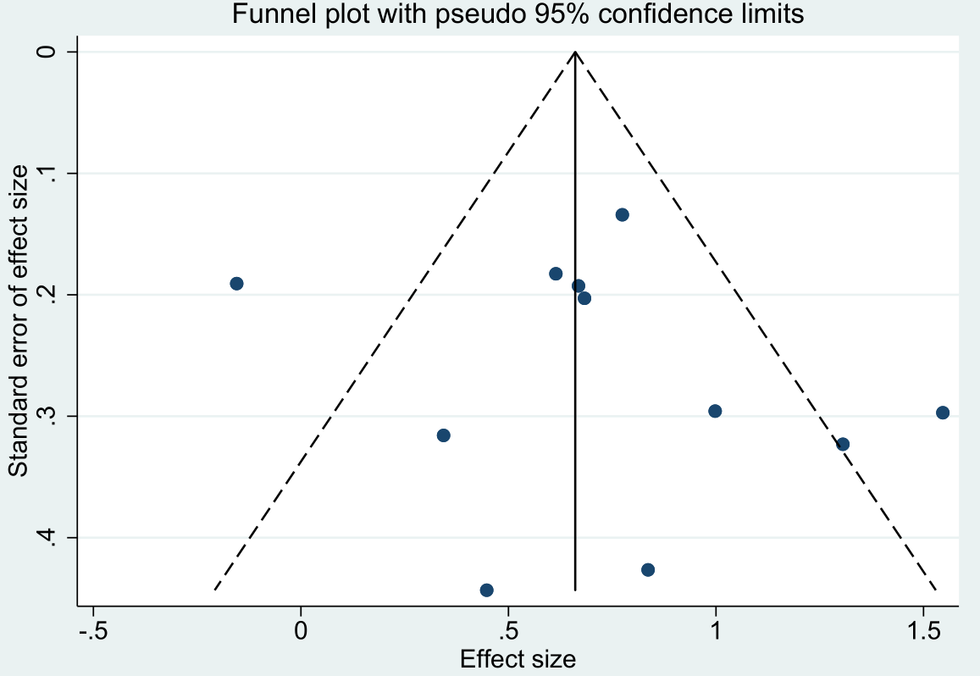
Egger’s test: bias=1.16; standard error=1.68; t=0.69; p-value=0.508

S8 Fig. Funnel plot of sCr estimates
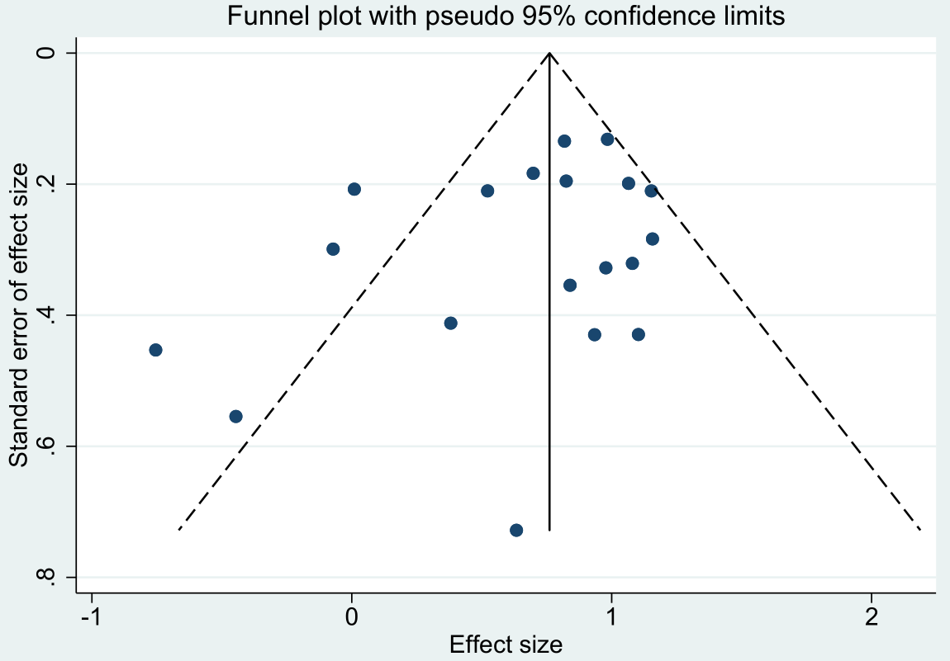
Egger’s test: bias=-130; standard error=0.93; t=-1.41; p-value=0.178

S9 Fig. Funnel plot of CRP estimates
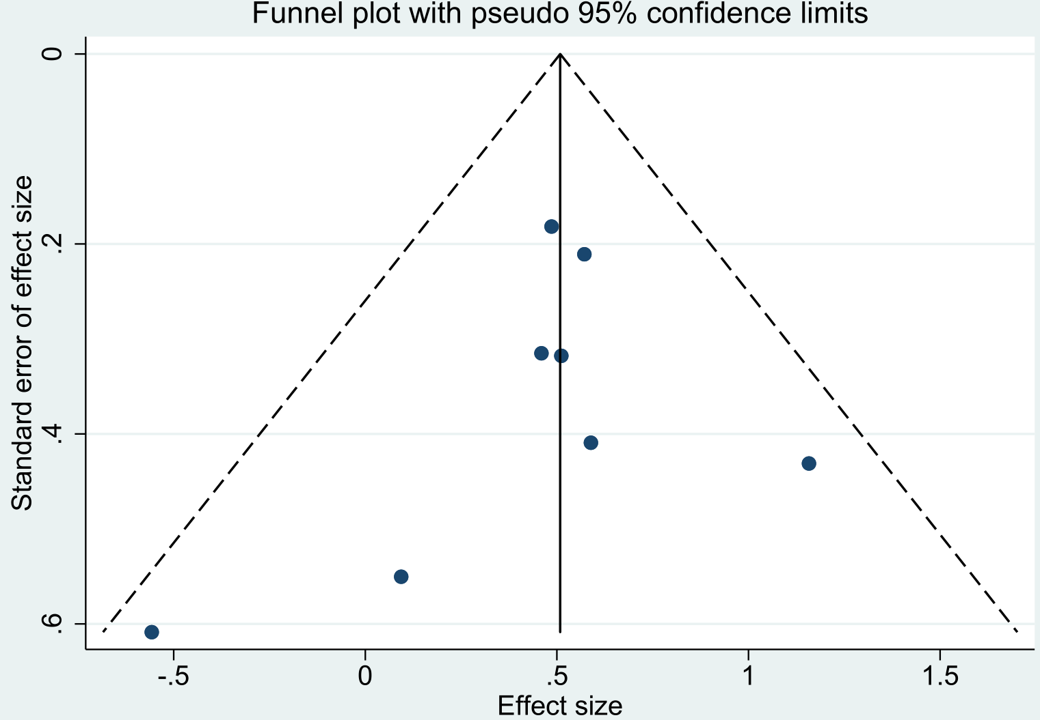
Egger’s test: bias=-0.66; standard error=0.89; t=-0.74; p-value=0.488

S10 Fig. Funnel plot of Hgb estimates
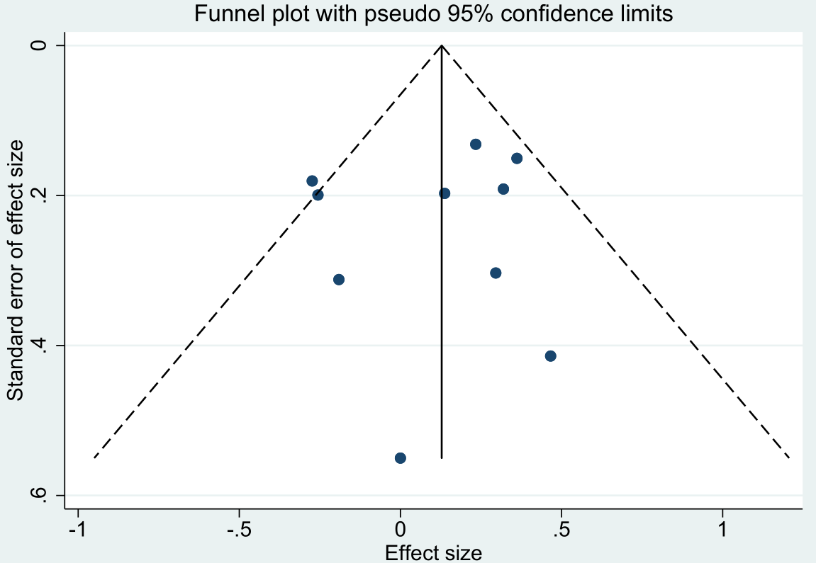
Egger’s test: bias=-0.49; standard error=1.19; t=-0.41; p-value=0.689

S11 Fig. Funnel plot of K estimates
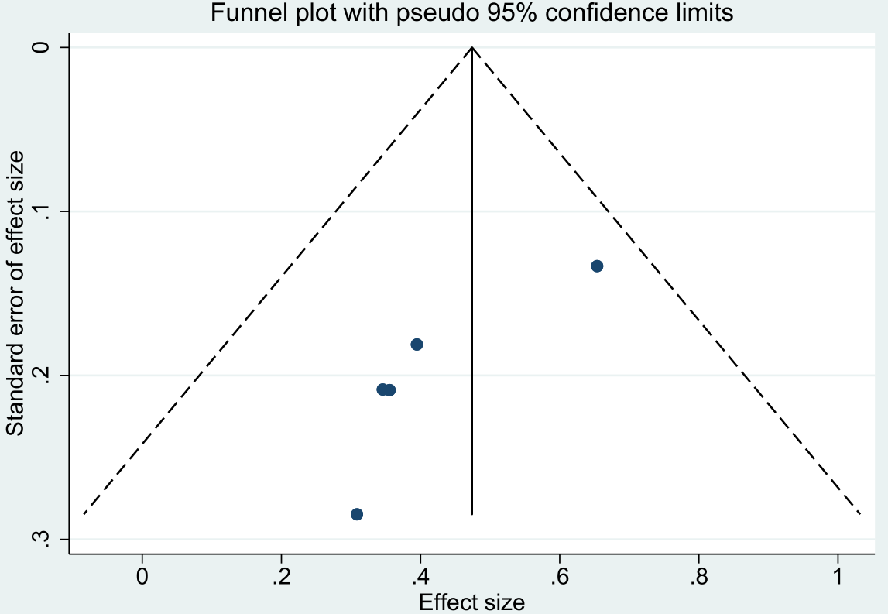
Egger’s test: bias=-2.88; standard error=0.82; t=-3.51; p-value=0.039

S12 Fig. Funnel plot of LDH estimates
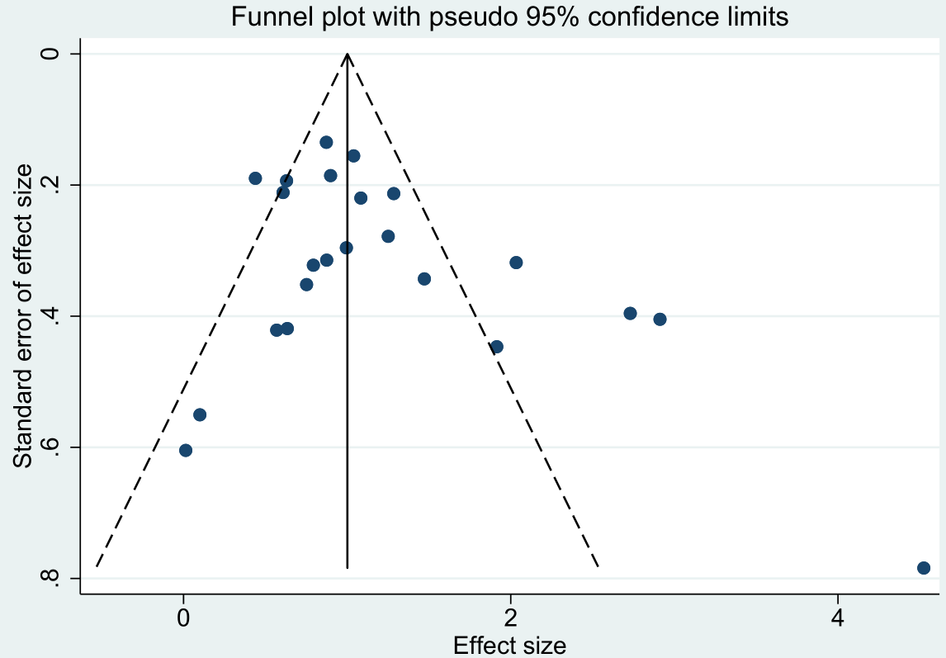
Egger’s test: bias=2.17; standard error=1.08; t=2.01; p-value=0.058

S13 Fig. Funnel plot of viral load estimates
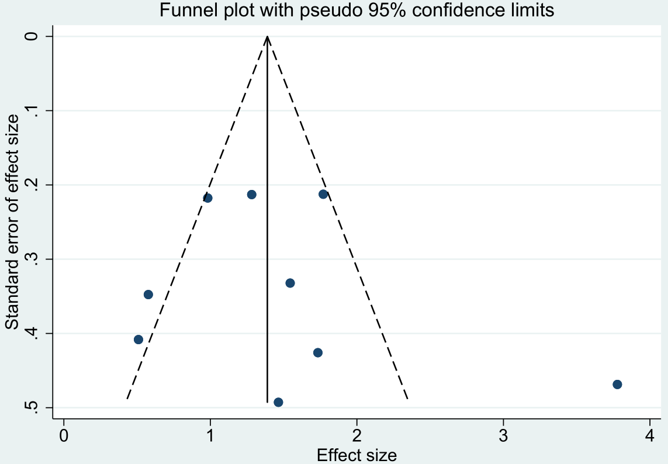
Egger’s test: bias=1.51; standard error=2.08; t=0.72; p-value=0.490

S14 Fig. Funnel plot of LYM% estimates
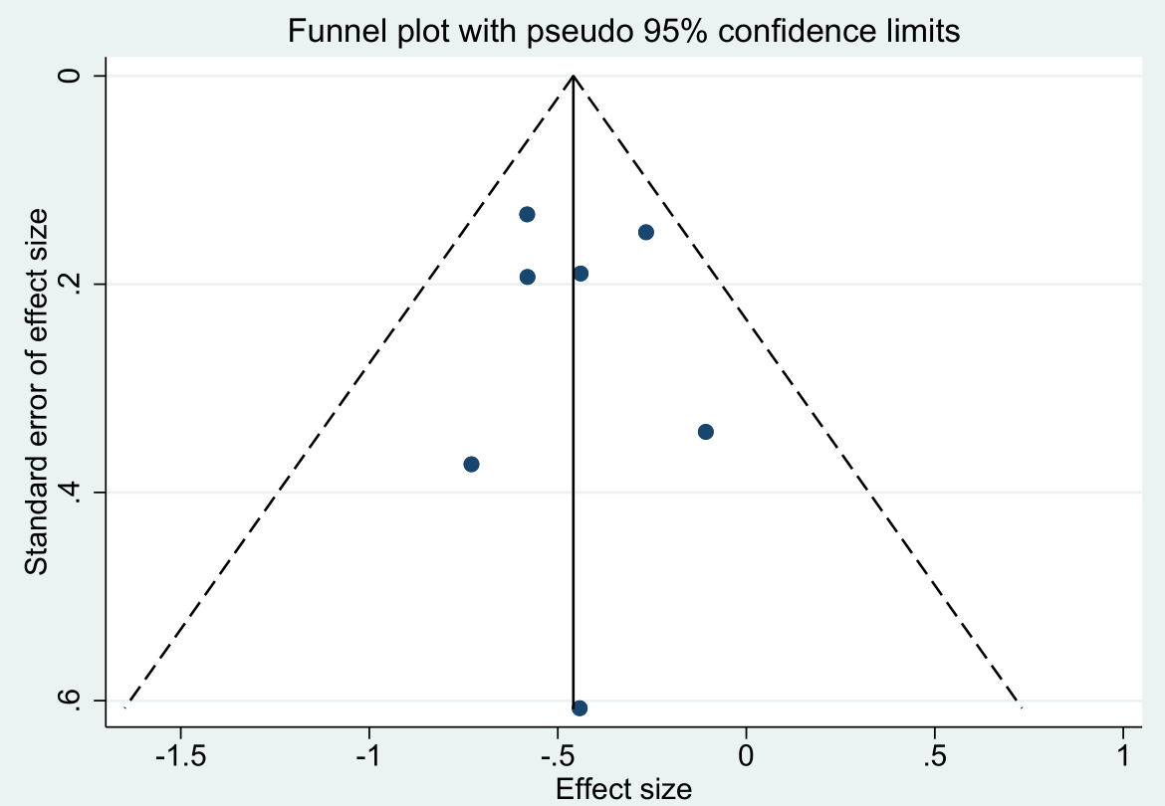
Egger’s test: bias=0.14; standard error=0.88; t=0.16; p-value=0.878

S15 Fig. Funnel plot of MON% estimates
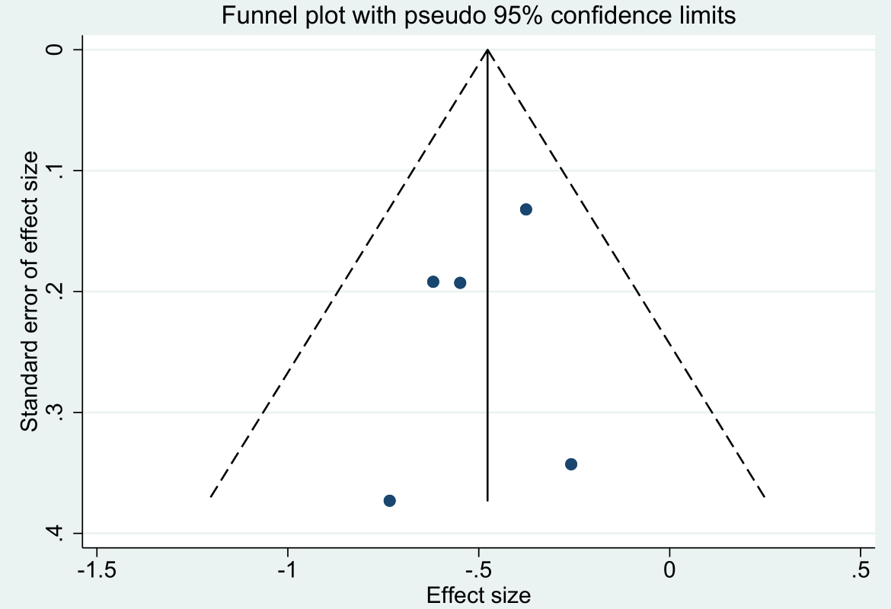
Egger’s test: bias=-0.64; standard error=1.00; t=-0.63; p-value=0.571

S16 Fig. Funnel plot of MON estimates
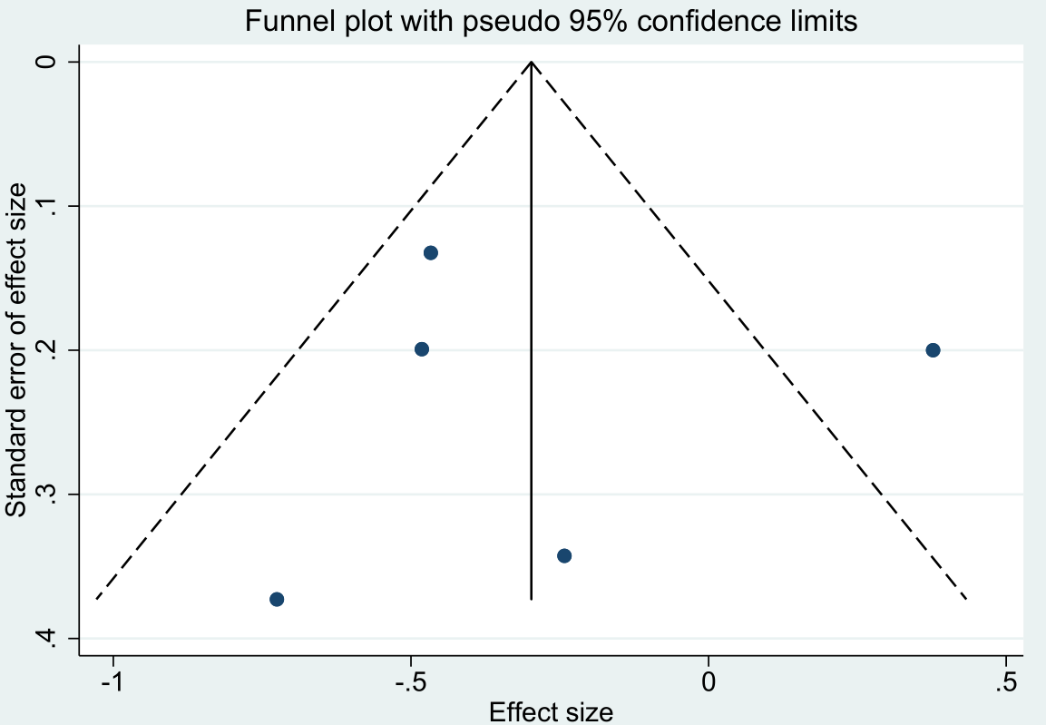
Egger’s test: bias=0.30; standard error=2.83; t=0.11; p-value=0.922

S17 Fig. Funnel plot of Na estimates
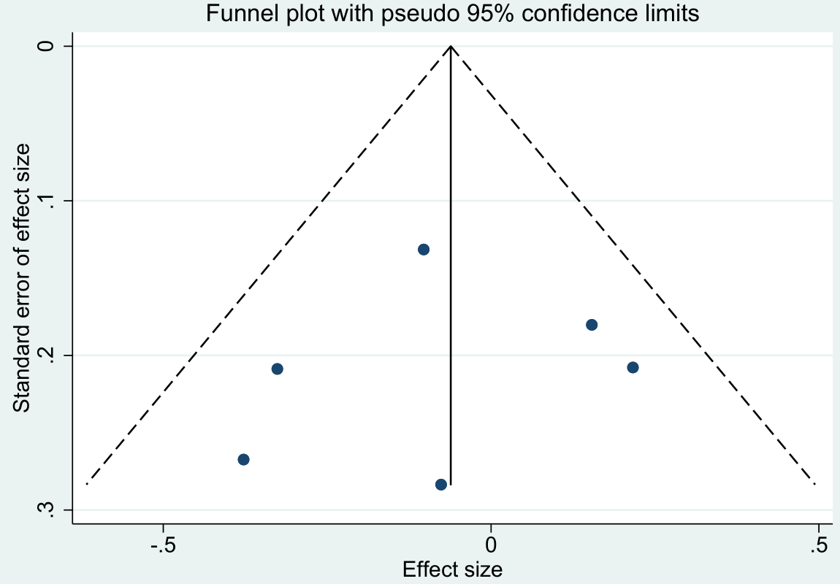
Egger’s test: bias=-0.70; standard error=1.94; t=-0.36; p-value=0.738

S18 Fig. Funnel plot of NEU% estimates
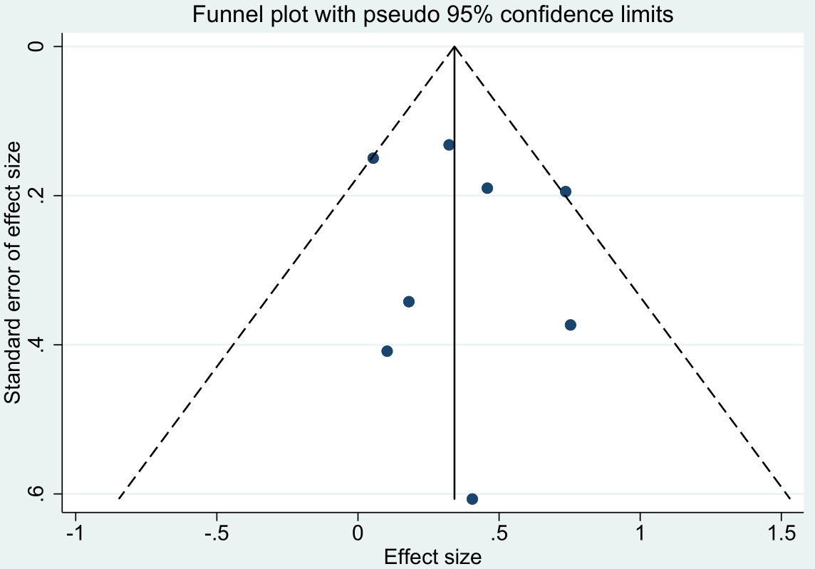
Egger’s test: bias=0.49; standard error=1.05; t=0.47; p-value=0.656

S19 Fig. Funnel plot of NEU estimates
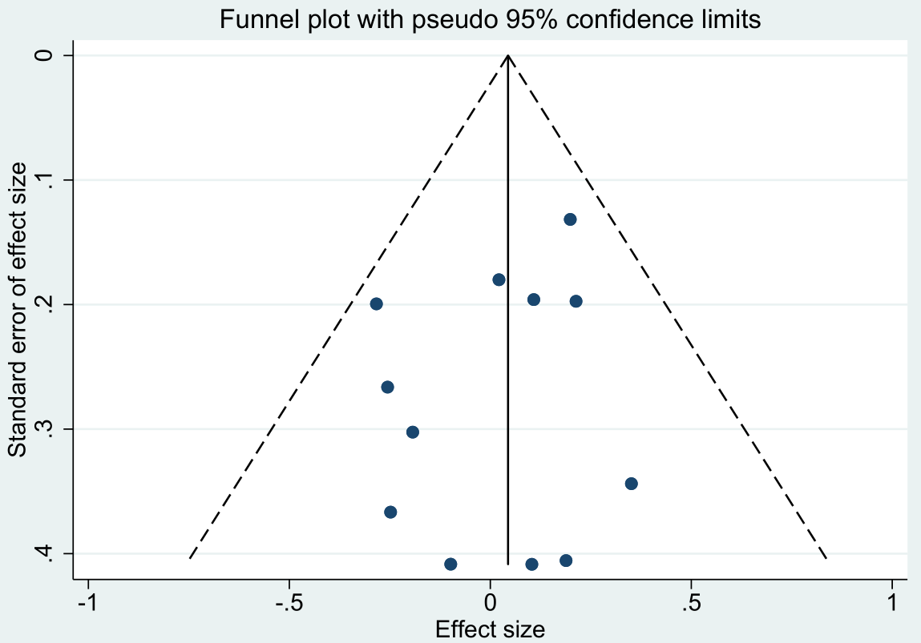
Egger’s test: bias=-0.68; standard error=0.71; t=-0.97; p-value=0.356

S20 Fig. Funnel plot of PLT estimates
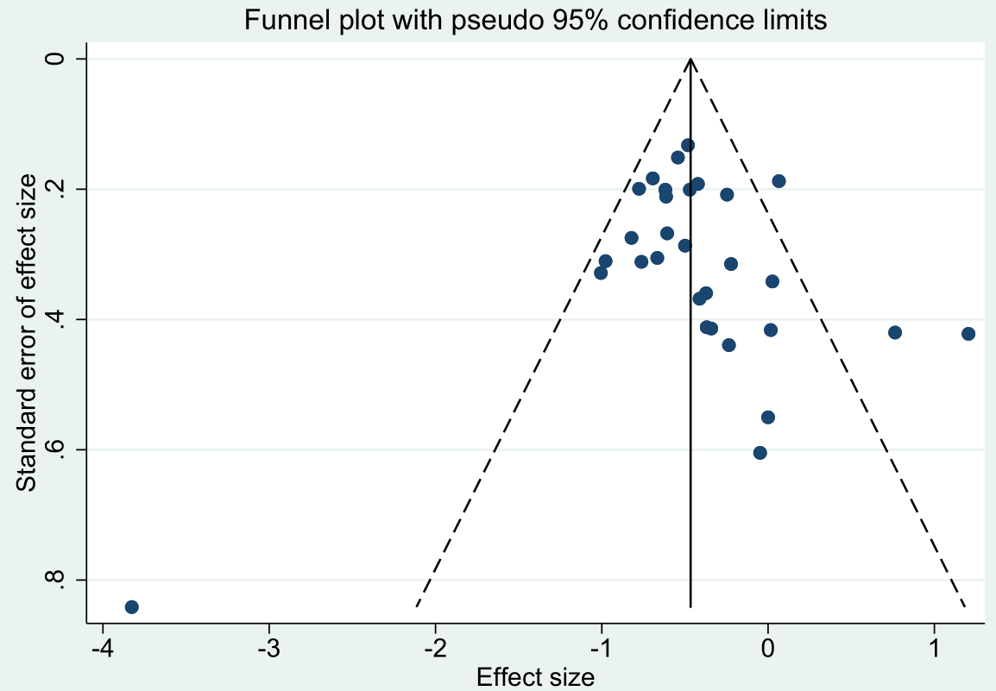
Egger’s test: bias=0.37; standard error=0.75; t=0.50; p-value=0.622

S21 Fig. Funnel plot of PT estimates
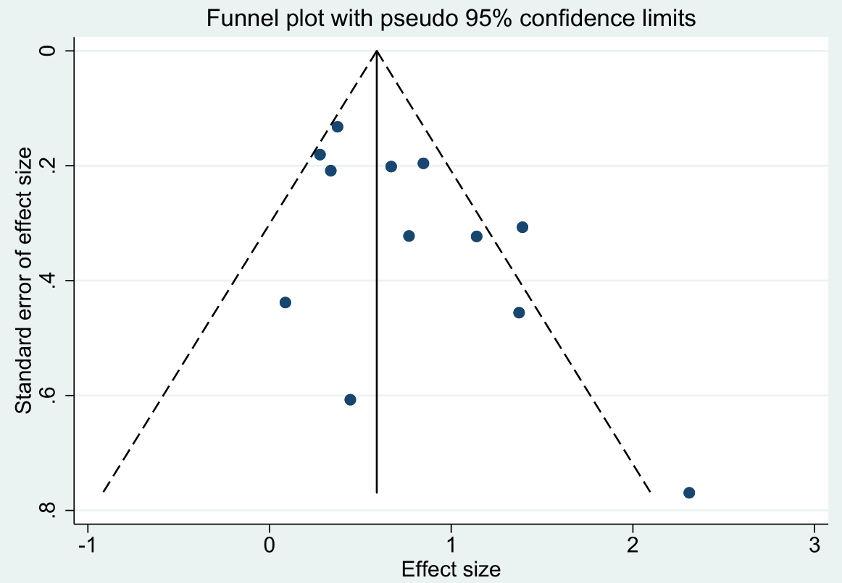
Egger’s test: bias=2.04; standard error=0.92; t=2.21; p-value=0.052

S22 Fig. Funnel plot of TB estimates
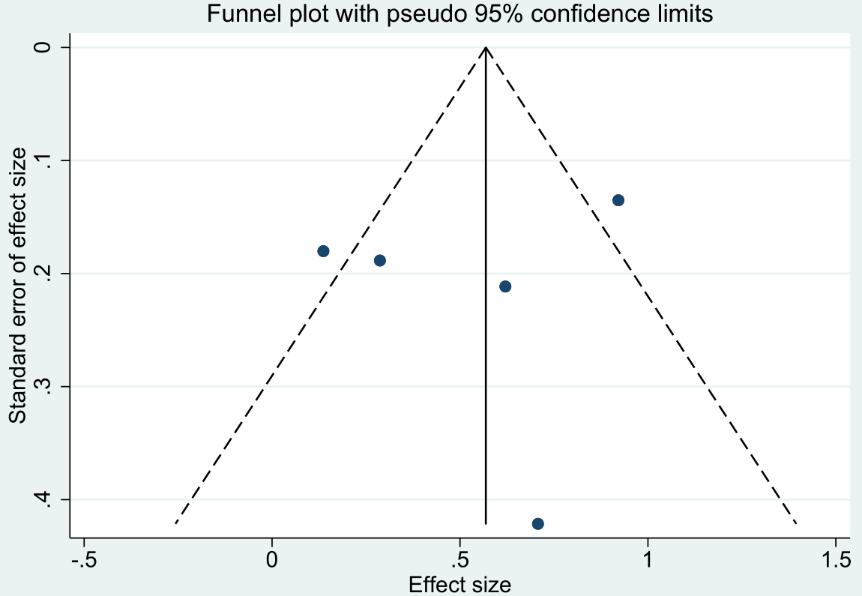
Egger’s test: bias=-1.54; standard error=3.16; t=-0.49; p-value=0.660

S23 Fig. Funnel plot of TT estimates
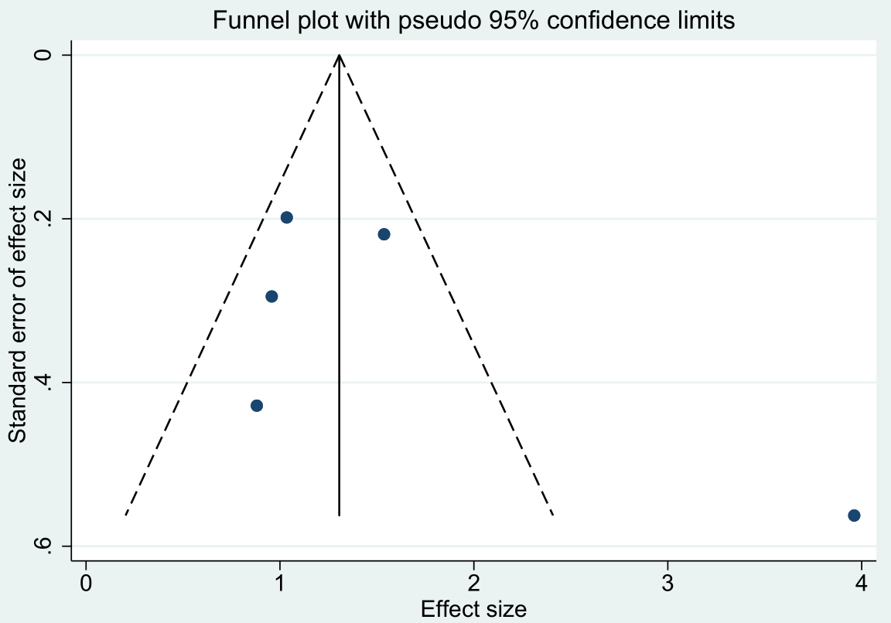
Egger’s test: bias=3.80; standard error=3.29; t=1.15; p-value=0.333

S24 Fig. Funnel plot of WBC estimates
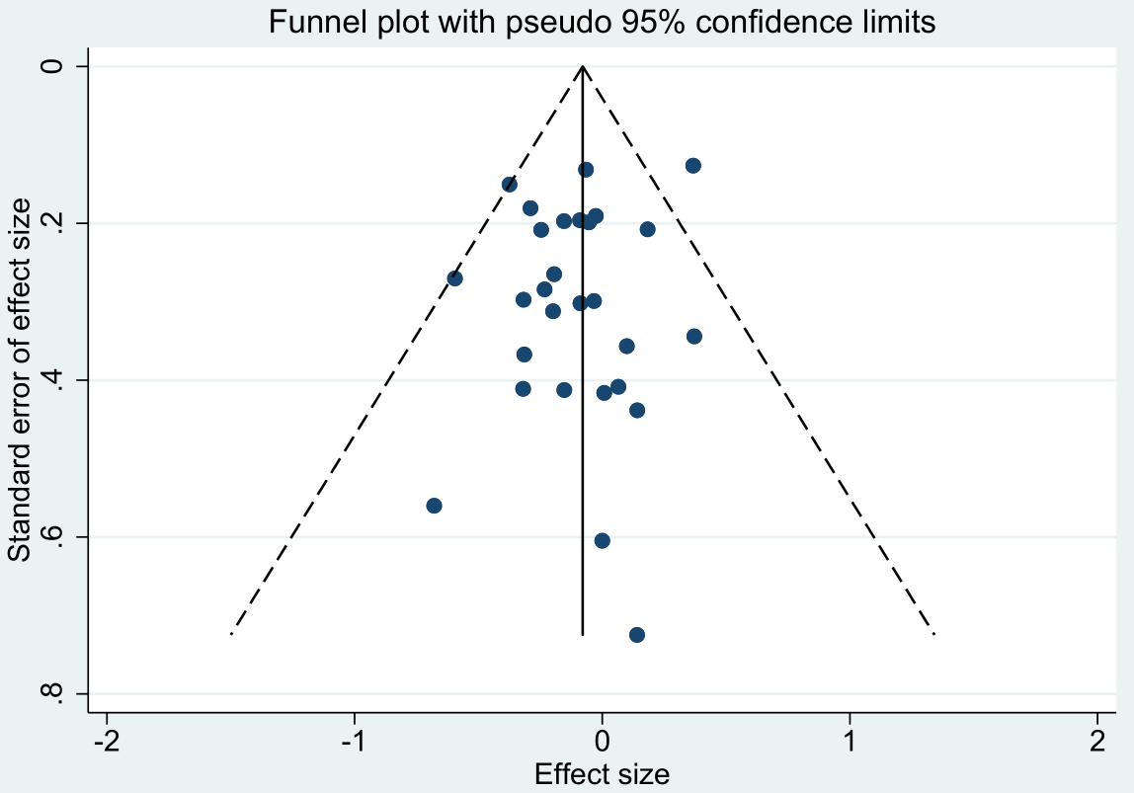
Egger’s test: bias=-0.48; standard error=0.49; t=-0.98; p-value=0.336

S25 Fig. Funnel plot of LYM estimates
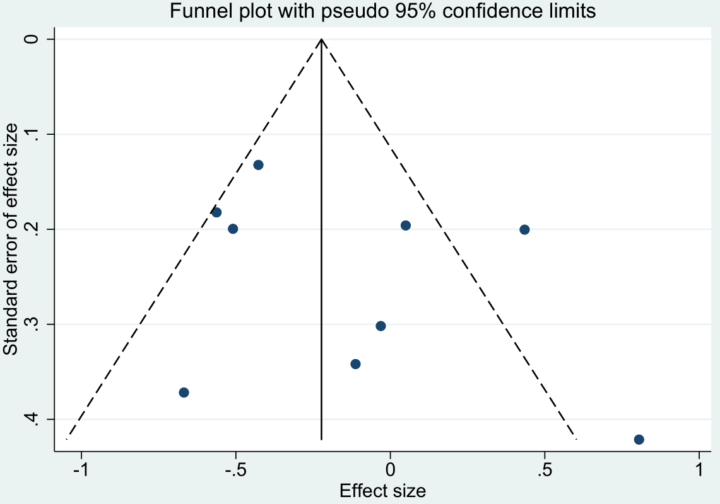
Egger’s test: bias=1.94; standard error=1.83; t=1.06; p-value=0.325

