Fig. S1 Forest plot comparing the posttreatment weight of the control and GLP-1RA groups.

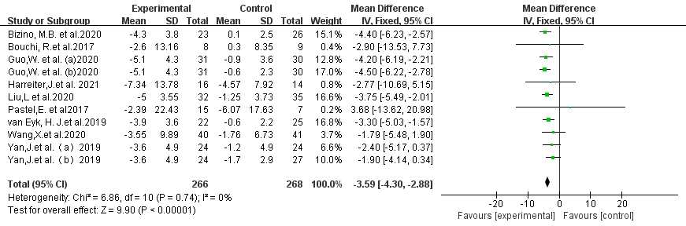

Fig. S2 Forest plot comparing the posttreatment WC of the control and GLP-1RA groups.

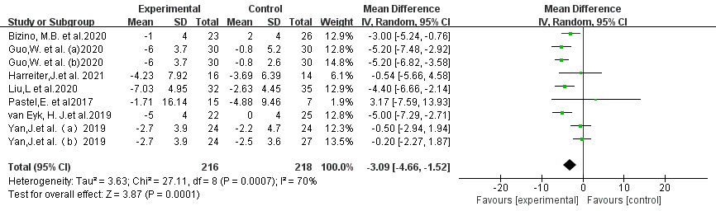

Fig. S3 Forest plot comparing the posttreatment BMI of the control and GLP-1RA groups.

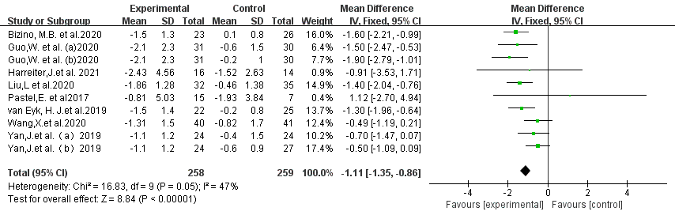

Fig. S4 Funnel plots for VAT.

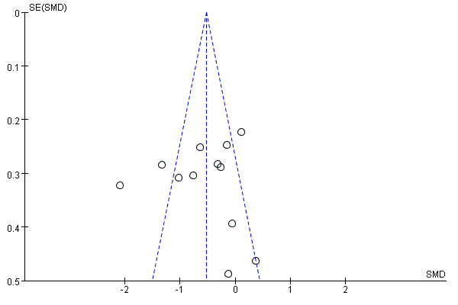

Fig. S5 Funnel plots for SAT

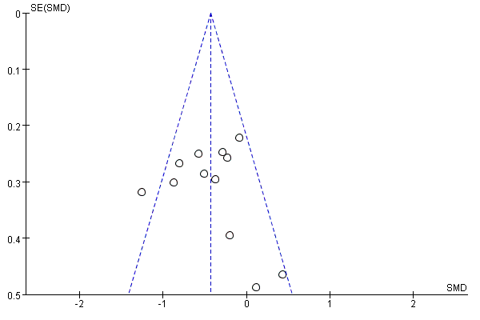

Fig. S6 Funnel plots for weight
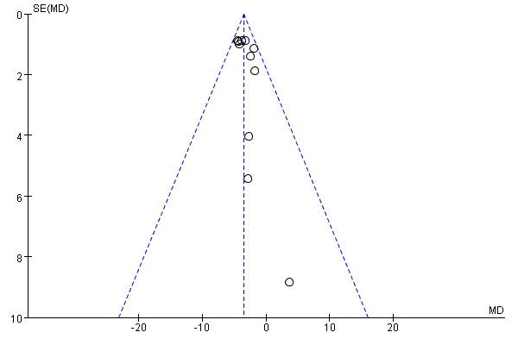

Fig. S7 Funnel plots for WC
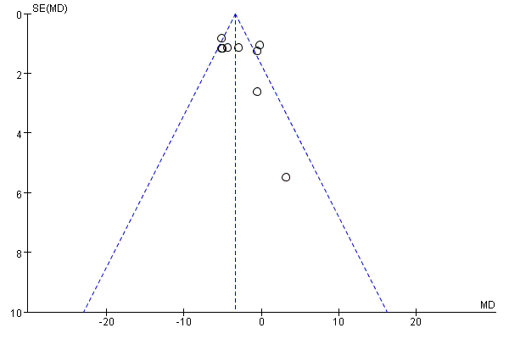

Fig. S8 Funnel plots for BMI


