Table S1. Details of search strategy.
Pubmed | Embase | The Cochrane Central Register of Controlled Trials
#1 “pregnancy” [Mesh] | #1 ‘pregnancy’/exp | #1 [pregnancy] explode all trees
#2 gestation | #2 ‘gestation’ | #2 gestation
#3 pregnan* | #3 pregnan* | #3 pregnan*
#4 prenatal | #4 ‘prenatal’/exp | #4 prenatal
#5 maternal | #5 ‘maternal’/exp | #5 maternal
#6 "mothers" [Mesh] | #6 ‘mother’/exp | #6 [mother] explode all trees
#7 mother | #7 mothers | #7 mothers
#8 (#1 OR #2 OR #3 OR #4 OR #5 OR #6 OR #7)
#9 sleep duration | #9 ‘sleep duration’ | #9 sleep duration
#10 sleep time | #10 ‘sleep time’/exp | #10 sleep time
#11 nocturnal sleep | #11 ‘nocturnal sleep’ | #11 nocturnal sleep
#12 night sleep | #12 ‘night sleep’/exp | #12 night sleep
#13 mid-sleep time | #13 ‘mid-sleep time’ | #13 mid-sleep time
#14 sleep timing | #14 ‘sleep timing’ | #14 sleep timing
#15 sleep pattern | #15 ‘sleep pattern’/exp | #15 sleep pattern
#16 sleep rhythm | #16 ‘sleep rhythm’ | #16 sleep rhythm
#17 "sleep" [Mesh] | #17 ‘sleep’/exp | #17 [sleep] explode all trees
#18 sleeping habit | #18 ‘sleeping habit’ | #18 sleeping habit
#19 sleep Habit | #19 ‘sleep Habit’/exp | #19 sleep Habit
#20 (#9 OR #10 OR #11 OR #12 OR #13 OR #14 OR #15 OR #16 OR #17 OR #18 OR #19)
#21 "pregnancy outcome" [Mesh] | #21 ‘pregnancy outcome’/exp | #21 [pregnancy outcome] explode all trees
#22 birth outcome | #22 ‘birth outcome’ | #22 birth outcome
#23 obstetric outcome | #23 ‘obstetric outcome’ | #23 obstetric outcome
#24 perinatal outcome | #24 ‘perinatal outcome’/exp | #24 perinatal outcome
#25 fetal outcome | #25 ‘fetal outcome’/exp | #25 fetal outcome
#26 fetus outcome | #26 ‘fetus outcome’ | #26 fetus outcome
#27 adverse outcome | #27 ‘adverse outcome’/exp | #27 adverse outcome
#28 (#21 OR #22 OR #23 OR #24 OR #25 OR #26 OR #27)
#29 "premature birth" [Mesh] | #29 ‘premature labor’/exp | #29 premature birth
#30 preterm birth | #30 ‘preterm birth’ | #30 [preterm birth] explode all trees
#31 premature delivery | #31 ‘premature delivery’ | #31 premature delivery
#32 preterm delivery | #32 ‘preterm delivery’ | #32 preterm delivery
#33 prematurity | #33 ‘prematurity’/exp | #33 prematurity
#34 infant, premature | #34 ‘infant, premature’ | #34 [infant, premature] explode all trees
#35 preterm infant | #35 ‘preterm infant’ | #35 preterm infant
#36 (#29 OR #30 OR #31 OR #32 OR #33 OR #34 OR #35)
#37 "infant, small for gestational age" [Mesh] | #37 ‘small for date infant’/exp | #37 infant, small for gestational age
#38 small for date infant | #38 ‘small for date infant’ | #38 small for date infant
#39 small for gestational age | #39 ‘small for gestational age’ | #39 small for gestational age
#40 SGA newborn | #40 ‘SGA newborn’ | #40 SGA newborn
#41 (#37 OR #38 OR #39 OR #40)
#42 "diabetes, gestational" [Mesh] | #42 ‘pregnancy diabetes mellitus’/exp | #42 [diabetes, gestational] explode all trees
#43 gestational diabetes mellitus | #43 ‘gestational diabetes mellitus’ | #43 gestational diabetes mellitus
#44 gestational diabetes | #44 ‘gestational diabetes’ | #44 gestational diabetes
#45 pregnancy diabetes mellitus | #45 ‘pregnancy diabetes mellitus’ | #45 pregnancy diabetes mellitus
#46 pregnancy diabetes | #46 ‘pregnancy diabetes’ | #46 pregnancy diabetes
#47 GDM | #47 ‘GDM’ | #47 GDM
#48 (#42 OR #43 OR #44 OR #45 OR #46 OR #47)
#49 "hypertension, pregnancy-induced" [Mesh] | #49 ‘maternal hypertension’/exp | #49 [hypertension, pregnancy-induced] explode all trees
#50 gestational gypertension | #50 ‘hypertension, pregnancy-induced’ | #50 gestational gypertension
#51 maternal hypertension | #51 ‘gestational hypertension’ | #51 maternal hypertension
#52 pre-eclampsia | #52 ‘pre-eclampsia’/exp | #52 [pre-eclampsia] explode all trees
#53 eclampsia | #53 ‘eclampsia’/exp | #53 [eclampsia] explode all trees
#54 (#49 OR #50 OR #51 OR #52 OR #53)
#55 birth grow | #55 ‘birth grow’ | #55 birth grow
#56 birth length | #56 ‘birth length’/exp | #56 birth length
#57 "birth weight" [Mesh] | #57 ‘birth weight’/exp | #57 [birth weight] explode all trees
#58 LBW | #58 ‘LBW’ | #58 LBW
#59 (#55 OR #56 OR #57 OR #58)
#60 "cesarean section" [Mesh] | #60 ‘cesarean section’/exp | #60 [cesarean section] explode all trees
#61 postcesarean section | #61 ‘postcesarean section’/exp | #61 postcesarean section
#62 abdominal delivery | #62 ‘abdominal delivery’ | #62 abdominal delivery
#63 cesarean delivery | #63 ‘cesarean delivery’ | #63 cesarean delivery
#64 caesarian birth | #64 ‘caesarian birth’ | #64 caesarian birth
#65 (#60 OR #61 OR #62 OR #63 OR #64)
#66 (#28 OR #36 OR #41 OR #48 OR #54 OR #59 OR #65)
#67 (#8 AND #20 AND #66)

Table S2. Results of Bgge’s and Egger’s test.
Outcomes of interest |  | GDM | GH | CS | LBW | PTB | SGA
SSD | Begg's test (P) | 0.005 | 0.327 | 0.677 | 0.453 | 0.143 | 0.180
SSD | Egger's test (P) | 0.001 | 0.465 | 0.374 | 0.507 | 0.245 | 0.226
LSD | Begg's test (P) | 0.138 | 0.317 | 0.317 | 0.317 | 0.497 | 0.881
LSD | Egger's test (P) | 0.078 | (-) | (-) | (-) | 0.230 | 0.837
Note: SSD: short sleep duration; LSD: long sleep duration;
GDM: gestational diabetes mellitus; GH: gestational hypertension; CS: cesarean section; LBW: low birthweight; PTB: preterm birth; SGA: small for gestational age;
(-): the number of the study was not enough to be analyzed.

Figure S1. Funnel plot for outcome of gestational diabetes mellitus.
Note: (A) the funnel plot of the included literatures for outcome of gestational diabetes mellitus; (B) the funnel plot with the Duval and Tweedie Trim and Fill test for outcome of gestational diabetes mellitus

Figure S2. Plot for sensitivity analysis of short sleep duration and adverse pregnancy outcomes.
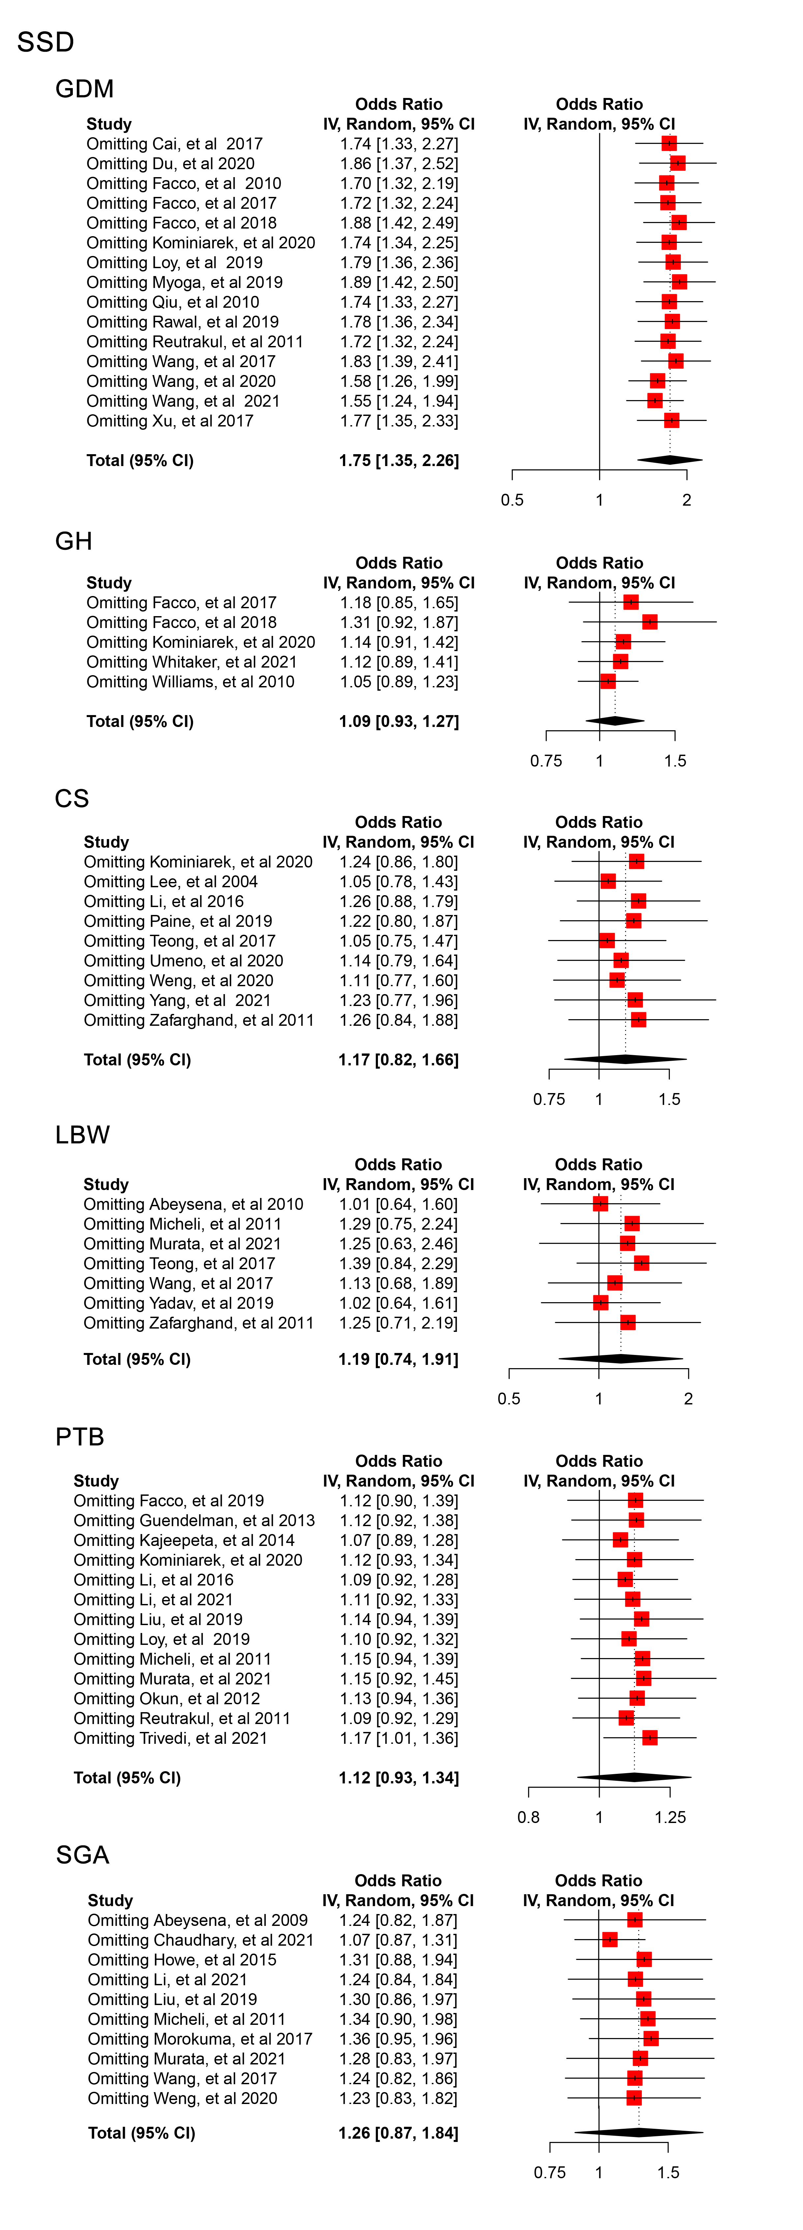
Note: GDM: gestational diabetes mellitus; GH: gestational hypertension; CS: cesarean section; LBW: low birthweight; PTB: preterm birth; SGA: small for gestational age.

Figure S3. Plot for sensitivity analysis of long sleep duration and adverse pregnancy outcomes.
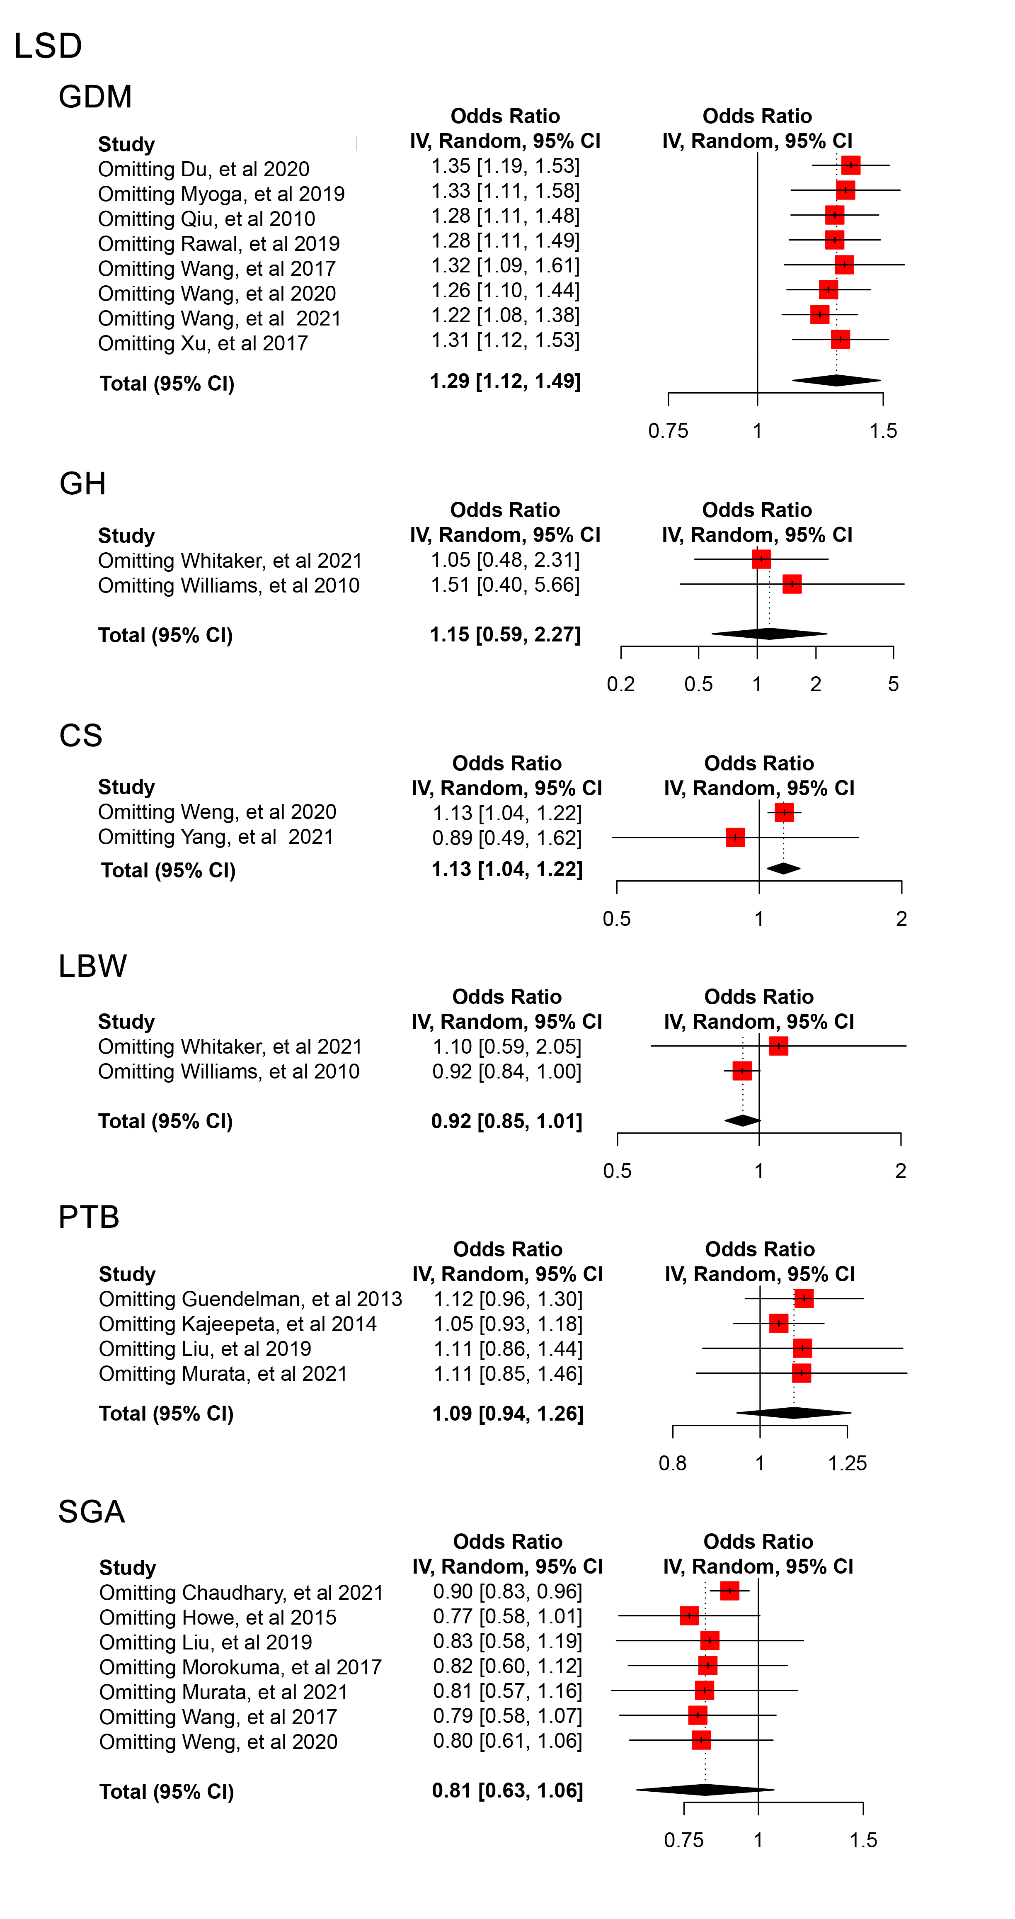
Note: GDM: gestational diabetes mellitus; GH: gestational hypertension; CS: cesarean section; LBW: low birthweight; PTB: preterm birth; SGA: small for gestational age.

