E-Supplement
Content
eTable 1 PRISMA Checklist
eTable 2 The features of the articles eliminated in the process of full-text screening
eTable 3 The diagnosis of COVID-19 illness in enrolled articles
eTable 4 Quality assessment of the included studies
eTable 5 The detailed information and data on outcomes of patients co-infected asthma and COVID-19
eTable 6 Characteristics of studies reporting adjusted effect estimates
eFigure 1. The pooled prevalence of asthma in patients with COVID-19: subgroup analysis by sample size
eFigure 2. The pooled prevalence of asthma in patients with COVID-19: subgroup analysis by settings
eFigure 3. The pooled prevalence of asthma in patients with COVID-19: subgroup analysis by region
eFigure 4. The pooled prevalence of asthma in patients with COVID-19: subgroup analysis by study design
eFigure 5. The pooled prevalence of asthma in patients with COVID-19: subgroup analysis by quality score
eFigure 6. Begg’s funnel plot and Egger’s test for publication bias

Section/topic | # | Checklist item | Reported on page #
TITLE
Title | 1 | Identify the report as a systematic review, meta-analysis, or both. | 1
ABSTRACT
Structured summary | 2 | Provide a structured summary including, as applicable: background; objectives; data sources; study eligibility criteria, participants, and interventions; study appraisal and synthesis methods; results; limitations; conclusions and implications of key findings; systematic review registration number. | Abstract
INTRODUCTION
Rationale | 3 | Describe the rationale for the review in the context of what is already known. | 1
Objectives | 4 | Provide an explicit statement of questions being addressed with reference to participants, interventions, comparisons, outcomes, and study design (PICOS). | 2
METHODS
Protocol and registration | 5 | Indicate if a review protocol exists, if and where it can be accessed (e.g., Web address), and, if available, provide registration information including registration number. | N/A
Eligibility criteria | 6 | Specify study characteristics (e.g., PICOS, length of follow-up) and report characteristics (e.g., years considered, language, publication status) used as criteria for eligibility, giving rationale. | 2
Information sources | 7 | Describe all information sources (e.g., databases with dates of coverage, contact with study authors to identify additional studies) in the search and date last searched. | 2
Search | 8 | Present full electronic search strategy for at least one database, including any limits used, such that it could be repeated. | 2
Study selection | 9 | State the process for selecting studies (i.e., screening, eligibility, included in systematic review, and, if applicable, included in the meta-analysis). | 2-3
Data collection process | 10 | Describe method of data extraction from reports (e.g., piloted forms, independently, in duplicate) and any processes for obtaining and confirming data from investigators. | 3
Data items | 11 | List and define all variables for which data were sought (e.g., PICOS, funding sources) and any assumptions and simplifications made. | 3
Risk of bias in individual studies | 12 | Describe methods used for assessing risk of bias of individual studies (including specification of whether this was done at the study or outcome level), and how this information is to be used in any data synthesis. | 3
Summary measures | 13 | State the principal summary measures (e.g., risk ratio, difference in means). | 4
Synthesis of results | 14 | Describe the methods of handling data and combining results of studies, if done, including measures of consistency (e.g., I²) for each meta-analysis. | 4

eTable 1 PRISMA Checklist
Section/topic | # | Checklist item | Reported on page #
Risk of bias across studies | 15 | Specify any assessment of risk of bias that may affect the cumulative evidence (e.g., publication bias, selective reporting within studies). | 4
Additional analyses | 16 | Describe methods of additional analyses (e.g., sensitivity or subgroup analyses, meta-regression), if done, indicating which were pre-specified. | 4
RESULTS
Study selection | 17 | Give numbers of studies screened, assessed for eligibility, and included in the review, with reasons for exclusions at each stage, ideally with a flow diagram. | 4-5
Study characteristics | 18 | For each study, present characteristics for which data were extracted (e.g., study size, PICOS, follow-up period) and provide the citations. | 5
Risk of bias within studies | 19 | Present data on risk of bias of each study and, if available, any outcome level assessment (see item 12). | 5
Results of individual studies | 20 | For all outcomes considered (benefits or harms), present, for each study: (a) simple summary data for each intervention group (b) effect estimates and confidence intervals, ideally with a forest plot. | 5-7
Synthesis of results | 21 | Present results of each meta-analysis done, including confidence intervals and measures of consistency. | 5-7
Risk of bias across studies | 22 | Present results of any assessment of risk of bias across studies (see Item 15). | 7
Additional analysis | 23 | Give results of additional analyses, if done (e.g., sensitivity or subgroup analyses, meta-regression [see Item 16]). | 5-6
DISCUSSION
Summary of evidence | 24 | Summarize the main findings including the strength of evidence for each main outcome; consider their relevance to key groups (e.g., healthcare providers, users, and policy makers). | 7-8
Limitations | 25 | Discuss limitations at study and outcome level (e.g., risk of bias), and at review-level (e.g., incomplete retrieval of identified research, reporting bias). | 8-9
Conclusions | 26 | Provide a general interpretation of the results in the context of other evidence, and implications for future research. | 9
FUNDING
Funding | 27 | Describe sources of funding for the systematic review and other support (e.g., supply of data); role of funders for the systematic review. | Title page

eTable 2 The features of the articles eliminated in the process of full-text screening
Author | Title | PMID | Country | Sample size | Asthma (%)
Articles with a sample size less than 100
Abdallah et al.¹ | Characteristics of critically ill patients infected with  COVID-19 in Abu Dhabi, United Arab Emirates | 32660852 | United Arab Emirates | 55 | 3 (5.5)
Abrishami et al.² | Clinical and radiologic characteristics of COVID-19 in patients with CKD | 32655021 | Iran | 43 | 1 (2.3)
Aleva et al.³ | COVID-19 in critically ill patients in North Brabant, the Netherlands: Patient characteristics and outcomes | 32799179 | Netherlands | 50 | 3 (6.0)
Arentz et al.⁴ | Characteristics and outcomes of 21 critically ill patients with COVID-19 in Washington State | 32191259 | US | 21 | 2 (9.5)
Axelrad et al.⁵ | From the American epicenter: coronavirus disease 2019 in patients with inflammatory bowel disease in the New York City Metropolitan Area | 32578843 | US | 83 | 9 (10.8)
Batteux et al.⁶ | Abnormal laboratory findings and plasma concentration monitoring of lopinavir and ritonavir in COVID-19 | 32692462 | France | 65 | 0 (0.0)
Carpagnano et al.⁷ | Vitamin D deficiency as a predictor of poor prognosis in patients with acute respiratory failure due to COVID-19 | 32772324 | Italy | 42 | 2 (4.8)
Caturegli et al.⁸ | Clinical validity of serum antibodies to SARS-CoV-2: A case-control study | 32628534 | US | 55 | 6 (10.9)
Davoudi-Monfare et al.⁹ | A randomized clinical trial of the efficacy and safety of interferon β-1a in treatment of s evere COVID-19 | 32661006 | Iran | 81 | 1 (1.2)
Durrani et al.¹⁰ | Chest X-rays findings in COVID 19 patients at a University Teaching Hospital - A descriptive study | 32582309 | Pakistan | 30 | 1 (3.3)
Egol et al.¹¹ | Increased mortality and major complications in hip fracture care during the COVID-19 pandemic: A New York City Perspective | 32482976 | US | 17 | 0 (0.0)
Eslami et al.¹² | The impact of sofosbuvir/daclatasvir or ribavirin in patients with severe COVID-19 | 32812051 | Iran | SOF/DCV: 35  RBV: 27 | SOF/DCV: 2 (5.7)  RBV: 1 (3.7)
Ferreli et al.¹³ | Clinical presentation at the onset of COVID-19 and allergic rhinoconjunctivitis | 32818700 | Italy | 22 | 3 (13.6)
Fominskiy et al.¹⁴ | Prevalence, characteristics, risk factors, and outcomes of invasively ventilated COVID-19 patients with acute kidney injury and renal replacement therapy | 32659757 | Italy | 99 | 4 (4.0)
Gregoriano et al.¹⁵ | Characteristics, predictors and outcomes among 99 patients hospitalised with COVID-19 in a tertiary care centre in Switzerland: an observational analysis | 32668007 | Switzerland | 99 | 16 (16.2)
Huang et al.¹⁶ | Predictors of coronavirus disease 2019 severity: A retrospective study of 64 cases | 32741931 | China | 64 | 1 (1.6)
Infante et al.¹⁷ | COVID-19 in patients with hematological malignancies: A retrospective case series | 32749757 | Spain | 41 | 1 (2.4)
Iturrieta-Zuazo et al.¹⁸ | Possible role of HLA class-I genotype in SARS-CoV-2 infection and progression: A pilot study in a cohort of Covid-19 Spanish patients | 32810602 | Spain | 45 | 1 (2.2)
Kewan et al.¹⁹ | Tocilizumab for treatment of patients with severe COVID-19: A retrospective cohort study | 32766537 | US | 51 | 9 (17.6)
Kim et al.²⁰ | Clinical course and outcomes of patients with severe acute respiratory syndrome coronavirus 2 infection: A preliminary report of the first 28 patients from the Korean cohort study on COVID-19 | 32242348 | Korea | 28 | 1 (3.6)
Klein et al.²¹ | Unrecognized diabetes in critically ill COVID-19 patients | 32646467 | Austria | 44 | 4 (9.1)
Laing et al.²² | A dynamic COVID-19 immune signature includes associations with poor prognosis | 32807934 | UK | 63 | 11 (17.5)
Liu et al.²³ | Convalescent plasma treatment of severe COVID-19: a propensity score-matched control study | 32934372 | US | 39 | 3 (7.7)
Longchamp et al.²⁴ | Venous thromboembolism in critically Ill patients with COVID-19: Results of a screening study for deep vein thrombosis | 32685893 | Switzerland | 25 | 1 (4.0)
Louis et al.²⁵ | Continuous electroencephalography characteristics and acute symptomatic seizures in COVID-19 patients | 32949985 | US | 22 | 8 (36.4)
Martinelli et al.²⁶ | COVID-19 and pneumothorax: A multicenter retrospective case series | 32907891 | UK | 60 | 10 (16.7)
Martos et al.²⁷ | Comorbidity and prognostic factors on admission in a COVID-19 cohort of a general hospital | 32680592 | Spain | 96 | 11 (11.5)
Morrison et al.²⁸ | Clinical characteristics and predictors of survival in adults with coronavirus disease 2019 receiving tocilizumab | 32646770 | US | 81 | 11 (13.6)
Myrstad et al.²⁹ | National Early Warning Score 2 (NEWS2) on admission predicts severe disease and in-hospital mortality from Covid-19 - a prospective cohort study | 32660623 | Norway | 66 | 7 (10.6)
Patel et al.³⁰ | Pulmonary angiopathy in severe COVID-19: Physiologic, imaging, and hematologic observations | 32667207 | UK | 39 | 3 (7.7)
Rahmani et al.³¹ | Interferon β-1b in treatment of severe COVID-19: A randomized clinical trial | 32862111 | Iran | Treated: 33  Control: 33 | Treated: 1 (0.3)  Control: 2 (0.6)
Ramiro et al.³² | Historically controlled comparison of glucocorticoids with or without tocilizumab versus supportive care only in patients with COVID-19-associated cytokine storm syndrome: results of the CHIC study | 32719045 | Netherlands | Treated: 86  Control: 86 | Treated: 7 (8.1)  Control: 5 (5.8)
Rivera-Izquierdo et al.³³ | Clinical factors, preventive behaviours and temporal outcomes associated with COVID-19 infection in health professionals at a Spanish Hospital | 32560180 | Spain | 76 | 8 (10.5)
Roberts et al.³⁴ | COVID-19 in solid organ transplant recipients: Dynamics of disease progression and inflammatory markers in ICU and non-ICU admitted patients | 32654303 | US | 52 | 3 (5.8)
Rojas-Marte et al.³⁵ | Outcomes in patients with severe COVID-19 disease treated with tocilizumab: a case-controlled study | 32569363 | US | Tocilizumab: 96  Control: 97 | Tocilizumab: 4 (4.2)  Control: 9 (9.3)
Rubin et al.³⁶ | Characterization of acute kidney injury in critically ill patients with severe coronavirus disease 2019 | 32695326 | France | 71 | 3 (4.2)
Sadeghi et al.³⁷ | Sofosbuvir and daclatasvir compared with standard of care in the treatment of patients admitted to hospital with moderate or severe coronavirus infection (COVID-19): a randomized controlled trial | 32812039 | Iran | SOF/DCV: 33  Control: 33 | SOF/DCV: 1 (3.0)  Control: 1 (3.0)
Serrano-Martínez et al.³⁸ | Characteristics and results of a series of 59 patients with severe pneumonia due to COVID-19 admitted in the ICU | 32653237 | Spain | 59 | 8 (13.6)
Tomlins et al.³⁹ | Clinical features of 95 sequential hospitalized patients with novel coronavirus 2019 disease (COVID-19), the first UK cohort | 32353384 | UK | 95 | 21 (22.1)
Uzzan et al.⁴⁰ | Patients with COVID-19 present with low plasma citrulline concentrations that associate with systemic inflammation and gastrointestinal symptoms | 32646736 | France | 26 | 2 (7.7)
Wang et al.⁴¹ | Clinical features of 69 cases with Coronavirus disease 2019 in Wuhan, China | 32176772 | China | 69 | 2 (2.9)
Wright et al.⁴² | Fibrinolysis shutdown correlates to thromboembolic events in severe COVID-19 | 32422349 | USA | 44 | 4 (9.1)
Yi et al.⁴³ | Clinical characteristics and outcomes of coronavirus disease 2019 infections among diabetics: A retrospective and multicenter study in China | 32725691 | China | 54 | 0 (0.0)
Zangrillo et al.⁴⁴ | Characteristics, treatment, outcomes and cause of death of invasively ventilated patients with COVID-19 ARDS in Milan, Italy | 32353223 | Italy | 73 | 3 (4.5)
Articles with duplicate data
Atkins et al.⁴⁵ | Preexisting comorbidities predicting COVID-19 and mortality in the UK Biobank Community Cohort | 32687551 | UK | 507 | 90 (17.8)
Bello-Chavolla et al.⁴⁶ | Unequal impact of structural health determinants and comorbidity on COVID-19 severity and lethality in older Mexican adults: Considerations beyond chronological aging | 32598450 | Mexico | 20804 | 420 (2.0)
Chand et al.⁴⁷ | COVID-19-associated critical illness-report of the first 300 patients admitted to intensive care units at a New York City Medical Center | 32812834 | US | 300 | 39 (13.0)
Del Valle et al.⁴⁸ | An inflammatory cytokine signature predicts COVID-19 severity and survival | 32839624 | US | 1268 | 72 (5.7)
Emami et al.⁴⁹ | Survival rate in hypertensive patients with COVID-19 | 32835530 | Iran | 1239 | 25 (2.0)
Ferrando et al.⁵⁰ | Patient characteristics, clinical course and factors associated to ICU mortality in critically ill patients infected with SARS-CoV-2 in Spain: A prospective, cohort, multicentre study | 32800622 | Spain and Andorra | 663 | 17 (2.6)
Giannouchos et al.⁵¹ | Characteristics and risk factors for COVID-19 diagnosis and adverse outcomes in Mexico: an analysis of 89,756 laboratory–confirmed COVID-19 cases | 32732325 | Mexico | 89756 | 2603 (2.9)
Hernandez-Garduno et al.⁵² | Obesity is the comorbidity more strongly associated for COVID-19 in Mexico. A case-control study | 32536475 | Mexico | 12304 | 623 (5.1)
Hernandez-Vasquez et al.⁵³ | Association of comorbidities with pneumonia and death among COVID-19 patients in Mexico: A nationwide cross-sectional study | 32752589 | Mexico | 51053 | 1590 (3.1)
Hippisley-Cox et al.⁵⁴ | Risk of severe COVID-19 disease with ACE inhibitors and angiotensin receptor blockers: cohort study including 8.3 million people | 32737124 | UK | 19486 | 2764 (14.2)
Jehi et al.⁵⁵ | Individualizing risk prediction for positive coronavirus disease 2019 testing: Results from 11,672 patients | 32533957 | US | Development: 818  Validation: 290 | Development: 147 (18.0)  Validation: 16 (5.5)
Jeon et al.⁵⁶ | Analysis of risk factors on readmission cases of COVID-19 in the republic of Korea: Using Nationwide Health Claims Data | 32806775 | Korea | 7590 | 195 (2.6)
Jeong et al.⁵⁷ | Association between NSAIDs use and adverse clinical outcomes among adults hospitalized with COVID-19 in South Korea: A nationwide study | 32717066 | Korea | 1824 | 116 (6.4)
Khalil et al.⁵⁸ | Clinical characteristics and 28-day mortality of medical patients admitted with COVID-19 to a central London teaching hospital | 32562795 | UK | 220 | 23 (10.5)
Kim et al.⁵⁹ | Risk factors for intensive care unit admission and in-hospital mortality among hospitalized adults identified through the U.S. coronavirus disease 2019 (COVID-19)-associated hospitalization surveillance network (COVID-NET) | 32674114 | US | 2491 | 314 (12.6)*
Kummer et al.⁶⁰ | History of stroke is independently associated with in-hospital death in patients with COVID-19 | 32772679 | US | 3248 | 426 (13.1)
Lala et al.⁶¹ | Prevalence and impact of myocardial injury in patients hospitalized with COVID-19 infection | 32517963 | US | 2736 | 229 (8.4)
Lam et al.⁶² | Continued in-hospital ACE inhibitor and ARB Use in hypertensive COVID-19 patients is associated with positive clinical outcomes | 32702098 | US | 614 | 33 (5.4)
Lee et al.⁶³ | Epidemiological and clinical characteristics of coronavirus disease 2019 in Daegu, South Korea | 32702415 | Korea | 694 | 14 (2.0)
Lee et al.⁶⁴ | Severe clinical outcomes of COVID-19 associated with proton pump inhibitors: a nationwide cohort study with propensity score matching | 32732368 | Korea | 4785 | 338 (7.1)
Lee et al.⁶⁵ | Clinical course and molecular viral shedding among asymptomatic and symptomatic patients with SARS-CoV-2 infection in a community treatment center in the Republic of Korea | 32780793 | Korea | 303 | 1 (0.3)
Lieberman-Cribbin et al.⁶⁶ | The impact of asthma on mortality in patients with COVID-19 | 32522556 | US | 6245 | 272 (4.4)
Lundon et al.⁶⁷ | A decision aide for the risk stratification of GU cancer patients at risk of SARS-CoV-2 infection, COVID-19 related hospitalization, intubation, and mortality | 32872607 | US | 149 | 8 (5.4)
Maeda et al.⁶⁸ | The association of interleukin-6 value, interleukin inhibitors, and outcomes of patients with COVID-19 in New York City | 32720702 | US | 224 | 23 (10.3)
Miller et al.⁶⁹ | The impact of sociodemographic factors, comorbidities and physiologic response on 30-day mortality in COVID-19 patients in metropolitan Detroit | 32945856 | US | 3633 | 319 (8.8)
Murillo-Zamora et al.⁷⁰ | Male gender and kidney illness are associated with an increased risk of severe laboratory-confirmed coronavirus disease | 32938419 | Mexico | 740 | 33 (4.5)
Nadkarni et al.⁷¹ | Anticoagulation, mortality, bleeding and pathology among patients hospitalized with COVID-19: A single health system study | 32860872 | US | 4389 | 274 (6.3)*
Negreira-Caamano et al.⁷² | Impact of treatment with renin-angiotensin system inhibitors on clinical outcomes in hypertensive patients hospitalized with COVID-19 | 32949380 | Spain | 545 | 22 (4.0)
Ng J et al.⁷³ | Outcomes among patients hospitalized with COVID-19 and acute kidney injury | 32961245 | US | 9657 | 797 (8.3)
Pakos et al.⁷⁴ | Characteristics of peripheral blood differential counts in hospitalized patients with COVID-19 | 32794205 | US | 242 | 18 (7.4)
Parra-Bracamonte et al.⁷⁵ | Clinical characteristics and risk factors for mortality of patients with COVID-19 in a large dataset from Mexico | 32798701 | Mexico | 142690 | 4028 (2.8)
Peterson et al.⁷⁶ | The relationship between coronary artery disease and clinical outcomes in COVID-19: a single-center retrospective analysis | 32732512 | US | 355 | 27 (7.6)
Phipps et al.⁷⁷ | Acute liver injury in COVID-19: Prevalence and association with clinical outcomes in a large US cohort | 32473607 | US | 2273 | 308 (13.6)
Salacup et al.⁷⁸ | Characteristics and clinical outcomes of COVID-19 patients in an underserved-inner city population: A single tertiary center cohort | 32617986 | US | 242 | 18 (7.4)
Satlin et al.⁷⁹ | Safety, tolerability, and clinical outcomes of hydroxychloroquine for hospitalized patients with coronavirus 2019 disease | 32701969 | US | 153 | 24 (15.7)
Seo et al.⁸⁰ | Update on association between exposure to renin-angiotensin-aldosterone system inhibitors and coronavirus disease 2019 in South Korea | 32872736 | Korea | 1644 | 466 (28.3)
Shabrawishi et al.⁸¹ | Clinical, radiological and therapeutic characteristics of patients with COVID-19 in Saudi Arabia | 32760107 | Saudi Arabia | 150 | 4 (2.7)
Shah et al.⁸² | Prognostic value of elevated cardiac troponin I in hospitalized CIVID-19 patients | 32861733 | US | 309 | 51 (16.5)
Shah et al.⁸³ | Acute encephalopathy is associated with worse outcomes in COVID-19 patients | 32904923 | Countries† | 12601 | 1016 (8.1)
Shahriarirad et al.⁸⁴ | Epidemiological and clinical features of 2019 novel coronavirus diseases (COVID-19) in the South of Iran | 32552751 | Iran | 113 | 7 (6.2)
Son et al.⁸⁵ | Association Between Renin-Angiotensin-Aldosterone System Inhibitors and COVID-19 Infection in South Korea | 32654557 | Korea | 950 | 355 (37.4)
Stoeckle et al.⁸⁶ | COVID-19 in hospitalized adults with HIV | 32864388 | US | 120 | 11 (9.2)
Sung et al.⁸⁷ | Clinical course and outcomes of 3,060 patients with coronavirus disease 2019 in Korea, January-May 2020 | 32743995 | Korea | 3060 | 56 (1.9)*
Toussie et al.⁸⁸ | Clinical and chest radiography features determine patient outcomes in young and middle age adults with COVID-19 | 32407255 | US | 338 | 46 (13.6)
van Gerwen et al.⁸⁹ | Risk factors and outcomes of COVID-19 in New York City; a retrospective cohort study | 32706392 | US | 3703 | 430 (11.6)
Zhang et al.⁹⁰ | Clinical characteristics of 140 patients infected with SARS-CoV-2 in Wuhan, China | 32077115 | China | 140 | 0 (0.0)
Zhang et al.⁹¹ | Distinct characteristics of COVID-19 patients with initial rRT-PCR-positive and rRT-PCR-negative results for SARS-CoV-2 | 32281110 | China | 290 | 1 (0.3)
Articles reporting unclear prevalence of asthma in COVID-19 patients
Annweiler et al.⁹² | National French survey of COVID-19 symptoms in people aged 70 and over | 32556328 | France | 353 | 46 (13.0)‡
Weng et al.⁹³ | Characteristics and clinical outcomes of COVID-19 in Hispanic/Latino patients in a community setting: A retrospective cohort study | 32558963 | US | 105 | 9 (8.6)‡
Abbreviations: COVID-19, coronavirus disease 2019; US, United States; UK, United Kingdom; COPD, chronic obstructive pulmonary disease; SOF/DCV, sofosbuvir/daclatasvir; RBV, ribavirin.
*, Data missing for patients.
†, Patients were collected from a network of health care organizations across U.S.A. and some outside US territories.
‡, The number and prevalence of asthma and COPD in patients with COVID-19.

eTable 3 The diagnosis of COVID-19 illness in enrolled articles
Author | The diagnosis of COVID-19
Adrish et al.⁹⁴ | A positive result on the nasopharyngeal swab for SARS-CoV-2 via RT-PCR
Agarwal et al.⁹⁵ | Laboratory confirmed SARS-CoV-2 infection
Argyropoulos et al.⁹⁶ | A positive result on the nasopharyngeal swab for SARS-CoV-2 via RT-PCR
Arshad et al.⁹⁷ | A positive result on the nasopharyngeal swab for SARS-CoV-2 via RT-PCR
Bajaj et al.⁹⁸ | A positive result on the nasopharyngeal swab for SARS-CoV-2 via RT-PCR
Broadhurst et al.⁹⁹ | N/R
Capone et al.¹⁰⁰ | A positive result on the nasopharyngeal or sputum samples for SARS-CoV-2 via RT-PCR
Chachkhiani et al.¹⁰¹ | A positive result for SARS-CoV-2 testing
Chhiba et al.¹⁰² | International Statistical Classification of Diseases, Tenth Revision, Clinical Modification [ICD-10-CM] code U07.1¹⁰³
Cummings et al.¹⁰⁴ | A positive result on the nasopharyngeal or oropharyngeal swab for SARS-CoV-2 via RT-PCR
Enzmann et al.¹⁰⁵ | A positive result on the nasopharyngeal swab for SARS-CoV-2 via PCR
Fox et al.¹⁰⁶ | A positive result on the nasopharyngeal swab for SARS-CoV-2 via RT-PCR
Garg et al.¹⁰⁷ | A positive result by any nucleic acid test with an Emergency Use Authorization from the U.S. Food and Drug Administration
Garibaldi et al.¹⁰⁸ | A positive result by any nucleic acid test with an Emergency Use Authorization from the U.S. Food and Drug Administration
Gavin et al.¹⁰⁹ | A positive result for SARS-CoV-2 via PCR
Gayam et al.¹¹⁰ | A positive result on the nasopharyngeal swab for SARS-CoV-2 via qualitative RT-PCR
Gottlieb et al.¹¹¹ | A positive result on the nasopharyngeal, mid-turbinate, or nasal swab for SARS-CoV-2 via RT-PCR
Goyal et al.¹¹² | Confirmed SARS-CoV-2 infection
Gupta et al.¹¹³ | A positive result on the nasopharyngeal or oropharyngeal swab for SARS-CoV-2
Haberman et al.¹¹⁴ | A positive result on the nasopharyngeal swab for SARS-CoV-2 via PCR, serologic confirmation of SARS-CoV-2, or any patient with new fever > 99ºF or a known positive contact plus one or more respiratory symptoms (dry cough, anosmia, sore throat, or shortness of breath according to the guidelines of Centers for Disease Control and Prevention (CDC)¹¹⁵
Hernandez-Galdamez et al.¹¹⁶ | Laboratory confirmed SARS-CoV-2 infection
Jehi et al.¹¹⁷ | A positive result on the nasopharyngeal or oropharyngeal swab for SARS-CoV-2 via RT-PCR
Keller et al.¹¹⁸ | A positive result for SARS-CoV-2 testing
Kim et al.¹¹⁹ | Laboratory confirmed SARS-CoV-2 infection
Ko et al.¹²⁰ | A positive result on the nasopharyngeal swab for SARS-CoV-2 via RT-PCR
Krishnan et al.¹²¹ | A positive result on the nasopharyngeal swab for SARS-CoV-2 via PCR
Lara et al.¹²² | A positive result on the nasopharyngeal swab for SARS-CoV-2 via RT-PCR, serologic confirmation of SARS-CoV-2, or a diagnosis of COVID-19 based on radiologic imaging (including chest radiography or chest computed tomography)
Latz et al.¹²³ | A positive result for SARS-CoV-2 testing
Lovinsky-Desir et al.¹²⁴ | A positive result on the nasopharyngeal swab for SARS-CoV-2 via PCR
Maatman et al.¹²⁵ | A positive result for SARS-CoV-2 testing in accordance with the Centers for Disease Control and Prevention (CDC) guidelines¹²⁶
Magagnoli et al.¹²⁷ | Laboratory confirmed SARS-CoV-2 infection
Magleby et al.¹²⁸ | A positive result on the nasopharyngeal swab for SARS-CoV-2 via RT-PCR
McCarthy et al.¹²⁹ | Confirmed SARS-CoV-2 infection
Mikami et al.¹³⁰ | A positive result on the nasopharyngeal swab for SARS-CoV-2 via RT-PCR
Moll et al.¹³¹ | A positive result on the nasopharyngeal swab for SARS-CoV-2 via RT-PCR
Mughal et al.¹³² | A positive result for SARS-CoV-2 via RT-PCR
Mukherjee et al.¹³³ | A positive result on the nasopharyngeal or oropharyngeal swab for SARS-CoV-2 via RT-PCR
Nakeshbandi et al.¹³⁴ | A positive result on the nasopharyngeal swab for SARS-CoV-2 via RT-PCR
Ng et al.¹³⁵ | A positive result on the nasopharyngeal swab for SARS-CoV-2 via PCR
Ortizz-Brizuela et al.¹³⁶ | A positive result on the nasopharyngeal or oropharyngeal swab for SARS-CoV-2 testing
Ramachandran et al.¹³⁷ | A positive result on the nasopharyngeal swab for SARS-CoV-2 testing
Richardson et al.¹³⁸ | A positive result on the nasopharyngeal swab for SARS-CoV-2 via PCR
Robilotti et al.¹³⁹ | A positive result for SARS-CoV-2 testing
Santos et al.¹⁴⁰ | A positive result for SARS-CoV-2 via RT-PCR
Shady et al.¹⁴¹ | Confirmed SARS-CoV-2 infection
Shah et al.¹⁴² | A positive result on the nasopharyngeal swab for SARS-CoV-2 via PCR
Silver et al.¹⁴³ | A positive result on the nasopharyngeal swab for SARS-CoV-2 via RT-PCR
Singer et al.¹⁴⁴ | A positive result for SARS-CoV-2 testing
Sinha et al.¹⁴⁵ | A positive result for SARS-CoV-2 via PCR
Skipper et al.¹⁴⁶ | A positive result for SARS-CoV-2 via PCR, any patient with four or fewer days of symptoms, or any patient with compatible symptoms after a known positive contact
Smith et al.¹⁴⁷ | A positive result for SARS-CoV-2 testing or a diagnosis of COVID-19 based on clinical presentation
Somers et al.¹⁴⁸ | A positive result for SARS-CoV-2 via RT-PCR
Souza et al.¹⁴⁹ | N/R
Suleyman et al.¹⁵⁰ | A positive result on the nasopharyngeal swab for SARS-CoV-2 via PCR
Tartof et al.¹⁵¹ | A diagnosis of COVID-19 based on diagnostic codes or positive laboratory test results
Tenforde et al.¹⁵² | A positive result for SARS-CoV-2 via RT-PCR
Twigg et al.¹⁵³ | A positive result on the nasopharyngeal swab for SARS-CoV-2 via PCR
Vaughn et al.¹⁵⁴ | A positive result for SARS-CoV-2 via PCR
Yao et al.¹⁵⁵ | A positive result for SARS-CoV-2 via quantitative RT-PCR
Yehia et al.¹⁵⁶ | A positive result on the nasopharyngeal swab for SARS-CoV-2 via PCR
Zhao et al.¹⁵⁷ | A positive result for SARS-CoV-2 via RT-PCR
Zuniga-Moya et al.¹⁵⁸ | A positive result for SARS-CoV-2 via RT-PCR
Almazeedi et al.¹⁵⁹ | A positive result on the nasopharyngeal swab for SARS-CoV-2 via RT-PCR in accordance with WHO interim guidance¹⁶⁰
Alsofayan et al.¹⁶¹ | A positive result on the nasopharyngeal swab for SARS-CoV-2 via quantitative RT-PCR in accordance with the protocol established by the WHO¹⁶²
Asghar et al.¹⁶³ | A positive result on the nasopharyngeal or oropharyngeal swab for SARS-CoV-2 via RT-PCR
Gao et al.¹⁶⁴ | A diagnosis of COVID-19 according to WHO interim guidance¹⁶⁰ and the 7th edition of the guidelines issued by the Chinese National Health Commission¹⁶⁵
Huang et al.¹⁶⁶ | A diagnosis of COVID-19 according to the 7th edition of the guidelines issued by the Chinese National Health Commission¹⁶⁵
Li et al.¹⁶⁷ | A diagnosis of COVID-19 according to WHO interim guidance¹⁶⁰ and the 5th edition of the guidelines issued by the Chinese National Health Commission¹⁶⁸
Lian et al.¹⁶⁹ | A positive result for SARS-CoV-2 via RT-PCR in accordance with WHO interim guidance¹⁶⁰
Liu et al.¹⁷⁰ | Confirmed SARS-CoV-2 infection
Mao et al.¹⁷¹ | A diagnosis of COVID-19 according to the 5th edition of the guidelines issued by the Chinese National Health Commission¹⁶⁸
Ozger et al.¹⁷² | A positive result on the nasopharyngeal or lower respiratory tract samples (sputum, endotracheal aspirate) for SARS-CoV-2 via PCR
Pan et al.¹⁷³ | A diagnosis of COVID-19 according to the 6th edition of the guidelines issued by the Chinese National Health Commission¹⁷⁴
Satici et al.¹⁷⁵ | A positive result on the nasopharyngeal swab for SARS-CoV-2 via PCR
Song et al.¹⁷⁶ | A positive result on the throat or nasopharyngeal swab for SARS-CoV-2 via RT-PCR in accordance with WHO interim guidance¹⁶⁰
Sy et al.¹⁷⁷ | A positive result for SARS-CoV-2 via RT-PCR
Tezcan et al.¹⁷⁸ | A positive result for SARS-CoV-2 via PCR or a diagnosis of COVID-19 based on three clinical criteria: fever and/or respiratory symptoms, compatible chest imaging findings, and decreased lymphocyte count while normal or decreased white blood
Trabulus et al.¹⁷⁹ | A positive result for SARS-CoV-2 via RT-PCR
Tsou et al.¹⁸⁰ | A positive result on the respiratory specimen for SARS-CoV-2 via RT-PCR or virus culture and compatible criteria: fever and/or respiratory symptoms
Wang et al.¹⁸¹ | A positive result for SARS-CoV-2 via RT-PCR in accordance with the 7th edition of the guidelines issued by the Chinese National Health Commission¹⁶⁵
Yang et al.¹⁸² | A positive result on the nasal or pharyngeal swab for SARS-CoV-2 via RT-PCR in accordance with WHO interim guidance¹⁶⁰
Yu et al.¹⁸³ | A diagnosis of COVID-19 according to Diagnosis and Treatment Protocols for Patients with Novel Coronavirus Pneumonia provided by the National Health Commission of China
Zhang et al.¹⁸⁴ | A positive result for SARS-CoV-2 via RT-PCR
Zhou et al.¹⁸⁵ | A diagnosis of COVID-19 according to Diagnosis and Treatment Protocols for Patients with Novel Coronavirus Pneumonia provided by the National Health Commission of China
Alkundi et al.¹⁸⁶ | A positive result for SARS-CoV-2 testing in accordance with WHO interim guidance¹⁸⁷
Avdeev et al.¹⁸⁸ | A positive result for SARS-CoV-2 via PCR or a diagnosis of COVID-19 based on the following clinical criteria: severe acute respiratory infection and typical CT findings (bilateral multilobar ground-glass opacification or multifocal consolidative opacities superimposed on ground-glass opacification)
Azoulay et al.¹⁸⁹ | A positive result on the nasopharyngeal swab for SARS-CoV-2 via RT-PCR
Barillari et al.¹⁹⁰ | A positive result on the nasopharyngeal swab for SARS-CoV-2 via RT-PCR in accordance with WHO interim guidance¹⁶⁰ or a diagnosis of COVID-19 based on compatible clinical symptoms
Barroso et al.¹⁹¹ | A positive result for SARS-CoV-2 via PCR
Berenguer et al.¹⁹² | A positive result on the nasopharyngeal swab, pharyngeal swab, low respiratory tract specimens or other specimens for SARS-CoV-2 via RT-PCR
Beurnier et al.¹⁹³ | A positive result for SARS-CoV-2 via RT-PCR and/or typical CT findings (ground-glass opacities and/or consolidation in the lung periphery)
Cellina et al.¹⁹⁴ | A positive result on the nasopharyngeal swab for SARS-CoV-2 via RT-PCR
Docherty et al.¹⁹⁵ | A positive result for SARS-CoV-2 via RT-PCR
Fang et al.¹⁹⁶ | A positive result for SARS-CoV-2 via RT-PCR
Ferrando et al.¹⁹⁷ | A positive result on the respiratory tract sample for SARS-CoV-2 via PCR
Fond et al.¹⁹⁸ | A positive result on the nasopharyngeal swab for SARS-CoV-2 via PCR and/or typical CT findings (extended bilateral ground-glass opacities and area of consolidation)
Garcia-Pachon et al.¹⁹⁹ | A positive result for SARS-CoV-2 via RT-PCR in accordance with WHO interim guidance¹⁸⁷
Grandbastien et al.²⁰⁰ | A positive result on the nasopharyngeal swab for SARS-CoV-2 via RT-PCR, compatible clinical symptoms (fever, asthenia, dyspnea, tachypnea, cough, chest pain and/or crackles), and typical CT findings (ground glass opacity, bilateral involvement, peripheral distribution, multilobar involvement, consolidations)
Helms et al.²⁰¹ | A positive result on the nasopharyngeal swab for SARS-CoV-2 via quantitative RT-PCR
Ierardi et al.²⁰² | A diagnosis of COVID-19 according to WHO interim guidance¹⁸⁷
Joseph et al.²⁰³ | A positive result on the nasopharyngeal swab for SARS-CoV-2 via PCR
Lechien et al.²⁰⁴ | A positive result on the nasal or throat swab for SARS-CoV-2 via RT-PCR in accordance with WHO interim guidance¹⁸⁷
Lendorf et al.²⁰⁵ | A positive result on the oropharyngeal swab or a lower respiratory tract specimen for SARS-CoV-2 via RT-PCR
Lenti et al.²⁰⁶ | A positive result on the nasopharyngeal swab for SARS-CoV-2 testing
Lombardi et al.²⁰⁷ | N/R
Lund et al.²⁰⁸ | A positive result for SARS-CoV-2 via RT-PCR
Maguire et al.²⁰⁹ | A positive result for SARS-CoV-2 via PCR or a diagnosis of COVID-19 based on radiologic imaging
Martinez-Del Rio et al.²¹⁰ | A positive result for SARS-CoV-2 via PCR
Perez-Guzman et al.²¹¹ | A positive result for SARS-CoV-2 via RT-PCR
Poblador-Plou et al.²¹² | Laboratory confirmed SARS-CoV-2 infection
Sapey et al.²¹³ | Positive results on the nasopharyngeal and oropharyngeal swab for SARS-CoV-2 testing
Siso-Almirall et al.²¹⁴ | A positive result on the nasopharyngeal swab for SARS-CoV-2 via PCR
Jalili et al.²¹⁵ | A positive result on the nasopharyngeal swab for SARS-CoV-2 via RT-PCR
COVIDSurg Collaborative²¹⁶ | A positive result on the nasal swabs or bronchoalveolar lavage for SARS-CoV-2 via quantitative RT-PCR
Mato et al.²¹⁷ | A positive result for SARS-CoV-2 via PCR
Olender et al.²¹⁸ | A positive result for SARS-CoV-2 via PCR
Abbreviations: COVID-19, coronavirus disease 2019; SARS-CoV-2, severe acute respiratory syndrome coronavirus 2; RT-PCR, reverse transcription-polymerase chain reaction; CDC, Centers for Disease Control and Prevention; WHO, World Health Organization; CT, computed tomography; N/R, not (clearly) reported.

eTable 4 Quality assessment of the included studies
Author | 11-item checklist recommended by the Agency for Healthcare Research and Quality (AHRQ) |  |  |  |  |  |  |  |  |  |  | Score (Rating)
Author | Q1 | Q2 | Q3 | Q4 | Q5 | Q6 | Q7 | Q8 | Q9 | Q10 | Q11 | Score (Rating)
Adrish et al.⁹⁴ | No | Yes | Yes | Unclear | No | Yes | No | Yes | No | Yes | Yes | 6 (Moderate)
Agarwal et al.⁹⁵ | Yes | Yes | Yes | Yes | No | Yes | No | Yes | No | Yes | No | 7 (Moderate)
Argyropoulos et al.⁹⁶ | Yes | Yes | Yes | Unclear | No | Yes | No | Yes | No | Yes | No | 6 (Moderate)
Arshad et al.⁹⁷ | Yes | Yes | Yes | Yes | No | Yes | Yes | Yes | No | Yes | Yes | 9 (High)
Bajaj et al.⁹⁸ | Yes | Yes | Yes | Unclear | No | Yes | No | Yes | No | Yes | No | 6 (Moderate)
Broadhurst et al.⁹⁹ | Yes | No | No | Unclear | No | Yes | No | No | Yes | Yes | No | 4 (Moderate)
Capone et al.¹⁰⁰ | Yes | Yes | Yes | Unclear | No | Yes | No | Yes | Yes | No | No | 6 (Moderate)
Chachkhiani et al.¹⁰¹ | Yes | Yes | Yes | Unclear | Yes | Yes | Yes | No | No | Yes | No | 7 (High)
Chhiba et al.¹⁰² | Yes | Yes | Yes | Unclear | No | Yes | Yes | Yes | No | Yes | No | 7 (Moderate)
Cummings et al.¹⁰⁴ | Yes | Yes | Yes | Unclear | No | Yes | No | Yes | No | Yes | Yes | 7 (Moderate)
Enzmann et al.¹⁰⁵ | Yes | Yes | Yes | Unclear | No | Yes | No | No | No | Yes | No | 5 (Moderate)
Fox et al.¹⁰⁶ | Yes | Yes | Yes | Unclear | No | Yes | Yes | Yes | No | Yes | No | 7 (Moderate)
Garg et al.¹⁰⁷ | Yes | Yes | Yes | Unclear | No | Yes | No | Yes | No | Yes | No | 6 (Moderate)
Garibaldi et al.¹⁰⁸ | Yes | Yes | Yes | Yes | No | Yes | No | Yes | Yes | Yes | Yes | 9 (High)
Gavin et al.¹⁰⁹ | Yes | Yes | Yes | Yes | No | Yes | No | Yes | No | Yes | Yes | 8 (High)
Gayam et al.¹¹⁰ | Yes | Yes | Yes | Unclear | Yes | Yes | No | Yes | No | Yes | No | 7 (Moderate)
Gottlieb et al.¹¹¹ | Yes | Yes | Yes | Unclear | No | Yes | No | Yes | No | Yes | Yes | 7 (Moderate)
Goyal et al.¹¹² | Yes | Yes | Yes | Yes | No | Yes | Yes | No | No | Yes | No | 7 (Moderate)
Gupta et al.¹¹³ | Yes | Yes | Yes | Yes | No | Yes | No | Yes | No | Yes | Yes | 8 (High)
Haberman et al.¹¹⁴ | Yes | Yes | Yes | Unclear | No | Yes | No | Yes | No | Yes | No | 6 (Moderate)
Hernandez-Galdamez et al.¹¹⁶ | Yes | Yes | Yes | Unclear | No | Yes | Yes | Yes | No | Yes | No | 7 (Moderate)
Jehi et al.¹¹⁷ | Yes | Yes | Yes | Unclear | No | Yes | No | No | No | Yes | Yes | 6 (Moderate)
Keller et al.¹¹⁸ | Yes | Yes | Yes | Unclear | No | Yes | Yes | Yes | Yes | Yes | Yes | 9 (High)
Kim et al.¹¹⁹ | Yes | Yes | Yes | Unclear | No | Yes | Yes | Yes | Yes | Yes | Yes | 9 (High)
Ko et al.¹²⁰ | Yes | Yes | Yes | Unclear | Yes | Yes | Yes | Yes | No | Yes | No | 8 (High)
Krishnan et al.¹²¹ | Yes | Yes | Yes | Yes | No | Yes | No | Yes | No | No | No | 6 (Moderate)
Lara et al.¹²² | Yes | Yes | Yes | Unclear | No | Yes | No | Yes | No | Yes | No | 6 (Moderate)
Latz et al.¹²³ | Yes | Yes | Yes | Unclear | No | Yes | No | Yes | No | Yes | Yes | 7 (Moderate)
Lovinsky-Desir et al.¹²⁴ | Yes | Yes | Yes | Yes | No | Yes | Yes | Yes | No | Yes | No | 8 (High)
Maatman et al.¹²⁵ | Yes | Yes | Yes | Yes | No | Yes | Yes | No | No | Yes | No | 7 (Moderate)
Magagnoli et al.¹²⁷ | Yes | Yes | Yes | Unclear | No | Yes | No | Yes | No | Yes | Yes | 7 (Moderate)
Magleby et al.¹²⁸ | Yes | Yes | Yes | Unclear | No | Yes | Yes | Yes | No | Yes | No | 7 (Moderate)
McCarthy et al.¹²⁹ | Yes | Yes | Yes | Unclear | No | Yes | No | Yes | No | Yes | Yes | 7 (Moderate)
Mikami et al.¹³⁰ | Yes | Yes | Yes | Unclear | No | Yes | No | Yes | No | Yes | No | 6 (Moderate)
Moll et al.¹³¹ | Yes | Yes | Yes | Unclear | No | Yes | No | No | No | Yes | Yes | 6 (Moderate)
Mughal et al.¹³² | Yes | Yes | Yes | Unclear | No | Yes | No | Yes | No | Yes | No | 6 (Moderate)
Mukherjee et al.¹³³ | Yes | Yes | Yes | Yes | No | Yes | No | Yes | No | Yes | Yes | 8 (High)
Nakeshbandi et al.¹³⁴ | Yes | Yes | Yes | Unclear | No | Yes | Yes | Yes | No | Yes | Yes | 8 (High)
Ng et al.¹³⁵ | Yes | Yes | Yes | Unclear | No | Yes | Yes | Yes | Yes | Yes | Yes | 9 (High)
Ortizz-Brizuela et al.¹³⁶ | Yes | Yes | Yes | Yes | No | Yes | Yes | Yes | No | Yes | Yes | 9 (High)
Ramachandran et al.¹³⁷ | Yes | Yes | Yes | Unclear | No | Yes | Yes | Yes | No | Yes | Yes | 8 (High)
Richardson et al.¹³⁸ | Yes | Yes | Yes | Yes | No | Yes | No | Yes | No | Yes | Yes | 8 (High)
Robilotti et al.¹³⁹ | Yes | Yes | Yes | Unclear | No | Yes | No | Yes | No | Yes | No | 6 (Moderate)
Santos et al.¹⁴⁰ | Yes | Yes | Yes | Unclear | No | Yes | Yes | Yes | Yes | No | No | 7 (Moderate)
Shady et al.¹⁴¹ | Yes | Yes | Yes | Unclear | No | Yes | No | No | Yes | Yes | No | 6 (Moderate)
Shah et al.¹⁴² | Yes | Yes | Yes | Unclear | No | Yes | No | Yes | No | Yes | No | 6 (Moderate)
Silver et al.¹⁴³ | Yes | Yes | Yes | Yes | No | Yes | No | Yes | No | Yes | Yes | 8 (High)
Singer et al.¹⁴⁴ | Yes | Yes | Yes | Unclear | No | Yes | No | No | No | Yes | Yes | 6 (Moderate)
Sinha et al.¹⁴⁵ | Yes | Yes | Yes | Yes | No | Yes | No | Yes | Yes | Yes | No | 8 (High)
Skipper et al.¹⁴⁶ | Yes | Yes | Yes | Unclear | Yes | Yes | Yes | Yes | No | Yes | Yes | 9 (High)
Smith et al.¹⁴⁷ | Yes | Yes | Yes | Unclear | No | Yes | No | Yes | No | Yes | No | 6 (Moderate)
Somers et al.¹⁴⁸ | Yes | Yes | Yes | Unclear | No | Yes | Yes | Yes | Yes | Yes | Yes | 9 (High)
Souza et al.¹⁴⁹ | Yes | Yes | Yes | Unclear | No | Yes | No | No | No | Yes | No | 5 (Moderate)
Suleyman et al.¹⁵⁰ | Yes | Yes | Yes | Yes | No | Yes | Yes | Yes | No | Yes | No | 8 (High)
Tartof et al.¹⁵¹ | Yes | Yes | Yes | Unclear | No | Yes | No | Yes | Yes | Yes | Yes | 8 (High)
Tenforde et al.¹⁵² | Yes | Yes | Yes | Unclear | No | Yes | Yes | Yes | No | Yes | No | 7 (Moderate)
Twigg et al.¹⁵³ | Yes | Yes | Yes | Yes | No | Yes | No | Yes | No | Yes | No | 7 (Moderate)
Vaughn et al.¹⁵⁴ | Yes | Yes | Yes | Unclear | No | Yes | No | Yes | No | Yes | Yes | 7 (Moderate)
Yao et al.¹⁵⁵ | Yes | Yes | Yes | Unclear | No | Yes | No | Yes | No | Yes | Yes | 7 (Moderate)
Yehia et al.¹⁵⁶ | Yes | Yes | Yes | Unclear | No | Yes | Yes | Yes | No | Yes | Yes | 8 (High)
Zhao et al.¹⁵⁷ | Yes | Yes | Yes | Unclear | No | Yes | Yes | Yes | No | Yes | Yes | 8 (High)
Zuniga-Moya et al.¹⁵⁸ | Yes | Yes | Yes | Yes | Yes | Yes | Yes | Yes | No | Yes | Yes | 10 (High)
Almazeedi et al.¹⁵⁹ | Yes | Yes | Yes | Yes | Yes | Yes | No | Yes | No | Yes | Yes | 9 (High)
Alsofayan et al.¹⁶¹ | Yes | Yes | Yes | Unclear | No | Yes | No | No | No | Yes | No | 5 (Moderate)
Asghar et al.¹⁶³ | Yes | Yes | Yes | Unclear | No | Yes | No | Yes | No | Yes | No | 6 (Moderate)
Gao et al.¹⁶⁴ | Yes | Yes | Yes | Yes | Yes | Yes | Yes | Yes | No | Yes | Yes | 10 (High)
Huang et al.¹⁶⁶ | Yes | Yes | Yes | Unclear | Yes | Yes | No | Yes | No | Yes | No | 7 (Moderate)
Li et al.¹⁶⁷ | Yes | Yes | Yes | Yes | No | Yes | Yes | Yes | No | Yes | No | 8 (High)
Lian et al.¹⁶⁹ | Yes | Yes | Yes | Unclear | No | Yes | No | Yes | No | Yes | No | 6 (Moderate)
Liu et al.¹⁷⁰ | Yes | Yes | Yes | Unclear | No | Yes | Yes | Yes | No | Yes | No | 7 (Moderate)
Mao et al.¹⁷¹ | Yes | Yes | Yes | Unclear | Yes | Yes | Yes | Yes | No | Yes | Yes | 9 (High)
Ozger et al.¹⁷² | Yes | Yes | Yes | Unclear | No | Yes | No | No | No | Yes | No | 5 (Moderate)
Pan et al.¹⁷³ | Yes | Yes | Yes | Yes | No | Yes | No | Yes | No | Yes | No | 7 (Moderate)
Satici et al.¹⁷⁵ | Yes | Yes | Yes | Unclear | No | Yes | No | Yes | No | Yes | Yes | 7 (Moderate)
Song et al.¹⁷⁶ | Yes | Yes | Yes | Unclear | Yes | Yes | No | Yes | No | Yes | No | 7 (Moderate)
Sy et al.¹⁷⁷ | Yes | Yes | Yes | Unclear | No | Yes | Yes | Yes | No | Yes | Yes | 8 (High)
Tezcan et al.¹⁷⁸ | No | Yes | No | Unclear | No | Yes | No | Yes | No | Yes | Yes | 5 (Moderate)
Trabulus et al.¹⁷⁹ | Yes | Yes | Yes | Yes | No | Yes | No | Yes | No | Yes | No | 7 (Moderate)
Tsou et al.¹⁸⁰ | Yes | Yes | Yes | Unclear | No | Yes | No | No | No | Yes | No | 5 (Moderate)
Wang et al.¹⁸¹ | Yes | Yes | Yes | Unclear | No | Yes | No | No | No | Yes | Yes | 6 (Moderate)
Yang et al.¹⁸² | Yes | Yes | Yes | Unclear | No | Yes | Yes | Yes | No | Yes | Yes | 8 (High)
Yu et al.¹⁸³ | Yes | Yes | Yes | Unclear | Yes | Yes | Yes | Yes | No | Yes | No | 8 (High)
Zhang et al.¹⁸⁴ | Yes | Yes | Yes | Unclear | Yes | Yes | No | Yes | No | Yes | Yes | 8 (High)
Zhou et al.¹⁸⁵ | Yes | Yes | Yes | Unclear | Yes | Yes | No | Yes | No | Yes | No | 7 (Moderate)
Alkundi et al.¹⁸⁶ | Yes | Yes | Yes | Unclear | No | Yes | No | Yes | No | Yes | No | 6 (Moderate)
Avdeev et al.¹⁸⁸ | Yes | No | No | Yes | No | Yes | No | No | No | No | No | 3 (low)
Azoulay et al.¹⁸⁹ | Yes | Yes | Yes | Yes | No | Yes | No | Yes | Yes | No | No | 7 (Moderate)
Barillari et al.¹⁹⁰ | Yes | Yes | No | Unclear | No | Yes | No | No | No | Yes | No | 4 (Moderate)
Barroso et al.¹⁹¹ | Yes | Yes | Yes | Yes | No | Yes | Yes | No | No | No | No | 6 (Moderate)
Berenguer et al.¹⁹² | Yes | Yes | Yes | Yes | No | Yes | Yes | Yes | Yes | Yes | Yes | 10 (High)
Beurnier et al.¹⁹³ | Yes | Yes | Yes | Unclear | No | Yes | No | No | No | No | Yes | 5 (Moderate)
Cellina et al.¹⁹⁴ | Yes | Yes | Yes | Yes | Yes | Yes | No | Yes | No | Yes | No | 8 (High)
Docherty et al.¹⁹⁵ | Yes | Yes | Yes | Yes | No | Yes | No | Yes | Yes | Yes | Yes | 9 (High)
Fang et al.¹⁹⁶ | Yes | Yes | Yes | Yes | Yes | Yes | Yes | Yes | No | Yes | No | 9 (High)
Ferrando et al.¹⁹⁷ | Yes | Yes | Yes | Yes | Yes | Yes | Yes | Yes | No | Yes | Yes | 10 (High)
Fond et al.¹⁹⁸ | Yes | Yes | Yes | Yes | No | Yes | No | Yes | No | Yes | Yes | 8 (High)
Garcia-Pachon et al.¹⁹⁹ | No | Yes | Yes | Yes | No | Yes | No | No | No | No | No | 4 (Moderate)
Grandbastien et al.²⁰⁰ | Yes | Yes | Yes | Unclear | No | Yes | Yes | Yes | No | Yes | No | 7 (Moderate)
Helms et al.²⁰¹ | Yes | Yes | Yes | Yes | Yes | Yes | Yes | Yes | No | Yes | Yes | 10 (High)
Ierardi et al.²⁰² | Yes | Yes | Yes | Unclear | No | Yes | No | No | No | Yes | No | 5 (Moderate)
Joseph et al.²⁰³ | Yes | Yes | Yes | Unclear | No | Yes | No | Yes | No | Yes | Yes | 7 (Moderate)
Lechien et al.²⁰⁴ | Yes | Yes | Yes | Unclear | No | Yes | No | No | No | Yes | Yes | 6 (Moderate)
Lendorf et al.²⁰⁵ | Yes | Yes | Yes | Yes | Yes | Yes | No | Yes | No | Yes | No | 8 (High)
Lenti et al.²⁰⁶ | Yes | Yes | Yes | Yes | No | Yes | Yes | No | No | Yes | No | 7 (Moderate)
Lombardi et al.²⁰⁷ | Yes | Yes | Yes | Unclear | Yes | Yes | No | No | No | No | No | 5 (Moderate)
Lund et al.²⁰⁸ | Yes | Yes | Yes | Unclear | No | Yes | Yes | Yes | No | Yes | Yes | 8 (High)
Maguire et al.²⁰⁹ | Yes | Yes | Yes | Unclear | No | Yes | Yes | Yes | Yes | Yes | No | 8 (High)
Martinez-Del Rio et al.²¹⁰ | Yes | Yes | Yes | Yes | No | Yes | Yes | Yes | No | Yes | No | 8 (High)
Perez-Guzman et al.²¹¹ | Yes | Yes | Yes | Unclear | No | Yes | No | Yes | No | Yes | Yes | 7 (Moderate)
Poblador-Plou et al.²¹² | Yes | Yes | Yes | Unclear | No | Yes | No | Yes | No | Yes | No | 6 (Moderate)
Sapey et al.²¹³ | Yes | Yes | Yes | Yes | No | Yes | No | Yes | No | Yes | Yes | 8 (High)
Siso-Almirall et al.²¹⁴ | Yes | Yes | Yes | Yes | No | Yes | No | Yes | No | Yes | No | 7 (Moderate)
Jalili et al.²¹⁵ | Yes | Yes | Yes | Yes | No | Yes | Yes | No | No | Yes | No | 7 (Moderate)
COVIDSurg Collaborative²¹⁶ | Yes | Yes | Yes | Unclear | Yes | Yes | Yes | Yes | No | Yes | Yes | 9 (High)
Mato et al.²¹⁷ | Yes | Yes | Yes | Unclear | No | Yes | No | Yes | No | Yes | Yes | 7 (Moderate)
Olender et al.²¹⁸ | Yes | Yes | Yes | Unclear | No | Yes | Yes | Yes | No | Yes | Yes | 8 (High)
Q1, Define the source of information?
Q2, List inclusion and exclusion criteria?
Q3, Indicate time period used for identifying patients?
Q4, Indicate whether or not subjects were consecutive?
Q5, Indicate if evaluators of subjective components of study were masked to other aspects of the status of the participants?
Q6, Describe any quality assurance assessments?
Q7, Explain any patient exclusions from analysis?
Q8, Describe how confounding was assessed and/or controlled?
Q9, If applicable, explain how missing data were handled in the analysis?
Q10, Summarize patient response rates and completeness of data collection?
Q11, Clarify what follow-up, if any, was expected and the proportion of missing data?

eTable 5 The detailed information and data on outcomes of patients co-infected asthma and COVID-19
Author | Poor outcomes* | Outcomes of patients with COVID-19
Author | Poor outcomes* | Poor outcomes |  |  | No poor outcomes
Author | Poor outcomes* | Total | Asthma |  | Total | Asthma
Alkundi et al.¹⁸⁶ | Death | 24 | 0 |  | 63 | 2
Almazeedi et al.¹⁵⁹ | Death | 19 | 4 |  | 1077 | 39
Berenguer et al.¹⁹² | Death | 1116 | 69 |  | 2884 | 230
Broadhurst et al.⁹⁹ | ICU admission | 139 | 15 |  | 212 | 29
Chhiba et al.¹⁰² | Death | 72 | 8 |  | 1454 | 212
COVIDSurg Collaborative²¹⁶ | Death | 268 | 21 |  | 845 | 57
Garibaldi et al.¹⁰⁸ | Severe illness†/death | 302 | 24 |  | 523 | 54
Gavin et al.¹⁰⁹ | Death | 18 | 1 |  | 118 | 14
Gayam et al.¹¹⁰ | Death | 132 | 16 |  | 276 | 38
Gupta et al.¹¹³ | Death | 784 | 70 |  | 1431 | 188
Hernandez-Galdamez et al.¹¹⁶ | Death | 25928 | 533 |  | 185075 | 5321
Jalili et al.²¹⁵ | Death | 5693 | 141 |  | 23288 | 432
Kim et al.¹¹⁹ | Death | 121 | 10 |  | 696 | 78
Krishnan et al.¹²¹ | Death | 92 | 16 |  | 60 | 9
Lara et al.¹²² | Severe illness‡ | 20 | 3 |  | 101 | 7
Lendorf et al.²⁰⁵ | ICU admission | 20 | 2 |  | 91 | 10
Li et al.¹⁶⁷ | Severe illness§ | 269 | 3 |  | 279 | 2
Lian et al.¹⁶⁹ | Severe illness/critical illness¶ | 92 | 3 |  | 140 | 1
Liu et al.¹⁷⁰ | Severe illness# | 30 | 6 |  | 74 | 6
Lovinsky-Desir et al.¹²⁴ | Death | 110 | 9 |  | 1188 | 154
Maguire et al.²⁰⁹ | Death | 52 | 4 |  | 172 | 42
Martinez-Del Rio et al.²¹⁰ | Death | 248 | 9 |  | 673 | 30
Mato et al.²¹⁷ | Death | 65 | 7 |  | 132 | 5
McCarthy et al.¹²⁹ | ICU admission /death | 112 | 11 |  | 135 | 18
Mikami et al.¹³⁰ | Death | 806 | 31 |  | 2902 | 142
Moll et al.¹³¹ | ICU admission | 102 | 15 |  | 108 | 20
Mughal et al.¹³² | Requirement of MV | 30 | 2 |  | 99 | 1
Ortizz-Brizuela et al.¹³⁶ | ICU admission | 29 | 0 |  | 111 | 2
Sapey et al.²¹³ | Death | 769 | 143 |  | 1448 | 296
Satici et al.¹⁷⁵ | Death | 55 | 1 |  | 626 | 42
Shah et al.¹⁴² | Death | 92 | 11 |  | 430 | 57
Siso-Almirall et al.²¹⁴ | ICU admission /death | 56 | 2 |  | 266 | 11
Song et al.¹⁷⁶ | Severe illness** | 242 | 1 |  | 719 | 21
Suleyman et al.¹⁵⁰ | ICU admission | 141 | 19 |  | 214 | 34
Tartof et al.¹⁵¹ | Death | 206 | 44 |  | 6710 | 1229
Trabulus et al.¹⁷⁹ | Death | 43 | 1 |  | 293 | 19
Wang et al.¹⁸¹ | Critical illness†† | 50 | 0 |  | 73 | 1
Zhang et al.¹⁸⁴ | Severe illness‡‡/death | 127 | 1 |  | 162 | 0
Zhao et al.¹⁵⁷ | ICU admission | 195 | 16 |  | 398 | 25
Zuniga-Moya et al.¹⁵⁸ | Requirement of MV | 38 | 3 |  | 142 | 7
Abbreviations: COVID-19, coronavirus disease 2019; ICU, intensive care unit; MV, mechanical ventilation.
*, Poor outcomes included severe or critical illness, ICU admission, requirement of MV, or death.
†, Severe COVID-19 was defined according to the World Health Organization (WHO) COVID-19 disease severity scale.²¹⁹
‡, Severe cases included the patients admitted to ICU, or required invasive MV, or died.
§, Severe COVID-19 was defined according to the American Thoracic Society guidelines for community-acquired pneumonia.²²⁰
¶, Severe and critical COVID-19 were defined according to the diagnosis and treatment scheme for COVID-19 in China, based on a minor modification of WHO standards.²²¹
#, Severe cases included the patients underwent continuous renal replacement therapy (CRRT), high flow oxygen absorption, noninvasive and invasive MV, and extracorporeal membrane oxygenation (ECMO).
**, Severe COVID-19 was defined according to the American Thoracic Society guidelines for community-acquired pneumonia.²²⁰
††, Critical COVID-19 was defined according to the 7th edition of the guidelines issued by the Chinese National Health Commission.¹⁶⁵
‡‡, Severe COVID-19 was defined according to the 5th edition of the guidelines issued by the Chinese National Health Commission.¹⁶⁸

eTable 6 Characteristics of studies reporting adjusted effect estimates
Authors | Groups | Adjusted ES (95% CI) | Confounders
Almazeedi et al.¹⁵⁹ | Non-survival vs. Survival | OR 4.92 (1.03-23.44) | Age > 50 years old, obesity, DM, hypertension, CKD, elevated procalcitonin, elevated CRP
Arshad et al.⁹⁷ | Non-survival vs. Survival | HR 0.92 (0.63-1.33) | Age, gender, race, BMI, chronic lung disease, immunodeficiency, CVD, CKD, COPD, hypertension, cancer, DM, mSOFA, O2 saturation
Fox et al.¹⁰⁶ | Non-survival vs. Survival | OR 0.71 (0.08-6.67) | Age, BMI, gender, ethnicity, COPD, heart failure, CAD, hypertension, atrial fibrillation, CKD
Hernandez-Galdamez et al.¹¹⁶ | Non-survival vs. Survival | OR 0.82 (0.74-0.90) | Age, gender, CKD, immunosuppression, DM, COPD, hypertension, CVD, obesity, smoking
Perez-Guzman et al.²¹¹ | Non-survival vs. Survival | OR 0.42 (0.19-0.91) | Age
Poblador-Plou et al.²¹² | Non-survival vs. Survival (men) | OR 0.45 (0.18-1.11) | Age
Poblador-Plou et al.²¹² | Non-survival vs. Survival (women) | OR 0.68 (0.40-1.17) | Age
Santos et al.¹⁴⁰ | Non-survival vs. Survival | HR 0.71 (0.61-0.81) | N/R
Shah et al.¹⁴² | Non-survival vs. Survival | OR 0.74 (0.33-1.64) | Age, BMI, gender, race, hypertension, DM, CAD, congestive heart failure, COPD, CKD, immunosuppression, chronic liver disease, cancer, smoking
Tartof et al.¹⁵¹ | Non-survival vs. Survival | RR 0.81 (0.54-1.21) | Age, BMI, gender, race, smoking, metastatic tumor/cancer, hyperlipidemia, myocardial infarction, Other immune condition, organ transplant, congestive heart failure, peripheral vascular disease, cerebrovascular disease, chronic pulmonary disease, renal disease, hypertension, DM status, time
Trabulus et al.¹⁷⁹ | Non-survival vs. Survival | OR 3.09 (0.38-24.97) | Age
Yehia et al.¹⁵⁶ | Non-survival vs. Survival | HR 0.91 (0.74-1.12) | Age, race, gender, insurance, ECI, NDI, cancer, CKD, COPD, congestive heart failure, CAD, DM, obesity
Abbreviations: ES, effect sizes; CI, confidence interval; ICU, intensive care unit; BMI, body mass index; DM, diabetes mellitus; CAD, coronary artery disease; CVD, cardiovascular disease; CKD, chronic kidney disease; COPD, chronic obstructive pulmonary disease; AR, allergic rhinitis; OSA, obstructive sleep apnea; mSOFA, modified sequential organ failure assessment score; qSOFA, quick sequential organ failure assessment score; CRP, C-reactive protein; ECI, Agency for Healthcare Research and Quality Elixhauser Comorbidity Index; NDI, neighborhood deprivation index; N/R, not (clearly) reported.
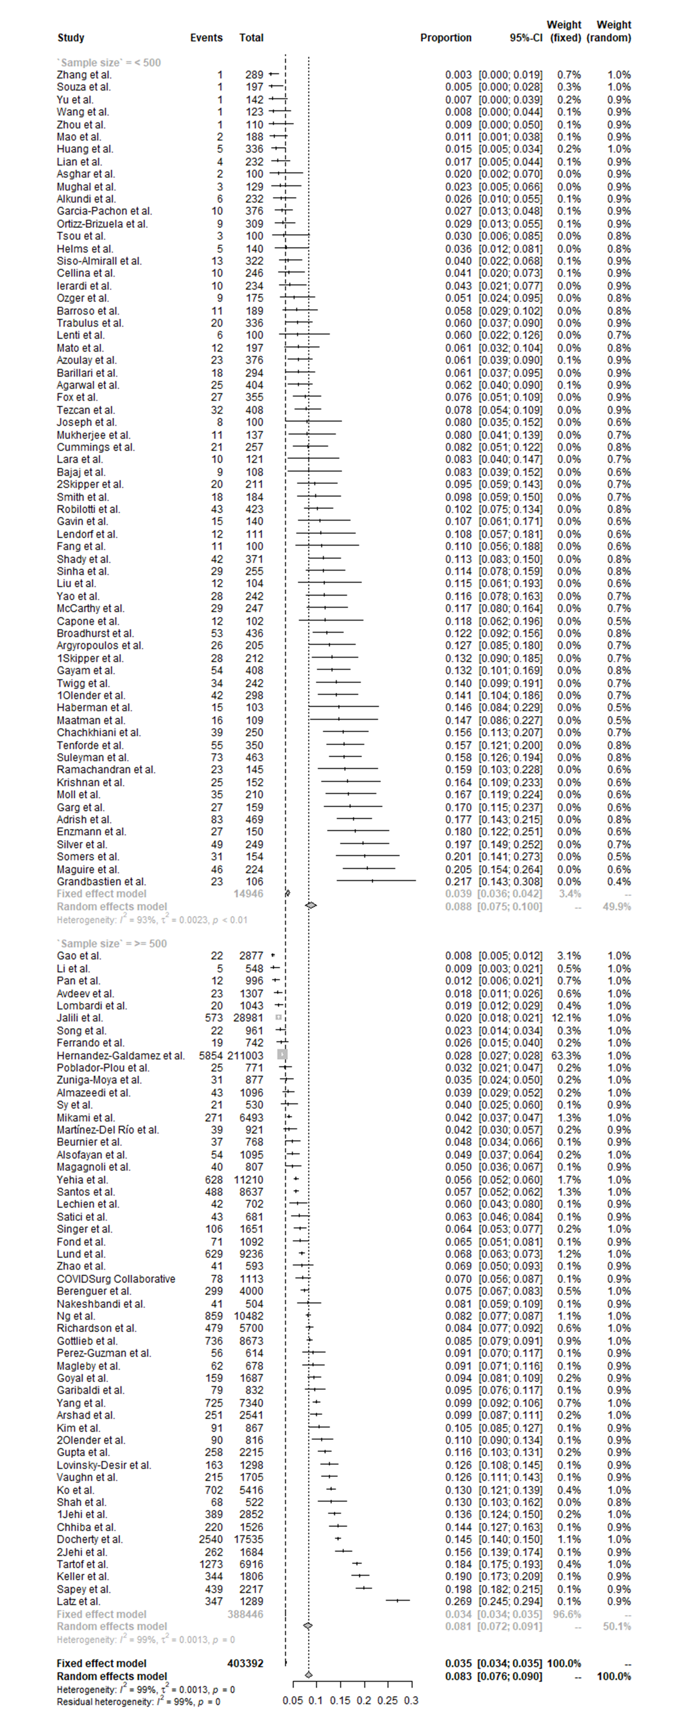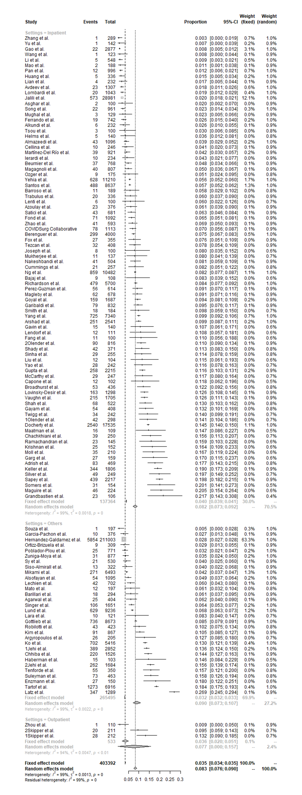

eFigure 1. The pooled prevalence of asthma in patients with COVID-19: subgroup analysis by sample size

eFigure 2. The pooled prevalence of asthma in patients with COVID-19: subgroup analysis by settings

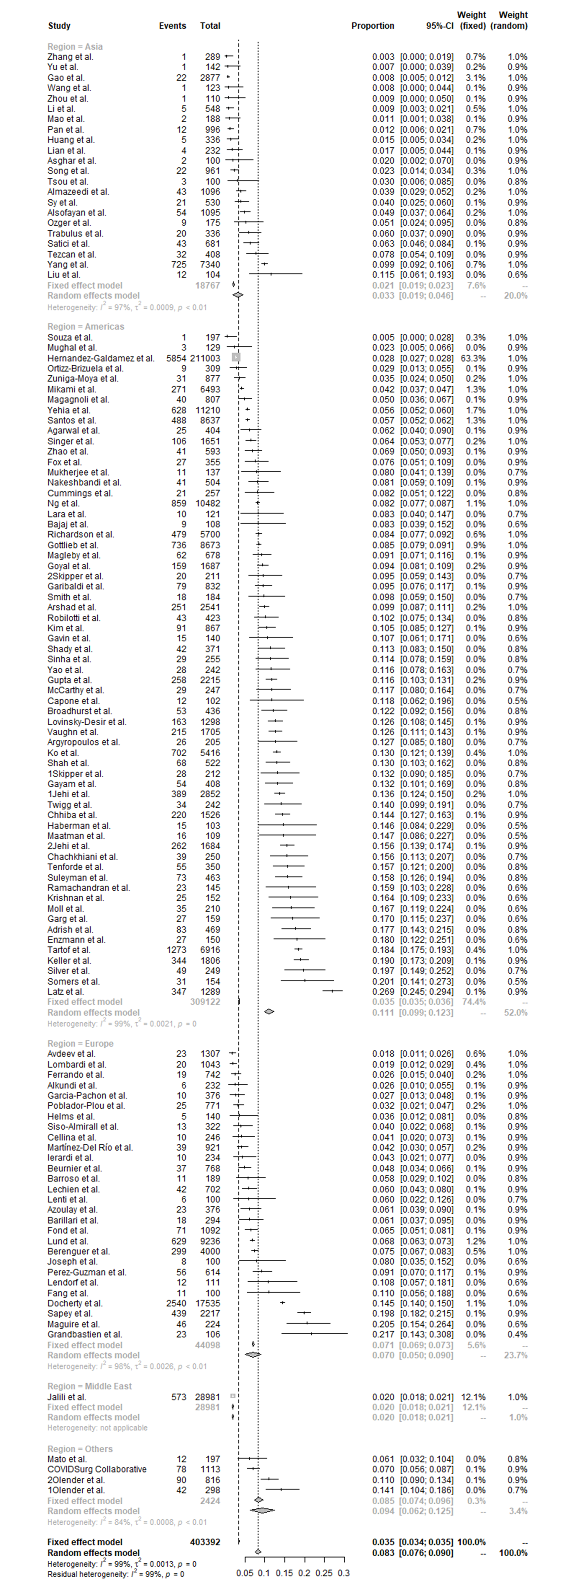

eFigure 3. The pooled prevalence of asthma in patients with COVID-19: subgroup analysis by region
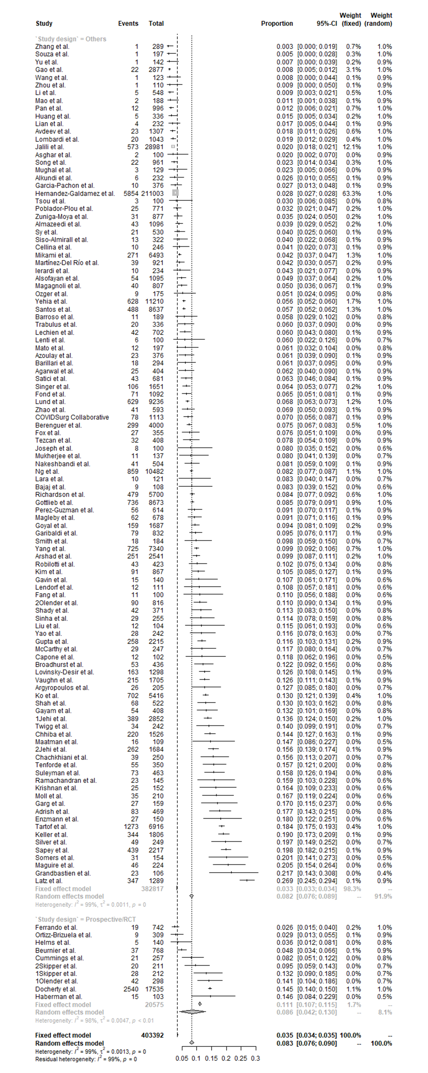

eFigure 4. The pooled prevalence of asthma in patients with COVID-19: subgroup analysis by study design
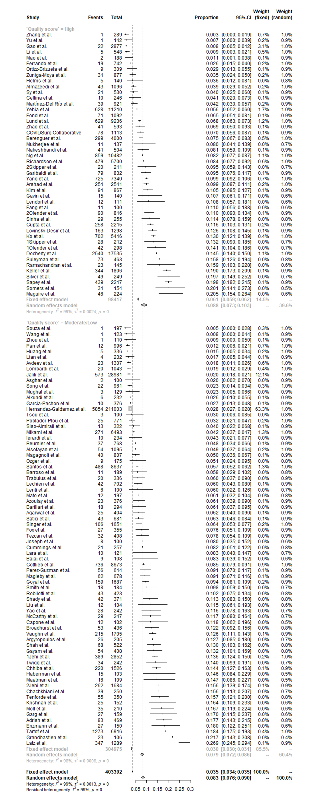

eFigure 5. The pooled prevalence of asthma in patients with COVID-19: subgroup analysis by quality score
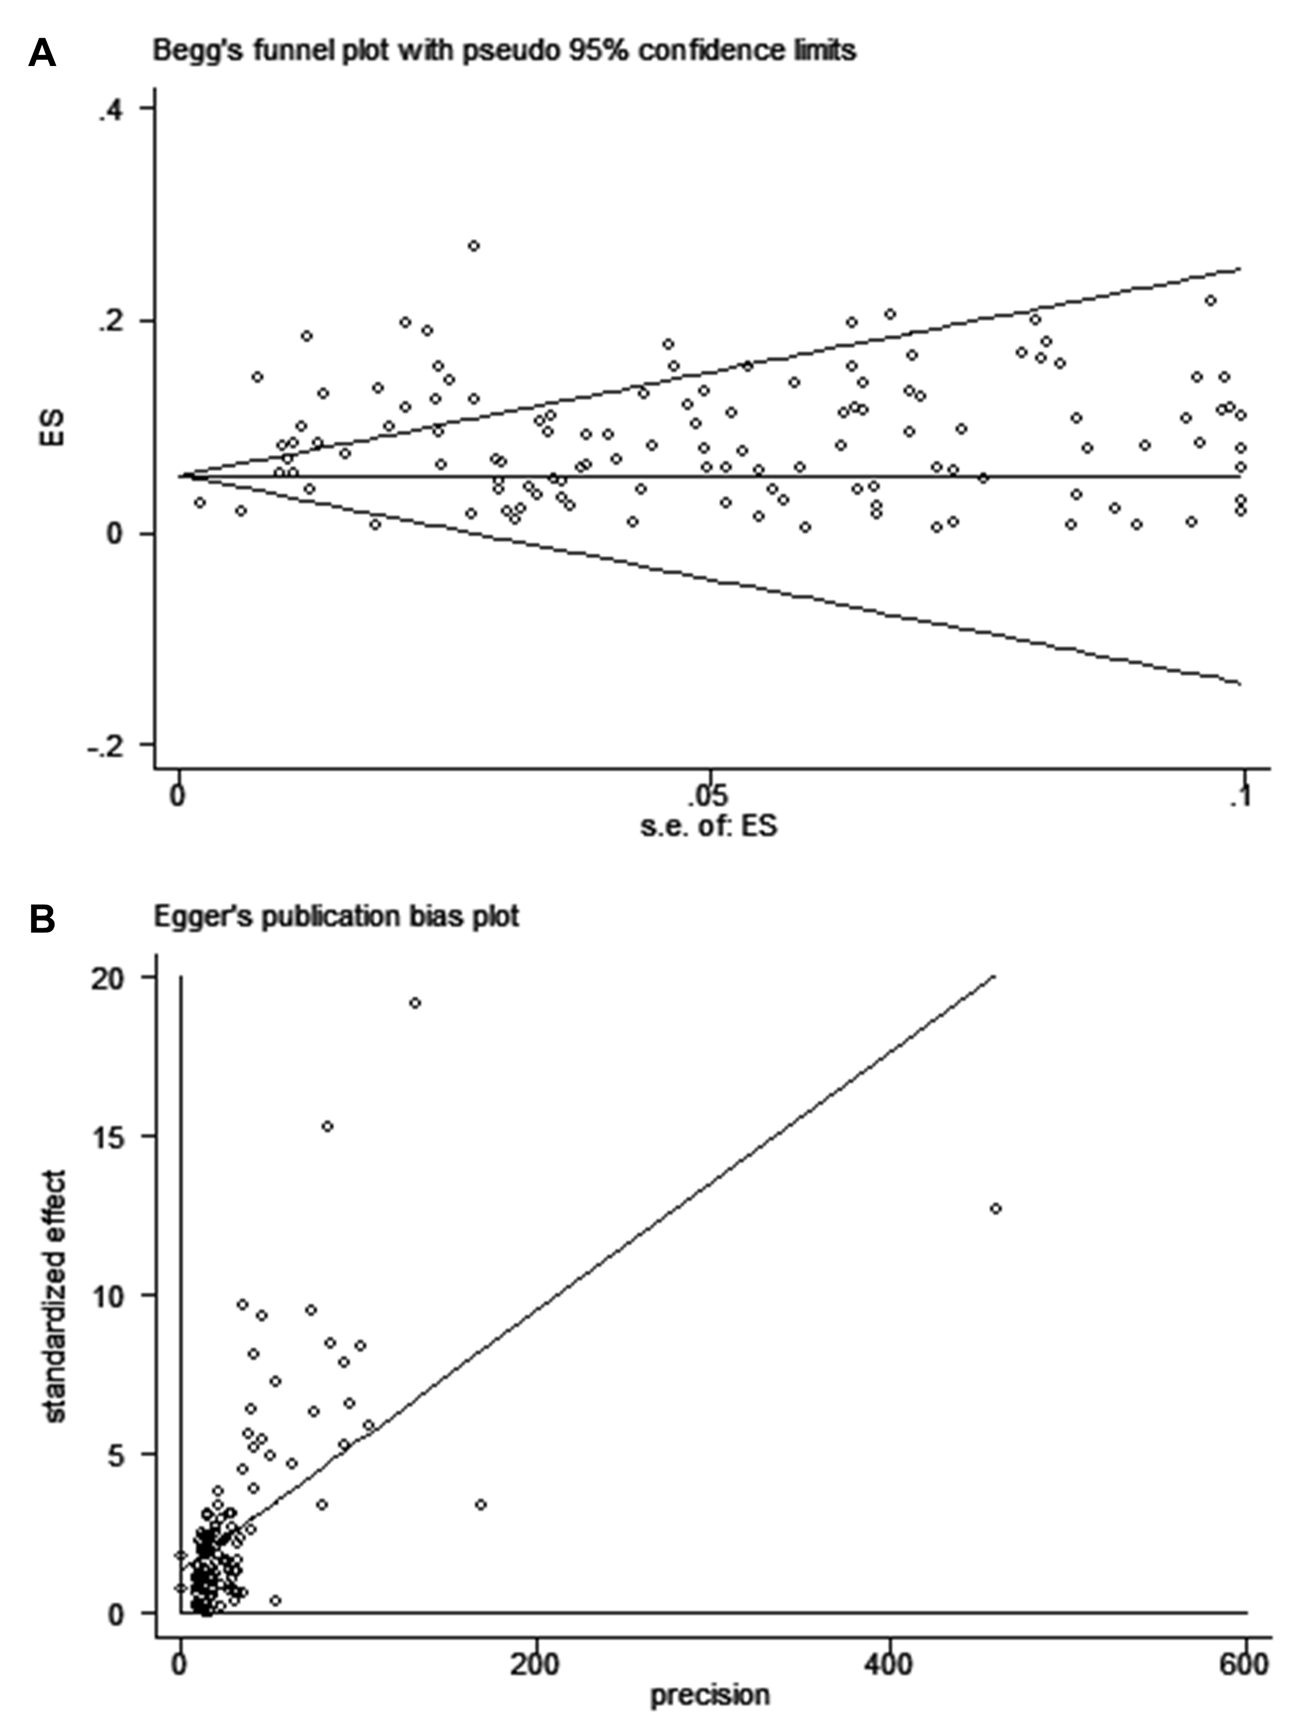

eFigure 6. Begg’s funnel plot and Egger’s test for publication bias

