Supplementary Figures

Meta-analysis, sensitivity analysis and publication bias in this study

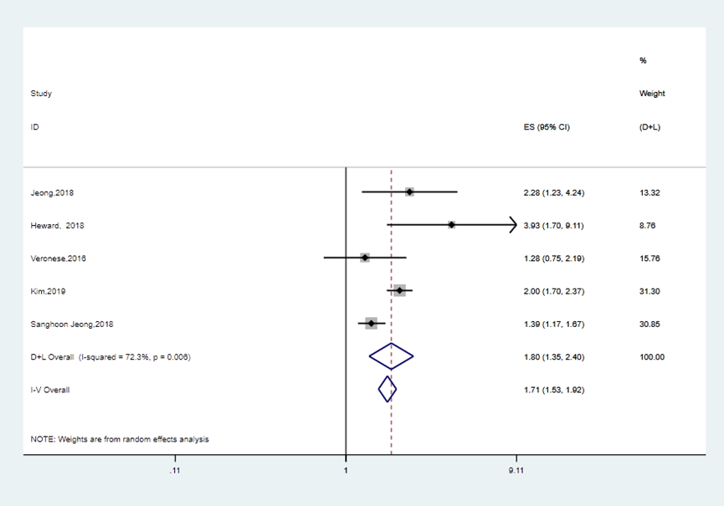
Figure 1a Meta-analysis of the association between grip strength and cognitive decline in all five studies
Pooled HR of overall five studies on the association between grip strength and cognitive decline.

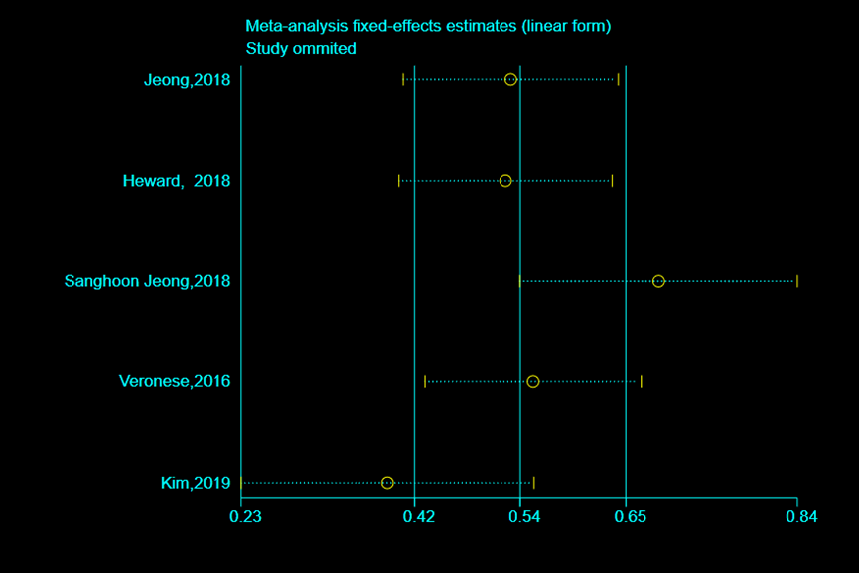
Figure 1b Sensitivity analysis of meta-analysis of the five studies on the association between grip strength and cognitive decline
Sensitivity analysis indicated that the study of Sanghoon et al. might be the source of
heterogeneity.

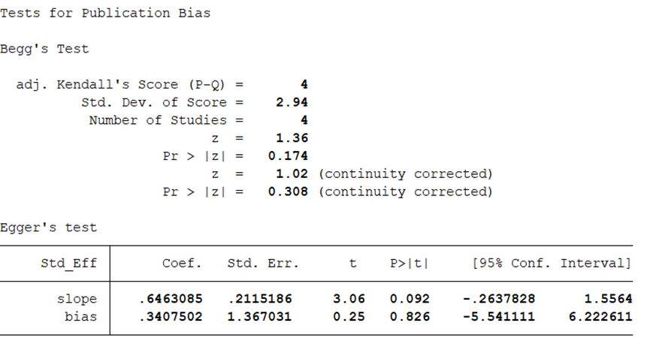Figure 1c Publication bias on the association between grip strength and cognitive decline
There is no publication bias.

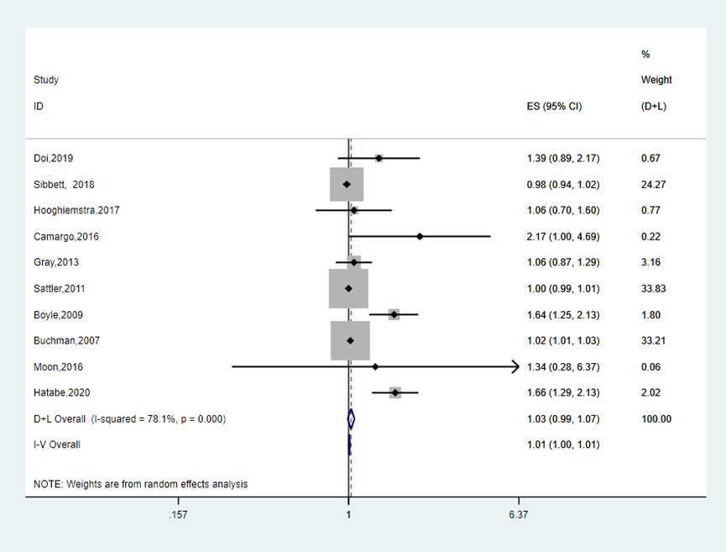
Figure 2a Meta-analysis of the association between grip strength and dementia in all ten studies
Pooled HR of overall ten studies on the association between grip strength and dementia.

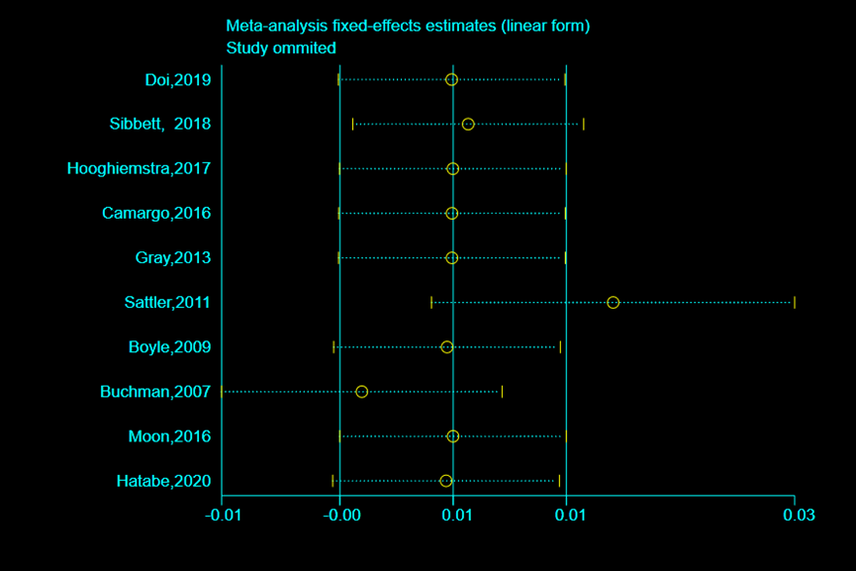
Figure 2b Sensitivity analysis of meta-analysis of the ten studies on the association between grip strength and dementia

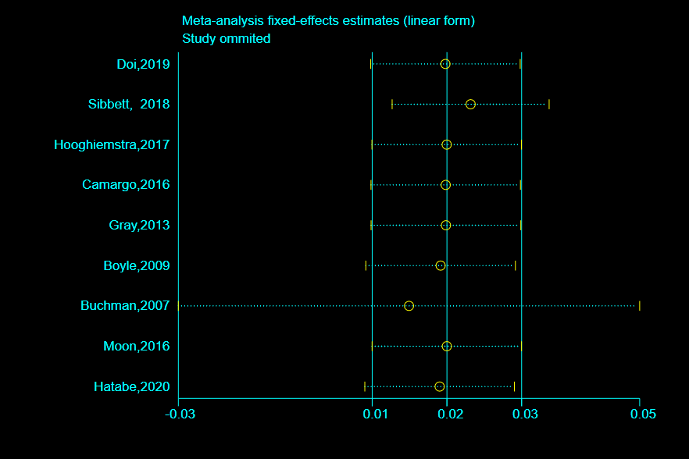
Figure 2c Sensitivity analysis of meta-analysis of the studies on the association between grip strength and dementia after removing one study

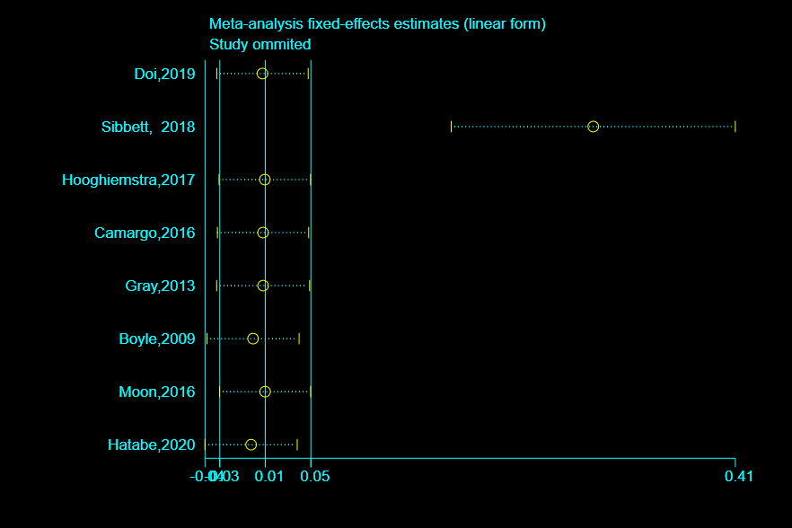
Figure 2d Sensitivity analysis of meta-analysis of the studies on the association between grip strength and dementia after removing two studies

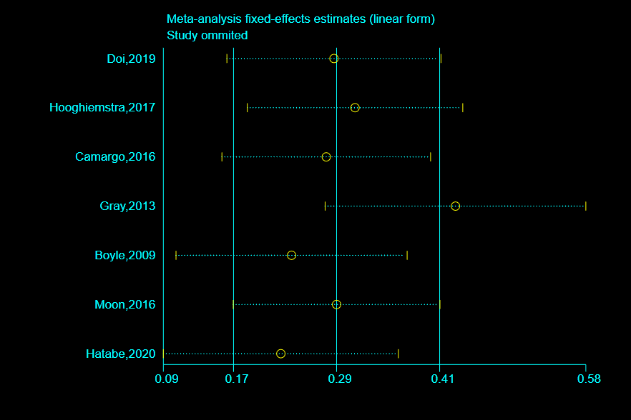
Figure 2e Sensitivity analysis of meta-analysis of the studies on the association between grip strength and dementia after removing three studies

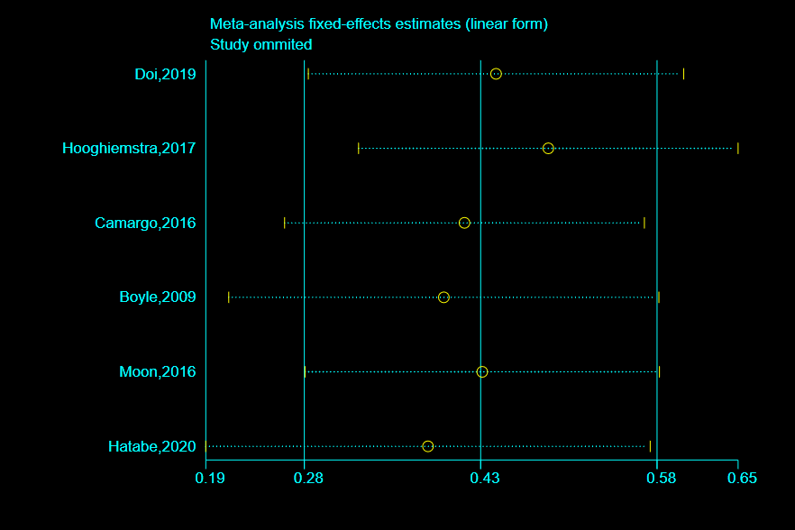
Figure 2f Sensitivity analysis of meta-analysis of the studies on the association between grip strength and dementia after removing four studies

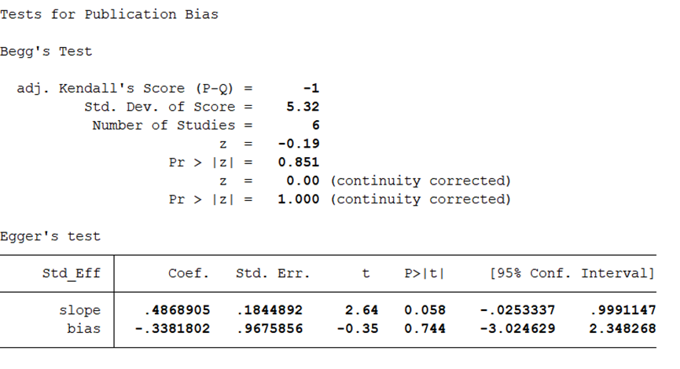Figure 2g Publication bias on the association between grip strength and dementia
There is no publication bias.

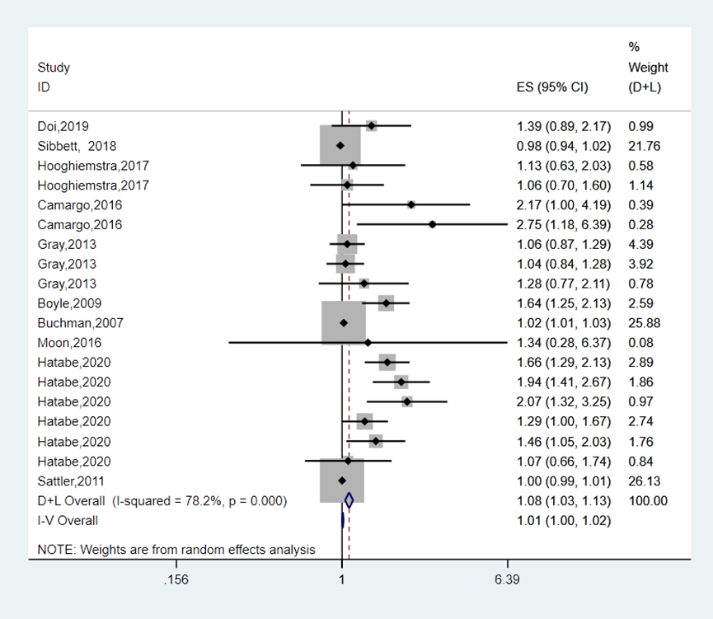
Figure 3 Meta-analysis of the association between grip strength and all outcomes including dementia, AD and non-AD dementia
Pooled HR of the association between grip strength and dementia when extracting all outcomes of each study including dementia, AD and non-AD dementia.

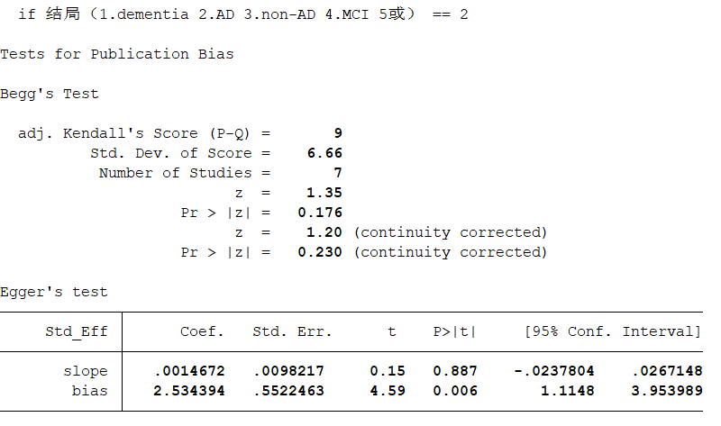
Figure 4a Publication bias on the association between grip strength and AD
Begg's test indicated there is no publication bias.

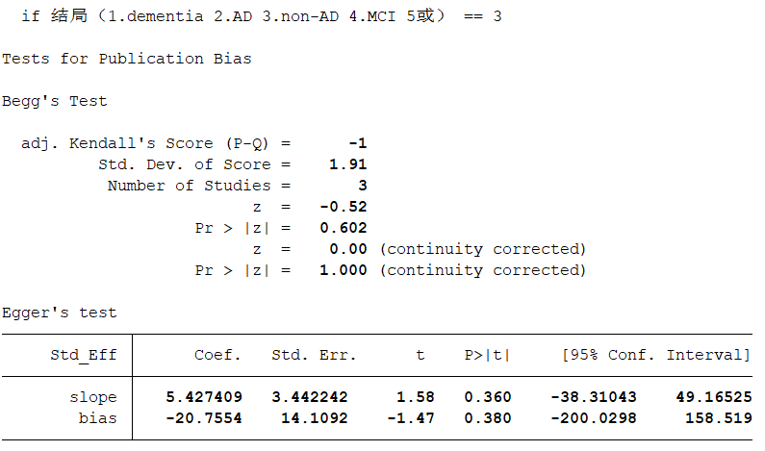

Figure 4b Publication bias on the association between grip strength and non-AD
There is no publication bias.

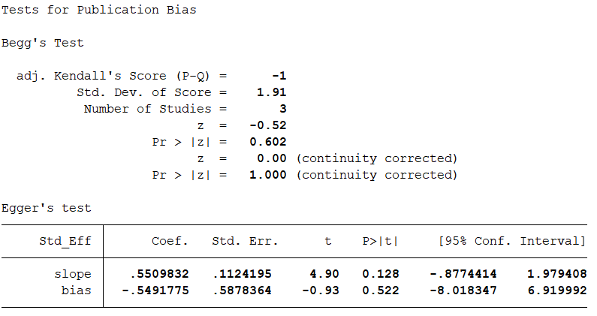
Figure 4c Publication bias on the association between grip strength and dementia if study region is Asia
There is no publication bias.

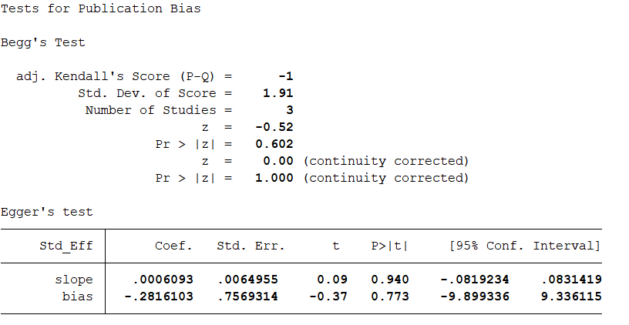
Figure 4d Publication bias on the association between grip strength and dementia if study region is Europe
There is no publication bias.

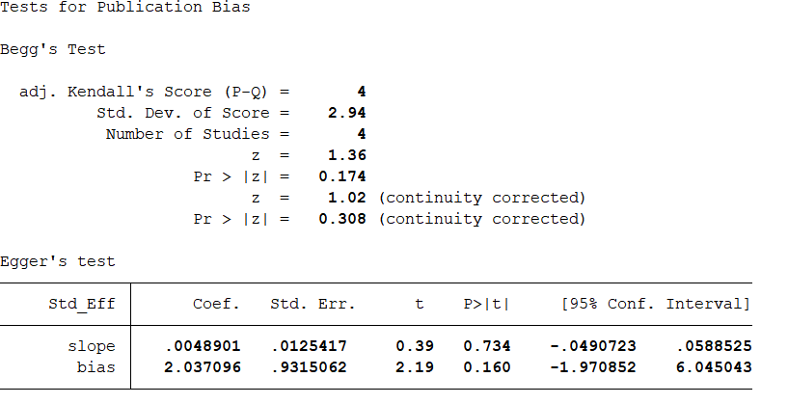Figure 4e Publication bias on the association between grip strength and dementia if study region is North America
There is no publication bias.

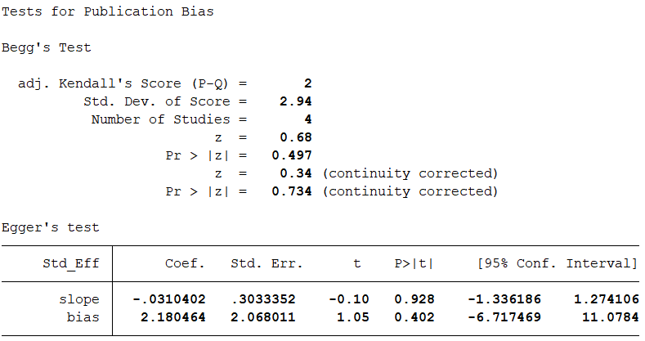
Figure 4f Publication bias on the association between grip strength and dementia if sample size≥1000
There is no publication bias.

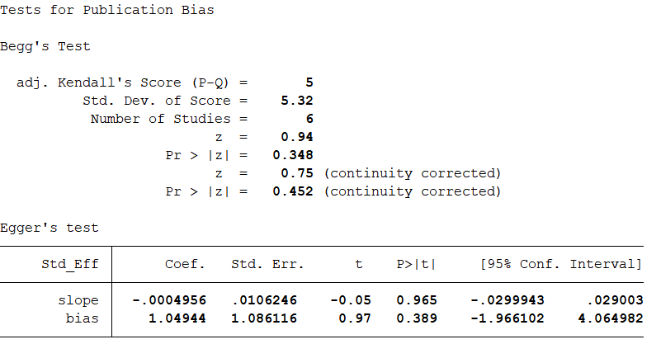
Figure 4g Publication bias on the association between grip strength and dementia if sample size＜1000
There is no publication bias.

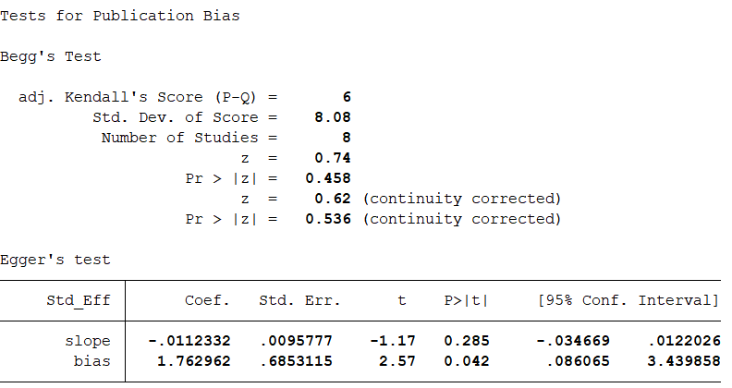
Figure 4h Publication bias on the association between grip strength and dementia if setting is community
Begg’s test showed there is no publication bias.

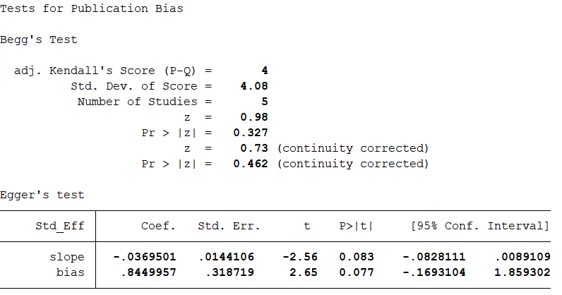
Figure 4i Publication bias on the association between grip strength and dementia if grip strength assessment is dominant hand with handheld dynamometer
There is no publication bias.

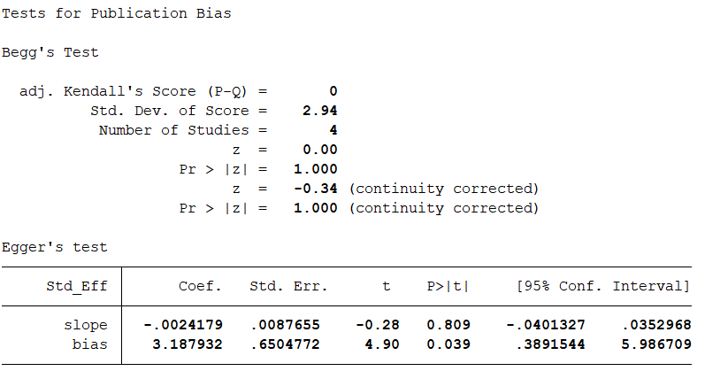
Figure 4j Publication bias on the association between grip strength and dementia if grip strength assessment is both hands with handheld dynamometer
Begg’s test indicated there is no publication bias.

