Table S1
PubMed | (("Meningioma"[majr] OR "Meningioma"[ti] OR "Meningiomas"[ti] OR "Meningiomatosis"[ti] OR "Meningiomatoses"[ti] OR "Meningeal Neoplasms"[majr:noexp] OR "Meningeal Neoplasms"[ti] OR "Meningeal Neoplasm"[ti] OR "Osteomeningioma"[ti]) AND ("Spheno-orbital"[ti] OR "Sphenoorbital"[ti] OR "Sphenoid Wing"[ti] OR "Sphenoid-wing"[ti] OR "Sphenoidal Wing"[ti] OR "Sphenoid Bone"[ti] OR "Sphenoidal Bone"[ti] OR "Sphenoid"[ti] OR "Sphenoid Ridge"[ti] OR "Sphenoidal Ridge"[ti] OR "Sphenoid Sinus"[ti] OR "Sphenoidal Sinus"[ti] OR "Frontotemporosphenoid"[ti] OR "Spheno-ethmoidal-orbital"[ti] OR "Spheno-ethmoidal"[ti] OR "Sphenocavernous"[ti] OR "en-plaque"[ti] OR "en plaque"[ti] OR "carpet"[ti] OR "Sphenoid Bone"[Majr:NoExp]) AND (english[la] OR dutch[la]) AND ("Epidemiologic Studies"[mesh] OR "Case-Control"[tw] OR "Retrospective"[tw] OR "Cohort"[tw] OR "Follow-Up"[tw] OR "Longitudinal "[tw] OR "Prospective"[tw] OR Case-Control*[tw] OR Retrospecti*[tw] OR Cohort*[tw] OR Follow-Up*[tw] OR Longitudinal*[tw] OR Prospecti*[tw]) NOT ("case reports"[ptyp] OR "case report"[ti]) NOT "Clinical Study"[ptyp]))
Embase | ((*"Meningioma"/ OR *"malignant meningioma"/ OR "Meningioma".ti OR "Meningiomas".ti OR "Meningiomatosis".ti OR "Meningiomatoses".ti OR "Meningeal Neoplasms".ti OR "Meningeal Neoplasm".ti OR "Osteomeningioma".ti) AND ("Spheno-orbital".ti OR "Sphenoorbital".ti OR "Sphenoid Wing".ti OR "Sphenoid-wing".ti OR "Sphenoidal Wing".ti OR "Sphenoid Bone".ti OR "Sphenoidal Bone".ti OR "Sphenoid".ti OR "Sphenoid Ridge".ti OR "Sphenoidal Ridge".ti OR "Sphenoid Sinus".ti OR "Sphenoidal Sinus".ti OR "Frontotemporosphenoid".ti OR "Spheno-ethmoidal-orbital".ti OR "Spheno-ethmoidal".ti OR "Sphenocavernous".ti OR "en-plaque".ti OR "en plaque".ti OR "carpet".ti OR *"Sphenoid"/)) NOT (conference review or conference abstract).pt
Web of Science | TI=(("Meningioma" OR "malignant meningioma" OR Meningioma* OR "Meningiomas" OR "Meningiomatosis" OR "Meningiomatoses" OR "Meningeal Neoplasms" OR "Meningeal Neoplasm" OR "Osteomeningioma") AND ("Spheno-orbital" OR "Sphenoorbital" OR "Sphenoid Wing" OR "Sphenoid-wing" OR "Sphenoidal Wing" OR "Sphenoid Bone" OR "Sphenoidal Bone" OR "Sphenoid" OR "Sphenoid Ridge" OR "Sphenoidal Ridge" OR "Sphenoid Sinus" OR "Sphenoidal Sinus" OR "Frontotemporosphenoid" OR "Spheno-ethmoidal-orbital" OR "Spheno-ethmoidal" OR "Sphenocavernous" OR "en-plaque" OR "en plaque" OR "carpet" OR "Sphenoid"))
COCHRANE Library | (("Meningioma" OR "malignant meningioma" OR Meningioma* OR "Meningiomas" OR "Meningiomatosis" OR "Meningiomatoses" OR "Meningeal Neoplasms" OR "Meningeal Neoplasm" OR "Osteomeningioma") AND ("Spheno-orbital" OR "Sphenoorbital" OR "Sphenoid Wing" OR "Sphenoid-wing" OR "Sphenoidal Wing" OR "Sphenoid Bone" OR "Sphenoidal Bone" OR "Sphenoid" OR "Sphenoid Ridge" OR "Sphenoidal Ridge" OR "Sphenoid Sinus" OR "Sphenoidal Sinus" OR "Frontotemporosphenoid" OR "Spheno-ethmoidal-orbital" OR "Spheno-ethmoidal" OR "Sphenocavernous" OR "en-plaque" OR "en plaque" OR "carpet" OR "Sphenoid")):ti,ab,kw
Emcare | ((*"Meningioma"/ OR *"malignant meningioma"/ OR "Meningioma".ti OR "Meningiomas".ti OR "Meningiomatosis".ti OR "Meningiomatoses".ti OR "Meningeal Neoplasms".ti OR "Meningeal Neoplasm".ti OR "Osteomeningioma".ti) AND ("Spheno-orbital".ti OR "Sphenoorbital".ti OR "Sphenoid Wing".ti OR "Sphenoid-wing".ti OR "Sphenoidal Wing".ti OR "Sphenoid Bone".ti OR "Sphenoidal Bone".ti OR "Sphenoid".ti OR "Sphenoid Ridge".ti OR "Sphenoidal Ridge".ti OR "Sphenoid Sinus".ti OR "Sphenoidal Sinus".ti OR "Frontotemporosphenoid".ti OR "Spheno-ethmoidal-orbital".ti OR "Spheno-ethmoidal".ti OR "Sphenocavernous".ti OR "en-plaque".ti OR "en plaque".ti OR "carpet".ti OR *"Sphenoid"/))
PsychINFO | TI(("Meningioma" OR "malignant meningioma" OR Meningioma* OR "Meningiomas" OR "Meningiomatosis" OR "Meningiomatoses" OR "Meningeal Neoplasms" OR "Meningeal Neoplasm" OR "Osteomeningioma") AND ("Spheno-orbital" OR "Sphenoorbital" OR "Sphenoid Wing" OR "Sphenoid-wing" OR "Sphenoidal Wing" OR "Sphenoid Bone" OR "Sphenoidal Bone" OR "Sphenoid" OR "Sphenoid Ridge" OR "Sphenoidal Ridge" OR "Sphenoid Sinus" OR "Sphenoidal Sinus" OR "Frontotemporosphenoid" OR "Spheno-ethmoidal-orbital" OR "Spheno-ethmoidal" OR "Sphenocavernous" OR "en-plaque" OR "en plaque" OR "carpet" OR "Sphenoid"))
Academic Search Premier | TI(("Meningioma" OR "malignant meningioma" OR Meningioma* OR "Meningiomas" OR "Meningiomatosis" OR "Meningiomatoses" OR "Meningeal Neoplasms" OR "Meningeal Neoplasm" OR "Osteomeningioma") AND ("Spheno-orbital" OR "Sphenoorbital" OR "Sphenoid Wing" OR "Sphenoid-wing" OR "Sphenoidal Wing" OR "Sphenoid Bone" OR "Sphenoidal Bone" OR "Sphenoid" OR "Sphenoid Ridge" OR "Sphenoidal Ridge" OR "Sphenoid Sinus" OR "Sphenoidal Sinus" OR "Frontotemporosphenoid" OR "Spheno-ethmoidal-orbital" OR "Spheno-ethmoidal" OR "Sphenocavernous" OR "en-plaque" OR "en plaque" OR "carpet" OR "Sphenoid"))
Science direct | TITLE(("Meningioma" OR "malignant meningioma" OR Meningioma* OR "Meningiomas" OR "Meningiomatosis" OR "Meningiomatoses" OR "Meningeal Neoplasms" OR "Meningeal Neoplasm" OR "Osteomeningioma") AND ("Spheno-orbital" OR "Sphenoorbital" OR "Sphenoid Wing" OR "Sphenoid-wing" OR "Sphenoidal Wing" OR "Sphenoid Bone" OR "Sphenoidal Bone" OR "Sphenoid" OR "Sphenoid Ridge" OR "Sphenoidal Ridge" OR "Sphenoid Sinus" OR "Sphenoidal Sinus" OR "Frontotemporosphenoid" OR "Spheno-ethmoidal-orbital" OR "Spheno-ethmoidal" OR "Sphenocavernous" OR "en-plaque" OR "en plaque" OR "carpet" OR "Sphenoid"))

Table S2
Combined surgical approaches | - Pterional  - Frontotemporal/pterional  - Fronto-lateral  - Pterional extended  - Frontotemporal + orbitozygomatic  - Frontotemporal orbital  - Zygomatic temporal/fronto-orbital  - Supraorbital-pterional  - Transzygomatic  - Lateral orbitotomy  - Lateral obitotomy  - Lateral transorbital  Endoscopic/transnasal
Combined presenting symptoms | - VA: visual acuity, reduced vision, CN II palsy  - CN V palsy: CN V palsy, hypesthesia CN V, trigeminal impairment  - VF: visual field, inferior arcuate field loss, constricted field with an enlarged scotoma  - Frontal/temporal/orbital swelling: fronto/supraorbital swelling, supraorbital swelling, periorbital/temporal swelling, temporal region swelling, periorbital swelling  - Neurologic: mental change, amentia, memory, concentration, seizures (if not mentioned separately), slow mentation, aphasia  - Nausea: nausea, vomit  - CN VII: CN VII palsy, facial weakness  - Ophthalmoplegia: ophthalmoparesis, ocular paresis, CN III deficit/palsy, CN IV deficit/palsy, CN VI deficit/palsy
Combined reconstruction materials | - (Poly)methylmethacrylate: polymethylmethacrylate cranioplasty, methylmethacrylate, cranioplasty, PEEK cranioplasty  - Split cranial bone: split cranial bone graft, replacing healthy flap, internal cortical bone from the healthy flap  - Prothesis: nonmetallic orbital prothesis of porous high-density polyethylene, porex orbital prothesis  - Fascial graft: fascial graft, fascia lata

Table S3
Potential source of bias | Explanation | Points
Patient population |  | 3
Study period | Period of recruitment is adequately described | 1
Consecutive inclusion | Patients should be consecutively included | 1
Base-line characteristics | Key characteristics mentioned: age, gender, visual parameters | 1
Intervention |  | 2
Description of surgical approach | Intervention clearly stated, including the percentage patients operated using each described approach | 2
Outcome measurement |  | 3
Correct percentages reported* | The fraction of patients with certain outcomes should be clearly reported | 1
Pre- and postintervention comparison | Postoperative outcomes are compared with preoperative measures | 2
Follow-up | Lost to follow-up is described and is less than 10% | 1
 |  | Total 9
* It should be clear what study population is concerned (whole/part)

Table S4
 |  | Patient population  (3) | Intervention  (2) | Outcome measurement (3) | Follow-up  (1) | Total points | Risk of Bias
Bonnal | 1980 | 2 | 2 | 3 | 0 | 7 | Low
Maroon | 1994 | 3 | 2 | 3 | 0 | 8 | Low
Gaillard | 1996 | 1 | 0 | 3 | 0 | 4 | High
Honeybul | 2001 | 2 | 2 | 3 | 0 | 7 | Low
De Jesus | 2001 | 3 | 2 | 0 | 0 | 5 | High
Shrivastava | 2005 | 3 | 0 | 3 | 0 | 6 | High
Sandalcioglu | 2005 | 2 | 2 | 3 | 1 | 8 | Low
Leake | 2005 | 2 | 0 | 3 | 0 | 5 | High
Roser | 2005 | 2 | 2 | 3 | 0 | 7 | Low
Schick | 2006 | 2 | 2 | 3 | 0 | 7 | Low
Ringel | 2007 | 3 | 2 | 3 | 1 | 9 | Low
Bikmaz | 2007 | 3 | 0 | 3 | 0 | 6 | High
Mariniello | 2008 | 2 | 2 | 0 | 0 | 4 | High
Cannon | 2009 | 2 | 2 | 3 | 1 | 8 | Low
Heufelder | 2009 | 3 | 0 | 3 | 0 | 6 | High
Mirone | 2009 | 3 | 2 | 3 | 0 | 8 | Low
Scarone | 2009 | 2 | 2 | 3 | 0 | 7 | Low
Li | 2009 | 2 | 2 | 3 | 0 | 7 | Low
Saeed | 2011 | 2 | 2 | 2 | 0 | 6 | High
Oya | 2011 | 3 | 0 | 3 | 0 | 6 | High
Nochez | 2012 | 3 | 0 | 3 | 0 | 6 | High
Marcus | 2013 | 3 | 2 | 3 | 0 | 8 | Low
Simas | 2013 | 3 | 2 | 3 | 1 | 9 | Low
Mariniello | 2013 | 1 | 2 | 3 | 0 | 6 | High
Boari | 2013 | 3 | 2 | 3 | 1 | 9 | Low
Talacchi | 2014 | 3 | 2 | 3 | 0 | 8 | Low
Forster | 2014 | 3 | 2 | 3 | 0 | 8 | Low
Solmaz | 2014 | 2 | 0 | 3 | 0 | 5 | High
Amirjamshidi | 2015 | 3 | 0 | 3 | 0 | 6 | High
Leroy | 2016 | 2 | 2 | 3 | 0 | 7 | Low
Jiranukool | 2016 | 2 | 2 | 3 | 0 | 7 | Low
Honig | 2017 | 3 | 0 | 3 | 0 | 6 | High
Freeman | 2017 | 3 | 2 | 3 | 1 | 9 | Low
Belinsky | 2017 | 3 | 2 | 3 | 0 | 8 | Low
Peron | 2017 | 2 | 2 | 3 | 0 | 7 | Low
Gonen | 2018 | 3 | 2 | 3 | 1 | 9 | Low
Terrier | 2018 | 3 | 2 | 3 | 1 | 9 | Low
Nagahana | 2019 | 2 | 2 | 3 | 0 | 7 | Low

Table S5
_____________________________________________________________________________
Year published | No of articles included* | Pterional | Pterional extended | Lateral orbitotomy | Endoscopic/ transnasal
1980 | 1 | •₁
1994 | 1 | •₁
1996 | 1 | •₁
2001 | 2 | •₁ | •₁
2005 | 4 | •₂ | •₃
2006 | 1 | •₁
2007 | 2 | •₂
2008 | 1 | •₁ | •₁ | •₁
2009 | 5 | •₅ | •₁
2011 | 2 | •₂ | •₁ | •₁
2012 | 1 | •₁
2013 | 4 | •₄ | •₂ | •₁
2014 | 3 | •₃ | •₁ |  | •₁
2015 | 1 |  | •₁
2016 | 2 | •₂ |  |  | •₁
2017 | 3 | •₃ | •₁ | •₁ | •₁
2018 | 2 | •₂
2019 | 1 | •₁
* Noted per year, it is possible one year contains several articles

Table S6
A. Decompression/resection orbit
Year published | N articles included | Lateral orbital wall | Orbital roof | Orbital walls | Lateral orbital rim | Upper orbital rim | Superior orbital wall | Orbital apex | Posterior orbital wall | Medial orbital wall | Orbital rim
1980 | 1 |  | • | •
1994 | 1 |  | •
1996 | 1
2001 | 2 | •₁ |  | •₁ |  |  | •₁
2005 | 4 | •₁ |  |  | •₂ | •₁
2006 | 1 | •₁
2007 | 2 | •₂ | •₁ |  |  |  | •₁
2008 | 1 | •₁
2009 | 5 | •₄ | •₄ | •₁ | •₁ | •₁ |  | •₁
2011 | 2 | •₁ | •₂
2012 | 1
2013 | 4 | •₂ | •₁
2014 | 3 | •₃ | •₃ |  |  |  |  |  | •₁
2015 | 1 |  | •₁ | •₁ |  |  |  |  |  |  | •₁
2016 | 2 | •₁ | •₁ |  |  |  |  |  |  | •₁
2017 | 4 | •₂ | •₁ |  | •₁ | •₁
2018 | 2 | •₁ | •₂ | •₁
2019 | 1 | •₁ |  |  |  |  | •₁ |  |  |  | •₁

 | B. Decompression/resection of sphenoid bone
Year published |  | N articles included | Optic canal | SOF | ACP | Foramen Rotundum | Greater Sphenoid wing | Foramen Ovale | Foramen Spinosum | Temporal Bone | Zygomatic arch | Optic Foramen | Maxillary strut | Extra conal Lesions | Pterygoid process
1980 |  | 1 |  | •₁ | •₁ | •₁ | •₁ | •₁ |  |  |  | •₁
1994 |  | 1 | •₁ | •₁ | •₁ | •₁ | •₁ | •₁
1996 |  | 1 | •₁ | •₁ |  | •₁ |  | •₁ | •₁
2001 |  | 2 |  |  | •₁ | •₁ | •₁ | •₁ |  | •₁
2005 |  | 4 | •₁ | •₁ | •₁ |  | •₂
2006 |  | 1 | •₁ | •₁ | •₁ | •₁
2007 |  | 2 | •₂ | •₂ | •₂ | •₁ | •₁ | •₁ | •₁ |  |  | •₁ | •₁
2008 |  | 1 | •₁ | •₁ | •₁
2009 |  | 5 | •₅ | •₅ | •₃ | •₂ | •₁ | •₁ | •₁ | •₁ | •₁
2011 |  | 2 | •₂ | •₂ | •₂ | •₁ | •₁ | •₁ |  | •₁
2012 |  | 1
2013 |  | 4 | •₄ | •₂ | •₂
2014 |  | 3 | •₃ | •₃ | •₁ | •₁ |  |  |  |  | •₁ | •₁
2015 |  | 1 | •₁ |  | •₁ |  | •₁ |  |  | •₁ |  | •₁
2016 |  | 2 | •₂ | •₁ |  | •₁ | •₁ | •₁ |  |  |  |  |  | •₁
2017 |  | 4 | •₃ | •₂ | •₁
2018 |  | 2 | •₂ | •₁ | •₂ | •₁ |  | •₁ | •₁ | •₁
2019 |  | 1 | •₁ | •₁ | •₁ | •₁ | •₁ | •₁ |  |  |  |  |  |  | •₁

A. Decompression/resection orbit; B. Decompression/resection of sphenoid bone
* Noted per year, it is possible one year contains several articles.
The numbers given next to the bullets, represent the number of articles using this reconstruction material in this year.

Table S7
A. Dural defect reconstruction*
Year published | N articles included | Abdominal fat ⁺ | Pericranium | Lyophilized dura or galea | Epicranium | Fascial graft | Autologues galea | Cadaveric dura mater | Artificial dura | Dura-Gen graft
1980 | 1 | •¹
1994 | 1 |  | •¹ | •¹
1996 | 1 |  |  |  | •¹
2001 | 2 |  | •₁
2005 | 4 | •₂ | •₁ |  |  | •₂ | •₁
2006 | 1 |  |  | •¹
2007 | 2 | •₁ |  |  |  | •₁ | •₁ | •₁
2008 | 1
2009 | 5 |  | •₁ |  |  | •₁ |  |  | •₁
2010 | 1 |  |  |  |  |  |  |  | •₁
2011 | 2 | •₁ |  |  |  |  | •₁ |  |  | •₁
2012 | 1
2013 | 4
2014 | 3 |  |  | •₁ |  | •₁ |  |  |  | •₁
2015 | 1 | •₁ | •₁ |  |  | •₁
2016 | 2
2017 | 4 | •₁
2018 | 2 | •₁ | •₁ |  |  |  |  |  |  | •₁
2019 | 1 | •₁ |  |  |  | •₁

 | B. Bony defect reconstruction*
Year published |  | N articles included | Split Cranial Bone graft + Internal Cortical bone from healthy flap + Replacing healthy flap | Iliac crest bone graft | Coral Graft | Inner calvarial table grafts | Cranioplasty + PMM + MMA | Titanium Mesh | Nonmetallic orbital prothesis of porous high-density polyethylene + Porex Orbital Prothesis | Autogenic latissimus dorsi implant | Temporal muscle
1980 |  | 1
1994 |  | 1
1996 |  | 1 | •₁ | •₁ | •₁
2001 |  | 2 |  |  |  | •₁ | •₁
2005 |  | 4 | •₁ |  |  | •₃ | •₁ | •₂ | •₁ |  | •₁
2006 |  | 1 | •₁ |  |  |  | •₁
2007 |  | 2 |  |  |  | •₁ | •₁ | •₁
2008 |  | 1
2009 |  | 5 |  | •₁ |  | •₁ | •₂ | •₂ |  |  | •₁
2010 |  | 1
2011 |  | 2 |  |  |  | •₁ |  | •₁
2012 |  | 1
2013 |  | 4 |  |  |  |  | •₁ | •₃
2014 |  | 3 | •₁ |  |  |  | •₁ | •₁ | •₁
2015 |  | 1 | •₁
2016 |  | 2 |  | •₁
2017 |  | 4 |  |  |  | •₁ |  | •₁ |  | •₁ | •₁
2018 |  | 2 | •₁ |  |  | •₂ | •₁ | •₂
2019 |  | 1 |  |  |  | •₁
A. Dural defect reconstruction materials; B. Bony defect reconstruction materials
* Noted per year, it is possible one year contains several articles.
⁺Abdominal fat is not used for dural defects, but to fill up empty spaces
The numbers given next to the bullets, represent the number of articles using this reconstruction material in this year.

Table S8
Year published | No of articles included | Resected | Maintained | Opened
1980 | 1
1994 | 1 | •₁
1996 | 1
2001 | 2 | •₁ | •₁
2005 | 4 | •₁ |  | •₁
2006 | 1 |  |  | •₁
2007 | 2 | •₂
2008 | 1 | •₁
2009 | 5 | •₃ |  | •₂
2011 | 2 | •₁ | •₁
2012 | 1 | •₁
2013 | 4 | •₃ |  | •₁
2014 | 3 |  |  | •₃
2015 | 1 | •₁
2016 | 2 |  |  | •₁
2017 | 4 | •₂
2018 | 2 | •₂ |  | •₂
2019 | 1 | •₁
* Noted per year, it is possible one year contains several articles.

Figure S1

Figure S2
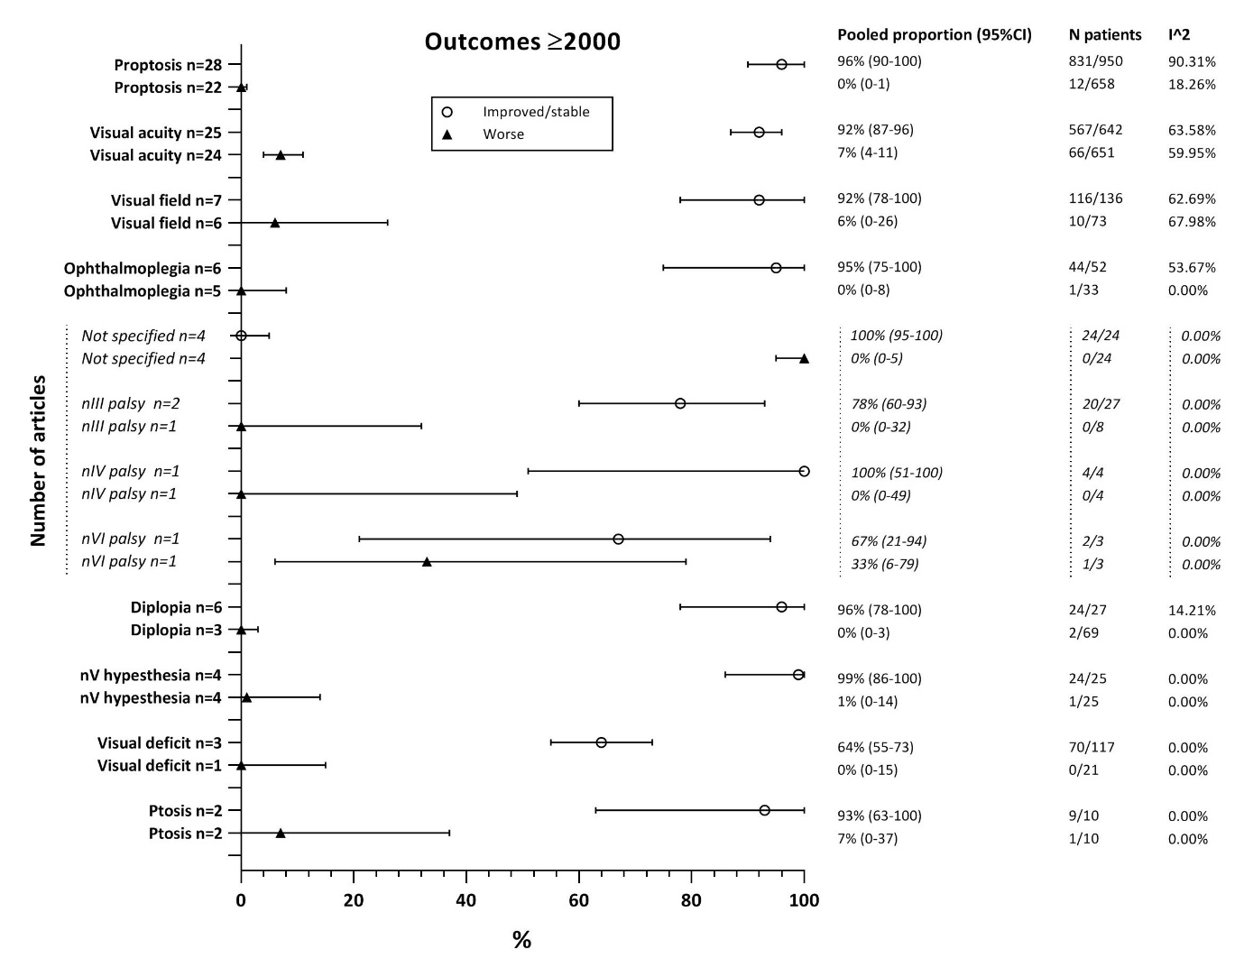

Figure S3
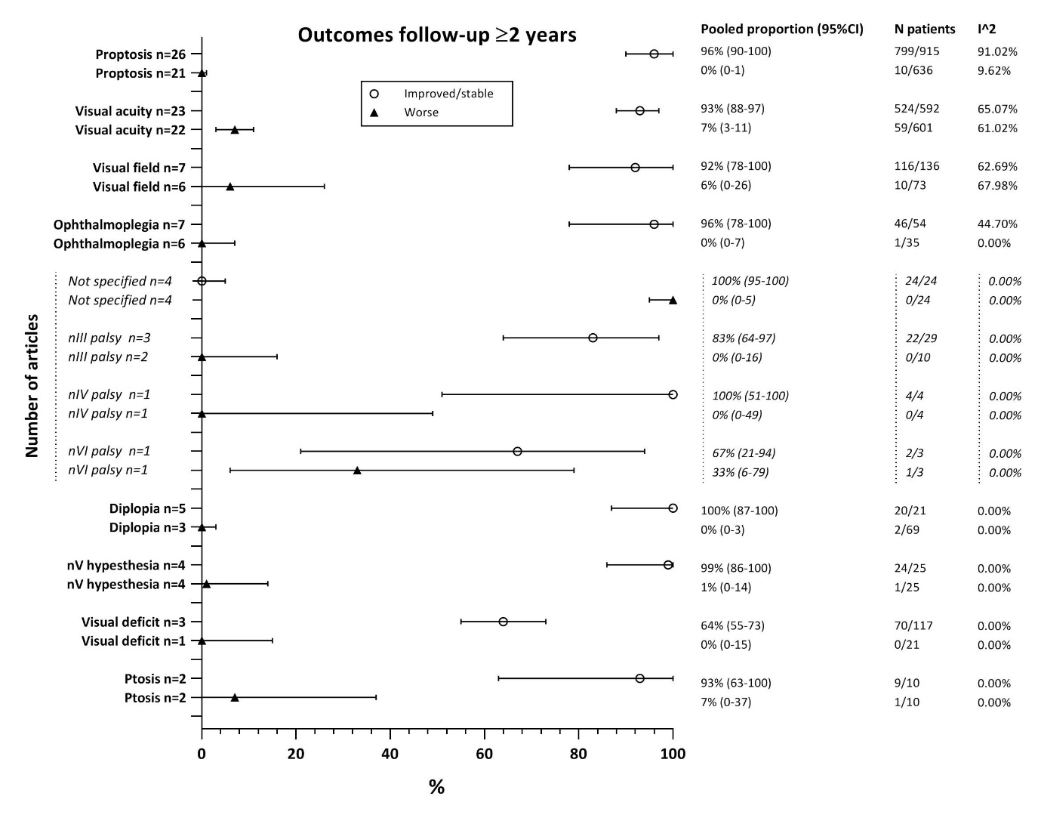

Figure S4

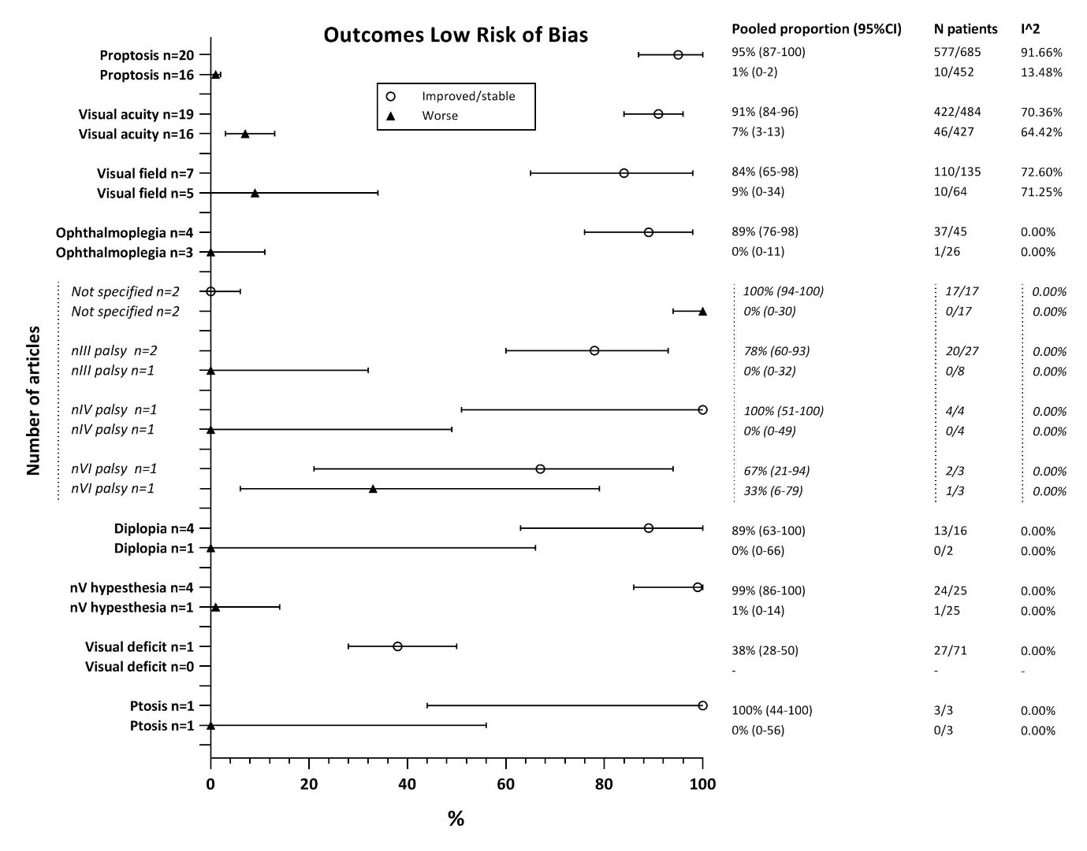

Figure S5

Table S9

Comparison complete and subgroup analysis common symptoms
Outcomes | Complete analysis | Subgroup analysis
Ophthalmoplegia | 96% (78-100%) | 93% (69-100%)
Not specified | 100% (94-100%) | 100% (94-100%)
CN III palsy | 83% (64-97%) | 83% (64-97%)
CN IV palsy | 100% (51-100%) | 100% (51-100%)
CN VI palsy | 67% (21-94%) | 67% (21-94%)
CN V hypesthesia | 100% (74-100%) | 100% (70-100%)
Diplopia | 96% (78-100%) | 100% (85-100%)
Proptosis | 96% (90-100%) | 96% (87-100%)
VA deficits | 91% (86-96%) | 90% (85-95%)
VF deficits | 87% (70-99%) | 84% (60-99%)
Complications | Complete analysis | Subgroup analysis
Ophthalmoplegia | 16% (10-24%) | 20% (13-29%)
Not specified | 13% (8-19%) | 14% (7-23%)
CN III palsy | 11% (6-17%) | 13% (8-19%)
CN IV palsy | 2% (1-4%) | 2% (1-4%)
CN VI palsy | 6% (10-24%) | 6% (1-13%)
Diplopia | 17% (5-33%) | 20% (6-38%)
Ptosis | 17% (10-26%) | 17% (8-28%)
CN V hypesthesia | 19% (10-30%) | 15% (8-24%)
VA deficits | 9% (2-18%) | 10% (1-23%)
VF deficits | 4% (1-8%) | 4% (1-8%)

