Supplementary Figure 1

Sensitivity analysis of case-control studies assessing the association between cholesterol consumption and risk of gastric cancer in adults. CI, confidence interval

Supplementary Figure 2
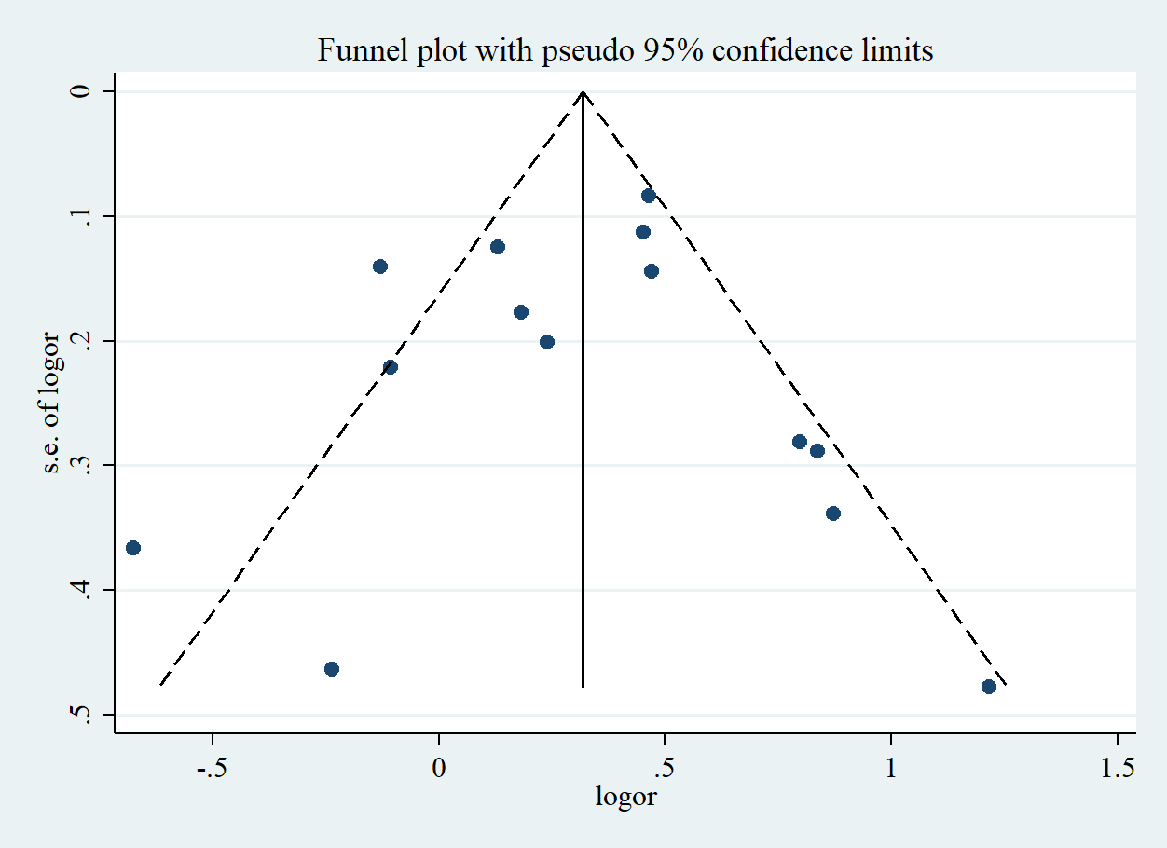
Funnel plot of the risk estimates of fourteen studies on the association between cholesterol consumption and risk of gastric cancer in adults. Each dot represents one study. Egger’s test P=0.83. Log RR: natural logarithm of relative risk. CI, confidence interval; SE, standard error.

Supplementary Figure 3
Sensitivity analysis of case-control studies assessing the association between 100 mg/d increment in cholesterol consumption and risk of gastric cancer in adults. CI, confidence interval

Supplementary Figure 4
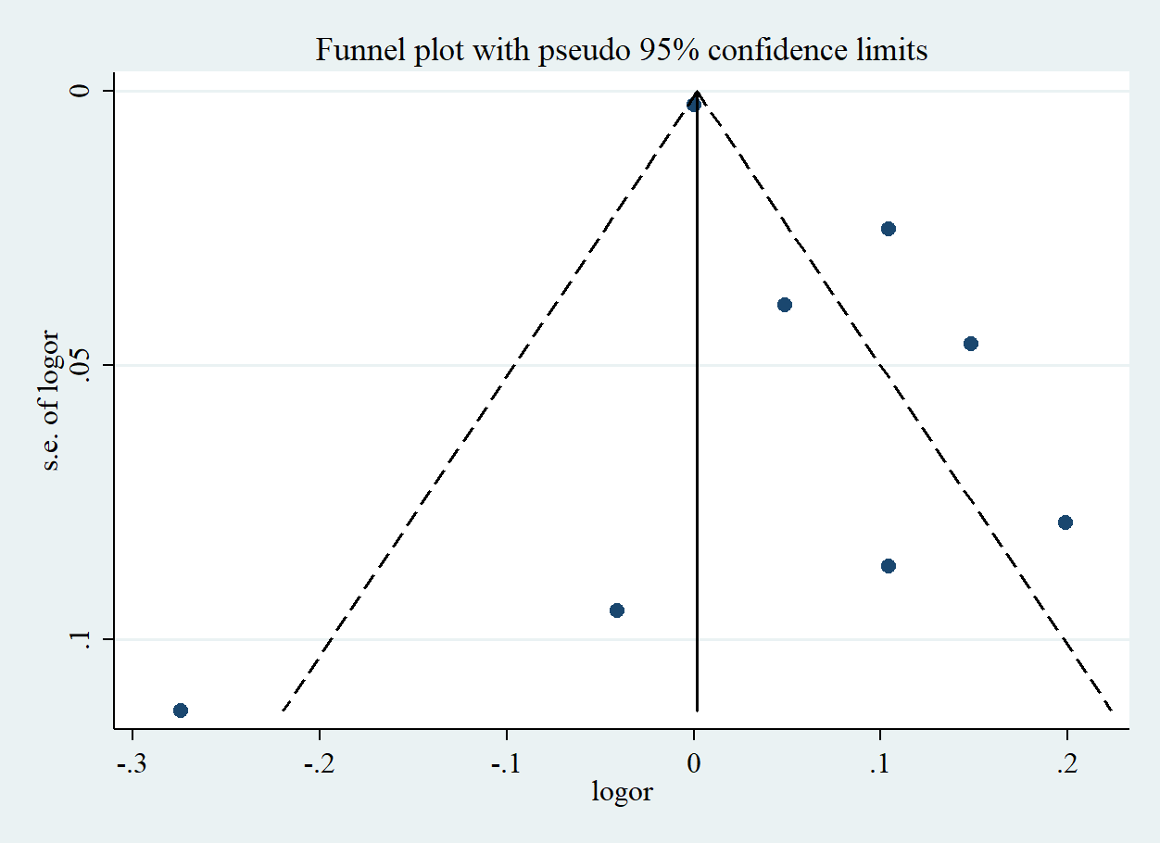

Funnel plot of the risk estimates of eight studies on the association between 100 mg/d increment in cholesterol consumption and risk of gastric cancer in adults. Each dot represents one study. Egger’s test P=0.18. Log RR: natural logarithm of relative risk. CI, confidence interval; SE, standard error.

