Effect of Exercise Training on Serum Transaminases in Patients with Nonalcoholic Fatty Liver Disease: A Systematic Review and Meta-Analysis
Feng Hong^{1#}, Yubo Liu^{2,3#}, Veeranjaneya Reddy Lebaka⁴, Arifullah Mohammed⁵, Weibing Ye², Biqing Chen^{1*} and Mallikarjuna Korivi^{2*}

Supplementary data

Supplementary Table 1S. Search strategy to identify the relevant articles on PubMed.

PubMed: | ((((((((((Non-alcoholic Fatty Liver Disease[Title/Abstract]) OR (Non alcoholic Fatty Liver Disease[Title/Abstract])) OR (NAFLD[Title/Abstract])) OR (Nonalcoholic Fatty Liver Disease[Title/Abstract])) OR (Fatty Liver*, Nonalcoholic[Title/Abstract])) OR (Liver*, Nonalcoholic Fatty[Title/Abstract])) OR (Nonalcoholic Fatty Liver*[Title/Abstract])) OR (Nonalcoholic Steatohepatitis*[Title/Abstract])) OR (Steatohepatitis*, Nonalcoholic[Title/Abstract])) AND (((((((((((((((Exercise[Title/Abstract]) ) OR (Exercise*[Title/Abstract])) OR (Physical Activity*[Title/Abstract])) OR (Activity*, Physical[Title/Abstract])) OR (Exercise*, Physical[Title/Abstract])) OR (Physical Exercise*[Title/Abstract])) OR (Acute Exercise*[Title/Abstract])) OR (Exercise*, Acute[Title/Abstract])) OR (Exercise*, Isometric[Title/Abstract])) OR (Isometric Exercise*[Title/Abstract])) OR (Exercise*, Aerobic[Title/Abstract])) OR (Aerobic Exercise*[Title/Abstract])) OR (Exercise Training*[Title/Abstract])) OR (Training*, Exercise[Title/Abstract]))) AND ((((Randomized controlled trial[Title/Abstract]) OR (Randomized[Title/Abstract])) OR (RCT[Title/Abstract])) OR (RCTs[Title/Abstract]))

We have followed the above search strategy to find the relevant articles from the PubMed database.
Search Results:
- We found a total of 209 studies that matches to the given keywords.
- After screening and reviewing the full-text articles, 8 studies were included.
List of records included in the systematic review and meta-analysis:
- Abdelbasset et.al 2019
- Cheng et al. 2017
- Dong et.al 2016
- Rezende et.al 2016
- Shojaee-Moradie et al. 2016
- Pugh et.al 2013
- Pugh et.al 2014
- Sullivan et.al 2012.

Supplementary Table 2S. Meta-regression analysis for exercise frequency, intensity and duration.

 | Exercise characteristics | Coefficient | Standard Error | T-Value | p-Value
ALT | Frequency (12 trials) | -1.050597 | 6.366631 | -0.17 | 0.872
ALT | Intensity | -7.178571 | 3.835437 | -1.87 | 0.076
ALT | Duration | 0.0550534 | 0.0817532 | 0.67 | 0.508
AST | Frequency (7 trials) | -20.71737 | 12.06776 | -1.72 | 0.147
AST | Intensity | -3.320546 | 3.252965 | -1.02 | 0.325
AST | Duration | 0.0671536 | 0.0521011 | 1.29 | 0.218

Changes in ALT and AST were not significantly associated with exercise frequency, intensity or duration.

Supplementary Figure 1S. Sensitivity analysis of included trials for both ALT and AST.

ALT
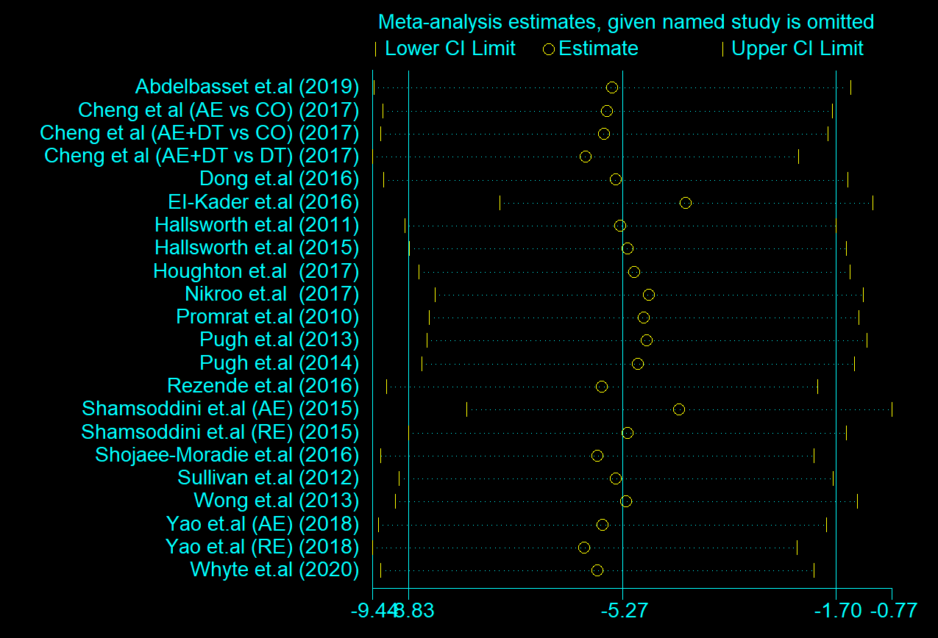

AST
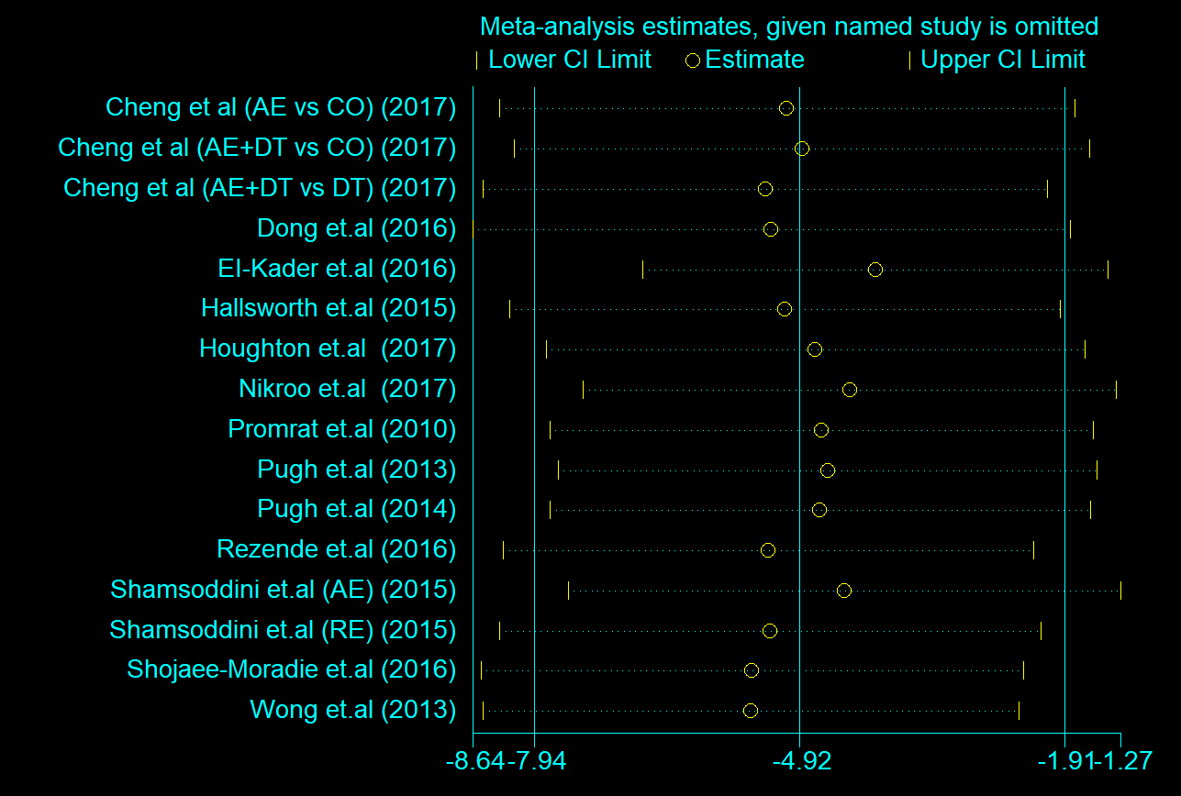

Supplementary Figure 2S. Funnel plot results for the included studies.

ALT
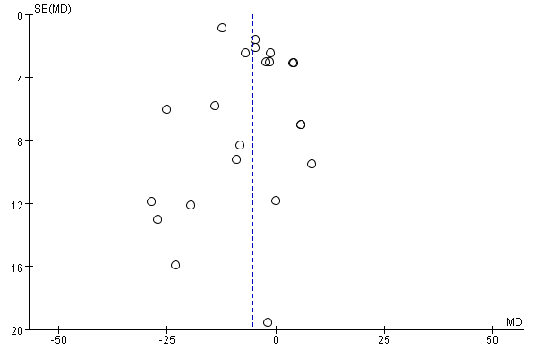

AST



