Supplementary Table I: PICOS, inclusion criteria and exclusion criteria applied to database search
PICOS | Inclusion Criteria | Exclusion Criteria
Population | - Patients initiated on SGLT2i in the acute setting (defined as during hospital admission or within 2 weeks of an acute hospital admission) | - Patients initiated on SGLT2i in the outpatient setting  - Patients whose time of SGLT2i initiation is unspecified
Intervention | - SGLT2i, including of Empagliflozin, Canagliflozin, Dapagliflozin, Ertugliflozin, Ipragliflozin, Remogliflozin  - Combined SGLT1i and SGLT2i, including Sotagliflozin, Luseogliflozin, Licogliflozin
Comparison | - Comparison with placebo  - Comparison with control group not on SGLT2i | - Comparison with non-placebo drugs
Outcome | - Efficacy: systolic blood pressure, diastolic blood pressure, weight, body mass index, waist circumference, low-density lipoprotein cholesterol, hemoglobin A1c, fasting plasma glucose, postprandial glucose, continuous glucose monitoring, urinary glucose, estimated glomerular filtration rate, urine volume, plasma electrolytes, serum uric acid, plasma osmolarity, urine osmolarity  - Safety: overall adverse events, cardiovascular adverse events, acute myocardial infarction, heart failure, hypotension, hypovolemia, volume depletion, stroke, respiratory adverse events, gastrointestinal adverse events, hepatic adverse events, pancreatitis, psychiatric adverse events, renal/ urinary adverse events, acute kidney injury, renal impairment, urinary tract infection, genital mycotic infection, reproductive adverse events, metabolic adverse events, diabetic ketoacidosis, hypoglycemia, musculoskeletal adverse events, fracture, amputation, thromboembolic adverse events, venous thrombotic events, infectious adverse events, all-cause mortality, hospitalization, malignancies, other adverse events
Study Design | - Randomized-controlled trials and observational studies, including conference abstracts  - Articles in English language  - Searches are not limited by historical time constraints  - Databases: PubMed, Embase, Cochrane, SCOPUS | - Case reports, case series, letters, editorials, perspectives  - Reviews, systematic reviews, meta-analyses

Supplementary Table 2: Outcome Characteristics
Outcomes | Pooled outcomes (95% CI) | No. of patients (no. of included studies) | Statistical heterogeneity | Quality of evidence (GRADE)
24h urine volume (ml) | MD 487.55 [126.86, 848.25] | 101 participants  2 studies | I² = 0%  P = 0.008 | ⊕⊕⊕⊝^{c}
Urine osmolarity (mOsm/kg) | MD 90.09 [-45.51, 225.69] | 166 participants  2 studies | I² = 91%  P = 0.19 | ⊕⊕⊕⊝ª
Urinary glucose (mmol/L) | MD 92.48 [-92.39, 277.36] | 101 participants  2 studies | I² = 95%  P = 0.33 | ⊕⊝⊝⊝^{b,c}
Continuous glucose monitoring (mmol/L) | MD -1.29 [-3.21, 0.62] | 88 participants  2 studies | I² = 70%  P = 0.19 | ⊕⊕⊝⊝^{a,c}
Plasma sodium (mEq/L) | MD 0.55 [0.01, 1.09] | 308 participants  4 studies | I² = 67%  P = 0.04 | ⊕⊕⊝⊝^{b}
Plasma potassium (mEq/L) | MD 0.18 [-0.18, 0.55] | 142 participants  2 studies | I² = 93%  P = 0.32 | ⊕⊝⊝⊝^{b,c}
Plasma uric acid (µmol/L) | MD -25.59 [-83.23, 32.06] | 188 participants  3 studies | I² = 89%  P = 0.38 | ⊕⊕⊝⊝^{b}
Plasma osmolarity (mOsm/kg) | MD -0.51 [-4.82, 3.79] | 166 participants  2 studies | I² = 61%  P = 0.81 | ⊕⊕⊝⊝^{b}
Systolic blood pressure (mmHg) | MD -1.51 [-4.56, 1.54] | 244 participants  4 studies | I² = 10%  P = 0.33 | ⊕⊕⊕⊕
Diastolic blood pressure (mmHg) | MD 2.28 [-2.43, 6.98] | 165 participants  3 studies | I² = 70%  P = 0.34 | ⊕⊕⊝⊝^{b}
Body weight (kg) | MD -0.73 [-1.60, 0.13] | 354 participants  5 studies | I² = 48%  P = 0.10 | ⊕⊕⊕⊝^{d}
Hospitalization duration | MD -0.27 [-0.77, 0.23] | 146 participants  2 studies | I² = 0%  P = 0.29 | ⊕⊕⊕⊝^{c}
Overall adverse events | RR 1.04 [0.96, 1.12] | 1355 participants  3 studies | I² = 0%  P = 0.34 | ⊕⊕⊕⊕
Adverse cardiovascular events | RR 0.57 [0.30, 1.07] | 125 participants  2 studies | I² = 0%  P = 0.08 | ⊕⊕⊕⊝^{c}
Cardiac failure | RR 0.70 [0.57, 0.87] | 1301 participants  2 studies | I² = 0%  P = 0.001 | ⊕⊕⊕⊕
Hypotension | RR 1.19 [0.75, 1.88] | 1388 participants  3 studies | I² = 0%  P = 0.46 | ⊕⊕⊕⊕
Adverse respiratory events | RR 0.82 [0.20, 3.37] | 125 participants  2 studies | I² = 7%  P = 0.78 | ⊕⊕⊕⊝^{c}
Adverse urinary disorders | RR 1.00 [0.76, 1.31] | 1434 participants  4 studies | I² = 0%  P = 0.99 | ⊕⊕⊕⊕
Acute kidney injury | RR 0.96 [0.57, 1.63] | 1301 participants  2 studies | I² = 0%  P = 0.89 | ⊕⊕⊕⊕
Renal impairment | RR 2.01 [0.23, 17.90] | 1309 participants  2 studies | I² = 59%  P = 0.53 | ⊕⊕⊕⊝^{d}
Urinary tract infections | RR 1.22 [0.84, 1.76] | 1434 participants  4 studies | I² = 0%  P = 0.30 | ⊕⊕⊕⊕
Adverse gastrointestinal disorders | RR 0.84 [0.37, 1.94] | 212 participants  3 studies | I² = 0%  P = 0.69 | ⊕⊕⊕⊕
Diabetic ketoacidosis | RR 0.46 [0.10, 2.04] | 1301 participants  2 studies | I² = 0%  P = 0.31 | ⊕⊕⊕⊕
Hypoglycemia | RR 1.32 [0.78, 2.24] | 1268 participants  2 studies | I² = 2%  P = 0.30 | ⊕⊕⊕⊕
All cause mortality | RR 0.86 [0.63, 1.17] | 1388 participants  3 studies | I² = 0%  P = 0.33 | ⊕⊕⊕⊕
Rehospitalization | RR 0.75 [0.14, 3.93] | 166 participants  2 studies | I² = 32%  P = 0.73 | ⊕⊕⊕⊝^{d}
Other adverse events | RR 2.11 [0.31, 14.50] | 125 participants  2 studies | I² = 81%  P = 0.45 | ⊕⊝⊝⊝^{b,c}
NT-proBNP, N-Terminal pro B-type Natriuretic Peptide; GRADE, Grades of Recommendation, Assessment, Development and Evaluation; RR, relative risk; WMD, weighted mean difference; ROM, ratio of means.
ªDowngraded by one level for substantial statistical heterogeneity, but forest plots indicate a consistent direction favouring study-level treatment effect.
^{b}Downgraded by two levels for severe statistical heterogeneity.
^{c}Downgraded by one level for statistical imprecision.
^{d}Downgraded by one level for moderate statistical heterogeneity.

Supplementary Table 3: Participant baseline characteristics
Study | Sample size | Males | Mean age (years) | Mean BMI (kg/m²) | Mean systolic blood pressure (mmHg) | Mean diastolic blood pressure (mmHg) | Mean HbA1c (%) | Mean LDL-C (mmol/L) | Reason for hospital admission
Yamada 2015 | 42 | 10 | 56.50 | 28.70 | 119.50 | 75.50 | 9.75 | 6.42 | Poor glycemic control in patients with type 2 diabetes mellitus
Gerards 2018 | 46 | 24 | 72.30 | 28.60 | 137.00 | 77.70 | 7.00 | NR | Acute chronic obstructive pulmonary disease exacerbation
Hao 2018 | 59 | 37 | 58.35 | 26.60 | NR | NR | 10.00 | NR | NR
Bhatt 2020 | 1222 | 810 | 70 | 30.75 | 122 | 72.50 | 7.15 | NR | Heart failure
Boorsma 2020 | 79 | 53 | 76.04 | NR | 124.54 | NR | NR | NR | Acute heart failure
Ibrahim 2020 | 100 | 54 | 61.33 | 28.01 | 111.91 | 73.20 | 8.85 | NR | Decompensated heart failure
Refardt 2020 | 87 | 32 | 75.00 | 23.50 | 140.00 | 72.00 | NR | NR | Syndrome of inappropriate antidiuretic hormone secretion- induced hyponatremia
Damman 2020 | 79 | 53 | 76.00 | NR | 124.00 | 74.00 | NR | NR | Acute heart failure
Lan 2020 | 44 | 34 | 62.90 | 30.50 | 125.80 | 70.60 | 8.20 | 2.65 | Acute coronary syndrome
Abbreviations: BMI: body mass index; HbA1c: hemoglobin A1c; LDL-C: low-density lipoprotein cholesterol.
*NR refers to ‘not reported’

Supplementary Table 4: Intervention Characteristics
Study | Article | Drug name | Drug dose | Drug frequency | Control group | Length of intervention | Mean length of follow-up
Yamada 2015 | Effects of a sodium glucose co-transporter 2 selective inhibitor, ipragliflozin, on the diurnal profile of plasma glucose in patients with type 2 diabetes: A study using continuous glucose monitoring | Ipragliflozin | 50mg | Once daily | Placebo | 7 days | 7 days
Gerards 2018 | Dapagliflozin for prednisone-induced hyperglycemia in acute exacerbation of chronic obstructive pulmonary disease | Dapagliflozin | 10mg | Once daily | Placebo | 2-14 days (average 7.3 days) | 14 days
Hao 2018 | Effects of dapagliflozin on serum uric acid levels in hospitalized type 2 diabetic patients with inadequate glycemic control: a randomized controlled trial | Dapagliflozin | 10mg | Once daily | Placebo | 3 days | 3 days
Bhatt 2020 | Sotagliflozin in Patients with Diabetes and Recent Worsening Heart Failure | Sotagliflozin | 200mg, 400mg | Once daily | Placebo | 7.70 months (median) | 9.05 months (median)
Boorsma 2020 | Effects of Empagliflozin on Renal Sodium and Glucose Handling in Patients with Acute Heart Failure | Empagliflozin | 10mg | Once daily | Placebo | 30 days | 30 days
Ibrahim 2020 | Safety and Efficacy of Adding Dapagliflozin to Furosemide in Type 2 Diabetic Patients With Decompensated Heart Failure and Reduced Ejection Fraction | Dapagliflozin | 10mg | Once daily | Placebo | NR | 4.78 days (mean)
Refardt 2020 | A Randomized Trial of Empagliflozin to Increase Plasma Sodium Levels in Patients with the Syndrome of Inappropriate Antidiuresis | Empagliflozin | 25mg | Once daily | Placebo | 4 days | 30 days
Damman 2020 | Randomized, double‐blind, placebo‐controlled, multicentre pilot study on the effects of empagliflozin on clinical outcomes in patients with acute decompensated heart failure (EMPA‐RESPONSE‐AHF) | Empagliflozin | 10mg | Once daily | Placebo | 30 days | 60 days
Lan 2020 | Empagliflozin and left ventricular diastolic function following an acute coronary syndrome in patients with type 2 diabetes | Empagliflozin | 10, 25mg | Once daily | Placebo | 3 months | 98 days

Supplementary Figure 1: Risk of Bias Graph
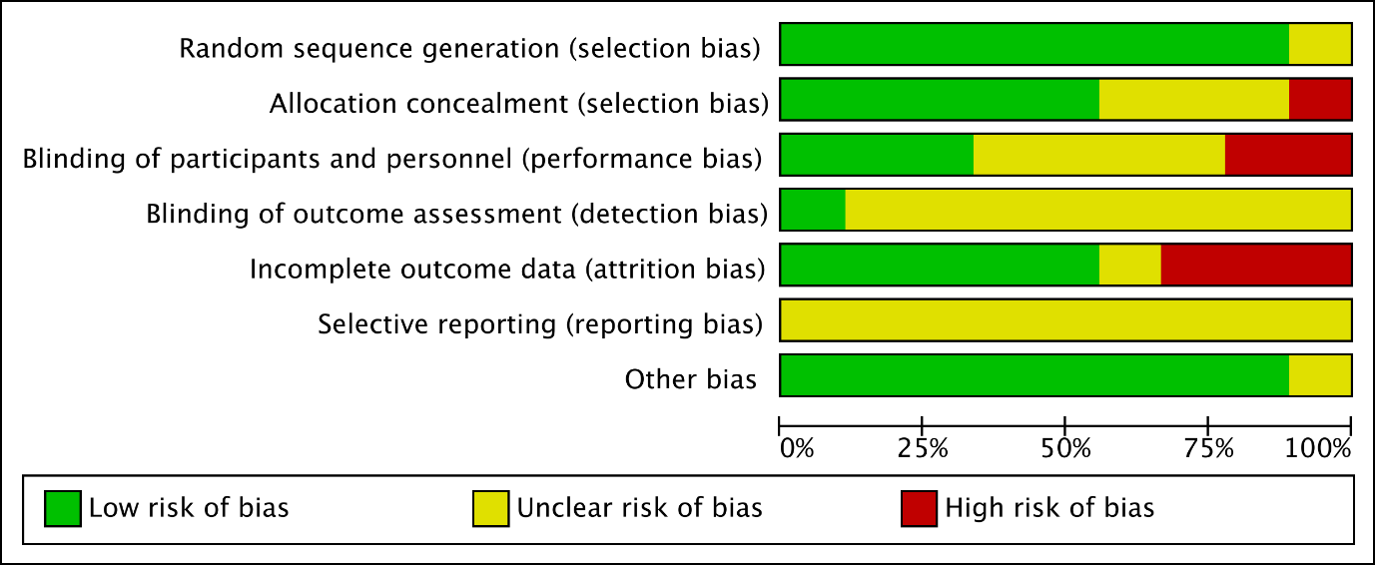

Supplementary Figure 2: PRISMA 2020 Checklist
Section/topic | # | Checklist item | Reported on page #
TITLE
Title | 1 | Identify the report as a systematic review, meta-analysis, or both. | 1
ABSTRACT
Abstract | 2 | PRISMA 2020 Abstract checklist:  - Identify the report as a systematic review.  - Provide an explicit statement of the main objective(s) or question(s) the review addresses.  - Specify the inclusion and exclusion criteria for the review.  - Specify the information sources (e.g. databases, registers) used to identify studies and the date when each was last searched.  - Specify the methods used to assess risk of bias in the included studies.  - Specify the methods used to present and synthesise results.  - Give the total number of included studies and participants and summarise relevant characteristics of studies.  - Present results for main outcomes, preferably indicating the number of included studies and participants for each. If meta-analysis was done, report the summary estimate and confidence/credible interval. If comparing groups, indicate the direction of the effect (i.e. which group is favoured).  - Provide a brief summary of the limitations of the evidence included in the review (e.g. study risk of bias, inconsistency and imprecision).  - Provide a general interpretation of the results and important implications.  - Specify the primary source of funding for the review.  - Provide the register name and registration number. | 3-4
INTRODUCTION
Rationale | 3 | Describe the rationale for the review in the context of existing knowledge. | 5
Objectives | 4 | Provide an explicit statement of the objective(s) or question(s) the review addresses. | 5
METHODS
Eligibility criteria | 5 | Specify the inclusion and exclusion criteria for the review and how studies were grouped for the syntheses. | 6-7
Information sources | 6 | Specify all databases, registers, websites, organisations, reference lists and other sources searched or consulted to identify studies. Specify the date when each source was last searched or consulted. | 6
Search strategy | 7 | Present the full search strategies for all databases, registers and websites, including any filters and limits used. | 6
Selection process | 8 | Specify the methods used to decide whether a study met the inclusion criteria of the review, including how many reviewers screened each record and each report retrieved, whether they worked independently, and if applicable, details of automation tools used in the process. | 9
Data collection process | 9 | Specify the methods used to collect data from reports, including how many reviewers collected data from each report, whether they worked independently, any processes for obtaining or confirming data from study investigators, and if applicable, details of automation tools used in the process. | 9
Data items | 10 | List and define all outcomes for which data were sought. Specify whether all results that were compatible with each outcome domain in each study were sought (e.g. for all measures, time points, analyses), and if not, the methods used to decide which results to collect.  List and define all other variables for which data were sought (e.g. participant and intervention characteristics, funding sources). Describe any assumptions made about any missing or unclear information. | 6-8
Study risk of bias assessment | 11 | Specify the methods used to assess risk of bias in the included studies, including details of the tool(s) used, how many reviewers assessed each study and whether they worked independently, and if applicable, details of automation tools used in the process. | 9
Effect measures | 12 | Specify for each outcome the effect measure(s) (e.g. risk ratio, mean difference) used in the synthesis or presentation of results. | NIL
Synthesis methods | 13 | Describe the processes used to decide which studies were eligible for each synthesis (e.g. tabulating the study intervention characteristics and comparing against the planned groups for each synthesis  Describe any methods required to prepare the data for presentation or synthesis, such as handling of missing summary statistics, or data conversions.  Describe any methods used to tabulate or visually display results of individual studies and syntheses.  Describe any methods used to synthesise results and provide a rationale for the choice(s). If meta-analysis was performed, describe the model(s), method(s) to identify the presence and extent of statistical heterogeneity, and software package(s) used.  Describe any methods used to explore possible causes of heterogeneity among study results (e.g. subgroup analysis, meta-regression).  Describe any sensitivity analyses conducted to assess robustness of the synthesised results. | 9
Reporting bias assessment | 14 | Describe any methods used to assess risk of bias due to missing results in a synthesis (arising from reporting biases). | NIL
Certainty assessment | 15 | Describe any methods used to assess certainty (or confidence) in the body of evidence for an outcome. | NIL

RESULTS
Study selection | 16 | Describe the results of the search and selection process, from the number of records identified in the search to the number of studies included in the review, ideally using a flow diagram  Cite studies that might appear to meet the inclusion criteria, but which were excluded, and explain why they were excluded. | 10
Study characteristics | 17 | Cite each included study and present its characteristics. | 11
Risk of bias in studies | 18 | Present assessments of risk of bias for each included study. | Supplementary Materials
Results of individual studies | 19 | For all outcomes, present, for each study: (a) summary statistics for each group (where appropriate) and (b) an effect estimate and its precision (e.g. confidence/credible interval), ideally using structured tables or plots. | Supplementary Materials
Results of syntheses | 20 | For each synthesis, briefly summarise the characteristics and risk of bias among contributing studies.  Present results of all statistical syntheses conducted. If meta-analysis was done, present for each the summary estimate and its precision (e.g. confidence/credible interval) and measures of statistical heterogeneity. If comparing groups, describe the direction of the effect.  Present results of all investigations of possible causes of heterogeneity among study results.  Present results of all sensitivity analyses conducted to assess the robustness of the synthesised results. | 12-13, 22-28
Reporting biases | 21 | Present assessments of risk of bias due to missing results (arising from reporting biases) for each synthesis assessed. | NIL
Certainty of evidence | 22 | Present assessments of certainty (or confidence) in the body of evidence for each outcome assessed. | NIL
DISCUSSION
Discussion | 23 | Provide a general interpretation of the results in the context of other evidence.  Discuss any limitations of the evidence included in the review.  Discuss any limitations of the review processes used.  Discuss implications of the results for practice, policy, and future research. | 14-16
OTHER INFORMATION
Registration and protocol | 24 | Provide registration information for the review, including register name and registration number, or state that the review was not registered.  Indicate where the review protocol can be accessed, or state that a protocol was not prepared.  Describe and explain any amendments to information provided at registration or in the protocol. | 6
Support | 25 | Describe sources of financial or non-financial support for the review, and the role of the funders or sponsors in the review. | 17
Competing interest | 26 | Declare any competing interests of review authors. | 17
Availability of data, code, and other materials | 27 | Report which of the following are publicly available and where they can be found: template data collection forms; data extracted from included studies; data used for all analyses; analytic code; any other materials used in the review. | 17

Supplementary Fig. 3. Forest plot for (A) overall adverse events (B) cardiovascular adverse events (C) rehospitalizations for heart failure (D) hypotension (E) respiratory adverse events (F) gastrointestinal adverse events (G) renal/ urinary adverse events (H) acute kidney injury (I) renal impairment (J) urinary tract infection (K) diabetic ketoacidosis (L) hypoglycemia (M) all-cause mortality (N) mean difference in duration of hospitalization in days (O) rehospitalization (P) other adverse events

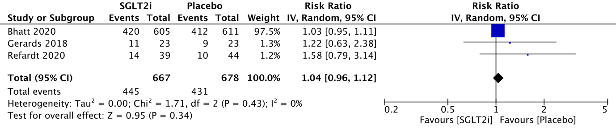
Fig. 3A.

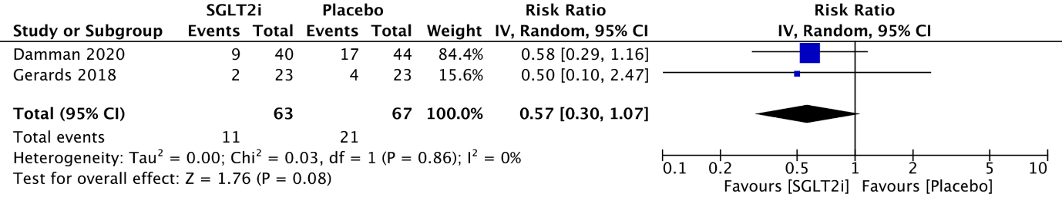
Fig. 3B.

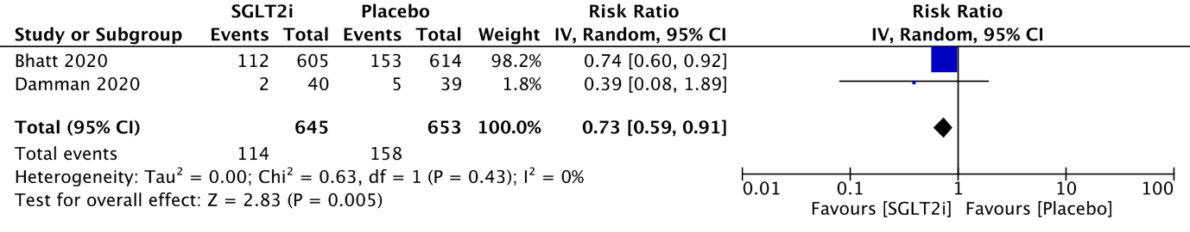
Fig. 3C.

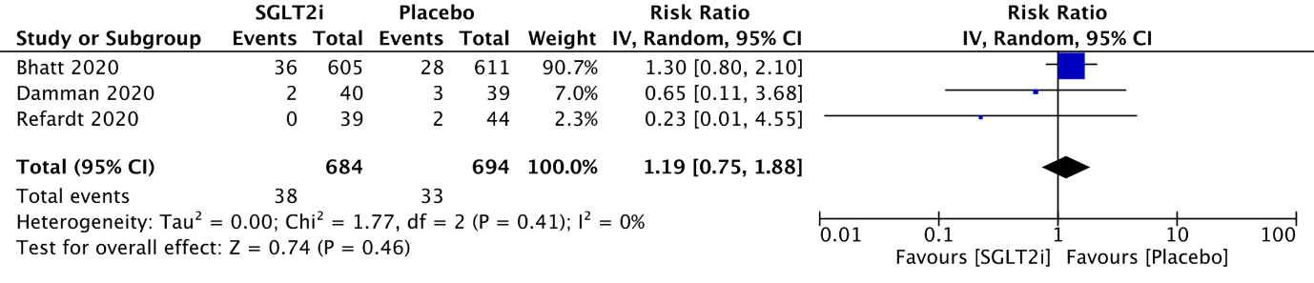
Fig. 3D.

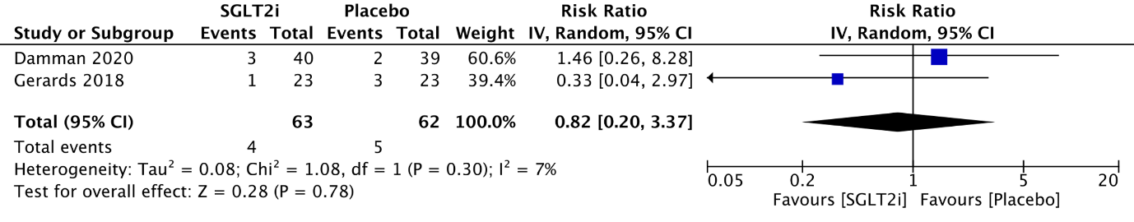
Fig. 3E.

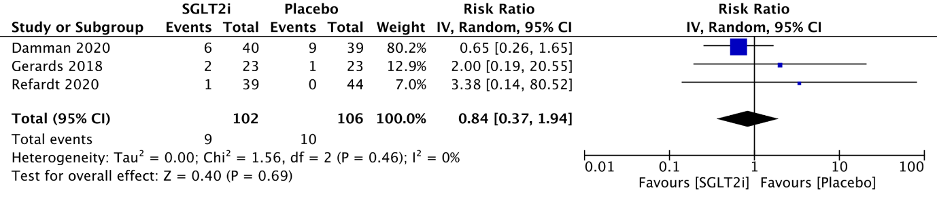
Fig. 3F.

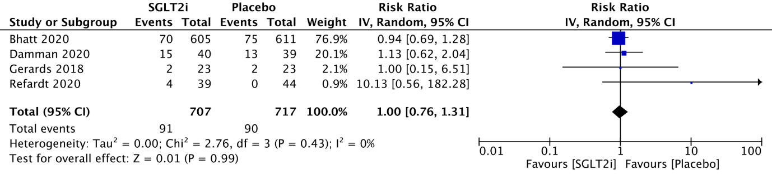
Fig. 3G.

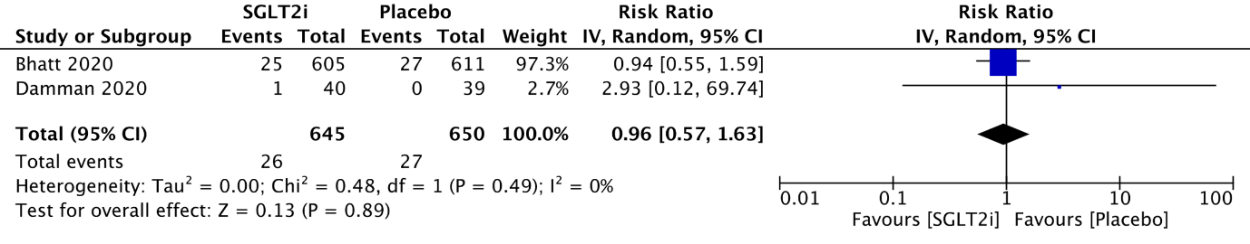
Fig. 3H.

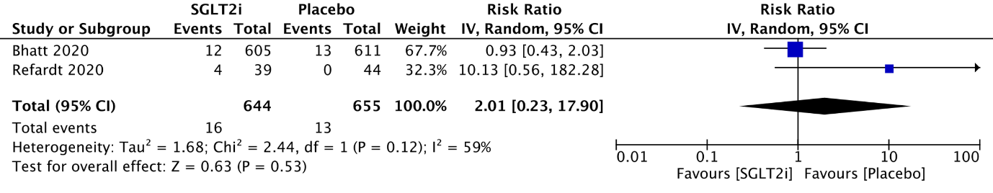
Fig. 3I.

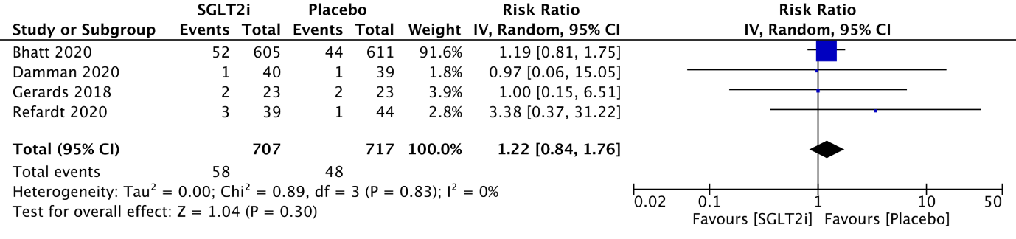
Fig. 3J.

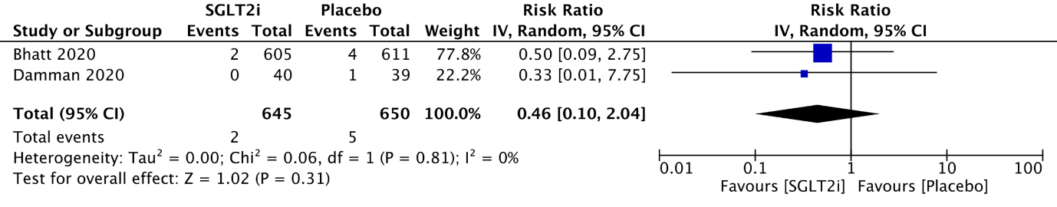
Fig. 3K.

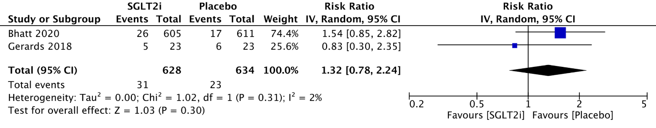
Fig. 3L.

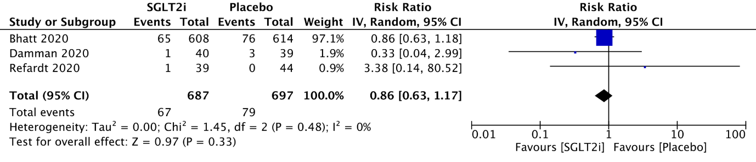
Fig. 3M.

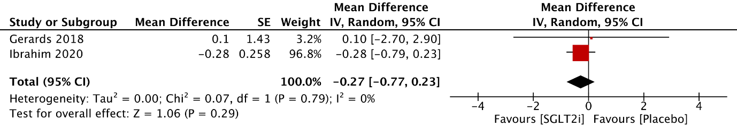
Fig. 3N.

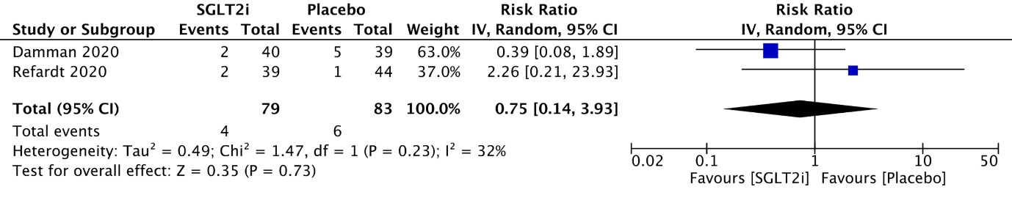
Fig. 3O.

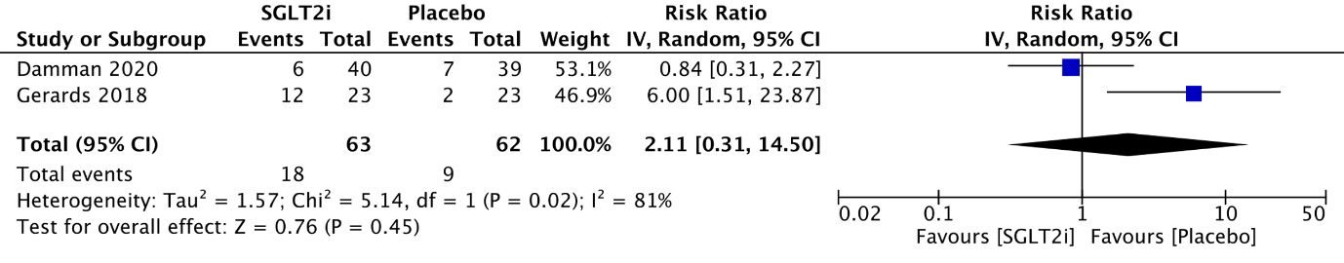
Fig. 3P.

Supplementary Fig. 4. Subgroup analysis of patients initiated on SGLT2i during acute hospital admission – forest plot of mean change in (A) systolic blood pressure in mmHg (B) diastolic blood pressure in mmHg (C) body weight in kg (D) plasma sodium in mEq/L (E) serum uric acid in umol/L (F) plasma osmolarity in mOsm/kg (G) urine osmolarity in mOsm/kg

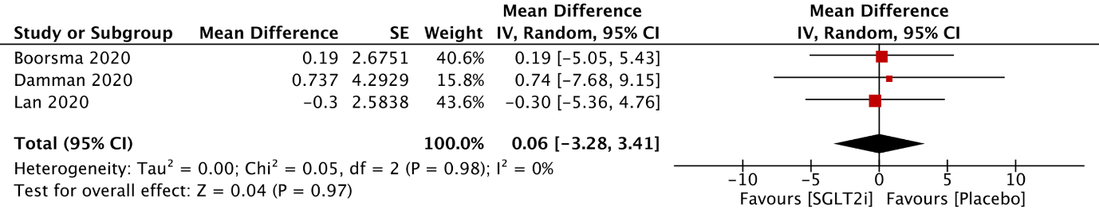
Fig. 4A.

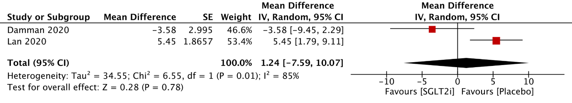
Fig. 4B.

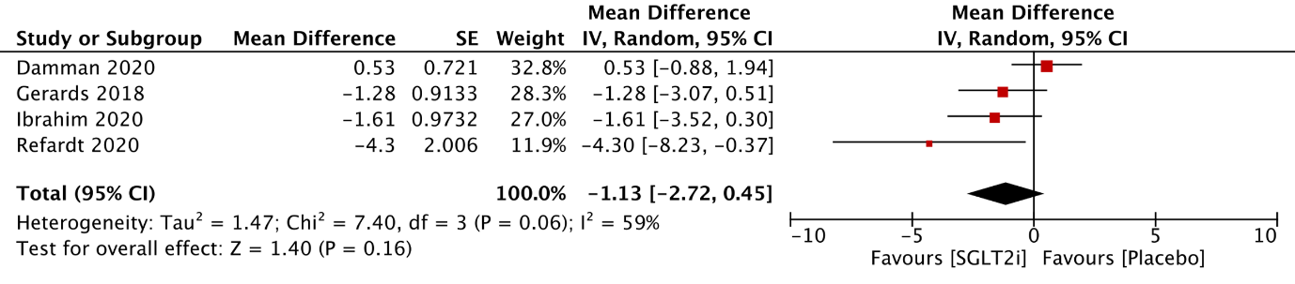
Fig. 4C.

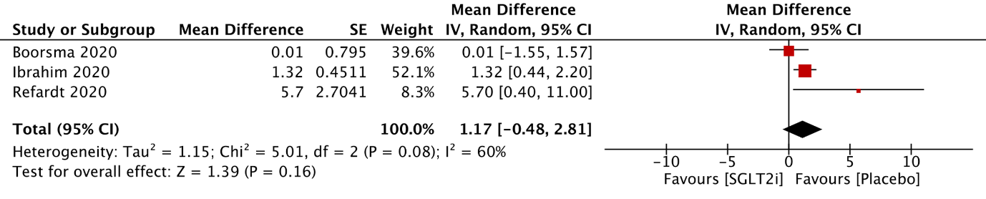Fig. 4D.

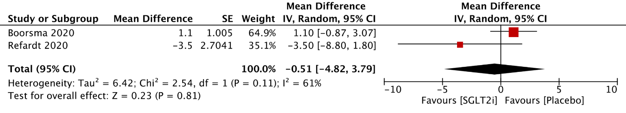Fig. 4E.

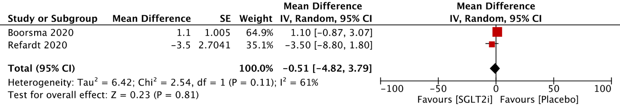
Fig. 4F.

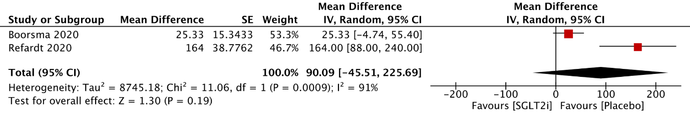
Fig. 4G.

Supplementary Fig. 5. Subgroup analysis of patients initiated on SGLT2i during acute hospital admission – forest plot for (A) overall adverse events (B) cardiovascular adverse events (C) rehospitalizations for heart failure (D) hypotension (E) respiratory adverse events (F) gastrointestinal adverse events (G) renal/ urinary adverse events (H) urinary tract infection (I) all-cause mortality (J) mean difference in duration of hospitalization in days (K) rehospitalisation

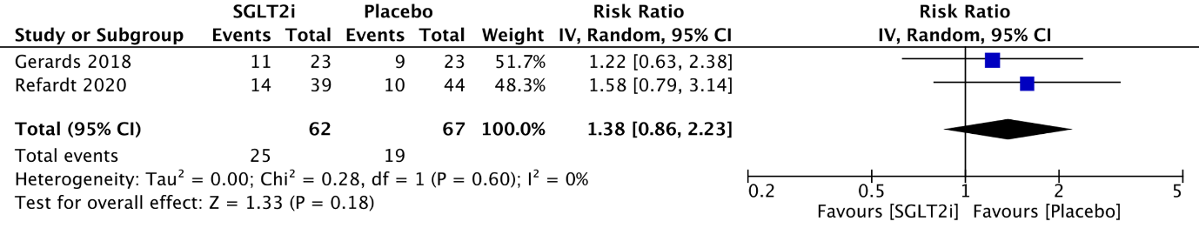
Fig. 5A.

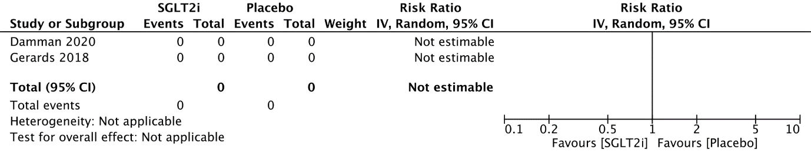
Fig. 5B.

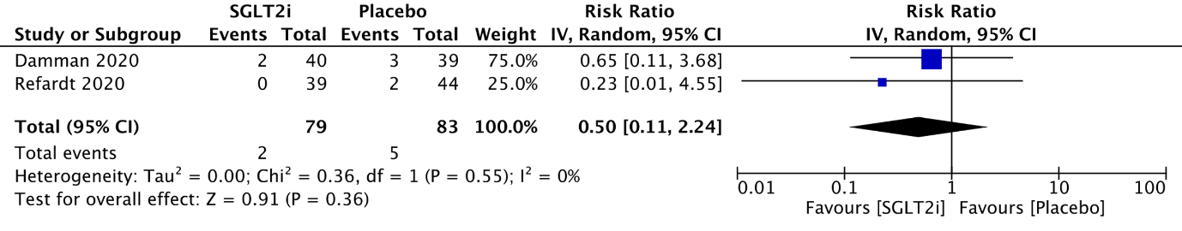Fig. 5C.

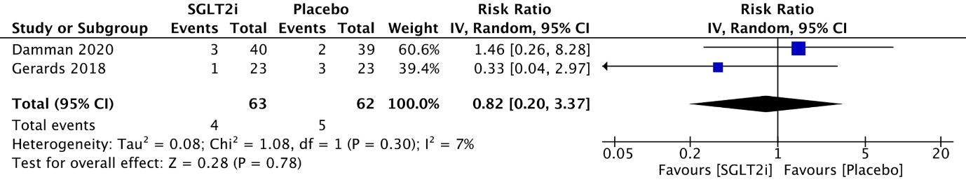
Fig. 5D.

Fig. 5E.

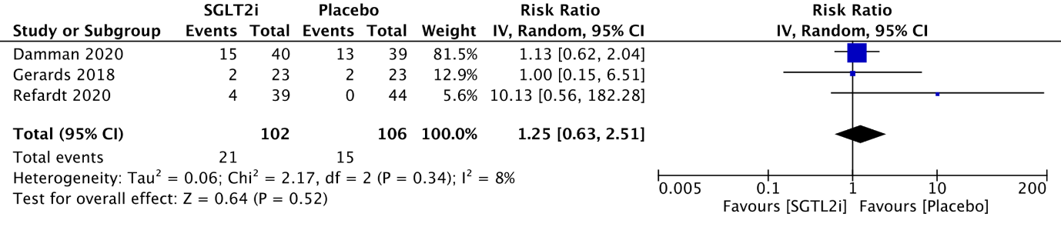Fig. 5F.

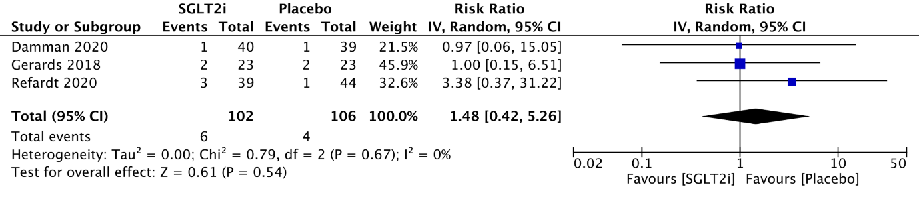
Fig. 5G.

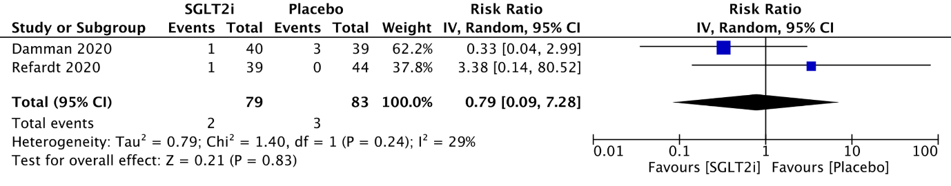
Fig. 5H.

Fig. 5I.

Fig. 5J.

Fig. 5K.

Supplementary Fig. 6. Subgroup analysis of heart failure patients – forest plot of mean change in (A) systolic blood pressure in mmHg (B) body weight in kg (C) plasma sodium in mEq/L
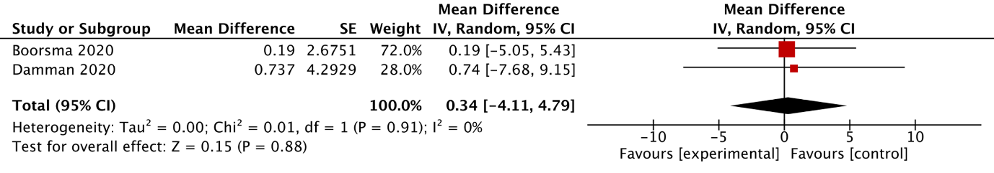
Fig. 6A.

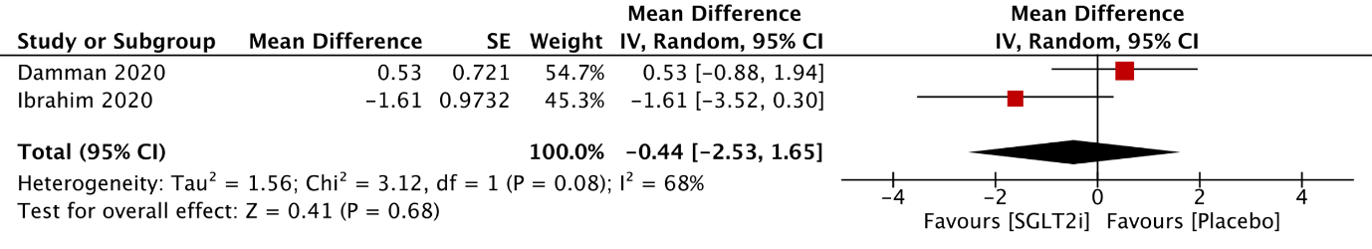
Fig. 6B.

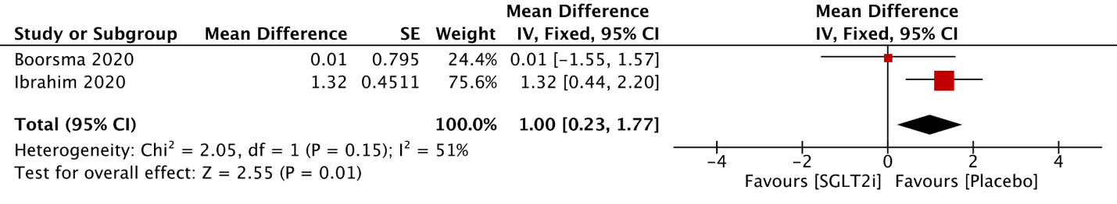
Fig. 6C.

Supplementary Fig. 7. Subgroup analysis of heart failure patients – forest plot for (A) rehospitalizations for heart failure (B) hypotension (C) acute kidney injury (D) renal/ urinary adverse events (E) urinary tract infection (F) diabetic ketoacidosis (G) all-cause mortality

Fig. 7A.

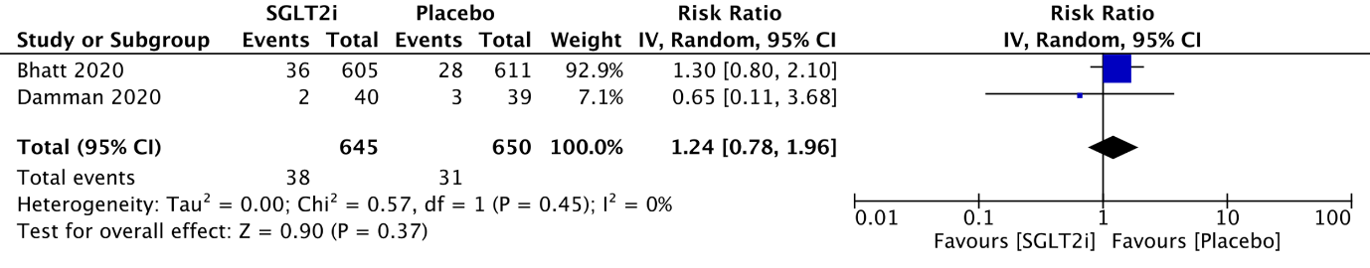
Fig. 7B.

Fig. 7C.

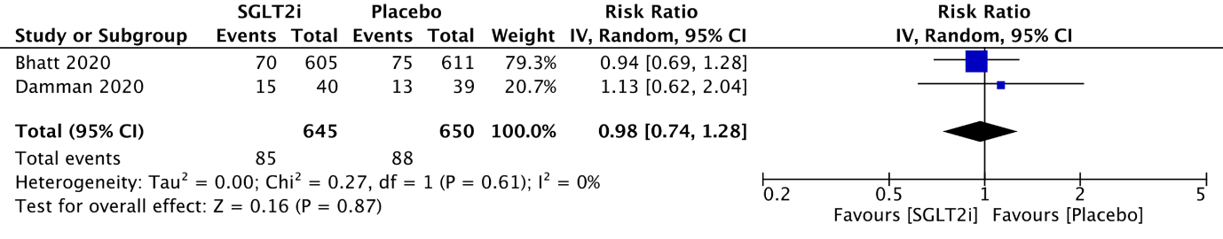
Fig. 7D.
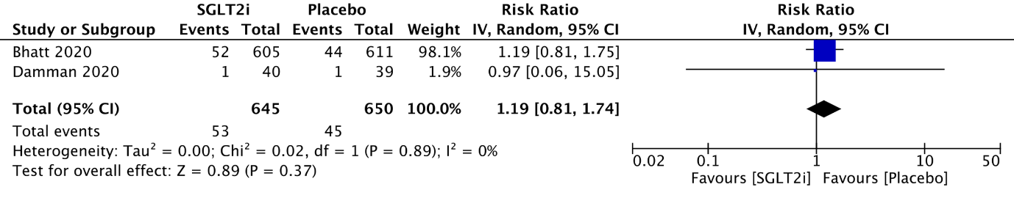
Fig. 7E.

Fig. 7F.

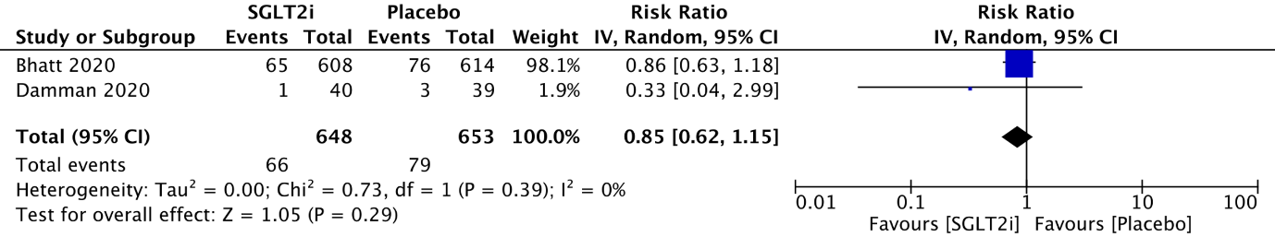
Fig. 7G.

