# Introduction to Computer Science and Programming 1

# CSCI120

### Chapter10: Tuples

Assignment 10

**Note:** This document has been designed and developed as part of an initiative for creating an OER (Open Education Resource) package for the course CSCI 120 at Columbia College.

Please contact [Alireza.davoodi@gmail.com](mailto:Alireza.davoodi@gmail.com) for any comment, modification, and questions.

**Terms of use:** Please feel free to customize this document as needed

Last Modified: July 2022

If it is a group assignment, please add the information here

|  |  |  |
| --- | --- | --- |
| **# of Students in the Group:** |  | |
|  |  |  |
| **Student 1** | *First name, last name* | *Student-ID* |
| **Student 2** | *First name, last name* | *Student-ID* |
| **Student 3** | *First name, last name* | *Student-ID* |
| **Student 4** | *First name, last name* | *Student-ID* |

# Requirements

* Please use meaningful name for your variables and functions
* Try to reuse your solutions as much as possible.
* For each of the following problem you need to
  + Define a function
  + For all test cases you have already written for your algorithm, write a function call inside the main function
* Define all the functions in one file (all in one)
* Define one main function
* Call the functions inside the main function
* If the function you have implemented for a question is big, please try to break down to multiple functions.
* Do not use methods, functions, statements that we have not covered in the previous lectures.

# Problem1

* Write a function which receives a list of number and calculate the average and standard deviation (std) of the numbers and returns both the average and std.

# Problem2

Write a function which receives 2 points in the a cartesian coordination system and calculate the distance between two numbers:

Note: The image below shows the formula.

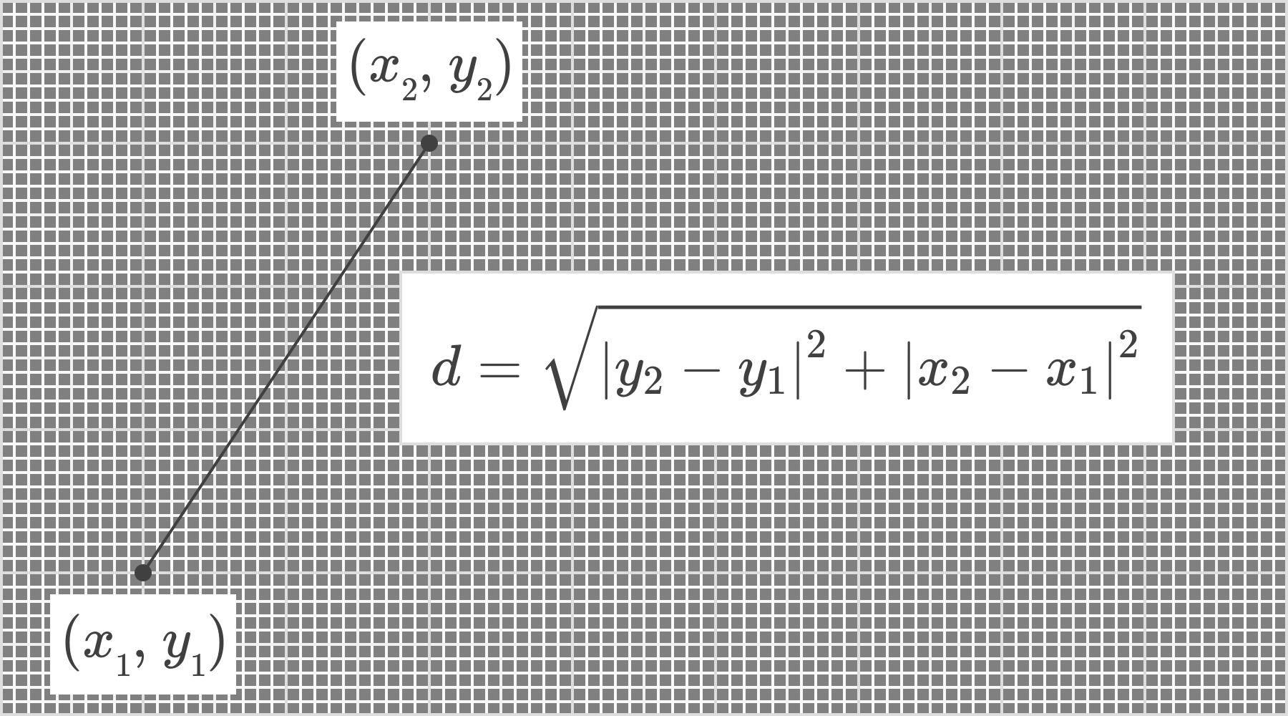

# Problem3

* Write a function that receives a tuple of Integers as its input parameters and converts the tuple to a list and returns it.

# Problem4

* The following table is given (as a sample data). Write a python function that receives such a table and returns a tuple containing the first name, last name and grade of the students who have received the maximum grade.

|  |  |  |
| --- | --- | --- |
| **Firstname** | **Lastname** | **Grade** |
| Bryan | Hinton | 80 |
| Adam | Juarez | 76 |
| Veronica | Morley | 83 |
| Harvir | Sandhu | 75 |
| Reis | Wheeler | 83 |

# Problem5

* Write a function with one input parameter which is a number called size. The function then asks the user to enter as many words as the size. Then the function will find the followings and returns it as a tuple:
  + The first item in the tuple is the size
  + The second item in the tuple is the number of words whose length is less than 5
  + The third item in the tuple is the number of words which only contains upper case letters.
  + The fourth item in the tuples is the number of words which contains at least one letter in the word

**Good Luck ☺**